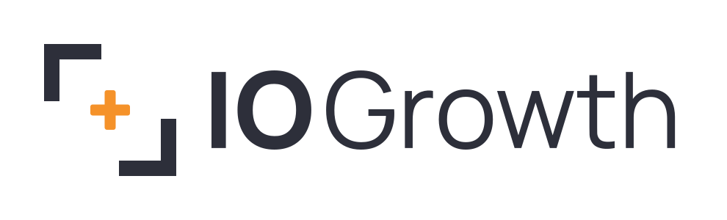

Logo & Brand Assets
April 2026

Primary Logo
The horizontal lockup is the primary logo for most applications. Use on light backgrounds whenever possible.

Light Background


Dark Background


Stacked Logo
The stacked lockup works well for social media profiles, compact spaces, and square formats.
 | 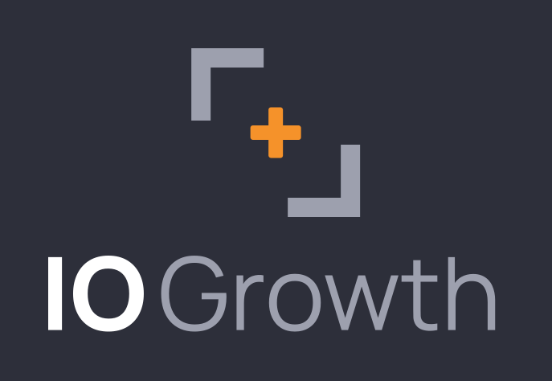

Symbol Mark
Use the standalone symbol for favicons, app icons, avatars, and anywhere the full wordmark is too wide.
 |  | 
Default | Dark | On Orange

Brand Colors

Charcoal  #2D2F3A | Orange  #F5922A | Light Gray  #9DA0AE

Typography
The IO Growth wordmark uses Manrope, a modern geometric sans-serif. "IO" is set in ExtraBold (800) and "Growth" in Regular (400). This weight contrast creates visual hierarchy within the name itself.
Primary Typeface: Manrope (Google Fonts, open source)
Wordmark Weights: 800 (ExtraBold) for IO, 400 (Regular) for Growth
Tracking: -1px (slightly tightened)

File Inventory
All logo files are provided as both SVG (vector, scalable) and PNG (raster, 3x resolution). SVGs have all text converted to outlined paths with no font dependencies.
File | Use
io-growth-horizontal-light.svg / .png | Primary logo, light backgrounds
io-growth-horizontal-dark.svg / .png | Primary logo, dark backgrounds
io-growth-stacked-light.svg / .png | Social profiles, compact layouts
io-growth-stacked-dark.svg / .png | Social profiles, dark backgrounds
io-growth-symbol.svg / .png | Favicon, app icon, avatar
io-growth-symbol-dark.svg / .png | Icon on dark backgrounds
io-growth-symbol-white.svg / .png | Icon on orange or colored backgrounds

