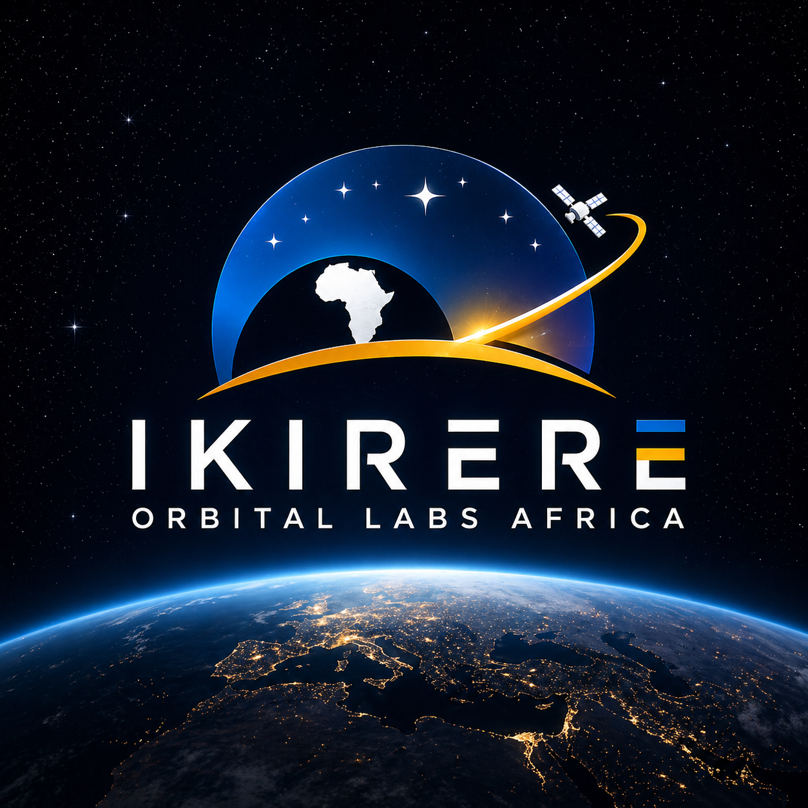

IKIRERE ORBITAL LABS AFRICA

OPEN PROBLEM
Real-Time Many-to-Many Conjunction Screening at Orbital Scale

Posed by Ikirere Orbital Labs Africa

2026 · jason@ikirere.com · ikirere.com

The Problem

Given a catalog of 15,000+ actively tracked orbital objects, compute all pairwise conjunction risks - including cascade-weighted orbital shell density - in under 100 milliseconds on commodity CPU hardware.

Why It Matters

The Kessler Cascade
In 1978 Donald Kessler and Burton Cour-Palais described a cascade failure scenario that has since become the defining existential risk of orbital infrastructure. A collision in Low Earth Orbit generates debris. Each fragment strikes other satellites. More debris, more collisions - until the orbital shell becomes self-sustaining in its own destruction.

This is not theoretical. The 2009 Iridium-Cosmos collision and the 2021 Cosmos-1408 ASAT test each generated thousands of fragments still in orbit today. The LEO shell between 400 and 600 km is approaching critical density.

The Scale of the Problem
The pair count is not fixed. It grows with the catalog, which grows continuously:

Catalog | Raw Pairs | Est. Year
15,447 active objects (today) | 119,267,631 pairs | 2026
27,000 all tracked objects | 364,486,500 pairs | 2026
50,000+ (megaconstellations + growth) | 1,249,975,000 pairs | ~2030

SpaceX has regulatory approval for 42,000 Starlinks alone. A solution that works today must be designed to scale to the 2030 catalog.

Why Current Systems Are Insufficient
System | Performance
Space-Track (USSPACECOM) | 8-hour screening cadence
LeoLabs | Under 30 seconds (proprietary, undisclosed)
GPU-accelerated propagation (Cambridge, 2026) | 4ms propagation only - not the full pipeline
Full pipeline on CPU at <100ms | Unsolved

GPU at sub-100ms is within reach for propagation. CPU at <100ms for the full pipeline - including pairwise geometry, time of closest approach computation, and cascade-weighted risk scoring - is an open problem. No publicly verifiable implementation exists.

Why CPU matters: A CPU solution runs on any ground station, any laptop, any operator anywhere in the world. GPU requires expensive specialised hardware unavailable to most satellite operators, university labs, and researchers in emerging markets. CPU is the democratising result.

What a Solution Must Do

For a catalog of n orbital objects, a valid solution must:

- Screen all pairs where altitude difference is below a configurable threshold (eliminating geometrically impossible conjunctions)
- Compute the time of closest approach (TCA) and minimum separation for surviving pairs
- Produce a risk score per pair that accounts for: geometric proximity, relative velocity, time urgency, positional uncertainty, and orbital shell population density
- Return results ranked by risk, highest first
- Complete the full pipeline in under 100 milliseconds on a modern CPU
- Scale to 50,000+ objects without architectural changes

Accuracy requirements:
- TCA accurate to within 2 seconds
- Miss distance accurate to within 1 km for LEO objects
- All pairs within the altitude threshold must appear in the output - no false negatives

The Gap to Close

The naive approach - serial pair evaluation with sequential propagation - takes approximately 2 hours for 15,000 satellites on a CPU. The target is 100 milliseconds. That is a 72,000x improvement.

Three distinct computational problems must be solved simultaneously in a single pass, without inter-stage data transfers that would dominate the latency budget:

- Propagation for N satellites across M future time steps
- Pairwise geometry for all surviving pairs (up to millions) simultaneously
- Per-pair risk scoring incorporating a whole-catalog density metric

If You Are Working on This

We are looking for researchers, engineers, and collaborators who are working on - or interested in - this class of problem. If you have solved a component, have relevant work, or want to collaborate, reach out.

Name | Jason Quist, Founder and CEO
Organisation | Ikirere Orbital Labs Africa
Email | jason@ikirere.com
Website | ikirere.com
Recognition | Deep Learning Indaba 2025 Winner
Fellowship | INSEAD AI Venture Lab Fellow
Programs | Google and NVIDIA Inception

Software first. Hardware second. Space third.

