# Option 1: Azure SQL DB Config From Scratch (Could restore Pulse)

1. Log into the Azure Portal with your UMGC Account

## Create SQL Database

1. Select Create SQL Database
2. 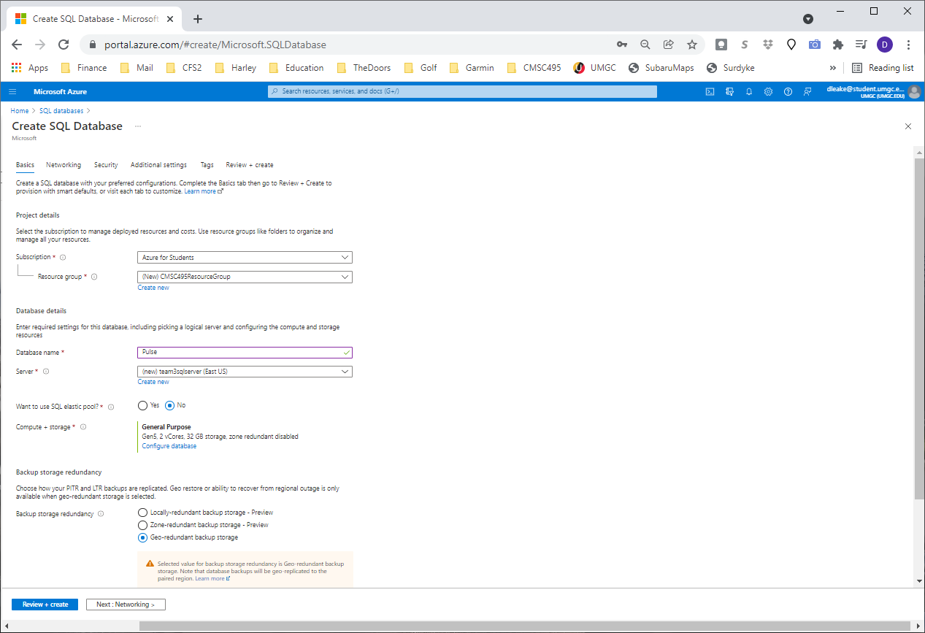
3. Set or Create Resource Group
   1. I set ours to CMSC495Resource Group
4. Create New Server
   1. Set Server Name
      1. team3sqlserver
   2. Set Location (I chose US East)
      1. 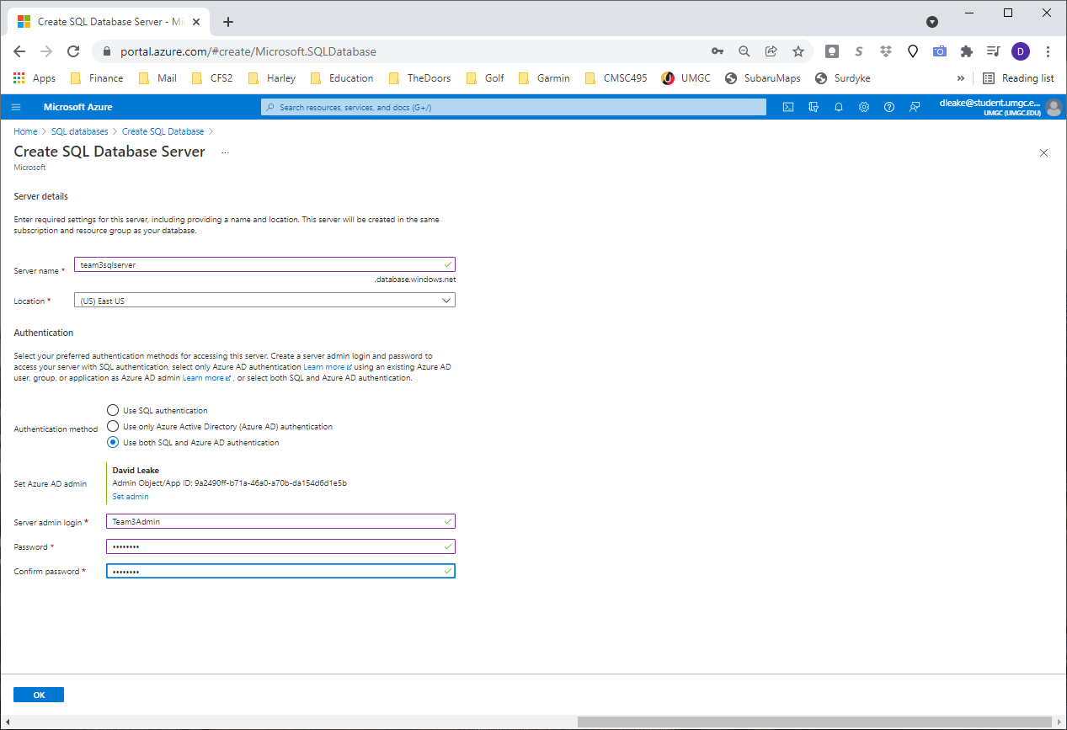
   3. Use both SQL and Azure AD Authentication (In case someone doesn’t want to use their Azure)
   4. Select Set Azure AD Admin ( I chose my umgc account
      1. 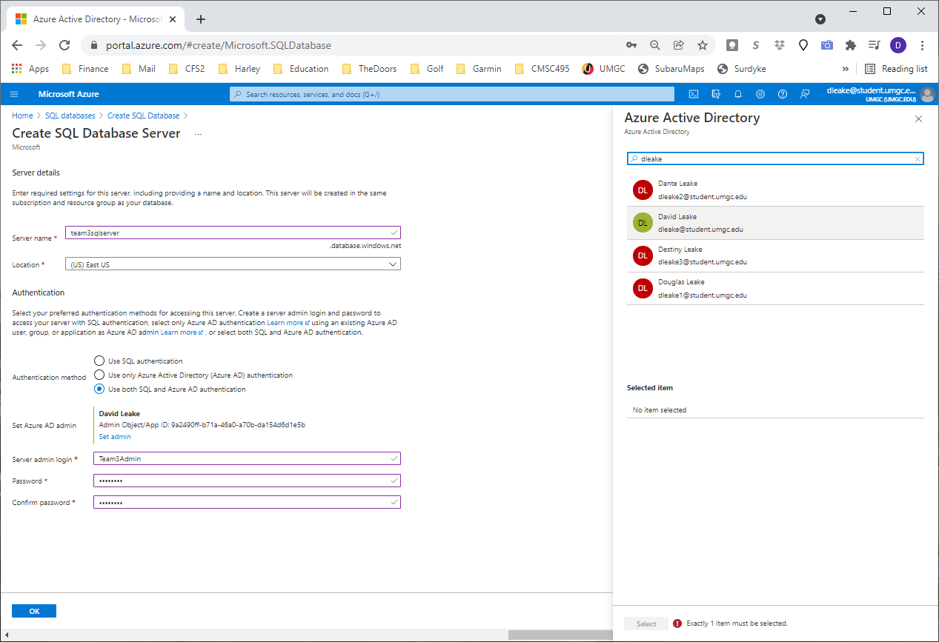
   5. Server Admin Login
      1. Team3Admin
      2. T3Admin!
   6. Select OK
5. Want to use SQL elastic pool:
   1. No
6. Comput + Storage
   1. Click: Configure database
   2. Select Serverless, Apply
      1. 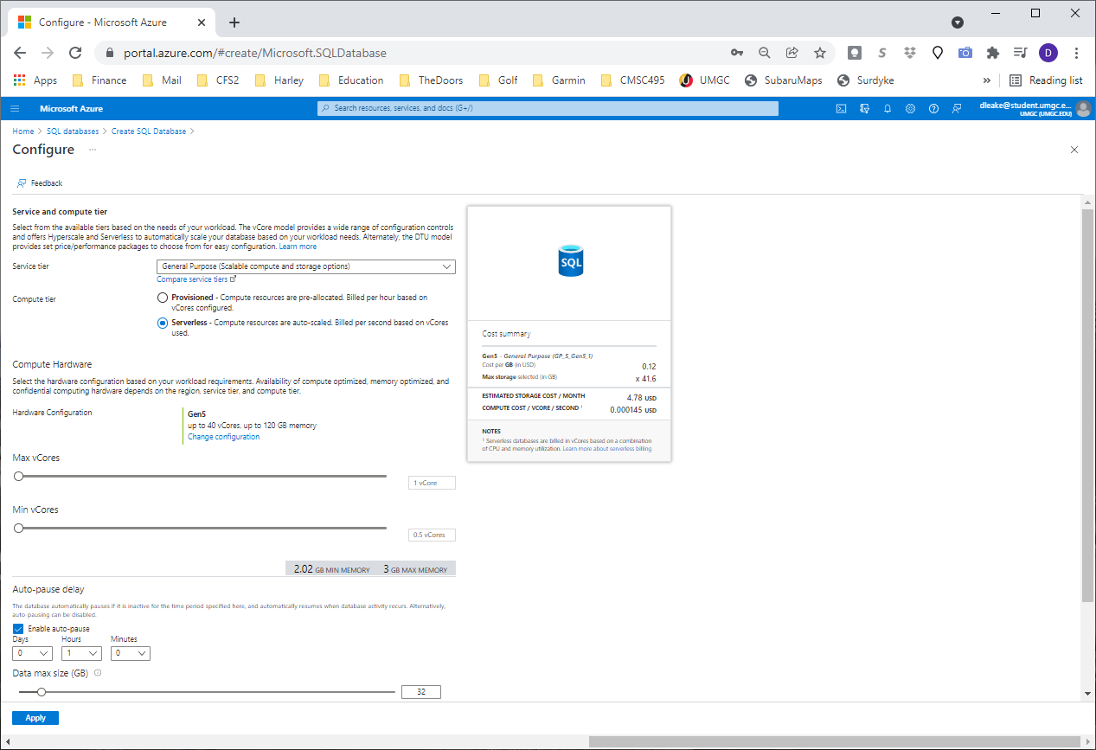
   3. Leave the Backup storage redundancy to Geo-Redundant backup

## Networking

1. Select Public Endpoint
2. Select Allow Azure services and resource to access this server
3. Add current client IP
   1. **Redirect (recommended):** Clients establish connections directly to the node hosting the database, leading to reduced latency and improved throughput. For connections to use this mode, clients need to:
   2. Allow outbound communication from the client to all Azure SQL IP addresses in the region on ports in the range of 11000 to 11999. Use the Service Tags for SQL to make this easier to manage.
   3. Allow outbound communication from the client to Azure SQL Database gateway IP addresses on port 1433.
4. Leave TLS Setting
   1. 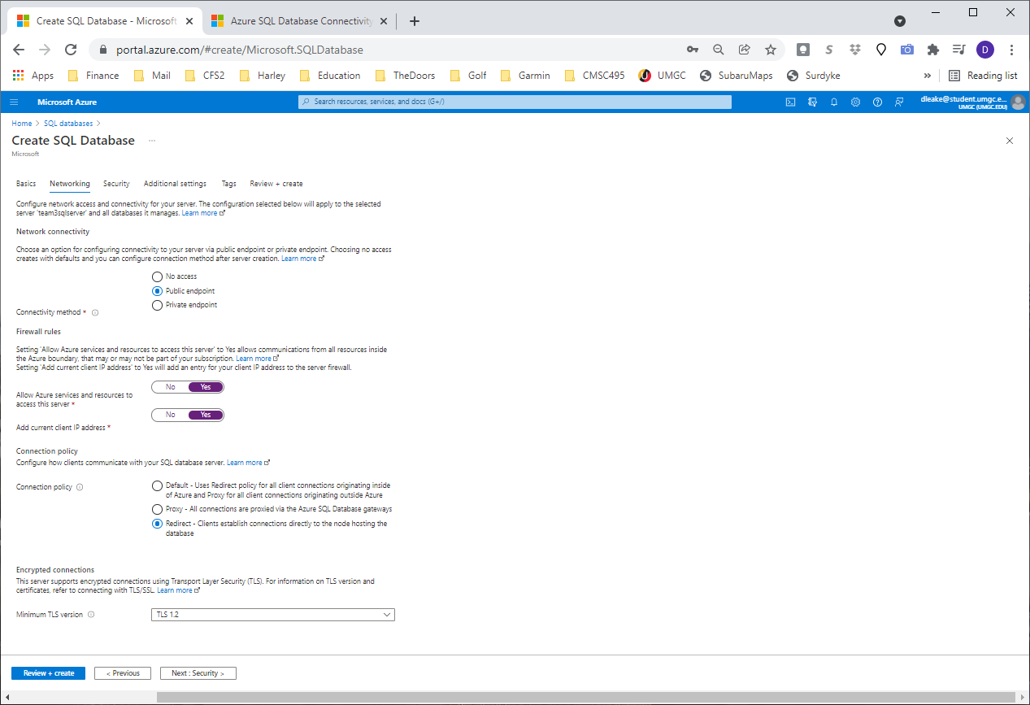
   2. <https://docs.microsoft.com/en-us/azure/azure-sql/database/connectivity-architecture#connection-policy>

## Security

1. Leave Defaults
   1. We COULD configure TDE!!!
   2. 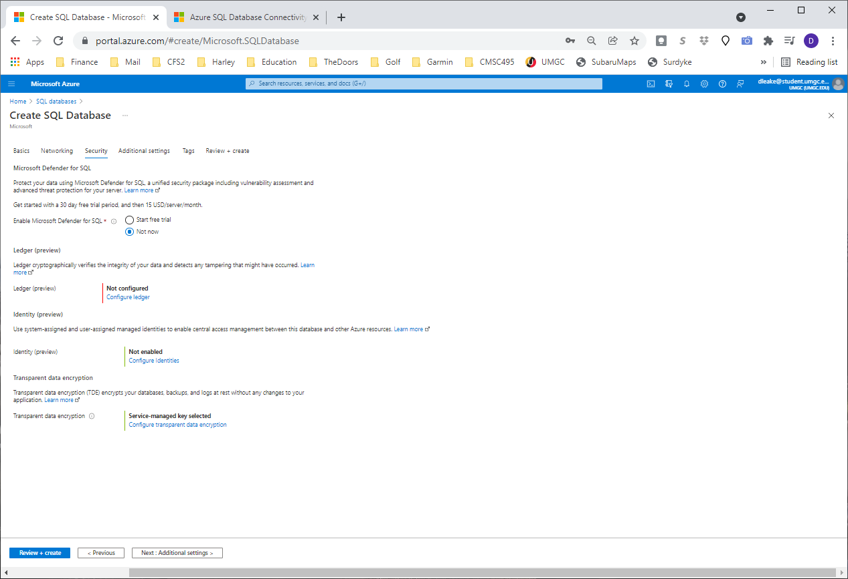

## Additional Settings

1. Use Existing Data: Sample
   1. 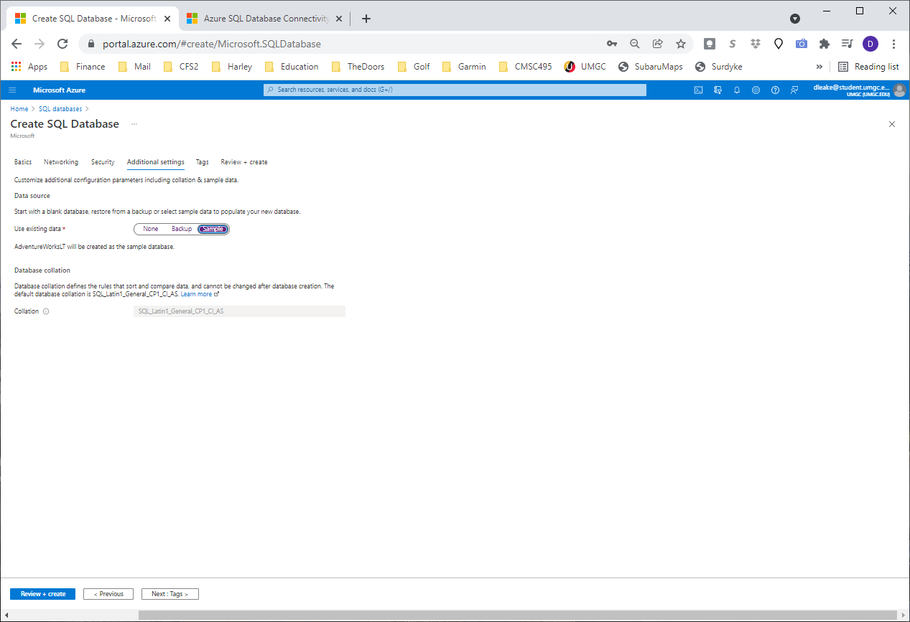

# Option 2: Create Azure Storage Account (No DB available)

1. Click “Storage Accounts”
   1. 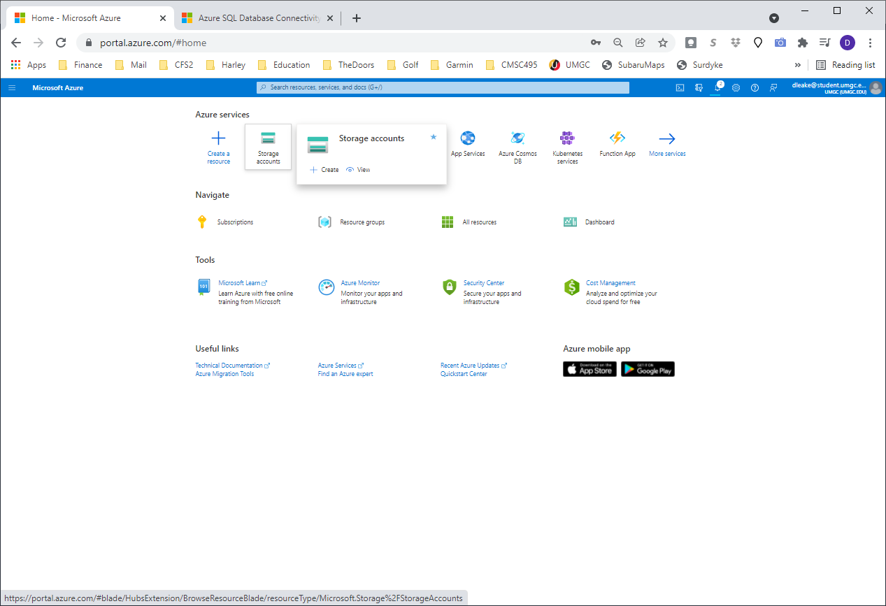
2. Create Storage Account
   1. 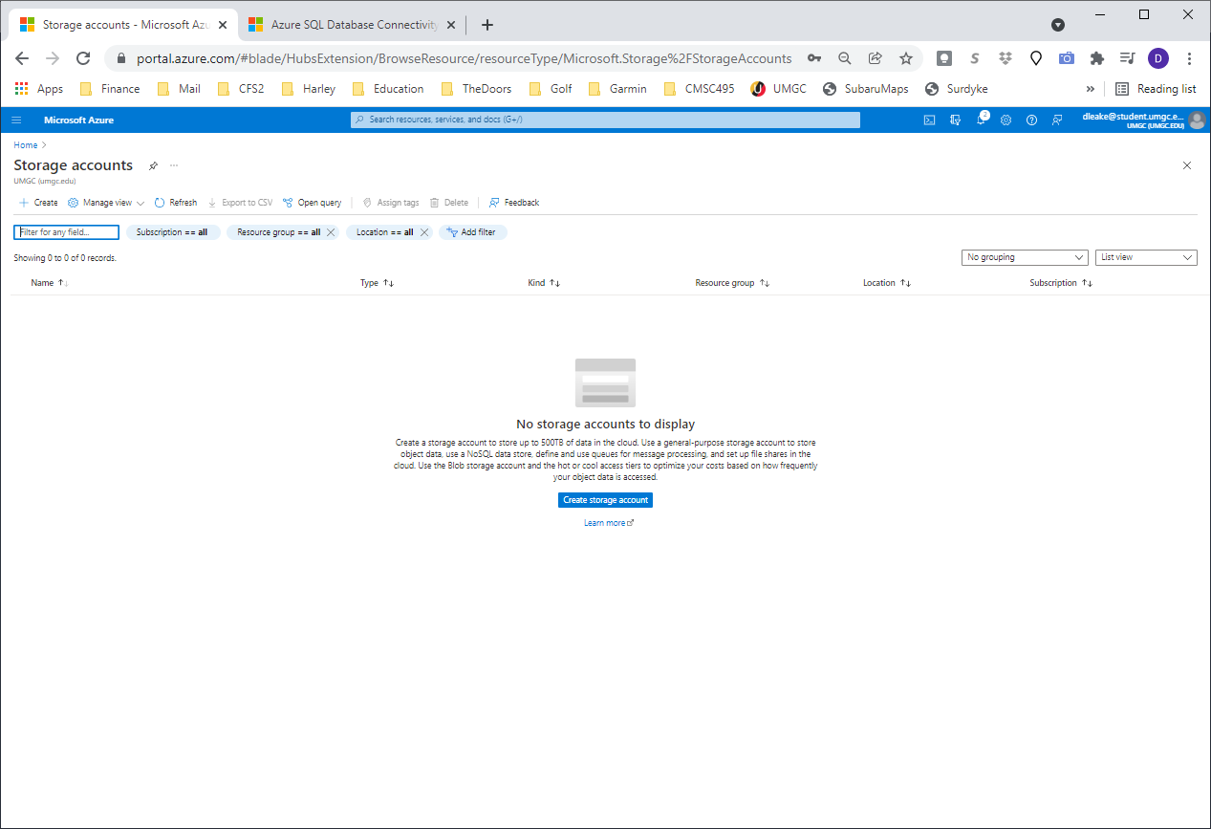
3. Type a name for the storage account
   1. 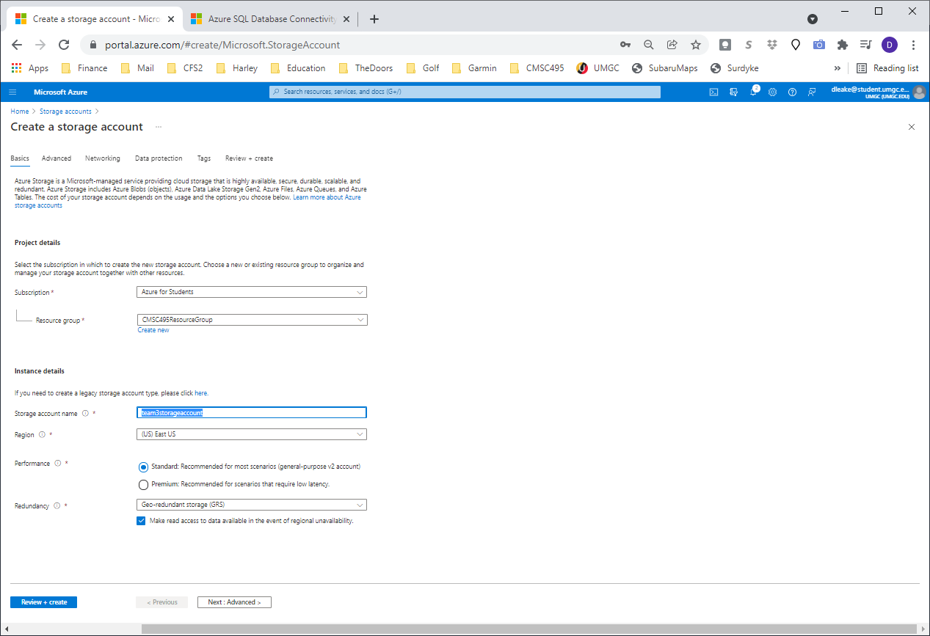

## Advanced

1. Leave the Defaults
   1. 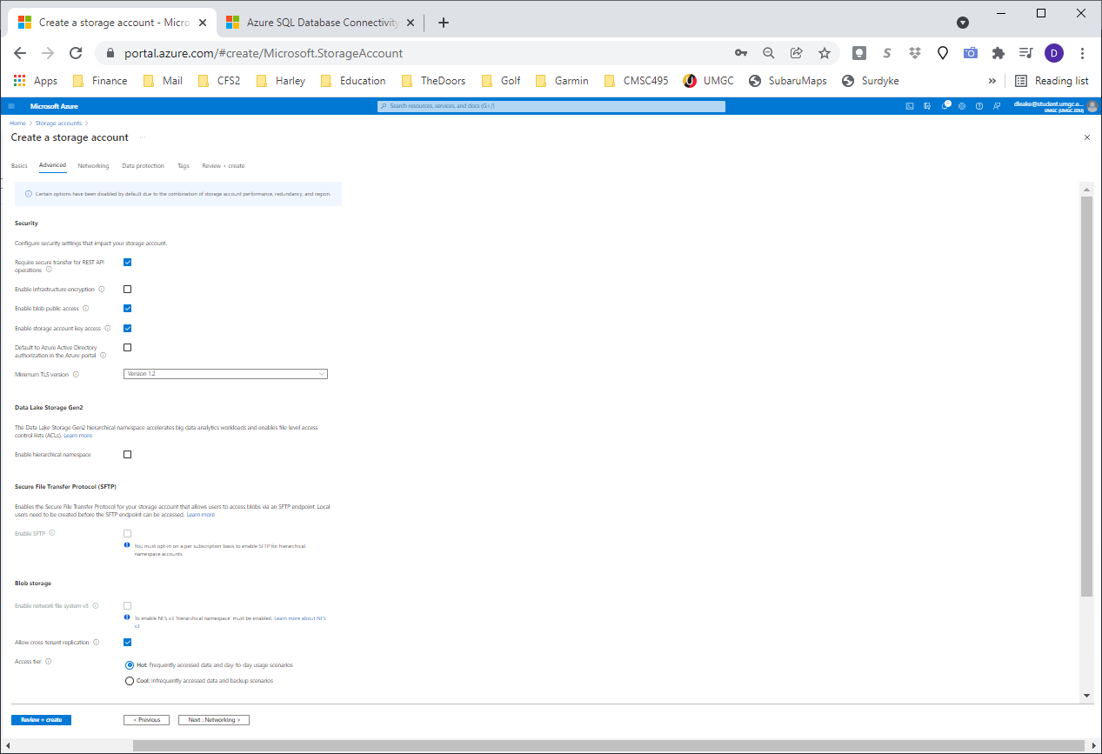

## Networking

1. Leave the Defaults
   1. 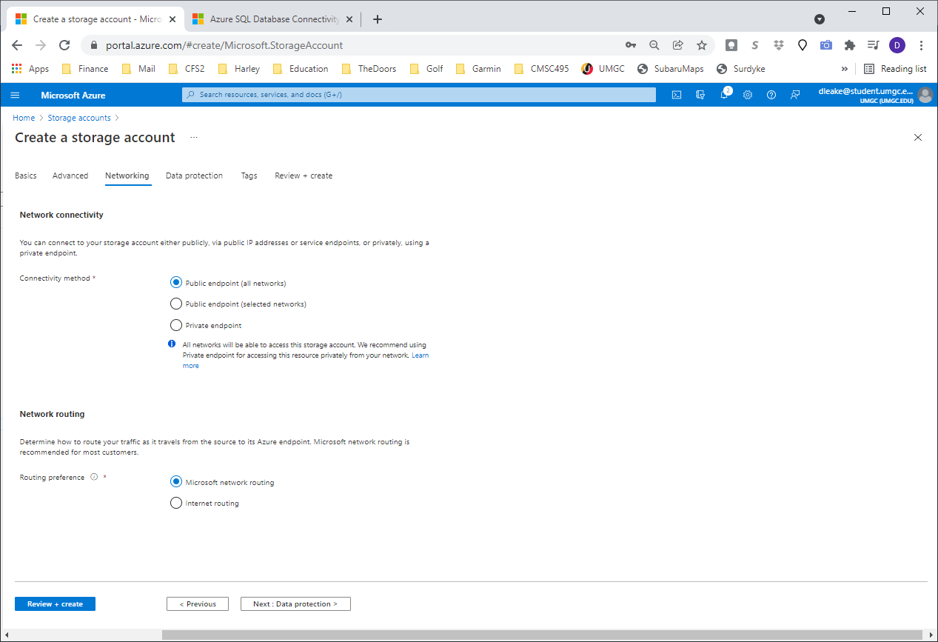

## Data Protection

1. Leave the Defaults:
   1. 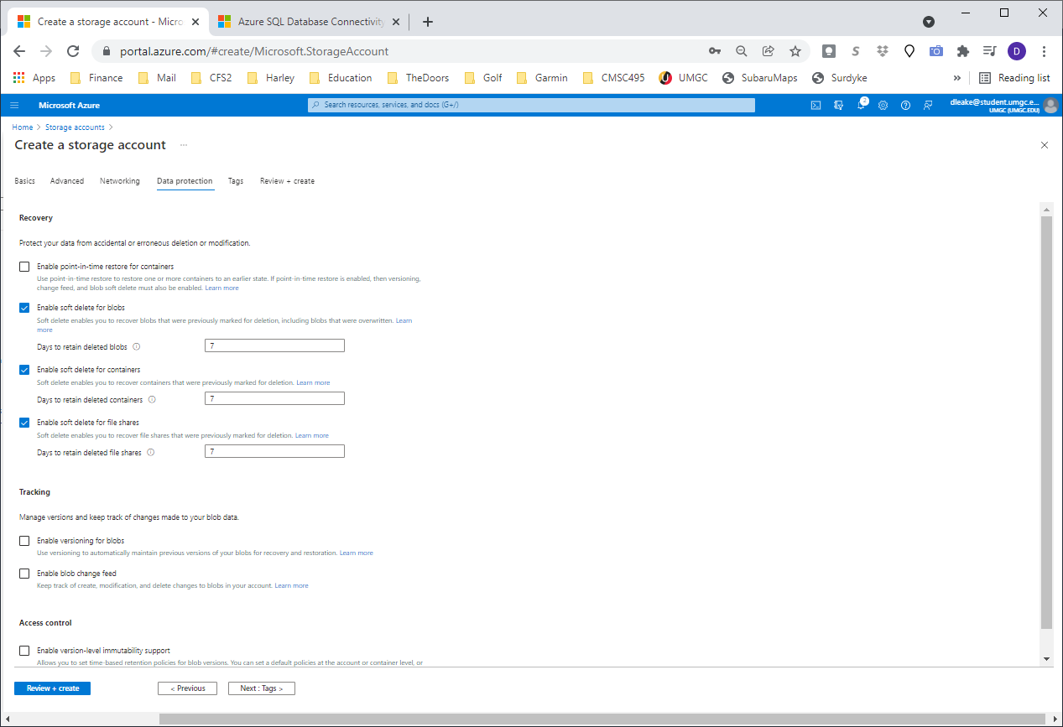
2. Let it run final validcation:
   1. 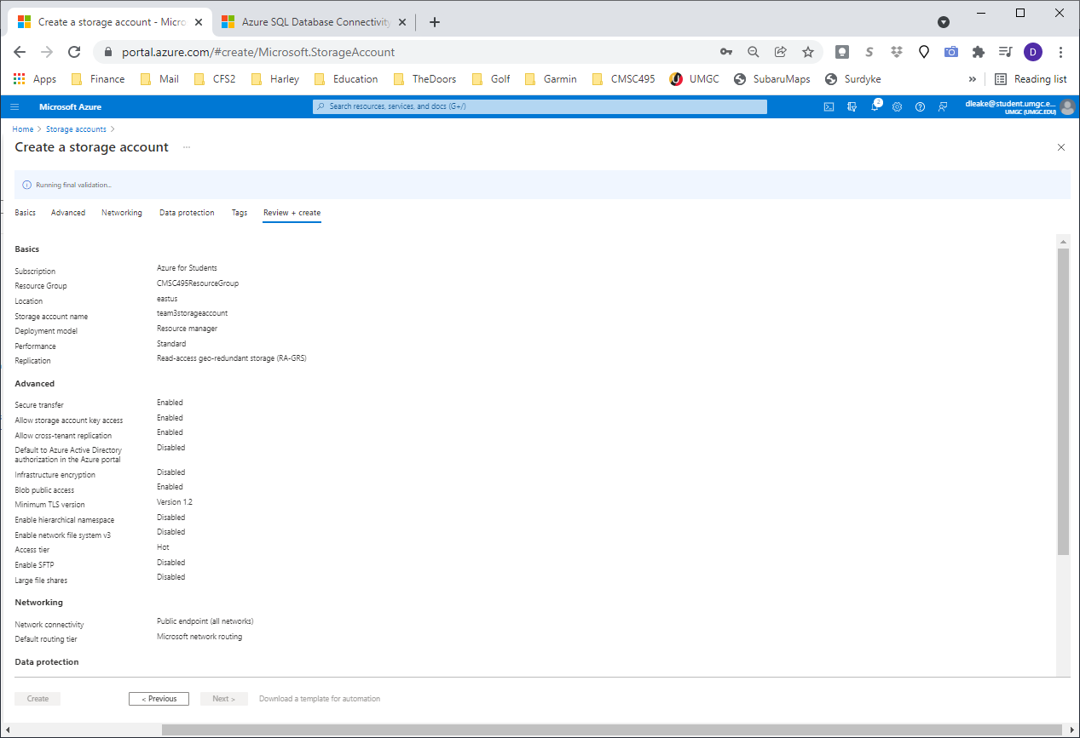
3. Click Create
   1. 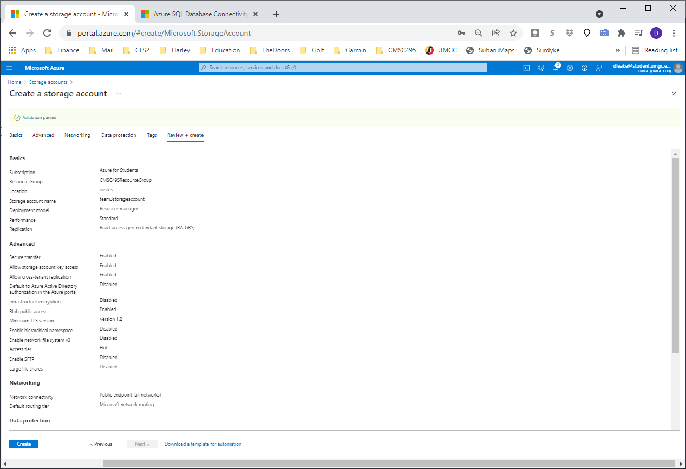
4. Wait for Your deployment is complete, Click “Go To Resource”
   1. 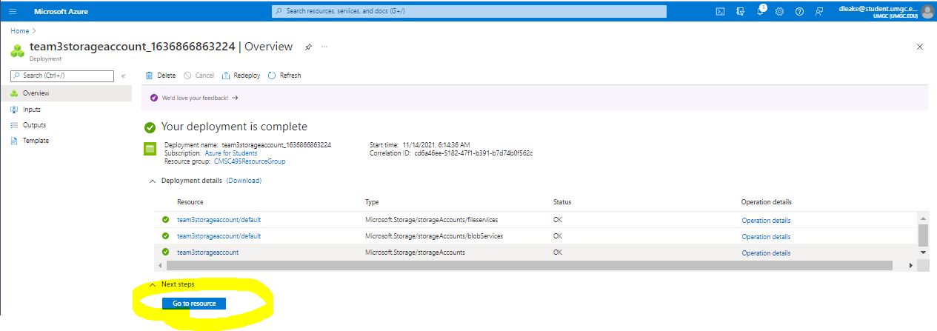
5. Click “Containers”
   1. 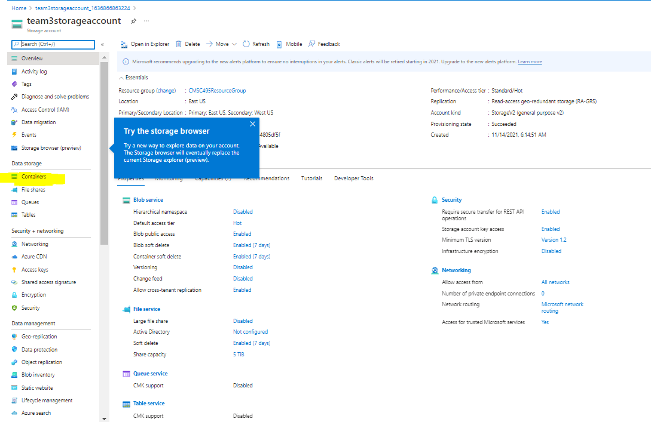
6. Select + Container, type a name and leave the private selected
   1. 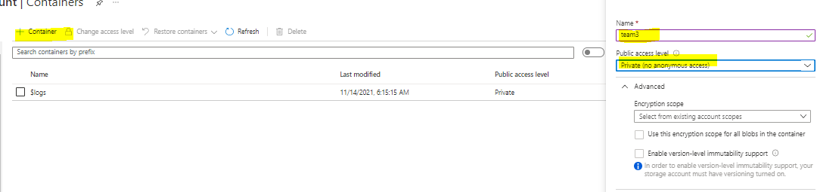
7. Wait for it to be created
   1. 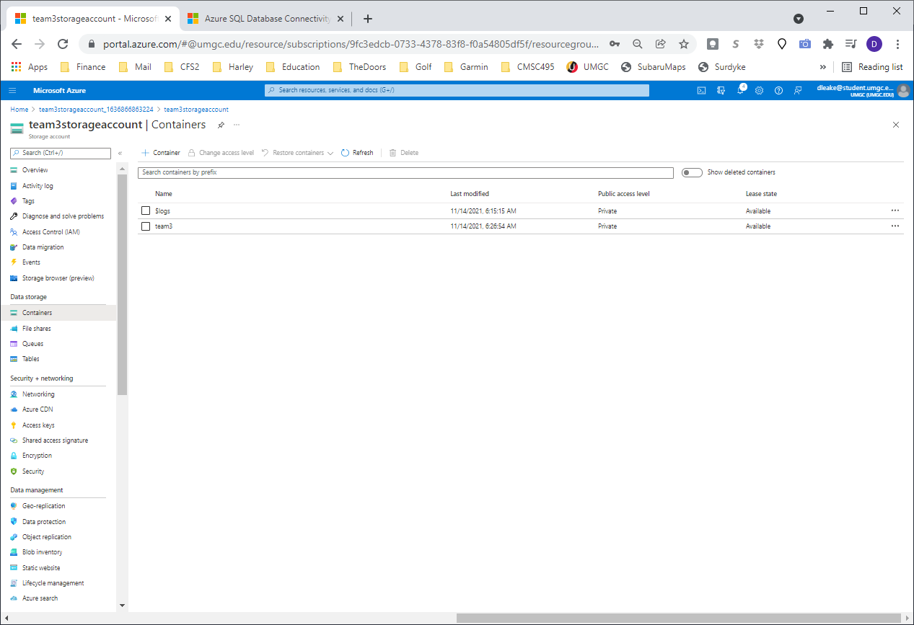

## Create a Blob Container

1. In your

# Connect SSMS to Azure Storage

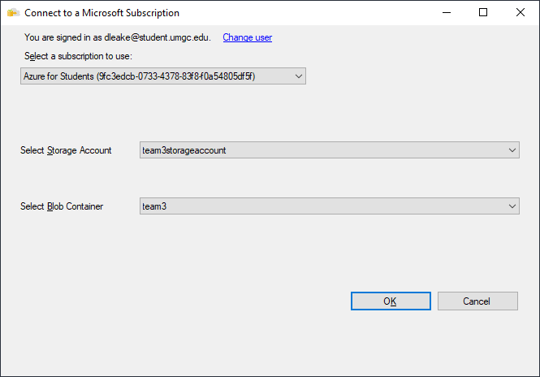

# Option 3: Create a SQL Server (Worked)

## Basics

1. Click Create a Resource
2. Search for SQL Server in the market place, select SQL Server 2019 on Windows Server 2019
   1. 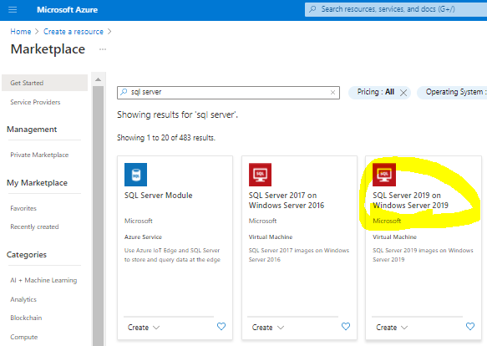
3. Select SQL Server 2019 Standard on Windows Server 2019, Create
   1. 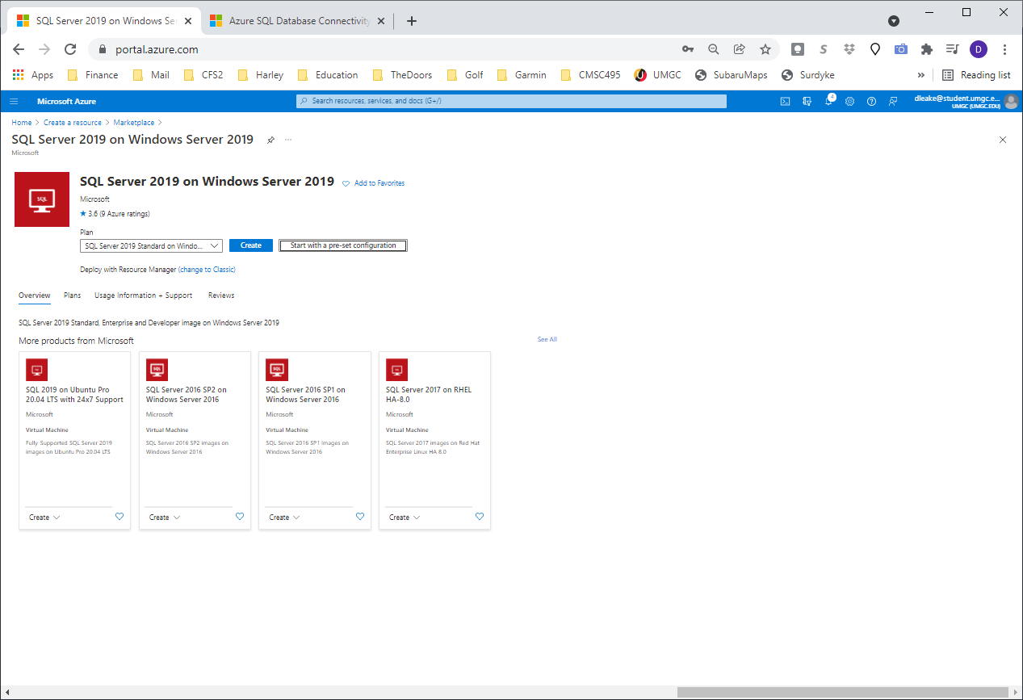
4. 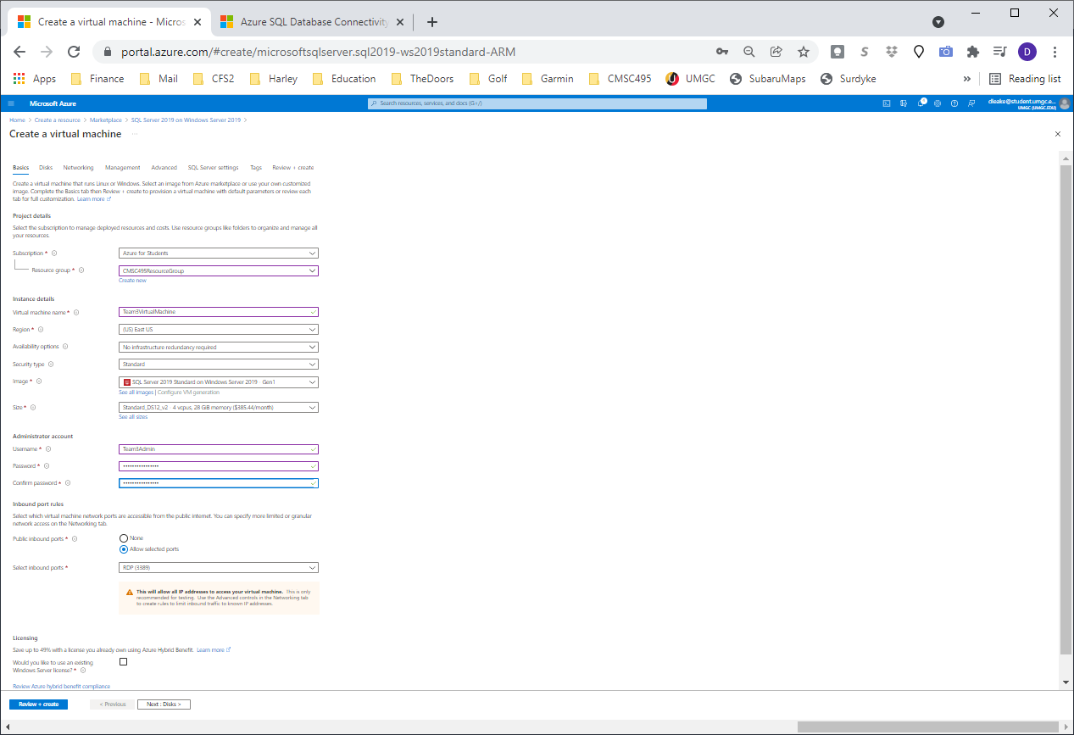
5. Click See all sizes to significantly decrease the monthly cost:
6. 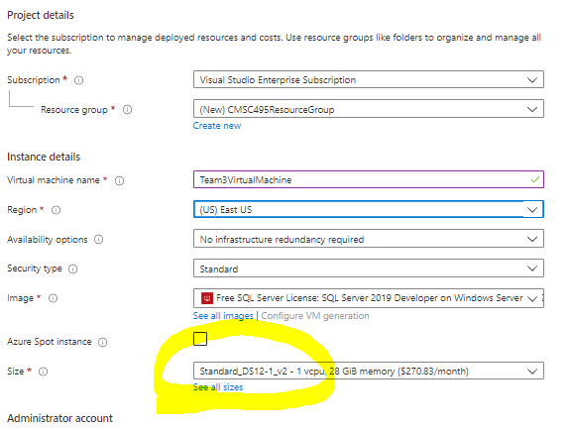
7. DS1_V2 – 1 vcpu, 3.5 GiB memory (53.29/month)
   1. Administrator AccountT:
      1. .\Team3Admin
      2. T3Admin!T3Admin!
   2. SQL Admin
      1. Team3Admin
      2. 1234567890

## Disks

1. 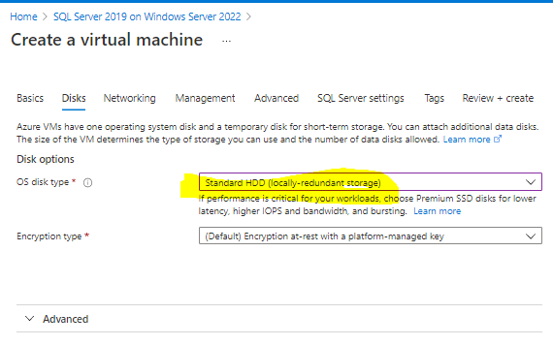

## Networking

1. 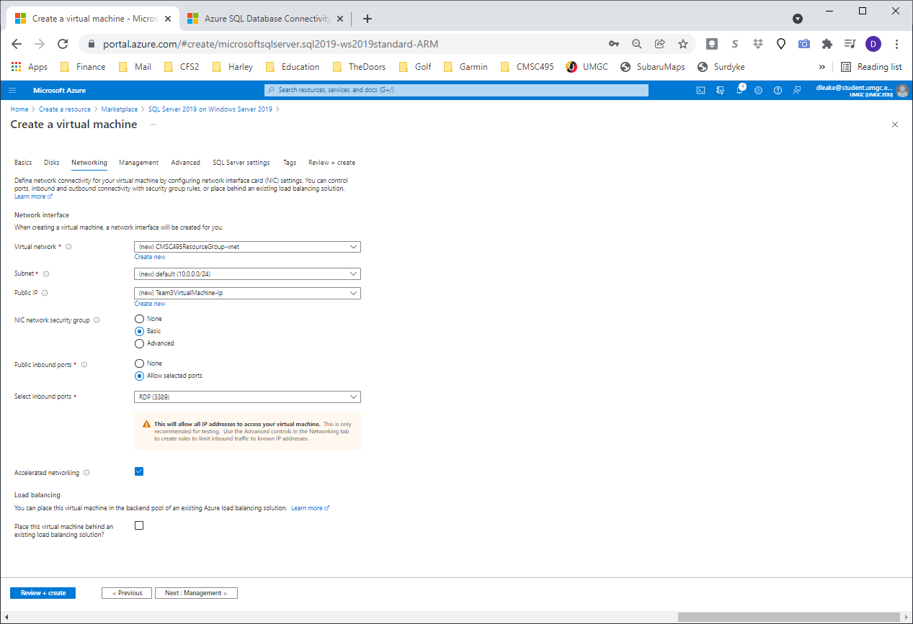

## NIC Network security group

1. Add inbound rule for SQL (Or just a select NONE)
   1. 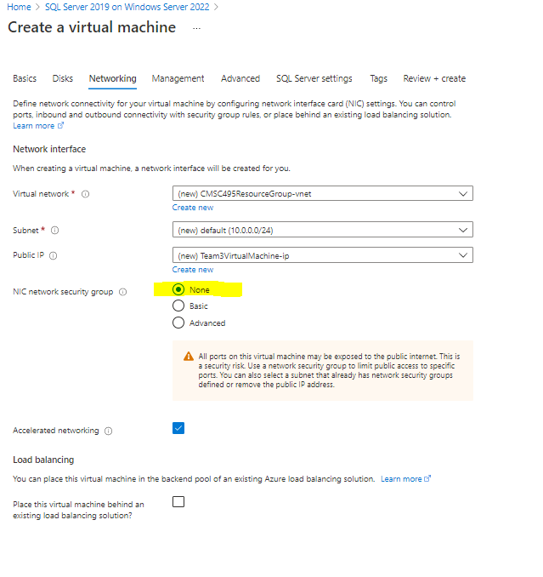

## Management

1. 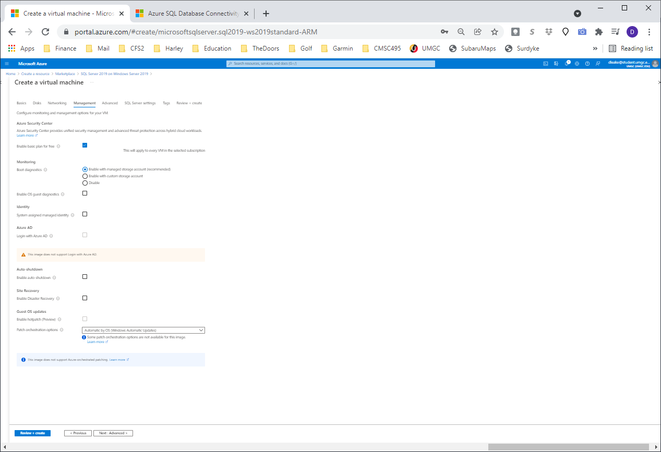

## Advanced

1. 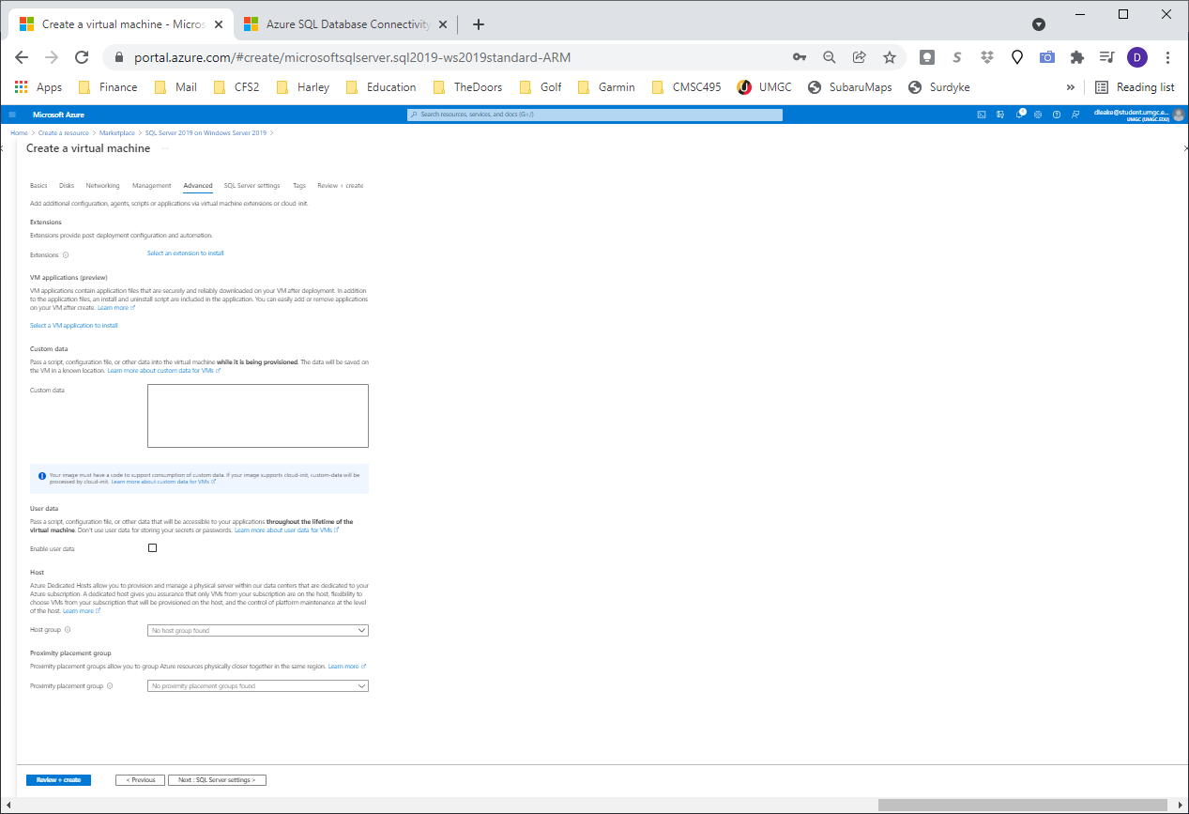

## SQL Server Settings

* 1. 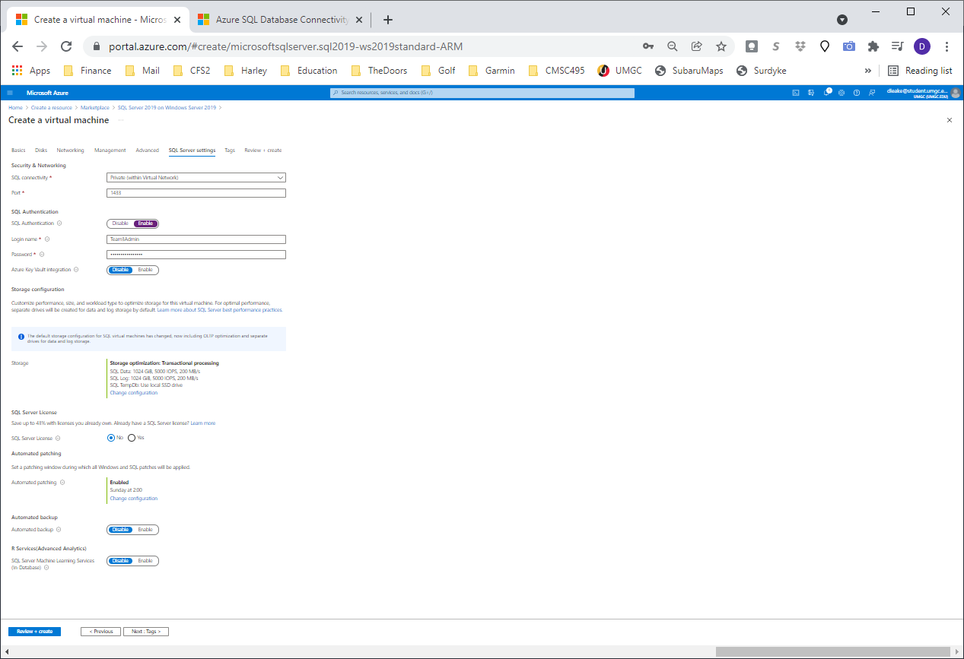
  2. Team3Admin
  3. T3Admin!T3Admin!

1. Click Create
   1. 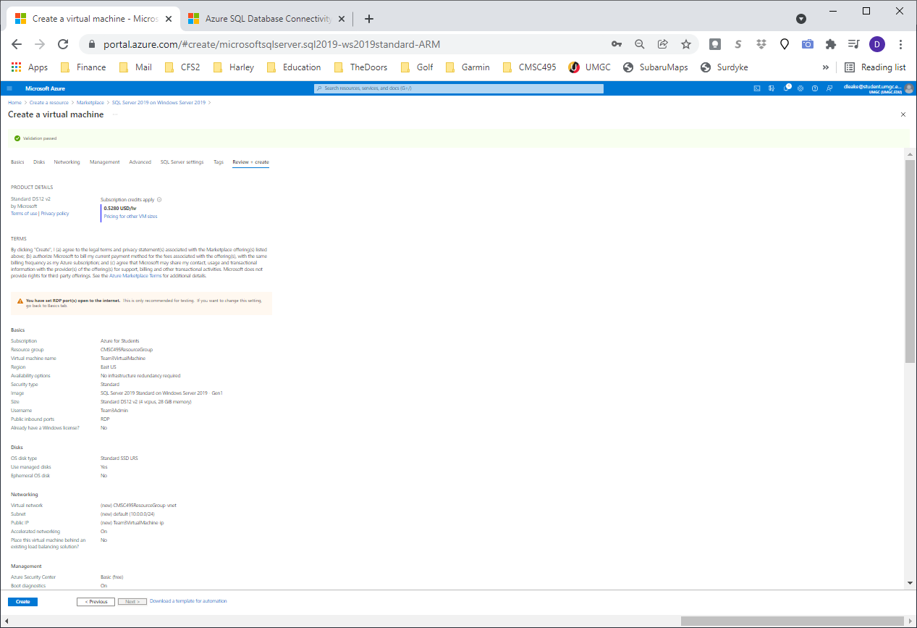
2. Wait for Deployment is in progess to finish:
   1. 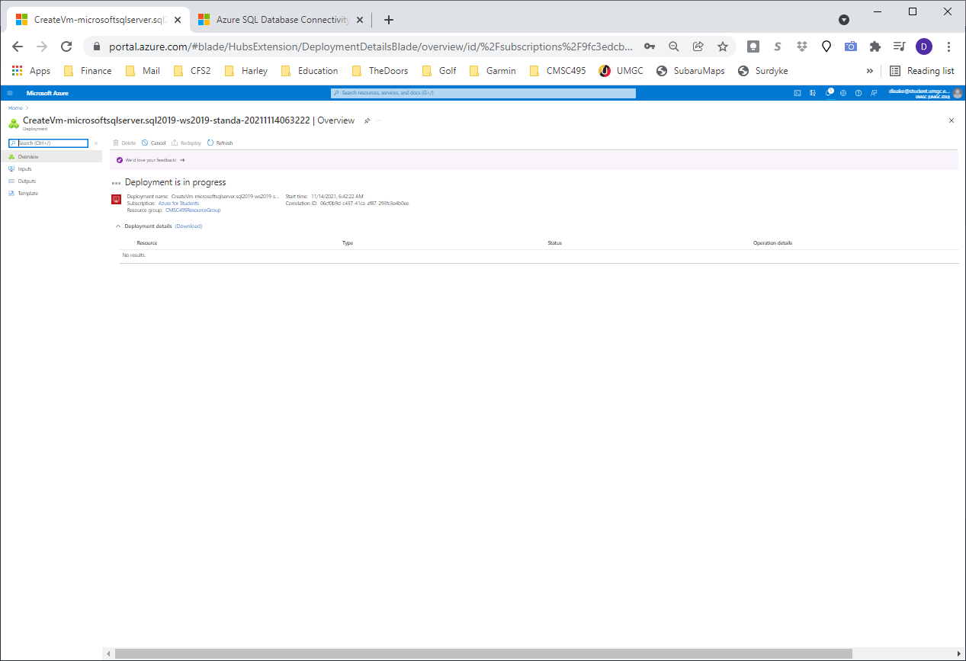
   2. 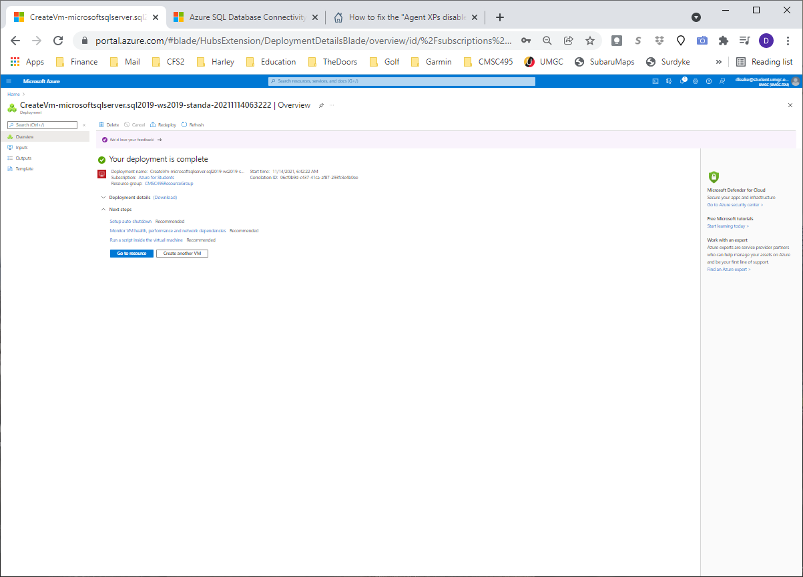
3. Click Go To Resource, Click on Properties, Copy the Resource ID
   1. 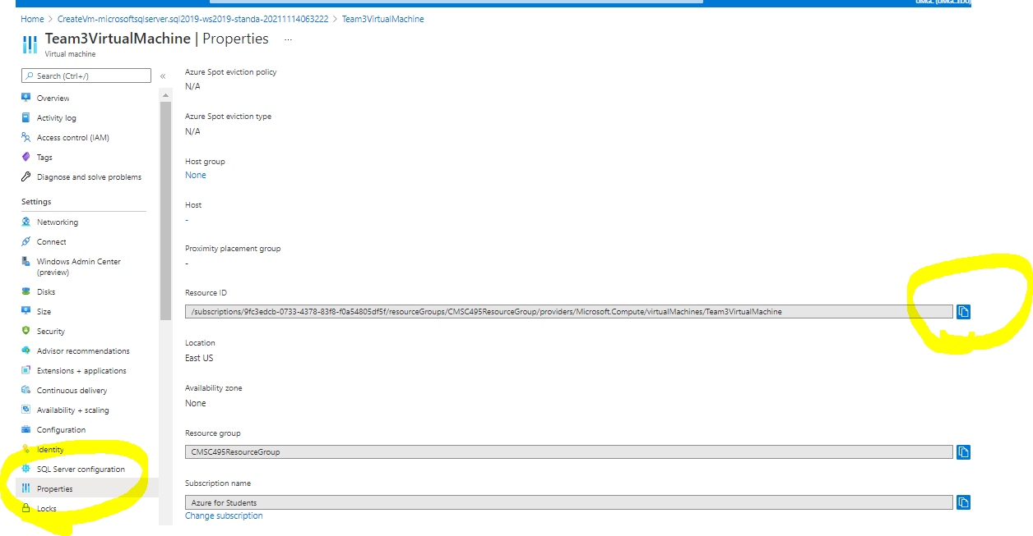



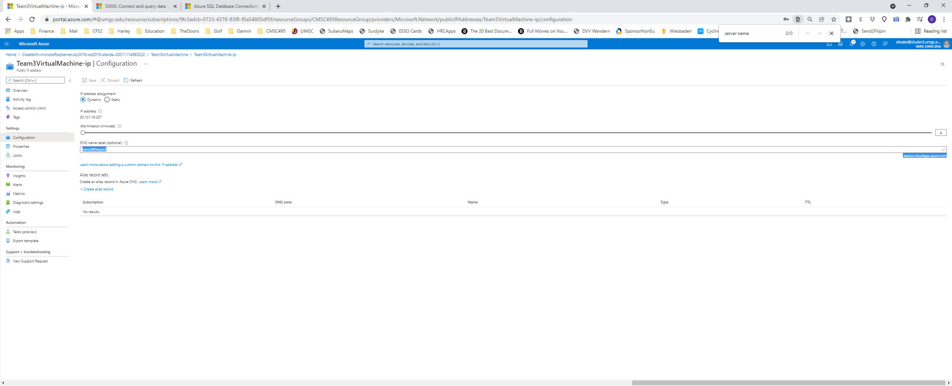

Cmsc495team3.eastus.cloudapp.azure.com

[**20.121.19.227**](https://portal.azure.com/)

<https://docs.microsoft.com/en-us/azure/azure-sql/virtual-machines/windows/sql-vm-create-portal-quickstart>

KEY:

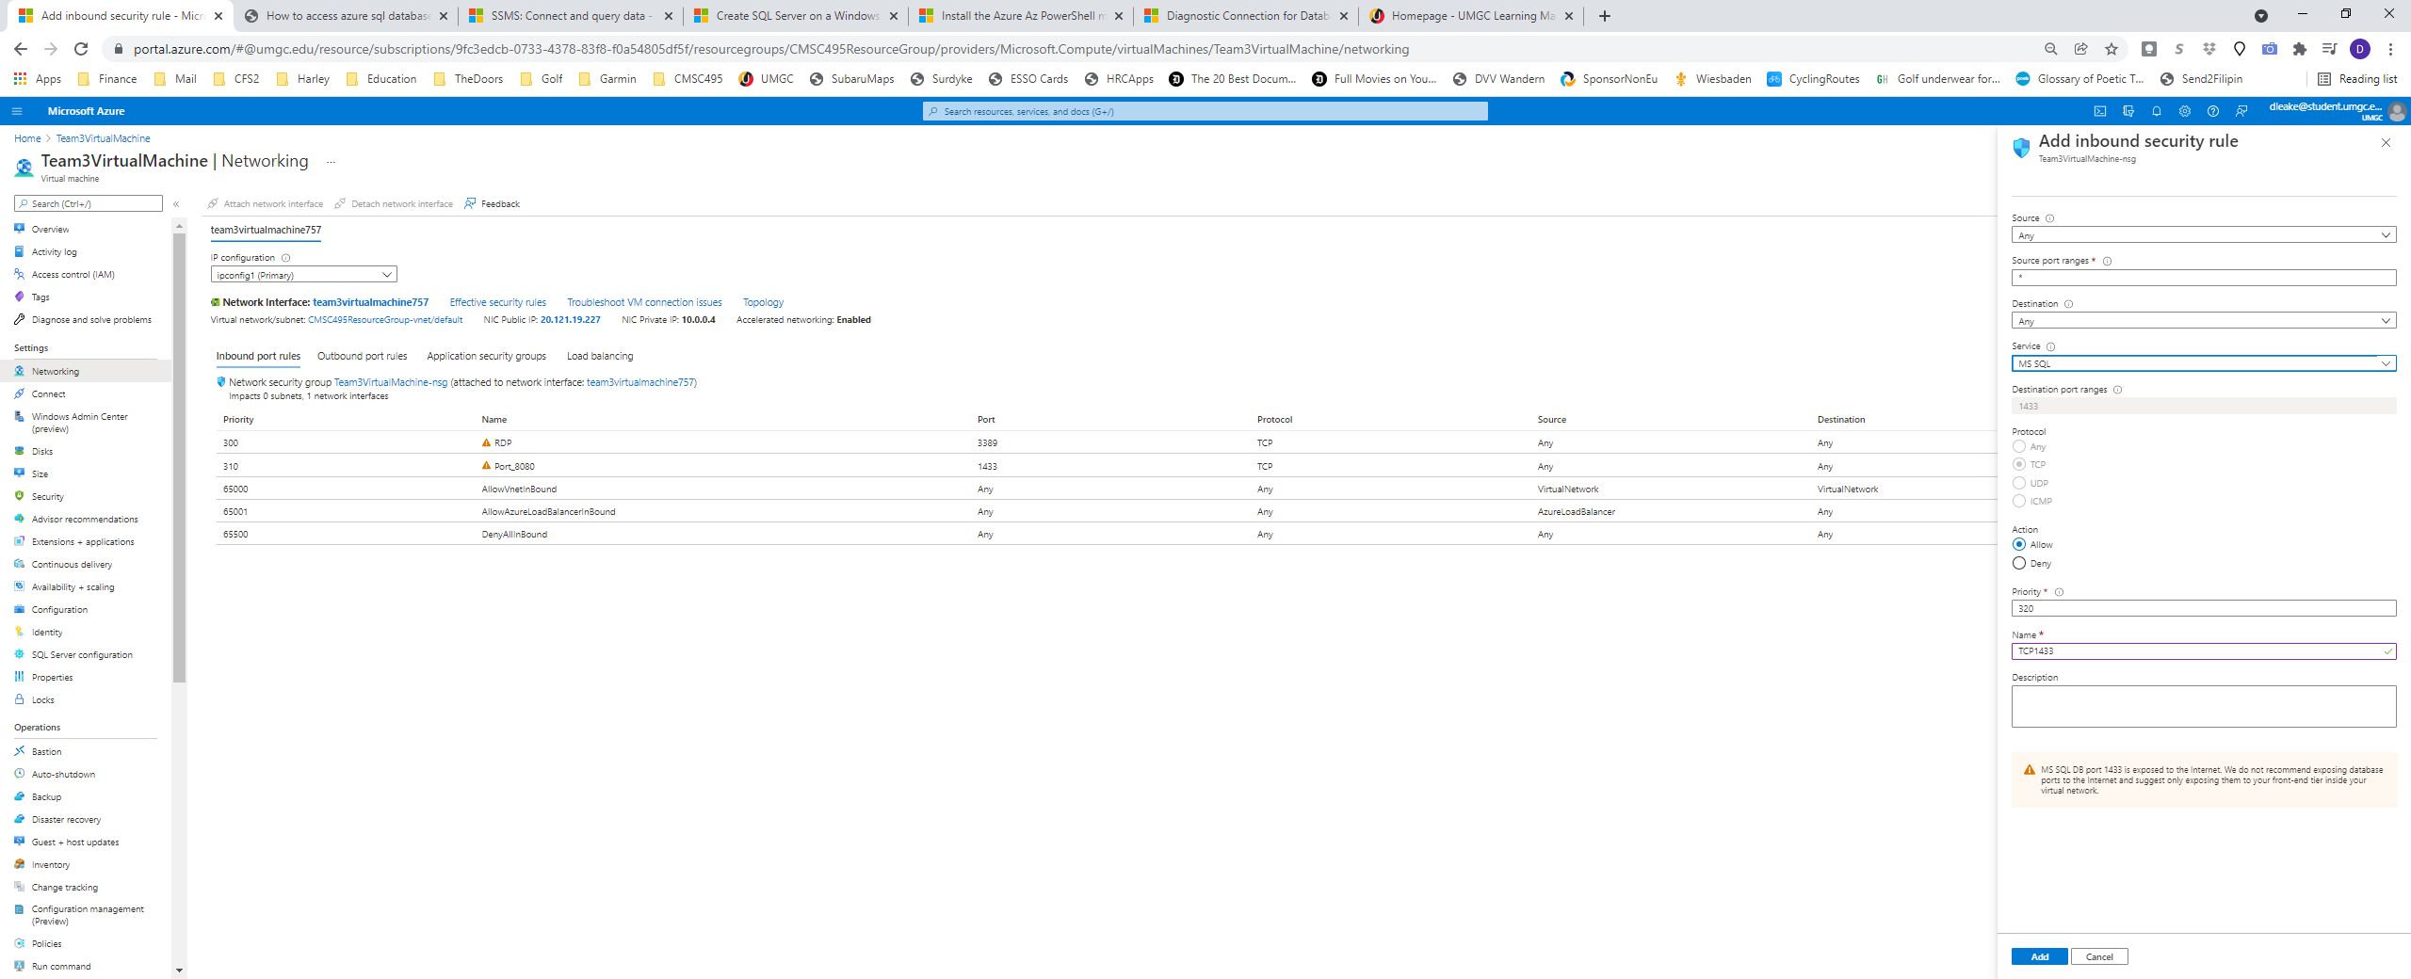

PS C:\Users\dave_> Test-NetConnection 20.121.19.227 -Port 1433

ComputerName : 20.121.19.227

RemoteAddress : 20.121.19.227

RemotePort : 1433

InterfaceAlias : Wi-Fi

SourceAddress : 192.168.86.190

TcpTestSucceeded : True

# Log into CMSC495Team3

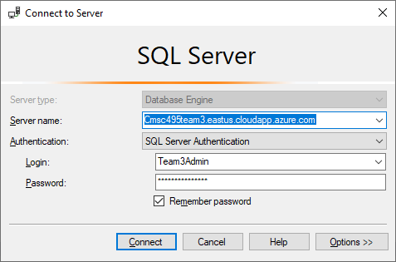

Server name: cmsc495team03final.eastus.cloudapp.azure.com

SQL Authentication

·         Sa

·         1234567890

·         Terry

·         1234567890

·         Ian

·         1234567890

·         Will

·         1234567890

Readonly

1234567890