*Work Request Application*

Product Design Specification

Version *1.0*

*Nov 15 2021*

VERSION HISTORY

|  |  |  |  |  |  |
| --- | --- | --- | --- | --- | --- |
| **Version #** | **Implemented**  **By** | **Revision**  **Date** | **Approved**  **By** | **Approval**  **Date** | **Reason** |
| 1.0 | *Ian Oliver* | *Nov 11 2021* | *<name>* | *<mm/dd/yy>* | Initial Design Definition draft |
|  |  |  |  |  |  |
|  |  |  |  |  |  |

TABLE OF CONTENTS

1 Introduction 5

1.1 Purpose of The Product Design Specification Document 5

2 General Overview and Design Guidelines/Approach 5

2.1 Assumptions / Constraints / Standards 5

3 Architecture Design 5

3.1 Logical View 5

3.2 Hardware Architecture 5

3.3 Software Architecture 5

3.4 Security Architecture 5

3.5 Communication Architecture 5

3.6 Performance 6

4 System Design 6

4.1 Use-Cases 6

4.2 Database Design 6

4.3 Data Conversions 6

4.4 Application Program Interfaces 6

4.5 User Interface Design 6

4.6 Performance 6

4.7 Section 508 Compliance 6

5 Product Design Specification Approval 7

Appendix A: References 8

Appendix B: Key Terms 9

# Introduction

## Purpose of The Product Design Specification Document

The Product Design Specification Document documents and tracks the necessary information required to effectively define architecture and system design in order to give the development team guidance on architecture of the system to be developed. The Product Design Specification Document is created during the Planning Phase of the project. Its intended audience is the project manager, project team, and development team. Some portions of this document such as the user interface (UI) may on occasion be shared with the client/user, and other stakeholder whose input/approval into the UI is needed.

# General Overview and Design Guidelines/Approach

This section describes the principles and strategies to be used as guidelines when designing and implementing the system.

## Assumptions / Constraints / Standards

There is a general assumption that this product is a proof of concept and not a polish/published work. The team working on this product are preforming an exploratory design.

There is a general understanding of a major time constraint and not all of the of the desired features will be finished the polished level that the team may want. As this product is proof of concept this should not prove to be an issue.

# Architecture Design

This section outlines the system and hardware architecture design of the system that is being built.

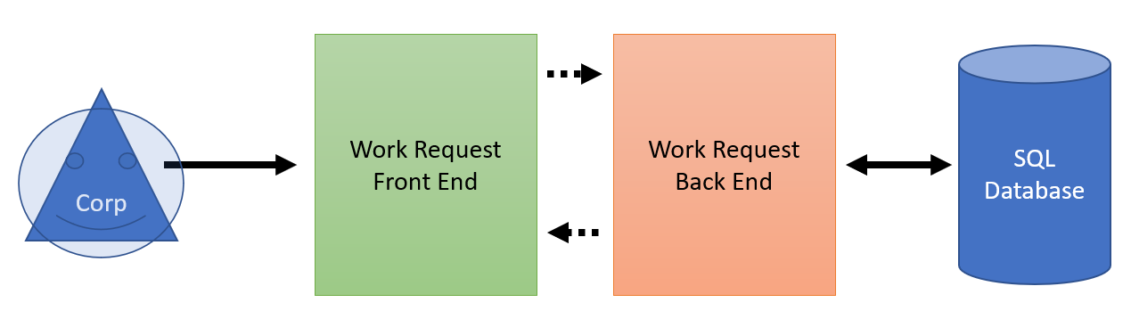

## Logical View

[Insert any related logical views or provide a reference to where they are stored.]

This field needs to be updated after the initial phase of programming has begun

## Software Architecture

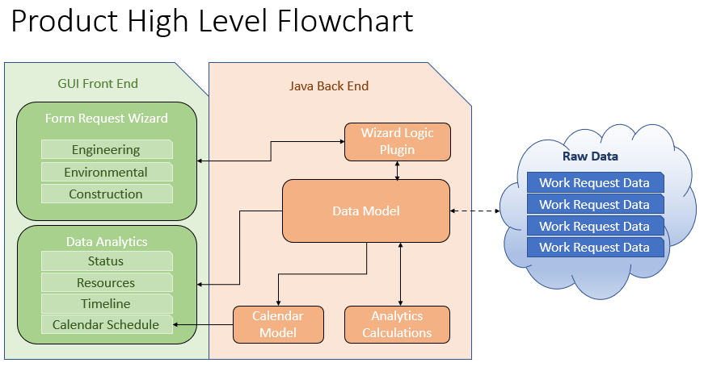

# System Design

## Use-Cases

Use cases are described in the Team3WorkRequestHighLevelRequirements.docx.

## Database Design

The Database design and decencies can be found in the files USACE_ECWR_Dependencies.pdf and USACE_ECWR_DependencyDiagram.pdf

## Application Program Interfaces

[Insert any application program interface documents or provide a reference to where they are stored.]

This field needs to be updated after the initial phase of programming has begun

## User Interface Design

[Insert any user interface design documents or provide a reference to where they are stored.]

This field needs to be updated after the initial phase of programming has begun

# Product Design Specification Approval

The undersigned acknowledge they have reviewed the *Work Request Application* **Product Design Specification** document and agree with the approach it presents. Any changes to this Requirements Definition will be coordinated with and approved by the undersigned or their designated representatives.

|  |  |  |  |
| --- | --- | --- | --- |
| Signature: |  | Date: |  |
| Print Name: | Ian Oliver |  |  |
| Title: | Software Designer |  |  |
| Role: |  |  |  |

|  |  |  |  |
| --- | --- | --- | --- |
| Signature: |  | Date: |  |
| Print Name: | Dave Leake |  |  |
| Title: | Project Manager |  |  |
| Role: |  |  |  |

|  |  |  |  |
| --- | --- | --- | --- |
| Signature: |  | Date: |  |
| Print Name: | Will Tchouente |  |  |
| Title: | Requirements Manager |  |  |
| Role: |  |  |  |

Appendix A: References

[Insert the name, version number, description, and physical location of any documents referenced in this document. Add rows to the table as necessary.]

The following table summarizes the documents referenced in this document.

|  |  |  |
| --- | --- | --- |
| **Document Name and Version** | **Description** | **Location** |
| *<Document Name and Version Number>* | *[Provide description of the document]* | *<URL or Network path where document is located>* |

Appendix B: Key Terms

*[Insert terms and definitions used in this document. Add rows to the table as necessary. Follow the link below to for definitions of project management terms and acronyms used in this and other documents.*

*http://www2.cdc.gov/cdcup/library/other/help.htm*

The following table provides definitions for terms relevant to this document.

|  |  |
| --- | --- |
| **Term** | **Definition** |
| *[Insert Term]* | *[Provide definition of the term used in this document.]* |
| *[Insert Term]* | *[Provide definition of the term used in this document.]* |
| *[Insert Term]* | *[Provide definition of the term used in this document.]* |