Work Request Application

High Level Requirements Document

Version # 1.0

Draft

Nov 15th 2021

Document Version Control

|  |  |  |
| --- | --- | --- |
| Ver | Date | Description |
| 1.0 | Nov 11th 2021 | Draft Version of High-Level Requirements Document |
|  |  |  |
|  |  |  |
|  |  |  |

Approvals

|  |  |  |
| --- | --- | --- |
| [Name]  [Title] |  | Date |
|  |  |  |
| [Name]  [Title] |  | Date |
|  |  |  |

Table of Contents

Document Version Control ii

Approvals iii

Table of Contents iv

Section 1 Introduction 1

1.1 Background 1

1.1 1

1.1 1

1.1 1

1.2 Purpose 1

Acceptance Criteria Factors 1

1.1 References and Related Documents 2

1.1 2

1.1 2

1.1 2

1.1 2

1.7 2

Section 3 Business Scenarios 4

Section 4 Use Case Model 6

Actors 6

1.1 Use Case Diagram 7

4.2 7

4.3 Use Case Outline 7

4.3.2 Triggers 7

4.3.3 Basic Flow 7

4.3.4 Post Conditions 7

Section 5 Business Requirements 9

5.1 Functional Requirements 9

5.2 Business Supplemental Requirements 10

Appendix A. Acronyms and Abbreviations 13

# Introduction

## Background

The U.S. Army Corps of Engineers has approximately 37,000 dedicated Civilians and Soldiers delivering engineering services to customers in more than 130 countries worldwide.

With environmental sustainability as a guiding principle, the Corps team is working diligently to strengthen the United States of America’s security by building and maintaining America’s infrastructure and providing military facilities where the USA’s servicemembers train, work and live. They are also researching and developing technology for the war fighters while protecting America’s interests abroad by using their engineering expertise to promote stability and improve quality of life.

To help streamline some of their complicated job, a centralized work request application has been requested. A user-friendly application to build the work requests required for the Corp to do their work and requestion the needed supplies and workforce.

## Purpose

The purpose of this document is to convey the high level requirements for the *Work Request Application*. This document provides the objectives the system will achieve by the end of the project cycle.

## Acceptance Criteria Factors

In broad strokes the application is considered complete when:

* The graphical user interface can be used to create and store work request forms
* The graphical user interface can be used to edit existing fields on forms **or** in database
* Database can be queried for analytics related to a selected form
* Visual analytics can be easily viewed in the graphical user interface

## References and Related Documents

All internal reference documents can be found in the Documents folder for the project github.

* Team3WorkRequestTestPlan.docx
* Team3WorkRequestUsability-Test-Plan.docx
* Team3WorkRequestUserGuide.docx
* CMSC 495-7381 High-Level Design_Overview.pptx

# Business Scenarios

[This section is required. Sub-sections should be defined by the project team as necessary based on the approach taken to Business Scenario definition for the project.

The manner in which the business processes and scenarios are documented, to what level of detail, what notation or tools are used, etc, will differ by project, and should be agreed upon at the start of the project. The Exemplar High Level Requirements Document contains one possible example of how to complete this section.

Typically, this section is intended to capture the key business scenarios, as-is business processes, to-be business processes and the resulting business process changes. Business Process Modeling is an intricate part of the requirements process. Through process modeling the following information is realized for each process:

* Current Business Processes
* Relationships between Business Processes, Data and Systems
* Data
* Systems
* Business logic
* Bottlenecks
* Areas for new and improved Business Processes

At the highest level processes identify the flow across an organization, and at the lowest level, the detailed tasks of each processes participant. There are two dimensions to keep in mind while modeling business processes:

1) Breadth (scope – high level business processes - Level 0 & 1)

* Level 0 – Definition of Enterprise Business Process Areas (i.e., lines of business)
* Level 1 – Definition of Business Processes

2) Depth (sub-processes – Level 2, Level 3, and Levels 4-6, if needed)

* Level 2 – Definition of Sub-Processes
* Level 3 – Definition of Activities / Actions
* Level 4 – Definition of Tasks / Work Steps
* Level 5-6 – Further detailed process definition as required

For process definition at level 4 and further, detail is expected to be documented through detailed (system) use cases, which are captured in the Detailed Requirements Document.

Process Flows are an effective means of communicating how work is performed in a time-based, cross-functional representation of the “business logic”. It shows things such as responsibility for work, collaboration between performers, branches in the process flow, results of key decisions, synchronization points where wait states must be resolved for the process flow to continue, and related instances of work that are performed throughout the end to end process.

The purpose for defining the business processes and scenarios is to:

* Identify the business operations that will occur within the scope of the effort
* Provide a basis for identifying problem areas within the existing processes
* Define how business operations should occur to achieve desired capabilities and value capture outlined by the client
* Illustrate desired interaction and outcomes when performing future business processes
* Link roles to the business situations for understanding and acceptance of future business processes and business process enablers
* Communicate and obtain buy-in to the future process design (whether it is business processes, IT processes, or management system processes, etc.)
* Support documentation of requirements related to the future organization and business processes
* Provide a common communication vehicle for the users, management, consultants, and technology implementation teams of the project
* Enable issues to be resolved early and risks to be mitigated
* Provide awareness of assumptions that have been made
* Provide the blueprint that can be a base for testing, training and procedures development

Impacts of not documenting this information may include:

* Communication within the project may be compromised
* Without an end to end actual flow and graphical representation, requirements can be missed
* Organizational impacts, key to implementing new process change, can be minimized
* Designing a solution can be flawed without the complete required capabilities and performance targets understood
* Synchronizing the design of the solution and the design of the business processes needs a complete and agreed to graphical representation]

# Use Case Model

## Actors

The actors for this system include the United States Army Corp of Engineers, front end Work Request Application, and Back End SQL Server acting as the database for Work Request Forms.

## Use Case Diagram

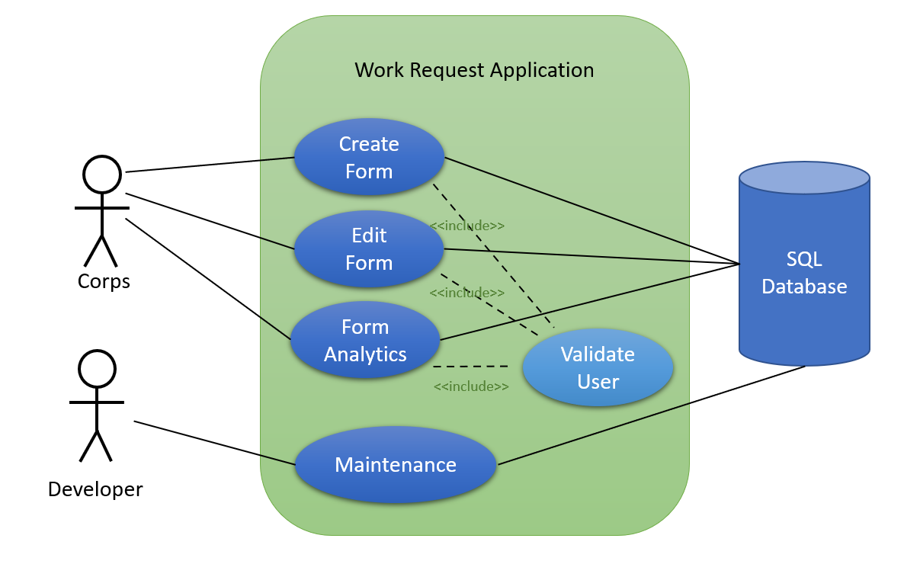

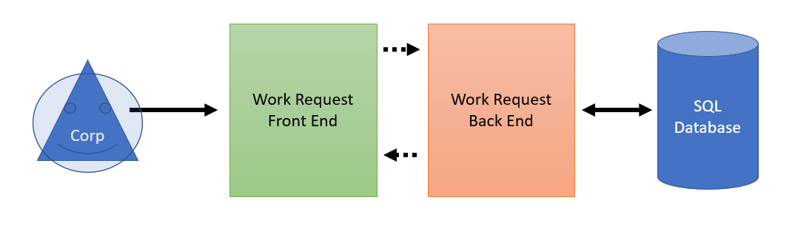

Table 4‑1: Use Case Inventory

|  |  |  |  |
| --- | --- | --- | --- |
| # | Use Case | Actor | Description |
| 1 | User Building Form | Corp Eng. | User building a work request form |
| 2 | Form Analytics | Corp Eng. | User accessing analytics data for selected form |
| 3 | Form Edit | Corp Eng. | User accessing/editing fields for selected form |

## Use Case Outline

### Preconditions

The conditions for the use cases are:

* Functioning hardware that is powered on and working
* A stable connection to the internal database, in this case the SQL Server
* Valid login credential

### Triggers

* User validation tells the system to allow for a work request to be fulfilled
* Submittal buttons

### Basic Flow

Start:

User logins into the application with their login credentials. At this time a basic username and password are used and checked. *Note: later versions may require badge access*.

After successfully logging in, user can then choose from the menu to either make a new work request, edit a work request already in the database, or view analytics of the an already created work request.

If creating a new work request then three options for request are presented:

* Engineering
* Environmental
* Construction

Each option will have a similar series of pages and fields to fill out, which will then be stored in the database.

If editing a work request a similar series of tabs will open as if creating a new request, however, all the required fields will be filled from the previous requests data.

If viewing analytics then a separate gui will be displayed with some quick view widgets of select analytical data, such as status, timeline, etc.

### Post Conditions

If creating a new work request form then the possible outcomes will be either “Successfully entered form”, “Missing required data”, or “Could not communicate with sever” as an incomplete.

If editing a form then possible outcomes will be either “Successfully saved form”, “Missing required data”, or “Could not communicate with sever” as an incomplete.

There are no post conditions for viewing the analytics of a view. Either the widgets will display information or an error will appear in their place.

# Business Requirements

[This section is required. The business requirements section captures functional and supplemental requirements as well as business constraints. The functional requirements identify the high level capabilities of the system, decomposed from the business processes and business wants and needs. It is often beneficial for requirements management and readability purposes to organize the functional and supplemental requirements by areas specific to the project, as opposed to documenting a long laundry list of requirements. Refer to the Exemplar High Level Requirements Document for an example of how to capture the high level functional and supplemental requirements. For requirements management purposes, it is helpful to capture attributes related to each requirement. The attributes to be captured for each requirement may be dictated by a given project’s requirements management plan. The following are examples:

* Requirement ID – The Requirement ID allows the requirement to be easily reference from other sections and documents, and enables traceability
* Source – This identifies the want/need, business process and/or stakeholder to from which the requirement was derived
* Requirement Definition – The requirement itself is captured here
* Requirement Priority (Including Priority Definitions)]

## Functional Requirements

[It may be helpful to organize this section into smaller categories (sub-sections) of business functional requirements. From an application development point of view, a business requirement is anything of interest to the business that the business would like to have delivered through an application intended to support the business. It forms the contract between the business for what the business is buying in the application solution and what is to be delivered in the application solution. Things that are normally of interest to the business include data (screens and reports), usability (screen or report design or fitness for use), processes, integrations to other business units, etc. In addition to being unambiguous, testable/verifiable, concise and complete, business requirement typically consist of the following:

* Statements that specify the features or capabilities that a user must have to support the business objectives and requirements
* Business Functional and Non-Functional Requirements specify the “What’s”:
  + What is expected to be done? To what level?
  + What inputs should be processed to produce what outputs (but not the How's)
  + What operations are required
  + What capacity, quantity, throughput, speed of response
* States whether user or operational needs are automated or manual
* Technology/Application independent

System requirements (functional and supplemental) are documented after the business requirements (in the Detailed Requirements Document), and define requirements from the perspective of what the system shall do. Table 5‑1 represents an example of a table which may be used to capture business functional requirements.]

Table 5‑1: Business Functional Requirements

|  |  |  |  |
| --- | --- | --- | --- |
| Business Functional Req ID | Source | Requirement Definition | Priority  (E)ssential (C)onditional (O)ptional |
|  |  |  |  |
|  |  |  |  |
|  |  |  |  |

## Business Supplemental Requirements

[It may be helpful to organize this section into smaller categories (sub-sections) of business supplemental requirements. From an application development point of view, a business requirement is anything of interest to the business that the business would like to have delivered through an application intended to support the business. It forms the contract between the business for what the business is buying in the application solution and what is to be delivered in the application solution. Supplemental requirements areas that are normally of interest to the business during the high level requirements stage include security, availability, volumes, etc. Examples might include the number of users required to be supported, the hours of operation for the system, or auditing and security requirements captured from the business stakeholders’ points of view. The detailed requirements document (system requirements) will capture these and more supplemental requirements in much more detail. Finally, business constraints may be captured as a subsection in the supplemental requirements. Refer to the Exemplar High Level Requirements Document for an example of how to complete this section. Table 5‑2 represents an example of a table which may be used to capture business supplemental requirements.]

Table 5‑2: Business Supplemental Requirements

|  |  |  |  |
| --- | --- | --- | --- |
| Business Supplemental Req ID | Source | Requirement Definition | Priority  (E)ssential (C)onditional (O)ptional |
|  |  |  |  |
|  |  |  |  |
|  |  |  |  |

1. Acronyms and Abbreviations

Definition of acronyms and abbreviations used in this and related Federal Student Aid documents.

|  |  |
| --- | --- |
| Acronym | Definition |
|  |  |
|  |  |
|  |  |
|  |  |