*Work Request*

USER GUIDE

Version *1.0  
Nov 4 2021*

VERSION HISTORY

|  |  |  |  |  |  |
| --- | --- | --- | --- | --- | --- |
| **Version #** | **Implemented**  **By** | **Revision**  **Date** | **Approved**  **By** | **Approval**  **Date** | **Reason** |
| 1.0 | *Dave Leake* | *Nov 4 2021* | *Ian Oliver* | *Nov 8th 2021* | User Guide draft |
|  |  |  |  |  |  |
|  |  |  |  |  |  |

**UP Template Version:** 12/31/07

Table of Contents

Work Request User Guide 4

1.1 How To: Open the Application 4

1.2 Main Page / Start Screen 4

2 Users and Roles 4

3 Create a new Work Request 4

3.1.1 General Information Tab 5

3.2 Project Information Tab 6

3.3 Assignment Type Tab 7

3.4 Cost Distribution Tab 8

3.5 Personnel Assignment Tab 10

3.6 History Tab 11

USER GUIDE Approval 12

# Work Request User Guide

## How To: Open the Application

Open the *Phase4_.Java*

## Work Request Login

* + - 1. Select SQL Server Connection / Azure / LocalHost Login depending on your environment
      2. Enter the credentials provided to you in the Test Plan

## Users and Roles

* + - Requestor: Creates new Work Request (WR)
    - Project Manager: Responsible for providing information about the project the WR is created for, the assignment type and how much time and money can be spent on a WR
    - Program Analyst: The Program Analyst provides financial information like the Labor Charge Code and Funded Work Item
    - Supervisor / Residential Engineer: The Supervisor for Engineering and Environmental and the Residential Engineer for Construction is responsible to assign personnel to a WR
    - Reassigner: The Reassigner is able to open a WR and reassign a WR to other Assignees
    - Assignee: Assignees are assigned to a WR to accomplish the requested actions

## General Information Tab

* + 1. 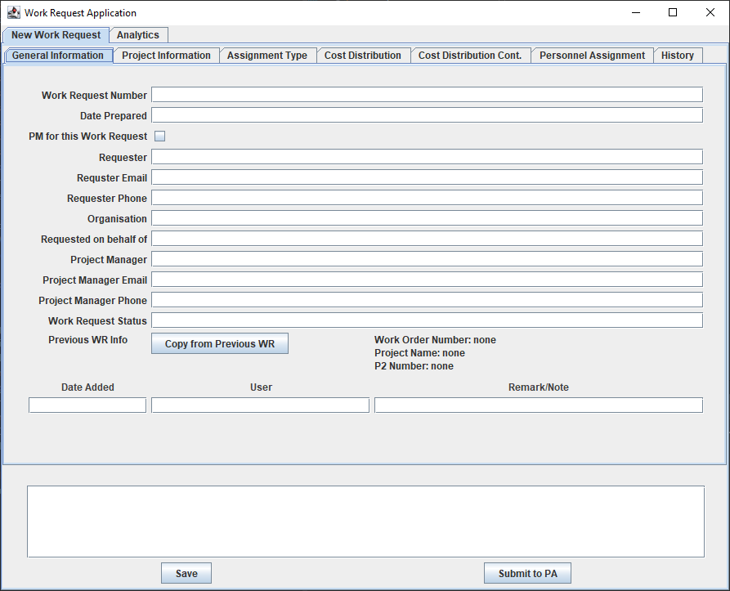
* Submitted by Requestor / PM
* Who requested the WR and when?
* Who is the PM?
* Special functions: Copy information from a previous WR
* Available on all tabs:
  + Add Remark/Notes: Remarks/Notes appear below the buttons and can‘t be deleted
  + The buttons to save, submit or reassign the WR
  + The top bar with general information on the WR, a hyperlink to open the print view and a hyperlink to go back to the Work Request list

## Project Information Tab

* + 1. 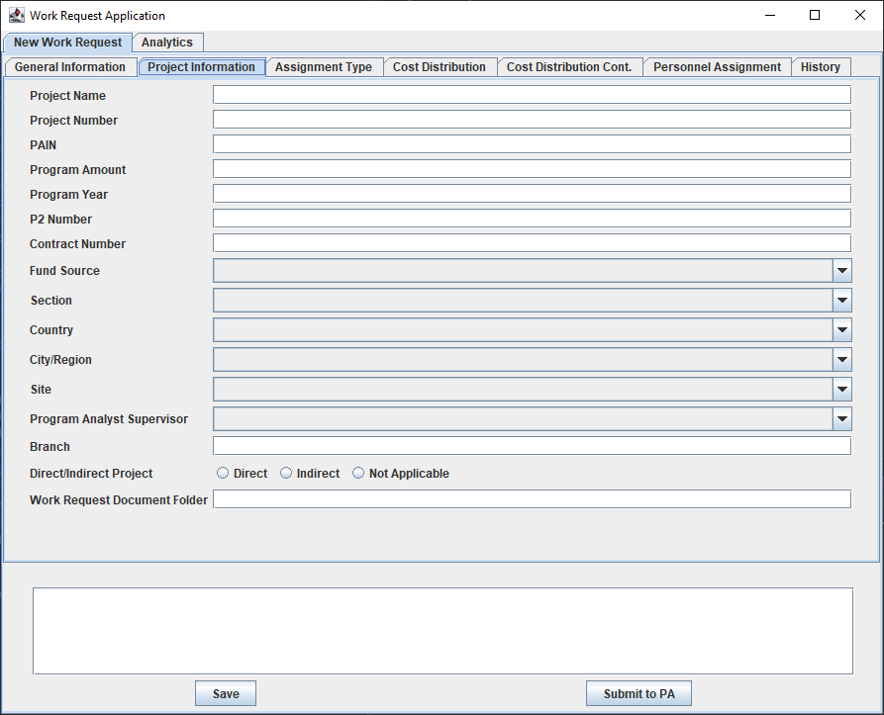
* Filled by Requester / PM and Program Analyst
* Which project WR belongs to
  + Project name / Number / Section Country
* Which branch (Engineering, Construction, Environmental)
* Who is the Program Analyst
* PA provides the Labor Charge Code, Funded Work Item and Order Work Item
* Special functions:
  + For Construction WRs, the Construction Supervisor (shown on the Assignment Type tab) is selected by location (Country and City)
  + If you provide a PAIN ID some information can be copied from the project on the PnA portal
  + Actual LCC balance and FWI balance are taken from CEFMS by clicking on the icon next to the LCC balance label

## Assignment Type Tab

* + 1. 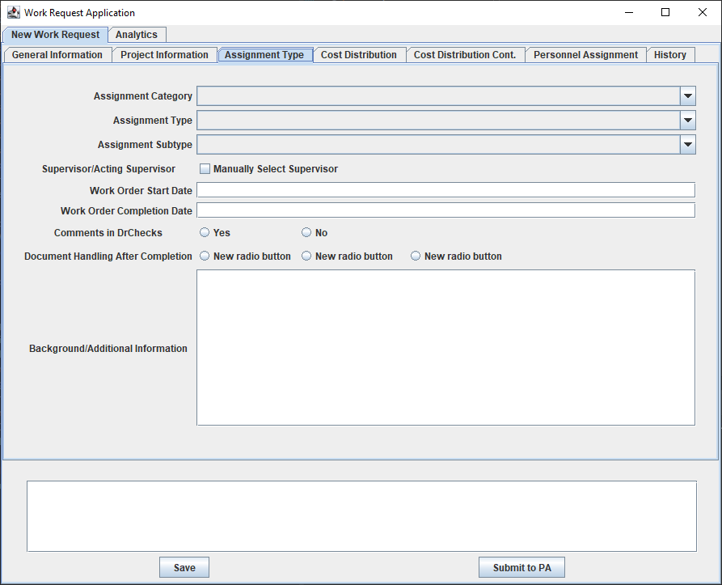
* Filled by Requester / PM (and later potentially by branch Supervisor)
* Which type of assignment is requested by the WR?
* The Assignment Type can’t be changed anymore once selected and saved
* Who is the responsible branch Supervisor?
* What are the WR start and end dates?
* Special functions:
  + For Engineering and Environmental WRs the branch Supervisor is automatically selected based on assignment type
  + The start and end date are automatically set based on certain rules (see Design Document for more information)
  + The management & admin fee and the fixed fee are added to the total labor costs on the Cost Distribution tab when selecting an Assignment type

## Cost Distribution Tab

* + 1. 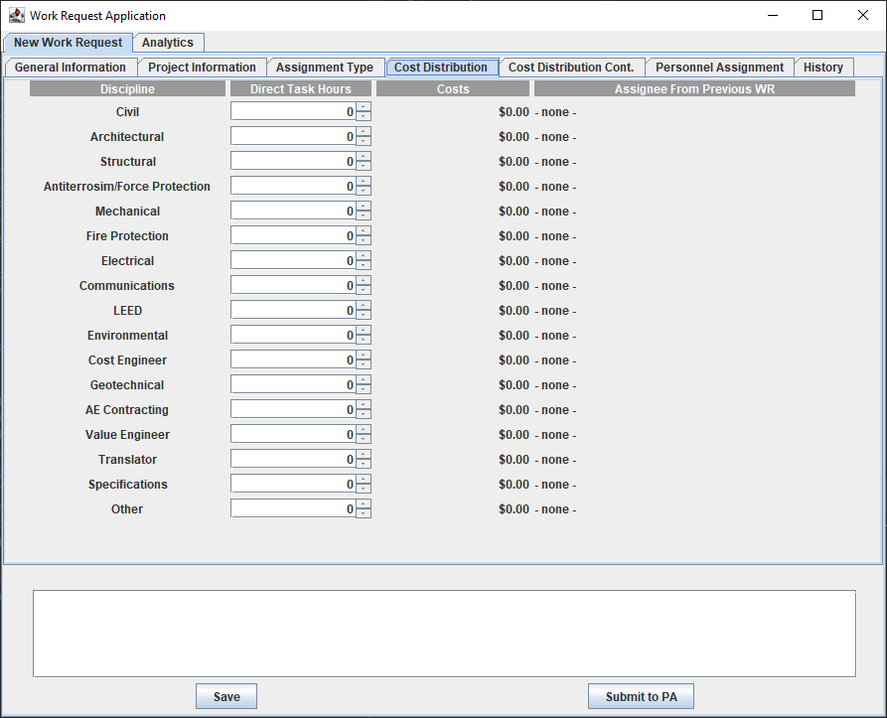
    2. 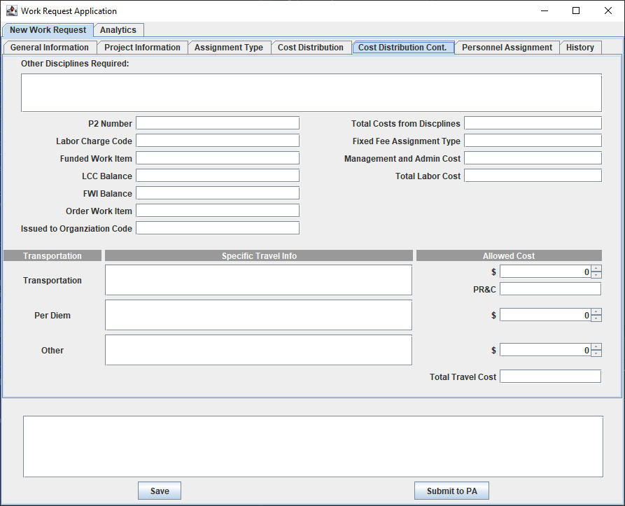
* Filled by Requester / PM (and later potentially by branch Supervisor)
* Engineering & Environmental:
  + Which Disciplines are requested?
* All branches:
  + How many hours (=money) are available for the requested work?
  + How much money can be spent on travel?
  + Are there any special instructions?
* Special functions:
  + If you used the copy function from the General Info tab, the assignees from the previous WR show up
  + The labor costs are calculated based on the branch‘s average work rate

## Personnel Assignment Tab

* + 1. 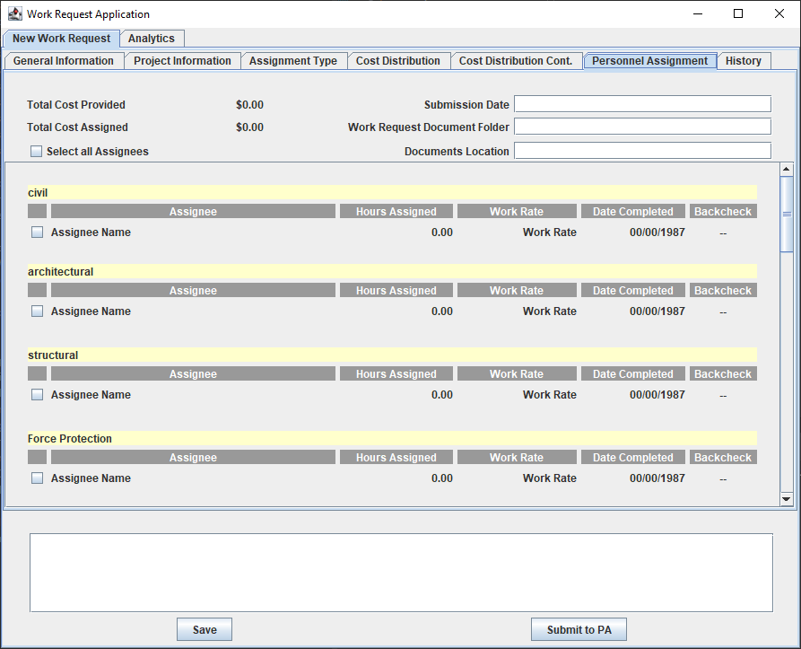
* Filled by branch Supervisor (and potentially by Requester / PM)
* Assignees that will work the Work Request and for how many hours
* Total assigned costs based on the actual Assignees‘ work rates
* Special functions:
  + Disciplines with hours assigned on the Cost Distribution tab are highlighted in yellow
  + Hours assigned are automatically calculated based on certain rules (see Design Document for more information)
  + Total cost planned come from the Cost Distribution tab and is calculated based on the average rate
  + Total cost assigned is calculated from the actual Assignees‘ work rate. If total cost assigned exceeds total cost planned the WR can‘t be submitted
  + Send Email notification to selected Assignees or other recipients

## History Tab

* + 1. 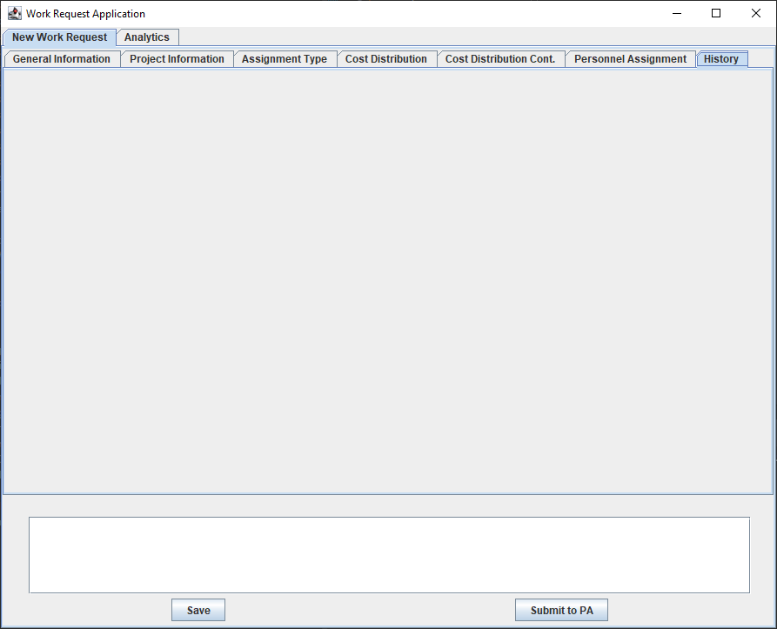
* Who changed which field on the form and when?
  + As soon as the Work Request is submitted the first time all fields are tracked for changes
* Newest entries at the top

# User Guide Approval

The undersigned acknowledge they have reviewed the Work Request Use **Guide** document and agree with the approach it presents. Any changes to this Requirements Definition will be coordinated with and approved by the undersigned or their designated representatives.

|  |  |  |  |
| --- | --- | --- | --- |
| Signature: | Dave Leake | Date: |  |
| Print Name: |  |  |  |
| Title: |  |  |  |
| Role: | Project Manager |  |  |

|  |  |  |  |
| --- | --- | --- | --- |
| Signature: | Will Tchouente (Aurelien) | Date: |  |
| Print Name: |  |  |  |
| Title: |  |  |  |
| Role: | Requirements Manager |  |  |

|  |  |  |  |
| --- | --- | --- | --- |
| Signature: | Ian Oliver | Date: |  |
| Print Name: |  |  |  |
| Title: | Software Engineer/Student |  |  |
| Role: | Software Designer |  |  |

**Appendix A: References**

*[Insert the name, version number, description, and physical location of any documents referenced in this document. Add rows to the table as necessary.]*

The following table summarizes the documents referenced in this document.

|  |  |  |
| --- | --- | --- |
| **Document Name and Version** | **Description** | **Location** |
| *<Document Name and Version Number>* | *[Provide description of the document]* | *<URL or Network path where document is located>* |

**Appendix B: Key Terms**

*[Insert terms and definitions used in this document. Add rows to the table as necessary. Follow the link below to for definitions of project management terms and acronyms used in this and other documents.*

*http://www2.cdc.gov/cdcup/library/other/help.htm*

The following table provides definitions for terms relevant to this document.

|  |  |
| --- | --- |
| **Term** | **Definition** |
| *[Insert Term]* | *[Provide definition of the term used in this document.]* |
| *[Insert Term]* | *[Provide definition of the term used in this document.]* |
| *[Insert Term]* | *[Provide definition of the term used in this document.]* |