**FULL OUTER JOIN**

In earlier lessons, we covered inner joins, which produce results for which the join condition is matched in both tables.

*Venn diagrams, which are helpful for visualizing table joins, are provided below along with sample queries. Consider the circle on the left Table A and the circle on the right Table B.*



INNER JOIN Venn Diagram

**SELECT** column_name(s)

**FROM** Table_A

**INNER** **JOIN** Table_B **ON** Table_A.column_name = Table_B.column_name;

Left joins also include unmatched rows from the left table, which is indicated in the “FROM” clause.



LEFT JOIN Venn Diagram

**SELECT** column_name(s)

**FROM** Table_A

**LEFT** **JOIN** Table_B **ON** Table_A.column_name = Table_B.column_name;

Right joins are similar to left joins, but include unmatched data from the right table -- the one that’s indicated in the JOIN clause.



RIGHT JOIN Venn Diagram

**SELECT** column_name(s)

**FROM** Table_A

**RIGHT** **JOIN** Table_B **ON** Table_A.column_name = Table_B.column_name;

In some cases, you might want to include unmatched rows from *both* tables being joined. You can do this with a full outer join.



FULL OUTER JOIN Venn Diagram

**SELECT** column_name(s)

**FROM** Table_A

**FULL** **OUTER** **JOIN** Table_B **ON** Table_A.column_name = Table_B.column_name;

A common application of this is when joining two tables on a timestamp. Let’s say you’ve got one table containing the number of *item 1* sold each day, and another containing the number of *item 2* sold. If a certain date, like January 1, 2018, exists in the left table but not the right, while another date, like January 2, 2018, exists in the right table but not the left:

* a left join would drop the row with January 2, 2018 from the result set
* a right join would drop January 1, 2018 from the result set

The only way to make sure both January 1, 2018 and January 2, 2018 make it into the results is to do a full outer join. A full outer join returns unmatched records in each table with null values for the columns that came from the opposite table.

If you wanted to return unmatched rows only, which is useful for some cases of data assessment, you can isolate them by adding the following line to the end of the query:

WHERE Table_A.column_name IS **NULL** **OR** Table_B.column_name IS **NULL**



FULL OUTER JOIN with WHERE A.Key IS NULL OR B.Key IS NULL Venn Diagram

**Appending Data via UNION**

**UNION Use Case**

* The UNION operator is used to combine the result sets of 2 or more SELECT statements. It removes duplicate rows between the various SELECT statements.
* Each SELECT statement within the UNION must have the same number of fields in the result sets with similar data types.
* Typically, the use case for leveraging the UNION command in SQL is when a user wants to pull together distinct values of specified columns that are spread across multiple tables. For example, a chef wants to pull together the ingredients and respective aisle across three separate meals that are maintained in different tables.

**Details of UNION**

* There must be the same number of expressions in both SELECT statements.
* The corresponding expressions must have the same data type in the SELECT statements. For example: expression1 must be the same data type in both the first and second SELECT statement.

**Expert Tip**

* UNION removes duplicate rows.
* UNION ALL does not remove duplicate rows.

**Resources**

The resource [**here**](https://www.techonthenet.com/sql/union.php) on SQL UNIONs is helpful in understanding syntax and examples.

Play Video

**Appending Data via UNION Demonstration**

Play Video

SQL's two strict rules for appending data:

1. Both tables must have the same number of columns.
2. Those columns must have the same data types in the same order as the first table.

A common misconception is that column names have to be the same. Column names, in fact, **don't** need to be the same to append two tables but you will find that they typically are.

**Pretreating Tables before doing a UNION**

Play Video

**Performing Operations on a Combined Dataset**

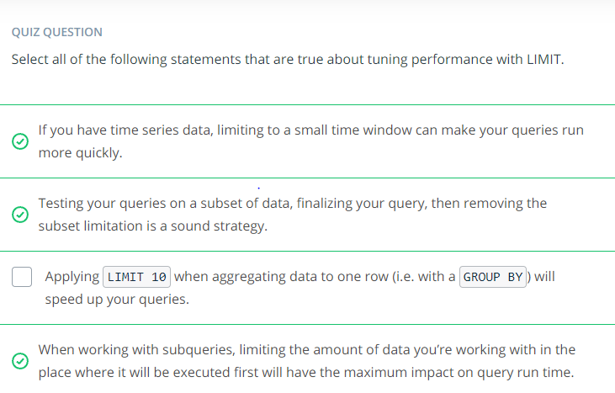

# Congratulations!

You have reached the end of the content for your Scholarship Challenge Phase. We commend you for your continued dedication to the program!

## Reiterate Timeline

The Scholarship Challenge Phase will end on **October 18th, 2021.** You will receive an email from Udacity informing you whether you were awarded a full Nanodegree scholarship seat on **October 28th, 2021.**

## What next?

Please use the time you have from now until the Scholarship Challenge Phase ends, **October 18th,** to review your coursework and to ensure that you did not miss any quizzes or lessons. This is also a great time to get more involved in the Slack Community. Use your expertise in the Challenge Course to support and motivate your fellow classmates!

Congratulations again for reaching the end of the Scholarship Challenge Course!

## Final Assessment Instructions

To win the full Nanodegree Program in this Scholarship, you need to complete the Final Assessment.

The Filtration Assessment will test the relevant skills you learned in the Challenge phase of your track. After taking the assessment, if you're found eligible, you will be shortlisted for the Nanodegree Program Scholarship! This is a selective process, so make sure you're ready for that Filtration Assessment when the date approaches.

Only those who complete the Final Assessment are eligible to win the full Nanodegree Program.

Here is what you need to know about the Final Assessment:

* The Final Assessment will be opened on **October 16, 2021 at 12 AM PT | 9 AM CAT for 48 hours**. The assessment will close on **October 18, 2021 at 11:59 PM PT | 8:59 AM CAT**. You will have more than enough time to complete the assessment during this time frame. There will be **no other dates** available to sit for the assessment.
* The assessment is completely online.
* You will receive a link to take the assessment via email once the assessment is available on October 16, 2021 at 12 AM PT | 9 AM CAT for 48 hours.
* The Final Assessment link expires **exactly 48 hours after it is made available.** Therefore, we recommend that you start the Final Assessment well in advance of the link expiration time **as the assessment will terminate automatically by this time,** and it will be closed, whether you were able to answer all the questions by then or not.
* **The Filtration Assessment can be attempted only once, and you cannot skip any questions.** So, make sure you take the time to thoughtfully answer each question.
* You will receive an email with the Scholarship Winner decision on **October 28, 2021.** Please make sure to check your inbox (and spam and promotions folders) frequently during this period.

We wish you the best of luck!