**LAG function**

**Purpose**  
It returns the value from a previous row to the current row in the table.

**Step 1:**  
Let’s first look at the **inner query** and see what this creates.

**SELECT** account_id, **SUM**(standard_qty) **AS** standard_sum

**FROM** orders

**GROUP** **BY** 1

**What you see after running this SQL code:**

1. The query sums the standard_qty amounts for each account_id to give the standard paper each account has purchased over all time. E.g., account_id 2951 has purchased 8181 units of standard paper.
2. Notice that the results are not ordered by account_id or standard_qty.

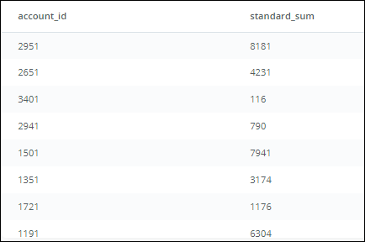

**Step 2:**  
We start building the **outer query**, and name the inner query as sub.

**SELECT** account_id, standard_sum

**FROM** (

**SELECT** account_id, **SUM**(standard_qty) **AS** standard_sum

**FROM** orders

**GROUP** **BY** 1

) sub

This still returns the same table you see above, which is also shown below.

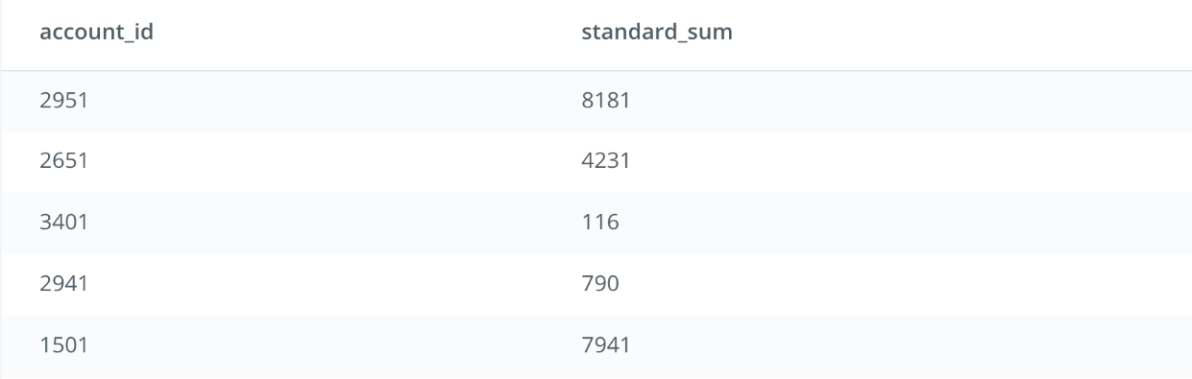

**Step 3 (Part A):**  
We add the Window Function OVER (ORDER BY standard_sum) in the outer query that will create a result set in ascending order based on the *standard_sum* column.

**SELECT** account_id,

standard_sum,

LAG(standard_sum) **OVER** (**ORDER** **BY** standard_sum) **AS** lag

**FROM** (

**SELECT** account_id, **SUM**(standard_qty) **AS** standard_sum

**FROM** orders

**GROUP** **BY** 1

) sub

This ordered column will set us up for the other part of the Window Function (see below).

**Step 3 (Part B):**  
The LAG function creates a new column called *lag* as part of the **outer query**: LAG(standard_sum) OVER (ORDER BY standard_sum) AS lag. This new column named *lag* uses the values from the ordered *standard_sum* (Part A within Step 3).

**SELECT** account_id,

standard_sum,

LAG(standard_sum) **OVER** (**ORDER** **BY** standard_sum) **AS** lag

**FROM** (

**SELECT** account_id,

**SUM**(standard_qty) **AS** standard_sum

**FROM** demo.orders

**GROUP** **BY** 1

) sub

Each row’s value in *lag* is pulled from the previous row. E.g., for account_id 1901, the value in *lag* will come from the previous row. However, since there is no previous row to pull from, the value in *lag* for account_id 1901 will be NULL. For account_id 3371, the value in *lag* will be pulled from the previous row (i.e., account_id 1901), which will be 0. This goes on for each row in the table.

**What you see after running this SQL code:**

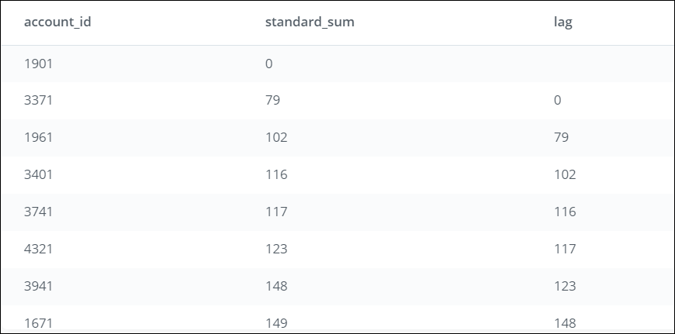

**Step 4:**  
To compare the values between the rows, we need to use both columns (*standard_sum* and *lag*). We add a new column named lag_difference, which subtracts the *lag* value from the value in *standard_sum* for each row in the table:  
standard_sum - LAG(standard_sum) OVER (ORDER BY standard_sum) AS lag_difference

**SELECT** account_id,

standard_sum,

LAG(standard_sum) **OVER** (**ORDER** **BY** standard_sum) **AS** lag,

standard_sum - LAG(standard_sum) **OVER** (**ORDER** **BY** standard_sum) **AS** lag_difference

**FROM** (

**SELECT** account_id,

**SUM**(standard_qty) **AS** standard_sum

**FROM** orders

**GROUP** **BY** 1

) sub

Each value in *lag_difference* is comparing the row values between the 2 columns (*standard_sum* and *lag*). E.g., since the value for *lag* in the case of account_id 1901 is NULL, the value in *lag_difference* for account_id 1901 will be NULL. However, for account_id 3371, the value in *lag_difference* will compare the value 79 (*standard_sum* for account_id 3371) with 0 (*lag* for account_id 3371) resulting in 79. This goes on for each row in the table.

**What you see after running this SQL code:**

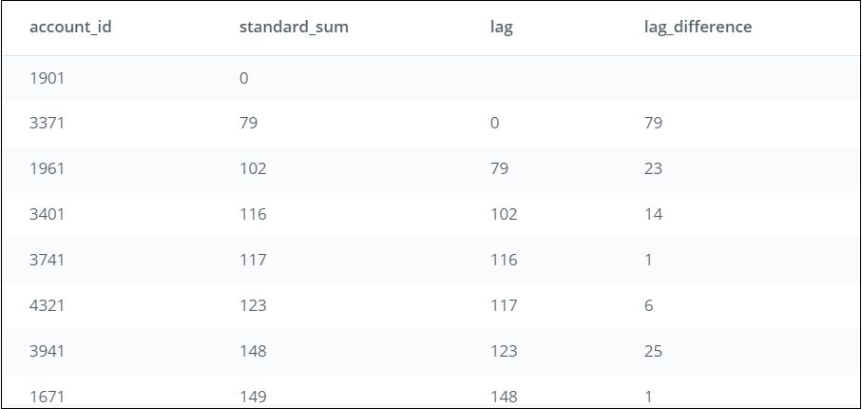

**Now let’s look at the LEAD function.**

**LEAD function**

**Purpose**:  
Return the value from the row following the current row in the table.

**Step 1:**  
Let’s first look at the **inner query** and see what this creates.

**SELECT** account_id,

**SUM**(standard_qty) **AS** standard_sum

**FROM** demo.orders

**GROUP** **BY** 1

**What you see after running this SQL code:**

1. The query sums the standard_qty amounts for each account_id to give the standard paper each account has purchased over all time. E.g., account_id 2951 has purchased 8181 units of standard paper.
2. Notice that the results are not ordered by account_id or standard_qty.



**Step 2:**  
We start building the **outer query**, and name the inner query as sub.

**SELECT** account_id,

standard_sum

**FROM** (

**SELECT** account_id,

**SUM**(standard_qty) **AS** standard_sum

**FROM** demo.orders

**GROUP** **BY** 1

) sub

This will produce the same table as above, but sets us up for the next part.



**Step 3 (Part A):**  
We add the Window Function (OVER BY standard_sum) in the outer query that will create a result set ordered in ascending order of the *standard_sum* column.

**SELECT** account_id,

standard_sum,

**LEAD**(standard_sum) **OVER** (**ORDER** **BY** standard_sum) **AS** **lead**

**FROM** (

**SELECT** account_id,

**SUM**(standard_qty) **AS** standard_sum

**FROM** demo.orders

**GROUP** **BY** 1

) sub

This ordered column will set us up for the other part of the Window Function (see below).

**Step 3 (Part B):**  
The LEAD function in the Window Function statement creates a new column called *lead* as part of the outer query: LEAD(standard_sum) OVER (ORDER BY standard_sum) AS lead

This new column named *lead* uses the values from *standard_sum* (in the ordered table from Step 3 (Part A)). Each row’s value in *lead* is pulled from the row after it. E.g., for account_id 1901, the value in *lead* will come from the row following it (i.e., for account_id 3371). Since the value is 79, the value in *lead* for account_id 1901 will be 79. For account_id 3371, the value in *lead* will be pulled from the following row (i.e., account_id 1961), which will be 102. This goes on for each row in the table.

**SELECT** account_id,

standard_sum,

**LEAD**(standard_sum) **OVER** (**ORDER** **BY** standard_sum) **AS** **lead**

**FROM** (

**SELECT** account_id,

**SUM**(standard_qty) **AS** standard_sum

**FROM** demo.orders

**GROUP** **BY** 1

) sub

**What you see after running this SQL code:**

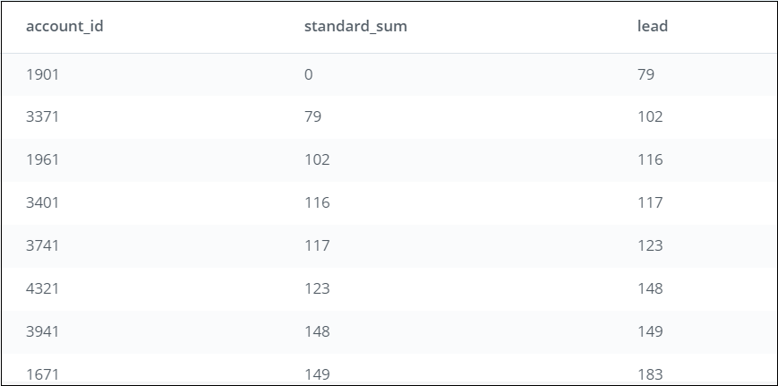

**Step 4:** To compare the values between the rows, we need to use both columns (*standard_sum* and *lag*). We add a column named *lead_difference*, which subtracts the value in *standard_sum* from *lead* for each row in the table: LEAD(standard_sum) OVER (ORDER BY standard_sum) - standard_sum AS lead_difference

**SELECT** account_id,

standard_sum,

**LEAD**(standard_sum) **OVER** (**ORDER** **BY** standard_sum) **AS** **lead**,

**LEAD**(standard_sum) **OVER** (**ORDER** **BY** standard_sum) - standard_sum **AS** lead_difference

**FROM** (

**SELECT** account_id,

**SUM**(standard_qty) **AS** standard_sum

**FROM** orders

**GROUP** **BY** 1

) sub

Each value in *lead_difference* is comparing the row values between the 2 columns (*standard_sum* and *lead*). E.g., for account_id 1901, the value in *lead_difference* will compare the value 0 (*standard_sum* for account_id 1901) with 79 (*lead* for account_id 1901) resulting in 79. This goes on for each row in the table.

**What you see after running this SQL code:**

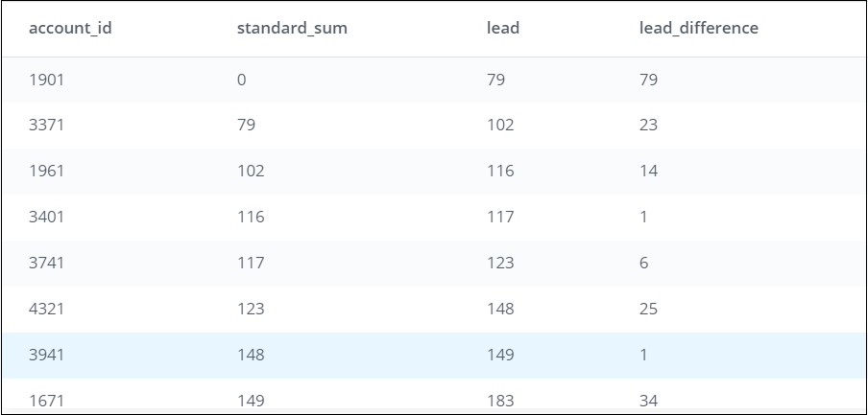

**Scenarios for using LAG and LEAD functions**

You can use LAG and LEAD functions whenever you are trying to compare the values in adjacent rows or rows that are offset by a certain number.

*Example 1:*You have a sales dataset with the following data and need to compare how the market segments fare against each other on profits earned.

| **Market Segment** | **Profits earned by each market segment** |
| --- | --- |
| A | $550 |
| B | $500 |
| C | $670 |
| D | $730 |
| E | $982 |

*Example 2:* You have an inventory dataset with the following data and need to compare the number of days elapsed between each subsequent order placed for Item A.

| **Inventory** | **Order_id** | **Dates when orders were placed** |
| --- | --- | --- |
| Item A | 001 | 11/2/2017 |
| Item A | 002 | 11/5/2017 |
| Item A | 003 | 11/8/2017 |
| Item A | 004 | 11/15/2017 |
| Item A | 005 | 11/28/2017 |

As you can see, these are useful data analysis tools that you can use for more complex analysis!

## Comparing a Row to Previous Row

In the previous video, Derek outlines how to compare a row to a previous or subsequent row. This technique can be useful when analyzing time-based events. Imagine you're an analyst at Parch & Posey and you want to determine how the current order's total revenue ("total" meaning from sales of all types of paper) compares to the next order's total revenue.

Modify Derek's query from the previous video in the SQL Explorer below to perform this analysis. You'll need to use occurred_at and total_amt_usd in the orders table along with LEAD to do so. In your query results, there should be four columns: occurred_at, total_amt_usd, lead, and lead_difference.

**SELECT** account_id,

standard_sum,

LAG(standard_sum) **OVER** (**ORDER** **BY** standard_sum) **AS** lag,

**LEAD**(standard_sum) **OVER** (**ORDER** **BY** standard_sum) **AS** **lead**,

standard_sum - LAG(standard_sum) **OVER** (**ORDER** **BY** standard_sum) **AS** lag_difference,

**LEAD**(standard_sum) **OVER** (**ORDER** **BY** standard_sum) - standard_sum **AS** lead_difference

**FROM** (

**SELECT** account_id,

**SUM**(standard_qty) **AS** standard_sum

**FROM** orders

**GROUP** **BY** 1

) sub