Large-scale biophysically detailed model of somatosensory thalamocortical circuits in NetPyNE

**Fernando S. Borges1,2, Joao V.S. Moreira1, Lavinia M. Takarabe2, Donald Doherty1, William W. Lytton1,3, Salvador Dura-Bernal1,4**

1Department of Physiology and Pharmacology, State University of New York, New York, USA

2Center for Mathematics, Computation, and Cognition, Federal University of ABC, São Paulo, Brazil

3Department of Neurology, Kings County Hospital Center, New York, USA

3Nathan Kline Institute for Psychiatric Research, New York, USA

**\* Correspondence:**Corresponding Author  
fernandodasilvaborges@gmail.com

**Keywords: keyword1, keyword2, keyword3, keyword4, keyword5. (Min.5-Max. 8)**

**Abstract**

The development of a model of the primary somatosensory cortex of the rat by the Blue Brain Project in 2015 provided a groundbreaking framework in the digital reconstruction of brain microcircuits. In this microcircuit, each column had around 31,000 neurons, 55 layer-specific morphological populations, and 207 morpho-electrical neuronal subtypes. The complex network of S1 included around 8 million connections with 37 million synapses. Here, we implemented an expanded version of the S1 model using NetPyNE, a high-level Python interface to the NEURON simulator. The model also includes populations from the somatosensory thalamus, allowing us to study the influence of thalamocortical and corticothalamic projections in the overall S1 dynamics. We obtained the data from the original model through The Neocortical Microcircuit Collaboration Portal. Each of the 1035 reconstructed cells were imported into NetPyNE and electrophysiologically characterized. Later, using the connectoma of 7 neocortical columns, we obtained the connection probability rules of the 1941 m-type pathways. The connection probability between two neurons depends on the distance between them, but we note that, in most cases, two different fits are required to describe these probability rules. The long range connections are well fitted by an exponential decay or Gaussian decay, but for short range (< 100 um), in some cases, the connections are well represented by using a linear fit rule. We reconstructed the S1 in NetPyNE distributing the 31346 cells within a cylindrical volume with 2082 um height and radius of 210 um, where each subtype was randomly distributed in its specific layer (L1, L2/3, L4, L5, or L6). Then, we created the network with synaptic transmission parameters for each pathway and added spontaneous synaptic release as a poisson stimulus. We simulated the model using a cloud computing platform, and explored the spontaneous rates for excitatory and inhibitory synapses in order to find biologically constrained values for neuronal firing rates. Finally, we were able to simulate the dynamics of the S1 model, and the addition of the somatosensory thalamic populations.

# Introduction

S1 model based on Markram et al., 2015, Cell 163, 456–492 [(Markram et al. 2015)](https://paperpile.com/c/5jDOtx/XDsN6/?locator_label=volume), 55 layer-specific morphological population, and 207 morpho-electrical neuron subtypes. cells, an extra stochastic potassium channel was added to the soma and dendrites of the four core e-types, creating channel noise in the models [(Diba, Koch, and Segev 2006)](https://paperpile.com/c/5jDOtx/106j).

# Material and Methods

## Individual neurons

The first step to simulate the microcircuit in NetPyNE was to download the files used to simulate the cells in the The Neocortical Microcircuit Collaboration Portal (<https://bbp.epfl.ch/nmc-portal>) [(Ramaswamy et al. 2015)](https://paperpile.com/c/5jDOtx/aWh12). The full dataset comprises 207 me-types, with 5 examples for each, totaling 1035 folders. Each folder includes a morphology file, descriptions of ion channels, and a template to instantiate the cell. As the template is in NEURON HOC language, it is possible to import all morphological and electrophysiological data into NetPyNE with a single command (Fig. 1A) [(Dura-Bernal et al. 2019)](https://paperpile.com/c/5jDOtx/6vui5).

The benchmark testing of the cells consists of simulating its response under a holding current, followed by stimulation using three current clamp amplitudes (120%, 130%, and 140% of the value needed for the neuron to start firing). In Figure 1B-E, we compare somatic traces from simulations in the online portal (BBP) and NetPyNE for 4 different cells under the same conditions (holding and 120% of reobase). Figure 1 shows the similarity between the BBP and NetPyNE implementations of a layer 1 (L1) inhibitory cell (Fig. 1B), as well as for pyramidal cells from layer 2 (L23_PC_cADpyr229_1) and 6 (L6_TPC_L4_cADpyr231_1) (Fig. 1C,E). However, slight differences are observed in the cells with a stochastic version of the K channel mechanism (StochKv) (Fig. 1D), and this is because NetPyNE uses the deterministic version of this channel mechanism, obtained from OpenSourceBrain [(Gleeson et al. 2019; Gleeson et al. 2019b)](https://paperpile.com/app/p/18ff8956-f735-02d2-9ace-9b6328bded91).

In order to understand the effects that the StochKv channel mechanism alteration of some cells have on the complete circuit, we computed the mean firing rate and the time to first spike after the stimulus onset for all 1035 cells. For this purpose, we applied a current clamp (0.1 nA, 2s) to the soma of each cell, and used the Electrophys Feature Extraction Library (eFEL) [(eFEL 2015)](https://efel.readthedocs.io/). We compared the BBP and NePyNE through mean firing rate (Fig. 1F) and time to first spike (Fig. 1G) altogether, and grouped by cell types (Fig. 1H). The StochKv channels are present in only 3.63% of 31346 cells (54 of 207 me-types). These cell types are also minorities in their m-types, for each m-type population there is only one e-type with StochKv, for example only 32% of L4_DBC cells have e-type bIR (with StochKv channels). Moreover, when the firing rate of the m-type population is considered, the BBP e NePyNE mean firing rate results are very similar (Figure 1H).

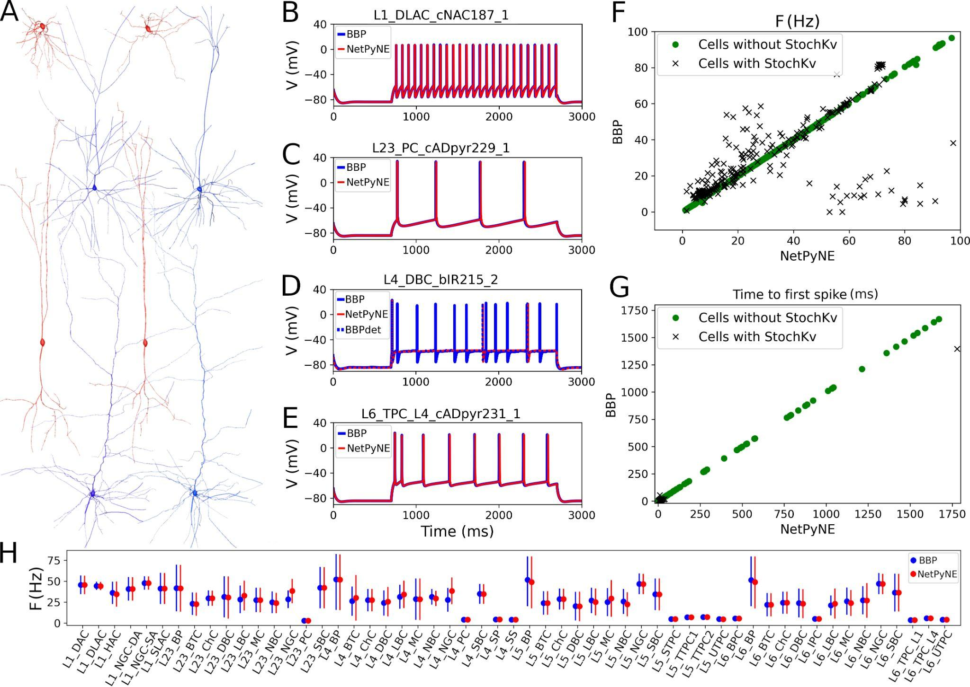

**Figure 1.** (A) Exemplar 3D reconstructions of 4 pairs of m-types in NetPyNE Graphical User Interface. The inhibitory cells L1_DLAC and L4_DBC are in red, the excitatory cells L23_PC and L6_TPC_L4 are shown in blue. (B-E) Somatic membrane potential under current clamp amplitude which represents 120% of the value needed for the neuron to start firing. The blue lines represent simulations using the standard neuron code available in the portal (BBP), the NetPyNE results are described by the red lines. (D) In the L4_DBC_bIR cells we use a deterministic version of stochastic potassium channel used in the BBP model, for this reason there is a divergence in the results of the simulations. When this deterministic version is used in BBP code (dashed blue line) the results converge. (F) Comparison of mean firing rate response to current clamp amplitude 0.1 nA during 2 seconds. (G) Same as in F for time to first spike after the stimulus onset. (H) Comparison of mean firing rate for all m-types populations.

## Connectivity

In order to create an S1 network with the same characteristics of the original model but with generic rules connections for each possible pathway we use Neocortical Microcircuit Collaboration Portal [(Ramaswamy et al. 2015)](https://paperpile.com/c/5jDOtx/aWh12) data. First, reconstructed the S1 in NetPyNE distributing the 31346 cells within a cylindrical volume with 2082 μm height and radius of 210 μm, where each population was randomly distributed in its specific layer (L1, L23, L4, L5, or L6). The number of cells in each one of 207 me-types was taken from Portal and no minicolumn rules were used in cell distributions. A 2D representation of the cell's distribution in a cylinder is shown in Figure 2A, where each subtype was randomly distributed in its specific layer, where the heights (in μm) for L1, L23, L4, L5, and L6 are 165, 502, 190, 525, and 700, respectively.

In the S1 BBP model, [(Markram et al. 2015)](https://paperpile.com/c/5jDOtx/XDsN6) the connectivity is related to the anatomical overlap of neuronal arbors using an algorithmic approach to reconstruct synaptic connectivity between neurons [(M. W. Reimann et al. 2015)](https://paperpile.com/c/5jDOtx/JM5sG). Here, we used the S1 connectome [(Gal et al. 2017)](https://paperpile.com/c/5jDOtx/Zz4HE) available in Portal. Similar to the work done in [(Michael W. Reimann et al. 2017)](https://paperpile.com/c/5jDOtx/BmaaF), we used the 7 stochastic instances of a model microcircuit based on averaged measurements of neuron densities to create distance dependence of connection probabilities in anatomically constrained connectivity. In each microcircuit instance, we calculated the connection probability for each pair of neurons based on the 2D soma distance (XZ-plane) for each of the 1941 pathways. After that, we calculated the mean probability of the 7 microcircuits in evenly spaced intervals (starting at 25 ± 12.5 μm, followed by increments of 25 μm and ± 25 μm boundaries along the XZ-plane) and used the mean values to fit the connection probability rules.

Figure 2B-D shows the connection probability based on the 2D soma distance (XZ). The cyan circles represent the data from the 7 microcircuit instances (mcs) and the mean over the 7 mcs are as green diamonds. In some pathways, the best fit is a single exponential (Fig. 2B, red line). But it also varied in other cases, such as one where the best fit was an exponential with a linear saturation rule (Fig. 2C), and in the case of pathways 1303 and 1941, where the best fit was a single gaussian (Fig. 2D, dashed line).

Using the fitted rules, we reconstructed a full S1 column in NetPyNE and compared the two versions using the mean number of connections. To avoid overfitting, we used 7 different seeds in NetPyNE constrained by the mean number of connections versus 7 BBP microcircuit instances for each one of the 1941 pathways. Comparison of the number of connections shows a good agreement between the two models in all pathways for all 4 projection types: excitatory-excitatory (EE), excitatory-inhibitory (EI), inhibitory-excitatory (IE) and inhibitory-inhibitory (II) (Fig. 2F). Because the original S1 model shows high variability in the number of synapses per connection, we calculated the mean values for each pathway and used that as a parameter to our model. The end result is a representative reconstruction of the S1 column connectivity in NetPyNE, with around 27.6 million excitatory synapses and 9.6 million inhibitory synapses.

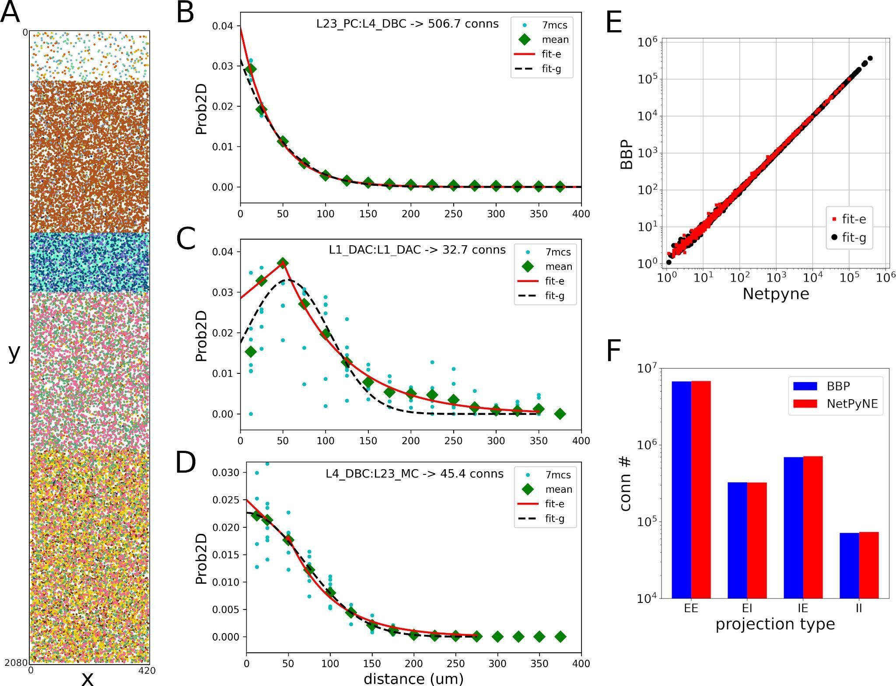

**Figure 2.** (A) 2D representation of the 31346 cells localization in a cylinder with 2082 um height and radius of 210 um, where each subtype was randomly distributed in its specific layer (L1, L2/3, L4, L5, or L6). (B) Exemplar pathway where the best fit is a single exponential (red line). (C) The best fit is an exponential with linear saturation rule (red line). (D) The best is a single gaussian fit (black dashed line). The cyan circles represent the data from the 7 microcircuit instances (mcs), and the green diamonds are the mean over the 7 mcs. (E-F) The comparison of the number of connections between BBP and NetPyNE for each one of the 1941 pathways and the 4 protection types.

In addition to intra-S1 connections, we also included projections from the somatosensory thalamus, composed of the excitatory ventral posterolateral (VPL), ventral posteromedial (VPM) and the posteromedial (POm) nuclei, and the inhibitory reticular nucleus (RTN). The VPL and VPM receive afferent information from peripheral sensory organs and are considered first-order nuclei (FO), presenting a topographical connectivity pattern.In the other hand, input to POm comes mostly from the cortex and, in this case, from S1, being considered a higher-order (HO) nucleus. The HO nuclei connectivity pattern remains to be understood, and here is represented via a divergence rule, following reports from the literature. All excitatory nuclei are interconnected within the thalamus through projections to the RTN, here represented by a three-layered sector (RTN), in line with reports of preferred innervation zones by each of the thalamic nuclei (REF) . We used single compartment cell models based on [(Destexhe et al. 1996)](https://paperpile.com/c/5jDOtx/QNYok) work on the interaction between thalamic relay and reticular cells, and parameter models were adjusted to match the target dynamics and large network size and connectivity [(Moreira et al. 2021)](https://docs.google.com/document/u/0/d/1ucYiQlmn5lPyrodyrJhJ5U0pURXAKUrlI22oPRS2uQE/edit).

The final architecture of the thalamic network consisted of six stacked populations, with three exclusively inhibitory and three exclusively excitatory (Fig 3A). The inhibitory populations comprised the outer, middle and inner sectors of the RTN, spanning a total of 78.0, 78.0 and 156.0 μm, respectively, and followed by the VPL and VPM at 156.0 μm each, and the POm, at 312.0 μm. All populations measured 420.0 μm in both the X- and Z-plane. Cells were randomly distributed across each nuclei and the number of cells in each population was based on cellular density obtained in A Cell Atlas for the Mouse Brain (<https://bbp.epfl.ch/nexus/cell-atlas/>) [(Erö et al. 2018)](https://paperpile.com/c/5jDOtx/NIBPP). The internal thalamic connectivity was based on data of axonal and dendritic footprints for each nuclei, combined with an exponentially decreasing probability of connection. For the RTN:RTN connections, two cells would connect only if their soma distance was smaller than 264.63 μm [(Lam, Nelson, and Sherman 2006)](https://paperpile.com/c/5jDOtx/0jlr). Similarly, the maximum distance was 64.33 μm in RTN:VPL and RTN:VPM connections [(Lam and Sherman 2007)](https://paperpile.com/c/5jDOtx/vKqQ), 97.67 μm in VPL:RTN and 103.57 μm in VPM:RTN [(Lam and Sherman 2011)](https://paperpile.com/c/5jDOtx/1qNu). The high order (HO) connections RTN:POm and POm:RTN were randomly distributed (Figure 3B). Synapses within RTN were mediated by GABAa, from RTN to the excitatory nuclei by a combination of GABAa and GABAb with equal weight, and by AMPA from the excitatory nuclei to RTN and to cortex (REF). The probability and weight of connections were the targets of parameter optimization. The matrix with the convergence of intra-thalamic connections is shown in Figure 3E.

The excitatory S1 populations were divided in 6 groups, L23 pyramid (L23_PY), L4 non spiny stellate (L4_SS), L4 spiny stellate (L4_nSS), L5 non thick tufted (L5_nTT), L5 thick tufted (L5_TT), and L6 pyramid (L6_PY). The thalamus convergence for cells in VPL and POm are taken from [(Meyer et al. 2010)](https://paperpile.com/c/5jDOtx/Zu0J9), and VPM convergence was estimated using VPL values (Figure 3C). [Markram et al. (2015)](https://paperpile.com/c/5jDOtx/XDsN6) model predicted that each VPM thalamic fiber innervates around 775 excitatory and 83 inhibitory S1 neurons, therefore the IE ratio of thalamic innervation should be around 0.107. Since the IE population ratio of S1 (4779/26567) in the average model is 0.18, a thalamic convergence factor of inhibitory populations (~0.595) can be estimated. Then, the 55 m-type convergences were taken using a weighted average on the populations of each layer, in addition, the factor for inhibitory populations 0.595 was multiplied. The reconstructed S1-thalamus column has around 4.95 million VPM synapses projections, 4.95 million VPL synapses projections, and 3.1 million POm synapses projections. In our model L1 cells receive only POm synapses projections, with this the inhibitory/excitatory ratio of thalamic innervation obtained was 0.102.

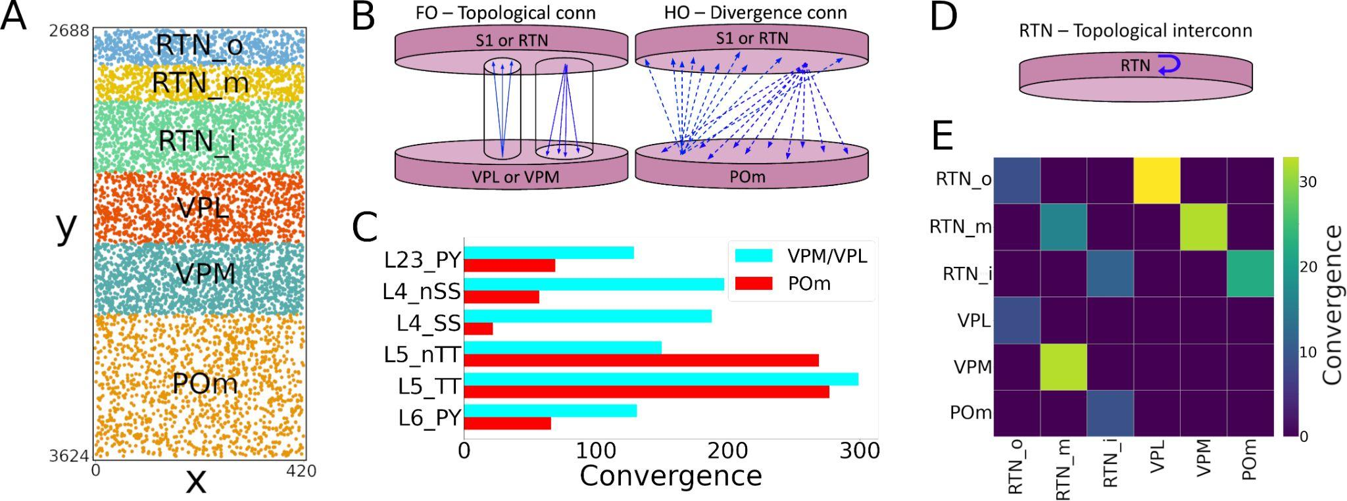

**Figure 3.** (A) Six layers of thalamic populations. (B) The connections between thalamus and S1 are topological (first order) when VPL or VPM cells are involved, and non-topological with POm cells (high order). (C) Thalamus convergence to S1 populations [(Meyer et al. 2010)](https://paperpile.com/c/5jDOtx/Zu0J9). (D) RTN cells have topological interconnections. (E) Matrix of convergence for thalamic connections.

The synapse physiology in the S1 model [(Markram et al. 2015)](https://paperpile.com/c/5jDOtx/XDsN6) was modeled using many synaptic properties and short-term dynamics. Based on the available experimentally measured and extrapolated data, they created many rules to describe the synaptic properties for the S1 pathways. There are 6 synapse types (s-types): inhibitory facilitating (I1), inhibitory depressing (I2), inhibitory pseudo-linear (I3), excitatory facilitating (E1), excitatory depressing (E2), and excitatory pseudo-linear (E3). Based on the Portal data, we identified 29 classes of connections determined from the combination of presynaptic and postsynaptic me-types. The parameters for synaptic transmission and a short description of the rules for each class of connection are described in Table 1. We rearrange the original BBP label number in the s-types sequence I1, I2, I3, E1, E2, and E3 (from 0 to 28). The quantal conductance (gsyn) and decay time (τdecay) are kinetic parameters, while utilization of synaptic efficacy (U), relaxation time constant from depression (D) and from facilitation (F) are dynamic parameters, all these are described in terms of mean ± standard deviation.

In Figure 4 the matrix of the s-types for the 1941 pathways is shown. As classes depend on me-types, it is possible to find multiple s-types in the same pathway, in this case only the I2 or E2 is shown in Figure 4A. For the NetPyNE simulations a deterministic version of the dual-exponential synaptic model was used ([Hennig 2013](https://paperpile.com/c/5jDOtx/fpmVJ), Fuhrmann et al. 2002). Exemplar simulations of inhibitory postsynaptic potentials (I1, I2, and I3) and excitatory postsynaptic potentials (E1, E2, and E3) are shown in Figure 4B. The exemplar inhibitory synapses were simulated using the pathway L23_SBC:L23_PC which is triple degenerate, pre synaptic cells with e-type cAC are I1 (class 1), dNAC pre cells are I2 (class 4), and in this pathways when the pre cell have e-type bNAC the s-type is I3 (class 9), as shown in Table 1. In the exemplar excitatory synapses, the pathway L23_PC:L23_LBC was used to E1 and E2, with post e-type cAC (class 12) and dNAC (class 25), respectively. For the E3 simulations the L6_TPC_L4:L6_TPC_L4 (class 26) was used. In Figure 4B we ran 20 simulations for each example, being 5 cells for each me-type in the postsynaptic neuron and 4 random synaptic distributions. As in [Markram et al. (2015)](https://paperpile.com/c/5jDOtx/XDsN6) somatic connections between excitatory neurons are not allowed.

| **#** | **BBP** | **gsyn (nS)** | **τdecay (ms)** | **U** | **D (ms)** | **F (ms)** | **types** | **rules** |
| --- | --- | --- | --- | --- | --- | --- | --- | --- |
| **0** | 0 | 0.83±0.55 | 10.40±6.10 | 0.16±0.100 | 45±21 | 376±253 | I1-II | L6:L6_(DBC-LBC-NBC-SBC) |
| **1** | 3 | 0.91±0.61 | 10.40±6.10 | 0.16±0.100 | 45±21 | 376±253 | I1-IE | SBC_cAC:Exc or L6_(NBC-LBC):L6_BPC |
| **2** | 13 | 0.75±0.32 | 10.40±6.10 | 0.41±0.212 | 162±69 | 690±5 | I1-IE | L6_MC:L6_IPC |
| **3** | 1 | 0.83±0.55 | 8.30±2.20 | 0.25±0.130 | 706±405 | 21±9 | I2-II | L1:Excitatory or Inhibitory:Inhibitory |
| **4** | 4 | 0.91±0.61 | 8.30±2.20 | 0.25±0.130 | 706±405 | 21±9 | I2-IE | SBC_dNAC:Excitatory |
| **5** | 8 | 0.75±0.32 | 8.30±2.20 | 0.25±0.130 | 706±405 | 21±9 | I2-IE | BTC-DBC-BP:Excitatory |
| **6** | 9 | 0.75±0.32 | 8.30±2.20 | 0.30±0.080 | 1250±520 | 2±4 | I2-IE | MC:Excitatory |
| **7** | 10 | 0.91±0.61 | 8.30±2.20 | 0.14±0.050 | 875±285 | 22±5 | I2-IE | LBC-NBC_(bAC cAC bNAC dNAC):Excitatory |
| **8** | 12 | 2.97±0.95 | 8.30±2.20 | 0.25±0.130 | 706±405 | 21±9 | I2-IE | Chc:Excitatory |
| **9** | 5 | 0.91±0.61 | 6.44±1.70 | 0.32±0.140 | 144±80 | 62±31 | I3-IE | SBC_bNAC or LBC-NBC_(cNAC dSTUT cSTUT bSTUT):Excitatory |
| **10** | 11 | 0.83±0.55 | 36.55±0.71 | 0.25±0.130 | 706±405 | 21±9 | I3-IE | NGC:Excitatory |
| **11** | 114 | 0.43±0.28 | 1.74±0.18 | 0.02±0.001 | 194±10 | 507±20 | E1-EI | Exc:(BP_cAC DBC_cAC BTC_cAC) |
| **12** | 115 | 0.72±0.50 | 1.74±0.18 | 0.02±0.001 | 194±10 | 507±20 | E1-EI | Ex:(NBC-LBC)_(cAC cIR bAC bIR cNAC) |
| **13** | 132 | 0.72±0.50 | 1.74±0.18 | 0.01±0.001 | 242±15 | 563±32 | E1-EI | L6_TPC_L:L6_(DBC-LBC-NBC-SBC) |
| **14** | 133 | 0.11±0.08 | 1.74±0.18 | 0.09±0.120 | 138±211 | 670±830 | E1-EI | Excitatory:MC |
| **15** | 116 | 0.72±0.50 | 1.74±0.18 | 0.50±0.020 | 671±17 | 17±5 | E2-EE | Excitatory:Excitatory |
| **16** | 117 | 0.43±0.28 | 1.74±0.18 | 0.50±0.020 | 671±17 | 17±5 | E2-EI | Excitatory:[L1-BP_(cNAC bNAC)-DBC_bAC-BTC_(bAC cNAC bIR)] |
| **17** | 118 | 0.72±0.50 | 1.74±0.18 | 0.50±0.020 | 671±17 | 17±5 | E2-EI | Excitatory:SBC-ChC |
| **18** | 119 | 0.68±0.46 | 1.74±0.18 | 0.46±0.260 | 671±17 | 17±5 | E2-EE | L23_PC:L23_PC |
| **19** | 120 | 0.68±0.46 | 1.74±0.18 | 0.86±0.049 | 671±17 | 17±5 | E2-EE | L4_Excitatory:L4_Excitatory |
| **20** | 121 | 0.19±0.12 | 1.74±0.18 | 0.79±0.040 | 671±17 | 17±5 | E2-EE | L4_SS:L23_PC |
| **21** | 122 | 0.80±0.53 | 1.74±0.18 | 0.39±0.030 | 671±17 | 17±5 | E2-EE | L5_STPC:L5_STPC |
| **22** | 123 | 1.50±1.05 | 1.74±0.18 | 0.50±0.020 | 671±17 | 17±5 | E2-EE | L5_TTPC:L5_TTPC |
| **23** | 127 | 0.80±0.53 | 1.74±0.18 | 0.39±0.134 | 780±54 | 51±36 | E2-EE | L6_IPC:L6_IPC |
| **24** | 131 | 0.72±0.50 | 1.74±0.18 | 0.58±0.070 | 240±43 | 71±47 | E2-EI | L6_IPC:L6_(DBC-LBC-NBC-SBC) |
| **25** | 134 | 0.72±0.50 | 1.74±0.18 | 0.72±0.065 | 227±38 | 14±12 | E2-EI | Exc:(NBC-LBC)_(bSTUT dNAC bNAC cSTUT) |
| **26** | 126 | 0.80±0.53 | 1.74±0.18 | 0.21±0.032 | 460±53 | 230±69 | E3-EE | L6_TPC_L:L6_TPC_L |
| **27** | 128 | 0.80±0.53 | 1.74±0.18 | 0.27±0.033 | 559±238 | 200±92 | E3-EE | L6_IPC:L6_BPC |
| **28** | 129 | 0.80±0.53 | 1.74±0.18 | 0.22±0.053 | 535±134 | 116±81 | E3-EE | L6_IPC:L6_TPC_L |

**Table 1.** Parameters for synaptic transmission, related to Figure 3, with the types (synapse type and projection type) and the rules of connections. We assign a number (from 0 to 28) to each parameter set based on BBP portal data.

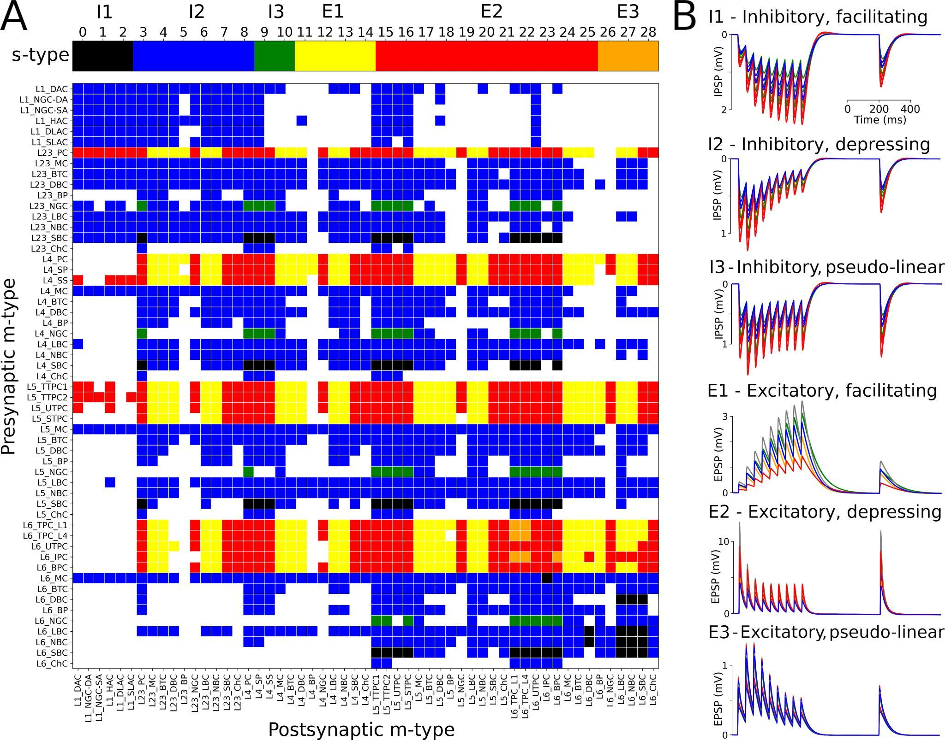

**Figure 4.** (A) A matrix of the synapse types for the 1941 pathways, when there are multiple s-types in the same pathway the I2 or E2 is shown. (B) Exemplar simulations of inhibitory postsynaptic potentials (I1, I2, and I3) and excitatory postsynaptic potentials (E1, E2, and E3).

## Simulations

In order to simulate the S1 microcircuit at the level of detail described above we used NetPyNE, a high-level Python interface to the NEURON simulator (Carnevale and Hines, 2006;Hines and Carnevale, 1997; Hines et al., 2008a, 2011, 2011; Migliore et al., 2006) with standard and CoreNEURON libraries [(Kumbhar et al. 2019)](https://paperpile.com/c/5jDOtx/0lX6G). For the simulations a deterministic version of the dual-exponential synaptic model was used. For each cell in S1 was added Np=10 poisson stimulus to represent the global effect of spontaneous synapses, background, and other noise sources. These stimuli were distributed randomly in the sections, the quantal conductance was calculated based on the average quantal conductance for excitatory and inhibitory synapses, and the stimuli rates were used as control parameters to obtain physiologicals firing rates for all S1 populations.

# Results

As shown in Figure 1, the cells imported into NePyNE using the files from The Neocortical Microcircuit Collaboration Portal [(Ramaswamy et al. 2015)](https://paperpile.com/c/5jDOtx/aWh12), reproduce the morphological and electrophysiological characteristics of the original model. The rest potential and time to the first spike after a current clamp stimulation are perfectly fitted for all the 1035 cells. The firing dynamic had very good agreement for most cells, but differences are observed in cells with the K channel StochKv. As just 3.63% of 31346 cells present this channel, the averaged firing rate of the m-type population is very similar (Fig. 1H).

Here we focus on recreating a model with the general characteristics of the 7 BBP microcircuit instances. In our model the 31346 cells are distributed randomly in its specific layer and the probabilistics connections rules are created for each one of the 1941 pathways (Fig. 2). This form to build the microcircuit allows us to rescale the microcolumn and generate different instances only by changing the seed of the random number generator. We observed that it is possible to reproduce the numbers of connections between each type of pathway using probabilistic rules to connect each neuron. In most cases (1303 out of 1941), with Gaussian fit the average number of connections obtained from the 7 BBP mcs was better reproduced. In the remaining 638, we had better success when we used an exponential fit plus a linear saturation rule in some cases (Fig. 2).

In addition to the S1 neurons we include the thalamic populations RTN, POm, VPL, and VPM. The number of thalamic cells was adapted to fit a cylindrical column with the same radius as S1. This facilitated the inclusion of topological rules of connection between the thalamus and S1. To reproduce the firing dynamics of the thalamus we use a model with single compartmental cells [(Moreira et al. 2021)](https://docs.google.com/document/u/0/d/1ucYiQlmn5lPyrodyrJhJ5U0pURXAKUrlI22oPRS2uQE/edit), the connections from TC cells to S1 are based in convergence rules [(Meyer et al. 2010)](https://paperpile.com/c/5jDOtx/Zu0J9), and the physiological mechanism of the synapses are generalized from the VPM projection into the layers L4 and L5 [(Markram et al. 2015)](https://paperpile.com/c/5jDOtx/XDsN6/?locator_label=volume). The S1 m-types L5_TTPC2 and L6_TPC_L4 have projections to thalamus; we consider a convergence 30 for these connections and connections only if the horizontal distance between the neurons is lower than 50.0 μm (Fig. 3). Differently from other thalamus populations, TC synapses with the POm are randomly chosen without distance rule (high order).

In order to obtain physiologicals firing rates for all S1 populations in the spontaneous activity, we used as control parameters the poisson stimuli rates of excitatory and inhibitory synapses. These stimuli represent the global effect of spontaneous synapses, background, and other noise sources. After numerically finding these values, we compare the results obtained with two NEURON libraries. In Figure 5 we show two examples of spontaneous activity of a S1 column simulated with 40 cores in Google Cloud using NetPyNE. The first of them using standard NEURON libraries, and the second using the CoreNEURON libraries, a state-of-the-art version of NEURON that enables simulations using GPU processing. We considered the first second as a transient and calculated the mean firing rate of the 55 m-types populations using the interval from 1 to 2 seconds. Figure 5A shows the raster plots for all the 31346 cells in the S1 column and Figure 4B shows examples of voltage traces for 1 second of spontaneous activity in each population. In the Raster the colors are related to m-type ordered as in Figure 5B. The traces for the 207 me-types in the microcircuit were grouped into their respective 55 m-types. Figure 5C shows the mean firing rate (F) and cell number (N) for the 55 m-types populations. We quantitatively compared the results between the two versions of the simulation. In both cases the F over all populations is 1 Hz, the excitatory and L1-L23 inhibitory cells had F smaller than L4-L6 inhibitory cells, showing that the results from NEURON and CoreNEURON have good agreements In this case, the CoreNEURON was 2.391 faster to create the full network and 2.162 faster to run the simulation (Figure 5D), being a viable alternative to study the current S1 network.

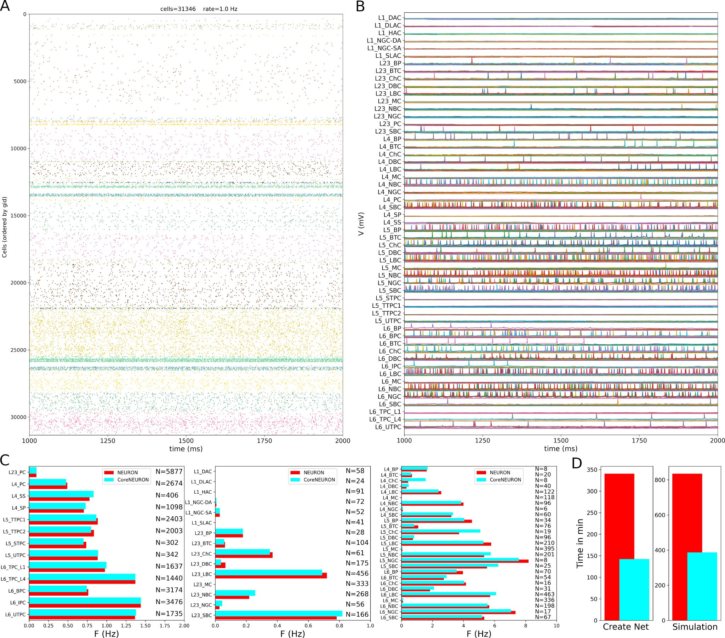

**Figure 5.** NetPyNE simulations of spontaneous activity. (A) Raster Plot for all the 31346 cells in the S1 column during 1 second. (B) Exemplar voltage traces for each of the 207 me-types during spontaneous activity in the microcircuit grouped into their respective 55 m-types. (C) Mean firing rates of each of the 55 m-types. The red bars show the results of the simulations with NEURON (used in A and B). While the cyan bars show the results obtained using CoreNEURON with the same parameters. (D) Comparison of the time needed to create the network and run the simulation on a 40-core cluster using NEURON (red) or CoreNEURON (cyan).

In the results shown in Figure 5 thalamic populations are not considered and synapses do not have short term plasticity (STP). We included in our S1 model a deterministic version of STP (Figure 4) and simulated them with the same conditions of the simulations done using only double exponentials to model the synapses (Fig. 5). The main difference observed is the emergence of spontaneous synchronous bursting (Figure 6)

The parameters of thalamus network were adjusted to reproduce a stable self-sustained rhythmic activity with rhythmic bursting and spindle oscillations, as well as a shift in dynamics following localized excitatory input in the relay cells [(Moreira et al. 2021)](https://docs.google.com/document/u/0/d/1ucYiQlmn5lPyrodyrJhJ5U0pURXAKUrlI22oPRS2uQE/edit). With the anatomical connectivity described in Figure 2, we considered two strengths for synaptic excitatory conductance. In the first case, the gsyn equal to 0.19 uS resulted in weak coupling and was used for all thalamic projections to S1 (Fig 5A), while gsyn equal to 0.72 uS resulted in a strong coupling within the network (Fig 5B). In the Rasters the 31346 cells in the S1 column are ordered as in Figure 4A, additionally the 7266 cells are ordered in RTN_o, RTN_m, RTN_i, VPL, VPM, and POm. Inclusion of thalamic projections resulted in an increase in mean firing rate (F) for most S1 populations. Comparing weak and strong coupling, we notice that the overall F increases for all populations, except for L5 excitatory neurons (Figure 5C). In the spontaneous activity simulations, the L1 cells had very low F values, which increased considerably with the presence of thalamic inputs, especially in the latter case. These differences in coupling are also observed in the voltage traces of cells in L1 (Fig 5D).

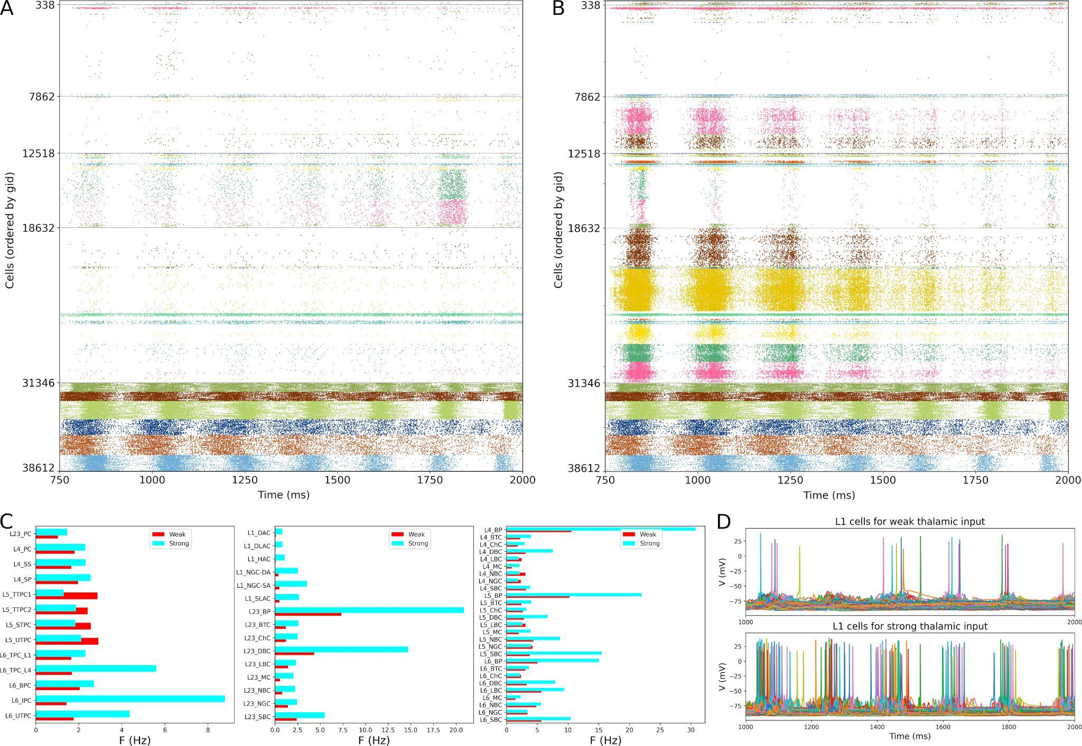

**Figure 6.** Influence of thalamic input in the S1 populations. (A) Raster Plot for weak coupling (0.19 uS). (B) Raster Plot for strong coupling (0.72 uS). (C) Mean firing rates of each of the 55 m-types. The red bars show the weak coupling results while the strong coupling are shown by the cyan bars. (D) Comparison of the L1 cells traces in the two cases.

# Discussions

# Acknowledgments

This work was funded by the following grants: NIH U24EB028998, NSF 1904444-1042C and NYS SCIRB DOH01-C32250GG-3450000.

# References

# Data Availability Statement

The datasets for this study can be found in the [github.com/suny-downstate-medical-center/S1_netpyne/](https://github.com/suny-downstate-medical-center/S1_netpyne/).

[Destexhe, A., T. Bal, D. A. McCormick, and T. J. Sejnowski. 1996. “Ionic Mechanisms Underlying Synchronized Oscillations and Propagating Waves in a Model of Ferret Thalamic Slices.” *Journal of Neurophysiology* 76 (3): 2049–70.](http://paperpile.com/b/5jDOtx/QNYok)

[Diba, Kamran, Christof Koch, and Idan Segev. 2006. “Spike Propagation in Dendrites with Stochastic Ion Channels.” *Journal of Computational Neuroscience* 20 (1): 77–84.](http://paperpile.com/b/5jDOtx/106j)

[Dura-Bernal, Salvador, Benjamin A. Suter, Padraig Gleeson, Matteo Cantarelli, Adrian Quintana, Facundo Rodriguez, David J. Kedziora, et al. 2019. “NetPyNE, a Tool for Data-Driven Multiscale Modeling of Brain Circuits.” *eLife* 8 (April). https://doi.org/](http://paperpile.com/b/5jDOtx/6vui5)[10.7554/eLife.44494](http://dx.doi.org/10.7554/eLife.44494)[.](http://paperpile.com/b/5jDOtx/6vui5)

[Erö, Csaba, Marc-Oliver Gewaltig, Daniel Keller, and Henry Markram. 2018. “A Cell Atlas for the Mouse Brain.” *Frontiers in Neuroinformatics* 12 (November): 84.](http://paperpile.com/b/5jDOtx/NIBPP)

[Gal, Eyal, Michael London, Amir Globerson, Srikanth Ramaswamy, Michael W. Reimann, Eilif Muller, Henry Markram, and Idan Segev. 2017. “Rich Cell-Type-Specific Network Topology in Neocortical Microcircuitry.” *Nature Neuroscience* 20 (7): 1004–13.](http://paperpile.com/b/5jDOtx/Zz4HE)

[Hennig, Matthias H. 2013. “Theoretical Models of Synaptic Short Term Plasticity.” *Frontiers in Computational Neuroscience* 7 (April): 45.](http://paperpile.com/b/5jDOtx/fpmVJ)

[Kumbhar, Pramod, Michael Hines, Jeremy Fouriaux, Aleksandr Ovcharenko, James King, Fabien Delalondre, and Felix Schürmann. 2019. “CoreNEURON : An Optimized Compute Engine for the NEURON Simulator.” *Frontiers in Neuroinformatics* 13 (September): 63.](http://paperpile.com/b/5jDOtx/0lX6G)

[Lam, Ying-Wan, Christopher S. Nelson, and S. Murray Sherman. 2006. “Mapping of the Functional Interconnections Between Thalamic Reticular Neurons Using Photostimulation.” *Journal of Neurophysiology* 96 (5): 2593–2600.](http://paperpile.com/b/5jDOtx/0jlr)

[Lam, Ying-Wan, and S. Murray Sherman. 2007. “Different Topography of the Reticulothalmic Inputs to First- and Higher-Order Somatosensory Thalamic Relays Revealed Using Photostimulation.” *Journal of Neurophysiology* 98 (5): 2903–9.](http://paperpile.com/b/5jDOtx/vKqQ)

[———. 2011. “Functional Organization of the Thalamic Input to the Thalamic Reticular Nucleus.” *The Journal of Neuroscience: The Official Journal of the Society for Neuroscience* 31 (18): 6791–99.](http://paperpile.com/b/5jDOtx/1qNu)

[Markram, Henry, Eilif Muller, Srikanth Ramaswamy, Michael W. Reimann, Marwan Abdellah, Carlos Aguado Sanchez, Anastasia Ailamaki, et al. 2015. “Reconstruction and Simulation of Neocortical Microcircuitry.” *Cell* 163 (2): 456–92.](http://paperpile.com/b/5jDOtx/XDsN6)

[Meyer, Hanno S., Verena C. Wimmer, Mike Hemberger, Randy M. Bruno, Christiaan P. J. de Kock, Andreas Frick, Bert Sakmann, and Moritz Helmstaedter. 2010. “Cell Type-Specific Thalamic Innervation in a Column of Rat Vibrissal Cortex.” *Cerebral Cortex*  20 (10): 2287–2303.](http://paperpile.com/b/5jDOtx/Zu0J9)

[Ramaswamy, Srikanth, Jean-Denis Courcol, Marwan Abdellah, Stanislaw R. Adaszewski, Nicolas Antille, Selim Arsever, Guy Atenekeng, et al. 2015. “The Neocortical Microcircuit Collaboration Portal: A Resource for Rat Somatosensory Cortex.” *Frontiers in Neural Circuits* 9 (October): 44.](http://paperpile.com/b/5jDOtx/aWh12)

[Reimann, Michael W., Anna-Lena Horlemann, Srikanth Ramaswamy, Eilif B. Muller, and Henry Markram. 2017. “Morphological Diversity Strongly Constrains Synaptic Connectivity and Plasticity.” *Cerebral Cortex*  27 (9): 4570–85.](http://paperpile.com/b/5jDOtx/BmaaF)

[Reimann, M. W., E. B. Muller, S. Ramaswamy, and H. Markram. 2015. “An Algorithm to Predict the Connectome of Neural Microcircuits’, Frontiers in Computational Neuroscience.” *Frontiers* 9.](http://paperpile.com/b/5jDOtx/JM5sG) <https://www.scopus.com/record/display.uri?eid=2-s2.0-84943656352&origin=inward&featureToggles=FEATURE_VIEW_PDF:1>[.](http://paperpile.com/b/5jDOtx/JM5sG)