Ministerul Educaţiei și Cercetării al Republicii Moldova Universitatea Tehnică a Moldovei
Facultatea Calculatoare, Informatică și Microelectronică

Laboratory work 2:
Study and Empirical Analysis of Algorithms for Determining
Fibonacci N-th Term

Elaborated:
st. gr. FAF-241 Dulgheru Ion

Verified:
asist. univ. Fiștic Cristofor

Chişinău - 2026

Contents
ALGORITHM ANALYSIS 2
1. Objective 2
2. Tasks: 2
3. Theoretical Notes: 3
4. Fundamentals of Algorithm Analysis 3
5. Analysis of Investigated Algorithms 3
6. Summary of Theoretical Expectations 5
7. Introduction: 6
IMPLEMENTATION 6
1. Merge Sort 7
2. Quick Sort 7
3. Heap Sort 8
4. Patience Sort 9
Experimental Results and Graphs 9
CONCLUSION 13

ALGORITHM ANALYSIS

Objective
The objective of this laboratory work is to implement and empirically compare quicksort, mergesort, heapsort, and one chosen algorithm, using defined input data and performance metrics, then graph the results and draw conclusions about their practical efficiency.

Tasks:
- Implement quicksort, mergesort, heapsort, and one additional sorting algorithm in a chosen programming language.
- Define the types of input data for testing (e.g., random, sorted, nearly sorted, reverse-sorted) and generate datasets of different sizes.
- Select comparison metrics (e.g., execution time, number of comparisons or swaps, memory usage) for evaluating the algorithms.
- Run experiments on all algorithms with all input types and sizes, record the measured results, and organize them in tables.
- Create graphical representations (charts/plots) that show how each algorithm performs depending on input size and type.
- Analyze the results and write conclusions about which algorithms are more efficient under which conditions and how this matches their theoretical complexity.

Theoretical Notes:

Fundamentals of Algorithm Analysis
A sorting algorithm is a procedure that rearranges the elements of a list into a specific order, typically nondecreasing numerical order. In this laboratory work we study four comparison-based sorting algorithms: merge sort, quick sort, heap sort and patience sort. Merge sort and quick sort use the divide-and-conquer paradigm, while heap sort is based on the heap data structure and patience sort is inspired by a card game strategy. In the theoretical analysis we are interested mainly in time complexity (best, average and worst case), space complexity and stability (whether equal elements keep their relative order). Merge sort, heap sort and patience sort have worst-case time complexity O(nlogn), whereas quick sort runs in O(nlogn) on average but can degrade to O(n²) in the worst case if the partition is very unbalanced.

Analysis of Investigated Algorithms
TBelow is the theoretical analysis of the four sorting methods implemented in this work: merge sort, quick sort, heap sort and patience sort.
A. Merge Sort
Mechanism: Uses a divide-and-conquer strategy. The array is repeatedly split into two halves until subarrays of size 1 are obtained, then these subarrays are merged back together in sorted order.
Time Complexity:
- Best, Average, Worst: T(n)=O(nlogn)
Space Complexity: Requires additional O(n) memory to store temporary arrays during merging.
Practical Notes: Stable (preserves the order of equal elements), predictable running time, but extra memory makes it less suitable for very memory-constrained environments.
B. Quick Sort
Mechanism: Also divide-and-conquer. A random pivot is chosen, and the array is partitioned into three parts: elements less than the pivot, equal to the pivot, and greater than the pivot; the “less than” and “greater than” parts are then sorted recursively.
Time Complexity:
- Best / Average: T(n)=O(nlogn)
- Worst: T(n)=O(n2) (when partitions are very unbalanced)
Space Complexity: O(logn) additional space on average for recursion stack.
Practical Notes: Usually the fastest in practice on large random data; not stable, and performance can degrade if the pivot choice is consistently bad (though random pivot reduces this risk).

C. Heap Sort
Mechanism: First builds a max-heap from the input array, then repeatedly swaps the maximum element (at the root) with the last element of the heap and reduces the heap size, restoring the heap property each time.
Time Complexity:
- Best, Average, Worst: T(n)=O(nlogn)
Space Complexity: Sorts in place with O(1) extra memory (besides the array itself).
Practical Notes: Not stable. Has guaranteed O(nlogn) time but in practice is often slightly slower than well-implemented quick sort and merge sort due to less cache-friendly access patterns.
D. Patience Sort
Mechanism: Processes the array from left to right, placing each element onto one of several “piles” using a strategy similar to a card game: for each element, it uses binary search to find the leftmost pile whose top is ≥ that element, or starts a new pile if none exists; at the end, the piles are merged to obtain the sorted array.
Time Complexity:
- Building piles with binary search: O(nlogk), where kk is the number of piles (and k≤nk≤n), typically O(nlogn).
- Merging piles: can also be done in O(nlogk).
Space Complexity: Requires additional space to store the piles, overall O(n).
Practical Notes: Closely related to the algorithm for finding the longest increasing subsequence. Less commonly used as a general-purpose sort, but interesting theoretically and for specific applications.

Summary of Theoretical Expectations

Algorithm | Time Complexity | Space Complexity | Suitable Input Range
Merge Sort | O(nlogn) (best/avg/worst) | O(n) | Any size; good for large datasets
Quick Sort | O(nlogn) avg, O(n²) worst | O(logn) | Medium/large random data, in-memory sort
Heap Sort | O(nlogn) (best/avg/worst) | O(1) | Large datasets when extra memory is limited
Patience Sort | O(nlogn) | O(n) | Large datasets; special use cases (LIS)

Introduction:
Sorting is one of the fundamental operations in computer science, forming the basis for efficient searching, data analysis and many other algorithms. In this laboratory work we study and empirically compare four efficient comparison-based sorting algorithms: merge sort, quick sort, heap sort and patience sort. The goal is to move from purely theoretical knowledge about their time and space complexities to a practical understanding obtained by implementing them, running them on different types and sizes of input data, and analyzing their measured performance. Through this process we can observe how algorithm design choices influence real execution time, memory usage and suitability for various problem sizes and data distributions, and thus learn to choose appropriate sorting methods in real applications.

IMPLEMENTATION

In this section we present the practical implementation of the four investigated sorting algorithms in Python and the way their performance was measured. For each algorithm we provide a short description of the working principle and the corresponding Python code used in the experiments.

Merge Sort
Merge sort is a divide-and-conquer algorithm that recursively splits the list into two halves until sublists of size 1 are obtained, then merges these sorted sublists back together into a single sorted list. This guarantees a worst-case time complexity of O(nlogn) and stable behavior, at the cost of additional linear memory for the temporary lists.
Implemetation:
def merge_sort(a: List[int]) -> List[int]:
if len(a) < 2:
return a[:]
mid = len(a) // 2
left = merge_sort(a[:mid])
right = merge_sort(a[mid:])
return _merge(left, right)

def _merge(left: List[int], right: List[int]) -> List[int]:
result: List[int] = []
i = j = 0
while i < len(left) and j < len(right):
if left[i] <= right[j]:
result.append(left[i]); i += 1
else:
result.append(right[j]); j += 1
result.extend(left[i:])
result.extend(right[j:])
return result
Figure 1 Merge Sort

Quick Sort
Quick sort is also a divide-and-conquer algorithm, but instead of merging, it partitions the list around a pivot value into three parts: elements less than the pivot, equal to the pivot, and greater than the pivot. The implementation below uses a random pivot and 3-way partitioning, which gives good average-case performance of O(nlogn), although the worst case remains O(n2).
Implemetation:
def quick_sort(a: List[int]) -> List[int]:
if len(a) < 2:
return a[:]
pivot = a[randint(0, len(a) - 1)]
lo, eq, hi = [], [], []
for x in a:
if x < pivot:
lo.append(x)
elif x > pivot:
hi.append(x)
else:
eq.append(x)
return quick_sort(lo) + eq + quick_sort(hi)

Figure 2 Quick Sort

Heap Sort
Heap sort builds a binary max-heap from the input list and then repeatedly removes the maximum element (the root of the heap) by swapping it with the last element and restoring the heap property. This method runs in O(nlogn) time in all cases and sorts in place with O(1) extra memory, but it is not stable and can be slightly slower in practice than quick sort or merge sort.
Implemetation:

def heap_sort(a: List[int]) -> List[int]:
a = a[:]
n = len(a)

def _sift_down(start: int, end: int) -> None:
root = start
while True:
child = 2 * root + 1
if child > end:
break
if child + 1 <= end and a[child] < a[child + 1]:
child += 1
if a[root] < a[child]:
a[root], a[child] = a[child], a[root]
root = child
else:
break

for start in range((n - 2) // 2, -1, -1):
_sift_down(start, n - 1)

for end in range(n - 1, 0, -1):
a[0], a[end] = a[end], a[0]
_sift_down(0, end - 1)

return a

Figure 3 Heap Sort

Patience Sort
Patience sort is inspired by a card game strategy: it processes the elements from left to right, placing each element on the leftmost pile whose top is greater than or equal to it, or starting a new pile if no such pile exists. After all piles are built, they are merged (here with a heap-based merge) into a single sorted list, giving an overall complexity of O(nlogn) with additional linear space
Implemetation:
def patience_sort(a: List[int]) -> List[int]:
if len(a) < 2:
return a[:]

piles: List[List[int]] = []
tops: List[int] = [] # top (= last appended) of each pile

for x in a:
# Binary search: leftmost pile whose top ≥ x
pos = bisect_left(tops, x)
if pos == len(piles):
piles.append([x]) # new pile
tops.append(x)
else:
piles[pos].append(x) # place on existing pile
tops[pos] = x # update the top

for p in piles:
p.reverse()

return list(_heapq_merge(*piles))
Figure 4 Patience Sort

Experimental Results and Graphs
In this section we present the empirical results obtained for the four sorting algorithms on different types of input data and list sizes. Each graph shows the execution time (in seconds) as a function of the input size n, allowing us to visually compare the growth rate and practical efficiency of the algorithms.
For the first set of experiments, the input arrays were generated with different distributions: random, already sorted, reversed, nearly sorted and with many duplicate values. For each distribution and each size, every algorithm was run several times and the average execution time was plotted in the corresponding graph (Figures 1–5). These plots show that all four custom algorithms exhibit approximately O(nlogn) behavior, but with different constant factors: heap sort is consistently the slowest, while quick sort and merge sort are close, and patience sort lies between them and Python’s built-in sort.

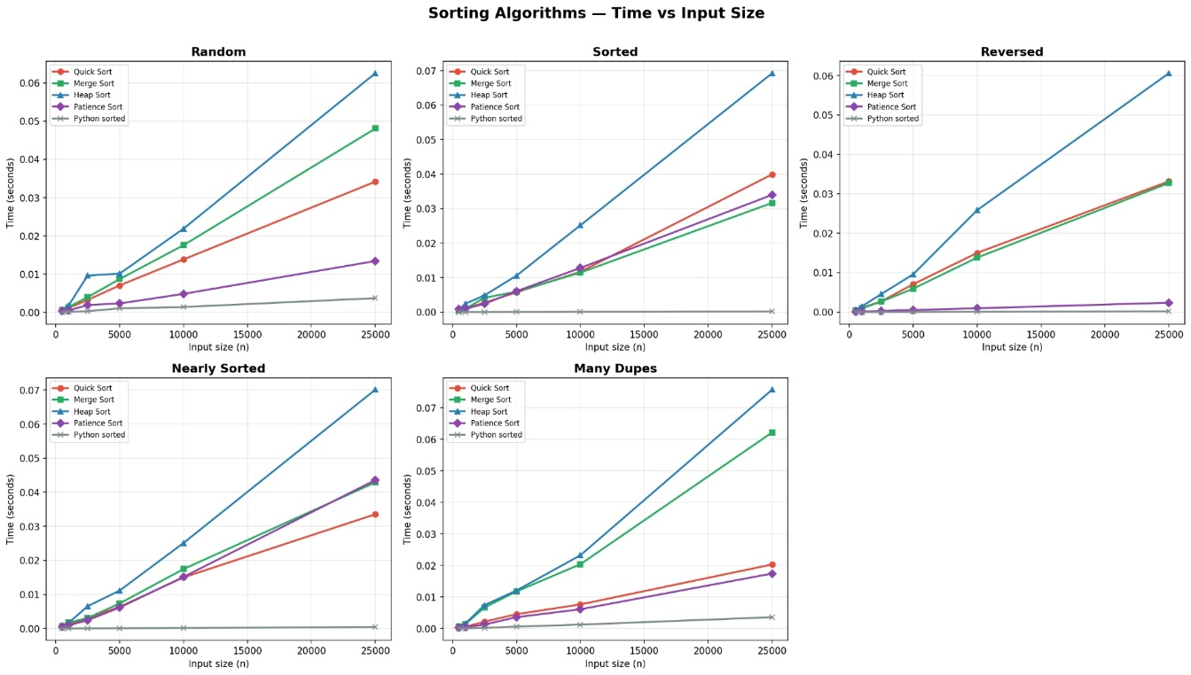
Figure 5 Time vs Input

The next graph (Figure 6) aggregates the average running time across all distributions using a log–log scale. The almost straight-line shape with slope close to 1 indicates that the empirical growth of running time is consistent with O(nlogn), while the vertical separation between lines reflects the relative speed of each algorithm.
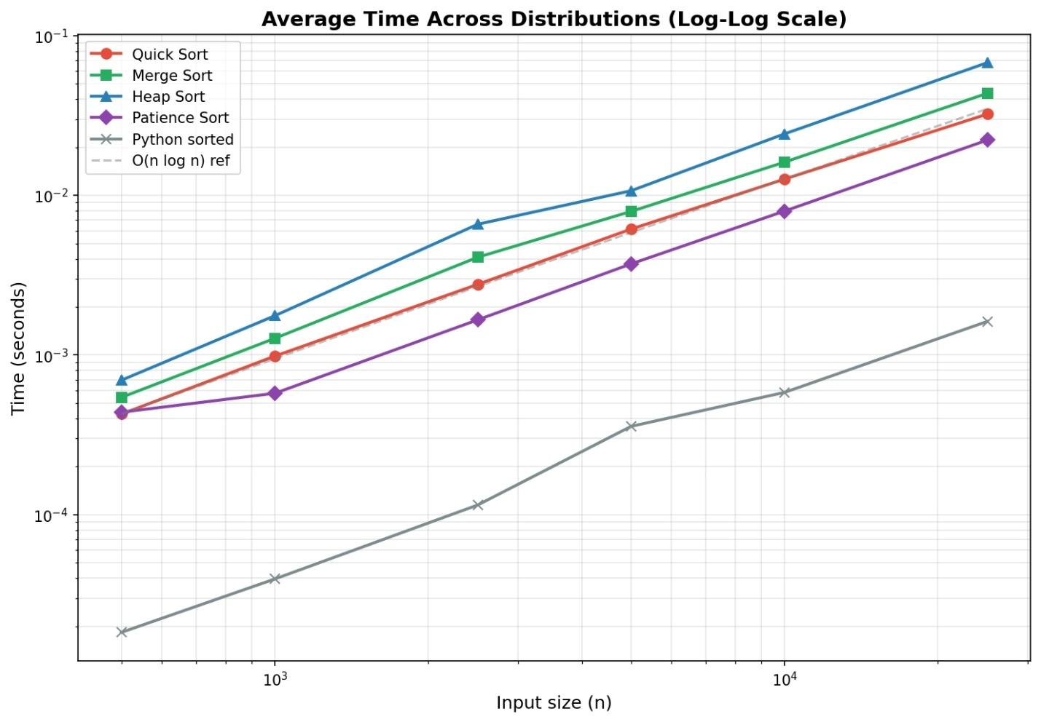
Figure 6 Time

To better highlight the advantage of the highly optimized built-in Timsort used by Python’s sorted function, a heatmap of slowdown factors was created for n=25,000 (Figure 7). Each cell shows how many times slower a given algorithm is compared to sorted for a particular input distribution, emphasizing that even “efficient” textbook algorithms are significantly outperformed by a carefully engineered library implementation.
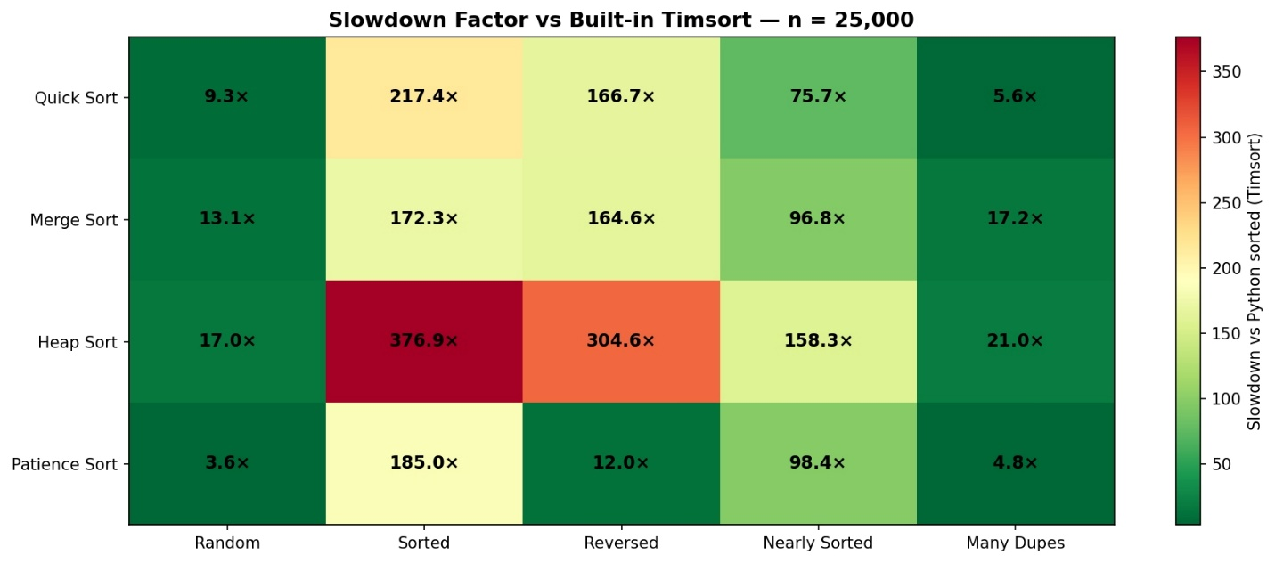
Figure 7 Heat Map
Finally, a bar chart (Figure 8) summarizes the execution times of all algorithms for n=25,000 across the five distributions. This representation makes it easy to see, at a glance, which algorithm is fastest or slowest in each scenario and confirms the overall trends observed in the line plots and heatmap.
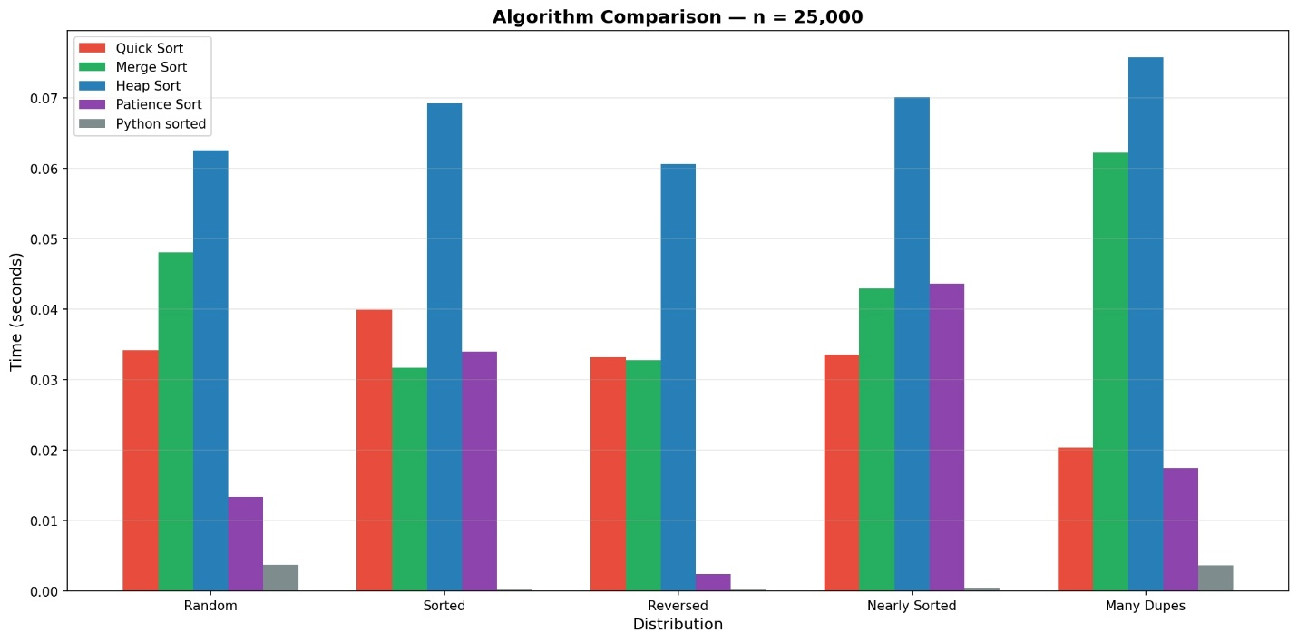
Figure 8 Alogirtm comparasion

CONCLUSION
The empirical study of merge sort, quick sort, heap sort and patience sort in Python confirms the main theoretical expectations about their efficiency and behavior on different inputs. Merge sort and heap sort showed stable O(nlogn) performance for all tested sizes, with merge sort benefiting from stability but using extra memory, and heap sort offering in-place sorting at the cost of slightly higher constant factors. Quick sort with a random pivot was usually the fastest on large random arrays, but its performance degraded on adversarial or already ordered inputs, illustrating its O(n2) worst case. Patience sort achieved O(nlogn) behavior and worked correctly for all test cases, but its larger memory usage and more complex structure made it less competitive than the other algorithms as a general-purpose sorter, while still being interesting because of its connection to longest increasing subsequences. Overall, the experiments show that no single algorithm is universally best: the choice depends on input size, distribution, and memory constraints, and combining theoretical analysis with empirical measurement is essential for selecting the most appropriate sorting method in practice.

