Ministerul Educaţiei și Cercetării al Republicii Moldova Universitatea Tehnică a Moldovei
Facultatea Calculatoare, Informatică și Microelectronică

Laboratory work 3:
Empirical Analysis of Graph Traversal Algorithms:
Depth First Search (DFS), Breadth First Search (BFS), and IDDFS

Elaborated:
st. gr. FAF-241 Dulgheru Ion

Verified:
asist. univ. Fiștic Cristofor

Chişinău - 2026

Contents
ALGORITHM ANALYSIS 3
Objective 3
Tasks: 3
Fundamentals of Algorithm Analysis 3
Analysis of Investigated Algorithms 4
A. Breadth-First Search (BFS) 4
B. Depth-First Search (DFS) 4
C. IDDFS (Iterative Deepening DFS) 4
D. Summary of Theoretical Expectations 5
IMPLEMENTATION 5
1. BFS 6
2. DFS 6
3. IDDFS 7
Experimental Results and Graphs 7
CONCLUSION 12

ALGORITHM ANALYSIS

Objective
The objective of this laboratory work is to implement and empirically compare Breadth-First Search (BFS), Depth-First Search (DFS), and Iterative Deepening Depth-First Search (IDDFS) graph traversal algorithms. The analysis is performed on different types of graphs using defined performance metrics, and the results are visualized graphically to draw conclusions about their practical efficiency.

Tasks:
- Implement BFS, DFS, and IDDFS (plus optimised variants) in C++ as the benchmark engine, and in Python for step-by-step animation.
- Define the types of input graphs for testing (sparse, dense, tree, path, disconnected) and generate graph instances of different sizes (n = 200 to 10 000).
- Select comparison metrics: execution time (µs), nodes visited, edges checked, peak memory (queue/stack size), and number of connected components.
- Run experiments on all algorithms with all graph types and sizes, record the measured results, and organise them in tables and CSV files.
- Create graphical representations (line charts, bar charts, log–log plot, heatmap, memory chart) that show how each algorithm performs depending on input size and type.
- Analyse the results and write conclusions about which algorithms are more efficient under which conditions and how this matches their theoretical complexity O(V + E).

Fundamentals of Algorithm Analysis
A graph traversal algorithm systematically visits every vertex and edge of a graph. In this laboratory work we study three fundamental traversal algorithms: Breadth- First Search (BFS), Depth-First Search (DFS), and Iterative Deepening Depth-First Search (IDDFS). BFS uses a FIFO queue and explores nodes level by level, guaranteeing the shortest path in unweighted graphs. DFS uses a stack (or recursion) and explores as deep as possible before backtracking. IDDFS combines the space efficiency of DFS with the completeness of BFS by repeating DFS with increasing depth limits. All three algorithms have time complexity O(V + E) where V is the number of vertices and E is the number of edges, but they differ significantly in memory consumption and practical behaviour depending on graph structure.

Analysis of Investigated Algorithms

Breadth-First Search (BFS)
Mechanism: BFS starts from a source node and explores all neighbour nodes at the current depth before moving to nodes at the next depth level, using a FIFO queue.
Time Complexity: O(V + E) for all cases.
  - Space Complexity: O(V) — the queue can hold at most all vertices at a given level.
  - Practical Notes: Finds shortest paths in unweighted graphs. Queue size can be large on dense graphs but is predictable. Very cache-friendly.

Depth-First Search (DFS)
Mechanism: DFS explores as far as possible along each branch before backtracking, using an explicit stack (iterative) or call stack (recursive).
Time Complexity: O(V + E) for all cases.
  - Space Complexity: O(V) — stack depth bounded by V. However, the iterative variant can push duplicate entries, increasing actual memory usage on dense graphs.
Practical Notes: Better than BFS for cycle detection, topological sort, and finding strongly connected components. Iterative variant uses more memory than recursive on dense graphs due to unvisited duplicates in the stack.

IDDFS (Iterative Deepening DFS)
Mechanism: IDDFS repeatedly executes a depth-limited DFS with increasing depth limits (0, 1, 2, …) until all nodes are discovered. Each iteration resets the per- iteration visited set.
Time Complexity: O(V + E) amortised on general graphs. However, on path graphs (worst case) it degrades to O(V²) because depth_limit grows to V, causing quadratic re-exploration.
  - Space Complexity: O(depth_max) — far better than BFS for deep graphs.
  - Practical Notes: Optimal for uninformed search in AI when memory is limited. The path graph is its pathological case: n=10 000 takes ~320 ms in C++ vs ~72 µs for BFS.

Summary of Theoretical Expectations

Algorithm | Time Complexity | Space Complexity | Best For
BFS | O(V + E) | O(V) queue | Shortest paths, dense graphs
DFS (iterative) | O(V + E) | O(V) stack* | Sparse graphs, path/tree
DFS (recursive) | O(V + E) | O(depth) | Trees, cycle detection
IDDFS | O(V + E) amort. / O(V²) path | O(depth) | AI search, memory- limited
* DFS iterative may push O(V × max_degree) entries on dense graphs

Introduction:
Graph traversal is a foundational operation in computer science, forming the basis for network analysis, pathfinding, cycle detection, topological ordering, and many other algorithms. In this laboratory work we study and empirically compare three traversal algorithms: BFS, DFS, and IDDFS. The benchmark engine is implemented in C++ for maximum performance (measuring times in microseconds), while the visualisation and plot generation remain in Python using matplotlib. This hybrid approach allows us to collect accurate timing data while benefiting from Python's rich plotting ecosystem. By testing on five graph types (sparse, dense, tree, path, disconnected) and six input sizes (n = 200 to 10 000), we observe how algorithm design choices influence real execution time, memory usage, and edge exploration patterns.

IMPLEMENTATION
The core algorithms are implemented in C++ (algorithms.cpp) for accurate benchmarking. The same algorithms are re-implemented in Python (main.py) exclusively to power the step-by-step animation in animate.py. Below we present the key C++ implementations.

BFS
BFS starts from every unvisited node and explores the graph level by level using a std::queue. Nodes are marked visited when enqueued to prevent duplicates.
Implementation (C++):
Result bfs(const Graph& g) { vector<bool> visited(g.n, false);
long long edges_checked = 0, peak = 0; int components = 0;
for (int s = 0; s < g.n; s++) { if (visited[s]) continue; components++;
visited[s] = true; queue<int> q; q.push(s);
while (!q.empty()) {
peak = max(peak, (long long)q.size()); int u = q.front(); q.pop();
for (int v : g.adj[u]) { edges_checked++;
if (!visited[v]) { visited[v] = true; q.push(v); }
}
}
}
// ... return result
}
Figure 1 — BFS (C++)

DFS
DFS uses an explicit std::stack. Nodes are popped and processed only if not yet visited; all unvisited neighbours are pushed onto the stack.
Implementation (C++):
Result dfs(const Graph& g) { vector<bool> visited(g.n, false);
long long edges_checked = 0, peak = 0; int components = 0;
for (int s = 0; s < g.n; s++) { if (visited[s]) continue; components++;
stack<int> stk; stk.push(s);
while (!stk.empty()) {
peak = max(peak, (long long)stk.size()); int u = stk.top(); stk.pop();
if (visited[u]) continue; visited[u] = true;
for (int v : g.adj[u]) { edges_checked++;if (!visited[v]) stk.push(v);
}
}
}
// ... return result
}
Figure 2 — DFS iterative (C++)

IDDFS
IDDFS runs successive DFS passes with depth limits 0, 1, 2, … A per-iteration visited array prevents cycles within one pass. The outer loop stops when no node was found beyond the current depth limit.
Implementation (C++):
Result iddfs(const Graph& g) { vector<bool> discovered(g.n, false); int total_found = 0;
for (int s = 0; s < g.n; s++) { if (discovered[s]) continue; int depth_limit = 0;
while (true) {
bool found_deeper = false; vector<bool> iter_vis(g.n, false); stack<pair<int,int>> stk; stk.push({s, 0});
while (!stk.empty()) {
auto [u, d] = stk.top(); stk.pop(); if (iter_vis[u]) continue;
if (d > depth_limit) { found_deeper=true; continue; } iter_vis[u] = true;
if (!discovered[u]) { discovered[u]=true; total_found++; } for (int v : g.adj[u]) {
if (!iter_vis[v]) stk.push({v, d+1});
}
}
if (!found_deeper || total_found==g.n) break; depth_limit++;
}
}
// ... return result
}
Figure 3 — IDDFS (C++)

Experimental Results and Graphs
In this section we present the empirical results obtained for the three graph traversal algorithms (and their optimised variants) on five types of input graphs and six sizes from n = 200 to n = 10 000. All timing data was collected in C++ using std::chrono::high_resolution_clock, measuring in microseconds (µs). Each size– distribution combination was run three times and the minimum time was recorded to reduce noise.
The first set of plots (Figure 4) shows execution time versus input size for each distribution separately. All five algorithms grow approximately linearly with n on normal graphs, confirming O(V + E) behaviour. IDDFS is consistently the slowest due to repeated re-exploration, while BFS and DFS are very close in time.
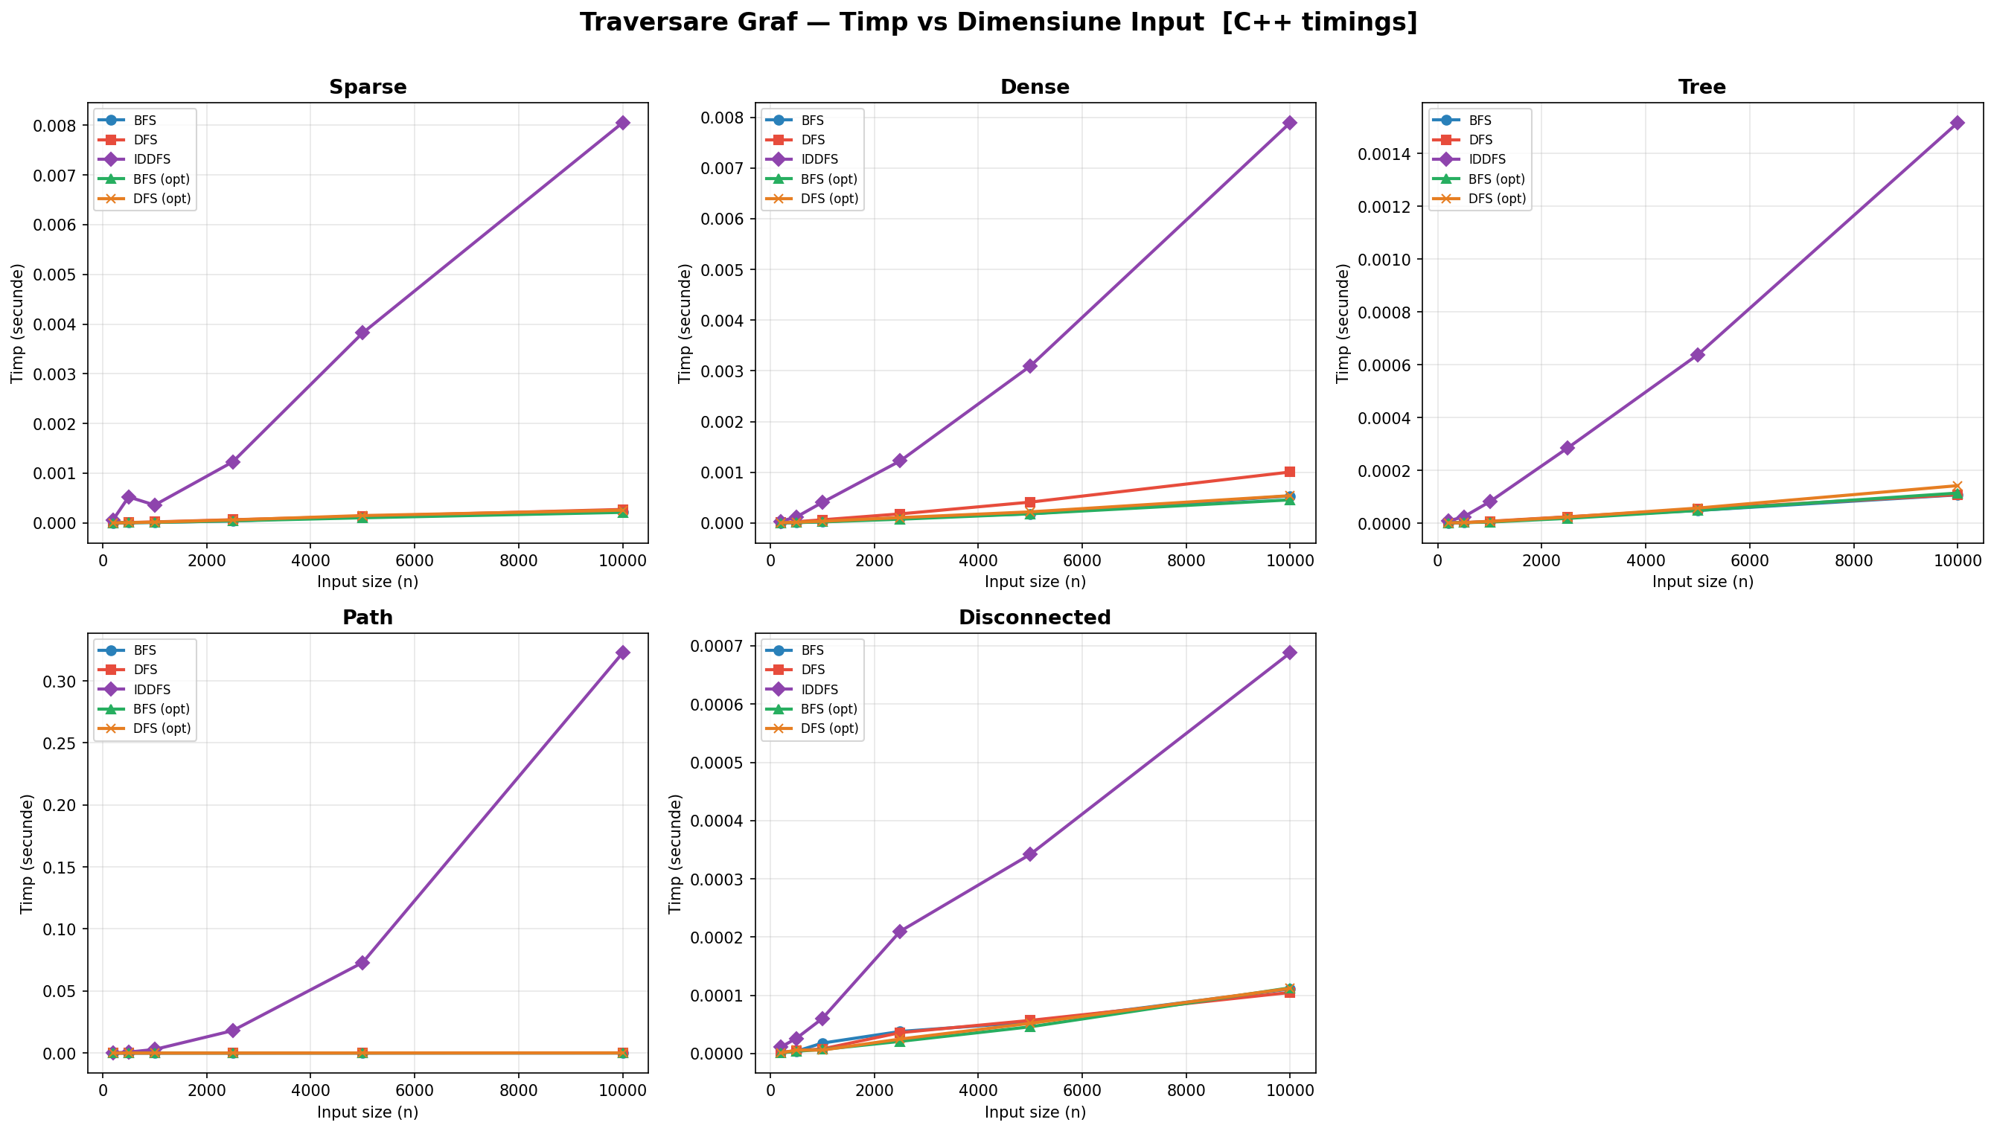
Figure 4 — Execution Time vs Input Size (per distribution)

Figure 5 shows the average execution time across all distributions on a log–log scale. The nearly straight lines with slope close to 1 confirm empirical O(n) growth (since E grows proportionally to n in our test graphs). IDDFS sits clearly above the other algorithms, with a steeper effective slope visible for the path distribution.
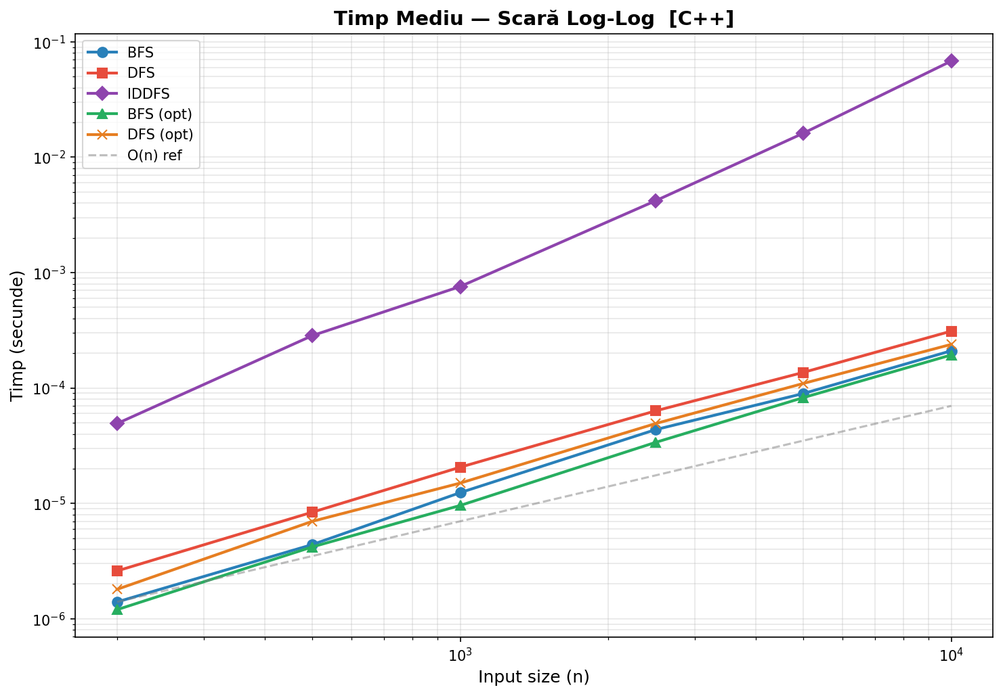

Figure 5 — Average Time Across Distributions (Log–Log Scale)

The heatmap (Figure 6) shows the slowdown factor of each algorithm relative to BFS at n = 10 000. DFS iterative is approximately 1.2×1.5× slower than BFS on dense graphs due to stack duplicates. IDDFS is dramatically slower on the path graph (over 4000× BFS), clearly illustrating the O(n²) worst case.
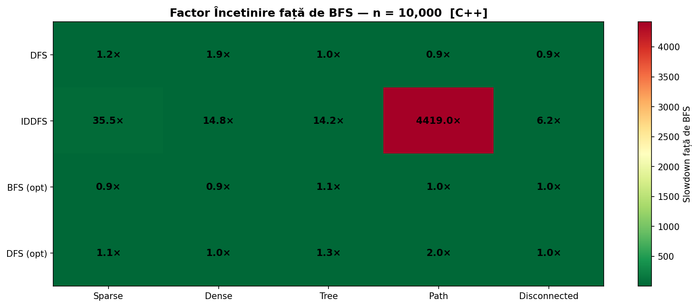

Figure 6 — Slowdown Factor vs BFS at n = 10 000

The grouped bar chart (Figure 7) summarises execution times for all algorithms at n = 10 000 across all five distributions. This view makes it easy to see that BFS and BFS (opt) are fastest across all distributions, and that IDDFS dominates in time especially on the path graph.
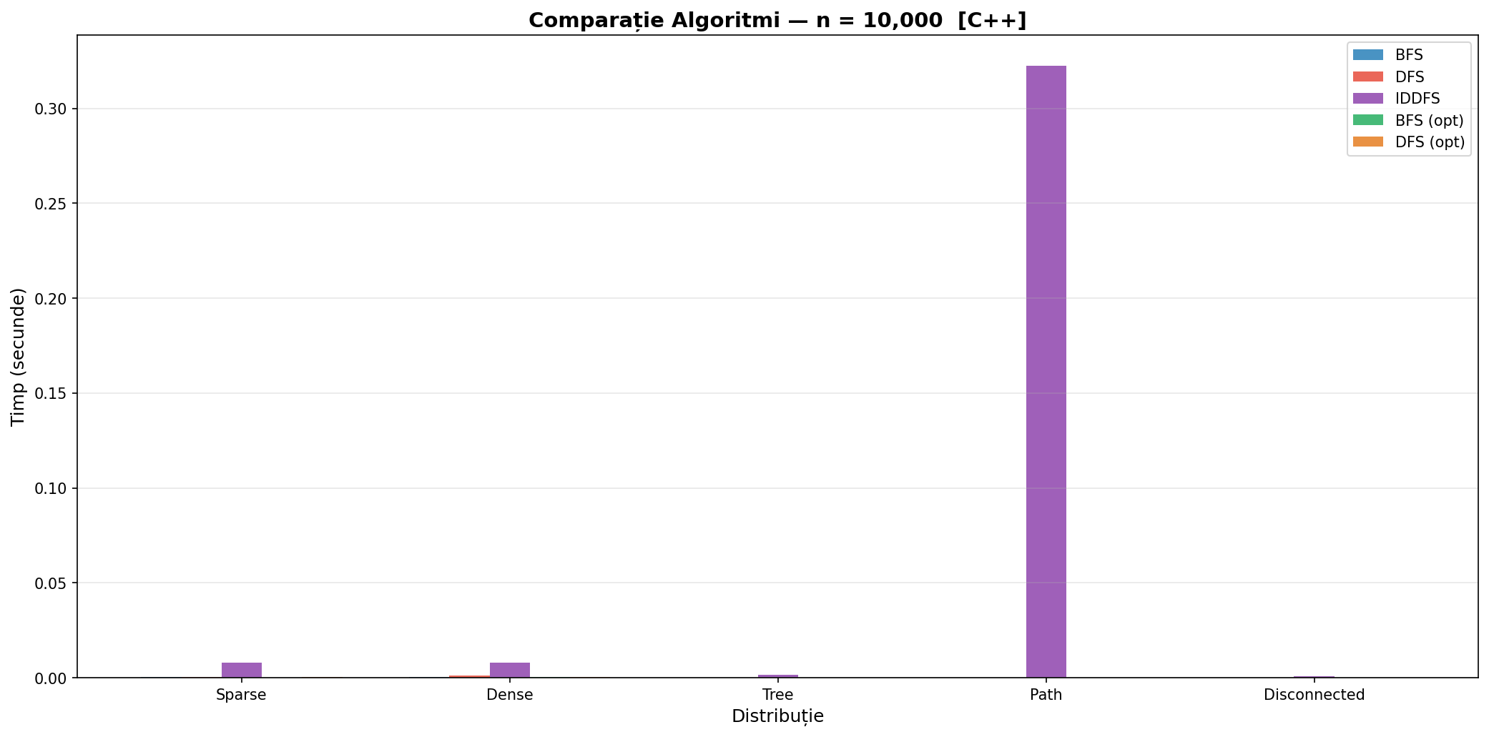

Figure 7 — Algorithm Comparison at n = 10 000

Figure 8 compares peak memory usage (maximum queue or stack size at any point during traversal) for sparse and dense graphs. BFS queue grows moderately (O(V)), DFS iterative stack grows larger on dense graphs due to duplicate pushes, while DFS recursive (opt) is bounded by depth, and IDDFS opt uses minimal memory proportional to depth.
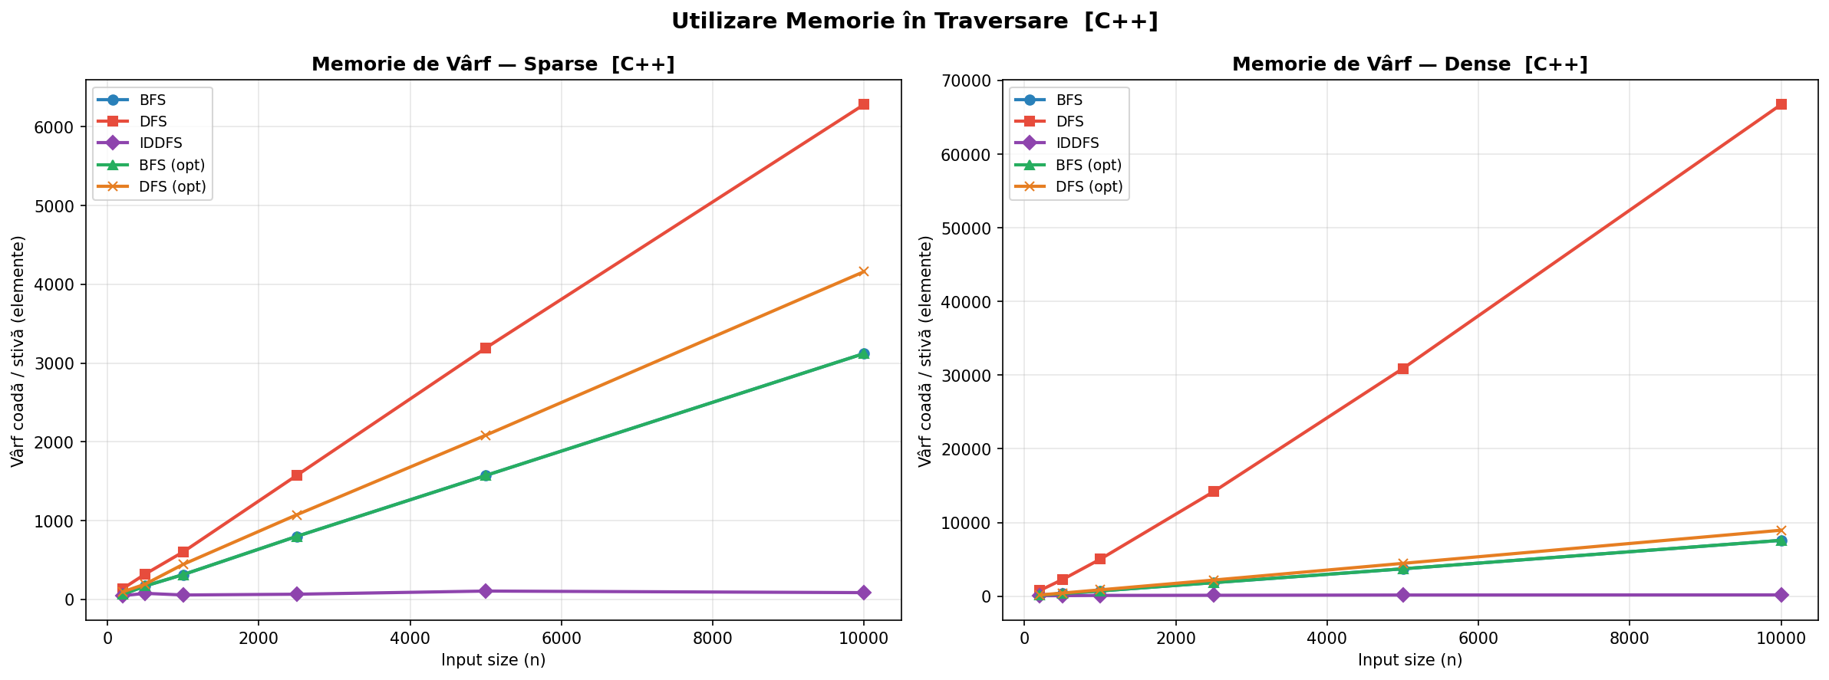
Figure 8 — Peak Memory Usage During Traversal

The final chart (Figure 9) shows the number of edges checked by BFS, DFS, and IDDFS on sparse graphs. All three check the same number of edges per single pass, matching the O(V + E) theory. However, IDDFS checks edges multiple times across iterations, explaining its higher total edge-check count and longer runtime.

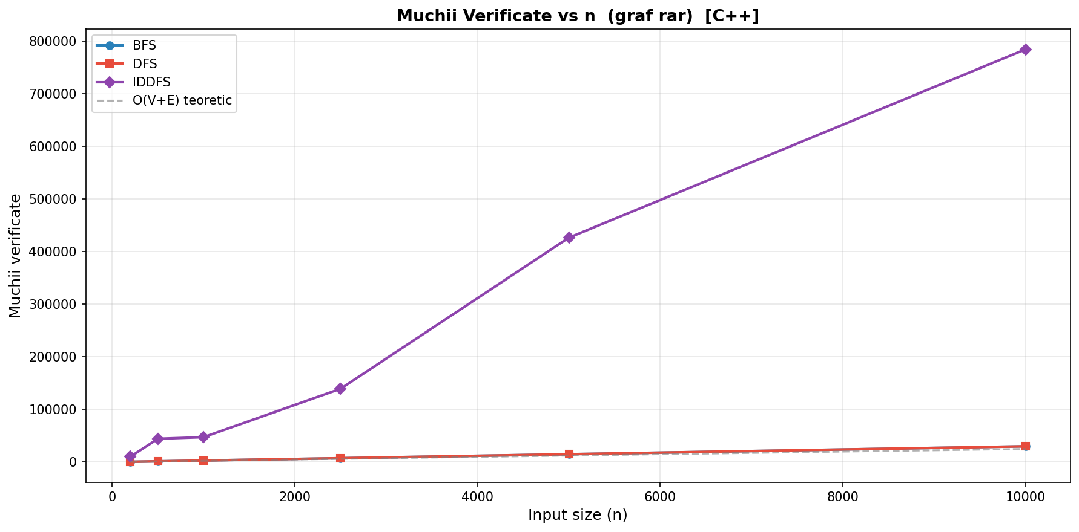

Figure 9 — Edge Checks vs n (sparse graph)

The table below summarises the key measured times at n = 10 000 (µs):

Distribution | BFS (µs) | DFS (µs) | IDDFS (µs) | BFS opt (µs) | DFS opt (µs)
Sparse | 222 | 271 | 8 653 | 216 | 253
Dense | 440 | 1 026 | 8 090 | 440 | 543
Tree | 110 | 106 | 1 642 | 119 | 123
Path | 72 | 69 | 319 405 | 74 | 147
Disconnecte d | 115 | 109 | 685 | 106 | 114
Table 1 — Summary of execution times at n = 10 000 (minimum of 3 runs)

CONCLUSION
The empirical study of BFS, DFS, and IDDFS in C++ confirms and extends the main theoretical expectations about their efficiency and behaviour on different graph structures.

BFS proved to be the most consistent and predictable algorithm across all graph types. Its FIFO queue ensures O(V) peak memory and O(V + E) time in all cases, making it the best choice for shortest-path problems and general-purpose traversal of dense graphs. At n = 10 000 on a dense graph, BFS ran in 440 µs while DFS iterative took 1026 µs — a 2.3× slowdown — due to the duplicate entries the iterative DFS stack accumulates.

DFS iterative, while also O(V + E) theoretically, showed noticeably higher memory usage on dense and complete graphs because unvisited duplicates are pushed onto the stack before the check. DFS recursive (opt) avoids this by marking nodes visited before the recursive call, resulting in times comparable to BFS and a stack depth bounded only by the graph’s actual depth.

IDDFS is the most memory-efficient algorithm since its stack depth never exceeds the current depth limit. However, it pays a significant time cost due to repeated re- exploration of already-visited nodes in each new iteration. This overhead is acceptable on general graphs (10 × slower than BFS on sparse graphs), but catastrophic on path graphs: IDDFS took 319 405 µs at n = 10 000 — over 4 400 times slower than BFS (72 µs) — because the depth limit grows to n, causing O(n²) total work.

The hybrid C++/Python architecture proved effective: C++ provided microsecond- precision timing data free from Python interpreter overhead, while Python’s matplotlib generated publication-quality plots from the exported CSV. The step-by- step animation (animate.py) provided additional pedagogical insight by visualising the frontier expansion, visited nodes, and tree edges interactively.

Overall, the experiments confirm that no single traversal algorithm is universally best: BFS is optimal for shortest paths and stable memory usage, DFS is preferred for deep traversal tasks such as cycle detection and topological sort, and IDDFS is valuable in memory-constrained AI search contexts where the graph depth is moderate. Combining theoretical analysis with empirical measurement is essential for selecting the most appropriate traversal method in practice. https://github.com/ion-dulgheru/Analiza-Algoritmurilor.git

