MINISTRY OF EDUCATION, CULTURE AND RESEARCH
OF THE REPUBLIC OF MOLDOVA
Technical University of Moldova
Faculty of Computers, Informatics and Microelectronics
Department of Software Engineering and Automation

Dulgheru Ion FAF-241

Report
Laboratory Work No. 4
Cryptography and Security
Topic: Block Ciphers – the DES Algorithm (Variant 10, Task 2.10)

Checked by:
[Teacher Name Surname], university assistant
DISA, FCIM, UTM

Chișinău – 2026

TABLE OF CONTENTS
1 AIM OF THE WORK 3
1.1 Purpose of the laboratory work 3
1.2 Problem statement 3
2 THEORETICAL BACKGROUND 4
2.1 Block ciphers 4
2.2 General structure of DES 4
2.3 Key schedule 5
2.4 The round function f 5
2.5 Calculation of Ri from the output of the S-boxes 6
2.6 Example worked by hand 6
3 IMPLEMENTATION 8
3.1 Structure of the application 8
3.2 The DES table 8
3.3 Operations on bits 8
3.4 Calculation of Ri 9
3.5 Validation of the input 10
3.6 User interface 11
4 RESULTS 13
4.1 Verification on the example from section 2.6 13
4.2 Randomly generated data 14
4.3 Validation of the input 14
5 CONCLUSION 16
REFERENCES 17

1 AIM OF THE WORK

1.1 Purpose of the laboratory work
The purpose of the laboratory work is to study block ciphers and the Data Encryption Standard (DES) algorithm – its Feistel structure, the key schedule and the round function – and to implement in a programming language one element of the algorithm, displaying on the screen the tables used and all the intermediate steps of the calculation [1].

1.2 Problem statement
The number of the task is chosen with the formula nr_sarcina = n mod 11, where n is the number of the student in the group list [1]. For n = 10 the result is 10 mod 11 = 10, so the report solves task 2.10:
In round i of the DES algorithm the following output of the substitution boxes is known: S₁(B₁)S₂(B₂)S₃(B₃)S₄(B₄)S₅(B₅)S₆(B₆)S₇(B₇)S₈(B₈). Compute R_{i}, if L_{i−1} (32 bits) is also known.
The general requirements of the laboratory work are the following:
- the tables used in the calculation must be displayed on the screen;
- all the intermediate steps of the calculation must be displayed;
- the input data can be entered by the user or generated randomly.
The program was written in C# (.NET 10) as a console application, in the same style as the applications of the previous laboratory works.

2 THEORETICAL BACKGROUND

2.1 Block ciphers
A block cipher processes the plaintext in blocks of fixed length and transforms every block into a ciphertext block of the same length, under the control of a secret key. A good block cipher realises the two principles formulated by C. Shannon: confusion, which makes the relation between the key and the ciphertext as complex as possible, and diffusion, which spreads the influence of every plaintext bit over many ciphertext bits [4]. In practice both properties are obtained by repeating a simple round several times; every round combines substitutions (for confusion) and permutations (for diffusion).
Many block ciphers, DES among them, are built as Feistel networks. The block is divided into a left half L and a right half R. In each round only one half is transformed with a round function f that depends on a round key, and the result is combined with the other half by XOR. Because XOR is its own inverse, decryption uses the same structure with the round keys in reverse order, and the function f does not need to be invertible [3], [4].

2.2 General structure of DES
DES was published in 1977 as the federal standard FIPS 46 and was revised as FIPS 46-3 in 1999 [2]. It encrypts blocks of 64 bits with a key of 64 bits, of which only 56 bits are used by the algorithm; every eighth bit is a parity bit. The encryption of one block consists of the following stages:
- the initial permutation IP of the 64 bits of the message;
- the division of the result into two halves L₀ and R₀ of 32 bits each;
- 16 rounds of the Feistel network, each with its own 48-bit round key K_{i};
- the swap of the halves, giving the block R₁₆L₁₆;
- the final permutation IP⁻¹, the inverse of the initial permutation.
In every round i (i = 1, 2, …, 16) the new halves are computed with formulas (2.1) and (2.2):
L_{i} = R_{i−1}, (2.1)
R_{i} = L_{i−1} ⊕ f(R_{i−1}, K_{i}), (2.2)
where:
- L_{i}, R_{i} – the left and the right halves of the block after round i, 32 bits each;
- L_{i−1}, R_{i−1} – the halves obtained after the previous round;
- ⊕ – the bitwise addition modulo 2 (XOR);
- f – the round function of DES;
- K_{i} – the 48-bit key of round i.

2.3 Key schedule
The 16 round keys are obtained from the 64-bit key K. The permutation PC-1 discards the 8 parity bits and rearranges the other 56 bits, which gives the key K+. K+ is divided into two halves C₀ and D₀ of 28 bits. For every round, C_{i} and D_{i} are obtained from C_{i−1} and D_{i−1} by a circular left shift of one or two positions, according to table 2.1. Finally, the permutation PC-2 selects 48 of the 56 bits of C_{i}D_{i}, giving the round key K_{i} [2], [3].
Table 2.1 – Number of left shifts in the key schedule
Round | 1 | 2 | 3 | 4 | 5 | 6 | 7 | 8 | 9 | 10 | 11 | 12 | 13 | 14 | 15 | 16
Shifts | 1 | 1 | 2 | 2 | 2 | 2 | 2 | 2 | 1 | 2 | 2 | 2 | 2 | 2 | 2 | 1

The total number of shifts is 28, so after the 16th round C₁₆ = C₀ and D₁₆ = D₀; this property allows the round keys to be generated in reverse order during decryption.

2.4 The round function f
The function f(R_{i−1}, K_{i}) is computed in four steps [2], [3]. First, the expansion permutation E extends the 32 bits of R_{i−1} to 48 bits, by repeating 16 of them. The result is added modulo 2 to the round key, as shown in formula (2.3):
B = K_{i} ⊕ E(R_{i−1}) = B₁B₂B₃B₄B₅B₆B₇B₈, (2.3)
where:
- B – the 48-bit result of the addition;
- E(R_{i−1}) – the expansion of the right half to 48 bits;
- B₁, …, B₈ – the eight groups of 6 bits into which B is divided.
Then every group B_{j} enters the substitution box S_{j}, a table of 4 rows and 16 columns. The first and the last bit of B_{j} give the row (0–3), the four middle bits give the column (0–15), and the number in that cell is written with 4 bits. The S-boxes are the only non-linear part of DES and provide its confusion. The eight outputs of 4 bits form a block of 32 bits, which is rearranged by the permutation P, as shown in formula (2.4):
f(R_{i−1}, K_{i}) = P(S₁(B₁)S₂(B₂)S₃(B₃)S₄(B₄)S₅(B₅)S₆(B₆)S₇(B₇)S₈(B₈)), (2.4)
where:
- S_{j}(B_{j}) – the 4-bit output of the S-box j for the input B_{j};
- P – the permutation of 32 bits given in table 2.2.
The permutation P is defined by table 2.2, which is read row by row: bit number k of the output is the bit of the input whose position is written in cell k of the table. For example, the first bit of the output is bit 16 of the input, the second is bit 7, and the last one is bit 25 [2].
Table 2.2 – The permutation P
16 | 7 | 20 | 21
29 | 12 | 28 | 17
1 | 15 | 23 | 26
5 | 18 | 31 | 10
2 | 8 | 24 | 14
32 | 27 | 3 | 9
19 | 13 | 30 | 6
22 | 11 | 4 | 25

Because the output of every S-box is spread by P over four different S-boxes of the next round, the permutation P provides the diffusion of DES.

2.5 Calculation of Ri from the output of the S-boxes
Task 2.10 starts from the moment when the outputs of the S-boxes are already known. Substituting formula (2.4) into formula (2.2) gives formula (2.5), which is the formula implemented in the program:
R_{i} = L_{i−1} ⊕ P(S₁(B₁)S₂(B₂) … S₈(B₈)), (2.5)
where:
- R_{i} – the right half after round i, which is the result of the task;
- L_{i−1} – the left half before round i, given in the input data;
- S₁(B₁) … S₈(B₈) – the 32-bit output of the S-boxes, given in the input data.
Neither the key K_{i} nor the half R_{i−1} are needed: their whole influence on round i is already contained in the output of the S-boxes. The calculation therefore has two steps: the permutation P of the 32 bits of the S-boxes and the XOR of the result with L_{i−1}. The other half of the block after the round, L_{i}, is simply equal to R_{i−1}, according to formula (2.1).

2.6 Example worked by hand
The example of J. O. Grabbe [3] is used, for the first round of the encryption of the message 0123456789ABCDEF with the key 133457799BBCDFF1. In round 1 the output of the S-boxes and the left half are:
S₁(B₁) … S₈(B₈) = 0101 1100 1000 0010 1011 0101 1001 0111 (hexadecimal 5C82B597),
L₀ = 1100 1100 0000 0000 1100 1100 1111 1111 (hexadecimal CC00CCFF).
In the first step the permutation P is applied. Table 2.3 shows, for every position k of the result, the position P(k) of the input bit that is copied there and the value of that bit.
Table 2.3 – Application of the permutation P to the output of the S-boxes
k | 1 | 2 | 3 | 4 | 5 | 6 | 7 | 8 | 9 | 10 | 11 | 12 | 13 | 14 | 15 | 16
P(k) | 16 | 7 | 20 | 21 | 29 | 12 | 28 | 17 | 1 | 15 | 23 | 26 | 5 | 18 | 31 | 10
Bit | 0 | 0 | 1 | 0 | 0 | 0 | 1 | 1 | 0 | 1 | 0 | 0 | 1 | 0 | 1 | 0

k | 17 | 18 | 19 | 20 | 21 | 22 | 23 | 24 | 25 | 26 | 27 | 28 | 29 | 30 | 31 | 32
P(k) | 2 | 8 | 24 | 14 | 32 | 27 | 3 | 9 | 19 | 13 | 30 | 6 | 22 | 11 | 4 | 25
Bit | 1 | 0 | 1 | 0 | 1 | 0 | 0 | 1 | 1 | 0 | 1 | 1 | 1 | 0 | 1 | 1

For example, the first bit of the result is bit 16 of the input, which is the last bit of the output of S₄, equal to 0; the second bit is bit 7, equal to 0. The result of the permutation is f = 0010 0011 0100 1010 1010 1001 1011 1011 (hexadecimal 234AA9BB).
In the second step f is added modulo 2 to L₀, bit by bit, as shown in table 2.4.
Table 2.4 – Calculation of R1 = L0 ⊕ f
 | Bits | Hex
L₀ | 1100 1100 0000 0000 1100 1100 1111 1111 | CC00CCFF
f | 0010 0011 0100 1010 1010 1001 1011 1011 | 234AA9BB
R₁ = L₀ ⊕ f | 1110 1111 0100 1010 0110 0101 0100 0100 | EF4A6544

The result R₁ = 1110 1111 0100 1010 0110 0101 0100 0100 = EF4A6544 coincides with the value given in [3]. Together with L₁ = R₀ it forms the block that enters the second round.

3 IMPLEMENTATION

3.1 Structure of the application
The application is a .NET 10 console project named Lab4DES. The bits are kept as strings of the characters ‘0’ and ‘1’, which makes every intermediate value easy to display. The files of the project are listed in table 3.1.
Table 3.1 – Files of the project
File | Responsibility
Constants/DesTables.cs | the permutation P of the DES round function
Services/BitOperations.cs | permutation by a table, XOR, random bits, conversion to hexadecimal
Services/DesRoundService.cs | the calculation of Ri with formula (2.5)
Modules/RoundResults.cs | the class RoundResult with the input data and the intermediate values
UI/InputValidator.cs | the reading and validation of the 32-bit input values
UI/ConsolePrinter.cs | the display of the table P and of the steps of the calculation
Program.cs | the choice between manual input and random generation

3.2 The DES table
The permutation P is stored exactly as in the standard [2]: 32 numbers from 1 to 32, written in 8 rows of 4, as in table 2.2.
namespace Lab4DES.Constants;

static class DesTables
{
public static readonly int[] P =
{
16, 7, 20, 21,
29, 12, 28, 17,
1, 15, 23, 26,
5, 18, 31, 10,
2, 8, 24, 14,
32, 27, 3, 9,
19, 13, 30, 6,
22, 11, 4, 25
};
}
Listing 3.1 – Constants/DesTables.cs

3.3 Operations on bits
The method Permute builds the output by taking, for every number t of the table, the bit at position t of the input. The index t − 1 is used because the DES tables number the bits from 1, while the strings of C# are indexed from 0. The method Xor checks that both operands have the same length and returns ‘0’ for equal bits and ‘1’ for different bits. RandomBits generates the random input data, and BinToHex converts every group of 4 bits into a hexadecimal digit.
using Lab4DES.Constants;
using Lab4DES.Modules;
using System.Text;
namespace Lab4DES.Services;

public static class BitOperations
{
private static readonly Random Rng=new Random();
public static string Permute(string bits, int[] table){
var sb = new StringBuilder(table.Length);
foreach (int t in table)
{
sb.Append(bits[t-1]);
}
return sb.ToString();
}
public static string Xor(string a,string b)
{
if (a.Length != b.Length)
{
throw new ArgumentException("Sirurile trebuie sa aiba aceeasi lungime.");
}
var sb = new StringBuilder(a.Length);
for (int i=0; i < a.Length; i++)
{
sb.Append(a[i]==b[i] ? '0' : '1');
}

return sb.ToString();
}
public static string RandomBits(int length)
{
var sb = new StringBuilder(length);
for (int i=0 ; i<length;i++)
{
sb.Append(Rng.Next(2));
}
return sb.ToString();
}
public static string BinToHex(string bits)
{
if (bits.Length % 4 != 0)
throw new ArgumentException("Lungimea trebuie sa fie multiplu de 4.");

var sb = new StringBuilder();
for (int i = 0; i < bits.Length; i += 4)
sb.Append(Convert.ToInt32(bits.Substring(i, 4), 2).ToString("X"));
return sb.ToString();
}

}
Listing 3.2 – Services/BitOperations.cs

3.4 Calculation of Ri
The method ComputeRi is a direct translation of formula (2.5): it applies the permutation P to the output of the S-boxes and adds the result to L_{i−1}. All the values are returned in an object of the class RoundResult, so that the interface can display every intermediate step.
using Lab4DES.Constants;
using Lab4DES.Modules;

namespace Lab4DES.Services;

public static class DesRoundService
{
public static RoundResult ComputeRi(string sOut, string lPrev)
{
string f = BitOperations.Permute(sOut, DesTables.P);
string ri = BitOperations.Xor(lPrev, f);

return new RoundResult
{
SOut = sOut,
LPrev = lPrev,
F = f,
Ri = ri
};
}
}
Listing 3.3 – Services/DesRoundService.cs
namespace Lab4DES.Modules;

public class RoundResult
{
public string SOut { get; set; } = "";
public string LPrev { get; set; } = "";

public string F { get; set; } = "";

public string Ri { get; set; } = "";
}
Listing 3.4 – Modules/RoundResults.cs

3.5 Validation of the input
The value entered by the user may contain spaces between the groups of bits, so the spaces are removed first. The value is accepted only if it contains exactly 32 characters, all of them ‘0’ or ‘1’; otherwise an error message is shown and the value is requested again.
public static class InputValidator
{
public static bool IsValidBits(string? input, int length)
{
if (input == null || input.Length != length)
return false;

foreach (char c in input)
if (c != '0' && c != '1')
return false;

return true;
}

public static string ReadBits(string prompt, int length)
{
while (true)
{
Console.Write(prompt);
string? line = Console.ReadLine();
string cleaned = (line ?? "").Replace(" ", "");

if (IsValidBits(cleaned, length))
return cleaned;

Console.WriteLine($"Eroare: trebuie exact {length} biti (doar 0 si 1). Incearca din nou.");
}
}
}
Listing 3.5 – UI/InputValidator.cs

3.6 User interface
At the start the user chooses between the manual input of the data and its random generation. The class ConsolePrinter displays the calculation in three steps: the output of the S-boxes with the labels S1–S8 above the groups of 4 bits, the table P and the result f of the permutation, and the XOR of L_{i−1} and f. At the end the result R_{i} is shown in binary and in hexadecimal.
using Lab4DES.Constants;
using Lab4DES.Modules;
using Lab4DES.Services;
Console.WriteLine("DES - Sarcina 2.10 (calcul Ri)");
Console.WriteLine("1 - introducere manuala");
Console.WriteLine("2 - generare aleatorie");
Console.Write("Alege: ");
string? choice = Console.ReadLine();

string sOut;
string lPrev;

if (choice == "1")
{
sOut = InputValidator.ReadBits("S1(B1)...S8(B8) (32 biti): ", 32);
lPrev = InputValidator.ReadBits("L(i-1) (32 biti): ", 32);
}
else
{
sOut = BitOperations.RandomBits(32);
lPrev = BitOperations.RandomBits(32);
Console.WriteLine("S-out generat: " + ConsolePrinter.Group(sOut));
Console.WriteLine("L(i-1) generat: " + ConsolePrinter.Group(lPrev));
}

RoundResult result = DesRoundService.ComputeRi(sOut, lPrev);
ConsolePrinter.PrintRoundResult(result);
Listing 3.6 – Program.cs
using Lab4DES.Constants;
using Lab4DES.Modules;
using Lab4DES.Services;
using System.Text;

public static class ConsolePrinter
{
public static string Group(string bits, int size = 4)
{
var sb = new StringBuilder();
for (int i = 0; i < bits.Length; i++)
{
if (i > 0 && i % size == 0)
sb.Append(' ');
sb.Append(bits[i]);
}
return sb.ToString();
}

public static void PrintTable(string name, int[] table, int columns)
{
Console.WriteLine($"Tabelul {name}:");
for (int i = 0; i < table.Length; i++)
{
Console.Write(table[i].ToString().PadLeft(3));
if ((i + 1) % columns == 0)
Console.WriteLine();
}
}

public static void PrintRoundResult(RoundResult r)
{
Console.WriteLine();
Console.WriteLine("=== Sarcina 2.10: calcul Ri ===");
Console.WriteLine();

// Etichete S1..S8 deasupra grupelor de 4 biti
var labels = new StringBuilder();
for (int j = 1; j <= 8; j++)
labels.Append(("S" + j).PadRight(5));
Console.WriteLine("Pas 1: iesirea S-boxurilor");
Console.WriteLine(" " + labels.ToString().TrimEnd());
Console.WriteLine("S-out = " + Group(r.SOut));
Console.WriteLine();

Console.WriteLine("Pas 2: permutarea P");
ConsolePrinter.PrintTable("P", DesTables.P, 4);
Console.WriteLine();
Console.WriteLine("f = P(S-out) = " + Group(r.F));
Console.WriteLine();

Console.WriteLine("Pas 3: Ri = L(i-1) XOR f");
Console.WriteLine("L(i-1) = " + Group(r.LPrev));
Console.WriteLine("f = " + Group(r.F));
Console.WriteLine(" " + new string('-', 39));
Console.WriteLine("Ri = " + Group(r.Ri));
Console.WriteLine();

Console.WriteLine("Rezultat:");
Console.WriteLine("Ri (binar) = " + Group(r.Ri));
Console.WriteLine("Ri (hex) = " + BitOperations.BinToHex(r.Ri));
}
}
Listing 3.7 – UI/ConsolePrinter.cs

4 RESULTS
The program was built with dotnet build without errors or warnings and was run from the terminal with dotnet run. The figures show the real sessions; the values typed by the user are displayed after the prompts.

4.1 Verification on the example from section 2.6
According to figure 4.1, the data of the example from section 2.6 were entered manually, in groups of 4 bits separated by spaces.
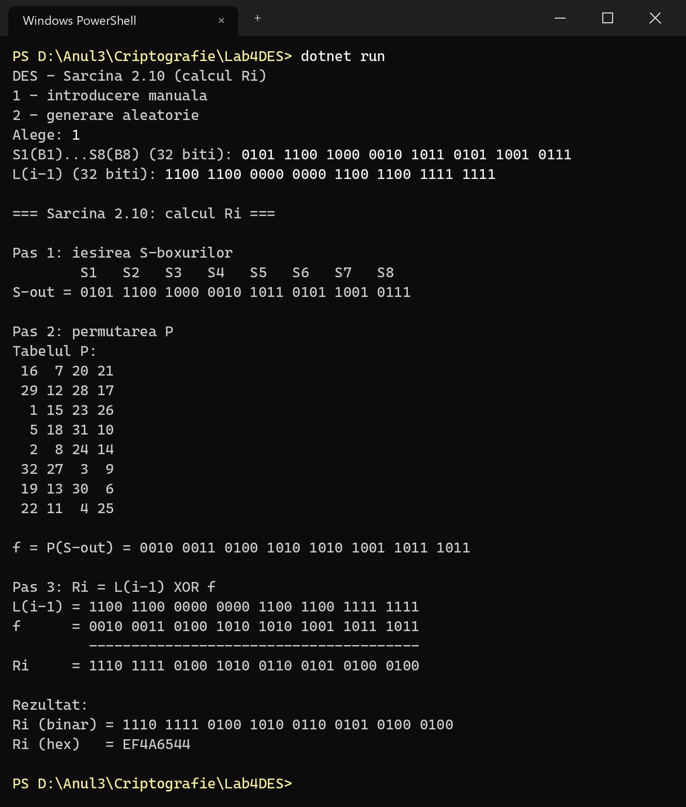
Figure 4.1 – Calculation of R1 for the example of section 2.6
The result f = 234AA9BB of the permutation and the result R_{i} = EF4A6544 coincide with the values computed by hand in tables 2.3 and 2.4 and with the values of the source [3].

4.2 Randomly generated data
Figure 4.2 shows a session in which the input data were generated randomly by the program.
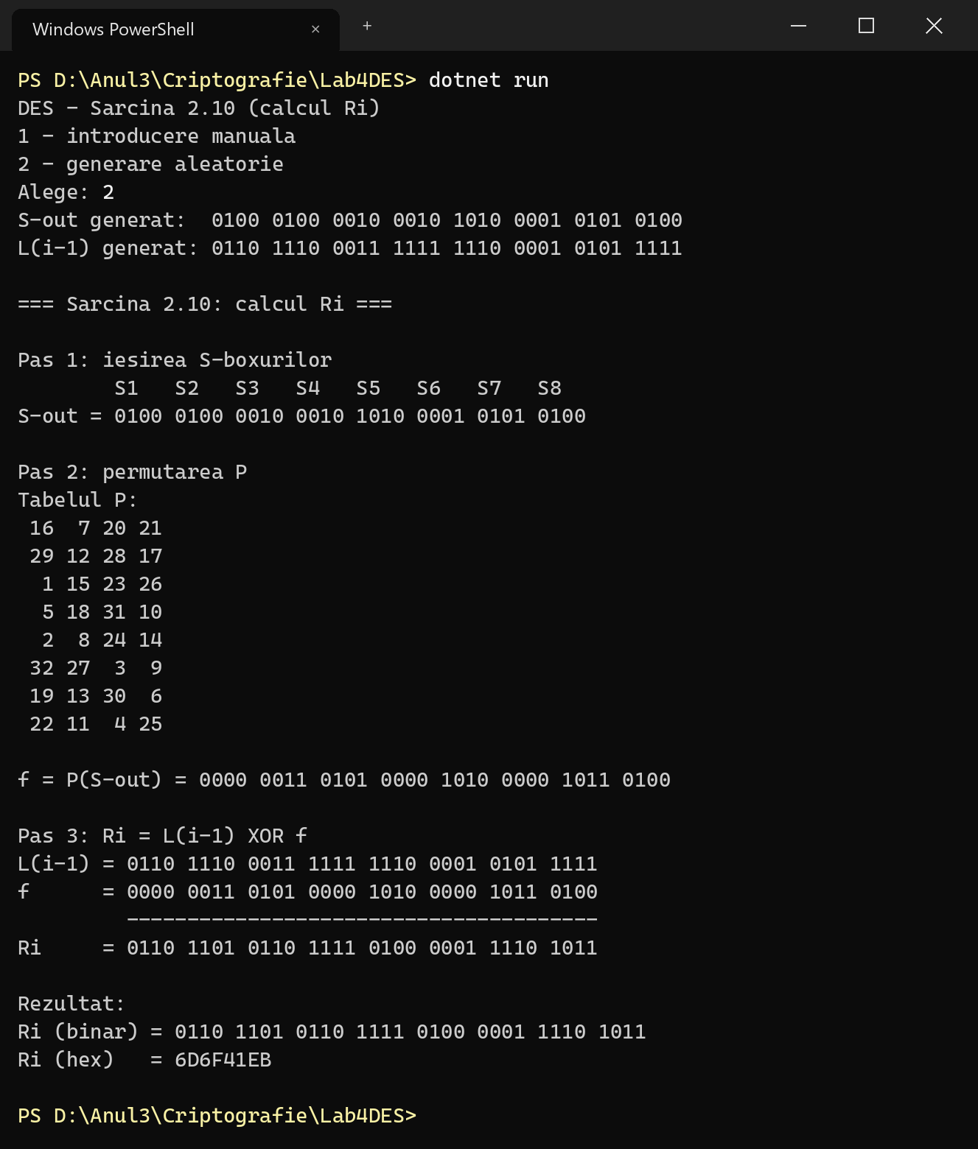
Figure 4.2 – Calculation of Ri for randomly generated data
The result was checked independently with formula (2.5): for S-out = 4422A154 and L_{i−1} = 6E3FE15F the permutation gives f = 0350A0B4, and 6E3FE15F ⊕ 0350A0B4 = 6D6F41EB, the same value as the one displayed by the program.

4.3 Validation of the input
In the session of figure 4.3 several invalid values were entered first: a value that is too short, a value of 32 characters that contains the characters ‘2’ and ‘a’, and an incomplete value of L_{i−1}.
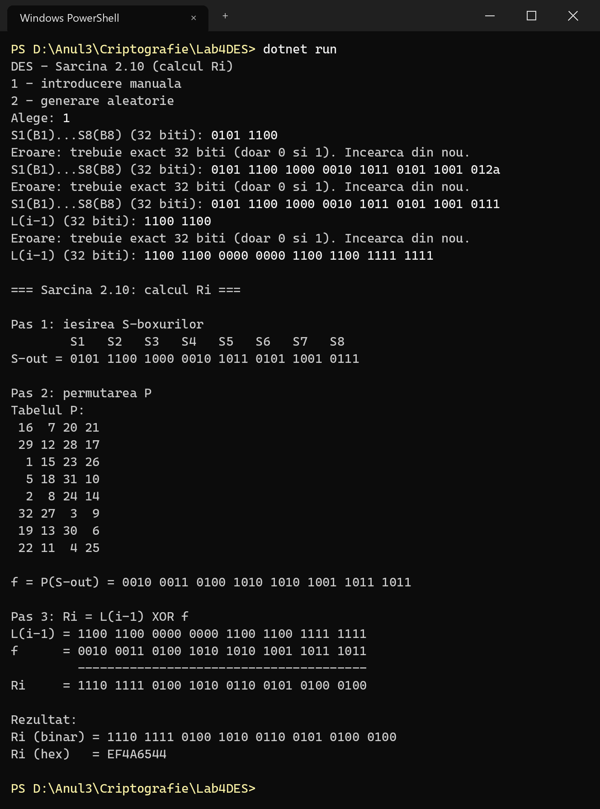
Figure 4.3 – Rejection of invalid input values
Every invalid value is rejected with the message that exactly 32 bits (only 0 and 1) are required, and the value is requested again, so the calculation is always performed with correct data.

5 CONCLUSION
The laboratory work presented the block ciphers and the DES algorithm: the Feistel structure with 16 rounds, the generation of the round keys from the key K+ by circular shifts and the permutation PC-2, and the round function f, made of the expansion E, the addition of the round key, the eight S-boxes and the permutation P.
For variant 10, task 2.10 was solved: the calculation of R_{i} from the output of the S-boxes and the left half L_{i−1}. The program applies the permutation P and the addition modulo 2 according to formula (2.5), displays the table P and every intermediate step, and accepts both manual and random input data, with validation of the entered values. The result obtained on the example of [3], R₁ = EF4A6544, coincides with the calculation by hand, and the result for random data was confirmed by an independent calculation.
The task also shows why the Feistel structure is convenient: the round function needs to be computed only in one direction, and once its output is known, a single XOR gives the new right half. At the same time DES is no longer considered secure, because its 56-bit key allows an exhaustive search of all 2⁵⁶ ≈ 7.2·10¹⁶ keys with modern hardware; for this reason it was replaced by Triple DES and later by AES [4].

REFERENCES
[1] Lucrare de laborator nr. 4. Cifruri bloc. Algoritmul DES. Cryptography and Security course, Technical University of Moldova, 2026.
[2] National Institute of Standards and Technology. FIPS PUB 46-3: Data Encryption Standard (DES). 1999.
[3] Grabbe, J. O. The DES Algorithm Illustrated. https://page.math.tu-berlin.de/~kant/teaching/hess/krypto-ws2006/des.htm
[4] Stallings, W. Cryptography and Network Security: Principles and Practice, 8th ed. Pearson, 2020.

