MINISTRY OF EDUCATION, CULTURE AND RESEARCH
OF THE REPUBLIC OF MOLDOVA
Technical University of Moldova
Faculty of Computers, Informatics and Microelectronics
Department of Software Engineering and Automation

Dulgheru Ion FAF-241

Report
Laboratory Work No. 3
Cryptography and Security
Topic: Polyalphabetic Ciphers – the Vigenère Cipher (Variant 2, Task 3.2)

Checked by:
[Teacher Name Surname], university assistant
DISA, FCIM, UTM

Chișinău – 2026

TABLE OF CONTENTS
1 AIM OF THE WORK 3
1.1 Purpose of the laboratory work 3
1.2 Problem statement 3
2 THEORETICAL BACKGROUND 3
2.1 Polyalphabetic substitution ciphers 3
2.2 The Vigenère cipher 4
2.3 Mathematical model for the Romanian alphabet 4
2.4 Example worked by hand 5
3 IMPLEMENTATION 6
3.1 Structure of the application 6
3.2 The Romanian alphabet 6
3.3 Encryption and decryption 6
3.4 Validation of the input 7
3.5 User interface 9
4 RESULTS 11
4.1 Encryption and decryption of the example from section 2.4 12
4.2 Message with Romanian diacritics 13
4.3 Validation of the input 15
4.4 Encoding of the alphabet and invalid menu option 16
5 CONCLUSION 16
REFERENCES 17

1 AIM OF THE WORK

1.1 Purpose of the laboratory work
The purpose of this laboratory work is to study polyalphabetic substitution ciphers, which were designed to remove the main weakness of monoalphabetic ciphers – the fact that the frequency distribution of the ciphertext reproduces the frequency distribution of the language. The practical goal is to implement the Vigenère cipher for messages written in the Romanian language and to verify that encryption and decryption follow exactly the mathematical model of the cipher.

1.2 Problem statement
The laboratory guide [1] proposes two tasks. Students with an odd number in the group register implement the Playfair algorithm (task 3.1), and students with an even number implement the Vigenère algorithm (task 3.2). My variant is 2, which is even, so this report solves task 3.2:
Implement the Vigenère algorithm in a programming language for messages in the Romanian language (31 letters), the letters being encoded with the numbers 0, 1, …, 30. The values of the characters of the text are between ‘A’ and ‘Z’, ‘a’ and ‘z’, and no other values are allowed. If the user enters other values, the correct range of characters must be suggested. The length of the key must not be smaller than 7. Encryption and decryption must be done according to the formulas of the mathematical model. In the message, the spaces are removed first, then all letters are converted to upper case. The user can choose the operation – encryption or decryption – enter the key and the message or the cryptogram, and obtain the cryptogram or the decrypted message.
The program was written in C# (.NET 10) as a console application, in the same style as the applications of the previous laboratory works.

2 THEORETICAL BACKGROUND

2.1 Polyalphabetic substitution ciphers
The weakness of monoalphabetic ciphers is that every occurrence of a plaintext letter is always replaced by the same ciphertext letter, so the frequency distribution of the cryptogram is only a permutation of the frequency distribution of the language. A cipher is cryptographically stronger when its distribution is as flat as possible and gives no information to the cryptanalyst [1].
One way to flatten the distribution is to combine high and low frequencies. If the letter T is sometimes encrypted as a and sometimes as b, and the letter X is also sometimes encrypted as a and sometimes as b, the high frequency of T is combined with the low frequency of X and both a and b obtain a moderate frequency. This is achieved by using several translation tables (alphabets) and choosing between them depending on the position of the character in the text. Such ciphers are called polyalphabetic: the substitution of a character varies along the text, which greatly increases the number of possible keys [1].

2.2 The Vigenère cipher
The method known as the “Vigenère cipher” was wrongly attributed to Blaise de Vigenère in the 19th century; it was first described by Giovan Battista Bellaso in his 1553 book La cifra del. Sig. [1], [2]. The cipher uses the same operation as the Caesar cipher – a shift of the letters – but instead of a single shift it uses several shifts k1, k2, …, kd, given by the letters of a key word. The first letter of the message is shifted by k1, the second by k2 and so on until the end of the key, after which the key is repeated from the beginning.
The multiple shift offers additional protection for two reasons:
- the attacker does not know the length of the key;
- the number of possible keys grows exponentially with the length of the key: for an alphabet of n letters and a key of length d there are n^d keys. For the Romanian alphabet (n = 31) and the minimal key length required in this work (d = 7) there are already 31^7 = 27 512 614 111 keys.
The encryption can be done with the Tabula Recta – a table that contains all the shifted alphabets, one per row – or, equivalently, with the formulas of the mathematical model, which is the approach used in the program.

2.3 Mathematical model for the Romanian alphabet
The Romanian alphabet has 31 letters. Each letter is encoded with its position in the alphabet, from 0 to 30, as shown in table 2.1.
Table 2.1 – Encoding of the Romanian alphabet
A | Ă | Â | B | C | D | E | F | G | H | I | Î | J | K | L | M
0 | 1 | 2 | 3 | 4 | 5 | 6 | 7 | 8 | 9 | 10 | 11 | 12 | 13 | 14 | 15

N | O | P | Q | R | S | Ș | T | Ț | U | V | W | X | Y | Z
16 | 17 | 18 | 19 | 20 | 21 | 22 | 23 | 24 | 25 | 26 | 27 | 28 | 29 | 30

Let mi be the code of the i-th letter of the message, ci the code of the i-th letter of the cryptogram and ki the code of the key letter that corresponds to position i (the key K of length d is repeated, so ki = K[(i − 1) mod d]). Then:
Encryption: ci = (mi + ki) mod 31,
Decryption: mi = (ci − ki) mod 31.
Because the difference ci − ki can be negative, in the program the decryption is computed as ((ci − ki) mod 31 + 31) mod 31, which always gives a value between 0 and 30.

2.4 Example worked by hand
Let us encrypt the message from the laboratory guide, “Per aspera ad astra”, but this time with the Romanian alphabet and the key K = SECURITATE (10 letters, which satisfies the minimal length of 7). First the spaces are removed and the letters are converted to upper case: M = PERASPERAADASTRA. Then the key is written under the message, repeated as many times as needed, and every column is computed with the encryption formula (table 2.2).
Table 2.2 – Encryption of the message PERASPERAADASTRA with the key SECURITATE
Plaintext M | P | E | R | A | S | P | E | R | A | A | D | A | S | T | R | A
Key K | S | E | C | U | R | I | T | A | T | E | S | E | C | U | R | I
M (code) | 18 | 6 | 20 | 0 | 21 | 18 | 6 | 20 | 0 | 0 | 5 | 0 | 21 | 23 | 20 | 0
K (code) | 21 | 6 | 4 | 25 | 20 | 10 | 23 | 0 | 23 | 6 | 21 | 6 | 4 | 25 | 20 | 10
(M+K) mod 31 | 8 | 12 | 24 | 25 | 10 | 28 | 29 | 20 | 23 | 6 | 26 | 6 | 25 | 17 | 9 | 10
Ciphertext C | G | J | Ț | U | I | X | Y | R | T | E | V | E | U | O | H | I

For example, for the third column: m3 = R = 20, k3 = C = 4, c3 = (20 + 4) mod 31 = 24 = Ț. For the fourth column the sum exceeds 30: m4 = A = 0, k4 = U = 25, c4 = 25 = U; and for the sixth: m6 = P = 18, k6 = I = 10, c6 = 28 = X. The resulting cryptogram is C = GJȚUIXYRTEVEUOHI.
Note that the five letters A of the message are encrypted as U, T, E, E and I, and the two letters E as J and Y – the same plaintext letter produces different ciphertext letters, which is exactly the property that flattens the frequency distribution.
The decryption is done in the same way with the reciprocal formula (table 2.3).
Table 2.3 – Decryption of the cryptogram GJȚUIXYRTEVEUOHI with the key SECURITATE
Ciphertext C | G | J | Ț | U | I | X | Y | R | T | E | V | E | U | O | H | I
Key K | S | E | C | U | R | I | T | A | T | E | S | E | C | U | R | I
C (code) | 8 | 12 | 24 | 25 | 10 | 28 | 29 | 20 | 23 | 6 | 26 | 6 | 25 | 17 | 9 | 10
K (code) | 21 | 6 | 4 | 25 | 20 | 10 | 23 | 0 | 23 | 6 | 21 | 6 | 4 | 25 | 20 | 10
(C−K) mod 31 | 18 | 6 | 20 | 0 | 21 | 18 | 6 | 20 | 0 | 0 | 5 | 0 | 21 | 23 | 20 | 0
Plaintext M | P | E | R | A | S | P | E | R | A | A | D | A | S | T | R | A

For example, c4 = U = 25, k4 = U = 25, m4 = 0 = A; c1 = G = 8, k1 = S = 21, m1 = (8 − 21) mod 31 = −13 mod 31 = 18 = P. The recovered plaintext is M = PERASPERAADASTRA.

3 IMPLEMENTATION

3.1 Structure of the application
The application is a .NET 10 console project named VigenereCipher, located in the folder Lab3Vingenere. It is split into three layers, in the same way as in the previous laboratory works:
File | Responsibility
Constants/RomanianAlphabet.cs | the 31-letter alphabet, its length and the minimal key length
Services/VigenereCipherService.cs | the encryption and decryption formulas of the cipher
UI/InputValidator.cs | normalisation and validation of the key and of the message
UI/ConsolePrinter.cs | printing of the alphabet and of the step-by-step calculation table
Program.cs | the main menu: encryption, decryption, alphabet, exit
Table 3.1 – Files of the project

3.2 The Romanian alphabet
The alphabet is stored as a string, so the code of a letter is simply its index in the string and the letter with code x is Letters[x]. The constant MinKeyLength holds the requirement that the key must have at least 7 letters.
namespace VigenereCipher.Constants;

public static class RomanianAlphabet
{
public const string Letters = "AĂÂBCDEFGHIÎJKLMNOPQRSȘTȚUVWXYZ";

public const int Length = 31;

public const int MinKeyLength = 7;

public static int IndexOf(char c) => Letters.IndexOf(c);

public static bool IsLetter(char c) => IndexOf(c) >= 0;
}

Listing 3.1 – Constants/RomanianAlphabet.cs

3.3 Encryption and decryption
The methods Encrypt and Decrypt are a direct translation of the formulas from section 2.3. For each position i, the code of the key letter is taken from position i mod d of the key, which repeats the key along the whole text without building a long key string. In Decrypt the expression ((c − k) % n + n) % n is used because the operator % of C# returns a negative result for a negative left operand. The helper ExtendKey is used only for displaying the repeated key in the calculation table.
using System.Text;
using VigenereCipher.Constants;

namespace VigenereCipher.Services;

public static class VigenereCipherService
{
public static string Encrypt(string plaintext, string key)
{
var result = new StringBuilder(plaintext.Length);
int n = RomanianAlphabet.Length;

for (int i = 0; i < plaintext.Length; i++)
{
int m = RomanianAlphabet.IndexOf(plaintext[i]);
int k = RomanianAlphabet.IndexOf(key[i % key.Length]);
result.Append(RomanianAlphabet.Letters[(m + k) % n]);
}

return result.ToString();
}

public static string Decrypt(string ciphertext, string key)
{
var result = new StringBuilder(ciphertext.Length);
int n = RomanianAlphabet.Length;

for (int i = 0; i < ciphertext.Length; i++)
{
int c = RomanianAlphabet.IndexOf(ciphertext[i]);
int k = RomanianAlphabet.IndexOf(key[i % key.Length]);
result.Append(RomanianAlphabet.Letters[((c - k) % n + n) % n]);
}

return result.ToString();
}

public static string ExtendKey(string key, int length)
{
var result = new StringBuilder(length);
for (int i = 0; i < length; i++)
{
result.Append(key[i % key.Length]);
}

return result.ToString();
}
}

Listing 3.2 – Services/VigenereCipherService.cs

3.4 Validation of the input
According to the task, the spaces are removed first and only then the letters are converted to upper case. NormalizeText also replaces the letters Ş and Ţ written with a cedilla (which are produced by some keyboards) with the correct Romanian letters Ș and Ț written with a comma, so that both variants are accepted. After the normalisation every character is checked against the alphabet. If a character is not allowed, the program names the wrong character and suggests the correct range: the letters ‘A’–‘Z’, ‘a’–‘z’ and the Romanian diacritics Ă Â Î Ș Ț. The key is additionally checked to have at least 7 letters. In all error cases the user is asked to enter the value again, so the cipher methods always receive valid data.
using VigenereCipher.Constants;

namespace VigenereCipher.UI;

public static class InputValidator
{
private const string AllowedRange =
"Sunt permise doar literele 'A'–'Z', 'a'–'z' și diacriticele românești Ă Â Î Ș Ț (ă â î ș ț).";

// Mai întâi se elimină spațiile, apoi literele se transformă în majuscule.
public static string NormalizeText(string input)
{
if (string.IsNullOrWhiteSpace(input))
{
return string.Empty;
}

string withoutSpaces = string.Concat(input.Where(c => !char.IsWhiteSpace(c)));
return withoutSpaces
.ToUpperInvariant()
.Replace('Ş', 'Ș')
.Replace('Ţ', 'Ț');
}

public static string ReadValidMessage(string prompt)
{
while (true)
{
Console.Write(prompt);
string normalized = NormalizeText(Console.ReadLine() ?? string.Empty);

if (string.IsNullOrEmpty(normalized))
{
Console.WriteLine("Eroare: Textul introdus nu poate fi gol! Încercați din nou.\n");
continue;
}

char? invalidChar = FindInvalidChar(normalized);
if (invalidChar.HasValue)
{
Console.WriteLine($"Eroare: Caracterul '{invalidChar.Value}' nu este permis! {AllowedRange}\n");
continue;
}

return normalized;
}
}

public static string ReadValidKey()
{
while (true)
{
Console.Write($"Introduceți cheia (minim {RomanianAlphabet.MinKeyLength} litere): ");
string normalized = NormalizeText(Console.ReadLine() ?? string.Empty);

char? invalidChar = FindInvalidChar(normalized);
if (invalidChar.HasValue)
{
Console.WriteLine($"Eroare: Caracterul '{invalidChar.Value}' nu este permis în cheie! {AllowedRange}\n");
continue;
}

if (normalized.Length < RomanianAlphabet.MinKeyLength)
{
Console.WriteLine($"Eroare: Cheia trebuie să aibă cel puțin {RomanianAlphabet.MinKeyLength} litere! " +
$"Ați introdus doar {normalized.Length}.\n");
continue;
}

return normalized;
}
}

private static char? FindInvalidChar(string normalized)
{
foreach (char c in normalized)
{
if (!RomanianAlphabet.IsLetter(c))
{
return c;
}
}

return null;
}
}

Listing 3.3 – UI/InputValidator.cs

3.5 User interface
The main menu allows the user to choose the operation. After the encryption or decryption the program prints the processed text and key, the calculation table (in the same format as the tables of the laboratory guide, split into blocks of 16 columns) and the result.
using System.Text;
using VigenereCipher.Services;
using VigenereCipher.UI;

Console.OutputEncoding = Encoding.UTF8;
Console.InputEncoding = Encoding.UTF8;

while (true)
{
Console.WriteLine("1. Cifrul Vigenère - Criptare");
Console.WriteLine("2. Cifrul Vigenère - Decriptare");
Console.WriteLine("3. Afișare alfabet și codificare (0-30)");
Console.WriteLine("0. Ieșire");
Console.Write("\nAlegeți o opțiune: ");

string? option = Console.ReadLine();
Console.WriteLine();

if (option == "0")
{
Console.WriteLine("La revedere!");
break;
}

switch (option)
{
case "1":
{
string key = InputValidator.ReadValidKey();
string text = InputValidator.ReadValidMessage("Introduceți mesajul clar: ");
string encrypted = VigenereCipherService.Encrypt(text, key);
Console.WriteLine($"\nMesaj prelucrat: {text}");
Console.WriteLine($"Cheia: {key}\n");
ConsolePrinter.PrintSteps(text, key, encrypted, encrypt: true);
Console.WriteLine($"Criptograma: {encrypted}\n");
break;
}
case "2":
{
string key = InputValidator.ReadValidKey();
string cipher = InputValidator.ReadValidMessage("Introduceți criptograma: ");
string decrypted = VigenereCipherService.Decrypt(cipher, key);
Console.WriteLine($"\nCriptograma prelucrată: {cipher}");
Console.WriteLine($"Cheia: {key}\n");
ConsolePrinter.PrintSteps(cipher, key, decrypted, encrypt: false);
Console.WriteLine($"Mesajul decriptat: {decrypted}\n");
break;
}
case "3":
ConsolePrinter.PrintAlphabet();
break;
default:
Console.WriteLine("Opțiune invalidă! Alegeți o cifră de la 0 la 3.\n");
break;
}
}

Listing 3.4 – Program.cs
using VigenereCipher.Constants;
using VigenereCipher.Services;

namespace VigenereCipher.UI;

public static class ConsolePrinter
{
private const int ColumnsPerBlock = 16;

public static void PrintAlphabet()
{
Console.WriteLine("Codificarea alfabetului român (31 de litere):");
for (int start = 0; start < RomanianAlphabet.Length; start += ColumnsPerBlock)
{
int end = Math.Min(start + ColumnsPerBlock, RomanianAlphabet.Length);
Console.Write(" ");
for (int i = start; i < end; i++)
{
Console.Write($"{RomanianAlphabet.Letters[i],3}");
}
Console.WriteLine();
Console.Write(" ");
for (int i = start; i < end; i++)
{
Console.Write($"{i,3}");
}
Console.WriteLine();
}
Console.WriteLine();
}

// Tabelul de calcul, ca în exemplul din îndrumar: textul de intrare, cheia, codurile lor și rezultatul.
public static void PrintSteps(string input, string key, string output, bool encrypt)
{
string extendedKey = VigenereCipherService.ExtendKey(key, input.Length);
string inputLabel = encrypt ? "Textul clar M" : "Textul cifrat C";
string outputLabel = encrypt ? "Textul cifrat C" : "Textul clar M";
string formula = encrypt ? "(M+K) mod 31" : "(C-K) mod 31";

Console.WriteLine("Tabelul de calcul:");
for (int start = 0; start < input.Length; start += ColumnsPerBlock)
{
int end = Math.Min(start + ColumnsPerBlock, input.Length);
PrintRow(inputLabel, start, end, i => input[i].ToString());
PrintRow("Cheia K", start, end, i => extendedKey[i].ToString());
PrintRow(inputLabel, start, end, i => RomanianAlphabet.IndexOf(input[i]).ToString());
PrintRow("Cheia K", start, end, i => RomanianAlphabet.IndexOf(extendedKey[i]).ToString());
PrintRow(formula, start, end, i => RomanianAlphabet.IndexOf(output[i]).ToString());
PrintRow(outputLabel, start, end, i => output[i].ToString());
Console.WriteLine();
}
}

private static void PrintRow(string label, int start, int end, Func<int, string> cell)
{
Console.Write($" {label,-16}|");
for (int i = start; i < end; i++)
{
Console.Write($"{cell(i),3}");
}
Console.WriteLine();
}
}

Listing 3.5 – UI/ConsolePrinter.cs

4 RESULTS
The program was built with dotnet build without warnings and run from the terminal with dotnet run. The screenshots below show the real sessions; the values typed by the user are shown in bright white after the prompts.

4.1 Encryption and decryption of the example from section 2.4
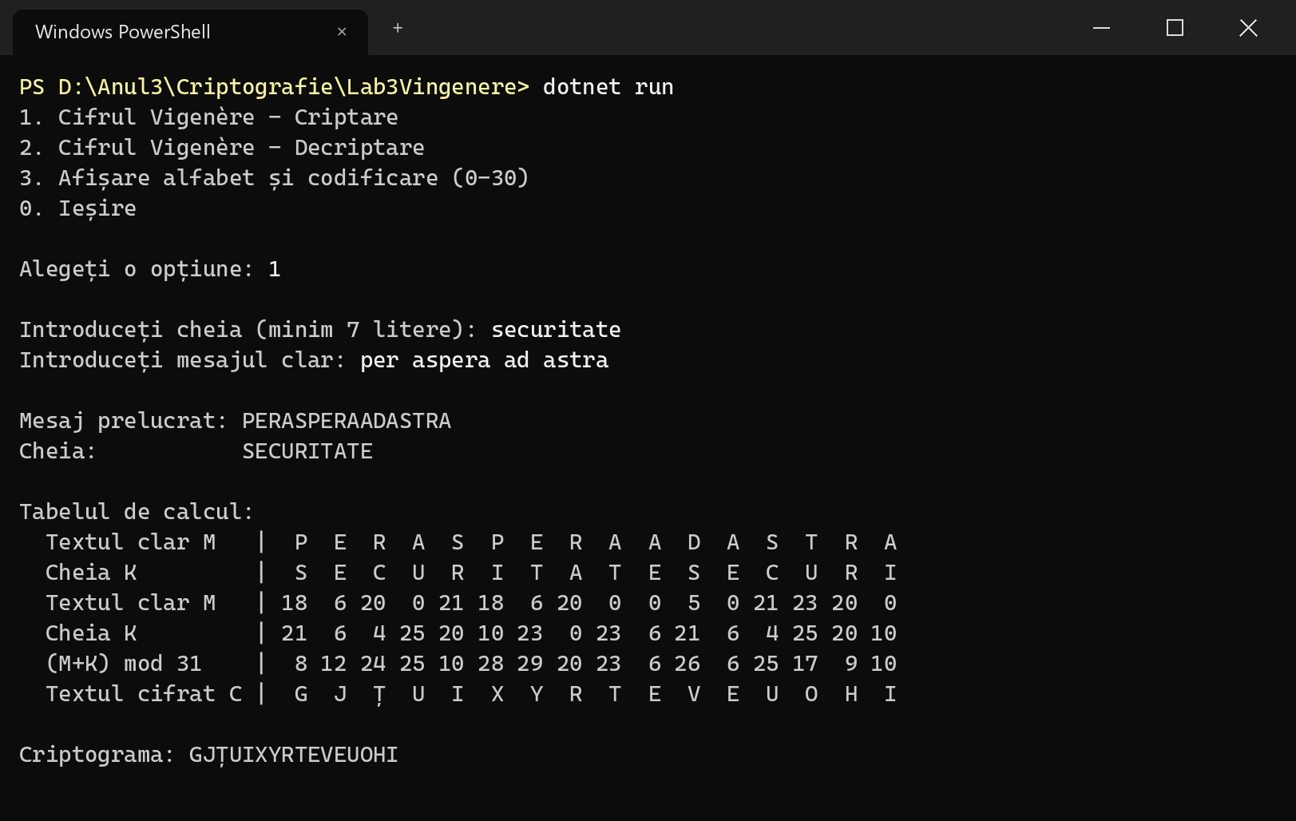
Figure 4.1 – Encryption of “per aspera ad astra” with the key “securitate”
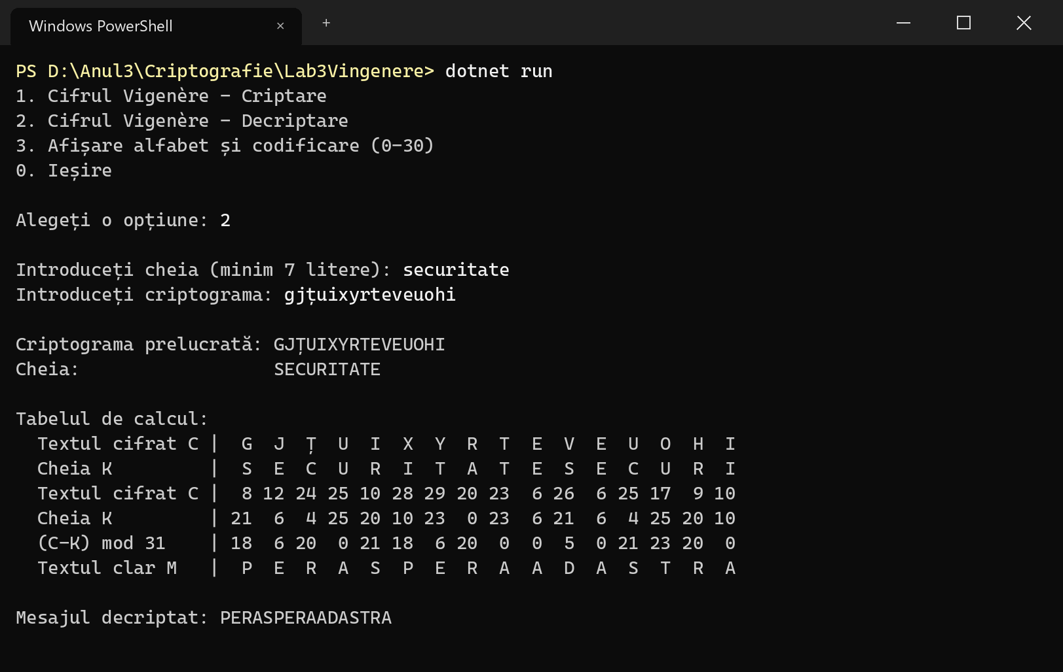
Figure 4.2 – Decryption of the cryptogram GJȚUIXYRTEVEUOHI
The results of the program coincide with the results computed by hand in tables 2.2 and 2.3. The cryptogram was entered in lower case, which shows that the conversion to upper case is applied to the cryptogram as well.

4.2 Message with Romanian diacritics
The second test uses a message with spaces and diacritics, written partly with cedilla letters (Ş, ţ), and the key “Criptografie” (12 letters). The message has 33 letters, so the key is repeated almost three times and the table is printed in three blocks.
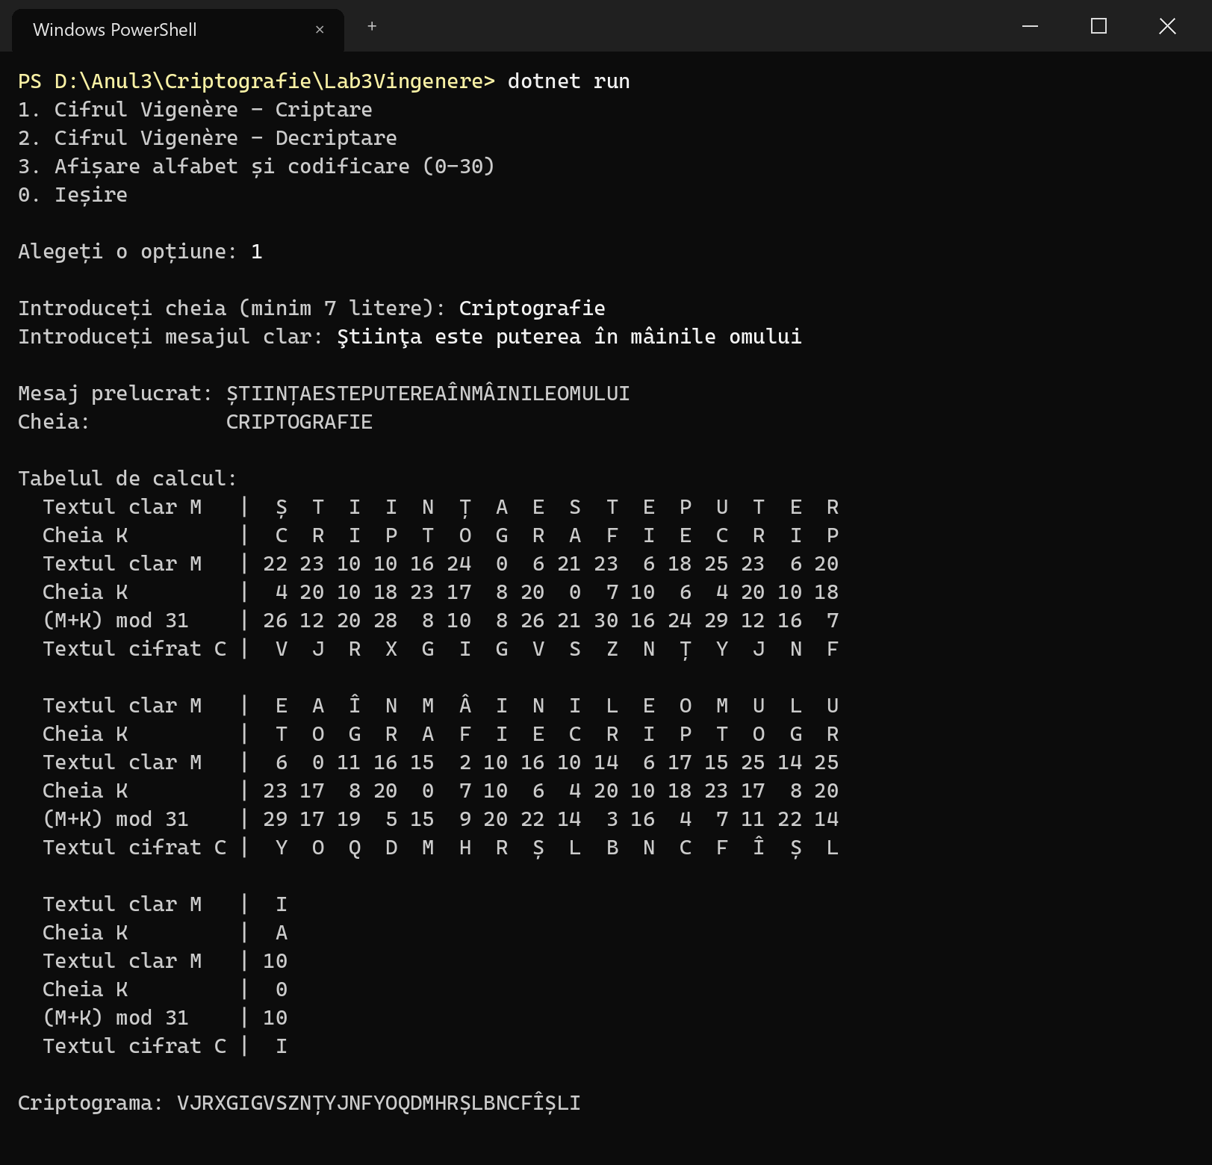
Figure 4.3 – Encryption of a message that contains diacritics
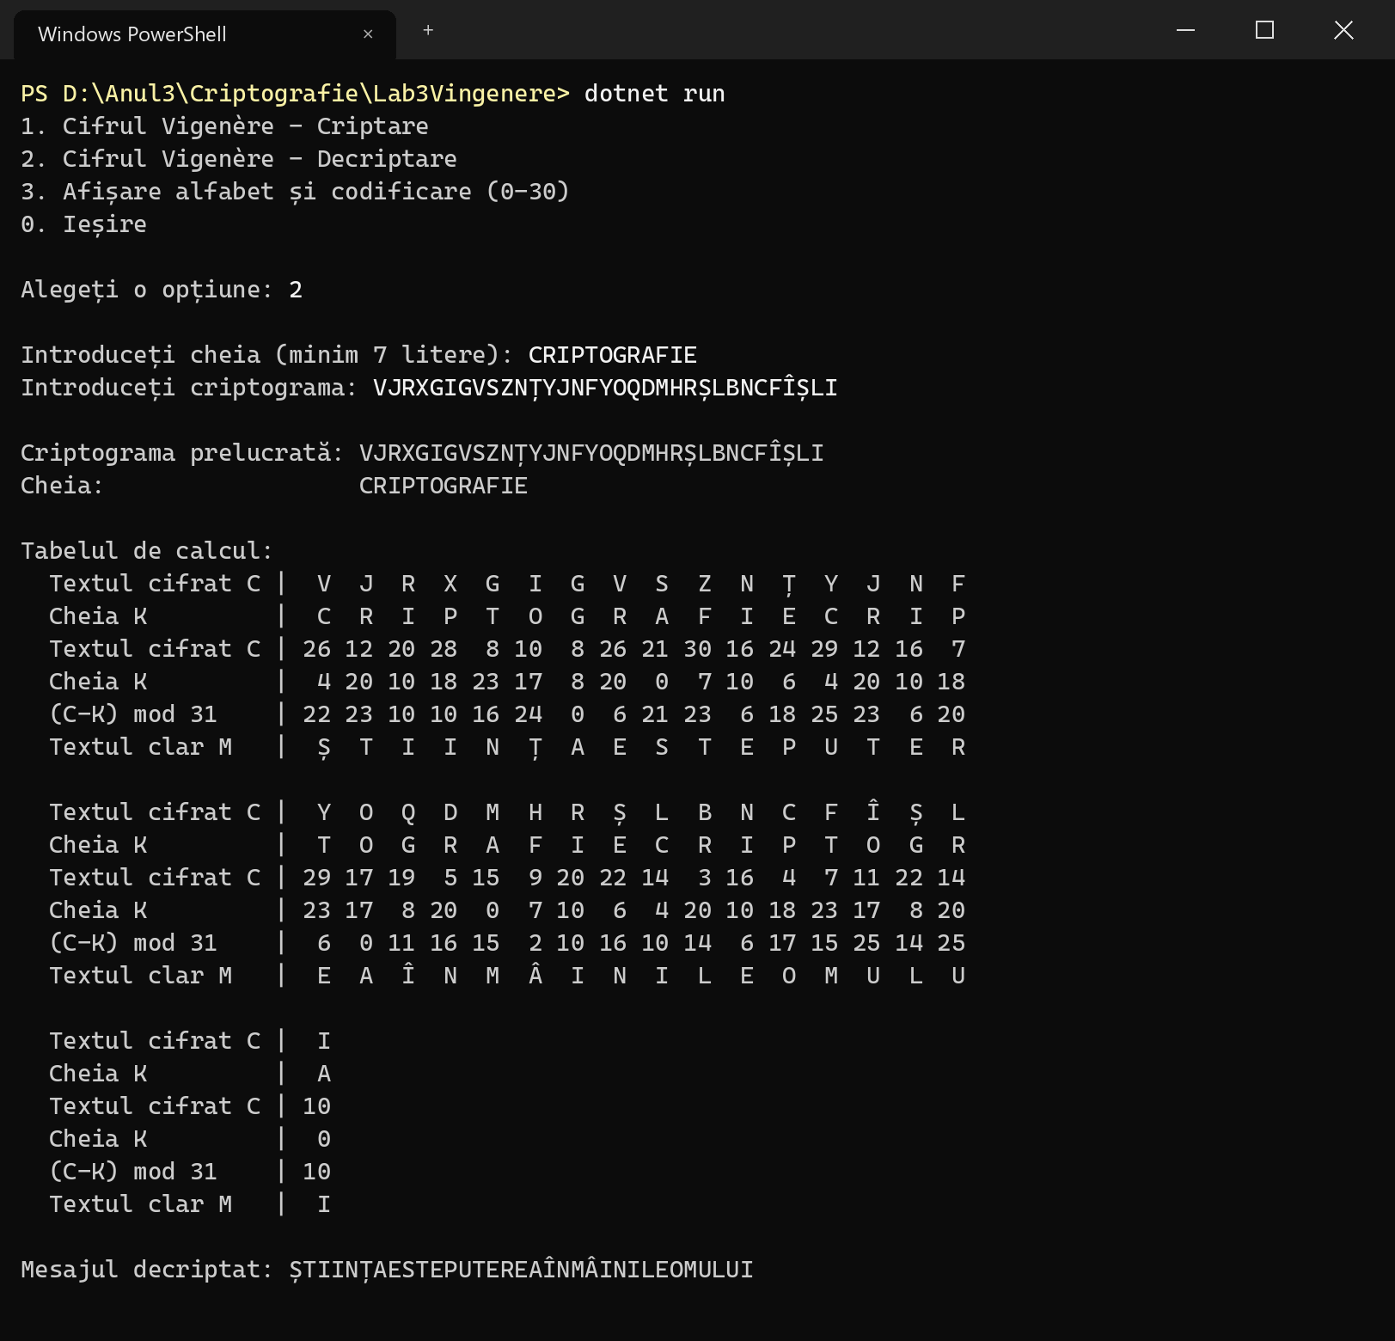
Figure 4.4 – Decryption of the cryptogram from figure 4.3
The decrypted text is identical to the processed message, so decryption is the exact inverse of encryption. After the manual insertion of spaces the message reads: “ȘTIINȚA ESTE PUTEREA ÎN MÂINILE OMULUI”. In the cryptogram the letter I of the plaintext was encrypted as R, X, L and I, and the letter E as V, N and Y – again showing how the Vigenère cipher hides the letter frequencies.

4.3 Validation of the input
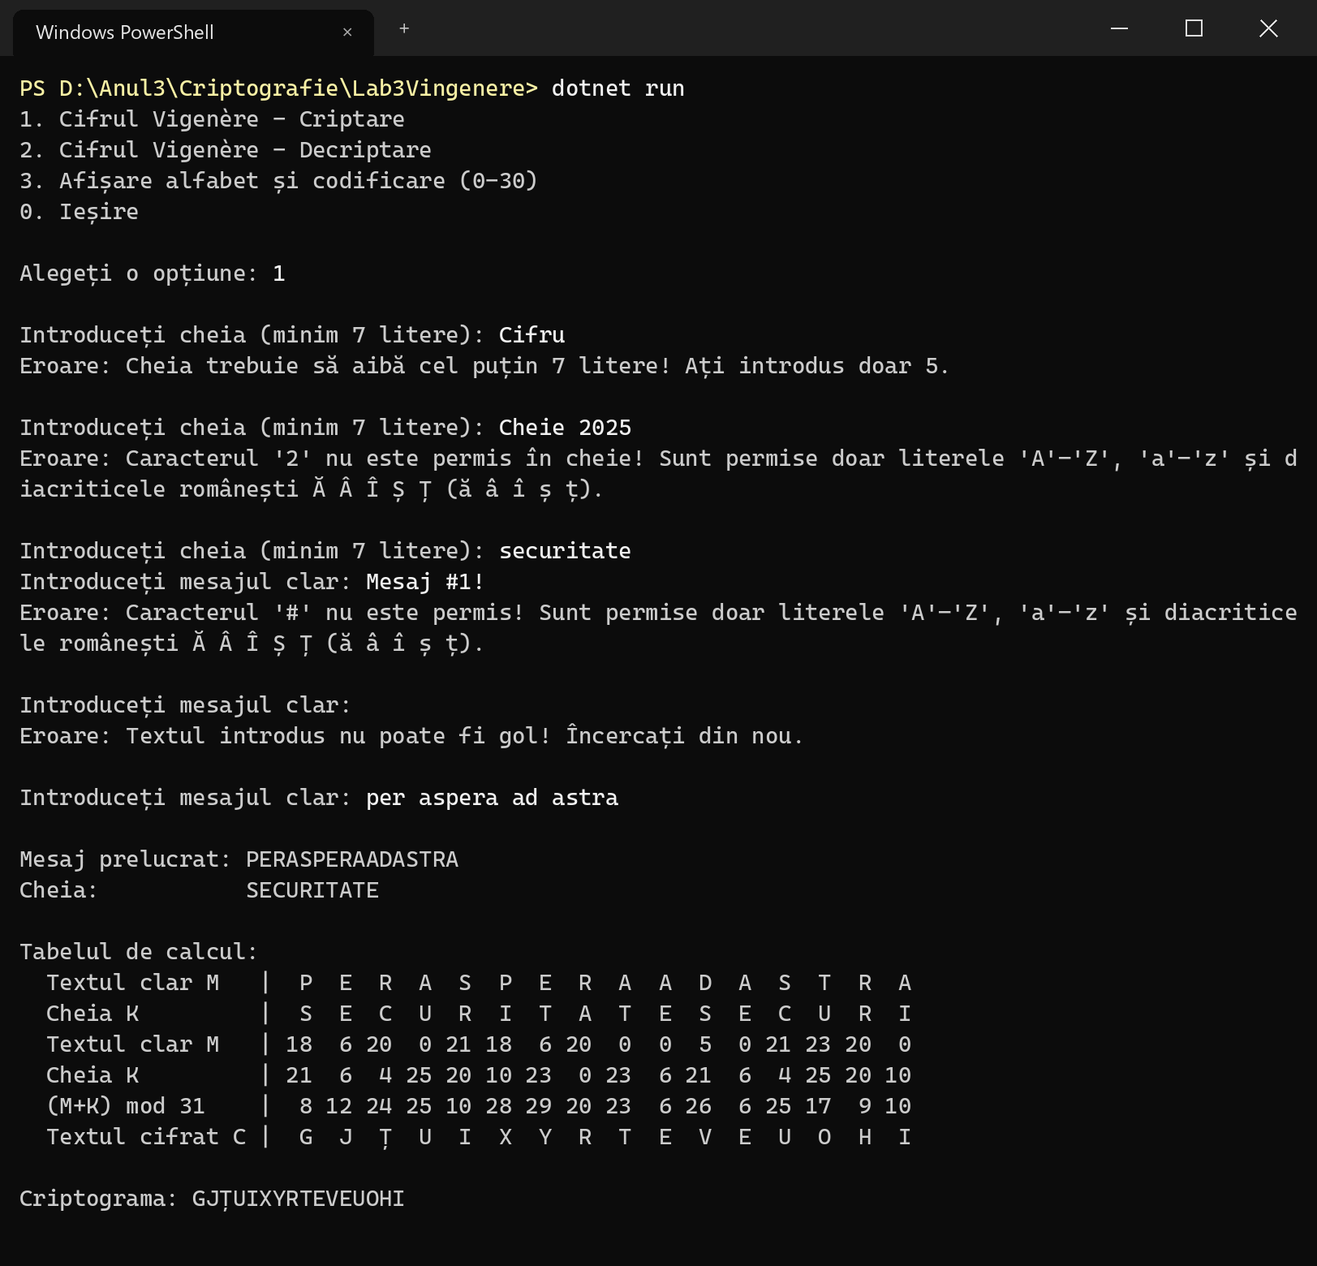
Figure 4.5 – Error messages for invalid keys and messages
A key shorter than 7 letters, a key or message that contains digits or symbols, and an empty message are all rejected; for invalid characters the program shows the allowed range, as required by the task, and asks for the value again.

4.4 Encoding of the alphabet and invalid menu option
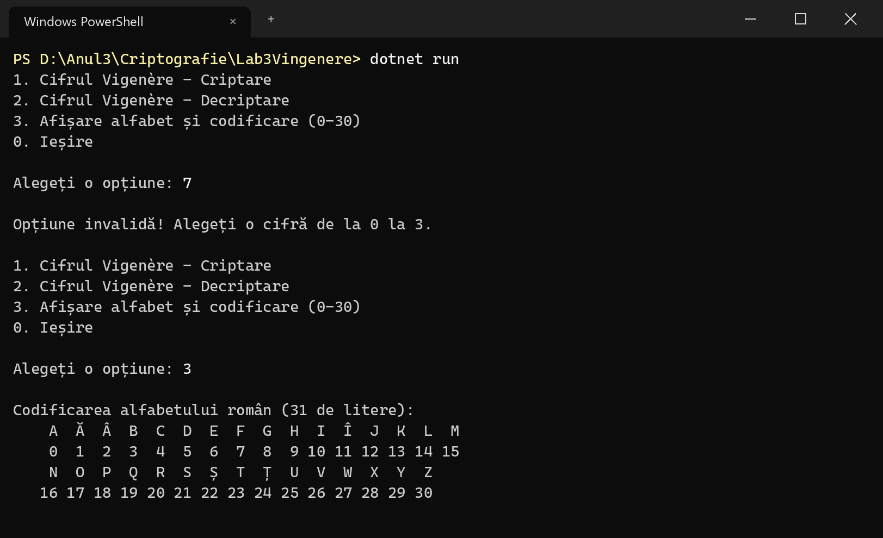
Figure 4.6 – Invalid menu option and the encoding of the Romanian alphabet

5 CONCLUSION
In this laboratory work I studied polyalphabetic substitution ciphers and implemented the Vigenère cipher for the 31-letter Romanian alphabet, with the letters encoded by the numbers 0–30. Encryption and decryption are performed strictly according to the mathematical model ci = (mi + ki) mod 31 and mi = (ci − ki) mod 31, and the program also prints the calculation table, so every result can be checked by hand, as was done for the example in section 2.4.
The program fulfils all the requirements of task 3.2: it removes the spaces and converts the text to upper case, accepts only letters of the Romanian alphabet and suggests the correct range when other characters are entered, requires a key of at least 7 letters, and lets the user choose between encryption and decryption. The tests showed that decryption always restores the original message.
The tests also illustrated the main advantage of the Vigenère cipher over the Caesar and the monoalphabetic ciphers studied in the previous works: the same plaintext letter is encrypted into different ciphertext letters depending on its position, so the simple frequency analysis used in laboratory work no. 2 cannot be applied directly. With a 7-letter key there are 31^7 ≈ 2.75·10^10 possible keys, which makes a brute-force search far more expensive than the 30 keys of the Caesar cipher. Nevertheless, the cipher is not secure by modern standards: the key is periodic, and once its length is found (for example with the Kasiski examination or the index of coincidence), the cryptogram splits into d Caesar ciphers that can each be broken by frequency analysis.

REFERENCES
[1] Lucrare de laborator nr. 3. Cifruri polialfabetice. Cryptography and Security course, Technical University of Moldova, 2026.
[2] Kahn, D. The Codebreakers: The Story of Secret Writing. New York: Scribner, 1996.
[3] Stallings, W. Cryptography and Network Security: Principles and Practice, 8th ed. Pearson, 2020.
[4] Microsoft. C# documentation – Arithmetic operators (remainder operator %). https://learn.microsoft.com/dotnet/csharp/language-reference/operators/arithmetic-operators

