Technical University of Moldova
Faculty of Computers, Informatics and Microelectronics
LABORATORY WORK No. 1
The Caesar Cipher
Discipline: Cryptography and Security

Performed by: Dulgheru Ion
Group: FAF-241
Chișinău, 2026

1. Short Theory
The Caesar cipher is a substitution cipher in which every letter of the plaintext is replaced by the letter found a fixed number of positions further along the alphabet. The number of positions, k, is the secret key and is the same for both encryption and decryption. It is named after Julius Caesar, who reportedly used it with k = 3 to communicate with his generals.
If x and y denote the numeric codes (alphabet positions, starting from 0) of a plaintext letter and of the corresponding ciphertext letter, encryption and decryption are defined as:
c = eₖ(x) = (x + k) mod n m = dₖ(y) = (y − k) mod n
where n is the length of the alphabet used. When y − k is negative, n must be added back to bring the result into the range 0 … n − 1 (some languages return a negative remainder, so this case has to be handled explicitly in code).
The key space of the classic Caesar cipher is k ∈ {1, 2, …, n − 1} (k = 0 is excluded because it leaves the text unchanged). For the English alphabet (n = 26) there are only 25 usable keys; for the Romanian alphabet used in this laboratory work (n = 31, Table 1) there are only 30 usable keys. Because the key space is so small, the cipher can be broken by simply trying every key in turn (exhaustive / brute-force search) — at most 30 attempts for the Romanian alphabet — and only the correct key will produce readable text.
Table 1. Letter encoding of the Romanian alphabet (n = 31) used in this work
Letter | A | Ă | Â | B | C | D | E | F | G | H | I | Î | J | K | L | M | N | O | P | Q | R | S | Ș | T | Ț | U | V | W | X | Y | Z
Code | 0 | 1 | 2 | 3 | 4 | 5 | 6 | 7 | 8 | 9 | 10 | 11 | 12 | 13 | 14 | 15 | 16 | 17 | 18 | 19 | 20 | 21 | 22 | 23 | 24 | 25 | 26 | 27 | 28 | 29 | 30

To increase the strength of the Caesar cipher, the natural alphabet order can first be scrambled using a keyword (the second key, k2, not to be confused with the numeric shift). The permuted alphabet is built by writing the distinct letters of the keyword first, in the order they first appear, followed by the remaining letters of the alphabet in their natural order. The numeric code of a letter is then no longer its position in the natural alphabet, but its position in this permuted alphabet, and the same shift formulas are applied:
c = eₖ₁(x) = (x + k₁) mod n m = dₖ₁(y) = (y − k₁) mod n
with x and y now read as positions in the permuted alphabet instead of the natural one.
The key space of this version is the product of all possible alphabet permutations and all possible shifts: n! × (n − 1). For the Romanian alphabet (n = 31) this is 31! × 30, an astronomically larger space than the 30 keys of the plain Caesar cipher, which makes brute-force search over the whole key space infeasible. However, the cipher remains a monoalphabetic substitution: each plaintext letter is still always mapped to the same ciphertext letter, so the letter frequencies of the language are preserved in the ciphertext and the cipher can still be broken through frequency analysis, independently of the size of the key space.

2. Implementation
The application was implemented in C# (.NET console application) and organized into three parts: a constants module holding the Romanian alphabet encoding, a services layer implementing the two cipher variants, and a UI/validation layer that reads and checks user input. The program itself (Program.cs) only drives a text menu and calls into these layers.
The Romanian alphabet and its length are defined once, as a single string in which the position of a letter is its numeric code (A = 0, Ă = 1, Â = 2, …, Z = 30), exactly as required by Table 2 of the assignment. No built-in character codes (ASCII/Unicode) are used anywhere to compute the shift — the code of a letter is always obtained with IndexOf on this string, and the encoded letter is obtained by indexing back into it.
namespace CaesarCipher.Constants;

public static class RomanianAlphabet{
public const string Letters = "AĂÂBCDEFGHIÎJKLMNOPQRSȘTȚUVWXYZ";

public const int Length = 31;
}

Encrypt() and Decrypt() implement the formulas from section 1.1 directly: each character is converted to its index in RomanianAlphabet.Letters, shifted by the key modulo n = 31, and converted back to a letter. In Decrypt(), the expression ((y - key) % n + n) % n is used instead of a plain (y - key) % n, because C#'s % operator can return a negative remainder when y - key is negative; adding n before taking the modulo again guarantees a result in the valid range 0 … 30, exactly as the assignment's note about negative remainders requires.
using System.Text;
using CaesarCipher.Constants;

namespace CaesarCipher.Services;

public static class CaesarCipherService{
public static string Encrypt(string plaintext, int key)
{
var result = new StringBuilder(plaintext.Length);
int n = RomanianAlphabet.Length;

foreach (char c in plaintext)
{
int x = RomanianAlphabet.Letters.IndexOf(c);
int newIndex = (x + key) % n;
result.Append(RomanianAlphabet.Letters[newIndex]);
}

return result.ToString();
}

public static string Decrypt(string ciphertext, int key)
{
var result = new StringBuilder(ciphertext.Length);
int n = RomanianAlphabet.Length;

foreach (char c in ciphertext)
{
int y = RomanianAlphabet.Letters.IndexOf(c);
int newIndex = ((y - key) % n + n) % n;
result.Append(RomanianAlphabet.Letters[newIndex]);
}

return result.ToString();
}
}

BuildPermutedAlphabet() implements the construction described in section 1.2: it first appends every distinct letter of the keyword, in the order it first appears (duplicate letters are skipped because of the Contains check), and then appends the remaining letters of the Romanian alphabet in their natural order. The resulting 31-letter string is printed by the program so the permutation can be checked by hand, as required by the assignment.
using System.Text;
using CaesarCipher.Constants;

namespace CaesarCipher.Services;

public static class PermutedCaesarCipherService
{
public static string BuildPermutedAlphabet(string keyword)
{
var permuted = new StringBuilder(RomanianAlphabet.Length);

foreach (char c in keyword)
{
if (!permuted.ToString().Contains(c))
{
permuted.Append(c);
}
}

foreach (char c in RomanianAlphabet.Letters)
{
if (!permuted.ToString().Contains(c))
{
permuted.Append(c);
}
}

return permuted.ToString();
}

Once the permuted alphabet is built, Encrypt() and Decrypt() apply exactly the same shift logic as the classic cipher (section 2.2), but look up letter positions in the permuted alphabet instead of in the natural one. This directly reuses the mathematics of section 1.2: the index of a letter is now its position in the permuted order, not in A…Z.
public static string Encrypt(string plaintext, int key, string permutedAlphabet)
{
var result = new StringBuilder(plaintext.Length);
int n = permutedAlphabet.Length;

foreach (char c in plaintext)
{
int x = permutedAlphabet.IndexOf(c);
int newIndex = (x + key) % n;
result.Append(permutedAlphabet[newIndex]);
}

return result.ToString();
}

public static string Decrypt(string ciphertext, int key, string permutedAlphabet)
{
var result = new StringBuilder(ciphertext.Length);
int n = permutedAlphabet.Length;

foreach (char c in ciphertext)
{
int y = permutedAlphabet.IndexOf(c);
int newIndex = ((y - key) % n + n) % n;
result.Append(permutedAlphabet[newIndex]);
}

return result.ToString();
}
}

InputValidator.cs centralizes all input checks requested by the assignment. ReadValidKey() loops until an integer between 1 and 30 is entered. NormalizeText() converts the input to uppercase, strips spaces, and folds the cedilla variants Ş/Ţ to the comma-below variants Ș/Ț, so that text typed with either keyboard layout is accepted, as suggested by the assignment's implementation tip. ReadValidMessage() rejects empty input and reports the exact invalid character together with the allowed range when a non-Romanian-alphabet letter is found. ReadValidKeyword() additionally enforces the minimum length of 7 letters required for the keyword of Task 1.2. All three methods keep re-prompting until valid input is supplied, instead of terminating the program.
using CaesarCipher.Constants;

namespace CaesarCipher.UI;
public static class InputValidator
{
public static string NormalizeText(string input)
{
if (string.IsNullOrWhiteSpace(input))
{
return string.Empty;
}
return input
.ToUpperInvariant()
.Replace(" ", "")
.Replace('Ş', 'Ș')
.Replace('Ţ', 'Ț');
}

public static int ReadValidKey()
{
while (true)
{
Console.Write("Introduceti cheie numerica (1-30): ");
string? rawInput = Console.ReadLine();
if (int.TryParse(rawInput, out int key) && key >= 1 && key <= 30)
{
return key;
}

Console.WriteLine("Eroare: Cheia trebuie să fie un număr întreg între 1 și 30.\n");
}
}

public static string ReadValidMessage(string promt)
{
while (true)
{
Console.Write(promt);
string? rewInput = Console.ReadLine();
string normalized = NormalizeText(rewInput ?? string.Empty);

if (string.IsNullOrEmpty(normalized))
{
Console.WriteLine("Eroare: Textul introdus nu poate fi gol! Încercați din nou.\n");
continue;
}

char? invalidChar = null;
foreach (char c in normalized)
{
if (!RomanianAlphabet.Letters.Contains(c))
{
invalidChar = c;
break;
}
}

if (invalidChar.HasValue)
{
Console.WriteLine($"Eroare: Caracterul '{invalidChar.Value}' nu este permis! Sunt permise doar litere din alfabetul român.\n");
continue;
}

return normalized;
}
}

public static string ReadValidKeyword()
{
while (true)
{
Console.Write("Introduceți cuvântul-cheie (minim 7 litere): ");
string? rawInput = Console.ReadLine();
string normalized = NormalizeText(rawInput ?? string.Empty);

if (normalized.Length < 7)
{
Console.WriteLine($"Eroare: Cuvântul-cheie trebuie să aibă cel puțin 7 litere! Ați introdus doar {normalized.Length}.\n");
continue;
}

char? invalidChar = null;
foreach (char c in normalized)
{
if (!RomanianAlphabet.Letters.Contains(c))
{
invalidChar = c;
break;
}
}

if (invalidChar.HasValue)
{
Console.WriteLine($"Eroare: Caracterul '{invalidChar.Value}' nu este permis! Sunt permise doar litere din alfabetul român.\n");
continue;
}

return normalized;
}
}
}

3. Results
The program was run from the command line (dotnet run) and exercised for both tasks: the classic Caesar cipher (Task 1.1) and the Caesar cipher with a keyword-based permutation (Task 1.2), in both the encryption and decryption directions, as well as for the invalid-input cases required by the assignment (invalid numeric key, invalid character in the text, keyword shorter than 7 letters).
Encryption with key k = 3, plaintext “ifrul cezar cu litere românești”:
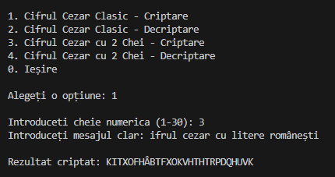
Figure 1. Classic Caesar encryption, option 1, k = 3
Encryption with key k = 7, plaintext “atac la miezul noptii”:
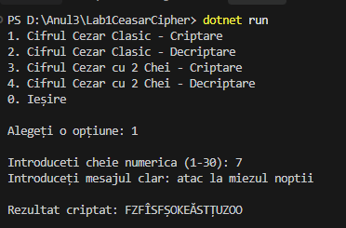
Figure 2. Classic Caesar encryption, option 1, k = 7
Decryption of the ciphertext obtained above (FZFÎSFȘOKEĂSTȚUZOO) with the same key k = 7, correctly recovering the original plaintext:
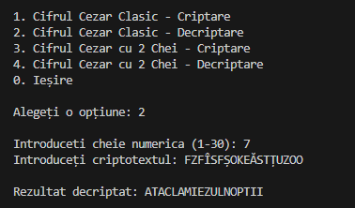
Figure 3. Classic Caesar decryption, option 2, k = 7 — round-trip with Figure 2
Encryption with numeric key k1 = 5 and keyword k2 = “CRIPTOGRAFIE”. The program first displays the resulting permuted alphabet (31 letters, built as described in section 2.3), then encrypts the plaintext “universitatea tehnica a moldovei”:
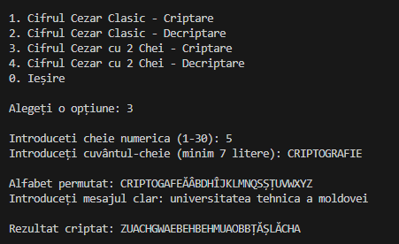
Figure 4. Permuted Caesar encryption, option 3, k1 = 5, k2 = CRIPTOGRAFIE
Decryption of the resulting ciphertext (ZUACHGWAEBEHBEHMUAOBBTAȘLĂCHA) with the same two keys, which correctly reconstructs the original message — confirming the encryption/decryption round-trip for Task 1.2:
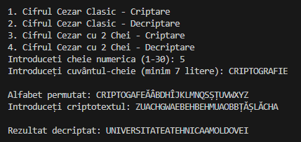
Figure 5. Permuted Caesar decryption, option 4, k1 = 5, k2 = CRIPTOGRAFIE — round-trip with Figure 4

The validation scenarios required by the assignment were exercised by running the program and feeding it invalid values.
The screenshot below shows, in sequence: a key of 0 rejected (below the allowed range), a key of 35 rejected (above the allowed range), a non-numeric key “abc” rejected, a valid key of 10 accepted, then a message containing a digit (“esaj secret 123”) rejected for the invalid character '1', and finally a message containing punctuation (“mesaj!corect”) rejected for the invalid character '!'. In every case the program states the allowed range or names the exact rejected character, and re-prompts instead of terminating.
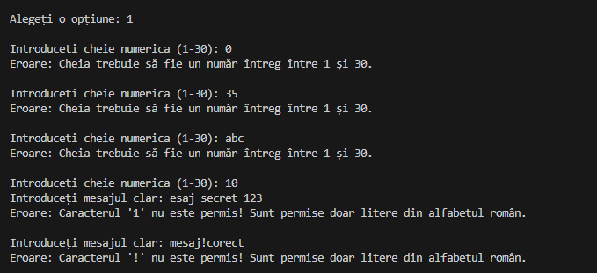
Figure 6. Invalid numeric key (below range, above range, non-numeric) and invalid characters in the message
Keyword shorter than the required 7 letters (“abc”) — captured from the compiled program's console output, since no separate screenshot was supplied for this case:
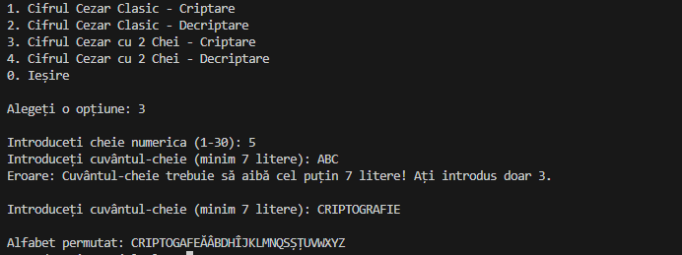Figure 7. Console output for a keyword shorter than 7 letters
In both cases the program displays a clear, specific error message (stating the allowed range, the rejected character, or the minimum length) and re-prompts for the same value, without terminating or losing previously entered data.

4. Conclusions
This laboratory work implemented and tested two variants of the Caesar cipher over the 31-letter Romanian alphabet. The results confirm the theoretical expectations from section 1.
The classic Caesar cipher (Task 1.1) is trivial to break: its key space contains only 30 possible shifts, so a cryptanalyst can recover the plaintext by brute force in at most 30 attempts, without any computational effort worth mentioning. Its only practical value today is pedagogical — it illustrates the basic idea of substitution and of modular arithmetic in cryptography, not an idea suitable for protecting real information.
Adding a keyword-based permutation of the alphabet (Task 1.2) increases the key space from 30 to 31! × 30, making an exhaustive key search completely infeasible in practice. However, the resulting cipher is still a monoalphabetic substitution cipher: every occurrence of a given plaintext letter is always mapped to the same ciphertext letter. This means the letter-frequency statistics of the Romanian language survive encryption unchanged, so the cipher remains breakable through frequency analysis regardless of how large its key space is — a good illustration of the fact that a large key space alone does not guarantee security.
On the implementation side, the main lessons were: the importance of defining an explicit letter-to-number encoding instead of relying on the language's built-in character codes, the need to correct negative remainders explicitly when implementing modular subtraction in C#, and the value of validating all user input (key range, keyword length, allowed characters) in a loop rather than letting the program crash or produce a silently wrong result.

5. Source Code
The full source code of this laboratory work is available in the following GitHub repository:
[INSERT GITHUB LINK HERE]
The project is a .NET console application (CaesarCipher.csproj) organized into Constants/ (Romanian alphabet encoding), Services/ (CaesarCipherService and PermutedCaesarCipherService), UI/ (InputValidator) and Program.cs (menu and orchestration).

