
MINISTRY OF EDUCATION, CULTURE AND RESEARCH
OF THE REPUBLIC OF MOLDOVA
Technical University of Moldova
Faculty of Computers, Informatics and Microelectronics
Department of Software Engineering and Automation
Dulgheru Ion FAF-241
Report
Laboratory Work No. 1
Cryptography and Security
Topic: The Caesar Cipher
Checked by:
[Teacher Name Surname], university assistant
DISA, FCIM, UTM
Chișinău – 2026

TABLE OF CONTENTS
1 AIM OF THE WORK 3
1.1 Purpose of the laboratory work 3
1.2 Problem statement 3
2 THEORETICAL BACKGROUND 4
2.1 The Caesar cipher 4
2.2 The Caesar cipher with a permutation 4
3 IMPLEMENTATION 6
3.1 Letter encoding 6
3.2 Classic Caesar cipher 6
3.3 Caesar cipher with a permutation 7
3.4 Input validation 8
4 RESULTS 11
4.1 Classic Caesar cipher (Task 1.1) 11
4.2 Caesar cipher with a permutation (Task 1.2) 12
4.3 Invalid input handling 13
CONCLUSION 15
REFERENCES 16

1 AIM OF THE WORK

1.1 Purpose of the laboratory work
The purpose of this laboratory work is to understand the operating principle of the Caesar cipher, to show why its small key space makes it insecure, to strengthen it with a keyword-based permutation of the alphabet and to implement both versions for the Romanian alphabet [1].

1.2 Problem statement
The laboratory work consists of two tasks, both solved for the Romanian alphabet of n = 31 letters [1]. Task 1.1 requires the implementation of the classic Caesar cipher under the following conditions:
- the letter encoding is the one given in table 2.1, without built-in character codes (ASCII or Unicode) being used to compute the shift;
- the key is an integer between 1 and 30 inclusive;
- the text contains only letters of the Romanian alphabet, in uppercase or lowercase, and the spaces are removed;
- the text is converted to uppercase before encryption;
- an invalid key or an invalid character produces a clear message stating the allowed range and the program asks for the value again;
- the user selects the operation (encryption or decryption), enters the key and the message, and receives the result.
Task 1.2 requires the implementation of the Caesar cipher with two keys, keeping all the conditions of Task 1.1. The first key is the numeric shift, the second key is a keyword of at least 7 letters used to build the permuted alphabet, and the program must display the permuted alphabet so that the result can be checked by hand.

2 THEORETICAL BACKGROUND

2.1 The Caesar cipher
The Caesar cipher is a substitution cipher in which every letter of the plaintext is replaced by the letter found a fixed number of positions further along the alphabet. The number of positions, k, is the secret key and is the same for both encryption and decryption. The cipher is named after Julius Caesar, who reportedly used it with k = 3 to communicate with his generals [1].
If x and y denote the numeric codes (alphabet positions, starting from 0) of a plaintext letter and of the corresponding ciphertext letter, encryption and decryption are defined by formulas (2.1) and (2.2):
c = e_{k}(x) = (x + k) mod n (2.1)
m = d_{k}(y) = (y − k) mod n (2.2)
where c – the ciphertext letter; m – the plaintext letter; e_{k}, d_{k} – the encryption and decryption functions with key k; x, y – the numeric codes of the plaintext and ciphertext letters; k – the secret key (the shift); n – the length of the alphabet used.
When y − k is negative, n must be added back to bring the result into the range 0 ... n − 1, because some programming languages return a negative remainder and this case has to be handled explicitly in code.
The key space of the classic Caesar cipher is k ∈ {1, 2, ..., n − 1}, since k = 0 leaves the text unchanged. For the English alphabet (n = 26) there are only 25 usable keys, and for the Romanian alphabet used in this laboratory work (n = 31, table 2.1) there are only 30 usable keys. Because the key space is so small, the cipher can be broken by trying every key in turn (exhaustive or brute-force search), which requires at most 30 attempts for the Romanian alphabet, and only the correct key produces readable text.
Table 2.1 – Letter encoding of the Romanian alphabet (n = 31) used in this work
Letter | A | Ă | Â | B | C | D | E | F | G | H | I | Î | J | K | L | M
Code | 0 | 1 | 2 | 3 | 4 | 5 | 6 | 7 | 8 | 9 | 10 | 11 | 12 | 13 | 14 | 15
Letter | N | O | P | Q | R | S | Ș | T | Ț | U | V | W | X | Y | Z
Code | 16 | 17 | 18 | 19 | 20 | 21 | 22 | 23 | 24 | 25 | 26 | 27 | 28 | 29 | 30

2.2 The Caesar cipher with a permutation
To increase the strength of the Caesar cipher, the natural alphabet order can first be scrambled using a keyword (the second key, k2, not to be confused with the numeric shift). The permuted alphabet is built by writing the distinct letters of the keyword first, in the order in which they first appear, followed by the remaining letters of the alphabet in their natural order. The numeric code of a letter is then its position in the permuted alphabet, and the same shift is applied, as shown by formulas (2.3) and (2.4):
c = e_{k1}(x) = (x + k₁) mod n (2.3)
m = d_{k1}(y) = (y − k₁) mod n (2.4)
where k₁ – the numeric shift (the first key); x, y – the positions of the plaintext and ciphertext letters in the permuted alphabet, not in the natural one; the other symbols have the same meaning as in formulas (2.1) and (2.2).
The key space of this version is the product of all possible alphabet permutations and all possible shifts, given by formula (2.5):
K = n! × (n − 1) (2.5)
where K – the number of key pairs (k1, k2); n – the length of the alphabet.
For the Romanian alphabet (n = 31) this is 31! × 30, an astronomically larger space than the 30 keys of the plain Caesar cipher, which makes a brute-force search over the whole key space infeasible. However, the cipher remains a monoalphabetic substitution: each plaintext letter is still always mapped to the same ciphertext letter, so the letter frequencies of the language are preserved in the ciphertext and the cipher can be broken through frequency analysis, independently of the size of the key space [1].

3 IMPLEMENTATION
The application was implemented in C# as a .NET console application and organized into three parts: a constants module holding the Romanian alphabet encoding, a services layer implementing the two cipher variants, and a UI and validation layer that reads and checks the user input. The program itself (Program.cs) only drives a text menu and calls into these layers.

3.1 Letter encoding
The Romanian alphabet and its length are defined once, as a single string in which the position of a letter is its numeric code (A = 0, Ă = 1, Â = 2, ..., Z = 30), exactly as required by the assignment [1]. No built-in character codes (ASCII or Unicode) are used anywhere to compute the shift: the code of a letter is always obtained with IndexOf on this string, and the encoded letter is obtained by indexing back into it.
namespace CaesarCipher.Constants;

public static class RomanianAlphabet
{
public const string Letters = "AĂÂBCDEFGHIÎJKLMNOPQRSȘTȚUVWXYZ";
public const int Length = 31;
}

3.2 Classic Caesar cipher
The methods Encrypt() and Decrypt() implement formulas (2.1) and (2.2) directly: each character is converted to its index in RomanianAlphabet.Letters, shifted by the key modulo n = 31 and converted back to a letter. In Decrypt(), the expression ((y - key) % n + n) % n is used instead of a plain (y - key) % n, because the % operator of C# can return a negative remainder when y - key is negative. Adding n before taking the modulo again guarantees a result in the valid range 0 ... 30, as required by the note of the assignment about negative remainders.
using System.Text;
using CaesarCipher.Constants;

namespace CaesarCipher.Services;

public static class CaesarCipherService
{
public static string Encrypt(string plaintext, int key)
{
var result = new StringBuilder(plaintext.Length);
int n = RomanianAlphabet.Length;
foreach (char c in plaintext)
{
int x = RomanianAlphabet.Letters.IndexOf(c);
int newIndex = (x + key) % n;
result.Append(RomanianAlphabet.Letters[newIndex]);
}
return result.ToString();
}

public static string Decrypt(string ciphertext, int key)
{
var result = new StringBuilder(ciphertext.Length);
int n = RomanianAlphabet.Length;
foreach (char c in ciphertext)
{
int y = RomanianAlphabet.Letters.IndexOf(c);
int newIndex = ((y - key) % n + n) % n;
result.Append(RomanianAlphabet.Letters[newIndex]);
}
return result.ToString();
}
}

3.3 Caesar cipher with a permutation
The method BuildPermutedAlphabet() implements the construction described in section 2.2. It first appends every distinct letter of the keyword, in the order of its first appearance (duplicate letters are skipped because of the Contains check), and then appends the remaining letters of the Romanian alphabet in their natural order. The resulting 31-letter string is printed by the program so that the permutation can be checked by hand, as required by the assignment [1].
using System.Text;
using CaesarCipher.Constants;

namespace CaesarCipher.Services;

public static class PermutedCaesarCipherService
{
public static string BuildPermutedAlphabet(string keyword)
{
var permuted = new StringBuilder(RomanianAlphabet.Length);
foreach (char c in keyword)
{
if (!permuted.ToString().Contains(c))
{
permuted.Append(c);
}
}
foreach (char c in RomanianAlphabet.Letters)
{
if (!permuted.ToString().Contains(c))
{
permuted.Append(c);
}
}
return permuted.ToString();
}

Once the permuted alphabet is built, the overloaded methods Encrypt() and Decrypt() apply the same shift logic as the classic cipher, given by formulas (2.3) and (2.4), but look up the letter positions in the permuted alphabet instead of the natural one.
public static string Encrypt(string plaintext, int key, string permutedAlphabet)
{
var result = new StringBuilder(plaintext.Length);
int n = permutedAlphabet.Length;
foreach (char c in plaintext)
{
int x = permutedAlphabet.IndexOf(c);
int newIndex = (x + key) % n;
result.Append(permutedAlphabet[newIndex]);
}
return result.ToString();
}

public static string Decrypt(string ciphertext, int key, string permutedAlphabet)
{
var result = new StringBuilder(ciphertext.Length);
int n = permutedAlphabet.Length;
foreach (char c in ciphertext)
{
int y = permutedAlphabet.IndexOf(c);
int newIndex = ((y - key) % n + n) % n;
result.Append(permutedAlphabet[newIndex]);
}
return result.ToString();
}
}

3.4 Input validation
The class InputValidator centralizes all the input checks requested by the assignment. The method ReadValidKey() repeats the request until an integer between 1 and 30 is entered. The method NormalizeText() converts the input to uppercase, removes the spaces and replaces the cedilla variants Ş and Ţ with the comma-below variants Ș and Ț, so that text typed with either keyboard layout is accepted. The method ReadValidMessage() rejects empty input and reports the exact invalid character together with the allowed range when a letter outside the Romanian alphabet is found. The method ReadValidKeyword() additionally enforces the minimum length of 7 letters required for the keyword of Task 1.2. All the methods keep re-prompting until valid input is supplied, instead of terminating the program.
using CaesarCipher.Constants;

namespace CaesarCipher.UI;

public static class InputValidator
{
public static string NormalizeText(string input)
{
if (string.IsNullOrWhiteSpace(input))
{
return string.Empty;
}
return input
.ToUpperInvariant()
.Replace(" ", "")
.Replace('Ş', 'Ș')
.Replace('Ţ', 'Ț');
}

public static int ReadValidKey()
{
while (true)
{
Console.Write("Introduceti cheie numerica (1-30): ");
string? rawInput = Console.ReadLine();
if (int.TryParse(rawInput, out int key) && key >= 1 && key <= 30)
{
return key;
}
Console.WriteLine("Eroare: Cheia trebuie să fie un număr întreg între 1 și 30.\n");
}
}

public static string ReadValidMessage(string promt)
{
while (true)
{
Console.Write(promt);
string? rewInput = Console.ReadLine();
string normalized = NormalizeText(rewInput ?? string.Empty);
if (string.IsNullOrEmpty(normalized))
{
Console.WriteLine("Eroare: Textul introdus nu poate fi gol! Încercați din nou.\n");
continue;
}
char? invalidChar = null;
foreach (char c in normalized)
{
if (!RomanianAlphabet.Letters.Contains(c))
{
invalidChar = c;
break;
}
}
if (invalidChar.HasValue)
{
Console.WriteLine($"Eroare: Caracterul '{invalidChar.Value}' nu este permis! Sunt permise doar litere din alfabetul român.\n");
continue;
}
return normalized;
}
}

public static string ReadValidKeyword()
{
while (true)
{
Console.Write("Introduceți cuvântul-cheie (minim 7 litere): ");
string? rawInput = Console.ReadLine();
string normalized = NormalizeText(rawInput ?? string.Empty);
if (normalized.Length < 7)
{
Console.WriteLine($"Eroare: Cuvântul-cheie trebuie să aibă cel puțin 7 litere! Ați introdus doar {normalized.Length}.\n");
continue;
}
char? invalidChar = null;
foreach (char c in normalized)
{
if (!RomanianAlphabet.Letters.Contains(c))
{
invalidChar = c;
break;
}
}
if (invalidChar.HasValue)
{
Console.WriteLine($"Eroare: Caracterul '{invalidChar.Value}' nu este permis! Sunt permise doar litere din alfabetul român.\n");
continue;
}
return normalized;
}
}
}

4 RESULTS
The program was run from the command line (dotnet run) and tested for both tasks, the classic Caesar cipher (Task 1.1) and the Caesar cipher with a keyword-based permutation (Task 1.2), in both the encryption and decryption directions, as well as for the invalid-input cases required by the assignment: an invalid numeric key, an invalid character in the text and a keyword shorter than 7 letters.

4.1 Classic Caesar cipher (Task 1.1)
Figure 4.1 shows the encryption with the key k = 3 of the plaintext "ifrul cezar cu litere românești".
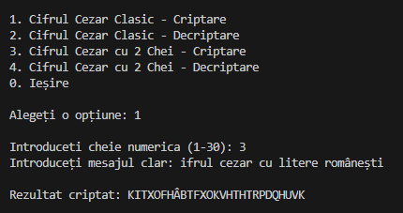
Figure 4.1 Classic Caesar encryption, option 1, k = 3
Figure 4.2 shows the encryption with the key k = 7 of the plaintext "atac la miezul noptii".
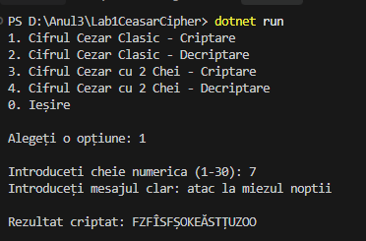
Figure 4.2 Classic Caesar encryption, option 1, k = 7
Figure 4.3 shows the decryption of the ciphertext obtained above (FZFÎSFȘOKEĂSTȚUZOO) with the same key k = 7, which correctly recovers the original plaintext.
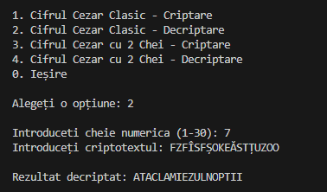
Figure 4.3 Classic Caesar decryption, option 2, k = 7 (round-trip with figure 4.2)

4.2 Caesar cipher with a permutation (Task 1.2)
Figure 4.4 shows the encryption with the numeric key k1 = 5 and the keyword k2 = "CRIPTOGRAFIE". The program first displays the resulting permuted alphabet (31 letters, built as described in section 3.3) and then encrypts the plaintext "universitatea tehnica a moldovei".
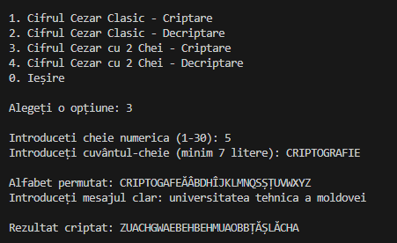
Figure 4.4 Permuted Caesar encryption, option 3, k1 = 5, k2 = CRIPTOGRAFIE
Figure 4.5 shows the decryption of the resulting ciphertext (ZUACHGWAEBEHBEHMUAOBBȚĂȘLĂCHA) with the same two keys, which correctly reconstructs the original message and confirms the encryption and decryption round-trip for Task 1.2.
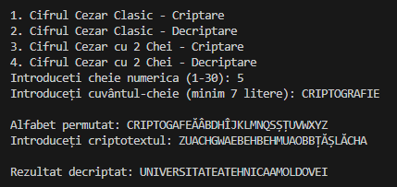
Figure 4.5 Permuted Caesar decryption, option 4, k1 = 5, k2 = CRIPTOGRAFIE (round-trip with figure 4.4)

4.3 Invalid input handling
The validation scenarios required by the assignment were tested by running the program with invalid values. Figure 4.6 shows, in sequence, a key of 0 rejected (below the allowed range), a key of 35 rejected (above the allowed range), a non-numeric key "abc" rejected, a valid key of 10 accepted, a message containing a digit ("esaj secret 123") rejected for the invalid character '1', and a message containing punctuation ("mesaj!corect") rejected for the invalid character '!'.
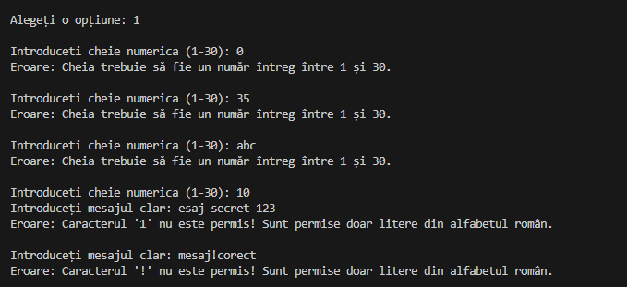
Figure 4.6 Invalid numeric key (below range, above range, non-numeric) and invalid characters in the message
Figure 4.7 shows the console output for a keyword shorter than the required 7 letters ("abc").
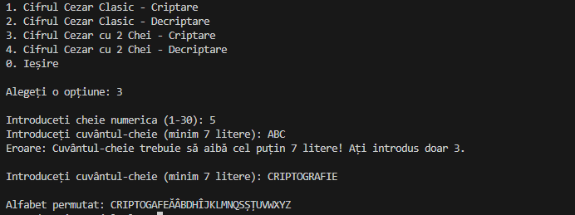
Figure 4.7 Console output for a keyword shorter than 7 letters
In all the cases the program displays a clear, specific error message, stating the allowed range, the rejected character or the minimum length, and asks again for the same value, without terminating or losing the previously entered data.

CONCLUSION
This laboratory work implemented and tested two variants of the Caesar cipher over the 31-letter Romanian alphabet. The results confirm the theoretical expectations from chapter 2.
The classic Caesar cipher (Task 1.1) is trivial to break: its key space contains only 30 possible shifts, so a cryptanalyst can recover the plaintext by brute force in at most 30 attempts, without any significant computational effort. Its only practical value today is pedagogical, as it illustrates the basic idea of substitution and of modular arithmetic in cryptography, and it is not suitable for protecting real information.
Adding a keyword-based permutation of the alphabet (Task 1.2) increases the key space from 30 to 31! × 30, which makes an exhaustive key search infeasible in practice. However, the resulting cipher is still a monoalphabetic substitution cipher: every occurrence of a given plaintext letter is always mapped to the same ciphertext letter. The letter-frequency statistics of the Romanian language therefore survive the encryption unchanged, and the cipher remains breakable through frequency analysis regardless of the size of its key space, which shows that a large key space alone does not guarantee security.
On the implementation side, the main lessons were the importance of defining an explicit letter-to-number encoding instead of relying on the built-in character codes of the language, the need to correct negative remainders explicitly when implementing modular subtraction in C#, and the value of validating all the user input (key range, keyword length, allowed characters) in a loop, instead of letting the program crash or produce a silently wrong result.
The full source code of this laboratory work is available in the GitHub repository [2]. The project is a .NET console application (CaesarCipher.csproj) organized into the folders Constants (Romanian alphabet encoding), Services (CaesarCipherService and PermutedCaesarCipherService) and UI (InputValidator), and the file Program.cs (menu and orchestration).

REFERENCES
[1] Laboratory Work no. 1. Caesar Cipher. Technical University of Moldova, Cryptography and Security course, 2026.
[2] Dulgheru I. CriptoGrafie. Source code of the laboratory work [online]. Available: https://github.com/ion-dulgheru/CriptoGrafie.git

