
MINISTRY OF EDUCATION, CULTURE AND RESEARCH
OF THE REPUBLIC OF MOLDOVA
Technical University of Moldova
Faculty of Computers, Informatics and Microelectronics
Department of Software Engineering and Automation
Report on laboratory work no. 4
Course: Operating Systems
Topic: The xv6 Shell from the Outside
Done by: st. gr. FAF-241, Ion Dulgheru
Checked by: Reitman Patricia
Chișinău – 2026
Table of Contents
PURPOSE OF THE WORK 3
1 FIXING SLEEP FOR THE CURRENT XV6
1.1 The name of the system call
1.2 The updated program and its test
2 BASH VERSUS THE XV6 SHELL
2.1 Method
2.2 Comparison table
2.3 Answers to the Observe questions 7
3 WHO EXPANDS THE ASTERISK
3.1 The programs args and args_linux
3.2 Results
3.3 Answers to the Observe questions
4 READING THE SHELL
4.1 Structure of sh.c
4.2 Answers to the Observe questions
CONCLUSIONS 15
REFERENCES 16

PURPOSE OF THE WORK
The purpose of the work is to compare the shell of xv6, which is a single small program (user/sh.c), with Bash, and to establish by experiment what a shell must do and what Bash adds on top of it [1]. A small program that prints the arguments it receives is used to show which component expands the asterisk and removes the quotes. Before that, the program sleep from Lab 2 is checked against the current version of xv6.
The work was performed on a Linux laptop; xv6 was built from the repository of the project [2] and run in the QEMU emulator. The files sleep.c, args.c, args_linux.c and the Makefile are stored in the folder lab4/ of the course repository.

1 FIXING SLEEP FOR THE CURRENT XV6

1.1 The name of the system call
In August 2025 the authors of xv6 renamed the system call sleep() to pause(), so a program written for the old name may no longer build. The name used by the local tree was determined with:
cd ~/xv6-riscv
grep -n "pause\|sleep" user/user.h
The result is a line that ends with int pause(int); (line 25 of the tree used), which shows that the tree declares pause and does not declare sleep (figure 1.1). The program sleep written in Lab 2 already called pause, so no change of the source was required.
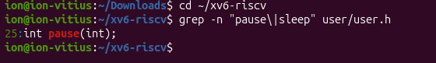
Figure 1.1 – The grep result in user.h

1.2 The updated program and its test
The source of user/sleep.c is given below; the line $U/_sleep\ is present in the list UPROGS of the Makefile, with a tab at the beginning and the backslash at the end, with nothing after the backslash.
#include "kernel/types.h"
#include "user/user.h"

int
main(int argc, char *argv[])
{
if(argc != 2){
fprintf(2, "usage: sleep <ticks>\n");
exit(1);
}
pause(atoi(argv[1])); // was sleep() before Aug 2025
exit(0);
}
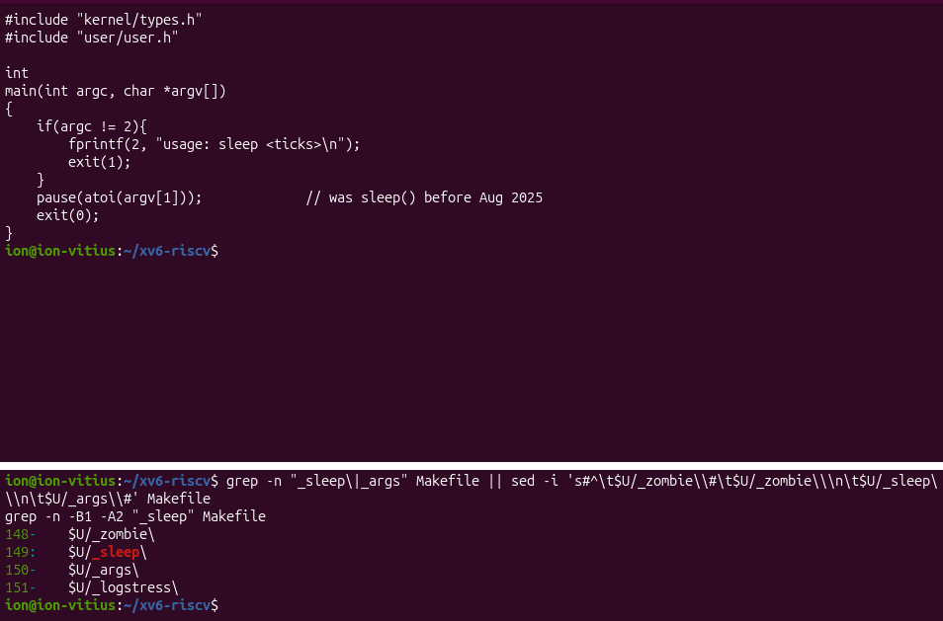
Figure 1.2 – The updated sleep.c
The system was rebuilt and started with make qemu, and the program was run with and without an argument: sleep 20 paused and returned to the prompt, and sleep without an argument printed usage: sleep <ticks> (figure 1.3).
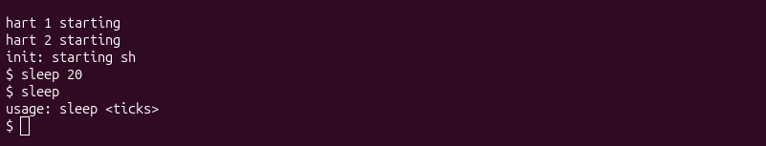
Figure 1.3 – sleep running in xv6, with and without an argument

2 BASH VERSUS THE XV6 SHELL

2.1 Method
Every command of table 2.1 was run twice: in Bash, in a test folder that contains one file named README (mkdir ~/shtest && cd ~/shtest && touch README), and at the $ prompt of xv6 started with make qemu. In xv6 the PATH row was typed as separate lines (mkdir d, cd d, ls ..), because the xv6 shell executes cd only when it is the first word of the line. The outputs are given in the table; the screenshots are shown in figures 2.1 and 2.2.
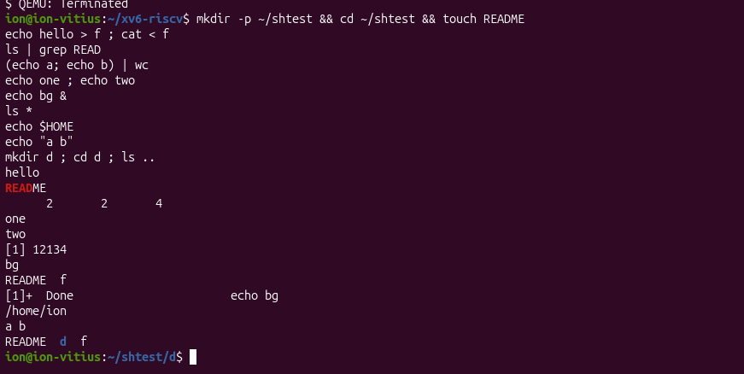
Figure 2.1 – The commands run in bash
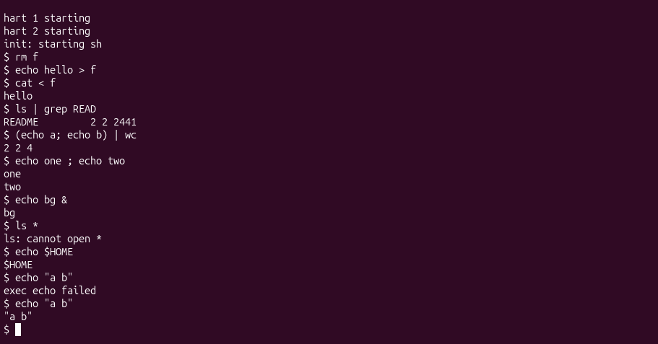
Figure 2.2 – The same commands run in xv6

2.2 Comparison table
Table 2.1 – Behaviour of bash and of the xv6 shell
Command | Tests | bash | xv6 | Why
echo hello > f ; cat < f | redirection | hello | hello | Both shells implement < and >
ls | grep READ | pipe | README | README 2 2 2441 | Both implement pipes; the xv6 ls also prints type, inode and size
(echo a; echo b) | wc | grouping, list | 2 2 4 | 2 2 4 | Both support parentheses and ;
echo one ; echo two | sequence | one two (on two lines) | one two (on two lines) | ; runs the commands in order
echo bg & | background | [1] 12134 and bg (job number and PID of the run) | bg (the prompt may appear before or after it) | Both implement & through fork without wait
ls * | globbing | README f (the files of the folder) | ls: cannot open * | xv6 does not expand *, so ls receives the literal name *
echo $HOME | variables | path of the home directory | $HOME | xv6 has no variables
echo "a b" | quotes | a b | "a b" (with the quotes) | xv6 does not process quotes, the quote marks stay in the words
mkdir d ; cd d ; ls .. | PATH | README d f | exec ls failed (lines typed separately) | xv6 has no PATH: ls is searched in the current directory d
arrow up, Tab, Ctrl+R | history, completion | recalls, completes, searches | arrow up prints the characters ^[[A and exec fails; Tab inserts a tab character (exec ech failed) | xv6 reads a plain line; no history and no completion

2.3 Answers to the Observe questions
Observe 1. Both shells have redirection (<, >, >>), pipes (|), command lists (;), grouping with parentheses and background execution (&). Only Bash has pattern expansion (*, ?, [ ], { }), variables and the substitution $( ), quote processing, a search path (PATH), command history, completion and reverse search, and the operators && and || with exit codes, together with job control and scripting.
Observe 2. In xv6 the shell calls exec(argv[0], argv) with the typed name and does not search any list of directories, so the name ls is looked up in the current directory. After cd d the current directory is d, which contains no file ls, and the shell prints exec ls failed. The xv6 programs are stored in the root directory, so the program can be started from inside d with its absolute path, /ls, or /ls .. to list the parent directory; the command /ls printed the entries . and .. of the directory d. The result is shown in figure 2.3.
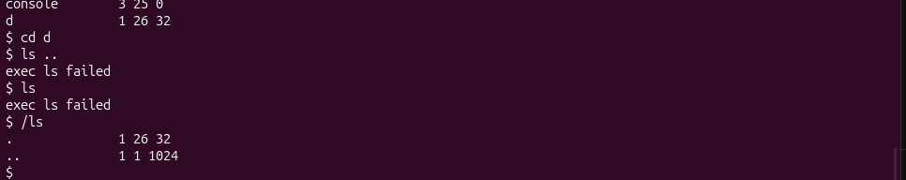
Figure 2.3 – ls failing after cd d, and the working alternative
Observe 3. The feature missed most in daily work is command history with completion, because every command has to be typed in full again. The easiest feature to add is a search path: when exec fails, the shell could try the same name in the root directory (/ followed by the name), which would be a few lines in runcmd.

3 WHO EXPANDS THE ASTERISK

3.1 The programs args and args_linux
The program user/args.c prints the number of arguments and each argument between square brackets; it was added to the list UPROGS with the line $U/_args\:
#include "kernel/types.h"
#include "user/user.h"

int
main(int argc, char *argv[])
{
printf("argc = %d\n", argc);
for(int i = 0; i < argc; i++)
printf("argv[%d] = [%s]\n", i, argv[i]);
exit(0);
}
The same program for Linux, args_linux.c, includes <stdio.h> instead of the two xv6 headers and uses return 0; it was compiled with gcc -o args args_linux.c.
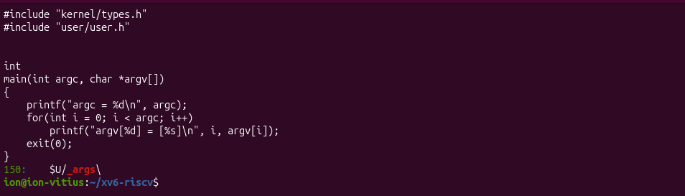
Figure 3.1 – args.c and the UPROGS line

3.2 Results
The same four lines were run in both shells (in Bash, as ./args in a folder with some .c files):
args one two three
args *.c "x y"
args $HOME
args 'single quoted'
In xv6 the outputs were: for args one two three, argc = 4 with the arguments one, two and three; for args *.c "x y", argc = 4 with *.c, "x and y"; for args $HOME, argc = 2 with $HOME; for args 'single quoted', argc = 3 with 'single and quoted'. In Bash the same commands gave argc = 4 for the first line; for the second line argc is the number of .c files plus 2 (for example, with the files a.c and b.c: a.c, b.c and x y, argc = 4), which was the case in the test folder; the third line gave argc = 2 with the path of the home directory; the fourth gave argc = 2 with single quoted as one argument. The results are shown in figures 3.2 and 3.3.
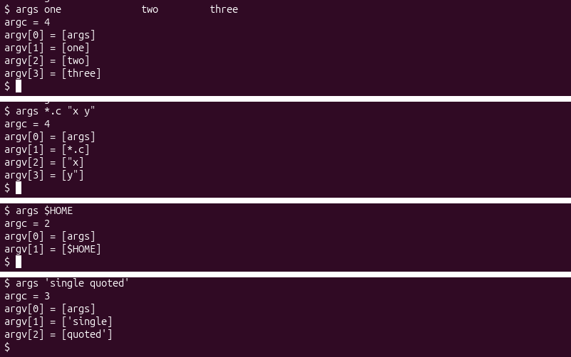
Figure 3.2 – args output in xv6 (top to bottom: one two three; *.c "x y"; $HOME; 'single quoted')
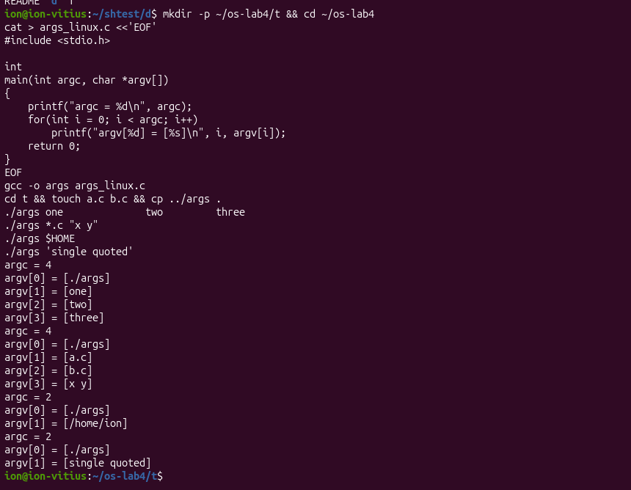
Figure 3.3 – args_linux output in bash

3.3 Answers to the Observe questions
Observe 1. For args *.c "x y", the xv6 program received 4 arguments: args, *.c, "x and y". The Linux program received the name of the program, the names of the .c files of the folder and the single argument x y: 4 arguments in the test folder (./args, a.c, b.c and x y).
Observe 2. The asterisk is expanded and the quotes are removed by the shell, not by the program and not by the kernel. The program only receives the finished list of arguments through argv; the kernel copies this list into the new process during exec. The xv6 shell does neither of the two operations, which is why the program saw *.c and the quote marks unchanged.
Observe 3. The extra spaces in one two three disappeared: the shell treats whitespace only as a separator between words and discards it, so the program received exactly three arguments, one, two and three. Both shells behave in this way.

4 READING THE SHELL

4.1 Structure of sh.c
The following commands were run in ~/xv6-riscv:
wc -l user/sh.c
grep -n "#define" user/sh.c
grep -n "case " user/sh.c
grep -n "cd" user/sh.c | head
The file has 499 lines. The command grep -n "#define" shows the five kinds of command (EXEC, REDIR, PIPE, LIST and BACK, lines 8 to 12) and the limit MAXARGS 10 of arguments per command (figure 4.1). The command grep -n "case " shows where each kind is run, in the function runcmd (lines 75 to 125), and in the parser (figure 4.2). The search for cd finds only the error message of the built-in command, at line 170, so the code itself was read around the lines 166 to 170 (figure 4.3).
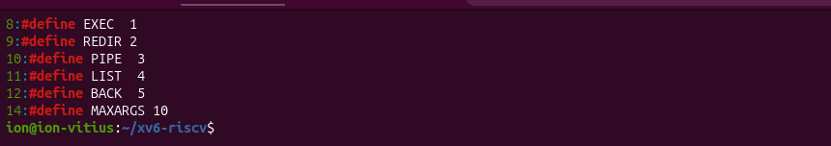
Figure 4.1 – The command kinds defined in sh.c
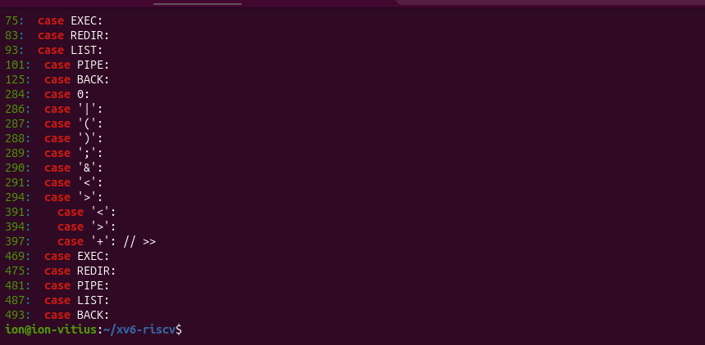
Figure 4.2 – Where each kind is run
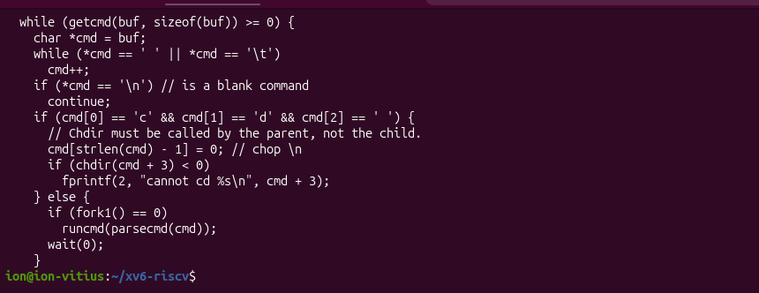
Figure 4.3 – The code that handles cd

4.2 Answers to the Observe questions
Observe 1. The shell knows five kinds of command, summarised in table 4.1.
Table 4.1 – Kinds of command of the xv6 shell
Kind | Character | Meaning
EXEC | none (a plain word) | A program with its arguments, started with exec
REDIR | < > >> | Redirection of the input or of the output of a command
PIPE | | | Two commands connected by a pipe
LIST | ; | Two commands run one after the other
BACK | & | A command run in the background

Parentheses only group commands for the parser; they do not form a separate kind.
Observe 2. The command cd is handled in the main loop of the shell, in the lines 166 to 170 of user/sh.c: if the line starts with cd , the shell itself calls chdir, and the comment in the code states that chdir must be called by the parent, not by the child. It is not run as a separate program for the same reason as in Bash: the current directory belongs to the process, so a child process would change its own directory and terminate, and the shell would stay in the old one.
Observe 3. The search for the characters * and $ finds no code that handles them: the symbols recognised by the parser are only <, |, >, &, ;, ( and ), and whitespace separates words. This explains the results of part 2: ls * and echo $HOME pass the text unchanged to the programs, so xv6 prints ls: cannot open * and $HOME. For the same reason, the line mkdir d ; cd d ; ls .. fails in xv6 with exec cd failed: only a line that starts with cd is handled by the shell itself, while inside a list the word cd is looked up as a program.

CONCLUSIONS
The work confirmed that the user interface of xv6 is a small program of about 500 lines that implements the essential functions of a shell: simple commands, redirection, pipes, lists, grouping, background execution and the built-in cd [1]. Everything else that makes Bash convenient, such as pattern expansion, variables, quotes, a search path and history, is an addition, and the experiments with ls *, echo $HOME, echo "a b" and ls after cd d showed what is missing in each case.
The program args established that the expansion of the asterisk and the removal of the quotes are performed by the shell before exec, and that the program and the kernel only receive and pass on the finished list of arguments. The program sleep from Lab 2 was checked against the current xv6, in which the system call is named pause [2].

REFERENCES
[1] Cox R., Kaashoek F., Morris R. xv6: a simple, Unix-like teaching operating system [online]. MIT. Available: https://pdos.csail.mit.edu/6.828/2023/xv6/book-riscv-rev3.pdf [accessed 05.10.2026].
[2] MIT PDOS. xv6-riscv source repository [online]. Available: https://github.com/mit-pdos/xv6-riscv [accessed 05.10.2026].

