
MINISTRY OF EDUCATION, CULTURE AND RESEARCH
OF THE REPUBLIC OF MOLDOVA
Technical University of Moldova
Faculty of Computers, Informatics and Microelectronics
Department of Software Engineering and Automation

Done by: st. gr. FAF-241, Dulgheru Ion

Report
Practical Work No. 13
Operating Systems
Topic: Semaphores in Your Own Kernel (xv6)

Checked by:
Reitman Patricia university assistant
DISA, FCIM, UTM

Chișinău – 2026
Table of Contents
1 AIM OF THE WORK 3
1.1 Purpose of practical work 3
1.2 Problem statement 3
2 THEORETICAL BACKGROUND 4
2.1 A semaphore inside the kernel 4
2.2 Sleep and wakeup 4
2.3 Why the test is a loop and why the spinlock is released 4
3 DESCRIPTION OF EXERCISES 5
3.1 Environment preparation 5
3.2 Part 1. The numbers and the user side 5
3.3 Part 2. The kernel side 6
3.4 Part 3. A semaphore as a lock: mix 7
CONCLUSION 8
REFERENCES 9

1 AIM OF THE WORK

1.1 Purpose of practical work
In the previous two works the semaphores of the C library were used. The purpose of this practical work is to build them inside the kernel of the teaching operating system xv6, as three new system calls: sem_init, sem_down and sem_up, with the numbers 24, 25 and 26 [1].
The work shows that a semaphore is only a number, a spinlock that protects it, and the kernel functions sleep and wakeup. A process that waits really goes to sleep and uses no CPU [2].

1.2 Problem statement
The practical work consists of three consecutive tasks:
- adding the numbers and the user side of the three calls: the constants, the declarations, the stubs and the test programs semtest and mix;
- adding the kernel side: the file kernel/sem.c with a table of 8 semaphores, and the entries in the table of system calls;
- using a semaphore as a lock with the program mix, with and without the lock, and explaining the result.

2 THEORETICAL BACKGROUND

2.1 A semaphore inside the kernel
The kernel keeps a small table of NSEM = 8 semaphores shared by all the processes. Each semaphore is a structure with an integer value, which says how many processes may still pass, and a spinlock that protects the value. A zeroed spinlock is a free spinlock, so the table needs no special initialization [2].

2.2 Sleep and wakeup
The call sem_down takes one unit. While the value is 0, the process registers the address of the semaphore as the thing it waits for (sleep_prepare), releases the spinlock and sleeps (sleep). The call sem_up adds 1 and wakes up all the processes that sleep on that address (wakeup). In our xv6 the sleep is made in two steps, sleep_prepare(chan) and sleep(), and not with sleep(chan, lock) as in the book [2].

2.3 Why the test is a loop and why the spinlock is released
After a wakeup the value can be 0 again, because another process may have taken the unit first, so the value is tested in a loop. The spinlock is released before sleeping, because a process must never sleep while it holds a spinlock: sem_up would need the same lock and the system would be blocked [3].

3 DESCRIPTION OF EXERCISES

3.1 Environment preparation
The work was performed in the tree ~/xv6-riscv, built with the RISC-V tool chain and started in QEMU with three CPUs, so two processes really run at the same time. The tree already contained the changes of the previous works, including the call trace with the number 23; the new calls use the numbers 24, 25 and 26.

3.2 Part 1. The numbers and the user side
The same steps as for trace in the previous practical work were made three times. In kernel/syscall.h and user/user.h the numbers and the declarations were added, and in user/usys.pl the stubs:
#define SYS_sem_init 24 /* kernel/syscall.h */
#define SYS_sem_down 25
#define SYS_sem_up 26

int sem_init(int, int); /* user/user.h: id, start value */
int sem_down(int); /* take one, or sleep */
int sem_up(int); /* give one back */

entry("sem_init"); # user/usys.pl
entry("sem_down");
entry("sem_up");
The program user/semtest.c makes two tests. In the first one the semaphore 0 starts at 0, so the child must wait until the parent calls sem_up. In the second one ping and pong take turns with two semaphores that pass the turn to each other. The program user/mix.c starts two processes that print five lines each, one letter per write(); with the argument lock the semaphore 3 is used as a lock. Both programs were added to the list UPROGS of the Makefile, after $U/_zombie\.
Check 1. The kernel does not know the new calls yet, so semtest prints the lines unknown sys call 24 and unknown sys call 25 and the child runs before the parent, as shown in figure 3.1. This proves that the numbers reached the kernel.
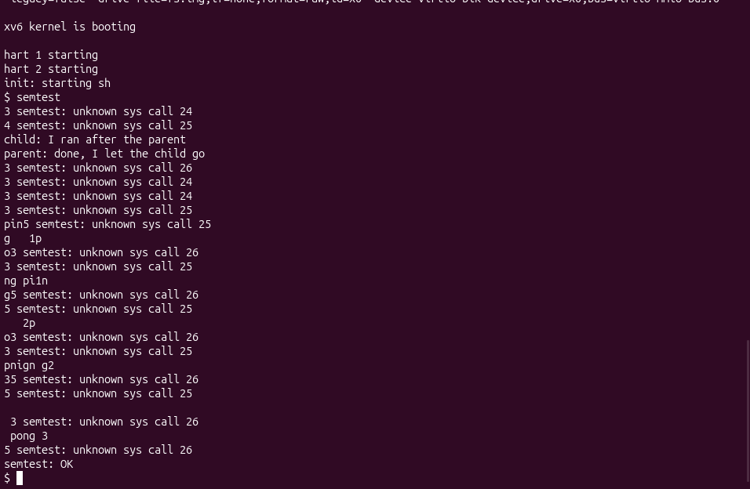
Figure 3.1 – Check 1: unknown sys call 24 and 25, the child before the parent

3.3 Part 2. The kernel side
The semaphores were written in the new file kernel/sem.c, which was added to the list OBJS of the Makefile after $K/sysproc.o, and the three functions were added to the table of system calls in kernel/syscall.c (the declarations extern uint64 sys_sem_init(void); and so on, and the entries [SYS_sem_init] = sys_sem_init, [SYS_sem_down] = sys_sem_down, [SYS_sem_up] = sys_sem_up). The core of the file is the function sys_sem_down:
struct sem {
struct spinlock lock; // a zeroed spinlock is a free spinlock
int value; // how many may still pass
};
static struct sem sems[NSEM]; // NSEM = 8

acquire(&s->lock);
while (s->value == 0) {
sleep_prepare(s); // I will sleep on the address of s
release(&s->lock); // never sleep holding a spinlock
sleep(); // returns at once if sem_up came in between
acquire(&s->lock);
if (killed(myproc())) { // kill must still work on a waiting process
release(&s->lock);
return -1;
}
}
s->value--;
release(&s->lock);
The function sys_sem_up does acquire, s->value++, wakeup(s) and release. The function sys_sem_init sets the start value and checks that the number of the semaphore is between 0 and 7 and that the value is not negative.
Check 2. After the new build, semtest printed the line of the parent before the line of the child, although the parent waits 10 ticks before it lets the child go: the child was asleep in sem_down. Then ping and pong alternated strictly, three times each, and the program ended with semtest: OK (figure 3.2).
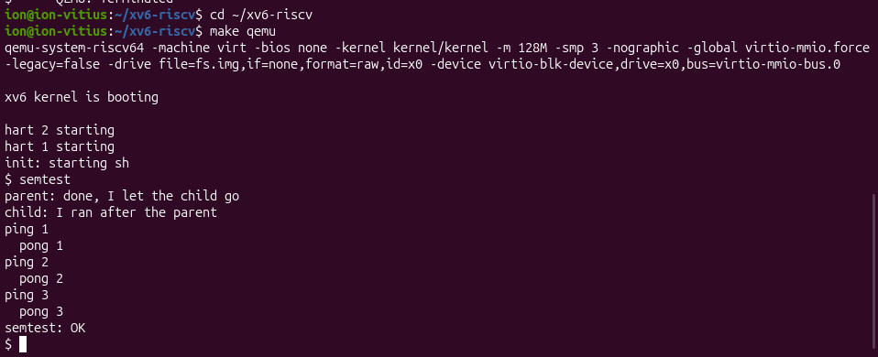
Figure 3.2 – Check 2: semtest, order and ping-pong, ends with semtest: OK

3.4 Part 3. A semaphore as a lock: mix
The program mix was run twice without the lock. The two processes print one letter per write() and run on different CPUs, so the letters of the lines A and b are mixed, as shown in figure 3.3.
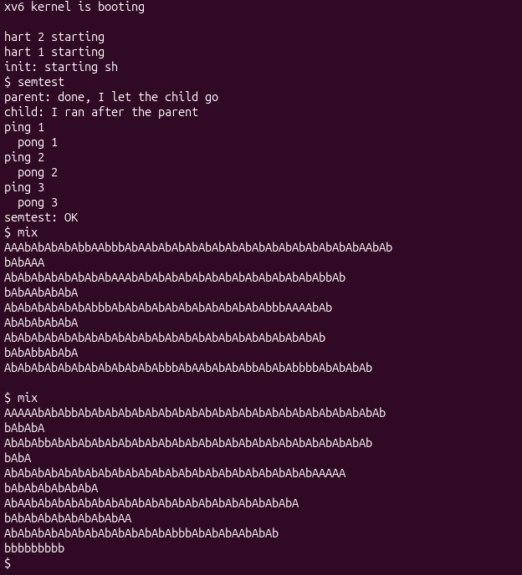
Figure 3.3 – mix without the lock: the letters of the two processes are mixed
With the argument lock, every line is written inside a critical section protected by the semaphore 3 (started at 1), and every line stays whole: first five lines of A and then five lines of b (figure 3.4).
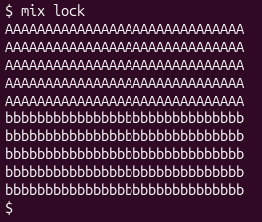
Figure 3.4 – mix lock: every line is whole
Answers to the questions of the assignment (they are also in the file notes.txt):
1. Without the lock the letters mix because one line costs 31 system calls: 30 letters and the new line, each one with its own write(). The two processes run at the same time on different CPUs, so the writes of the two processes alternate between the calls; a line is not one indivisible operation.
2. The two lines of mix.c are if (uselock) sem_down(3); before the loop that writes the letters, and if (uselock) sem_up(3); after it. The semaphore 3 starts at 1, so only one process can be between them: the whole line is a critical section.
3. The test is while (s->value == 0) because sem_up calls wakeup(s), which wakes all the processes that sleep on s, but it gave only one unit. The first process that runs takes it, the value is 0 again, and the others find 0 and must sleep again. With if they would continue with the value 0 and take a unit that does not exist.
4. If sem_down slept while holding the spinlock, sem_up, called by another process, would try to acquire the same spinlock and would spin forever, because the sleeper never releases it: the sleeper waits for sem_up and sem_up waits for the lock. This is a deadlock; besides, sleeping with a spinlock held is forbidden in xv6 and the kernel panics.

CONCLUSION
In this practical work three new system calls, sem_init, sem_down and sem_up, were added to xv6, and with them a counting semaphore was built inside the kernel. It is only an integer, a spinlock that protects it and the functions sleep and wakeup; a process that waits sleeps and uses no CPU.
Before the kernel side existed, semtest printed unknown sys call 24 and 25, which showed that the numbers reached the kernel. After it, the child waited for the parent, and ping and pong took turns, ending with semtest: OK. The program mix showed that one semaphore started at 1 is a lock: without it the letters of two processes are mixed, with it every line stays whole.
Two details of the code are important: the value is tested in a loop, because after a wakeup another process may have taken the unit, and the spinlock is released before sleep, because a process must not sleep while it holds a spinlock.

REFERENCES
[1] Operating Systems 2026. Lab 13: Semaphores in Your Own Kernel (xv6). Technical University of Moldova, FCIM, 2026.
[2] Cox R., Kaashoek F., Morris R. xv6: a simple, Unix-like teaching operating system. MIT. Available: https://pdos.csail.mit.edu/6.1810/ (accessed 02.11.2026).
[3] Tanenbaum A. S., Bos H. Modern Operating Systems. 4th ed. Boston: Pearson, 2015. 1136 p. ISBN 978-0-13-359162-0.

