
MINISTRY OF EDUCATION, CULTURE AND RESEARCH
OF THE REPUBLIC OF MOLDOVA
Technical University of Moldova
Faculty of Computers, Informatics and Microelectronics
Department of Software Engineering and Automation

Done by: st. gr. FAF-241, Dulgheru Ion

Report
Practical Work No. 10
Operating Systems
Topic: Adding a System Call: trace (xv6)

Checked by:
Reitman Patricia university assistant
DISA, FCIM, UTM

Chișinău – 2026
Table of Contents
1 AIM OF THE WORK 3
1.1 Purpose of practical work 3
1.2 Problem statement 3
2 THEORETICAL BACKGROUND 4
2.1 The path of a system call in xv6 4
2.2 The mask of traced calls 4
2.3 Inheritance of the mask 4
3 DESCRIPTION OF EXERCISES 5
3.1 Environment preparation 5
3.2 Part 1. The number and the user side 5
3.3 Part 2. The kernel side 7
3.4 Part 3. Play with the mask 9
CONCLUSION 11
REFERENCES 12

1 AIM OF THE WORK

1.1 Purpose of practical work
The purpose of the practical work is to change the kernel of the teaching operating system xv6 for the first time, by adding a new system call named trace [1]. The call makes a process print every system call that it makes, in the same way as the tool strace did on Linux in the previous work.
The work follows one number, 23, from the user program, through the stub that executes the instruction ecall, to the function sys_trace in the kernel [2].

1.2 Problem statement
The practical work consists of three consecutive tasks:
- adding the number and the user side of the call: the constant SYS_trace, the declaration, the stub and the program trace.c;
- adding the kernel side: the mask in the structure of the process, the handler sys_trace, the table of calls, the table of names with the printing, and the inheritance of the mask in fork;
- using different masks and explaining the observed output.

2 THEORETICAL BACKGROUND

2.1 The path of a system call in xv6
A user program calls a function from user/usys.S. The stub generated from user/usys.pl loads the number of the call in the register a7 and executes the instruction ecall, which switches the processor to the kernel mode [2]. The kernel saves the registers of the process in its trapframe and calls the function syscall(). This function reads the number from a7, finds the handler in the table syscalls[] and stores the returned value in a0, so the user program receives it as the result of the call.

2.2 The mask of traced calls
The mask is an integer read in binary: if the bit N is set, the calls with the number N are printed. For example, SYS_read has the number 5, so the mask 2^5 = 32 selects only read, and the mask 2147483647 has all the 31 low bits set and selects every call. The mask is stored in the structure of each process, so every process has its own mask.

2.3 Inheritance of the mask
The call exec replaces the program of the process, but the process remains the same and keeps its structure with the mask. Therefore the program trace can set the mask on itself and then become the command with exec. The call fork creates a new process with a new structure, so the mask must be copied from the parent explicitly; otherwise the children would not be traced.

3 DESCRIPTION OF EXERCISES

3.1 Environment preparation
The work was performed in the tree ~/xv6-riscv, which is built with the RISC-V tool chain and started in QEMU with the command make qemu. The tree is newer than the 6.1810 page of MIT: in it the number 22 is already used by sync, and the print function of the kernel is called printk. Therefore the new call has the number 23 and the kernel prints with printk.

3.2 Part 1. The number and the user side
Five small changes were made. First, the number was added at the end of kernel/syscall.h, and the declaration was added in user/user.h:
#define SYS_trace 23 /* kernel/syscall.h */
int trace(int); /* user/user.h */
Then the stub was added in user/usys.pl; at build time the script writes user/usys.S, where trace becomes the instructions li a7, SYS_trace; ecall; ret:
entry("trace"); # user/usys.pl
The program user/trace.c sets the mask on itself and then becomes the command with exec; the mask is kept, because exec does not create a new process:
#include "kernel/types.h"
#include "kernel/stat.h"
#include "user/user.h"
int
main(int argc, char *argv[])
{
if (argc < 3) {
fprintf(2, "usage: trace mask command [args...]\n");
exit(1);
}
if (trace(atoi(argv[1])) < 0) {
fprintf(2, "trace: failed\n");
exit(1);
}
exec(argv[2], argv + 2);
fprintf(2, "trace: exec %s failed\n", argv[2]);
exit(1);
}
Finally, the line $U/_trace\ was added to the list UPROGS of the Makefile, after $U/_zombie\, so that the program is placed on the disk of xv6. Before the kernel side existed, the command trace 32 grep hello README had to print the message unknown sys call 23, which proves that the number reached the kernel.

3.3 Part 2. The kernel side
Four files of the kernel were changed. In kernel/proc.h the field trace_mask was added to struct proc, after the field name. In kernel/sysproc.c the handler was added; it reads the argument 0 (register a0) and stores it in the process:
uint64
sys_trace(void)
{
int mask;
argint(0, &mask);
myproc()->trace_mask = mask;
return 0;
}
In kernel/syscall.c the function was declared with extern uint64 sys_trace(void); and the entry [SYS_trace] = sys_trace, was added to the table syscalls[]. The kernel knows only numbers, so a table of names was added above the function syscall(), and the printing was added in syscall() right after the line that runs the call, so that the returned value is already in a0:
static char *syscallnames[] = {
[SYS_fork] "fork", [SYS_exit] "exit", ... [SYS_sync] "sync", [SYS_trace] "trace",
};
...
p->trapframe->a0 = syscalls[num]();
if ((p->trace_mask >> num) & 1)
printk("%d: syscall %s -> %ld\n",
p->pid, syscallnames[num], p->trapframe->a0);
At last, in the function fork() of kernel/proc.c the line np->trace_mask = p->trace_mask; was added after the copy of the name, so that the children inherit the mask.
After the new build, the command trace 32 grep hello README printed the expected lines, as shown in figure 3.1. The numbers are the same as in the assignment: 1023 + 965 + 453 = 2441 bytes, which is the size of the file README, read in three pieces, and then 0 for the end of the file.
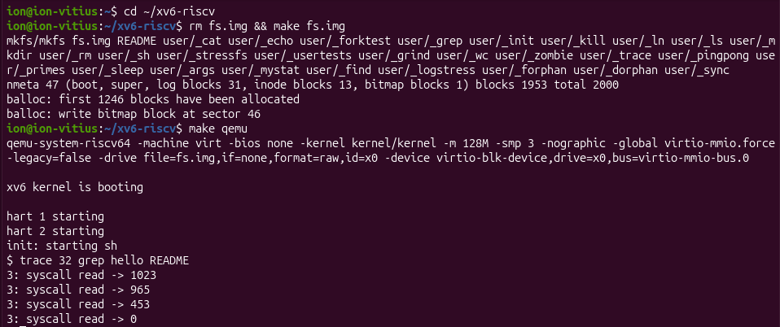
Figure 3.1 – Build of the disk, start of xv6 and the result of trace 32 grep hello README

3.4 Part 3. Play with the mask
Four masks were used; they are summarized in table 3.1.
Table 3.1 – Masks used in the experiments
Mask | Bits | Traced calls
32 | 5 | read
2147483647 | 0 – 30 | all calls
2 | 1 | fork
65536 | 16 | write
2129920 | 15 and 21 | open and close

All the calls. With the mask 2147483647 the command prints every call of grep: trace, exec, open, four calls read and close, as shown in figure 3.2. The first line shows the call trace itself, which sets the mask.
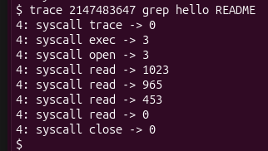
Figure 3.2 – trace 2147483647 grep hello README
Only fork. The mask 2 was used on the test forkforkfork, which creates processes until the table of processes is full. The result is shown in figure 3.3: the lines are printed by several processes (pid 9, 10 and 11 in the visible part), and the last calls return -1, because there is no free place in the table of processes. The test ends with OK and ALL TESTS PASSED.
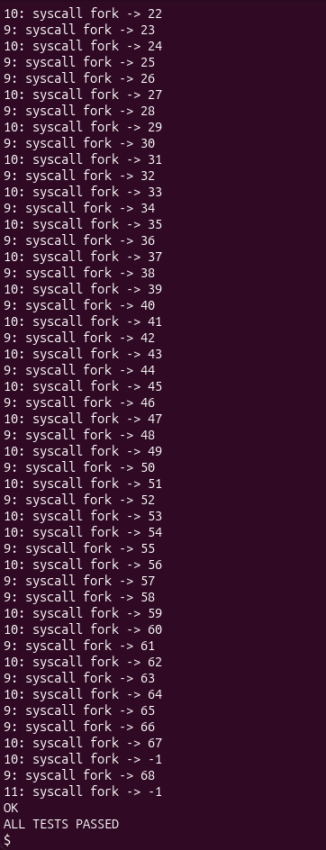
Figure 3.3 – trace 2 usertests forkforkfork
Only write. The mask 65536 = 2^16 selects the call write. The result for echo hi is shown in figure 3.4.
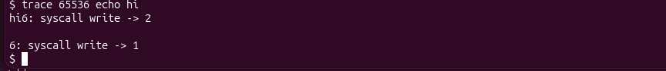
Figure 3.4 – trace 65536 echo hi
Open and close. The numbers of the calls are 15 for open and 21 for close, so the mask is 2^15 + 2^21 = 32768 + 2097152 = 2129920. Figure 3.5 shows that for the command cat README only the lines open -> 3 and close -> 0 are added to the text of the file.
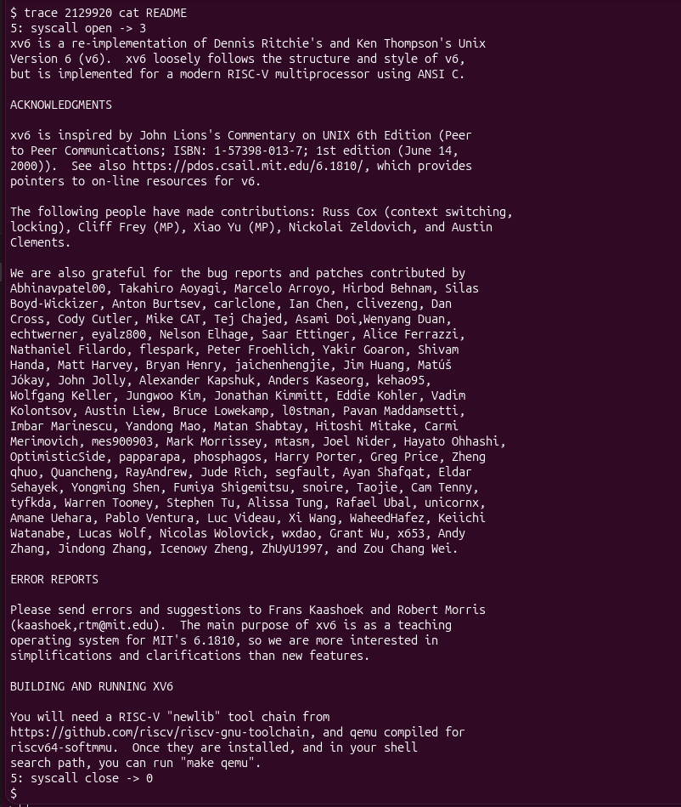
Figure 3.5 – trace 2129920 cat README
Answers to the questions of the assignment:
1. In trace 32 grep hello README only read is shown, because the mask 32 = 2^5 has only the bit 5 set, and 5 is SYS_read. The kernel prints a call only if its bit is set, (p->trace_mask >> num) & 1. The calls open (15) and close (21) are executed, but their bits are not set. With the mask 2147483647 they appear.
2. In forkforkfork several processes print lines because of the line np->trace_mask = p->trace_mask; in fork(). Every child inherits the mask of the parent, so the children and the grandchildren are traced too. Without this line only the process that called trace would print.
3. In trace 65536 echo hi the trace line is between hi and the new line, because echo calls write twice: once for the text hi (2 bytes, returns 2) and once for the new line (1 byte, returns 1). The kernel prints the trace line right after each call returns, so the first line appears after hi and before the new line is written.
4. The mask that traces open (15) and close (21) and nothing else is 2^15 + 2^21 = 2129920.

CONCLUSION
In this practical work a new system call, trace, was added to xv6. The number 23 was followed through all the levels: the constant in syscall.h, the declaration and the stub in the user space, the instruction ecall with a7 = 23, the table syscalls[] and the handler sys_trace in the kernel [2].
The experiments with the masks showed that the mask is a set of bits, one for every call, and that it is stored in each process. The line in fork() makes the children inherit it, and exec keeps it, because exec replaces only the program and not the process. The result of trace 32 grep hello README is exactly the expected one: 1023, 965, 453 and 0.

REFERENCES
[1] Operating Systems 2026. Lab 10: Add Your Own System Call: trace (xv6). Technical University of Moldova, FCIM, 2026.
[2] Cox R., Kaashoek F., Morris R. xv6: a simple, Unix-like teaching operating system. MIT. Available: https://pdos.csail.mit.edu/6.1810/ (accessed 02.11.2026).
[3] Tanenbaum A. S., Bos H. Modern Operating Systems. 4th ed. Boston: Pearson, 2015. 1136 p. ISBN 978-0-13-359162-0.
[4] fork(2) – Linux manual page. Available: https://man7.org/linux/man-pages/man2/fork.2.html (accessed 02.11.2026).
[5] execve(2) – Linux manual page. Available: https://man7.org/linux/man-pages/man2/execve.2.html (accessed 02.11.2026).

