
MINISTRY OF EDUCATION, CULTURE AND RESEARCH
OF THE REPUBLIC OF MOLDOVA
Technical University of Moldova
Faculty of Computers, Informatics and Microelectronics
Department of Software Engineering and Automation
Ion Dulgheru, group FAF-241
Report
Practical Work No. 1
Operating Systems
Topic: The OS as a Resource Manager
Checked by:
Patricia Reitman
DISA, FCIM, UTM
Chișinău – 2026
Table of Contents
1 AIM OF THE WORK 3
1.1 Purpose of practical work 3
1.2 Problem statement 3
2 THEORETICAL BACKGROUND 4
2.1 Operating system as a resource manager 4
2.2 Files, ownership and permissions 4
2.3 Processes 4
2.4 Memory 5
2.5 Devices and storage 5
3 DESCRIPTION OF EXERCISES 6
3.1 Exercise 1: System identification, files and directories 6
3.2 Exercise 2: Processes 7
3.3 Exercise 3: Memory 9
3.4 Exercise 4: Devices and storage 11
3.5 Summary of results 12
CONCLUSION 13
REFERENCES 14

1 AIM OF THE WORK

1.1 Purpose of practical work
The purpose of the work is to examine, from the user side of a running Linux system, how the operating system manages the resources placed under its control. Four classes of resources are considered: files, processes, memory and devices. The work also verifies that each of them is exposed to the user through a uniform, file-like interface, which illustrates the role of the operating system as an intermediary between application programs and hardware [1].

1.2 Problem statement
The work is carried out on a native Ubuntu installation (host ion-vitius, kernel 7.0.0-34-generic, architecture x86_64), using only the standard command-line tools. The following tasks are formulated:
- to identify the system and the current user, and to inspect file ownership and permissions before and after a change made with chmod;
- to list the running processes, to identify the process with PID 1, to start and terminate a background process and to read its state from /proc;
- to determine the amount of physical memory and swap space, and the resident memory of a single process;
- to identify the device on which the root file system is mounted and to inspect the entries of /dev.
For each task, the observed output is recorded in a screenshot and interpreted in chapter 3.

2 THEORETICAL BACKGROUND

2.1 Operating system as a resource manager
An operating system is the software layer that sits between application programs and the hardware. It fulfils two complementary roles: it provides abstractions (files instead of disk blocks, processes instead of raw CPU time) and it arbitrates between competing programs for the processor, memory, storage and input/output devices [1]. Protection is enforced at the same time, so that a program can access only the resources it is entitled to.

2.2 Files, ownership and permissions
Every file on a Unix-like system has an owner, a group and a mode. The mode is displayed by ls -l as ten characters: the first indicates the file type (- for a regular file, d for a directory, c and b for character and block devices, l for a symbolic link), and the remaining nine form three triples of the type rwx, which apply to the owner, the group and all other users respectively [2].
For the numeric (octal) notation, each triple is converted to one digit according to formula (2.1).
d = 4r + 2w + x (2.1)
where d is the octal digit of the triple; r, w and x are the read, write and execute bits, each equal to 1 if the permission is granted and 0 otherwise.
Following formula (2.1), the mode 644 corresponds to rw- for the owner and r-- for the group and others, while 600 grants read and write access to the owner only, as summarised in table 2.1.
Table 2.1 – Octal modes used in the work
Octal mode | Symbolic form | Meaning
644 | -rw-r--r-- | Owner reads and writes; group and others read only
600 | -rw------- | Owner reads and writes; group and others have no access

The directory tree is organised according to a common convention: /etc holds system-wide configuration files and /home holds the personal directories of the users [3].

2.3 Processes
A process is a program in execution. Each process is identified by a process identifier (PID) and has a parent. The first user-space process, with PID 1, is started by the kernel at boot and is the ancestor of all other processes; on Ubuntu this role is performed by systemd [4].
The kernel exposes information about every process through the pseudo-file system /proc, in which the directory /proc/<pid> contains files such as status, whose State: field gives the scheduling state of the process (for example, R for running and S for interruptible sleep) [5]. A process can be terminated with kill, which by default sends the signal SIGTERM.

2.4 Memory
Physical memory (RAM) is shared among all processes. When it becomes scarce, the kernel may move rarely used pages to swap, a region of the disk used as an extension of RAM. Part of the RAM is also used as a cache for disk data (the buff/cache column of free), which the kernel can reclaim when applications need memory [6].
For an individual process, the field VmRSS in /proc/<pid>/status reports the resident set size, i.e. the amount of its memory currently held in physical RAM [5]. Pages of shared libraries are included in this value, therefore it does not represent memory used exclusively by the process.

2.5 Devices and storage
Hardware devices are represented by special files in /dev. Block devices (disks and partitions) are accessed in fixed-size blocks, whereas character devices (terminals, consoles) are accessed as streams of bytes [3]. A storage partition becomes usable after it is mounted at a point in the directory tree, and the root of the tree (/) is mounted from a partition formatted with a file system such as ext4.
The principle that resources are accessed through the file interface, usually summarised as “everything is a file”, allows the same generic tools (cat, ls, grep) to be applied to ordinary files, processes and devices.

3 DESCRIPTION OF EXERCISES

3.1 Exercise 1: System identification, files and directories
Objective. To identify the host and the user, and to observe how the permissions of a file change after chmod.
Commands used. whoami, uname -a, uptime, ls -la ~, ls -l, chmod.
The exact sequence of commands is given below.
whoami
uname -a
uptime
ls -la ~
cd /etc && ls | head
cd ~/os-lab1/demo
ls -l note.txt
chmod 600 note.txt
ls -l note.txt
chmod 644 note.txt
Description. According to figure 3.1, whoami returned the user ion, and uname -a identified the system as Linux ion-vitius 7.0.0-34-generic #34-Ubuntu SMP PREEMPT_DYNAMIC Wed Sep 2 14:29:37 UTC 2026 x86_64. The command uptime reported that the system had been running for 5 minutes, with 1 user and load averages of 1.54, 1.40 and 0.69.
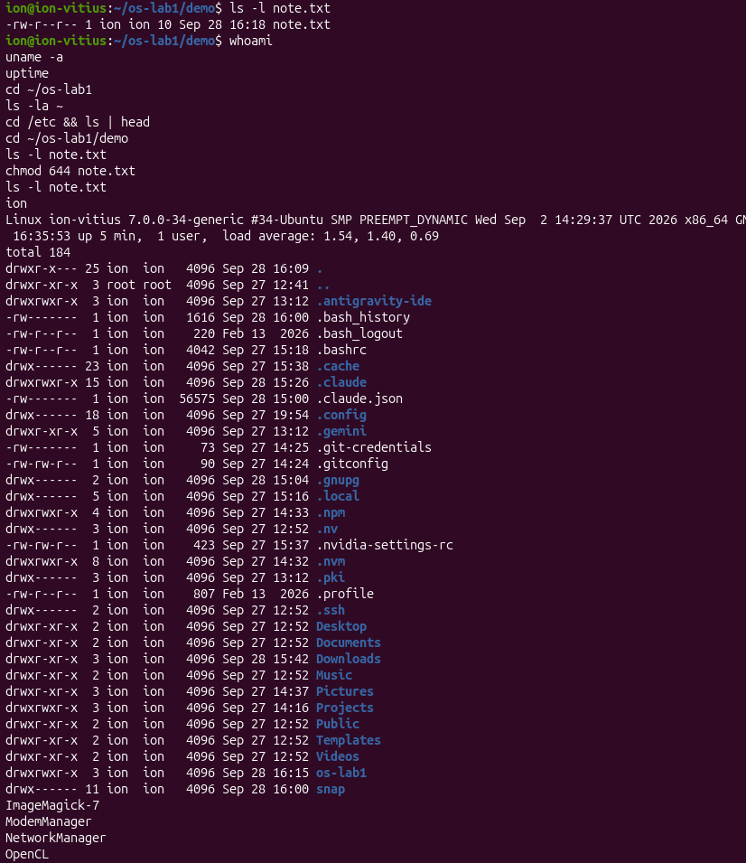
Figure 3.1 – Identification commands and file listings
The listing of the home directory in figure 3.1 shows that the files created in the working directory belong to the user ion and the group ion. The file note.txt (10 bytes) initially had the mode -rw-r--r--. After chmod 600, the mode became -rw-------, so that only the owner retains access, and the original mode was then restored with chmod 644; the three states are compared in table 3.1.
Table 3.1 – Permissions of note.txt
Step | Command | Octal mode | Symbolic form
Initial state | ls -l note.txt | 644 | -rw-r--r--
After change | chmod 600 note.txt | 600 | -rw-------
Restored | chmod 644 note.txt | 644 | -rw-r--r--

The listing of /etc (ImageMagick-7, NetworkManager, adduser.conf, alsa and others) confirms that the directory contains configuration files of the system and of installed applications, while /home contains the personal directory /home/ion. The notes taken during the exercise were stored in a Markdown file edited with nano, as shown in figure 3.2.
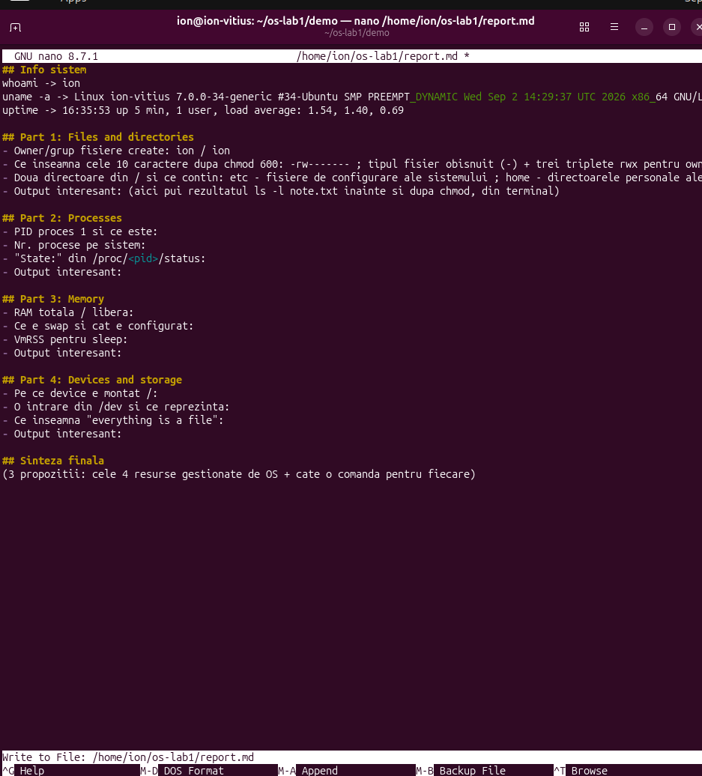
Figure 3.2 – Notes file opened in the nano editor

3.2 Exercise 2: Processes
Objective. To list the processes, to identify the process with PID 1, to start and stop a background process and to read its state from /proc.
Commands used. ps, jobs, kill, grep, ls /proc, cat /proc/<pid>/status.
The sequence of commands is given below.
ps aux | head
ps aux | wc -l
ps -p 1
sleep 300 &
jobs
ps -ef | grep sleep
kill 9133
sleep 300 &
PID=$!
ls /proc/$PID/
cat /proc/$PID/status | head -20
kill $PID
Description. According to figure 3.3, the first entry of ps aux is the process with PID 1, owned by root, whose command line is /usr/lib/systemd/systemd --switched-root --system --deserialize=52 splash; the same result is returned by ps -p 1, which prints the command name systemd. The command ps aux | wc -l returned 342 lines; since the first line is the column header, the system was running 341 processes. The large number is explained by the fact that the system is a full desktop installation with a graphical environment.
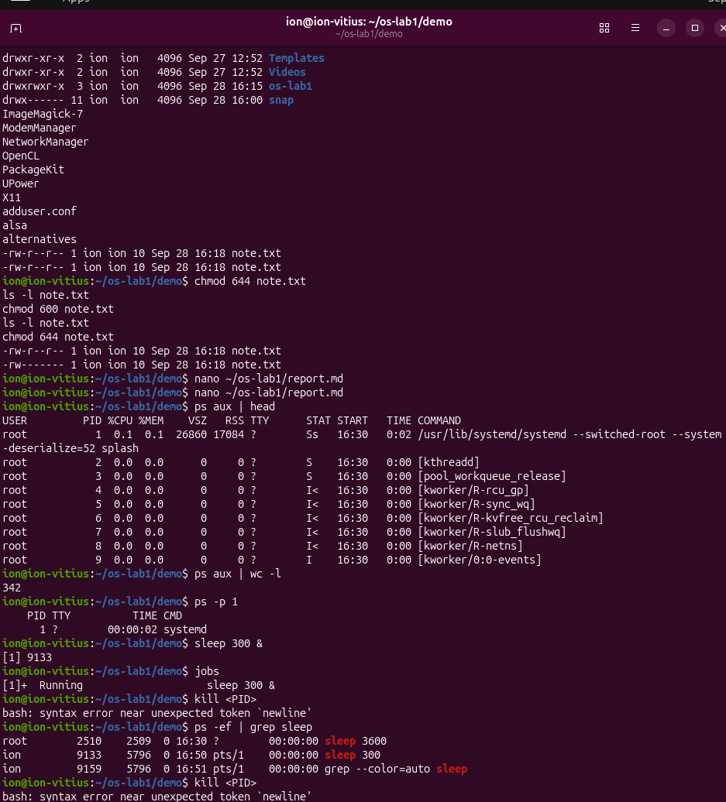
Figure 3.3 – Process listing and control of a background process
The command sleep 300 & started a background job (job [1], PID 9133), and jobs reported it as Running. The first attempts to stop it with kill <PID> failed with the message “syntax error near unexpected token newline”, because the placeholder was typed literally and the shell interpreted the angle brackets as redirection operators. The process was located with ps -ef | grep sleep, which showed PID 9133 with the parent PID 5796 on the terminal pts/1, and it was terminated with kill 9133, after which the shell reported Terminated.
For the second instance of sleep 300 & the PID was stored in a variable with PID=$!, and the directory /proc/$PID/ was inspected, as shown in figure 3.4. The file status contains Name: sleep, State: S (sleeping), Pid: 9242, PPid: 5796 and Uid: 1000. The state S means that the process is not executing, but waiting for an event, here the expiration of the timer, and therefore does not consume CPU time. The parent PID 5796 is identical to that of the first instance, which indicates that both were started from the same interactive shell.
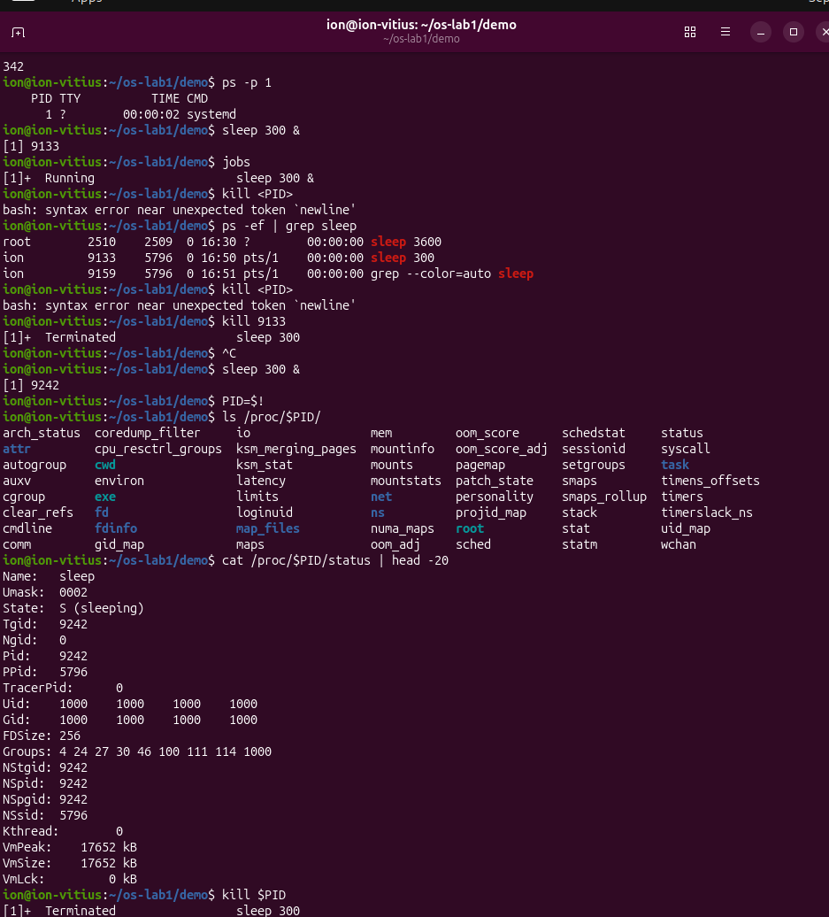
Figure 3.4 – Contents of /proc/$PID/status for the sleep process

3.3 Exercise 3: Memory
Objective. To determine the amount of RAM and swap and the resident memory of a single process.
Commands used. free -h, cat /proc/meminfo, grep VmRSS.
The sequence of commands is given below.
free -h
cat /proc/meminfo | head -6
sleep 300 &
PID=$!
grep VmRSS /proc/$PID/status
kill $PID
Description. The output of free -h, presented in figure 3.5, reports 14 GiB of total memory, 3.9 GiB used, 7.6 GiB free, 4.0 GiB in buff/cache and 10 GiB available. The more precise values from /proc/meminfo are MemTotal: 15472968 kB, MemFree: 8020004 kB and MemAvailable: 11370948 kB. The conversion from kilobytes to gibibytes is performed according to formula (3.1).
M_GiB = M_kB / 1024² (3.1)
where M_GiB is the amount of memory in gibibytes and M_kB is the amount in kilobytes, as reported by /proc/meminfo.
By formula (3.1), MemTotal equals 14.76 GiB and MemFree equals 7.65 GiB, which agrees with the rounded values printed by free -h. The used memory is obtained as the difference between the total and the available memory, as in formula (3.2).
M_used = M_total − M_avail (3.2)
where M_used is the used memory, M_total is MemTotal and M_avail is MemAvailable.
Substituting the values above gives 15472968 − 11370948 = 4102020 kB, i.e. 3.91 GiB, which corresponds to the 3.9 GiB reported in the column used. About 4 GiB are occupied by the cache (Cached: 4019320 kB), which the kernel can release on demand; for this reason, 10 GiB are available although only 7.6 GiB are strictly free.
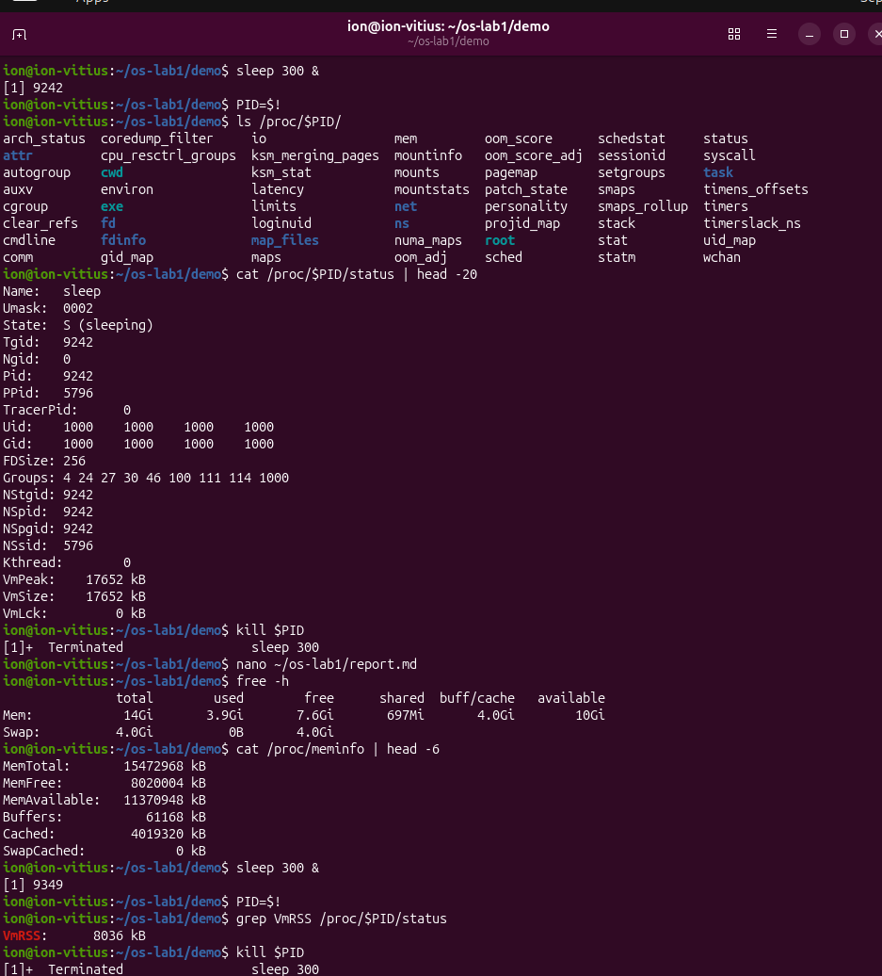
Figure 3.5 – Output of free -h, /proc/meminfo and VmRSS
The swap space is configured at 4.0 GiB, of which 0 B is used (SwapCached: 0 kB): the physical memory was sufficient and the kernel did not need to move pages to disk. For the sleep process (PID 9349), the field VmRSS is 8036 kB, which equals 7.85 MiB. The value is higher than expected for a process that performs no work; it is explained by the shared libraries (such as the C library) mapped into its address space, whose pages are counted in the resident set. Compared with graphical applications, which may occupy hundreds of megabytes, the value remains negligible.

3.4 Exercise 4: Devices and storage
Objective. To identify the device on which the root file system is mounted and to examine how devices are represented in /dev.
Commands used. df -h, lsblk, du -sh, mount, ls -l /dev.
The sequence of commands is given below.
df -h
lsblk
du -sh ~/os-lab1
mount | head
ls -l /dev | head
Description. According to figure 3.6, the command mount | head reports /dev/sda1 on / type ext4 (rw,relatime), so the root file system resides on the partition /dev/sda1 and uses ext4. The same conclusion follows from lsblk: the disk sda (223.6 GB) contains the partition sda1 (218.9 GB) mounted at / and the partition sda2 (1 GB) mounted at /boot/efi, which df -h shows as 1.1 GB with 1 % usage. A second disk, nvme0n1 (476.9 GB), is divided into five partitions, none of which has a mount point in the listing. The numerous loop devices correspond to the snap packages mounted under /snap. The command du -sh ~/os-lab1 reported 16 KB for the lab directory.
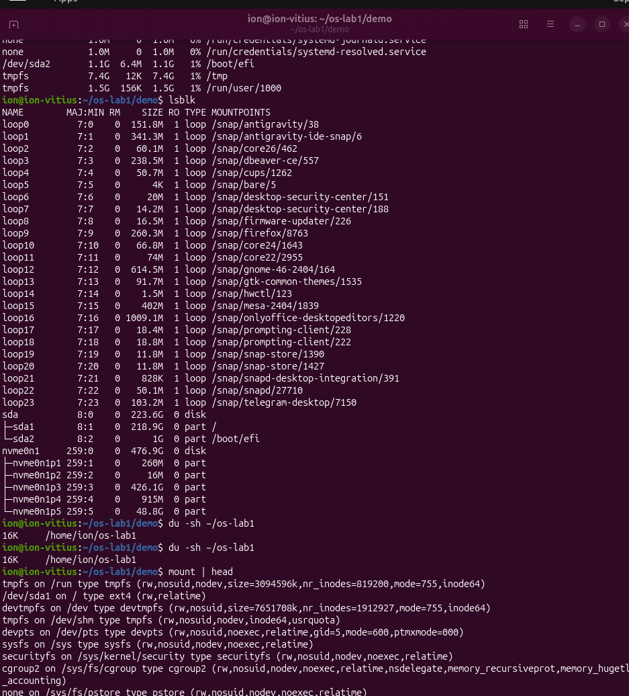
Figure 3.6 – Output of df -h, lsblk, du -sh and mount
The listing of /dev is presented in figure 3.7. The entry console has the type character c and the major and minor numbers 5 and 1, which identifies it as a character device; it represents the system console, on which the kernel writes its messages. Other entries have different types: block and char are directories, and core is a symbolic link to /proc/kcore. Disks, processes and the console were therefore all accessed with the generic tools ls, cat and grep, without dedicated commands for each resource, which confirms the principle “everything is a file”.
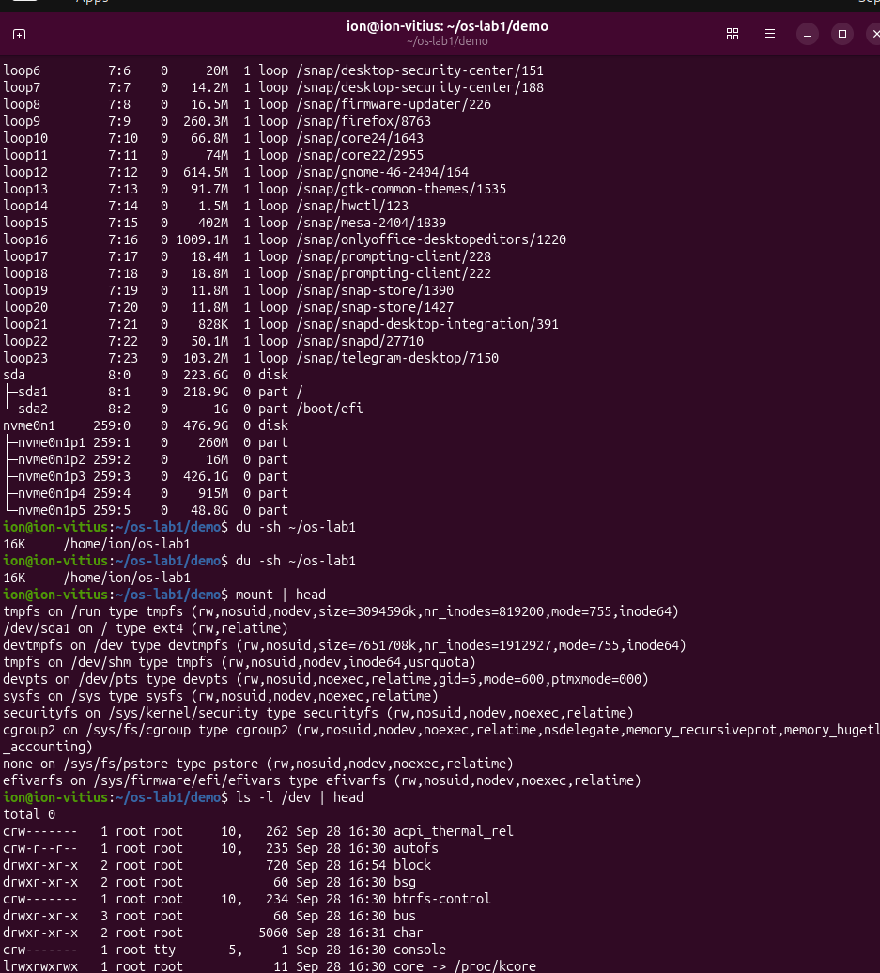
Figure 3.7 – Device files listed with ls -l /dev

3.5 Summary of results
The results of the four exercises are summarised in table 3.2.
Table 3.2 – Summary of the observed results
Resource | Command | Observed result
Files | ls -l, chmod | note.txt owned by ion:ion; mode 644 changed to 600 and restored
Processes | ps aux, /proc/$PID/status | PID 1 is systemd; 341 processes; sleep in state S (sleeping)
Memory | free -h, /proc/meminfo | 14.76 GiB RAM, 3.91 GiB used; swap 4.0 GiB, unused; VmRSS of sleep 8036 kB
Devices | lsblk, mount, ls -l /dev | Root on /dev/sda1 (ext4); console is a character device (5, 1)

CONCLUSION
The practical work confirmed, on a native Ubuntu system, that the operating system manages four classes of resources and exposes each of them through a file-like interface. Files are controlled through ownership and permission bits, and the change of mode from 644 to 600 removed all access for the group and other users [2]. Processes are organised in a tree whose root is systemd with PID 1, and the state of any process can be read from /proc [4], [5]. Memory is reported both globally and per process; the system had 14.76 GiB of RAM, of which 3.91 GiB was used, and the swap space of 4.0 GiB remained unused [6]. Devices are represented in /dev, and the root file system was identified as /dev/sda1 formatted with ext4 [3].
One error occurred during the work: the placeholder <PID> was typed literally in the kill command and rejected by the shell. The correct form, with the numeric PID or the variable $PID, was used afterwards. The exercise shows that a uniform interface simplifies administration, since the same generic tools are sufficient for all four classes of resources.

REFERENCES
[1] Silberschatz A., Galvin P. B., Gagne G. Operating System Concepts. 10th ed. Hoboken: Wiley, 2018.
[2] Linux man-pages project. inode(7) – inode characteristics [online]. Available: https://man7.org/linux/man-pages/man7/inode.7.html [accessed 28.09.2026].
[3] Linux man-pages project. hier(7) – description of the file system hierarchy [online]. Available: https://man7.org/linux/man-pages/man7/hier.7.html [accessed 28.09.2026].
[4] systemd(1) – systemd system and service manager [online]. Available: https://www.freedesktop.org/software/systemd/man/latest/systemd.html [accessed 28.09.2026].
[5] Linux man-pages project. proc(5) – process information pseudo-file system [online]. Available: https://man7.org/linux/man-pages/man5/proc.5.html [accessed 28.09.2026].
[6] The Linux Kernel documentation. The /proc filesystem [online]. Available: https://www.kernel.org/doc/html/latest/filesystems/proc.html [accessed 28.09.2026].

