
MINISTRY OF EDUCATION, CULTURE AND RESEARCH
OF THE REPUBLIC OF MOLDOVA
Technical University of Moldova
Faculty of Computers, Informatics and Microelectronics
Department of Software Engineering and Automation
Ion Dulgheru, group FAF-241
Report
Practical Work No. 2
Operating Systems
Topic: Meet the OS You Will Build
Checked by:
[Name Surname], [academic title]
DISA, FCIM, UTM
Chișinău – 2026
Table of Contents
1 AIM OF THE WORK 3
1.1 Purpose of practical work 3
1.2 Problem statement 3
2 THEORETICAL BACKGROUND 4
2.1 The xv6 operating system 4
2.2 System calls and privilege levels 4
2.3 Pipes and the shell 4
2.4 Emulation with QEMU 5
3 DESCRIPTION OF EXERCISES 6
3.1 Exercise 1: Preparation of the environment 6
3.2 Exercise 2: Building and booting xv6 6
3.3 Exercise 3: Using xv6 as a Unix system 7
3.4 Exercise 4: Reading the source code 9
3.5 Exercise 5: A new user program 10
3.6 Summary of results 12
CONCLUSION 13
REFERENCES 14

1 AIM OF THE WORK

1.1 Purpose of practical work
The purpose of the work is to become familiar with an operating system from the inside. For this, xv6, a small teaching operating system that reimplements Unix Version 6 for the RISC-V architecture, is built from source, started in an emulator, used through its shell, studied at the level of source code and extended with a new user program [1].

1.2 Problem statement
The work is carried out on a native Ubuntu installation (host ion-vitius); the xv6 sources are taken from the public repository of the project [2], and the RISC-V target is emulated with QEMU. The following tasks are formulated:
- to install the cross-compilation toolchain and the emulator required to build xv6;
- to compile the kernel and the user programs and to boot the system up to the shell prompt;
- to run the native programs cat, echo, ls, grep and wc, including a pipeline, and to explain what the operating system must provide for a pipe to work;
- to locate in the source code the implementation of the system calls read and write, and to explain the difference between the directories kernel/ and user/;
- to write a user program sleep, to add it to the build list and to test it inside xv6.

2 THEORETICAL BACKGROUND

2.1 The xv6 operating system
xv6 is a simple Unix-like operating system developed at MIT for teaching. It provides the classical Unix interface (processes, file descriptors, pipes, a hierarchical file system and a shell) in a kernel small enough to be read in full [1]. The source tree is divided by privilege level and purpose, as summarised in table 2.1.
Table 2.1 – Main directories of the xv6 source tree
Directory | Contents
kernel/ | Code executed in privileged mode: memory management, process scheduling, file system, system call handlers (for example, kernel/sysfile.c)
user/ | Programs executed in unprivileged mode (cat, ls, sh, and others), the system call prototypes (user/user.h) and the small user-level library (ulib.c, printf.c, umalloc.c)
mkfs/ | The host program mkfs, which builds the disk image fs.img containing the user programs

2.2 System calls and privilege levels
A modern processor executes code in at least two privilege levels. The kernel runs in the privileged level and has direct access to the hardware, whereas ordinary programs run in the unprivileged level and cannot access devices or the memory of other processes directly [3]. A program obtains a service from the kernel by a system call, which transfers control to the kernel through a controlled entry point, after which the kernel validates the arguments and performs the operation on behalf of the program.
The system calls read(fd, buf, n) and write(fd, buf, n) are the basic input/output primitives: the former copies up to n bytes from the file descriptor fd into a buffer of the calling process, the latter copies n bytes from the buffer to the descriptor [4]. In xv6, each system call is declared as a prototype in user/user.h, and the corresponding stubs of the user side are generated from a script (user/usys.pl).

2.3 Pipes and the shell
A pipe is a unidirectional channel between two processes: the bytes written at one end are read at the other end [5]. For a command line such as ls | grep c to work, the shell creates the pipe with the system call pipe(), creates a separate process for each command with fork(), connects the standard output of the first process and the standard input of the second one to the ends of the pipe, and starts the programs with exec(). Pipelines thus require both processes and an inter-process communication mechanism from the operating system.

2.4 Emulation with QEMU
QEMU is an emulator that reproduces a complete machine in software, which allows a RISC-V system to be executed on an x86_64 host [6]. The xv6 build uses the generic machine virt, loads the compiled kernel directly with the option -kernel, defines the number of processor cores with -smp and attaches the disk image fs.img as a virtual block device.

3 DESCRIPTION OF EXERCISES

3.1 Exercise 1: Preparation of the environment
Objective. To install the RISC-V toolchain and the emulator on the host system.
Commands used. apt, hash, qemu-system-riscv64.
The following command installs the base tools and the cross-compiler:
sudo apt install -y git build-essential gdb-multiarch \
qemu-system-misc gcc-riscv64-linux-gnu \
binutils-riscv64-linux-gnu
Description. The host is a native Ubuntu installation, not the virtual machine provided for the course, so the toolchain was not present and was installed manually. On the first attempt to run make qemu, the emulator qemu-system-riscv64 was not found. As shown in figure 3.1, the shell reports that the command can be installed with the package qemu-system-riscv; on this version of Ubuntu the binary was moved from qemu-system-misc into a separate package.
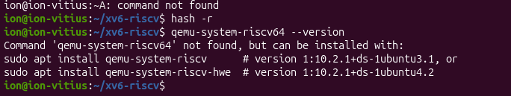
Figure 3.1 – Diagnosis of the missing qemu-system-riscv64 command
The package was installed with sudo apt install qemu-system-riscv; the installation added three packages (qemu-system-riscv, opensbi and qemu-efi-riscv64), with a download size of 10.3 MB. After refreshing the command cache of the shell with hash -r, the command qemu-system-riscv64 --version reported QEMU emulator version 10.2.1, as can be seen in the upper part of figure 3.2.

3.2 Exercise 2: Building and booting xv6
Objective. To compile the kernel and the user programs and to boot xv6 up to the shell prompt.
Commands used. git clone, make qemu.
git clone https://github.com/mit-pdos/xv6-riscv ~/xv6-riscv
cd ~/xv6-riscv
make qemu
Description. The command make qemu compiled the kernel and the user programs with the cross-compiler riscv64-linux-gnu-gcc, built the disk image with the host program mkfs and started QEMU. The emulator was launched with the parameters -machine virt, -kernel kernel/kernel, -m 128M, -smp 3 and -nographic, with fs.img attached as a virtio block device, as shown in figure 3.2.
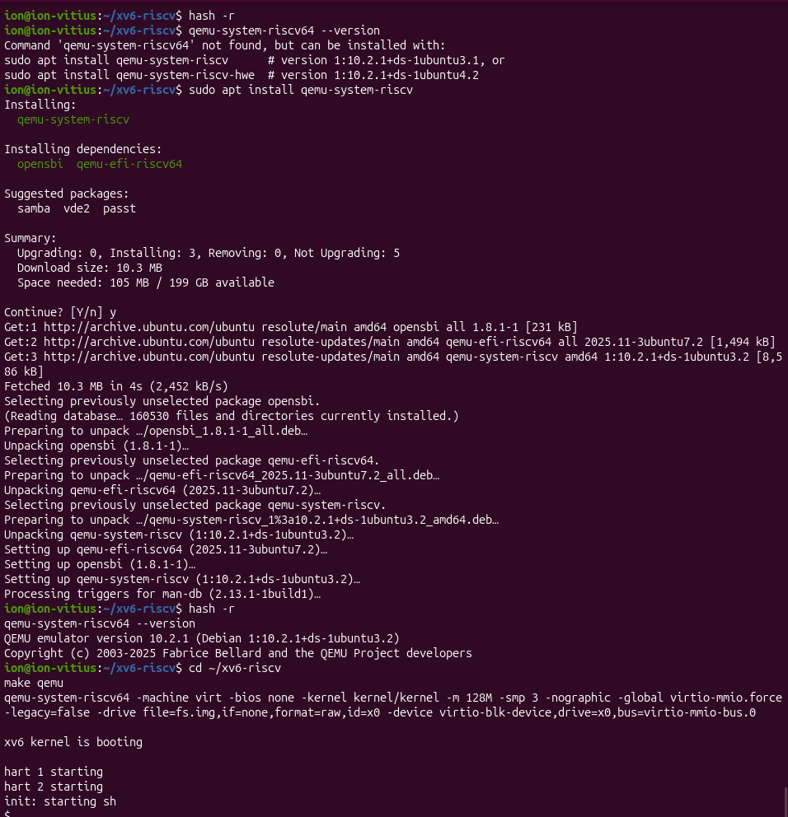
Figure 3.2 – Installation of the emulator package, build and boot of xv6
The boot sequence printed the messages xv6 kernel is booting, hart 1 starting, hart 2 starting and init: starting sh, followed by the prompt $. The two messages of the type hart N starting correspond to the additional processor cores, in agreement with the option -smp 3, and the last message shows that the first user process init started the shell, which confirms a successful boot.

3.3 Exercise 3: Using xv6 as a Unix system
Objective. To run native xv6 programs, including a pipeline, and to explain the mechanism of a pipe.
Commands used. ls, cat, echo, grep, wc.
ls
cat README
echo hello xv6
ls | grep c
wc README
Description. The results are presented in figure 3.3. The program cat prints the contents of a file (or of the standard input), echo prints its arguments (echo hello xv6 displayed hello xv6), and wc counts the lines, words and bytes of a file; for the file README, it returned 48 lines, 336 words and 2441 bytes.
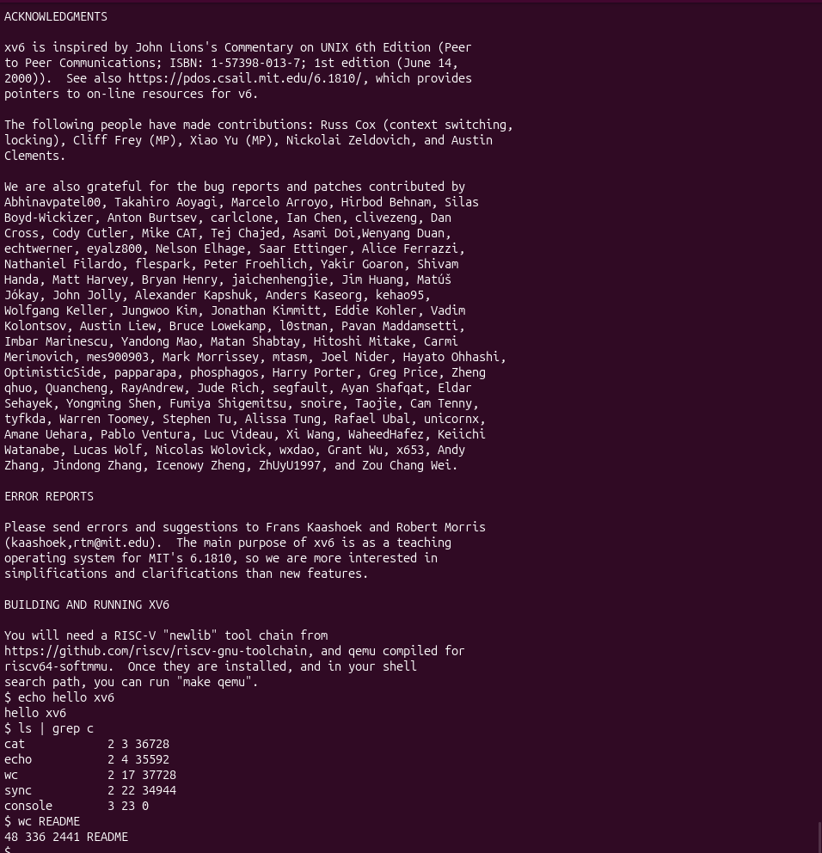
Figure 3.3 – Execution of native xv6 programs
The output of ls | grep c contains the five entries whose names include the letter c; the fields printed by the xv6 version of ls (name, type, inode number and size in bytes) are interpreted in table 3.1.
Table 3.1 – Output of ls | grep c in xv6
Name | Type | Inode | Size, bytes | Interpretation
cat | 2 | 3 | 36728 | Regular file (program)
echo | 2 | 4 | 35592 | Regular file (program)
wc | 2 | 17 | 37728 | Regular file (program)
sync | 2 | 22 | 34944 | Regular file (program)
console | 3 | 23 | 0 | Device file, without data on disk

The type code 2 denotes a regular file and 3 denotes a device [1]; the console has size 0 because it is not a sequence of bytes stored on disk, but an interface to a device, which illustrates the same principle of uniform file access observed in the previous work.
For the pipe in ls | grep c to work, two elements are required. The first is the existence of separate processes: the shell creates one process for ls and another for grep c with fork(). The second is an inter-process communication mechanism: the system call pipe() creates a channel with two ends, and the shell connects the output of the first process to the input of the second one. The shell of xv6 (sh.c) is a minimal program of a few hundred lines, which understands simple commands, redirections and pipes, whereas bash, studied in the previous work, adds job control, command history, completion and complex scripting; both rely on the same kernel primitives fork, exec and pipe.

3.4 Exercise 4: Reading the source code
Objective. To locate the system calls read and write in the kernel and to examine the interface between user programs and the kernel.
Commands used. grep -n, cat user/user.h.
grep -n "sys_read\|sys_write" kernel/sysfile.c | head
cat user/user.h
Description. The search returned 69:sys_read(void) and 83:sys_write(void), so the handler of read is implemented in the file kernel/sysfile.c at line 69, and the handler of write follows at line 83. In these handlers, the kernel validates the descriptor received from the user process, finds the corresponding file structure and copies the data.
The program user/cat.c uses the two system calls in a loop: it reads a block of bytes from the input descriptor with read(fd, buf, n), writes it to the output descriptor with write(fd, buf, n) and continues until read() returns 0, which signals the end of the file. The system calls are declared as prototypes in user/user.h, as shown in figure 3.4, and are not ordinary library functions. The section // system calls of this file contains 22 prototypes.
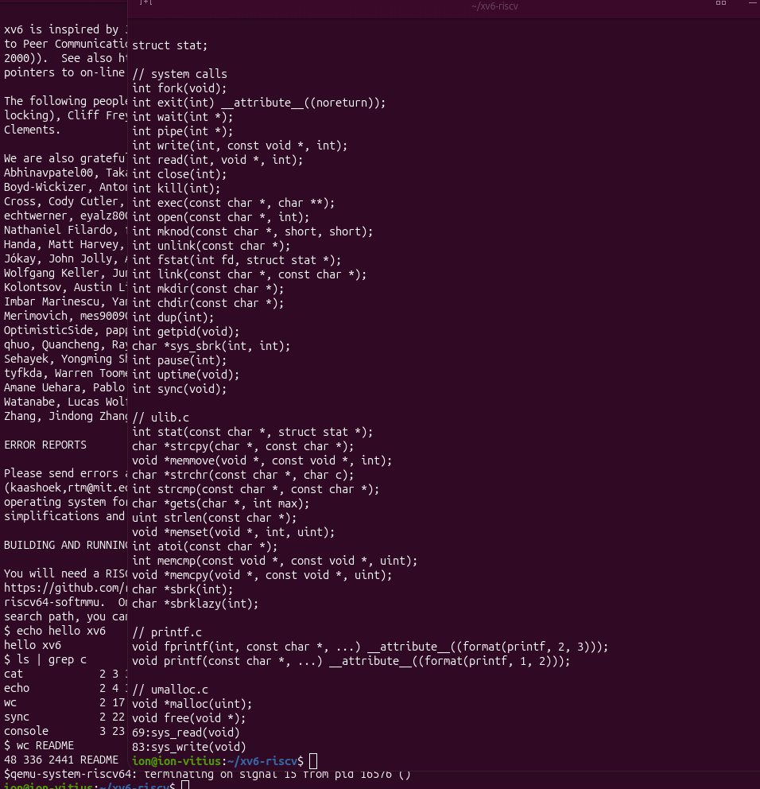
Figure 3.4 – Contents of user/user.h and the result of grep -n
The directory kernel/ contains the code executed in the privileged mode of the processor, with direct access to the hardware: memory management, the scheduler, the file system and the handlers of system calls. The directory user/ contains ordinary programs (cat, ls, the shell), executed in the unprivileged mode; any real action, such as reading a file or allocating memory, passes through a system call, i.e. an explicit request to the kernel.
Figure 3.4 also shows that the list contains the prototype int pause(int); and does not contain sleep: in this copy of xv6, the system call that suspends a process was renamed. This detail affects the next exercise.

3.5 Exercise 5: A new user program
Objective. To write the user program sleep, which pauses the execution for a given number of ticks, and to test it in xv6.
Commands used. nano, make qemu, sleep.
The source code of the program, saved as user/sleep.c, is the following:
// user/sleep.c
#include "kernel/types.h"
#include "user/user.h"

int
main(int argc, char *argv[])
{
if(argc != 2){
fprintf(2, "usage: sleep <ticks>\n");
exit(1);
}
// syscall-ul se numeste "pause" in aceasta copie de xv6
pause(atoi(argv[1]));
exit(0);
}
Description. The program checks the number of arguments: if it differs from two, it prints the message usage: sleep <ticks> to the standard error (descriptor 2) and terminates with the code 1. Otherwise, it converts the argument to an integer with atoi and calls the system call that pauses the process, after which it terminates with the code 0.
The first version of the program called sleep(...). As shown in the upper part of figure 3.6, the compilation failed with the error implicit declaration of function ‘sleep’ at line 11 of user/sleep.c. The compiler is invoked with the options -Wall -Werror, so the warning was treated as an error and make terminated with Error 1. Since the name of the system call is pause in this copy of xv6 (exercise 4), the call was replaced with pause(...); the name of the program was not changed.
For the program to be included in the disk image, it was added at the end of the list UPROGS in the Makefile, as follows:
UPROGS=\
$U/_cat\
$U/_echo\
...
$U/_sync\
$U/_sleep
The modified list is shown in figure 3.5.
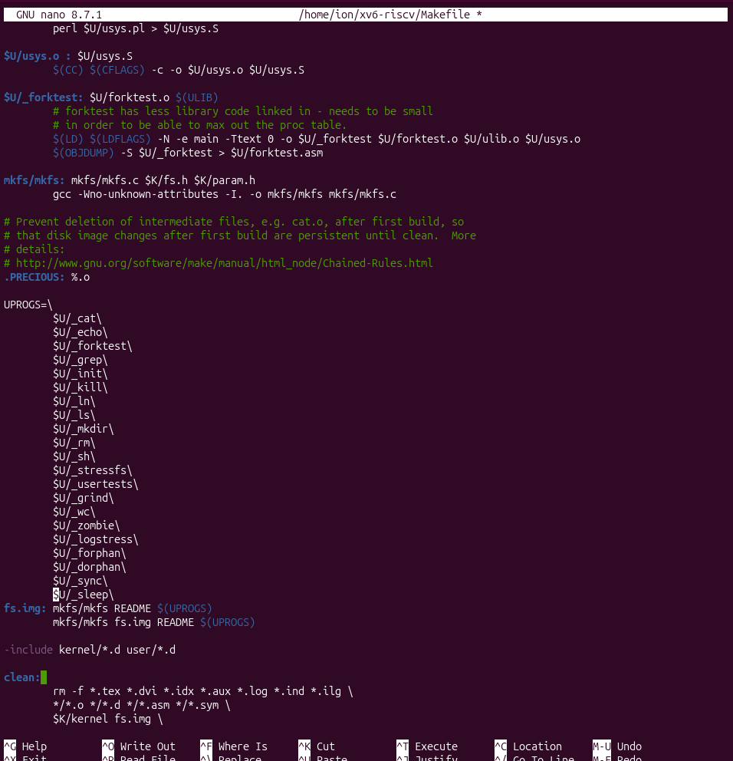
Figure 3.5 – The UPROGS list in the Makefile with $U/_sleep added
After the rebuild, the output of mkfs in figure 3.6 reports nmeta 47 (boot, super, log blocks 31, inode blocks 13, bitmap blocks 1) blocks 1953 total 2000. The number of metadata blocks follows formula (3.1).
N_meta = 2 + N_log + N_inode + N_bitmap (3.1)
where N_meta is the number of metadata blocks; the constant 2 stands for the boot block and the super block; N_log, N_inode and N_bitmap are the numbers of log, inode and bitmap blocks.
Substituting the values from the output gives 2 + 31 + 13 + 1 = 47, which agrees with nmeta 47. The number of blocks available for data is determined by formula (3.2).
N_data = N_total − N_meta (3.2)
where N_data is the number of data blocks and N_total is the total number of blocks of the image.
According to formula (3.2), N_data = 2000 − 47 = 1953, which equals the value blocks 1953 printed by mkfs. Since the block size of xv6 is 1024 bytes [1], the image has a size of 2000 KiB, i.e. approximately 1.95 MiB.
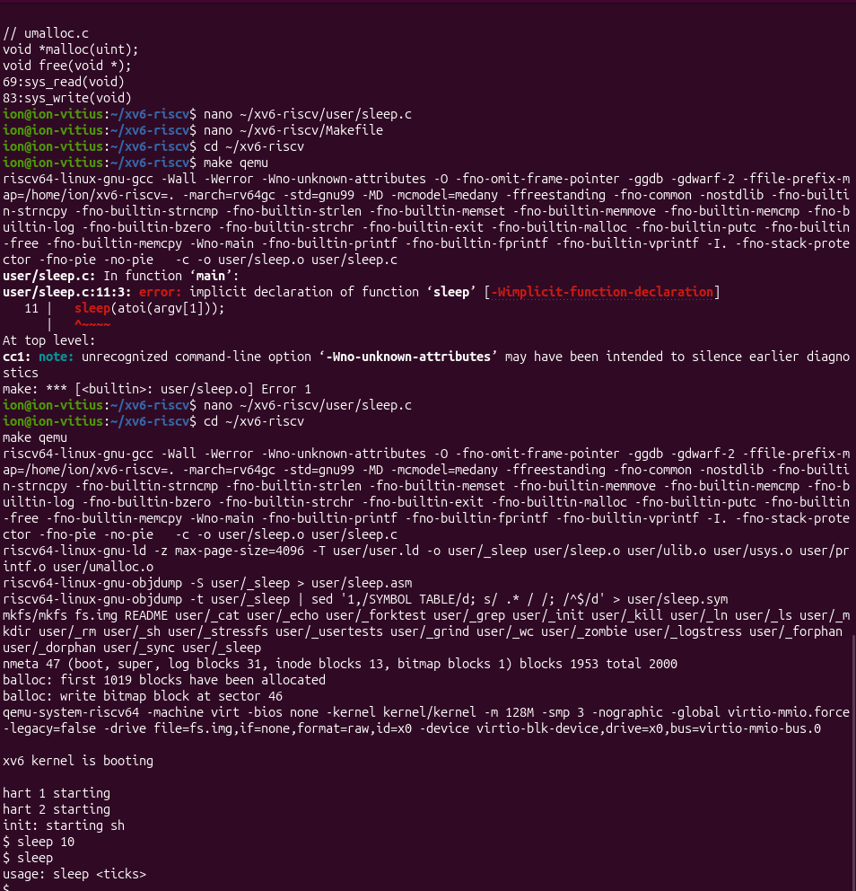
Figure 3.6 – Failed and successful compilation, and testing of the sleep program
After the successful build and boot, the command sleep 10 suspended the execution and returned to the prompt after the interval, and sleep without an argument printed usage: sleep <ticks>, as required.

3.6 Summary of results
The results of the exercises are summarised in table 3.2.
Table 3.2 – Summary of the observed results
Exercise | Result
Environment | Package qemu-system-riscv installed separately; QEMU 10.2.1
Build and boot | make qemu successful; xv6 reached the shell prompt with 3 cores
Native programs | cat, echo, wc and the pipeline ls | grep c executed; README has 48 lines, 336 words, 2441 bytes
Source code | sys_read at line 69 and sys_write at line 83 of kernel/sysfile.c; 22 system call prototypes in user/user.h
New program | user/sleep.c compiled after replacing sleep with pause; sleep 10 and sleep tested

CONCLUSION
The practical work confirmed that a complete, although small, operating system can be built and studied on an ordinary host. xv6 was compiled with the RISC-V cross-compiler and started in QEMU 10.2.1 up to the shell prompt [2], [6]. The native programs and the pipeline ls | grep c showed that the shell relies on the primitives fork, exec and pipe [5]. The reading of the source code located the handlers of read and write in kernel/sysfile.c and clarified the separation between the privileged code in kernel/ and the unprivileged programs in user/ [1], [3], [4].
Two problems occurred and were solved. The emulator qemu-system-riscv64 was missing and was installed as the separate package qemu-system-riscv. The first version of sleep.c did not compile because the system call is named pause in this copy of xv6, which was found by reading user/user.h. The finished program user/sleep.c was tested with a valid and an invalid number of arguments, and the work showed from the inside the system call interface that was used from the outside in the previous work.

REFERENCES
[1] Cox R., Kaashoek F., Morris R. xv6: a simple, Unix-like teaching operating system [online]. MIT. Available: https://pdos.csail.mit.edu/6.828/2023/xv6/book-riscv-rev3.pdf [accessed 28.09.2026].
[2] MIT PDOS. xv6-riscv source repository [online]. Available: https://github.com/mit-pdos/xv6-riscv [accessed 28.09.2026].
[3] Silberschatz A., Galvin P. B., Gagne G. Operating System Concepts. 10th ed. Hoboken: Wiley, 2018.
[4] Linux man-pages project. read(2) – read from a file descriptor [online]. Available: https://man7.org/linux/man-pages/man2/read.2.html [accessed 28.09.2026].
[5] Linux man-pages project. pipe(2) – create pipe [online]. Available: https://man7.org/linux/man-pages/man2/pipe.2.html [accessed 28.09.2026].
[6] QEMU documentation. RISC-V System emulator [online]. Available: https://www.qemu.org/docs/master/system/target-riscv.html [accessed 28.09.2026].

