
MINISTRY OF EDUCATION, CULTURE AND RESEARCH
OF THE REPUBLIC OF MOLDOVA
Technical University of Moldova
Faculty of Computers, Informatics and Microelectronics
Department of Software Engineering and Automation

Done by: st. gr. FAF-241, Dulgheru Ion

Report
Practical Work No. 9
Operating Systems
Topic: Watching System Calls with strace (Linux)

Checked by:
Reitman Patricia university assistant
DISA, FCIM, UTM

Chișinău – 2026
Table of Contents
1 AIM OF THE WORK 3
1.1 Purpose of practical work 3
1.2 Problem statement 3
2 THEORETICAL BACKGROUND 4
2.1 System calls and the kernel boundary 4
2.2 The tool strace 4
2.3 File descriptors 4
3 DESCRIPTION OF EXERCISES 5
3.1 Environment preparation 5
3.2 Part 1. The system calls of a real command 5
3.3 Part 2. A program that calls the kernel directly 5
CONCLUSION 6
REFERENCES 7

1 AIM OF THE WORK

1.1 Purpose of practical work
The purpose of the practical work is to observe the boundary between a user program and the operating system kernel, which is the system call, using Linux as the reference platform [1]. A program cannot read a file or write to the screen by itself; it asks the kernel to do this through a small set of calls such as open, read, write and close [2].
In the first stage the calls made by the real command ls -l are observed with the tool strace. In the second stage a small C program is written that uses open, write, read and close directly, and its calls are watched from outside with the same tool.

1.2 Problem statement
The practical work consists of two consecutive tasks:
- tracing the calls of the command ls -l with strace, counting them and finding the call used for printing;
- writing the program syscalls.c that creates a file, writes a line, reads it back, and observing the corresponding system calls with strace.
The program is compiled with gcc using the options -Wall -Wextra, and no warning is allowed.

2 THEORETICAL BACKGROUND

2.1 System calls and the kernel boundary
The processor works in two modes. The kernel runs in the privileged mode and controls the hardware, the files and the memory, and a user program runs in the unprivileged mode and cannot touch them directly. When a program needs a service of the kernel, it executes a system call, the processor switches to the kernel mode, the kernel performs the operation and returns the result [2], [3].
The functions open, read, write and close of the C library are thin wrappers around the corresponding system calls. The function printf is different: it formats the text in a buffer of the program and then calls write to hand the bytes to the kernel.

2.2 The tool strace
The tool strace runs a command and prints every system call made by it, together with the arguments and the returned value; a failed call returns -1 and strace shows the error name [4]. The option -f also follows the child processes, the option -e trace= selects the calls to be shown, and the option -c prints only a summary table with the number of calls, the time and the errors of every call.

2.3 File descriptors
A file descriptor is a small non-negative integer that identifies an open file in a process. Every process starts with three descriptors inherited from the shell: 0 is the standard input, 1 is the standard output and 2 is the standard error. The kernel always returns the lowest free descriptor number, so the first file opened by a program receives the number 3 [2].

3 DESCRIPTION OF EXERCISES

3.1 Environment preparation
The work was performed on a laptop with Ubuntu Linux. The tool strace was installed with the command sudo apt install strace, and its version, 6.19, is shown in figure 3.1.
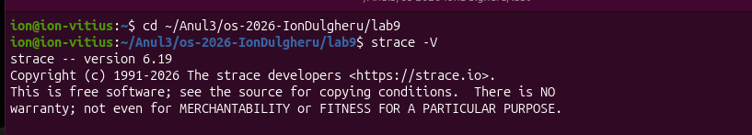
Figure 3.1 – Installation check of strace

3.2 Part 1. The system calls of a real command
The command ls -l was traced with the following command, which shows only the calls that work with files:
strace -f -e trace=openat,read,write,close ls -l
The result is shown in figure 3.2. First there is a burst of openat, read and close calls, as the program loads the dynamic linker, the C library and the files /etc/passwd and /etc/group, and at the end there is a write call that prints the listing.
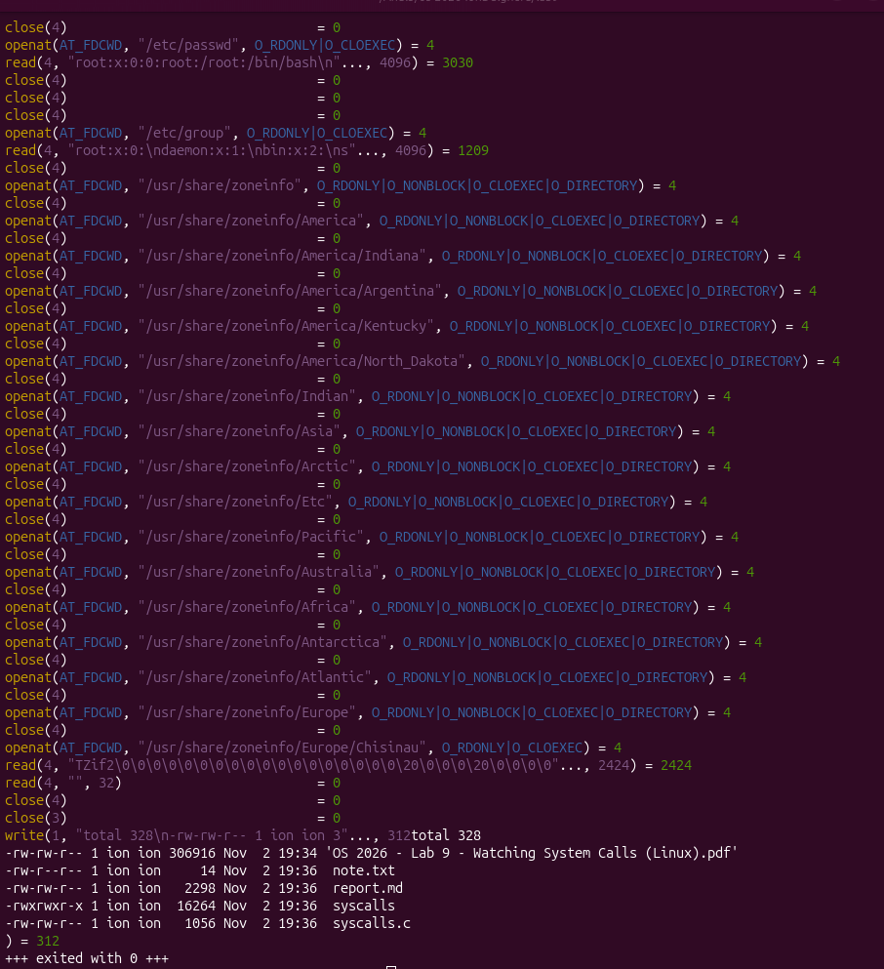
Figure 3.2 – File-related system calls of ls -l
To count the calls the option -c was used:
strace -f -c ls -l
The summary is presented in figure 3.3. One simple ls -l makes 289 system calls in total, and 9 of them fail. The most frequent calls are listed in table 3.1.
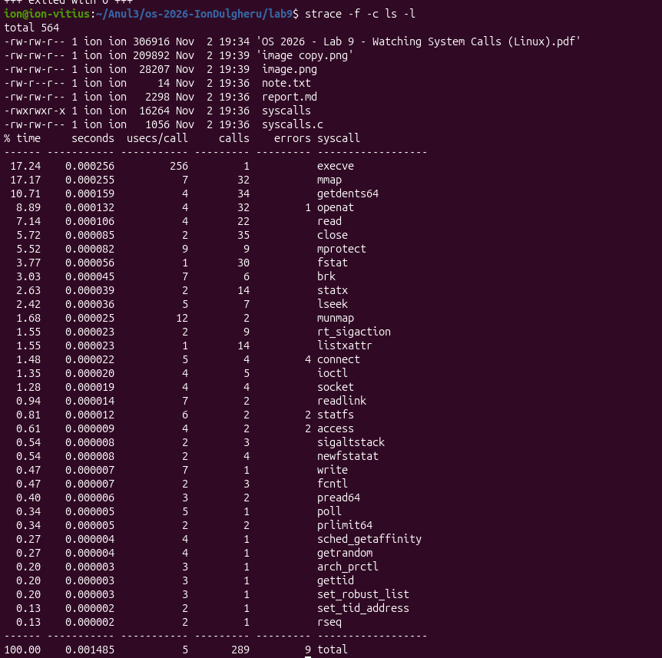
Figure 3.3 – Summary of the system calls of ls -l
Table 3.1 – The most frequent system calls of ls -l
System call | Count | Purpose
close | 35 | closes the opened files
getdents64 | 34 | reads the entries of the directory
mmap | 32 | maps the libraries and memory into the process
openat | 32 | opens files (libraries, /etc/passwd, the directory)
fstat | 30 | reads the attributes of an opened file
read | 22 | reads the content of the opened files
write | 1 | prints the listing on the screen

Most of the calls belong to the start-up of the program and not to the listing itself: loading of the dynamic linker and of the C library, reading of the user and group databases and of the time zone files, and getdents64 and statx for the directory.
Observation. The command ls prints with the system call write, to the descriptor 1, which is the standard output connected to the screen:
write(1, "total 328\n-rw-rw-r-- 1 ion ion 3"..., 312) = 312
Only one write call is needed, because ls prepares the whole listing in a buffer and sends it to the kernel at once.

3.3 Part 2. A program that calls the kernel directly
The program syscalls.c creates the file note.txt, writes the line hello, kernel into it, closes it, opens it again and reads the line back. The source is shown below and in figure 3.4.
#include <fcntl.h> /* open */
#include <unistd.h> /* write, read, close */
#include <string.h> /* strlen */
#include <stdio.h> /* printf */
int main(void) {
const char *msg = "hello, kernel\n";
int fd = open("note.txt", O_CREAT | O_WRONLY | O_TRUNC, 0644);
if (fd < 0) { perror("open"); return 1; }
printf("open returned descriptor %d\n", fd);
ssize_t n = write(fd, msg, strlen(msg));
printf("write sent %zd bytes\n", n);
close(fd);
fd = open("note.txt", O_RDONLY);
char buf[64];
n = read(fd, buf, sizeof(buf) - 1);
buf[n] = '\0';
printf("read got %zd bytes: %s", n, buf);
close(fd);
return 0;
}
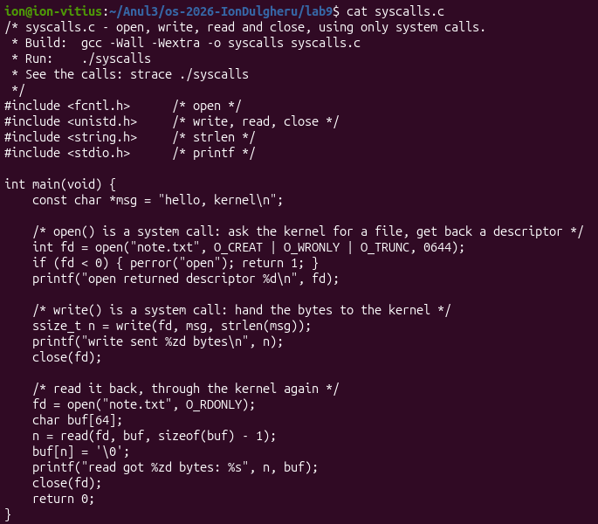
Figure 3.4 – Source code of syscalls.c
The program was compiled with the command gcc -Wall -Wextra -o syscalls syscalls.c without any warning and executed. The result is shown in figure 3.5 and it is the same as the expected output: the first descriptor is 3, 14 bytes are written and the same 14 bytes are read back.
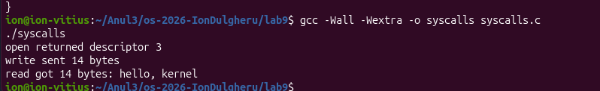
Figure 3.5 – Compilation and execution of syscalls
The same program was then watched from outside:
strace -e trace=openat,write,read,close ./syscalls
Among the start-up lines (/etc/ld.so.cache, libc.so.6), which belong to the loading of the C library before main, the calls of the program are visible in figure 3.6. They correspond to the C calls as shown in table 3.2.
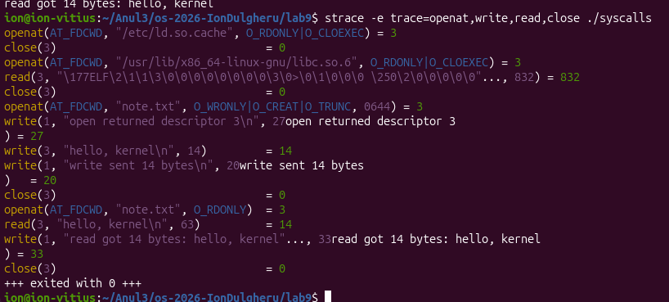
Figure 3.6 – System calls of syscalls
Table 3.2 – C calls and the system calls observed by strace
C call | System call | Result
open("note.txt", O_CREAT|O_WRONLY|O_TRUNC, 0644) | openat(AT_FDCWD, "note.txt", O_WRONLY|O_CREAT|O_TRUNC, 0644) | 3
write(fd, msg, 14) | write(3, "hello, kernel\n", 14) | 14
close(fd) | close(3) | 0
open("note.txt", O_RDONLY) | openat(AT_FDCWD, "note.txt", O_RDONLY) | 3
read(fd, buf, 63) | read(3, "hello, kernel\n", 63) | 14
close(fd) | close(3) | 0

The call open of the C library became openat(AT_FDCWD, ...), the modern Linux call, where AT_FDCWD means that the name is relative to the current directory. The call read asked for 63 bytes, which is sizeof(buf) - 1, but received only 14, the size of the file. The write(1, ...) lines between them belong to the printf calls that print on the screen.
Observation. The first descriptor returned by openat is 3 and not 0, 1 or 2, because every process starts with three descriptors already open, inherited from the shell: 0 is stdin (keyboard), 1 is stdout (screen) and 2 is stderr (screen, for errors). The kernel gives a new file the lowest free number, and 0, 1 and 2 are taken. After close(3) the number 3 is free again, which is why the second openat also returns 3.

CONCLUSION
In this practical work the system-call interface of Linux was observed with the tool strace. The command ls -l, which seems simple, makes 289 system calls, most of them during the start-up of the program, and it prints its result with one write call to the descriptor 1 [4].
The program syscalls.c showed that the functions open, write, read and close of C are real system calls: strace displays them as openat, write, read and close with the same arguments and results. The experiment also explained why the first opened file receives the descriptor 3: the descriptors 0, 1 and 2 are inherited by every process, and the kernel always returns the lowest free number [2], [5].

REFERENCES
[1] Operating Systems 2026. Lab 9: Watching System Calls with strace (Linux). Technical University of Moldova, FCIM, 2026.
[2] Kerrisk M. The Linux Programming Interface. San Francisco: No Starch Press, 2010. 1556 p. ISBN 978-1-59327-220-3.
[3] Tanenbaum A. S., Bos H. Modern Operating Systems. 4th ed. Boston: Pearson, 2015. 1136 p. ISBN 978-0-13-359162-0.
[4] strace(1) – Linux manual page. Available: https://man7.org/linux/man-pages/man1/strace.1.html (accessed 02.11.2026).
[5] open(2) – Linux manual page. Available: https://man7.org/linux/man-pages/man2/open.2.html (accessed 02.11.2026).
[6] write(2) – Linux manual page. Available: https://man7.org/linux/man-pages/man2/write.2.html (accessed 02.11.2026).
[7] read(2) – Linux manual page. Available: https://man7.org/linux/man-pages/man2/read.2.html (accessed 02.11.2026).

