Team 27

Mackenzie O’Connor  
Ion Mircea  
Priyanka Sharma  
Jason Shin

To help the Child Mind Institute “deploy further intervention and support services to children and their families,” were tasked with analyzing trends in over 6,000 open-ended survey responses that the Institute had collected during a survey they ran. The survey focused on Coronavirus and asked participants to describe how various aspects of their lives that have been affected by the changes implemented in our lifestyles due to the pandemic. In order to effectively derive conclusions based on this data, we focused on the April 2020 and April 2021 surveys, as they also included demographic information, to the propose the following methods:

* Pull top words that are used throughout the “specifypositive” attribute
  + Compare between 2020 and 2021 files (example below)
* Key word extractions from both files (2020, 2021 files shown in example below)
  + Compare/contrast
* Clustering based on key words & sentiment analysis
  + Comparison of 2020 and 2021 files shown in examples below
* “Dynamic Topic Modeling” (DTM) using BERTopic
  + Plug in CMI data and model the evolution of topic’s related to the outlook on COVID
  + Use to determine changes in thought as it relates to how the pandemic has affected our lives (using the survey data)

# Prolific Academic Data

Parent data

April 2020 April 2021

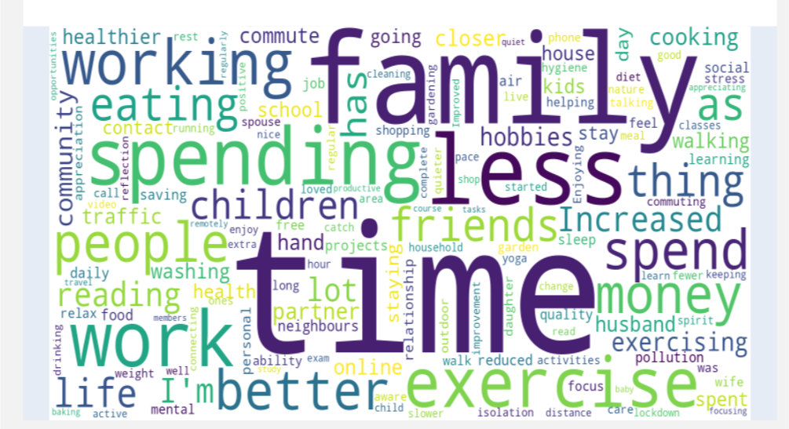 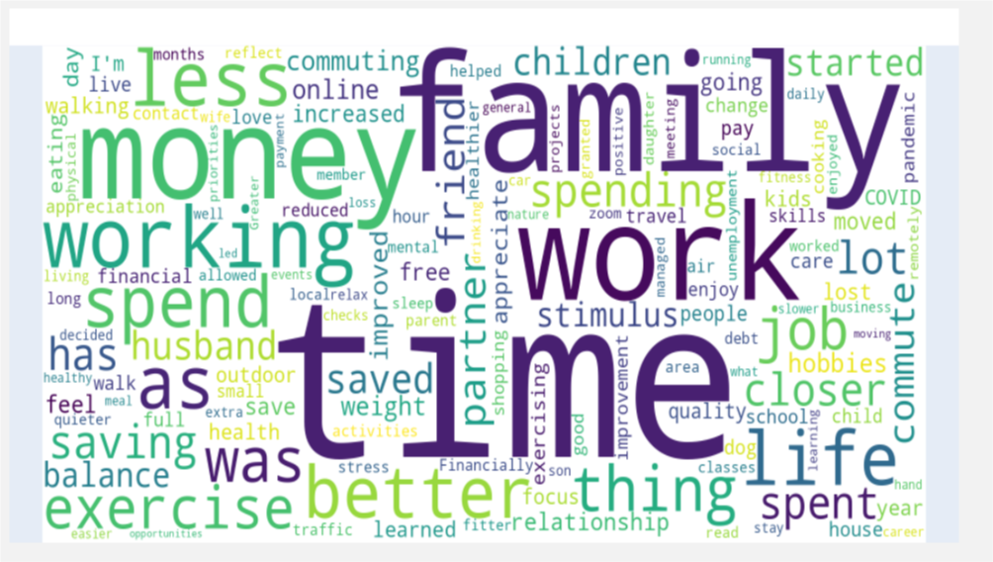

Sentiment distribution parent data

2020

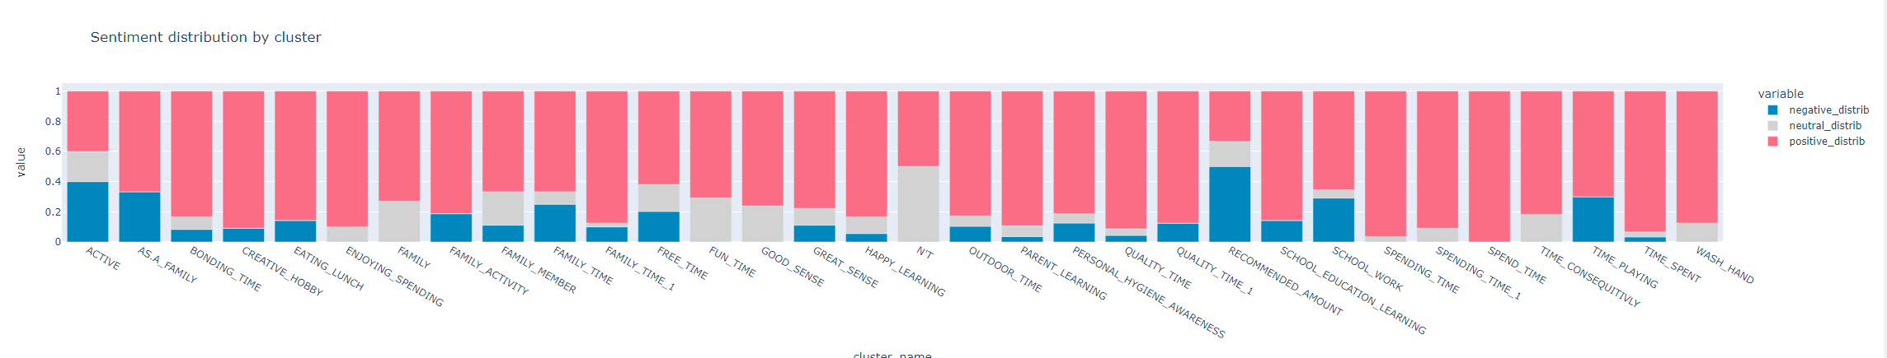

2021

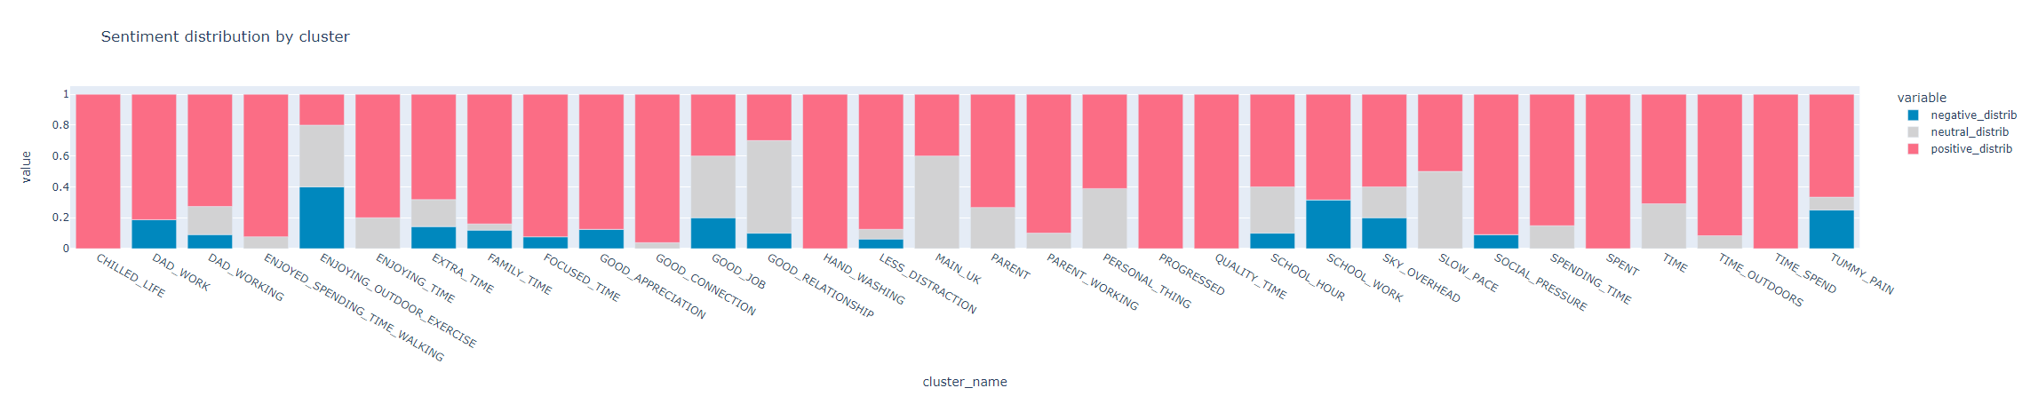

**Categories with no changes from April 2020 to April 2021 (Adult data)**

Free time

2020

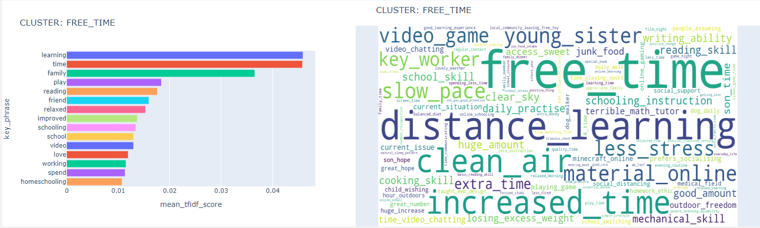

2021

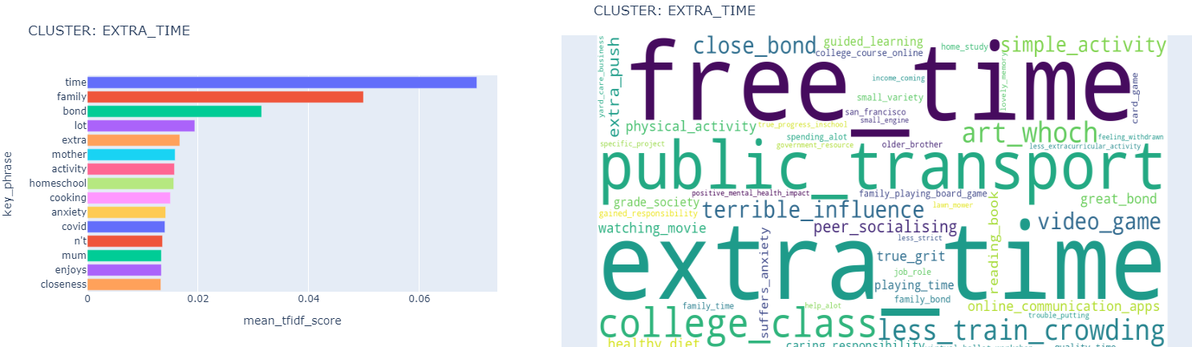

**Categories with sentiment changes from April 2020 to April 2021 (parent data**)

Family time

Slight degradation of the sentiment with “stressful” sentiment added in 2021

2020

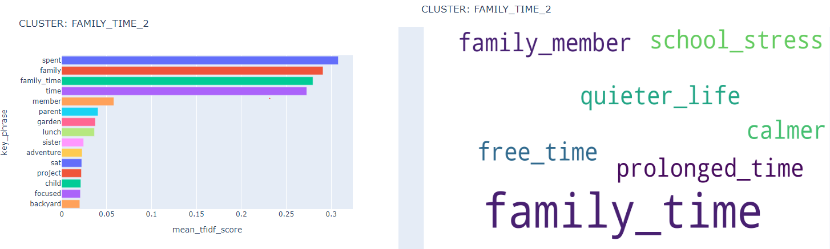

2021

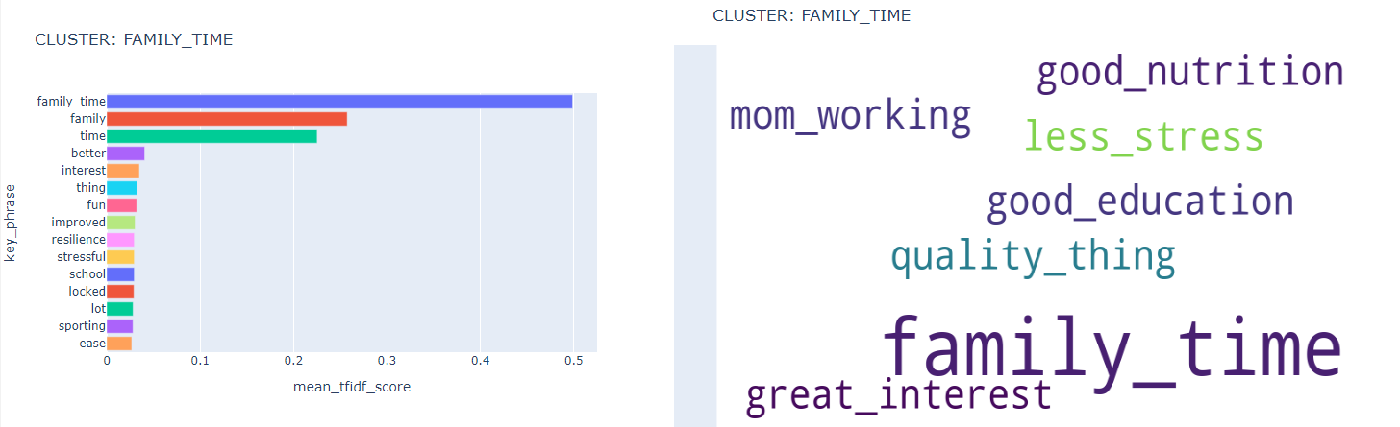

Adult data

Sentiment distribution Adult data

Adult 2020

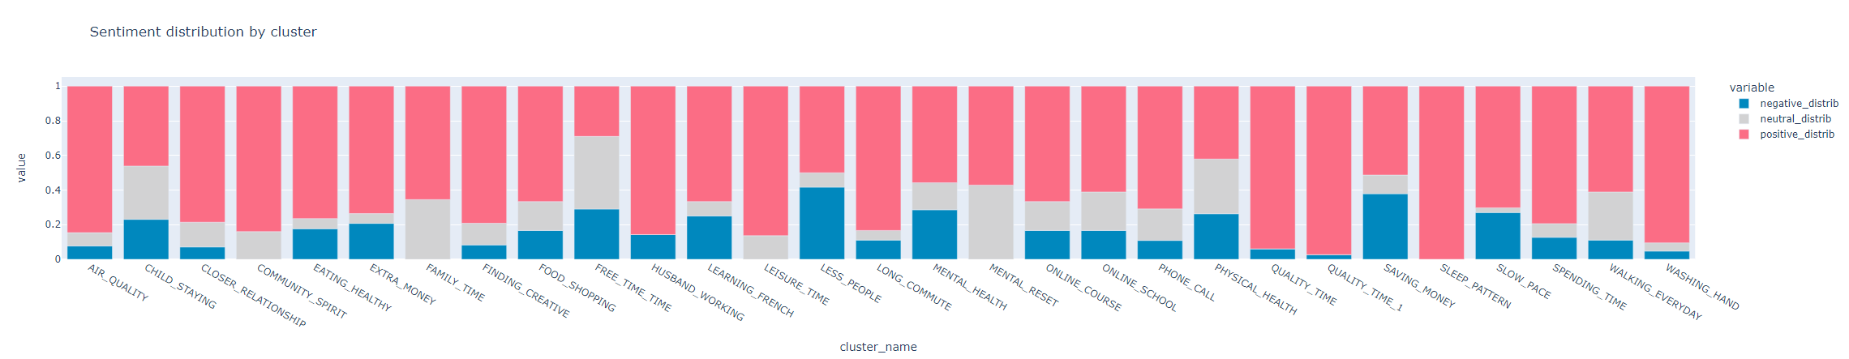

Adult 2021

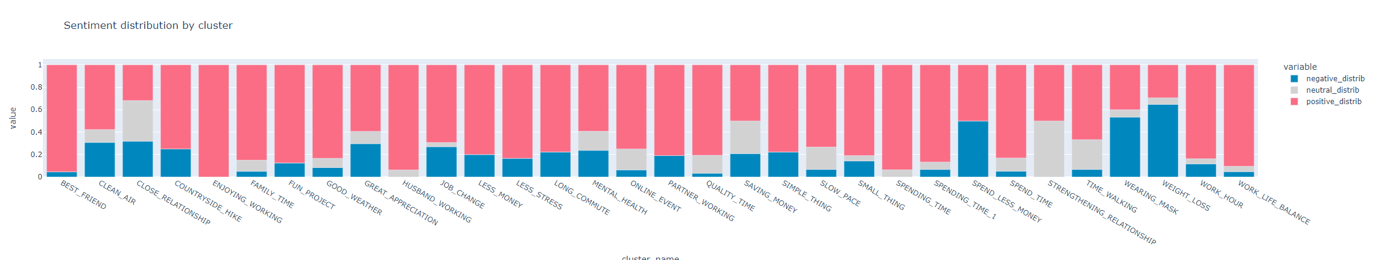

**Categories with no changes from April 2020 to April 2021 (Adult data)**

Clean Air

2020

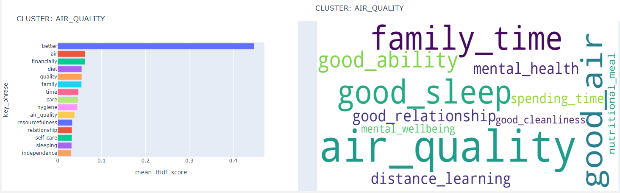

2021

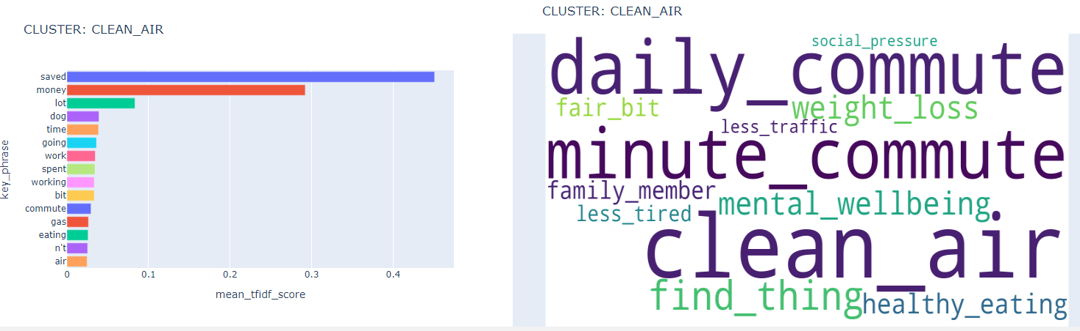

Mental health

2020

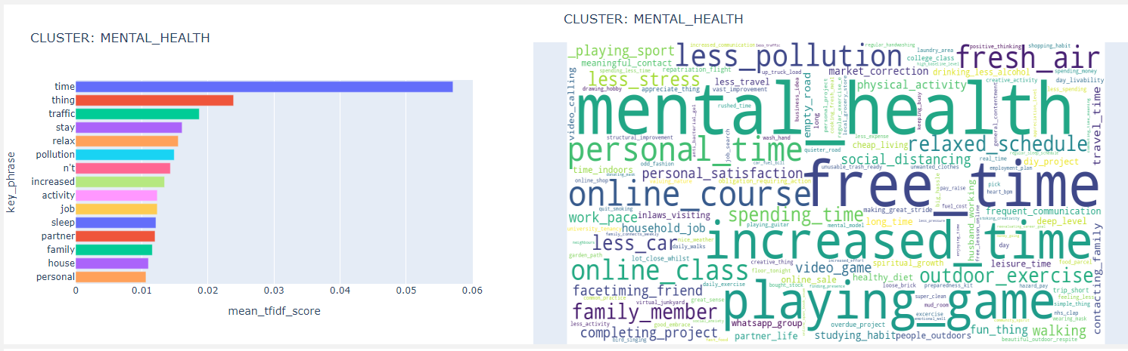

2021

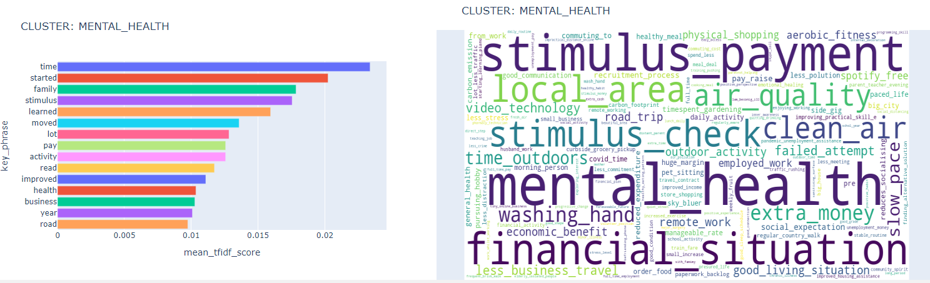

**Categories with sentiment changes from April 2020 to April 2021 (Adult data)**

Wearing masks

Was not observed in April 2020 and mixed positive/negative sentiments in 2021

2021

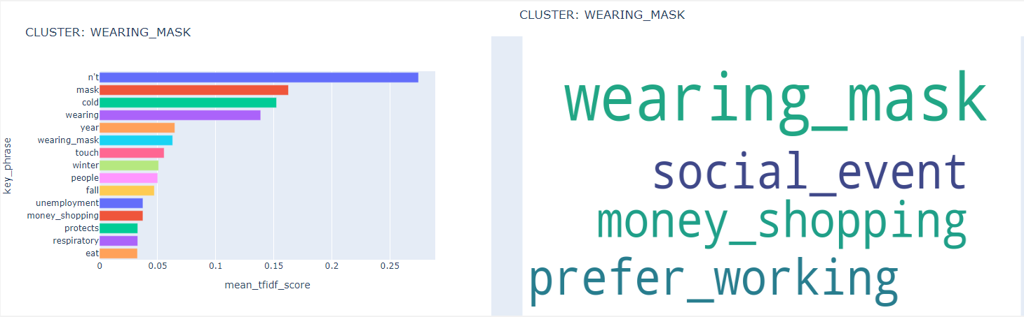

Weight loss

Not present in April 2020 Adult data becomes awareness in April 2021

