Practical 1 – Compression
Overview
The task of this practical is to write a GUI application in Java allowing experimentation with Huffman coding and arithmetic coding. The user has to enter an information source which is then to be encoded and decoded using the above-mentioned coding techniques.

Design
My program is divided into 3 parts: Arithmetic Coding, Huffman Coding and GUI.

GUI
The GUI makes use of the swing library and creates a JFrame that displays input fields for the user as well as text fields where results are displayed.

It is important to mention that the statistics that the GUI provides are the time each encoding and decoding method takes, the sizes of the original and encoded messages and the compression ratio. Those are displayed side by side to make it easy to compare.

Also, I decided, for ease of use purposes that the user does not have to input probabilities, but frequencies instead. I believe that this makes it a lot easier for the user, since the probabilities are calculated by the program automatically.

Huffman Coding
There are 3 classes: HuffmanDecoder, Huffman Encoder and HuffmanNode.

I decided to implement the class HuffmanNode, in order to represent elements inside the Huffman Tree. A Huffman Node contains the character and its respective frequency, the code generated once the character is encoded and two other HuffmanNode objects, which represents the left and right branches of the tree.

HuffmanEncoder builds a tree with the source symbols from the user’s input. A for loop goes through an int array containing the frequency of each character, at its respective index(i.e. if there is an “a” in the information source, index 97 in the “charFreqs” array will have the value of 1).

As seen below, I decided to make use of a PriorityQueue in order to store the elements of the Huffman Tree. This automatically sorts the elements inside as they are added. Thus, the last two elements will always be the ones with the lowest frequencies.
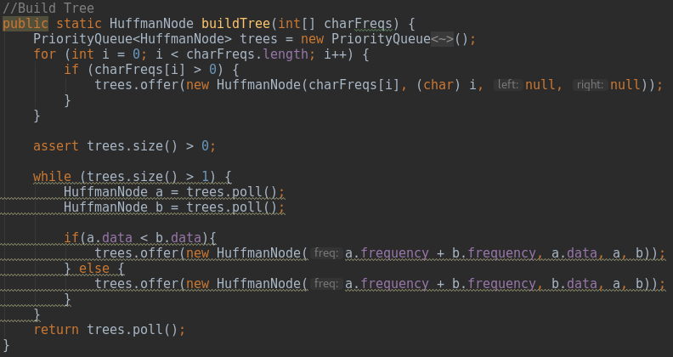
The elements are compared using the “compareTo()” method in HuffmanNode, which can be seen below.
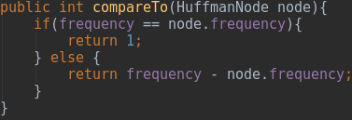
In case the newly added element has the same frequency, it will be added before the element that is already in the PriorityQueue.

Also, since HuffmanNode only stores one character for each node, I decided that whenever two elements are combined together, the newly created HuffmanNode will store the character which comes first in the alphabet (“if(a.data < b.data){“).
The tree is considered to be finished once there is only one element left in the PriorityQueue, which is the top of the Huffman Tree.

The next step is to traverse through the tree and assign codes to each of the characters. In case the HuffmanNode’s “left” and “right” are null, that means the node is a leaf, the end of the branch. Otherwise, I made use of recursion to move along the tree, through the “left” and “right” nodes of each HuffmanNode element. The left nodes are appended a “0”, while the right nodes are appended a “1”.

Once each character is generated a binary code, the original message is encoded and is returned as a String.

Arithmetic Coding
The Element class is used to store each element from the input. Each Element object has a value (the character), its probability, low and high probability boundaries, as well as the low and high probability boundaries.
I decided, that for better understanding, the program does not convert the interval probabilities to binary. Instead, the program does all the processing using decimal values. When the tag is found, it is converted to binary.

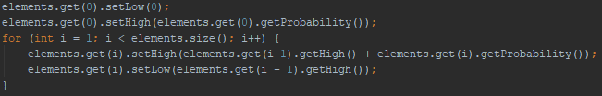

The probability intervals (“low” and “high”) are set in order to make it easier to process each character’s interval. Obviously, the first char’s interval starts at 0 and the following intervals are added on top of the previous, as seen above.
After the probability intervals are set, the program takes each char and starts dividing each interval, as seen below.
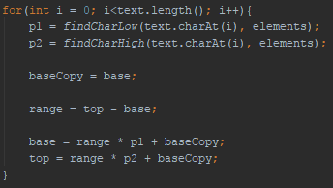
The “findCharLow()” and “findCharHigh()” methods are used to find the lower and higher limit of the probability interval for a respective char variable, by doing a simple search through the “elements” array.

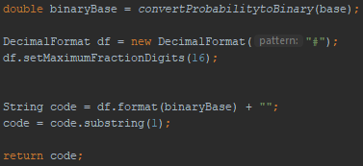
Once the tag is found, it is converted to binary. Binary numbers can be really small, thus a “DecimalFormat” is used to store a total of 16 fraction digits.

The ArithmeticDecoder works along the same lines as the encoder. However, each interval is divided into sub-intervals and the tag is checked against each single one of them, as seen below.
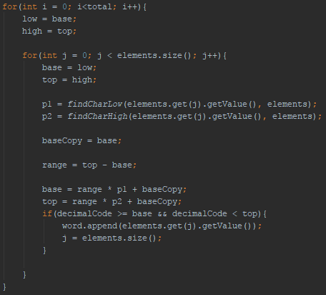
Once the original message is fully decoded, it is then returned as a String.
Testing

Evaluation
My program successfully achieves all tasks required in the practical. The GUI allows the user to input the information source and then generated automatically a piece of text, based on the information source. Once this is successfully achieved, the text is encoded and decoded using Huffman Coding and Arithmetic Coding.

The GUI also displays a set of statistics (time elapsed for each coding technique, size of original and encoded text and the compression ratio) side-by-side, making it very easy to compare the two coding techniques.

Conclusion
The practical has taught me very much about Huffman and Arithmetic coding. It was a good opportunity to apply the skills that I have learnt from lectures.

Given more time, I would fully complete the Adaptive Huffman Coding, so I could compare it against Huffman and Arithmetic Coding.

