Ionasco Gheorghe

FAF-193

**Condiții preliminare:**

SQL SERVER 2017(Dev. Edition)

**Obiective:**

*1.Crearea Tabelelor in SSMS*

*2.Introducerea datelor*

*3.Tipuri de date utilizate*

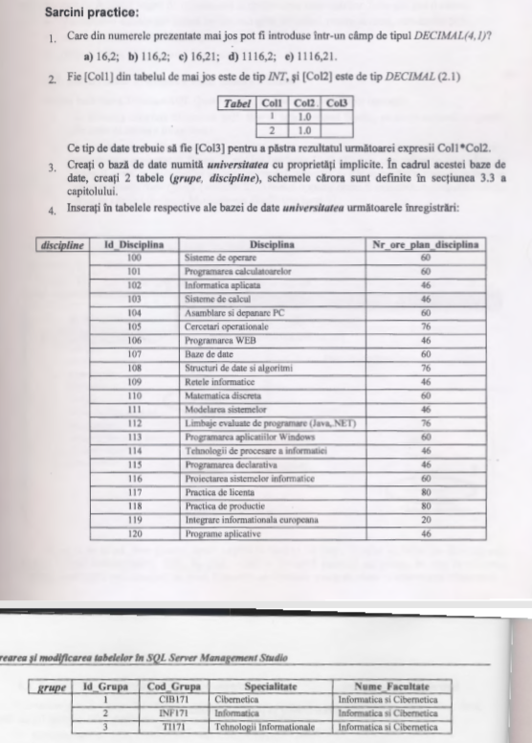**Задания :**

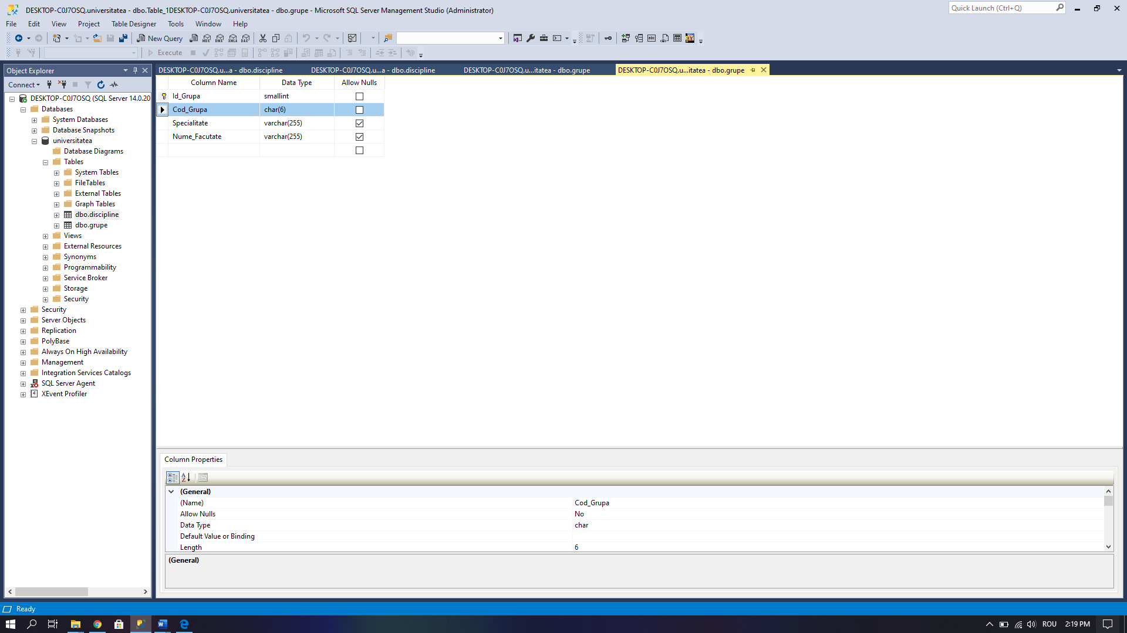Tabel ***grupe***

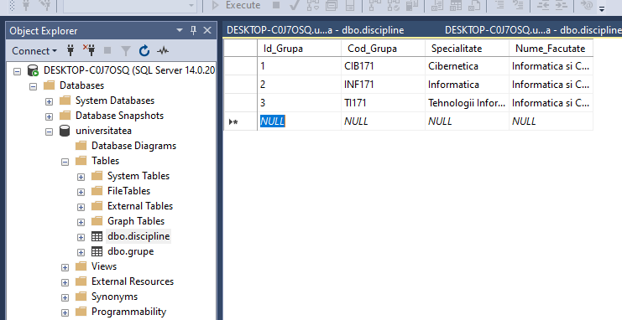

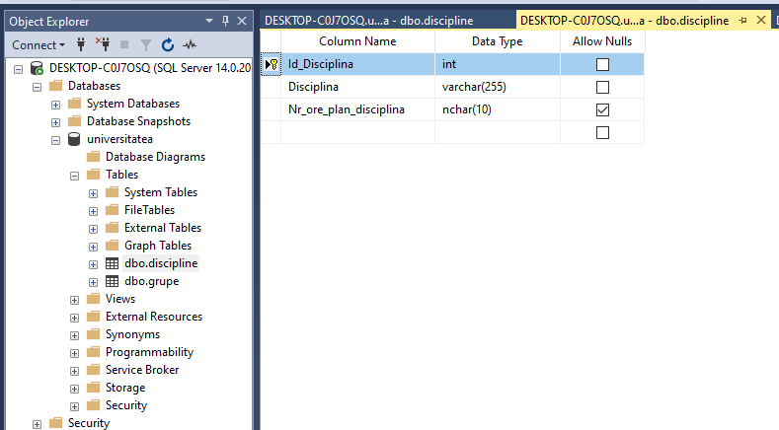Tabel ***discipline***

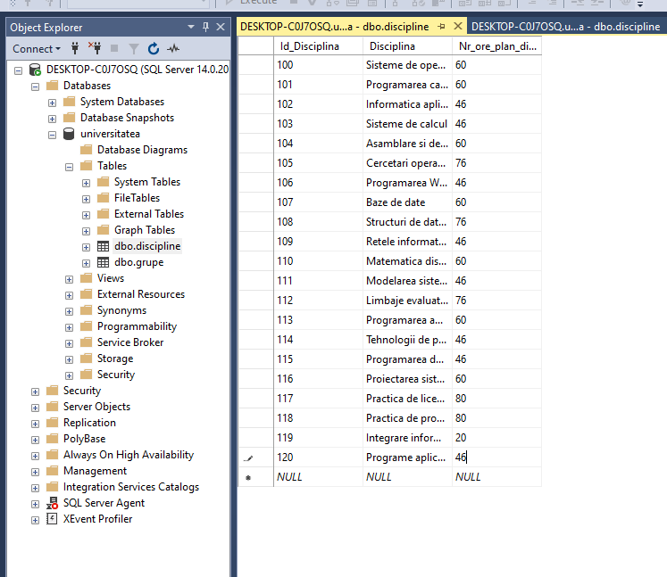

Conclusion.

In this work I acquired new information about creating tables and columns with different types (INT, VARCHA, NVARCHAR etc). Now I know how to update, drop and insert new values into table. This work will help me in future to work with databases and doing data analysis.