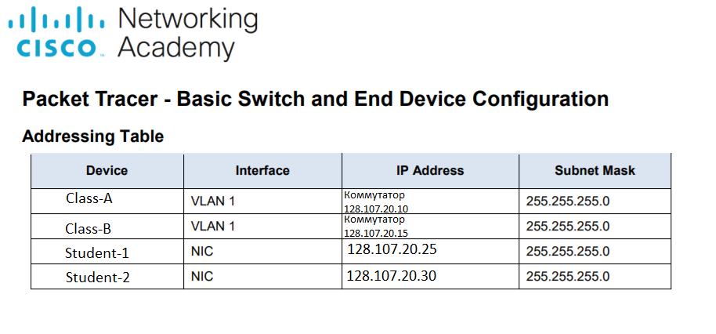
Requirements
Name Class-A and Class-B switchers.
Use the R4Xe3 password for all lines.
Use the C4aJa secret password.

