Domain analysis

The analysis of possible solutions

Tasks

1. turn led on/off using a button

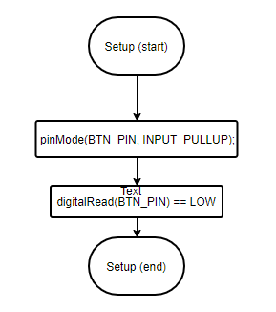

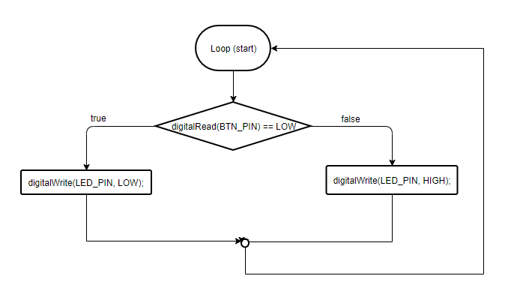

1. control a led using terminal commands **led on/led off**

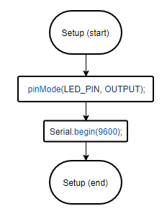

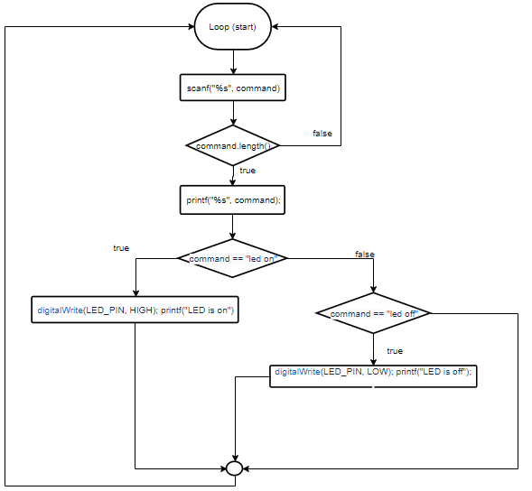

1. **check pin code**

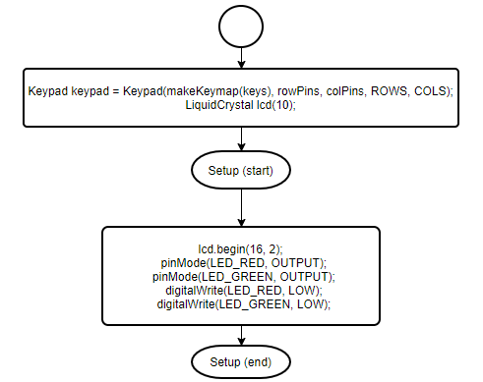

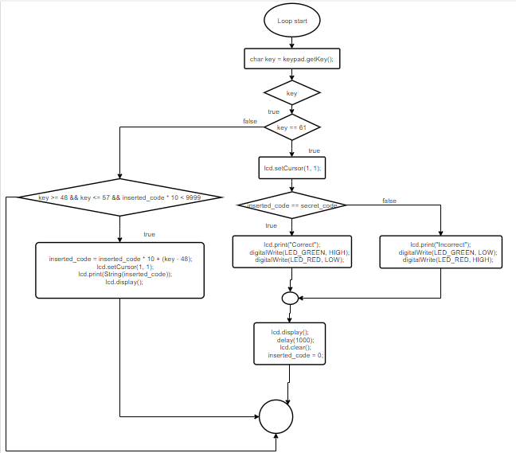

**Annex**

1. **turn led on/off using a button**

**global.h**

#ifndef HEADER_FILE

#define HEADER_FILE

#define BTN_PIN 4

#define LED_PIN 7

#endif

**code.ino**

#include "global.h"

void setup() {

pinMode(BTN_PIN, INPUT_PULLUP);

pinMode(LED_PIN, OUTPUT);

}

void loop() {

if(digitalRead(BTN_PIN) == LOW) {

digitalWrite(LED_PIN, HIGH);

} else {

digitalWrite(LED_PIN, LOW);

}

}

1. **control a led using terminal commands** **led on/led off**

**global.h**

#ifndef HEADER_FILE

#define HEADER_FILE

#define LED_PIN 12

#endif

**code.ino**

#include "global.h"

void setup() {

pinMode(LED_PIN, OUTPUT);

Serial.begin(9600);

}

void loop() {

scanf(“%s”, &command);

if(command.length()) {

Serial.println(command);

if(command == "led on") {

digitalWrite(LED_PIN, HIGH);

printf("LED is on");

} else

if(command == "led off") {

digitalWrite(LED_PIN, LOW);

printf("LED is off");

}

}

// printf("%d\n", 10);

}

1. **check pin code**

**global.h**

#ifndef HEADER_FILE

#define HEADER_FILE

#include<Keypad.h>

#include <SPI.h>

#include "LiquidCrystal.h"

#define LED_RED 1

#define LED_GREEN 0

const byte ROWS = 4; // four rows

const byte COLS = 4; // four columns

char keys[ROWS][COLS] = {

{'7', '8', '9', '/'},

{'4', '5', '6', '*'},

{'1', '2', '3', '-'},

{'c', '0', '=', '+'}

};

byte rowPins[ROWS] = {2, 3, 4, 5}; // connect to rows pinouts of the keypad

byte colPins[COLS] = {6, 7, 8, 9}; // connect to column pinouts of the keypad

int i = 0;

char arr[10];

int secret_code = 1234;

int inserted_code = 0;

#endif

**code.ino**

#include "global.h"

Keypad keypad = Keypad(makeKeymap(keys), rowPins, colPins, ROWS, COLS);

LiquidCrystal lcd(10);

void setup() {

// set up the LCD's number of columns and rows:

lcd.begin(16, 2);

pinMode(LED_RED, OUTPUT);

pinMode(LED_GREEN, OUTPUT);

digitalWrite(LED_RED, LOW);

digitalWrite(LED_GREEN, LOW);

// Print a message to the LCD.}

// lcd.cursor();

}

void loop() {

char key = keypad.getKey();

if(key) {

if(key == 61) {

lcd.setCursor(1, 1);

if(inserted_code == secret_code) {

lcd.print("Correct");

digitalWrite(LED_GREEN, HIGH);

digitalWrite(LED_RED, LOW);

} else {

lcd.print("Incorrect");

digitalWrite(LED_GREEN, LOW);

digitalWrite(LED_RED, HIGH);

}

lcd.display();

delay(1000);

lcd.clear();

inserted_code = 0;

} else if(key >= 48 && key <= 57 && inserted_code * 10 < 9999) {

inserted_code = inserted_code * 10 + (key - 48);

lcd.setCursor(1, 1);

lcd.print(String(inserted_code));

lcd.display();

}

}

}