
Happy
Cabbage
Adventure
Instruction Manual

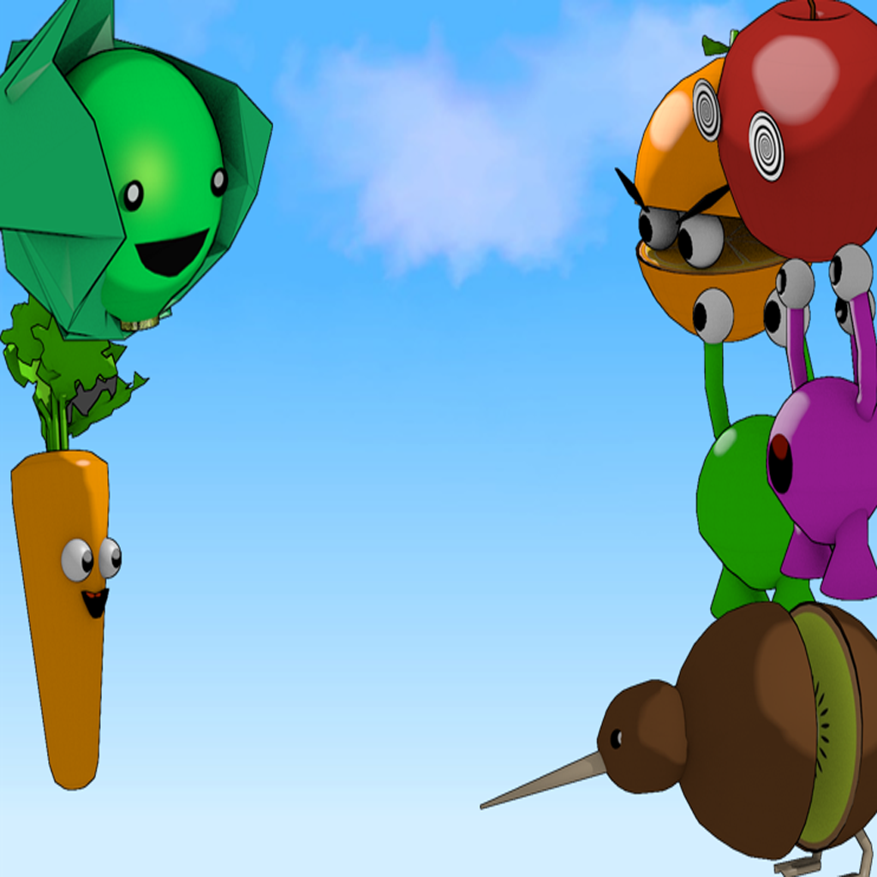
Controls
a: move left
d: move right
r: activate leaf shield
l: charge/fire laser
space: jump/select

The Basics
Firing the laser: Press and hold the 'l' key on the
keyboard to charge your laser. If you successfully charge the laser
for 3 seconds, the cabbage will have enough energy to release the
laser, decimating all in its path! Fire the laser by releasing the
'l' key after you have successfully charged. If you are damaged
during the charging process, you will lose all charge.

Recovery Items: Throughout the course of your adventure,
you may see enemies drop leaves and water droplets. These items
replenish the health and energy of the cabbage, so make sure to
pick them up!

