# Questions for Chapter 6 – Instructor version

## Q 6.1 Koffka Ring.

Make these three stimuli: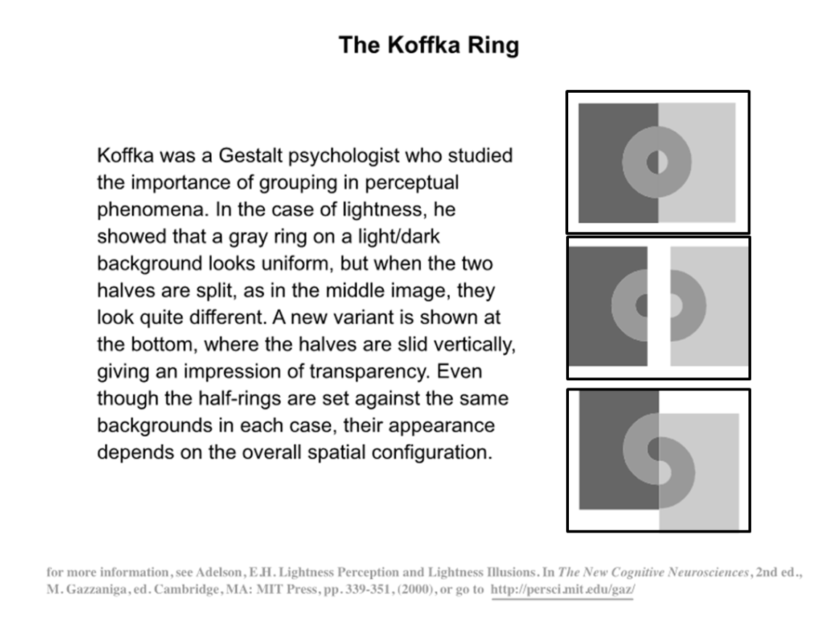

## Q 6.2 Funkystim

Create the following two stim (note, you need to go back to Chapter 6 and do exercise 6.2 first)

