CIS36A Class Project Documentation (Group 2)

Junhong Wang

Winnie Su

**Game Logic**

Rules:

* Any live cell with fewer than two live neighbors dies, as if caused by under-population.
* Any live cell with two or three live neighbors lives on to the next generation.
* Any live cell with more than three live neighbors dies, as if by overpopulation.
* Any dead cell with exactly three live neighbors becomes a live cell, as if by reproduction.

**Implementation**

Grid System

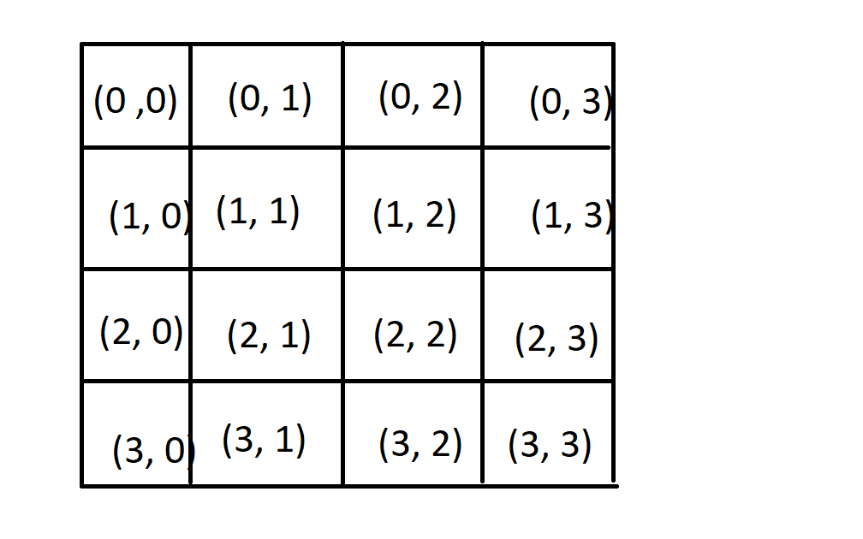

We use a two-dimensional array to simulate the universe. Each position has an “id” as shown above (e.g. row-0, column-1 has an id of (0, 1)).

Cell Property

A cell contains two information:

1. isAlive: True if the cell is alive
2. isAliveNext: True if the cell is alive the next generation

Game Loop

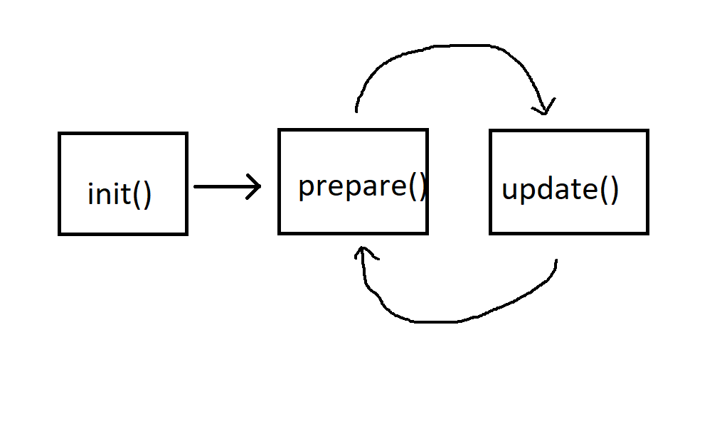

* init(): Initialize the grid
* prepare(): Update the value of isAliveNext for each cell
* update(): Update the value of isAlive for each cell. Update the cell color.

The game runs init() -> prepare() -> update() -> prepare() -> update() -> prepare() … and so on.

**Game System**

* run
* pause
* step
* clear
* connect/disconnect
* click

**Project Production**

Step1: Extract jar file

File -> Project Structure -> Project Settings -> Artifacts -> Click green plus sign -> Jar -> From modules with dependencies...

Then, go to

Build | Build Artifact

Step2: Run the jar file on Windows

On terminal, type

../../Screen%20Shot%202017-10-12%20at%201.07.53%20PM.png

**Reference**

[Wikipedia](https://en.wikipedia.org/wiki/Conway%27s_Game_of_Life)

(<https://en.wikipedia.org/wiki/Conway%27s_Game_of_Life)>

[How to build jar file with IntelliJ](https://stackoverflow.com/questions/1082580/how-to-build-jars-from-intellij-properly)

(<https://stackoverflow.com/questions/1082580/how-to-build-jars-from-intellij-properly)>

[How to run jar file on Windows](https://stackoverflow.com/questions/394616/running-jar-file-on-windows)

(<https://stackoverflow.com/questions/394616/running-jar-file-on-windows)>