Temporal and Spatial Network Evolution in EEG Data of Pediatric Epilepsy Patients during Ictal and Interictal Periods

Group Members: Antonia Spörk, Jione Kim, Marina Köhli, Simon Krummenacher

Social Media Analytics, SP 2026, University of Fribourg
Course lead: Mourad Khayati, Philippe Cudré-Mauroux

GitHub repository: https://github.com/ionikim/epilepsy_pediatrics_EEG

Content

1. Introduction 3
2. Architecture and Pipeline 3
3. Dataset 4
4. Data Preprocessing & Enrichment 4
5. Network Loading 6
6. Data Management 8
7. Network Exploration 8
8. Network Analytics 10
9. Network Visualization 14
10. Insights & Analysis 21
11. Conclusion 24
12. Appendix 26

- Introduction
This project develops and evaluates an end-to-end pipeline for analyzing temporal and spatial network evolution in epileptic brain activity. Using scalp EEG recordings from patient CHB01 in the CHB-MIT database, we construct a Multiplex Visibility Graph (MVG) from a 30-second segment spanning the transition from interictal to ictal activity, apply four community detection algorithms implemented from scratch, and benchmark their performance using structural quality metrics. Our central question is whether the transition into seizure activity is accompanied by structural changes of the network, specifically, whether channels form tighter, more synchronized functional groupings during the ictal phase relative to the interictal baseline. The pipeline covers the full workflow from raw EEG preprocessing through graph construction, community detection, benchmarking and visualization. A documentation of the work split can be found in the ‘readme’ file on GitHub.
- Architecture and Pipeline
Legend
Data Sources
Data Processing
Output

Figure 1. Architecture and pipeline of the proposed EEG network analysis framework. The workflow covers the full process from data selection and preprocessing to graph construction, network exploration, analytics, visualization, and final insights. Data are transformed into multiplex visibility graphs and analyzed using multiple community detection algorithms. The resulting outputs are integrated into a benchmarking and interpretation stage. The pipeline is adapted from the course project structure (Khayati, 2026) and tailored to the specific requirements of EEG-based network analysis.

- Dataset
We use data from the CHB-MIT Scalp EEG Database (Guttag, 2010) from PhysioNet (Goldberger et al., 2000), which includes EEG recordings from 5 male patients (ages 3–22) and 17 female patients (ages 1.5–19) with intractable seizures. The recordings contain 23 EEG channels sampled at 256 Hz with 16-bit resolution and are provided in EDF (European Data Format). The database also provides onset and end annotations of 182 seizures. EEG data is rich and spatial by nature, making it suitable for applying graph theoretical analyses to it. Network-level changes in neurological conditions such as epilepsy can be detected better using graphs than univariate analyses. The original article (Shoeb, 2009) applies machine learning to epileptic seizure onset detection, which was then used to control a Vagus Nerve Stimulator (an implantable neurostimulator for the treatment of intractable seizures).
For this project, we focus on one patient (CHB01) and analyze a 30-second segment centered on seizure onset, consisting of 15 seconds of pre-ictal activity and 15 seconds of ictal activity. We constrained the graph size to ensure the analyses remained feasible. With more capacity, we would have liked to apply our algorithm to other patients to see if it can detect seizures generally.
- Data Preprocessing & Enrichment
We preprocessed the data in Python before loading it into a graph. Namely, we loaded the raw EEG file (.edf) into Python and applied a commonly used bandpass filter (1-45 Hz). The high-pass cutoff (<1Hz) eliminated slow drift artifacts such as sweat, electrode movement, skin potential shifts. The low-pass cutoff (>45Hz) removed high-frequency noise, most importantly line noise (50 Hz) and muscle artifacts, which dominate above 45 Hz. Re-referencing was then applied to have numbers relative to the whole-scalp average. This improves spatial specificity by suppressing artifacts that are globally distributed and enhances relative spatial differences between electrodes.
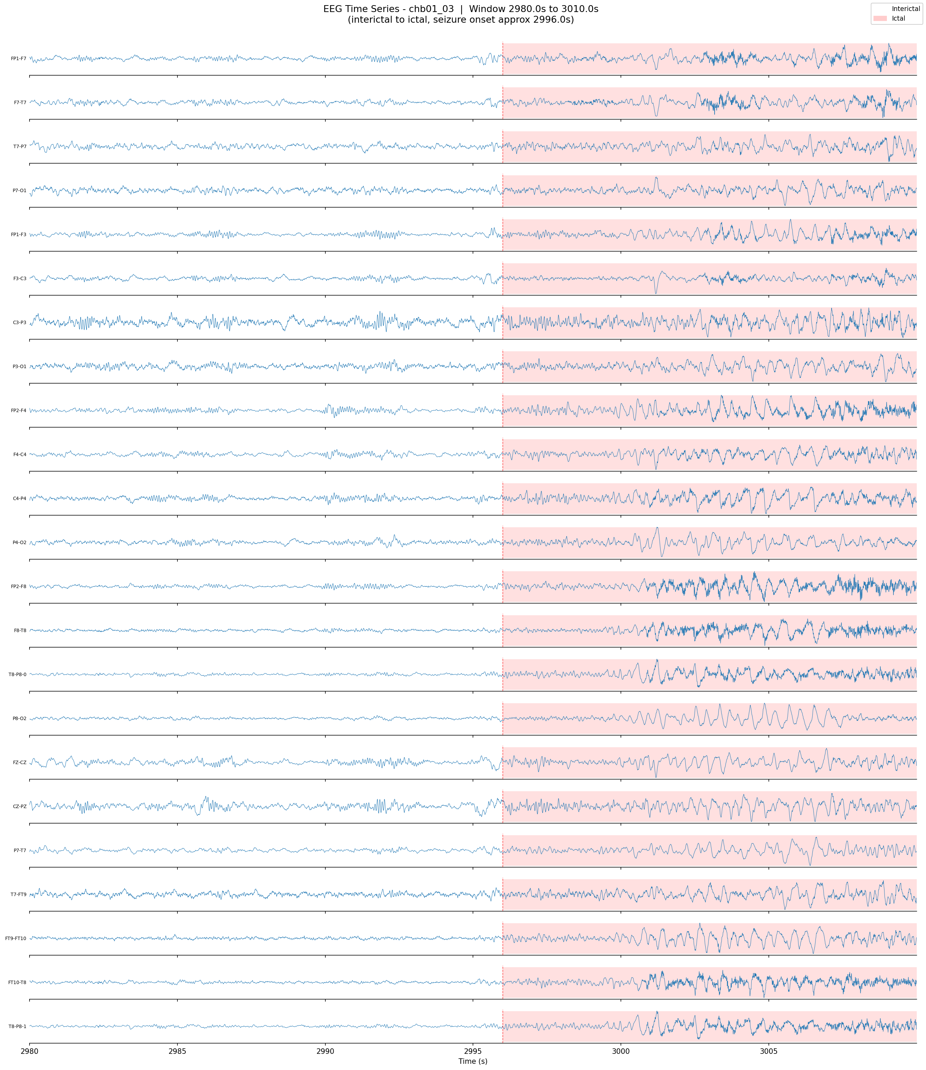
Figure 2. Preprocessed EEG time series around seizure onset. Filtered and re-referenced EEG signals across multiple channels. The ictal region (red) shows stronger amplitude and more rhythmic activity compared with the interictal period (white).
Figure 2 shows the filtered and re-referenced EEG signals around the onset of a seizure on multiple channels. Compared with interictal samples, seizure signals are clearly stronger in amplitude and more rhythmic across the channels.
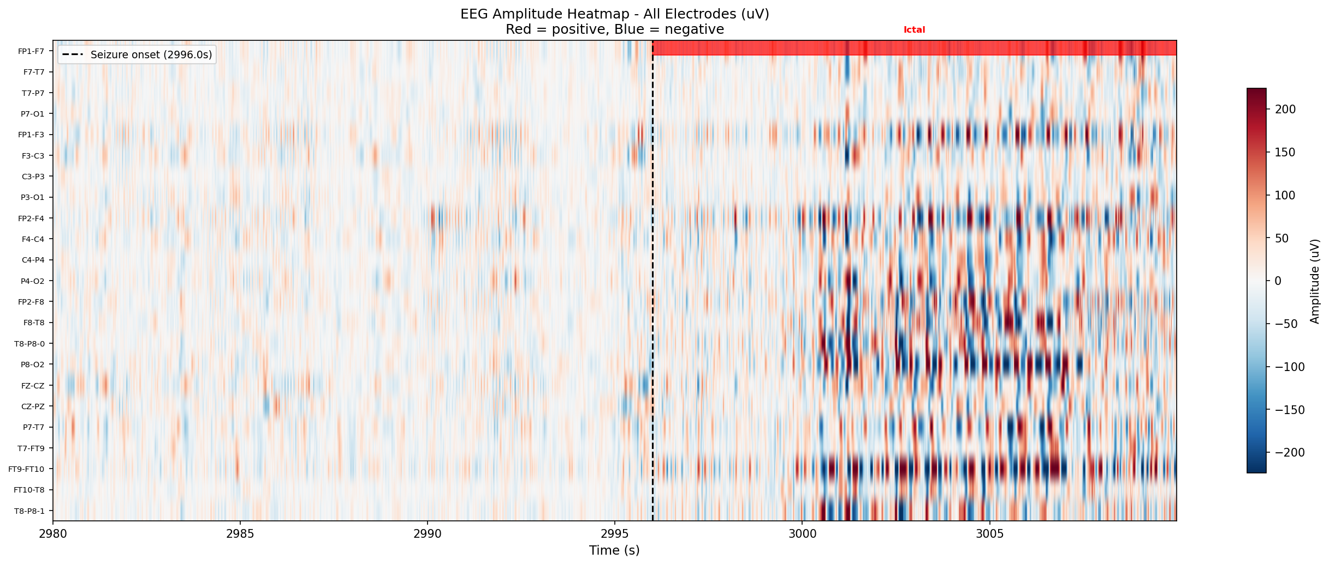
Figure 3. EEG amplitude heatmap across all electrodes. Time-by-electrode heatmap of the preprocessed EEG signal. The seizure onset and ictal region are highlighted, showing seizure-related amplitude changes across electrodes.
Figure 3 displays the preprocessed EEG signal across all electrodes as a time-by-electrode heatmap, highlighting the seizure onset and ictal region. This visualization reinforces the idea of converting an EEG time series into a suitable format for machine learning while emphasizing seizure-related variations. We then converted the signal into a 2D array, with rows as time points and columns as electrodes. A column was added for each timepoint specifying if the patient was currently in a seizure state or not. The brain state labels were provided by the CHB-MIT database in an additional file. This table was then used to build the graph that we needed for our analysis.
To help the construction of graphs that focus on seizure events, the analysis window was specifically designed to be centered around the annotated seizure onset. As depicted in Figure 4, the full recording timeline was utilized to pinpoint the period of the seizure. From this timeframe, a shorter window was selected, encompassing the transition from interictal to ictal brain activity. This approach allowed the data to be imbued with temporal significance, since each timestamp within the window now has a meaning relative to the seizure onset.
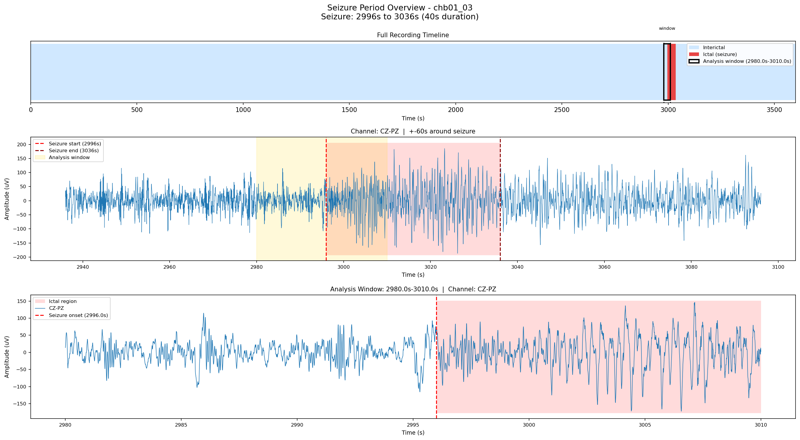
Figure 4. Seizure-centered analysis window. Overview of the seizure period within the EEG recording (red). The selected analysis window (yellow) captures the transition from interictal to ictal brain activity.
In sum, the preprocessing and enrichment process converted raw EEG recordings into a graph-ready format by: (i) cleaning the signals through filtering and re-referencing, (ii) arranging them into time-by-electrode matrices, (iii) annotating the data with seizure states, and (iv) centering the analysis window around seizure onsets.
- Network Loading
This section describes how we built different graphs until we found one that is suitable for our research questions. We describe how we started with a multiplex visibility graph (MVG), tried a different approach with the ordinal pattern transition network and came back to MVGs by extending the different layers into a multiplex visibility graph. We also explored different options for edge and node creation and the categorical vs. continuous differentiation between seizure (ictal) and non-seizure (pre-ictal) periods.
  - Multiplex Visibility Graph
Instead of measuring pairwise correlations between electrodes, we built a Visibility Graph (VG) separately for each electrode’s EEG time series. In each 1-second window, sampled at 256 timepoints, two timepoints are connected if they can “see” each other without any intermediate signal value blocking the line between them. In this way, the graph captures the temporal structure of the signal. More regular and seizure-like signals tend to form denser graphs with more long-range connections and higher node degree, while irregular normal EEG activity tends to produce sparser graphs with mostly short-range connections.
Our first try using a 5-second-window MVG, with 23 electrodes and 1,280 timepoints in each electrode, produced 29,440 nodes and 57,041 intra-layer edges. With 323,840 inter-layer edges added, the graph contained a total of 380,881 edges.
We then made the same type of MVG using one ictal and one interictal 5-second window. In terms of basic graph properties, the two networks produced very similar results (Table 1).
Condition | Timepoints | Nodes | Intra-layer Edges | Inter-layer Edges | Total Edges
Ictal, 5s | 1,280 | 29,440 | 57,974 | 323,840 | 381,814
Interictal, 5s | 1,280 | 29,440 | 57,827 | 323,840 | 381,667
Table 1. Characteristics of the 5s-window, lower-threshold MVG.
In both cases, there were the same number of timepoints, electrodes, nodes, and inter-layer edges. This is because the same electrodes and timepoints were used, and the inter-layer edges were determined by construction, linking electrodes at each corresponding timepoint. The only small difference appeared in the intra-layer edge counts: 57,974 for the ictal graph versus 57,827 for the interictal graph. This difference was small, showing that the basic graph structure remained highly similar between the two conditions.
We also experimented with using weights on the MVG edges by measuring amplitude differences between connected nodes, as shown below (Table 2), and keeping only the strongest 5% of intra-layer edges. This reduced the number of intra-layer edges, but we still observed only a minor difference between the ictal and interictal graphs based on basic edge counts.
Condition | Timepoints | Nodes | Intra-layer Edges | Inter-layer Edges | Total Edges
Ictal, weighted 10s | 2,560 | 58,880 | 5,845 | 647,680 | 653,525
Interictal,weighted 10s | 2,560 | 58,880 | 5,841 | 647,680 | 653,521
Table 2. Characteristics of the 10s-window, higher-threshold MVG.
The node count was identical due to the fixed number of timepoints and electrodes, and the inter-layer edge count was identical because those edges were fixed by definition. The intra-layer edge count differed by only 4 edges, and the total edge count also differed by only 4 edges.
Overall, these early MVG trials show that we were able to generate short-window MVGs and weighted MVGs, but node and edge count comparisons were unable to differentiate clearly between the ictal and interictal conditions, rendering them unsuitable for analyses. Much of the graph size was determined by the fixed number of electrodes and the length of the time window. Therefore, short-window ictal dynamics were not strongly reflected in these basic graph counts.
In our next step, we moved away from defining graph windows in a categorical way. Rather than defining one short ictal window and one short interictal window, we used one continuous 30-second time segment of the data file ‘chb01_03.edf’, spanning the interictal and ictal periods from seconds 2980 to 3010, to construct one MVG. We extended the window because the 5-second snippets in our original definition may not have been long enough to capture meaningful changes, given how seizure activity tends to develop over time. By using this 30-second transition window, the graph we constructed encompassed ongoing interictal activity, the approach to seizure onset, and the seizure itself.
In this new continuous graph, there were 23 electrodes, 7,680 timepoints, and 176,640 nodes. We increased the intra-layer threshold to 0.1 to emphasize stronger intra-layer connections among the weighted edges, leading to 35,161 intra-layer edges and 1,943,040 inter-layer edges, for a total of 1,978,201 edges. Because inter-layer edges connect corresponding timepoints across electrode layers, they far outnumber intra-layer edges in a multilayer graph structure. Therefore, this step was less about producing meaningful graph metrics directly and more about deciding how the graph should be constructed for later analysis.
In conclusion, the precomputed adjacency matrix is stored as a sparse matrix of size 176,640 × 176,640, representing all VG connections across 23 electrodes and 7,680 timepoints. Each node corresponds to an electrode at a specific timepoint within the full recording.
  - A Brief Comparison to Ordinal Pattern Transition Network creation
As a second alternative graph construction, we tested an Ordinal Pattern Transition Graph (OPTN) approach to characterize EEG dynamics. In OPTN, each node denotes a specific ordinal pattern found at a given time step for a given electrode. Intra-layer edges connect patterns within the same electrode if they are visited consecutively, while inter-layer edges connect the same pattern between two distinct electrodes, suggesting shared structural patterns.
Table 3 shows that graph-level metrics such as the number of nodes and edges did not provide a clear global separation between the two conditions. The ictal graph had 1,509 nodes and 18,471 total edges, including 3,234 intra-layer and 15,237 inter-layer edges. In comparison, the interictal graph had 1,545 nodes and 19,068 total edges, including 3,386 intra-layer and 15,682 inter-layer edges.
Condition | Nodes | Intra-layer Edges | Inter-layer Edges | Total Edges
Ictal | 1,509 | 3,234 | 15,237 | 18,471
Interictal | 1,545 | 3,386 | 15,682 | 19,068
Table 3. Level characteristics of the OPTN graph.
However, some electrode-level measures exhibited subtle localized differences. Several central and posterior electrodes, such as CZ-PZ, C3-P3, P3-O1, and P4-O2, showed lower normalized permutation entropy during the ictal state compared to the interictal state. This coincided with higher self-loop ratios in the ictal period relative to the interictal period.
Electrode | Ictal Entropy | Interictal Entropy | Ictal Self-loop Ratio | Interictal Self-loop Ratio
CZ-PZ | 0.444 | 0.606 | 0.595
C3-P3 | 0.540 | 0.681 | 0.447 | 0.102
P3-O1 | 0.573 | 0.690 | 0.397 | 0.097
P4-O2 | 0.581 | 0.686 | 0.390 | 0.070
Table 4. Metrics of selected electrode within OPTN graph.
This indicates that temporal variability across ordinal patterns decreases in certain areas, suggesting more persistent dynamics during an ictal event. However, this difference was not sufficiently pronounced or widespread across the entire network to establish a robust global separation of the two states.
While OTPN provided a useful complement for capturing dynamics tied to temporal order and ordinal transitions, it did not achieve a stronger distinction at the global graph level than MVG. With this limitation, we finalized the MVG approach and adjusted the window size to a 30-second segment as we mentioned above in the MVG section. This adjustment aimed to provide a more comprehensive view of the evolving transition from interictal activity to a fully ictal state.
- Data Management
Initially we planned to store the graph in the database Neo4j. However, as our graph was too big for this platform, we used Git Large File Storage. This was convenient because most of our analyses were conducted in Python (using e.g. NetworkX) and this way, we could access the graph directly through GitHub, as we stored all our code and information there. Storing the graph in another database would have led to inefficient transfers each time we wanted to operate on it.
- Network Exploration
We explored our EEG network to understand its basic structure before applying community detection algorithms from scratch. Our goal was to identify patterns in node interactions that are relevant for the next step, the network analysis, such as similarity between nodes and potential community structure. For this, we used the NetworkX library to extract basic properties such as density, edge weights, and node strength, mainly for descriptive analysis. Because we found our network to be large (as discussed in the data management part above), we consider computational feasibility and focus on smaller parts of the graph, such as subgraphs of high-strength nodes. Full visualizations are not very informative in this setting. In the sampled subgraphs (Fig. 5), we did not observe clear clusters or groups in these representations. Instead, the structure appears diffuse and weakly organized.
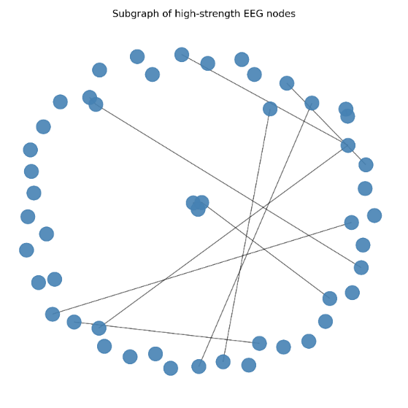
Figure 5. Sampled subgraph of nodes with high node strength. The visualization shows no clear clusters or densely connected regions. Most nodes are either weakly connected or isolated, and the overall structure appears diffuse.
This observation is supported by the statistical analysis. Node strengths are very similar across nodes, as shown in the ranked strength plot (Fig. 6a), where no dominant hubs appear and values vary only slightly. In addition, edge weights are almost identical, as visible in the edge weight distribution (Fig. 3b), which shows that most values are concentrated very close to 1. Because of this, thresholding removes only a very small number of edges, meaning that standard filtering does not reveal additional structures.
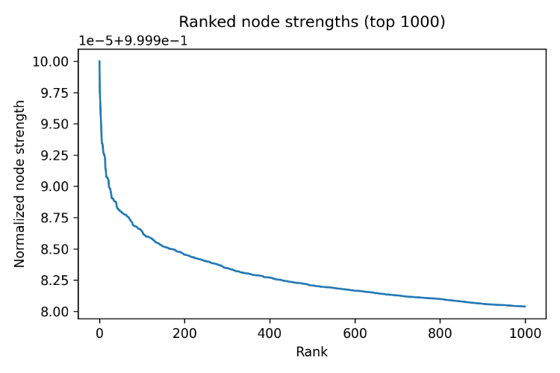 | 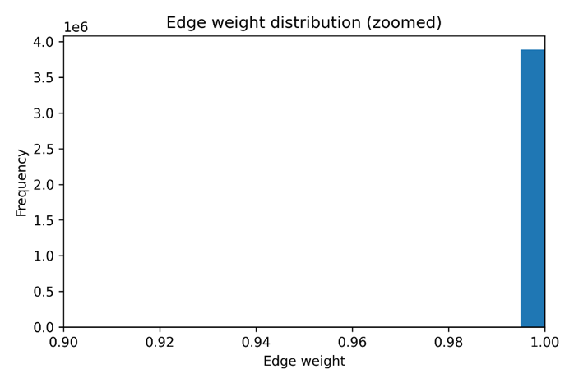
(a) | (b)
Figure 6. (a) Ranked node strengths for the top 1000 nodes. The distribution shows only a small variation between nodes, with no strong drop-off at the top ranks. (b) Edge weight distribution (zoomed view). Most edge weights are concentrated very close to 1, indicating extremely low variability.
Overall, this suggests that the network is highly uniform, with most connections having very similar weights, which makes it difficult to detect meaningful communities using standard approaches. At the same time, brain networks are dynamic and change between pre-ictal, interictal, and ictal phases (Kramer, 2012). This means that important structure may only appear over time, not in a single static snapshot.
Based on these findings, we conclude that static community detection methods are not well suited for our data. We therefore apply online streaming community detection methods from scratch in the network analytics part below to capture temporal changes. This direction is further supported by the added value emphasized by the course instructor.
- Network Analytics
In this section the results of applying four different community detection algorithms to the Multiplex Visibility Graph (MVG) network are presented. These algorithms were selected and implemented from scratch to capture different structural aspects of the MVG network. As presented in the network exploration section above, the MVG has a highly uniform node degree and no dominant hub nodes, which means that algorithms relying on a heterogenous degree structure do not work on this data type. Therefore, the algorithms were chosen to cover a range of paradigms. The first algorithm is a streaming modularity-based approach (here called Stream-Moore Algorithm), which was included to find out whether modularity maximization is compatible with a visibility graph structure (Clauset et al., 2004). The second included algorithm is a propagation based method (called Label Propagation), that was selected to detect global co-activation patterns without assumptions about the degree distribution (Gregory, 2010). Additionally, two clustering algorithms were chosen. Laplacian Spectral Clustering was selected for its capacity to capture functional groups of electrodes over time with a sliding window approach (Bühler & Hein, 2009; Fiedler, 1973). And lastly, Ward Linkage Hierarchical Clustering was included as a deterministic, agglomerative approach, that makes it possible to compare channel-level correlation between interictal and ictal phases clusters (Vijaya et al., 2019; Ward, 1963). Together, these algorithms provide a complementary framework on whether and how community structures change across the ictal-to-interictal transition.
  - Stream-Moore Algorithm
A streaming version of the Clauset-Newman algorithm was applied to the full continuous HVG adjacency matrix, consisting of 176,640 nodes and approximately 1.97 million edges. The algorithm processes edges one by one in a continuous stream and merges pairs of communities whenever the incremental modularity gain ΔQ is positive. The resulting community structure is tracked through a Union-Find (Clauset et al., 2004).
Despite processing the complete edge stream, the algorithm produced a modularity score of Q around −0.0001 and identified 7,665 communities, which corresponds almost exactly to the number of nodes and indicates that no meaningful merges were performed. When inspecting the modularity history recorded at intervals of 200,000 edges, it can be observed that Q remained constant throughout the entire stream, meaning the merge condition ΔQ > 0 was never satisfied after the very first few edges.
This outcome shows that this algorithm is structurally incompatible with the graph type. Reason for that is that the Multiplex Visibility Graph assigns each timepoint a degree of approximately 2, which means two neighbors to the left and two to the right, resulting in an almost uniform node degree across the entire matrix. The modularity gain formula ΔQ = 2(e_ab/m − a_a · a_b/(2m)²) depends on a positive difference between actual inter-community edges and the expected number under a null model and when all nodes have nearly identical degree, this difference is effectively zero or negative for every candidate merge and the algorithm halts immediately. This means that the streaming version of the Clauset-Newman algorithm assumes a heterogeneous degree distribution, which could be found in social or citation networks where hub nodes exist, which the MVG fundamentally does not exhibit.
Nevertheless, this is a meaningful result as it shows that algorithms that maximize modularity scores are not suitable for visibility-graph representation of EEG data. For this domain, the algorithms selected must account for the structural constraints imposed by the graph construction method rather than relying on generic community detection benchmarks.
  - Label Propagation Algorithm (LPA)
The Label Propagation Algorithm was applied directly to the MVG adjacency matrix after setting a threshold for the edge weight to 0.2 to suppress weak noise connections. In this algorithm, each node is initialized with a unique label and iteratively adopts the most frequent label among its neighbors. Nodes are processed in randomized order in each round, and the algorithm terminates when no node changes its label across iterations (Gregory, 2010).
The algorithm converged within a small number of iterations on this graph. To assess the robustness of the output, the algorithm was run ten times independently and label agreement was measured pairwise between runs. To contextualize the found community structure, modularity was computed on the real graph and compared against a degree-preserving null model constructed via the configuration model. The difference ΔQ = Q_real − Q_random provides a measure of whether the detected communities exceed what would be expected by chance given the graph's degree sequence alone.
Because LPA operates on the full node-timepoint space of the MVG, where each node represents a specific timepoint at a specific electrode, its communities form groups of timepoints rather than electrodes. This means that the output is difficult to interpret on a biological level. However, LPA captures global temporal co-activation patterns across electrodes and is well-suited for quickly establishing whether modular structure exists at all in the graph.
  - Laplacian Spectral Clustering
Laplacian Spectral Clustering was applied with a sliding window approach and produces 26 windows of 5 seconds each with a 1-second step across the full 30-second recording. For each window, the HVG adjacency matrix was used to extract a 23×23 channel-level temporal connectivity profile, from which a Pearson correlation matrix was computed. A weighted adjacency graph was then constructed by keeping only correlations above a threshold of r > 0.3, to suppress weak connections. The symmetric normalized graph Laplacian L = I − D^(−1/2) A D^(−1/2) was computed from this adjacency graph, where D is the diagonal degree matrix. The Laplacian was eigen decomposed and each of the 23 channels was embedded in a k = 4-dimensional eigenspace a method described by Fiedler (1973), using the four smallest eigenvectors. Row-normalized embeddings were then clustered using a custom k-means++ implementation with 10 random restarts to minimize sensitivity to initialization (Bühler & Hein, 2009; Fiedler, 1973).
The most informative output of this algorithm is the temporal evolution of the eigengap, which is the difference between the (k+1)-th and k-th eigenvalues of the Laplacian and measures how well-separated the k clusters are in the spectral structure. Across the sliding windows, the eigengap shows a strong peak immediately before seizure onset (approximately after 14-15 seconds) and decreases strongly during the ictal phase. This pattern indicates that the 23 EEG channels form maximally distinct functional clusters just before seizure onset, which means maximum modularity of the network and then this cluster structure breaks down as the seizure propagates. This is consistent with the hypersynchrony hypothesis in which ictal activity can be observed as widespread, undifferentiated co-activation across regions that were previously separated (Bühler & Hein, 2009; Jiruska et al., 2013; Vijaya et al., 2019).
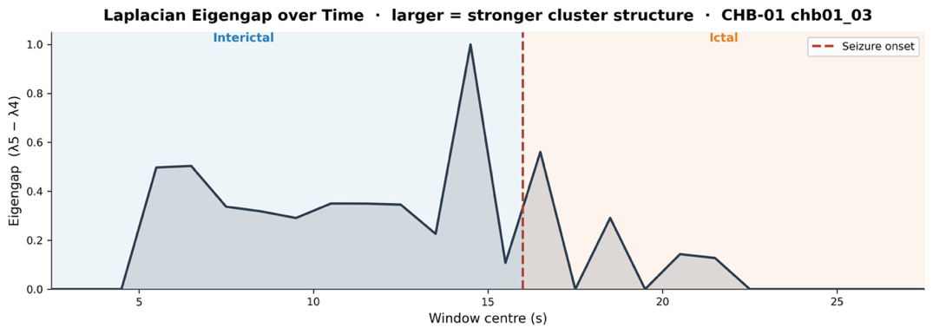
Figure 7. Eigengap over time for Laplacian Spectral Clustering. The eigengap quantifies how spectrally distinct the 4 clusters are at each sliding window. A larger value means stronger community separation. The eigengap remains elevated during the interictal phase (0–16 s), peaks sharply at approximately 14–15 s immediately before seizure onset, and collapses after the onset marker (dashed red line).
The cluster assignment raster plot aligns with this interpretation. While during the interictal phase, channels stay relatively stable in their clusters, at seizure onset assignments reorganize. Hereby show frontal and temporal channels the strongest transitions. Comparing the dominant cluster per channel between the interictal (0–16s) and ictal (16–30s) phases reveals that the functional groupings are systematically reconfigured and channels that were split across different clusters during the resting state converge into shared clusters during the seizure.
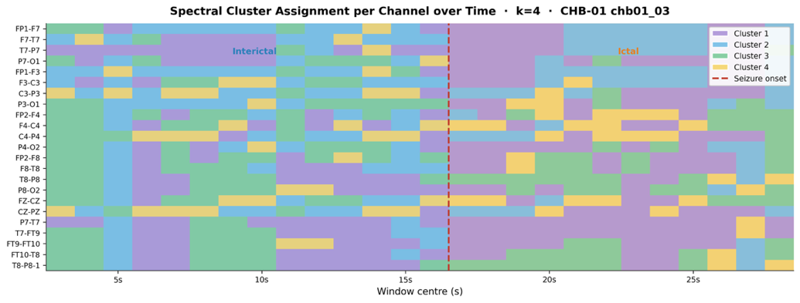
Figure 8. Spectral cluster assignment per channel over time. During the interictal phase (left), cluster assignments are relatively stable, with Cluster 2 (green) dominating across channels. After onset, assignments become more fragmented, with Cluster 4 (yellow) emerging and several channels shifting away from their pre-ictal groupings, which reflects a reorganization of functional connectivity during the ictal phase.
  - Ward Linkage Hierarchical Clustering
Ward linkage hierarchical clustering was applied using the same sliding-window pipeline as spectral clustering with 26 windows of 5 seconds and a 1-second step. For each window, a 23×23 Pearson correlation matrix was computed from the channel-level temporal connectivity profiles extracted from the HVG. The matrix was converted into a distance matrix as d = 1 − r, Ward linkage was applied to produce a full dendrogram over all 23 channels, and flat cluster assignments were obtained by cutting the dendrogram at k = 4 clusters (Vijaya et al., 2019; Ward, 1963).
Unlike LPA and spectral clustering, Ward linkage is fully deterministic, which means when it is applied twice to the same correlation matrix, it produces identical results. The dendrogram grid plot, which displays the Ward dendrogram for each of the 26 sliding windows in sequence, shows evidence that the structure of the network is changing at the seizure transition. In the interictal windows (0–15s), channels form loose groups with relatively long linkage distances, indicating low inter-channel correlation and spatially distributed activity. At the 15–16 second during seizure onset, the dendrogram structure compresses and linkage distances shorten. Channels that were previously distributed across multiple clusters merge into one or two dominant clusters.
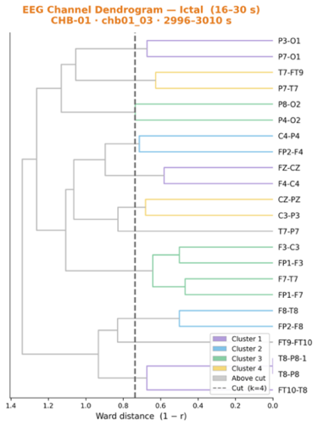
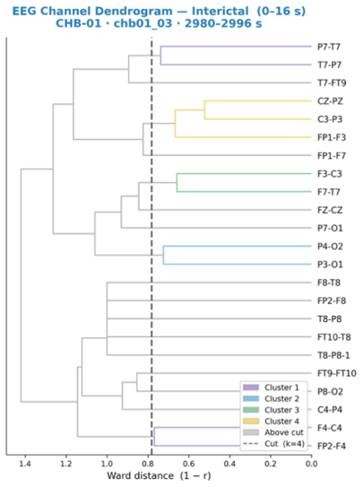

(b) Ward linkage dendrogram in ictal phase
- Ward linkage dendrogram in interictal phase
Figure 9. Ward linkage dendrograms for interictal and ictal phases. (a) During the interictal phase, channels merge at relatively large Ward distances, reflecting weak inter-channel correlation and spatially distributed activity. Posterior and temporal channels (P7-T7, T7-P7, T7-FT9) form one early cluster, while frontal and central channels remain separated until late in the tree. (b) During the ictal phase, overall linkage distances shorten markedly, indicating a global increase in inter-channel correlation. Channels that were distributed across separate subtrees in the interictal dendrogram consolidate into fewer, tighter clusters, with a large group of frontal, central, and temporal channels merging at distances below 0.6.
This reflects the global increase in inter-channel synchrony that characterizes ictal activity. The global synchrony plot shows this directly: mean Pearson correlation across all 253 electrode pairs increases strongly at onset and remains elevated throughout the ictal window, confirming that the result in the dendrogram is driven by a real change in the EEG signal rather than an artefact of the clustering procedure (Jiruska et al., 2013).
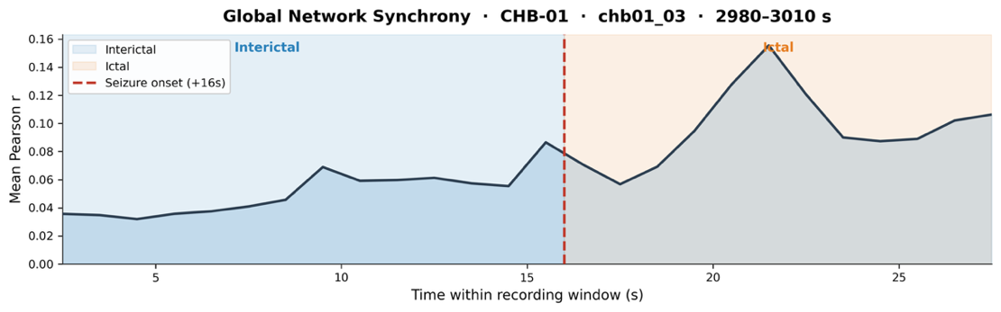
Figure 10. Mean inter-channel synchrony over time. During the interictal phase (blue), synchrony remains low and stable (r ≈ 0.03–0.08), reflecting loose and spatially distributed channel activity. Following seizure onset (orange), mean synchrony rises, peaking at r ≈ 0.14 around 21 s, indicating a rapid increase in global inter-channel coupling during the ictal phase consistent with the hypersynchrony hypothesis of epileptic seizure propagation by Jiruska et al (2013).
- Network Visualization
In terms of visualization, we split the section into two parts. First, we visualized graphs before analyzing metrics to explore our graph. Second, we visualized our brain networks by applying metrics we calculated.
  - Exploratory Visualization
The EEG Multiplex visibility Graph is made available primarily through Cosmograph-compatible CSV files, which enable GPU-accelerated graph visualization and exploration. In addition, two self-contained HTML visualizations are provided as supplementary tools to make the network structure and its temporal dynamics easier to interpret. To create the HTML visualizations, we used generative artificial intelligence (Claude AI) for support.
  - Cosmograph CSV Files
For high-performance graph exploration, we provide four pairs of CSV files, consisting of node and edge files. In Cosmograph, the static phase-comparison graphs are presented first because they enable direct comparison between pre-ictal and ictal network configurations. The streaming files are presented afterward to support second-by-second exploration of network changes over time.

Static Phase-Comparison Graphs
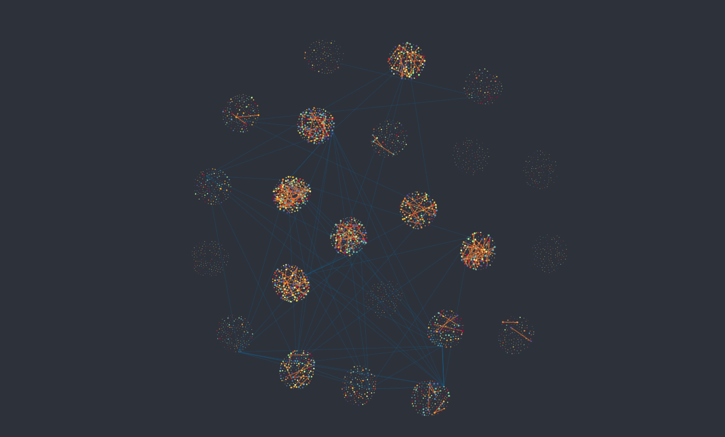 | 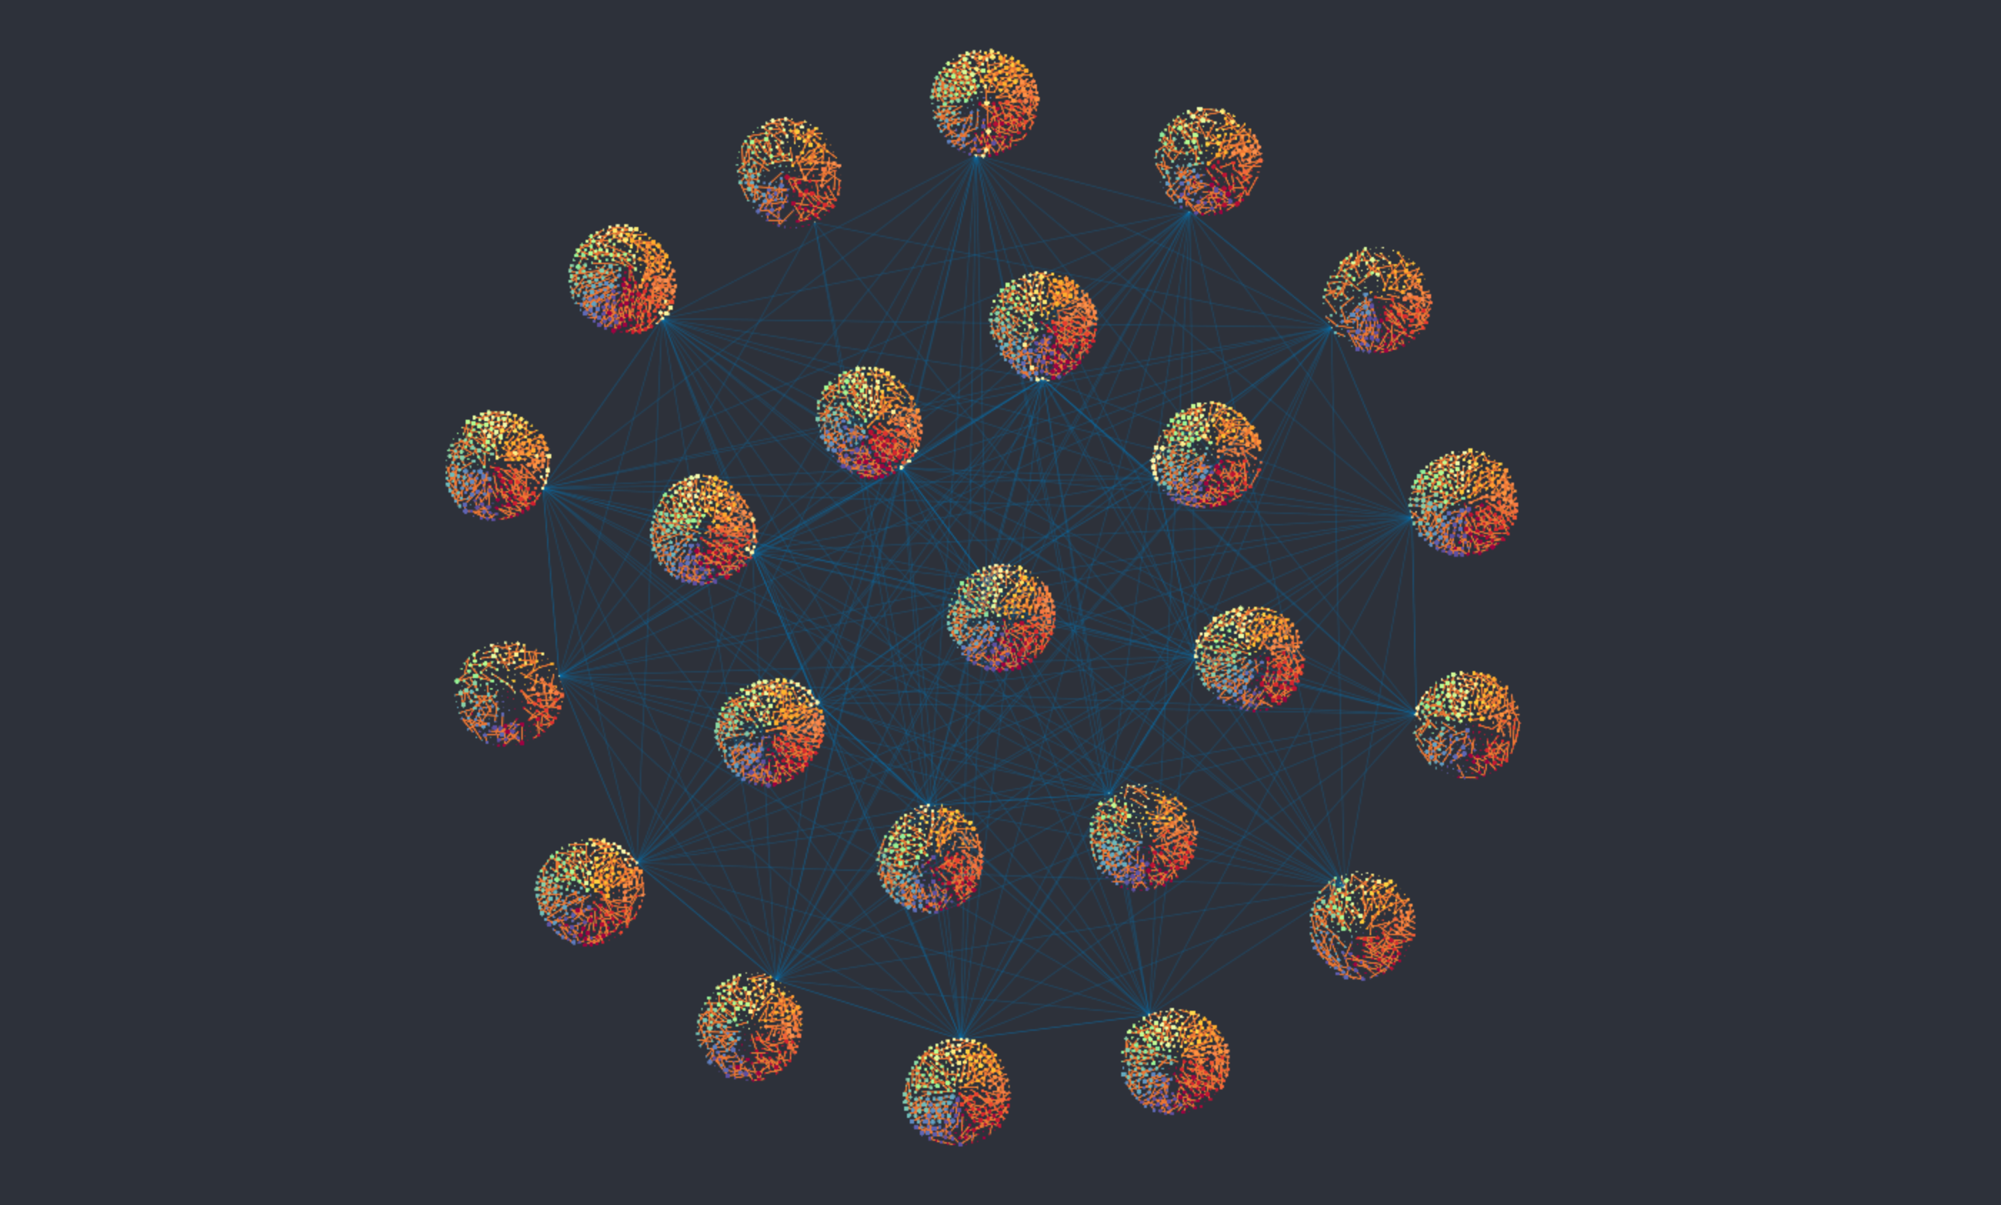
(a) Pre-ictal | (b) Ictal
Figure 11. Static Cosmograph visualization of pre-ictal and ictal Multiplex Visibility Graph networks. The pre-ictal graph shows more sparse structure, whereas the ictal graph forms denser connectivity. The number of retained edges increased from 302 in the pre-ictal phase to 4,342 in the ictal phase, indicating a 14.4-fold increase in network connectivity during seizure activity.
To explore the difference between pre-ictal and ictal status, we divided horizontal visibility graph into two parts. ‘cosmo_pre_nodes.csv’ and ‘cosmo_pre_edges.csv’ consist of networks that average the node information and edge information across 15 windows for the pre-ictal condition, and ‘cosmo_ict_nodes.csv’ and ‘cosmo_ict_edges.csv’ do the same for the ictal condition. Static networks use the same 23 electrodes and are averaged over 15 seconds. For an intra-layer edge to be retained between two timepoints within the same electrode, the edge had to appear in at least 3 of the 15 one-second windows, corresponding to a VG frequency ≥ 0.2. To examine whether electrodes showed similar visibility-based activity patterns, we also retained functional inter-electrode edges when the Pearson correlation between their VG degree sequences was ≥ 0.5. This was inspired by Visibility Graph Similarity, which uses degree-sequence correlations to quantify dynamic similarity between time series (Ahmadlou & Adeli, 2012).
In the figure, electrodes have grouped nodes together, where the color of the node indicates the electrode and the size of the node represents the VG degree averaged over 15 windows. Edges represent either intra-layer visibility connections or functional inter-electrode connections. This result suggests clear differences between the pre-ictal and ictal conditions.
In the pre-ictal network, there are relatively few intra-layer edges as well as functional inter-electrode edges. Electrodes are connected more loosely, and nodes tend to be small, meaning that the Multiplex Visibility Graph connection of a node to other nodes within the same electrode is weak. The low number of functional inter-electrode edges might suggest weaker connectivity or lower synchronization between different electrodes before the start of the seizure.
In contrast, in the ictal state, there are connections across more electrodes, and the overall number of connections is much higher. The groups appear more tightly connected, and many of the nodes are larger than in the pre-ictal case, which indicates that their node degrees are higher. There are many more intra-layer edges present compared to the pre-ictal network, showing stronger Multiplex Horizontal Visibility Graph connectivity within each electrode. There are also more functional inter-electrode edges, which suggests increased synchronization among electrodes. Overall, this indicates an increased number of connections, a higher node degree on average, and more synchronized activity between different electrodes during the seizure period.

Streaming Timeline Graphs
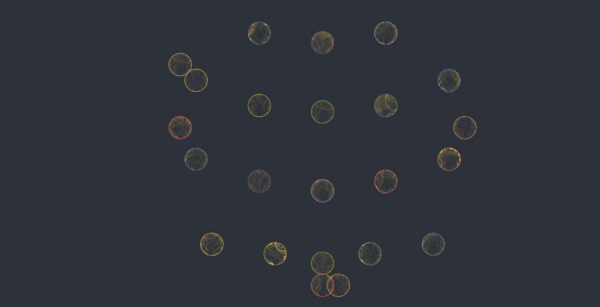 | 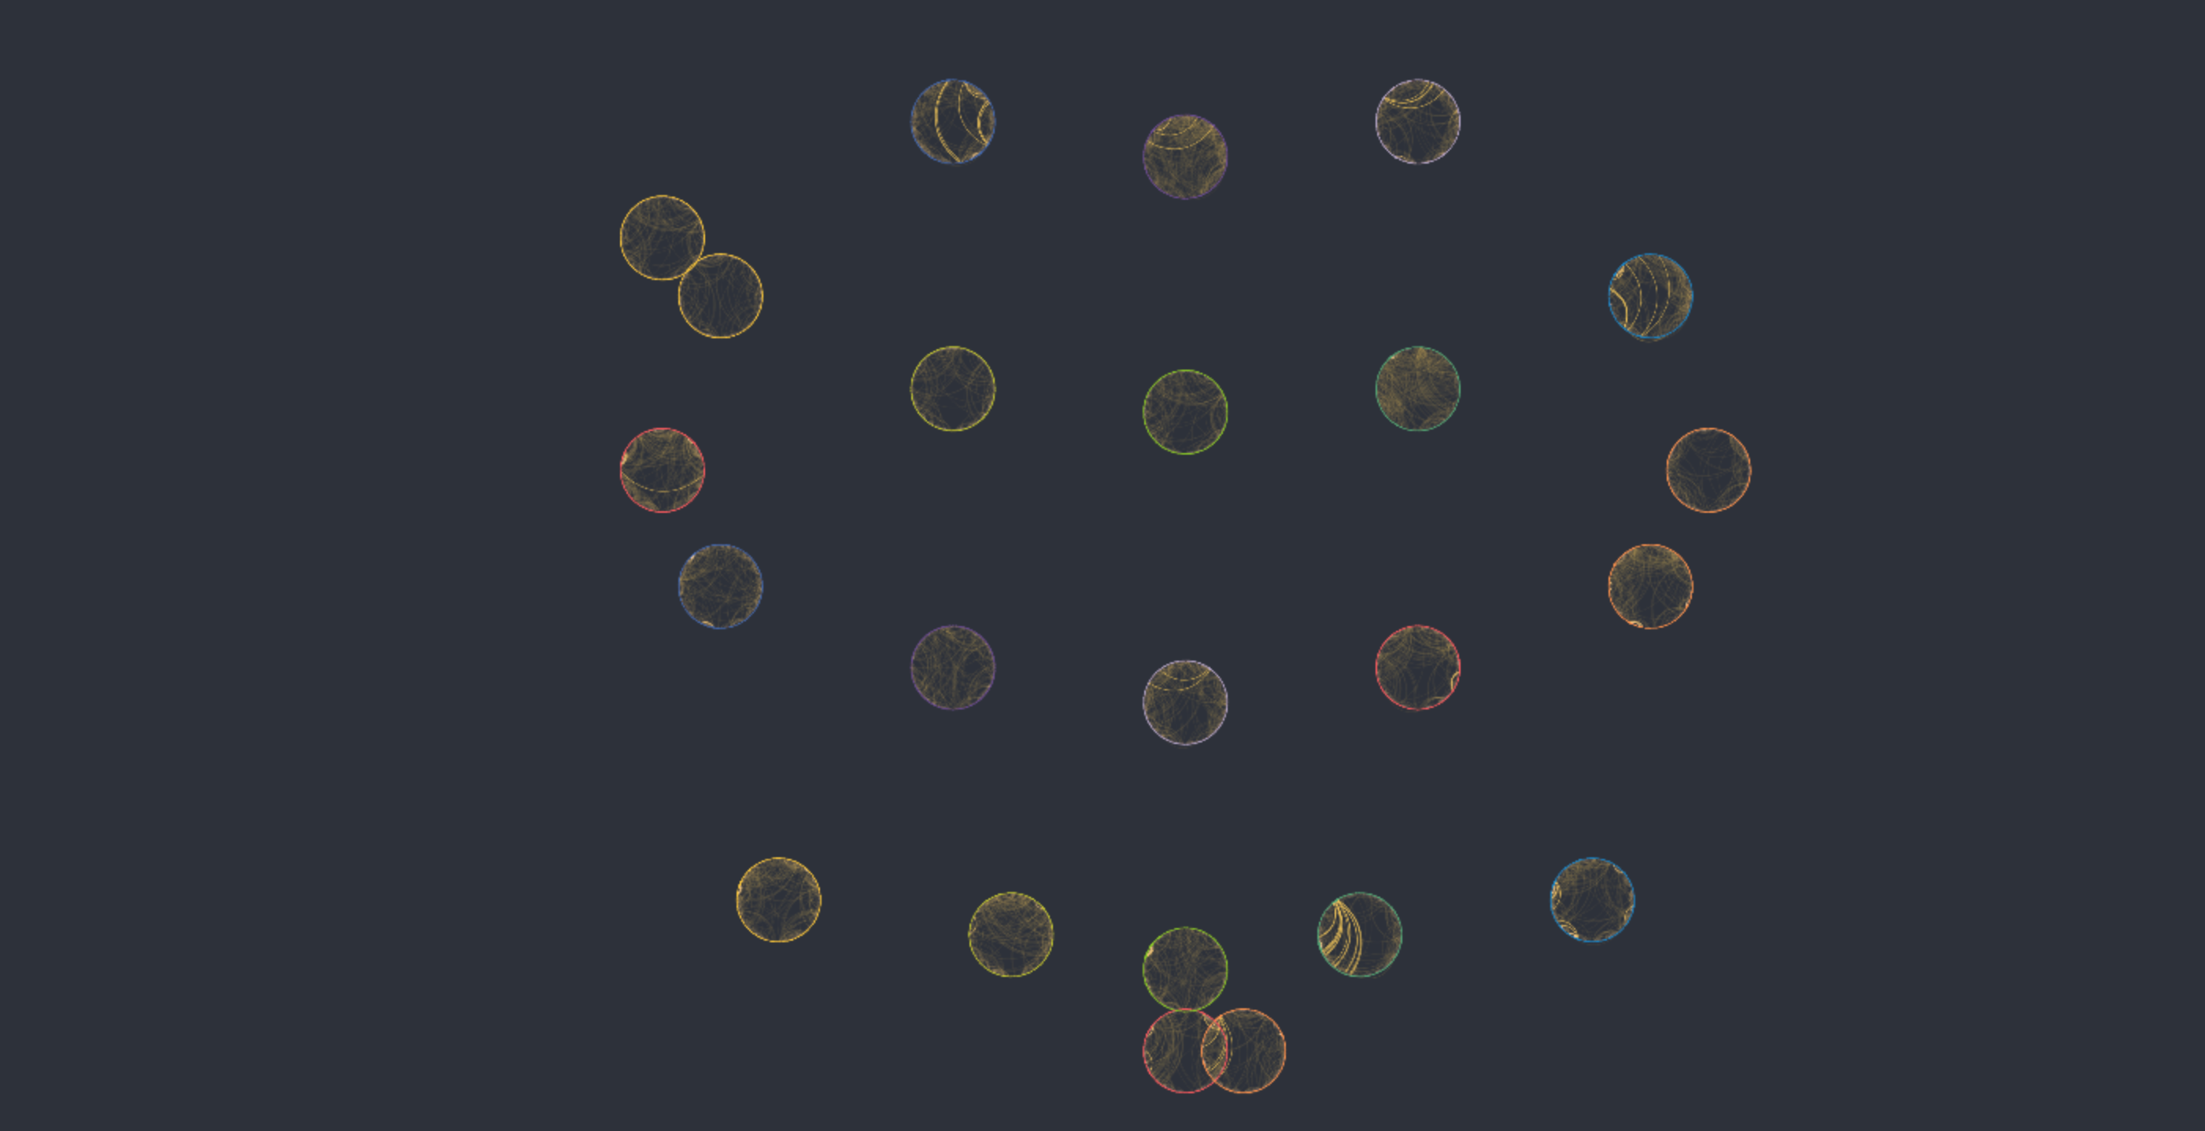 | 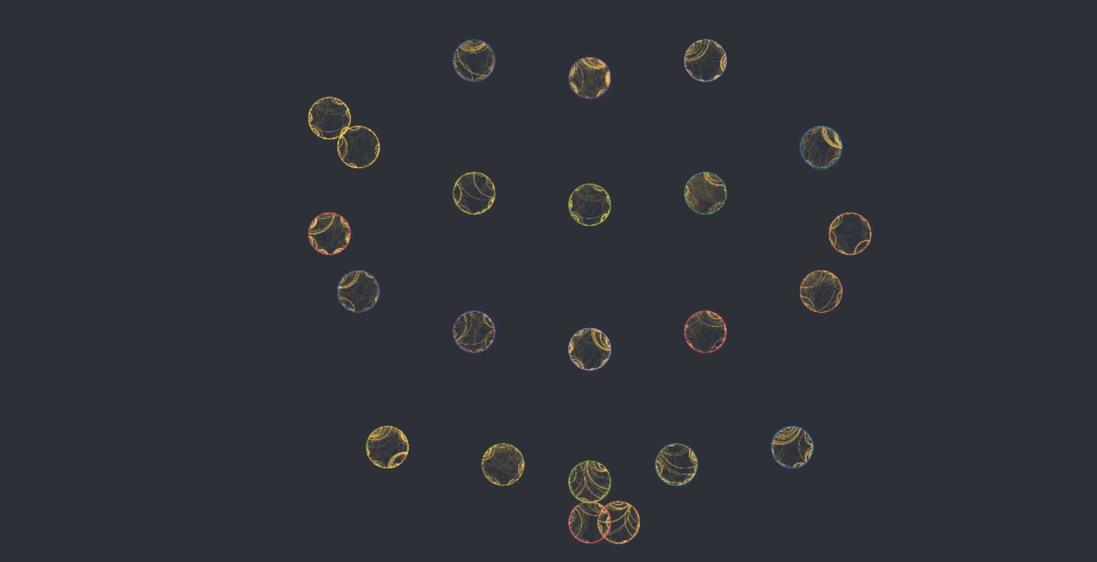
(a) all electrodes (pre-ictal); t =5s | (b) all electrodes (transition); t = 15s | (c) all electrodes (ictal); t = 30s
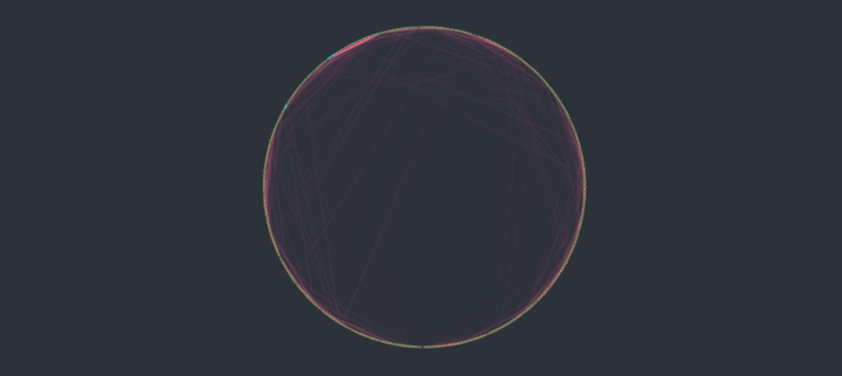 | 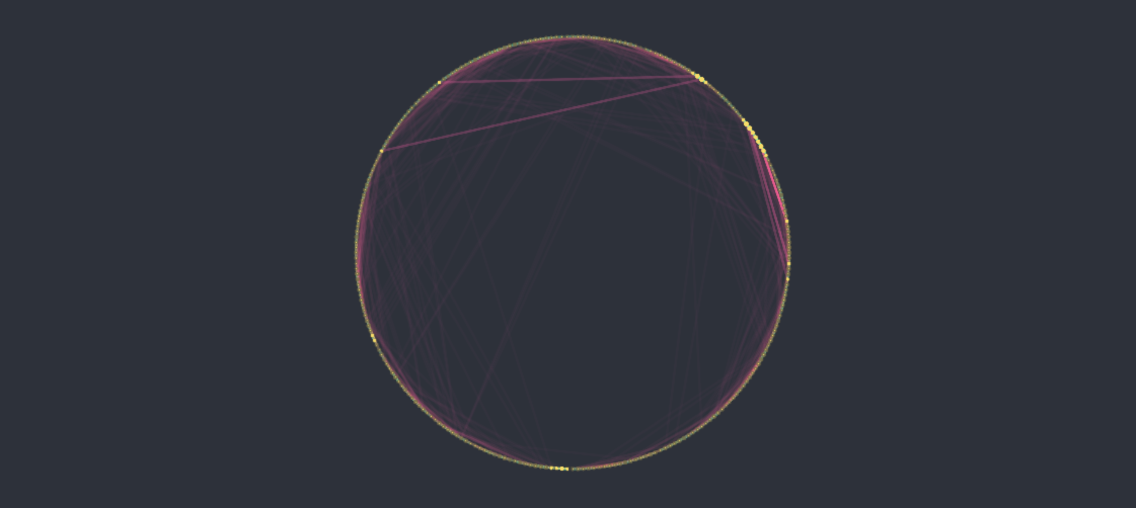 | 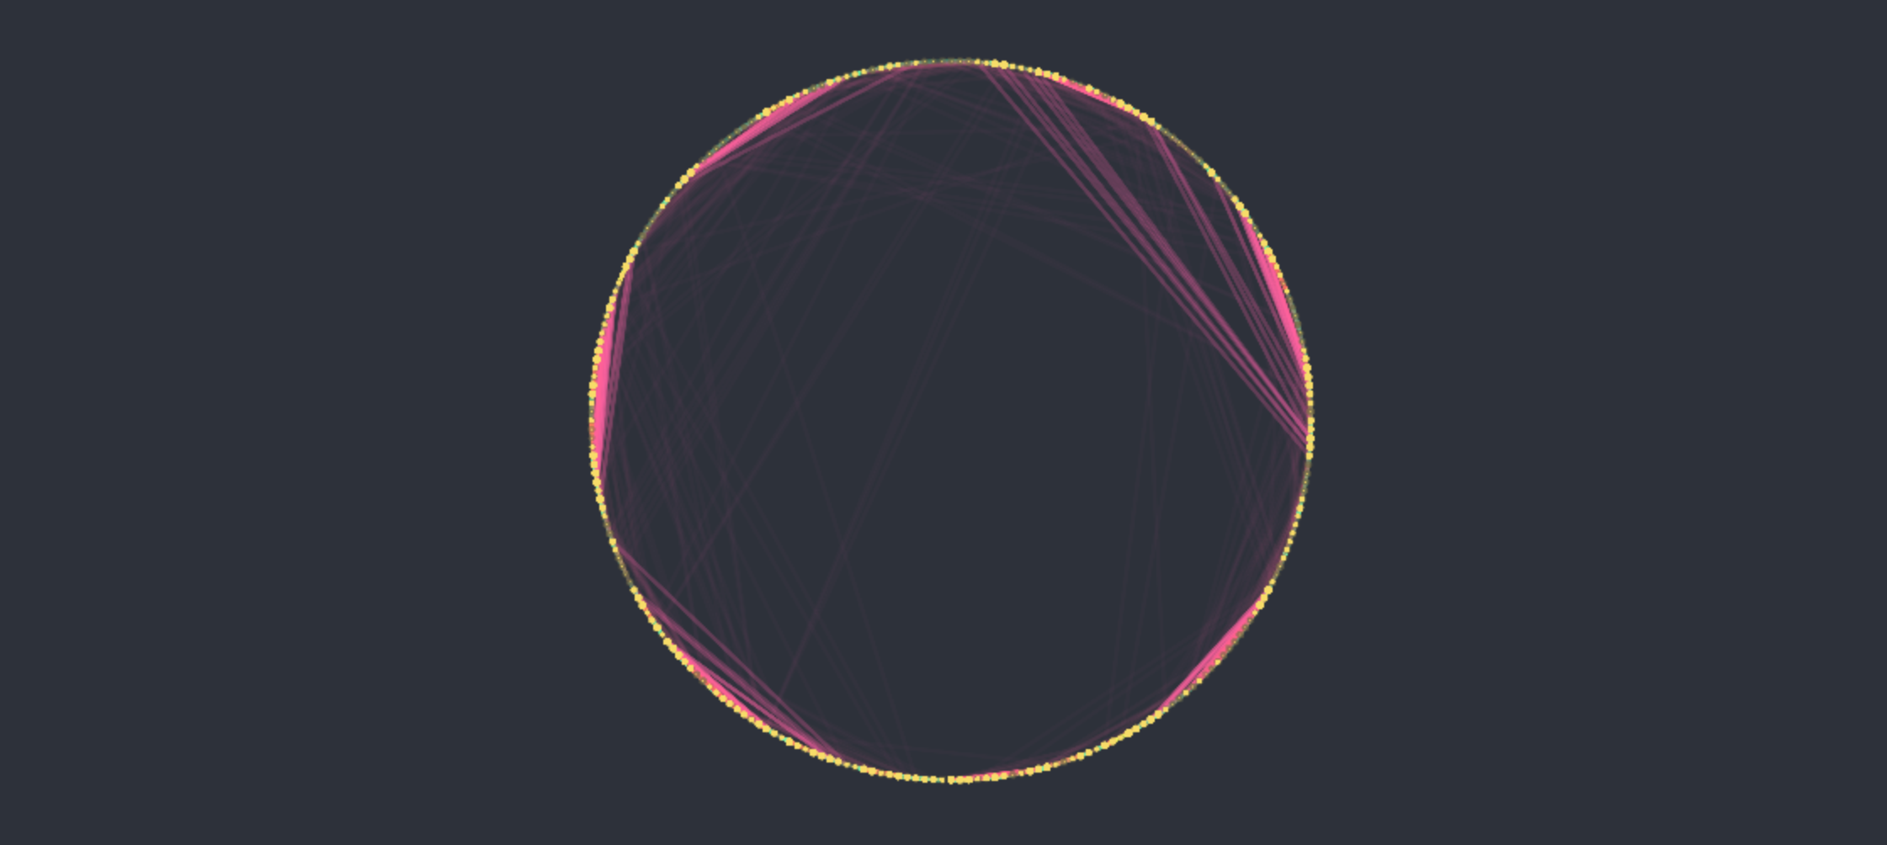
(d) electrode CZ (pre-ictal); t =5s | (e) electrode CZ (transition); t = 15s | (f) electrode CZ (ictal); t = 30s
Figure 12. Time-based Cosmograph visualization of changing intra-electrode Multiplex Horizontal Visibility Graph structure. The stream shows second-by-second changes during the 30-second EEG segment. Panels (a)–(c) show the full 23-electrode version at 5 seconds, 15 seconds, and 29 seconds, arranged in the 10-20 layout. Panels (d)–(f) show the corresponding circular Multiplex Visibility Graph stream for the CZ electrode at the same timepoints. Together, these views demonstrate how intra-electrode connectivity changes from the pre-ictal phase to the ictal phase.
To obtain visualizations, two Cosmograph file pairs were used. One pair was composed of ‘cosmograph_nodes_CZ.csv’ and ‘cosmograph_edges_CZ.csv’, which contain the nodes and edges for a single-electrode stream. The other pair contains the Cosmograph nodes and edges for the entire 23-electrode stream: ‘cosmograph_nodes_all.csv’ and ‘cosmograph_edges_all.csv’.
The single-electrode stream contains 7,680 nodes and 1,458 edges over 30 one-second windows. In comparison, the all-electrode stream contains 176,640 nodes and 33,419 edges over the same 30 one-second windows. Both file pairs include a time variable that marks seconds 0 through 29. Cosmograph can play this timeline to visualize the progression of node connections second by second.
Each circular graph contains 256 nodes, representing the timepoints within one second. In the all-electrode stream, these circular graphs are positioned according to the 10-20 electrode layout. The 10-20 electrode layout is a standard EEG electrode placement system in which electrodes are positioned at fixed proportional distances across the scalp. In this visualization, the 23 electrode-specific circular graphs are arranged according to their approximate anatomical locations on the head.
When exporting the streaming files, inter-electrode connections were removed because node-to-node connections between electrodes are less meaningful in a second-by-second stream. Inter-electrode relationships require aggregation over multiple seconds and are therefore visualized in the static phase-comparison graphs instead.
  - HTML Visualizations
The three HTML visualizations are provided as supplementary tools to make Multiplex Visibility Graph patterns more visible and interpretable. All files are self-contained and can run directly in a modern web browser without additional extensions or installation.

brain streaming visualization of intra-electrode multiplex visibility graph
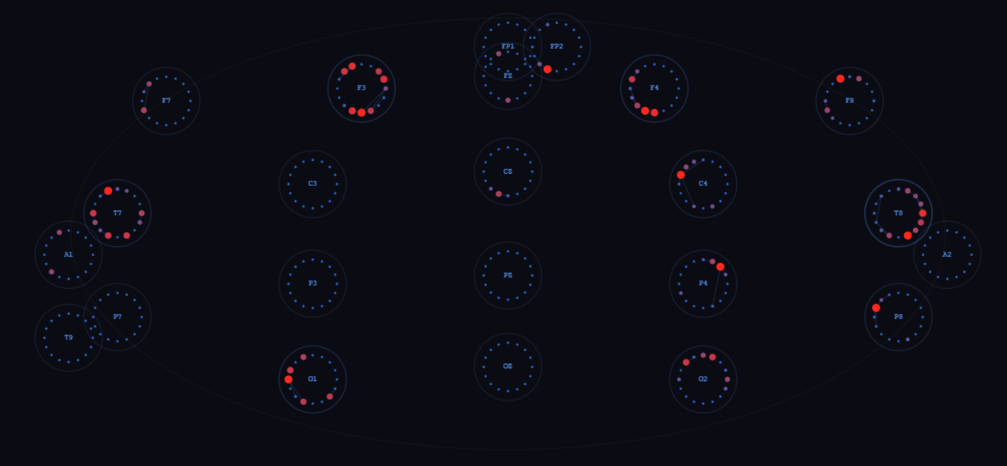 | 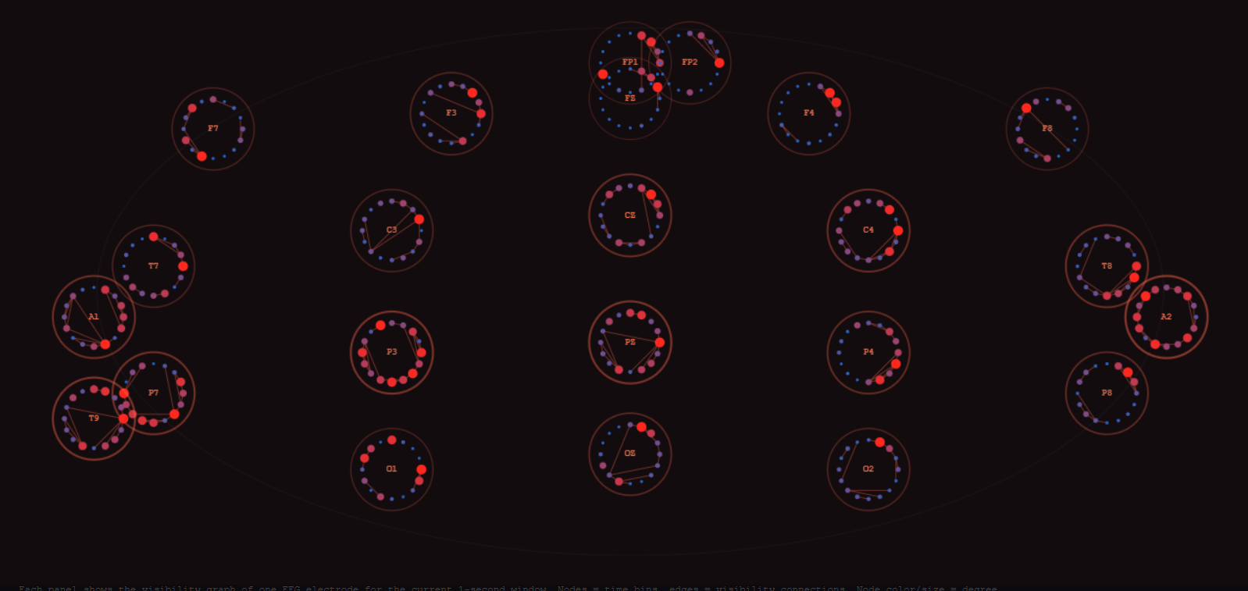
(a) preictal; t = 5s | (b) ictal; t = 25s
Figure 13. HTML-based full-brain streaming visualization of intra-electrode Visibility Graph. (a) In the pre-ictal phase, electrode-level circular Multiplex Visibility Graphs appear sparse, with relatively weak local connectivity. (b) In the ictal phase, the circular graphs become brighter and denser, indicating increased VG degree and stronger intra-electrode connectivity. This HTML visualization was created to make intra-electrode streaming changes more visually interpretable than the full-electrode Cosmograph timeline.
To aid understanding, we created a browser-based HTML animation that supplements the original full-electrode streaming graph produced in Cosmograph. we found that the simultaneous streaming data rendered by Cosmograph did not adequately highlight the difference between the pre-ictal and ictal phases. Specifically, seeing all electrodes streamed at the same time in Cosmograph made changes in the underlying Multiplex Visibility Graph structure difficult to discern by eye.
Instead, we constructed a new HTML visualization with the aid of Claude AI to focus only on intra-electrode connectivity at each site. This visualization shows the same data, with all individual electrodes streaming in parallel and arranged in a standard 10-20 layout. Each electrode is represented as a circular graph composed of 256 timepoint nodes.
The animation runs across 30 one-second time intervals. It begins with sparse and weak connectivity in the pre-ictal phase and becomes progressively denser at seizure onset, as the circular graphs brighten and fill with more connections. Within each circular graph, node brightness is weighted by VG degree, representing the activation of each timepoint in the Multiplex Visibility Graph. Edges are colored to reflect visibility distance.
A panel along the bottom of the animation displays running statistics, including the mean VG degree across all electrodes, the number of edges between connected nodes in each time interval, and the electrode with the highest average VG degree during that time frame. This visualization helps clarify the spatial spread of seizure-related network changes across the scalp and serves as a more effective view of intra-electrode streaming changes than the full-electrode Cosmograph streaming timeline.

23-Electrode Inter-layer Functional Connectivity Network
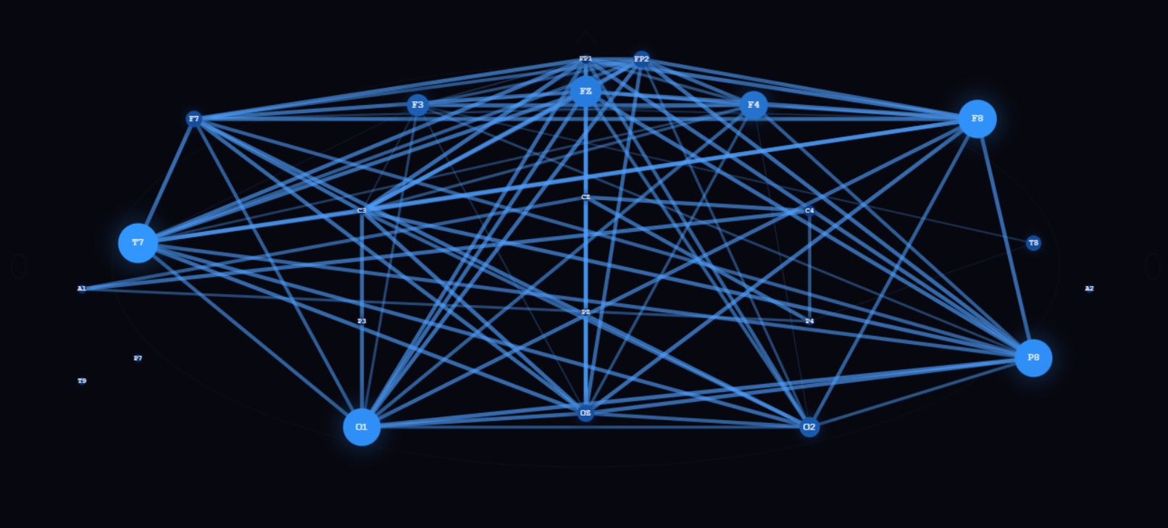 | 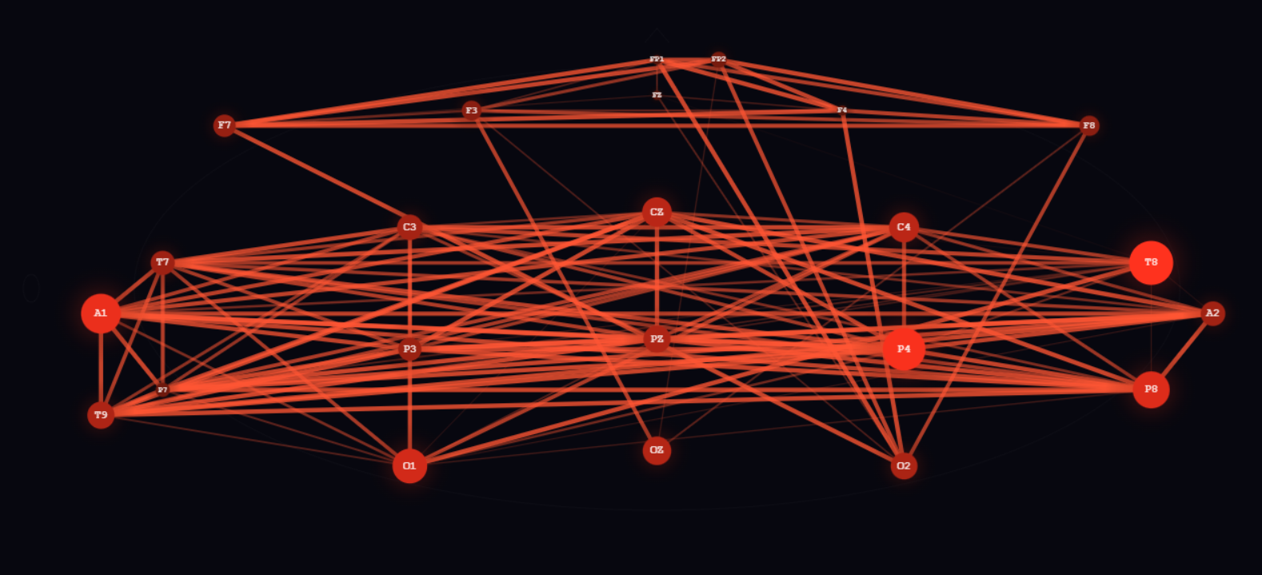
(b) pre-ictal; t = 5s | (b) ictal; t = 25s
Figure 14. HTML-based inter-electrode functional connectivity network derived from VG degree time series. Each EEG electrode is represented as a single node in the 10-20 head layout. Edges represent Pearson correlations between electrode-level VG degree time series, showing only inter-electrode functional connectivity. The pre-ictal network shows fewer and weaker cross-electrode connections, whereas the ictal network shows denser and more widespread connectivity, indicating stronger synchronization between electrodes during seizure activity.
This visualization represents each EEG electrode as a single node positioned according to the 10-20 head layout. Unlike the circular Multiplex Visibility Graph visualizations, this view focuses only on inter-electrode connectivity. Each node summarizes one electrode, and the links represent functional relationships between different electrodes.
Node size and color indicate the mean VG degree of each electrode over time. Blue represents the pre-ictal baseline state, while red represents ictal activation. Edge thickness represents the Pearson correlation between pairs of electrodes, computed from their VG degree time series. An adjustable threshold slider allows weak inter-electrode connections to be filtered.
The pre-ictal network shows a relatively sparse inter-electrode structure, with weaker and fewer connections between electrode sites. In contrast, the ictal network shows a denser inter-electrode connectivity pattern, with more widespread links across the head layout. This indicates that during the seizure period, electrodes become more functionally synchronized based on their VG degree dynamics.

  - Interictal-Ictal Difference Analysis
The following section displays, explains and comments on visualizations of the four implemented algorithms, highlighting the observed difference between data from the two brain states.
The two Stream-Moore graph visualizations (Figure 15) are visually not distinguishable, as both show a uniform mass of nodes with no recognizable groupings or internal organization. This aligns with the incompatibility between modularity maximization and the HVG structure discussed earlier. When node degrees are almost uniform across the entire graph, no merge ever produces a positive modularity gain, and the algorithm effectively halts after the first few edges.

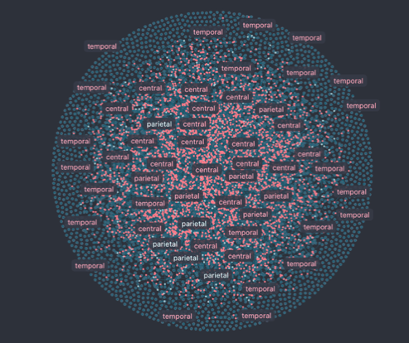 | 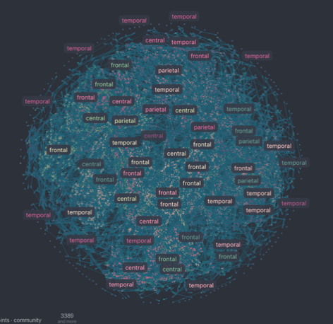
- Stream-Moore Interictal | - Stream-Moore Ictal
Figure 15. Stream-Moore algorithm visualizations.
Also, for the LPA algorithm, both visualizations (Figure 16) again appear very similar, dense and with an almost uniform node distribution. However, looking carefully, the ictal graph appears slightly more concentrated toward the center, with frontal labels appearing more densely clustered in the interior relative to the interictal graph where temporal labels dominate the periphery. Additionally, the ictal graph shows more and stronger connections. Nevertheless, also this algorithm converged into a single community, which shows that community detection was not compatible with this type of data.

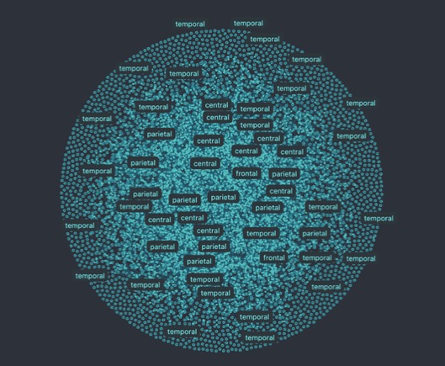 | 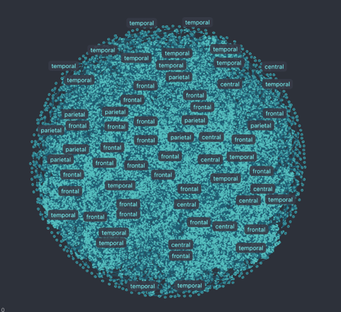
- Label Propagation Interictal | - Label Propagation Ictal
Figure 16. LPA algorithm visualizations.
The visualizations for the Laplacian Spectral Clustering (Figure 17) is the most informative pair across graphs. The interictal graph clearly shows two distinct areas, a large blue region and a distinct pink/magenta region, indicating that the algorithm has partitioned the network into spatially separated communities. Frontal and temporal nodes appear distributed across both colors, suggesting the clustering reflects functional rather than purely anatomical boundaries. The ictal graph however shows a different pattern: the blue region shrinks substantially and a large community that is here portrayed in orange emerges and occupies much of the graph. This color shift represents the reorganization of community assignments during the seizure, nodes that previously belonged to one functional group are reassigned as ictal hypersynchrony drives them into a single dominant cluster.

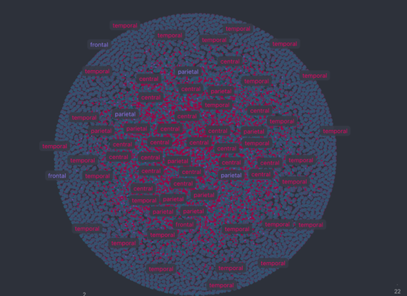 | 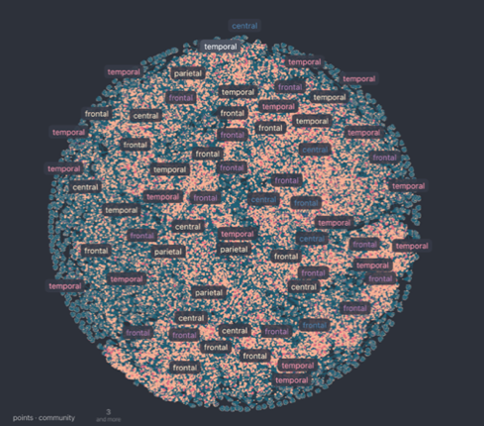
- Laplacian Spectral Clustering Interictal | - Laplacian Spectral Clustering Ictal
Figure 17. Laplacian Spectral Clustering algorithm visualizations.
For the interictal and ictal graph of the Ward algorithm visualizations (Figure 18), a clear difference is recognizable. The interictal graph shows a relatively balanced distribution of teal and pink nodes spread across the full graph, with temporal labels dominating the periphery and central and parietal labels occupying the center, suggesting that Ward has partitioned the network into communities that approximately reflect anatomical boundaries. The ictal graph shows a shift in this balance: pink nodes become more concentrated and prominent, particularly toward the center, while frontal labels grow more numerous and centrally positioned. This consolidation is consistent with the dendrogram result showing that frontal and central channels merge into a dominant cluster at shorter linkage distances during the seizure. However, compared to the Laplacian Spectral Clustering pair, the visual contrast here is less obvious, which reflects the static nature of Ward clustering. Since this algorithm operates on a phase-averaged correlation matrix rather than tracking community assignments window by window, the Cosmograph visualization captures the aggregate community structure instead of a reorganization happening moment-to-moment.

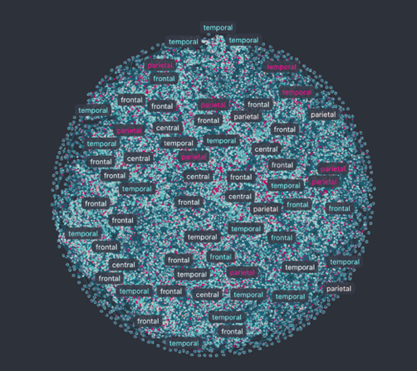 | 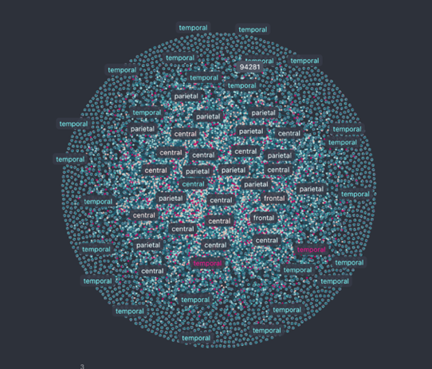
- Ward Hierarchical Clustering Interictal | - Ward Hierarchical Clustering Ictal
Figure 18. Ward Hierarchical Clustering algorithm visualizations.
- Insights & Analysis
After analyzing the behavior of each algorithm individually, we now move from method-specific results to a comparative perspective. The following section focuses on benchmarking and synthesizing the observed behaviors, linking algorithm performance back to the overall pipeline and the constraints of EEG-based network analysis.
Benchmarking community detection is inherently difficult. As pointed out by Fortunato (2010), many studies rely on inconsistent or misleading comparisons between algorithms without a clear evaluation framework. Similarly, Wang et al. (2015) emphasize that algorithm comparison must consider multiple dimensions such as efficiency and robustness rather than relying on a single metric. In the context of EEG data, this challenge becomes even more significant because no ground truth community structure exists.
To address this, we deliberately adopt a simplified benchmarking approach that focuses on the most important and comparable aspects: outputs, runtime, and stability. This decision follows the recommendation by the teaching assistant that benchmarking frameworks should remain interpretable and avoid unnecessary complexity, focusing instead on key metrics such as runtime. Accordingly, we evaluate algorithms primarily based on runtime (CPU time) as a measure of computational efficiency and stability, quantified using normalized mutual information (NMI) across repeated runs as an indicator of robustness.
At the same time, following multi-dimensional benchmarking frameworks (Wang et al., 2015; Khayati et al., 2020), we explicitly treat algorithm performance as a trade-off problem rather than aiming to identify a single best method. Different algorithms capture different aspects of the data, and their behavior must therefore be interpreted across multiple dimensions. This perspective is later visualized using a radar diagram (Figure 20), which highlights that no algorithm dominates across all criteria.
Importantly, we do not compare internal optimization objectives such as modularity or sum of squared errors (SSE), since these are algorithm-specific and not directly comparable across methods (Wang et al., 2015). Instead, we rely on external evaluation criteria that allow for a consistent and fair comparison of algorithm behavior under EEG-specific constraints.
To systematically analyze the relationship between computational cost and clustering quality, we extend the benchmark with a sweet-spot analysis (Figure 19). This analysis follows the idea discussed in the course Social Media Analytics – Community Structure Analysis (Khayati, lecture 04b, 2026) and evaluates the trade-off between runtime and partition stability using normalized mutual information (NMI). NMI is a bounded measure between 0 and 1, where values close to 1 indicate high similarity between partitions across runs, while values close to 0 indicate strong dissimilarity. By jointly considering CPU time and stability, the sweet-spot analysis identifies regions where further increases in computational effort do not lead to meaningful improvements in partition consistency. As emphasized by the lecturer, such analysis is particularly useful in the absence of ground truth, as it allows for principled comparison of algorithms based on efficiency–stability trade-offs rather than absolute performance.
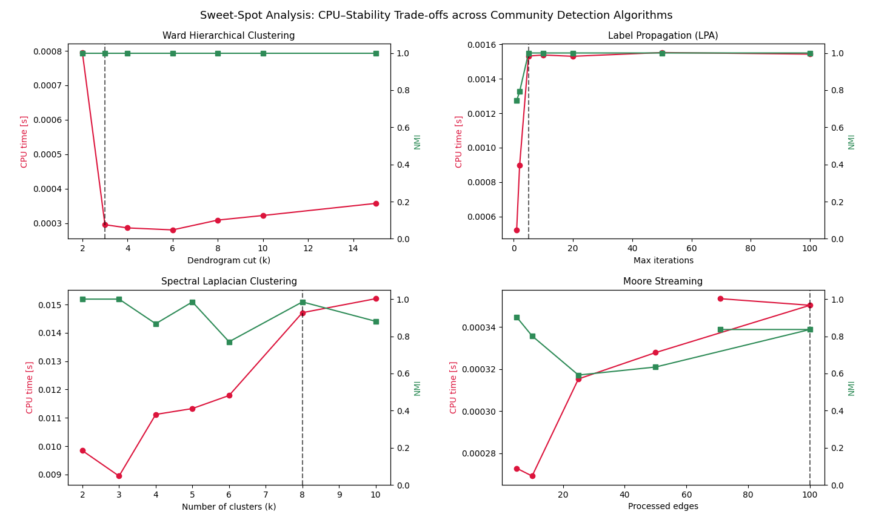
Figure 19. Sweet-spot analysis illustrating the trade-off between computational cost (CPU time) and partition stability (normalized mutual information, NMI) across different community detection algorithms. Each panel shows how stability and runtime evolve with increasing algorithm complexity or resolution. The dashed vertical line indicates the point where increases in computational cost no longer lead to meaningful gains in stability. For Spectral Laplacian Clustering, Label Propagation, and Moore Streaming, this highlights an efficient operating region with diminishing returns beyond this point. In contrast, Ward hierarchical clustering shows constant stability (NMI ≈ 1.0) across all runs due to its deterministic nature, meaning no meaningful sweet spot can be identified. This demonstrates that not all algorithms exhibit a stability–cost trade-off, and that parameter selection depends on the underlying algorithm properties. Overall, the sweet-spot analysis supports informed method selection rather than ranking algorithms by a single performance metric.
To complement the qualitative discussion, Table 5 summarizes the main benchmarking results across all algorithms using the selected core metrics. The table highlights key differences in runtime, stability, and algorithm behavior, and provides a compact comparison of how each method performs under the same graph conditions. Importantly, the results confirm that differences between algorithms are mainly driven by computational characteristics rather than large structural differences in the detected communities.

Algorithm | Runtime | Stability (NMI) | Deterministic | Sweet Spot
Moore Streaming | High (~10 s) | High  (no changes) | Yes | Weak
Label Propagation | Low (~0.3 s) | Medium (~0.8) | No | Clear
Ward Hierarchical | Very low (<0.1 s) | Perfect (1.0) | Yes | None
Spectral Clustering | Medium (~0.3–0.4 s) | High (~0.8) | Mostly | Clear

Table 5. Quantitative comparison of community detection algorithms based on runtime, stability (measured via normalized mutual information, NMI), determinism, and presence of a sweet-spot region. All methods are evaluated on the same graph and produce comparable community assignments over identical nodes and edges. Runtime reflects computational efficiency, stability captures consistency across runs, and the sweet-spot column indicates whether a meaningful trade-off between computational cost and stability exists.
  - Comparison between Label Propagation from-scratch and Network X version
To verify the correctness of our implementation of the Label Propagation algorithm we compared it directly against the reference by the Network X library. Both implementations were applied to the same visibility graph, and the results align completely across all evaluated criteria. Both versions produced 7,680 communities, each containing precisely 23 nodes. This means both versions of this algorithm perfectly partitioned the graph. The modularity score was also identical for both, with a value of Q = 0.9999, demonstrating an almost perfect community structure. Running both implementations 10 times each, they always produce the same partitions with NMI of 1, which shows that they converge exactly to the same solution each time. This stability is interesting given that LPA is surprising and reflects the rigidity of the underlying graph structure, that the intra-layer edges within each window are so much stronger than the inter-layer edges between channels. That’s why the two algorithms seem to converge to the same partition regardless of the ordering of the nodes. The only difference between the two versions is runtime. The version from-scratch completed the analysis in 2.8 seconds, whereas the Network X implementation of LPA needed 1.85 seconds. Overall this confirms that our implementation from-scratch is correct, however, for practical use in the pipeline, the NetworkX version is preferred due to its advantage in speed.
The radar diagram (Figure 20) is used to visualize the multi-dimensional trade-offs between the evaluated community detection algorithms, based on four key dimensions: runtime efficiency, stability, adaptability, and interpretability (adapted from Khayati et al., 2020). The results show clear differences between methods. Ward clustering performs best in terms of runtime and stability but lacks adaptability to temporal dynamics. Label Propagation is fast and adaptive, but less stable across runs. Spectral clustering offers balanced performance across all dimensions, while the streaming approach is highly adaptive but computationally expensive. Overall, the diagram highlights that no algorithm dominates across all criteria, confirming that performance is inherently multi-dimensional. The benchmark further shows that differences between algorithms are mainly driven by computational behavior, while the EEG visibility graph itself is highly uniform, which limits the detection of strong structural differences. Importantly, the goal of the benchmark is not to recommend a single best algorithm, but to provide a clear understanding of these trade-offs. As emphasized by the lecturer, while it is possible to suggest suitable methods for specific use cases, the primary objective is to inform users about the strengths and weaknesses of each approach, allowing them to make their own informed decision depending on their application.
Nevertheless, we would like to provide a practical guideline for this specific use case: streaming methods are well suited for real-time EEG analysis, Label Propagation enables fast exploratory analysis, Ward clustering is appropriate for stable offline analysis, and spectral methods are particularly useful for analyzing global network structure. While the final choice depends on the priorities of the user, this mapping can serve as an initial orientation for similar EEG-based applications.
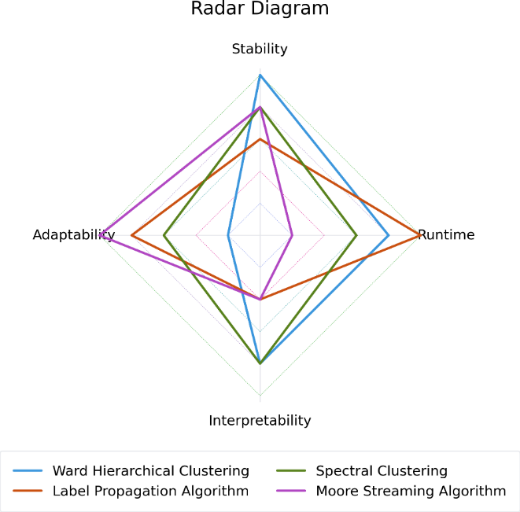
Figure 20. Radar diagram illustrating the strengths and weaknesses of the evaluated community detection algorithms across four key dimensions: runtime efficiency, stability, adaptability, and interpretability. Scores are normalized on a scale from 0 to 5, where higher values indicate better performance. Each algorithm is represented by a polygon formed by connecting its scores across dimensions, enabling direct visual comparison. Differences in polygon shape and extent reflect trade-offs between computational efficiency and analytical capabilities. Adapted from Khayati et al. (2020).
- Conclusion
This project presents an end-to-end pipeline for analyzing temporal and spatial network changes in pediatric EEG data using community detection methods. By combining graph construction, algorithm comparison, and benchmarking, we show that community detection in EEG networks is strongly influenced by the structural properties of the data and the computational behavior of the algorithms.
Our results highlight that there is no single best method, but rather a set of trade-offs between runtime, stability, and adaptability. This reinforces the idea that algorithm choice should be guided by the specific research question and the constraints of the application.
Looking back, several aspects of the project could be improved. First, the benchmarking framework could be extended with more datasets and additional evaluation scenarios to increase robustness. Second, the organization of the GitHub repository could be improved to better reflect the pipeline structure and make the workflow more transparent. In addition, at the beginning of the project, tasks and sections were divided too independently, which led to a somewhat fragmented understanding of the overall system. Only later, following feedback by the teaching assistant, we realized the importance of a more integrated approach. A deeper understanding of all parts of the pipeline by all team members would likely have resulted in a more coherent and consistent final outcome. Despite these limitations, the project demonstrates that combining network-based representations with careful benchmarking provides valuable insights into EEG dynamics and highlights the importance of understanding algorithmic trade-offs in real-world applications. Future analyses could include the application of our algorithms to other segments of the same patient or to other patients. An attempt to make a generalizable tool would enhance the value of the current work. Predicting epileptic seizures is crucial for diagnostic purposes, especially for disorders as severe as epilepsy. Another important analysis would be to determine in which electrode a seizure first appears and whether this onset consistently occurs in the same electrode, for example by applying information diffusion algorithms. This would represent an initial step toward identifying the epileptic focus in a patient. Localizing the epileptogenic zone is one of the most critical steps in the treatment of intractable epilepsy (Mansouri, 2012).
Overall, this project was a rewarding opportunity to explore a topic that is of interest to us and we acquired substantial knowledge throughout the process, including implementing the proposed pipeline, creating the graphs, analysing the results, and creating understandable visualizations. It also provided valuable experience in scientific collaboration, methodological problem-solving, and the application of theoretical concepts to a clinically relevant problem.

- Appendix

  - References
Ahmadlou, M., & Adeli, H. (2012). Visibility graph similarity: A new measure of generalized synchronization in coupled dynamic systems. Physica D: Nonlinear Phenomena, 241(4), 326–332.
Bühler, T., & Hein, M. (2009). Spectral clustering based on the graph p-Laplacian. Proceedings of the 26th Annual International Conference on Machine Learning, 81–88.
Clauset, A., Newman, M. E. J., & Moore, C. (2004). Finding community structure in very large networks. Physical Review E, 70(6), 066111.
Fiedler, M. (1973). Algebraic connectivity of graphs. Czechoslovak Mathematical Journal, 23(2), 298–305.
Fortunato, S. (2010). Community detection in graphs. Physics Reports, 486(3–5), 75–174.
Goldberger, A., Amaral, L., Glass, L., Hausdorff, J., Ivanov, P. C., Mark, R., & Stanley, H. E. (2000). PhysioBank, PhysioToolkit, and PhysioNet: Components of a new research resource for complex physiologic signals. Circulation, 101(23), e215–e220.
Gregory, S. (2010). Finding overlapping communities in networks by label propagation. New Journal of Physics, 12(10), 103018.
Guttag, J. (2010). CHB-MIT Scalp EEG Database (version 1.0.0). PhysioNet.
Jiruska, P., De Curtis, M., Jefferys, J. G. R., Schevon, C. A., Schiff, S. J., & Schindler, K. (2013). Synchronization and desynchronization in epilepsy: Controversies and hypotheses. The Journal of Physiology, 591(4), 787–797.
Khayati, M., Lerner, A., Tymchenko, Z., & Cudré-Mauroux, P. (2020). Mind the Gap: An Experimental Evaluation of Imputation of Missing Values Techniques in Time Series. Proceedings of the VLDB Endowment, 13(5), 768–782. https://doi.org/10.14778/3377369.3377383
Kramer, M. A., & Cash, S. S. (2012). Epilepsy as a disorder of cortical network organization. Neuroscientist, 18(4), 360–372.
Luo, S., & Ye, F. (2019). A comparison of community detection algorithms in complex networks.
Mansouri, Alireza, Fallah, Aria, Valiante, Taufik A., Determining Surgical Candidacy in Temporal Lobe Epilepsy, Epilepsy Research and Treatment, 2012, 706917, 16 pages, 2012. https://doi.org/10.1155/2012/706917
Nicosia, V., Lacasa, L., & Latora, V. (2014). From multivariate time series to multiplex visibility graphs. arXiv preprint arXiv:1408.0005.
Shoeb, A. H. (2009). Application of machine learning to epileptic seizure onset detection and treatment. Doctoral dissertation, Massachusetts Institute of Technology.
Vijaya, Sharma, S., & Batra, N. (2019). Comparative study of single linkage, complete linkage, and Ward method of agglomerative clustering. 2019 International Conference on Machine Learning, Big Data, Cloud and Parallel Computing (COMITCon), 568–573.
Von Luxburg, U. (2007). A tutorial on spectral clustering. Statistics and Computing, 17.
Wang, M., Wang, C., Yu, J. X., & Zhang, J. (2015). Community Detection in Social Networks: An In-depth Benchmarking Study with a Procedure-Oriented Framework. Proceedings of the VLDB Endowment, 8(10), 998–1009.
Yang, Z., Algesheimer, R., & Tessone, C. J. (2016). A comparative analysis of community detection algorithms on artificial networks. Scientific Reports, 6, 30750.
  - AI Statement
Artificial intelligence (AI) tools were used to support different stages of this project. First, they were used for brainstorming ideas and structuring the initial approach at the beginning of the project. During implementation, AI was helpful for debugging code and resolving technical issues. During the visualization stage, AI tools supported the development of the HTML-based streaming visualizations used to present our results. In addition, AI tools were used for polishing grammar and improving the clarity of the written report.

