Author: Yoan Tyankovski

ionivt@abv.bg

Short description

MQTTApp is a small application which goal is to show the real time transfer of data trough the MQTT protocol

MQTTApp

Tutorial and User Manual

Table of Contents

1 Introduction 2

2 Getting Started With MQTTApp 2

2.1 Launchingthe app 2

2.2 Publishing Messages 3

2.3 Subscribing to Topics 4

2.4 Viewing Subscribed Messages 4

3 Wrap Up 5

# Introduction

Welcome to MQTTApp, an application designed to showcase the efficient and reliable transfer of data through the MQTT (Message Queuing Telemetry Transport) protocol. MQTTApp is built using the Qt framework and C++, demonstrating the integration of these technologies in a real-world context.

MQTTApp serves as an educational tool, demonstrating the practical application of the MQTT protocol in software development.

# Getting Started With MQTTApp

## Launchingthe app

Open MQTTApp by double-clicking the application .exe. Once open, you will see the main window:

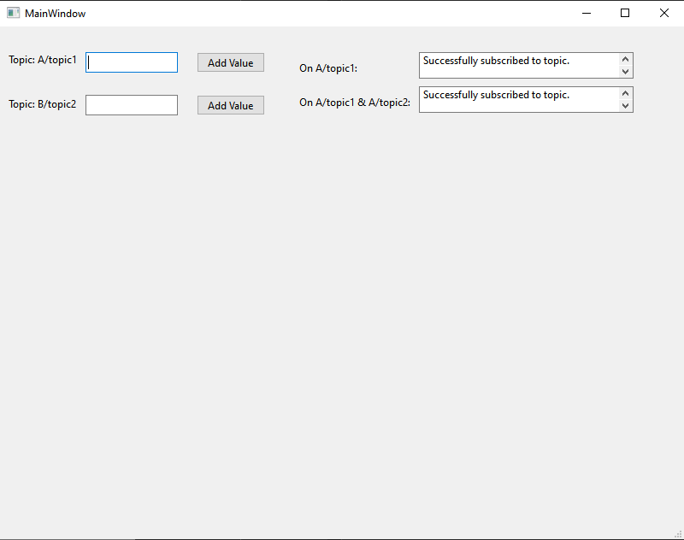

This windows is divided into two main sections:

* **Publishing to Topics:**

On the left side, you have two input fields where you can enter text to publish to the respective MQTT topics:

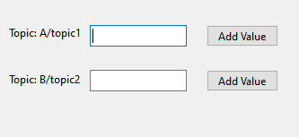

* **Subscriptions Display:**

On the right side, two display areas show messages received from the subscribed topics:

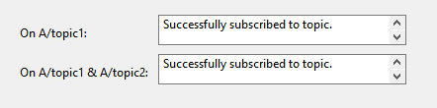

## Publishing Messages

**To publish a message to an MQTT topic:**

* **Choose a Topic:**

Decide in which of the two topics you want to publish a message.

* **Enter Your Value:**

Click inside the text box next to the topic you chose and type your number value:

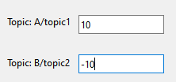

The input box will only allow you to enter a number value.

* **Publish the Message:**

Click the “Add Value” button to publish your message to the MQTT broker:



## Subscribing to Topics

The application subscribes to topics automatically upon startup. In the provided interface screenshot, the application is already subscribed to “A/topic1” and uses a wildcard + to subscribe to multiple topics under A/. Messages received from these subscriptions are displayed in the respective areas on the right side of the window:  
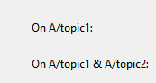

## Viewing Subscribed Messages

When messages are published to topics that the app is subscribed to, these messages will appear in the subscription display areas. For instance:

Messages published to **“A/topic1”** will appear under the "On A/topic1:" section.

Messages published to any topic matching **“A/+”** (like A/topic2) will appear under the **"On A/topic1 & B/topic2:"** section.

This automatic display of messages allows you to see real-time communication between different clients and the MQTT broker.

Example below:

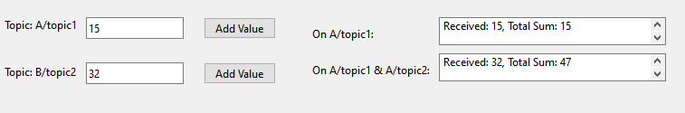

# Wrap Up

MQTTApp provides a simple interface for interacting with the MQTT protocol. With the ability to publish messages and view subscribed topic feeds in real-time, it serves as a valuable tool for anyone looking to understand or demonstrate the MQTT communication model.

Start experimenting by publishing different messages to various topics and observe the immediate updates in the subscription areas. Enjoy exploring the capabilities of MQTT with MQTTApp!