**4. Initial Results**

(I want to make one thing clear here, YUM is not only a search engine, it’s more than that, but we compare to other SE because they are the most similar thing. Tell me if you get it or not from the text and feel free to rephrase.)

In this section we detail the results of initial experiments conducted for validating the performance of YouUnderstooMe. YouUnderstoodMe is more than a search engine oriented to children, it incorporates features oriented to facilitate and enhance the learning process. Therefore, in this initial assessment we focus on demonstrating the need and effectiveness of its enhanced search environment. For this reason, we compare YouUnderstoodMe with a number of popular search engines oriented to children, including Kiddle \footnote{ <http://www.kiddle.co/>}, KidRex \footnote{http://www.kidrex.org/}, SafeSearchKids \footnote{ <http://www.safesearchkids.com/>} and Gogoolingans \footnote{<http://www.gogooligans.com>} . In addition, studies [Ref?] show that children tend to prefer popular search engines such as Google or Bing, oriented to a more general audience, which is why we also include Google in our comparisons.

Due to the lack of benchmark datasets available for evaluating search-related tools focused on young users, we collected our own sample of queries written by children, consisting of 300 unique queries written by a total of 50 children between the ages of 6 and 13. For doing so, we asked various K-12 teachers in the Idaho (USA) area to propose their students an information discovery task for which the students had to create queries.

We submitted YY queries (randomly-sampled from QSC) to each of the search engines considered in this study and proceeded to examine the retrieved results. Based on the conducted analyses, we identified diverse facts that allowed us to assess not only the quality of the retrieved results, but also the general user experience from a child perspective. Moreover, in Table YY, we presents statistical information based on the analysis conducted on YY children queries using Google, well-known children search-engines, and YUM. A description for each of the considered facts is presented below.

**Inability to retrieve resources.** Children are known to struggle when composing queries, often creating queries that are too long and in a natural language form, as opposed to succinct keyword queries search engines usually expect [Dru09]. Based on our assessment using queries in QSC, we observed that for a number of children queries, search engines do not retrieve any results, due to their inability to properly handle this type of queries. Based on the percentage of queries for which each of the compared search engines is unable retrieve results, as shown in table YY, YUM is able to get results for YY% queries more than all the other considered search engines. In a more in-depth analysis we discovered that YY% of the queries that only YUM could handle were queries containing more that YY terms, demonstrating the validity of using a children oriented search intent strategy.

**Readability.** Thereadability level of resources retrieved in response to a child query is also a relevant aspect to explore to quantify the success of a search, from a child perspective.Retrieving too complex documents can lead a child to frustration due to the inability to understand what has been retrieved. Therefore, we measured the average readability level of the top-N results retrieved for YY queries in QSC for each tested query. Given that "children are known to systematically go through retrieved resources and rarely judge retrieved information sources" [r15] we computed the readability scores reported in Table Y based on top-3 retrieved documents. For measuring the readability level of retrieved resources, we selected two metrics commonly used by teachers nation-wide for estimating readability: Flesch [Ref] and Spache [Ref]. Note that YUM enables the selection of the target grade level wanted for the retrieved documents, assuring the results to be of the selected grade level. Since YUM is oriented to K-12 students, the expected readability of retrieved results is in the range of [0-12]. As shown in Table XX, YUM documents retrieved by YUM are in average at least X grades lower that all its other contenders … demonstrating that X and Y only filter results based on children-friendliness and not on the adequateness of those results…

**General experience.** The quality of a search engine is not only determined by its retrieved results, instead the general experience of searching is also important. Hereby, we highlight the most noticeable issues that arisen during our experimental process. We observed that the presence of ads was recurrent among the search engines considered in this study, usually unnoticed among the retrieved documents and more importantly, sometimes advertising non adequate products for children, e.g., ads that referred to drug rehabilitation programs or anti-aging products, were included among the search results. Platform adaptability was also an issue for some of the search engines, since they showed poor support for small screens, such as the ones from phones or tablets, making it hard for a child to use the same system in all platforms. This supposes significant drawback, given that 71% of children have internet access though a tablet [tabletRef]. Finally, we would also like to highlight that none of the search engines oriented to children considered show any support for local searches, such as in libraries or school catalogs. We find this sources of information vital for children, since most of the information they for academic purposes is usually condensed there. YUM currently meets the three criteria described, by containing no ads, being adaptable to smaller screens and supporting diverse types of searches.

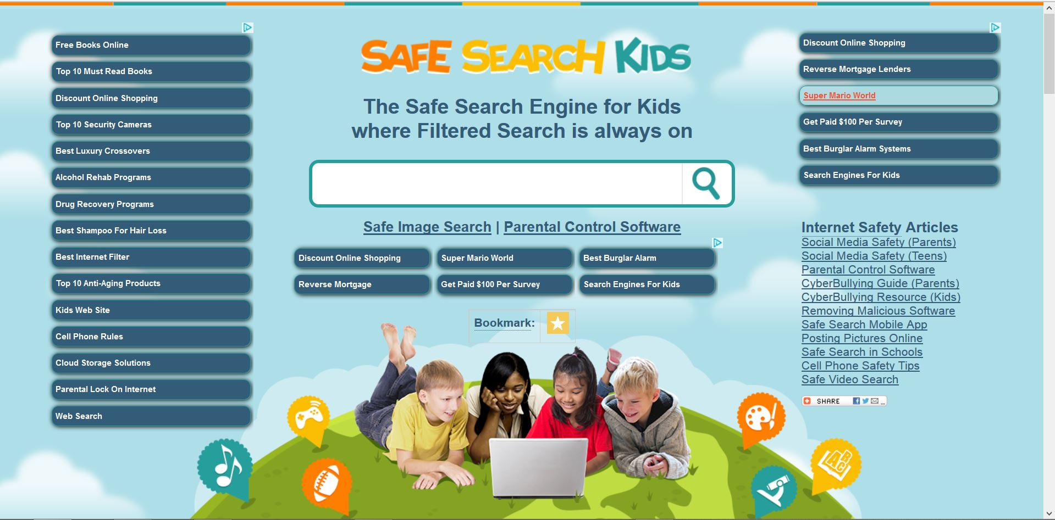

|  |  |  |  |  |  |  |
| --- | --- | --- | --- | --- | --- | --- |
|  | YUM | Google | Kiddle | KidRex | Safe Search Kids | Gogooligans |
| **Unable to retrieve** |  |  |  |  |  |  |
| Average readability(Flesh/Spache) | Chosen for the user |  |  |  |  |  |
| Non adequate contents |  |  |  |  | Ads showing infor related to drug recovery and alcohol rehab |  |
| Mobile friendly? |  |  |  |  |  |  |
| Can search on local/school libraries? |  |  |  |  |  |  |
|  |  |  |  |  |  |  |

In this initial assessment we focused on features that can intrude in the search experience. For every analyzed criteria YUM was the system that intruded less in the search process for children, enhancing the search experience and easing the learning process that can take place as a results of information-discovery tasks.

@inproceedings{Dru09,

title={How children search the internet with keyword interfaces},

author={Druin, Allison and Foss, Elizabeth and Hatley, Leshell and Golub, Evan and Guha, Mona Leigh and Fails, Jerry and Hutchinson, Hilary},

booktitle={SIGCHI},

pages={89--96},

year={2009},

organization={ACM}

}

Tablets and internet: <http://stakeholders.ofcom.org.uk/binaries/research/media-literacy/media-use-attitudes-14/Childrens_2014_Report.pdf>

Children and Parents: Media Use and Attitudes Report Ofcom 2014

The ability to handle long natural language queries, the retrieval of documents adequate to children reading skills and the child friendly and adaptable environment, make YouUnderstoodMe and unique system in the area of search engines for children. Furthermore, the search engine is not everything YouUnderstoodMe has to offer, incorporating features such as student tracking that can enhance the learning experience. All this features, make searching as learning a continuous but pleasant (ameno?) for the education of children, allowing them to integrate in the information society at early stages, while also improving their reading skills at the same time.