Formal Verification of Safety-Critical Cyber-Physical Systems

Table of Contents

- Introduction
1.1 Cyber-Physical Systems (CPS)
1.2 Safety-Critical Systems
1.3 Motivation and Objectives of the Thesis
- Background and Tools
2.1 Formal Verification
2.2 The F★ Language
2.3 Modeling Cyber-Physical Systems in F★
- Case Study I: Smart Agriculture Cyber-Physical System
3.1 System Architecture
3.2 System State and Initialization
3.3 Controller Logic and Threshold-Based Decisions
3.4 Physical Dynamics and Environmental Effects
3.5 Safety Properties
3.6 Liveness and Progress Guarantees
3.7 Code Structure and Modular Design
3.8 Summary and Discussion
- Case Study II: Insulin Dose System
4.1 System Description
4.2 Formal Modeling
4.3 Safety Properties and Lemmas
4.4 Discussion
- Discussion and Conclusions
5.1 Summary of Results
5.2 Limitations
5.3 Future Work
- References

1. Introduction
Cyber-Physical Systems (CPS) are systems in which computational components are tightly integrated with physical processes. In such systems, software controllers interact continuously with the physical world through sensors and actuators, forming feedback loops that govern the overall system behavior. Typical examples of CPS include medical devices, autonomous vehicles, industrial automation systems, and smart infrastructure.
Unlike traditional software systems, CPS operate in dynamic and often unpredictable environments. Their behavior is influenced not only by the correctness of the control software, but also by the physical dynamics of the environment in which they are deployed. As a result, errors in CPS can lead to physical consequences, such as equipment damage, financial loss, or threats to human safety. This tight coupling between computation and physical processes makes correctness and reliability fundamental requirements.

1.1 Cyber-Physical Systems
A defining characteristic of Cyber-Physical Systems is the continuous interaction between digital computation and physical evolution. Sensors provide measurements of physical quantities, such as temperature, pressure, or biological signals, while actuators apply control actions that affect the physical system. The controller processes sensor data, makes decisions, and issues commands, forming a closed control loop.
From a modeling perspective, CPS combine discrete software logic with continuous or discrete-time physical dynamics. This hybrid nature significantly increases system complexity, as correctness properties must hold not only for individual software functions, but across sequences of state transitions that reflect the evolution of the physical system over time.

A key abstraction for reasoning about Cyber-Physical Systems is the notion of system state. At any given time, the state captures both computational variables, such as controller decisions and actuator configurations, and physical quantities, such as sensor readings and environmental conditions. System behavior can therefore be understood as a sequence of state transitions, driven by control logic and physical dynamics.

1.2 Safety-Critical Systems
Many Cyber-Physical Systems are classified as safety-critical, meaning that their failure can result in severe consequences. In medical systems, incorrect behavior may endanger human life; in industrial systems, it may lead to accidents or large-scale damage; in infrastructure systems, it may cause service disruption or environmental harm.
In safety-critical contexts, it is not sufficient to show that a system works correctly under typical conditions. Instead, strong guarantees are required to ensure that unsafe states are never reached, even in the presence of faults, unexpected inputs, or adverse environmental conditions. This requirement motivates the use of rigorous design and verification techniques that go beyond conventional testing.
Failures in safety-critical CPS may arise from multiple sources, including software bugs, unexpected environmental conditions, sensor faults, and incorrect assumptions about physical dynamics. Importantly, even minor software errors may be amplified through interaction with the physical environment, leading to unsafe system behavior.

1.3 Motivation and Objectives of the Thesis
Traditional validation approaches, such as testing and simulation, are widely used in the development of Cyber-Physical Systems. While valuable, these techniques can only examine a finite set of scenarios and cannot provide guarantees for all possible system behaviors. In contrast, formal verification aims to mathematically prove that a system satisfies specified correctness properties for all admissible executions.
The objective of this thesis is to explore the application of formal verification techniques to safety-critical Cyber-Physical Systems using the F★ programming language. F★ allows system behavior, safety properties, and proofs to be expressed within a unified framework, enabling the development of systems that are correct by construction.
To demonstrate the proposed approach, two case studies are presented. The first is a simplified insulin dose system, which illustrates core safety concepts in a medically critical context. The second is a smart agriculture Cyber-Physical System, which introduces greater complexity through multiple interacting components, environmental dynamics, and fault-handling mechanisms. Together, these case studies show how formal verification can be applied across different levels of system complexity while maintaining strong safety and liveness guarantees.
The main contribution of this thesis is the development of formally verified models for safety-critical Cyber-Physical Systems using F★. By explicitly modeling system state, controller logic, physical dynamics, and fault-handling mechanisms, the thesis demonstrates how strong safety and liveness guarantees can be established for CPS of increasing complexity.
Beyond the individual case studies, the thesis illustrates a general methodology for CPS modeling and verification, which can be adapted to other safety-critical domains.

2. Background and Tools
This chapter presents the theoretical background and tools used throughout the thesis. It introduces the concept of formal verification, discusses its advantages compared to traditional validation techniques, and provides an overview of the F★ programming language. Finally, it explains how Cyber-Physical Systems can be modeled and reasoned about within a formal verification framework.
2.1 Formal Verification
Formal verification refers to a set of techniques that use mathematical methods to prove that a system satisfies specific correctness properties. Unlike testing or simulation, which examine system behavior under a finite number of scenarios, formal verification aims to establish guarantees that hold for all possible executions within a given model.
In the context of software and Cyber-Physical Systems, formal verification is particularly valuable for safety-critical applications. Properties such as absence of runtime errors, maintenance of safety invariants, and correct response to abnormal conditions can be expressed precisely and proven rigorously. These guarantees are especially important in systems where failures may lead to severe physical, economic, or human consequences.
Traditional testing techniques remain an important part of the development process, but they cannot provide exhaustive coverage of all system states. As system complexity increases, the number of possible execution paths grows rapidly, making complete testing infeasible. Formal verification complements testing by providing proofs that certain classes of errors are impossible, assuming the model accurately captures the intended system behavior.
2.2 The F★ Programming Language
F★ is a functional programming language designed for program verification. It integrates expressive specification constructs with a powerful automated verification engine, allowing developers to write executable code together with precise correctness specifications. Programs written in F★ are verified using a combination of type checking, SMT solving, and, when necessary, interactive proof techniques.
A central feature of F★ is its support for refinement types. Refinement types extend conventional type systems by allowing logical predicates to be attached to types. For example, instead of using an unrestricted integer type, a refinement type can specify that a value must lie within a given range or satisfy a particular property. This capability enables many safety properties to be enforced directly at the type level. As a result, invalid or physically impossible values are excluded by construction, before the system is ever executed.
In addition to refinement types, F★ supports preconditions and postconditions for functions. Preconditions specify the assumptions under which a function may be called, while postconditions describe properties that must hold after the function executes. These constructs allow developers to reason precisely about state transformations and to ensure that critical invariants are preserved across function boundaries. This style of specification is particularly useful for systems that manipulate shared state or evolve over time.
F★ also provides native support for lemmas, which are functions used exclusively for proving logical properties. Lemmas enable the explicit formulation and verification of safety and correctness arguments within the code. By structuring proofs as lemmas, complex verification tasks can be decomposed into smaller, modular reasoning steps. This approach improves proof clarity and allows key system guarantees to be documented and checked mechanically.
Beyond its individual language features, F★ is particularly well-suited for the development of safety-critical systems because it unifies programming and verification within a single framework. Unlike approaches that separate formal models from executable implementations, F★ allows the same artifact to serve both as a precise specification and as verified executable code. This eliminates the risk of discrepancies between a verified model and its implementation, a common source of errors in high-assurance systems.
Another important advantage of F★ is its strong support for reasoning about stateful systems. Through the use of explicit state representations, invariants, and step-based specifications, F★ enables precise modeling of systems whose behavior evolves over time. This capability is essential for Cyber-Physical Systems, where correctness depends not only on individual computations but also on the preservation of safety properties across long-running executions.
In the context of this thesis, F★ is used to encode physical constraints, control logic, and safety requirements in a uniform and machine-checkable manner. Thresholds, capacity limits, and admissible ranges for physical quantities are expressed as refinement types, while system evolution is governed by functions whose specifications guarantee invariant preservation. Lemmas are then used to establish global safety and liveness properties that cannot be derived from local checks alone.
This combination of expressive specifications, executable code, and machine-checked proofs makes F★ particularly suitable for developing and verifying high-assurance Cyber-Physical Systems. As demonstrated in the subsequent chapters, the language scales from small safety-critical examples to more complex systems with multiple interacting components and environmental dynamics, while maintaining strong formal guarantees.

2.3 Modeling Cyber-Physical Systems in F★
Modeling a Cyber-Physical System requires representing both the discrete control logic and the evolution of physical state over time. In this thesis, CPS behavior is modeled using an explicit system state that captures all relevant variables, such as sensor readings, actuator states, and physical quantities.
System evolution is expressed through a step-based semantics. Each step represents a single iteration of system execution and typically consists of two phases: a control phase, in which the controller makes decisions based on the current state, and a physical phase, in which the effects of these decisions and environmental dynamics are applied. By composing these steps, the execution of the CPS over time can be analyzed.
Safety and correctness properties are captured through invariants that must hold for all reachable system states. An initial state is defined such that it satisfies all invariants, and formal proofs establish that each step preserves these invariants. This approach enables reasoning about unbounded executions of the system, rather than isolated function calls.
The combination of refinement types, preconditions, postconditions, and lemmas allows F★ to serve as a unified framework for modeling CPS behavior and verifying both safety and liveness properties. As demonstrated in the following chapters, this methodology can be applied to systems of increasing complexity while maintaining strong formal guarantees.
The modeling approach presented in this chapter forms the methodological foundation of the case studies that follow. The insulin dose system demonstrates how these techniques can be applied to a minimal safety-critical example, while the smart agriculture CPS illustrates their scalability to more complex systems with multiple interacting components and environmental dynamics.

3. Case Study I: Smart Agriculture Cyber-Physical System
This chapter presents the main case study of the thesis: a smart agriculture Cyber-Physical System (CPS) for automated irrigation management. This case study introduces increased complexity, multiple interacting components, environmental dynamics, and fault-handling mechanisms. The goal is to demonstrate how formal verification techniques can apply to realistic CPS scenarios while preserving strong safety and liveness guarantees.
3.1 System Architecture
The smart agriculture CPS consists of a collection of interacting physical and computational components organized around an automated irrigation workflow. At the physical level, the system includes three water tanks, a set of controllable valves, soil moisture as the main physical quantity of interest, and environmental processes that affect system behavior independently of control actions.
Tank A represents a main water reservoir that can be refilled from an external supply source. Tank B serves as an intermediate irrigation tank from which water is delivered directly to the soil. Tank C contains nutrient-rich liquid that can be mixed into the irrigation flow when additional nutrients are required. The use of multiple tanks introduces resource dependencies and constraints that must be managed carefully by the controller.
Water flow between tanks, as well as irrigation to the soil, is regulated by a set of valves. These valves are controlled discretely by the controller and determine which physical transfers are applied at each execution step. In addition to internal flows, external supply valves allow Tank A and Tank C to be replenished when their levels fall below acceptable thresholds.
The system is equipped with sensors that provide measurements of soil moisture, temperature, and humidity. These sensor readings influence controller decisions and also determine the strength of environmental effects such as evaporation. Environmental phenomena, including rainfall and evaporation, affect soil moisture regardless of controller actions, emphasizing the cyber-physical nature of the system.
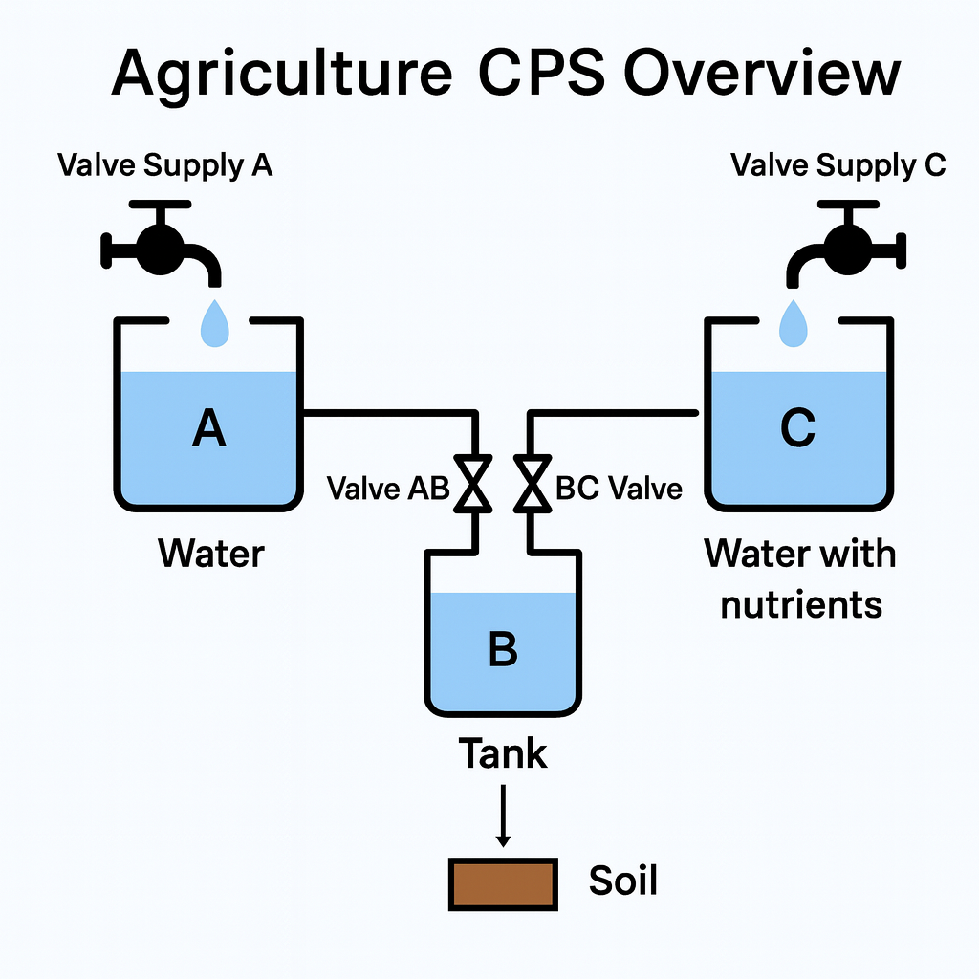

3.2 System State and Initialization
To enable precise reasoning about system behavior, the entire CPS is modeled using an explicit system state. This state captures all relevant information required to describe both the cyber and physical aspects of the system at a given point in time. In particular, the system state includes tank levels, valve states, soil moisture, sensor readings, valve operation counters, environmental conditions, and the current operational mode.
Modeling the CPS as a single, unified state is a deliberate design choice. It allows system evolution to be expressed as transitions between well-defined states and enables safety and liveness properties to be formulated as invariants over state variables. This approach is particularly well-suited to formal verification, as it avoids implicit assumptions about hidden variables or external processes.
An initial system state is defined to represent the starting point of execution at time $t_{0}$. This initial state satisfies all safety invariants, including valid tank levels, bounded soil moisture, and consistent valve configurations. Formal verification guarantees that if the system begins in a valid initial state, all subsequent states produced through system execution will also satisfy these invariants.

3.3 Controller Logic and Threshold-Based Decisions
The controller implements discrete decision logic that governs the behavior of the CPS. Its primary responsibility is to determine which valves should be opened or closed at each step, based on the current system state and sensor inputs. Controller decisions are driven by threshold-based conditions that encode domain-specific irrigation policies.
Soil moisture thresholds play a central role in the controller logic. When soil moisture falls below a predefined lower threshold and sufficient water is available in the irrigation tank, the controller opens the irrigation valve to increase moisture levels. A separate target moisture value is used to regulate nutrient injection, ensuring that nutrient-rich liquid is added only when appropriate.
Resource management is another key aspect of the controller. When the irrigation tank level drops below a critical level, the controller may open valves to refill it from the main reservoir or the nutrient tank. External refill valves are also activated when Tank A or Tank C falls below their respective operating thresholds.
The controller explicitly handles sensor faults. Sensor readings are validated before use, and if invalid data is detected, the system transitions into a safe mode. In safe mode, all valves are closed, preventing unsafe or unintended physical actions caused by unreliable inputs. This behavior reflects a fail-safe design philosophy commonly adopted in safety-critical CPS.

3.4 Physical Dynamics and Environmental Effects
Physical system evolution is modeled independently of controller decisions. A dedicated physics step applies the effects of valve-controlled flows and environmental processes to the system state. This separation between control logic and physical dynamics mirrors the structure of real-world CPS, where discrete decisions influence continuous physical processes.
Water transfers between tanks and from tanks to the soil respect physical constraints such as available volume and tank capacity. These transfers are applied deterministically based on valve states determined by the controller. As a result, the physical consequences of control actions are predictable and amenable to formal analysis.
Environmental effects are explicitly incorporated into the model. Evaporation reduces soil moisture based on temperature and humidity conditions, while rainfall increases soil moisture independently of controller actions. By modeling these effects explicitly, the CPS captures realistic interactions between control decisions and environmental disturbances.

3.5 Safety Properties
A comprehensive set of safety properties is specified to guarantee correct system behavior under all admissible conditions. These properties are expressed as invariants over the system state and are required to hold for all reachable states.
Key safety guarantees include the absence of tank overflow, ensuring that water levels never exceed tank capacities, and bounded soil moisture, preventing physically unrealistic or harmful moisture levels. Additional invariants ensure that valve operation counters remain within predefined limits, preventing indefinite actuation.
Fault-handling properties are also enforced. In particular, whenever sensor readings are detected as invalid, the system is guaranteed to enter safe mode and disable all actuation. These properties are formally proven using lemmas that demonstrate invariant preservation across system steps.
3.6 Liveness and Progress Guarantees
In addition to safety, the system satisfies liveness properties that ensure progress under normal operating conditions. Specifically, when sufficient water resources are available and no sensor faults are present, the system is guaranteed to eventually increase soil moisture if it falls below acceptable levels.
This progress guarantee is established by analyzing the interaction between irrigation and evaporation. Irrigation increases soil moisture at a rate that exceeds the maximum possible reduction caused by evaporation. As a result, repeated execution steps lead to convergence toward desired moisture levels within a bounded number of steps.
These liveness arguments demonstrate that the CPS does not merely avoid unsafe behavior but also actively achieves its intended functional goals.

3.7 Code Structure and Modular Design
The smart agriculture Cyber-Physical System is implemented in a modular and highly structured manner. The code is explicitly divided into well-defined parts, each addressing a specific conceptual aspect of the system. This modular decomposition is not accidental; it reflects the separation of concerns that is fundamental in the design of safety-critical CPS and supports both clarity and verifiability.
Each part of the implementation corresponds to concepts already introduced in the previous sections of this chapter. The following overview explains the role of each part and its contribution to the overall system behavior.
PART 1: Core Types and Constants
The first part of the code defines all global constants and system parameters. These include physical bounds for soil moisture, threshold values used by the controller, tank capacities, flow rates, and environmental parameters such as evaporation and rainfall.
By declaring these values as constants, the system ensures that all safety-relevant limits are fixed and globally consistent. Thresholds such as low, high, and target moisture levels are used throughout the controller logic to determine irrigation and refill actions, while capacity limits prevent overflows at the physical level. This part provides the numerical foundation of the system and directly supports the threshold-based reasoning described in Section 3.3.
PART 2: Basic Types
This part introduces the basic data types used across the system. Valve states are modeled as an enumeration, allowing only well-defined actuator states. Tanks are represented as records containing a current level and a fixed capacity, while sensor readings are modeled explicitly as structured data.
Defining these types explicitly improves readability and ensures that all components operate on consistent representations. It also allows safety properties to be expressed in a natural way, for example by restricting tank levels to remain within their capacities.
PART 3: System State
The complete state of the CPS is captured in a single system_state structure. This state includes the levels of all tanks, the current soil moisture, valve states, valve counters, sensor readings, environmental conditions, and the system mode.
Modeling the entire CPS state explicitly is a key design choice. It enables precise reasoning about system evolution over time and allows all safety invariants to be expressed as properties over a single state object. This approach directly supports the step-based semantics discussed earlier and makes formal verification tractable.
PART 4: Predicates and Invariants
This part defines predicates that express the fundamental safety conditions of the system. These include bounds on tank levels, valid ranges for sensor readings, limits on valve counters, and acceptable soil moisture values.
The global invariant state_ok combines these predicates into a single condition that characterizes all valid system states. All major system functions require this invariant as a precondition and guarantee that it is preserved. This establishes a strong safety backbone: any state reachable through valid execution is guaranteed to satisfy all basic safety constraints.

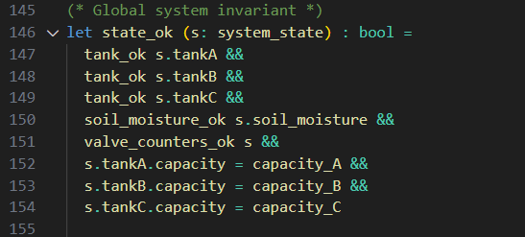

PART 5: Sensor Module and Fault Detection
This part of the implementation is dedicated to sensor handling and fault detection. In a Cyber-Physical System, sensors constitute the primary interface between the physical environment and the discrete control logic. As a result, incorrect or faulty sensor readings represent one of the most critical sources of unsafe behavior. A single erroneous measurement may lead the controller to make decisions that are inconsistent with the true physical state of the system.
To address this challenge, sensor handling is encapsulated in a dedicated module that explicitly separates raw sensor data from trusted control inputs. The module performs two essential functions: sensor validation and safe value derivation.
First, the function sanitize_sensor_data classifies each sensor reading as either SensorOK or SensorFaulty. This classification is based on predefined admissible bounds for soil moisture, temperature, and humidity. Any reading that violates these bounds is immediately marked as faulty. By reducing sensor health to a small and well-defined status type, the system enables uniform and deterministic reasoning about sensor reliability.
Second, the function get_safe_moisture translates raw sensor readings into a safe soil moisture value that can be used by the controller. When the sensor status is SensorOK, the moisture value is accepted only if it lies within the physical moisture bounds of the model. Otherwise, it is replaced by a conservative safe default value equal to the target moisture level. When the sensor status is SensorFaulty, the function always returns this safe default value.
This two-level protection mechanism serves an important safety purpose. Even if sensor readings are numerically valid but physically suspicious, they are prevented from influencing control decisions. In the presence of confirmed sensor faults, the controller is guaranteed to operate on neutral and predictable values, avoiding aggressive or unsafe actuation.
From a system design perspective, this module establishes a clear trust boundary. All subsequent control logic operates exclusively on validated or safely substituted inputs, simplifying both implementation and verification. Moreover, this design directly supports the system’s fault-tolerance strategy: whenever faulty sensors are detected, the controller can reliably enter safe mode, closing all valves and preventing further actuation based on unreliable data.
Overall, the sensor module plays a central role in preserving system safety. It prevents invalid environmental data from propagating into the controller, supports the global invariant state_ok, and enables a clean separation between physical uncertainty and verified control decisions. This modular treatment of sensor reliability is essential for building robust and formally verifiable Cyber-Physical Systems.
Without this module, the controller would implicitly trust all sensor readings, making the system vulnerable to transient faults or extreme outliers. By explicitly modeling sensor faults and enforcing safe defaults, the system guarantees that unsafe control actions cannot be triggered by erroneous environmental inputs.

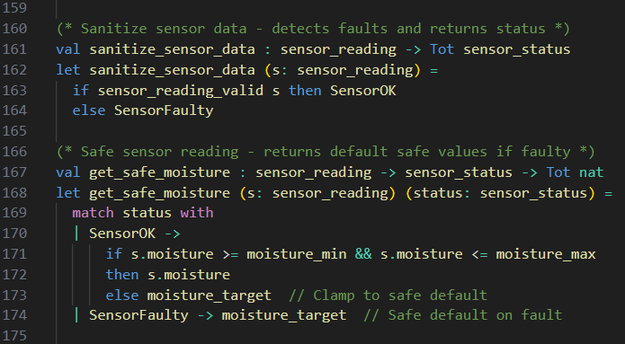

PART 6: Helper Functions for Safe Arithmetic
This part of the implementation provides a collection of helper functions that guarantee safe arithmetic operations. In Cyber-Physical Systems, numeric computations directly correspond to physical quantities such as water volume, soil moisture, and flow rates. As a result, arithmetic errors such as underflow or overflow may lead to physically invalid system states and violate safety invariants.
To prevent such issues, all arithmetic operations that affect physical state variables are encapsulated in verified helper functions. These functions ensure that numeric updates remain within well-defined and physically meaningful bounds.
The function safe_sub implements subtraction with underflow protection. When the subtracted value exceeds the available quantity, the result is clamped to zero. This is particularly important for modeling evaporation effects on soil moisture, where excessive evaporation must not result in negative moisture values.
The function safe_add_capped implements bounded addition. It ensures that increases in tank levels or other quantities never exceed predefined capacity limits. This mechanism prevents overflow and directly supports safety properties such as the absence of tank overflow.
Finally, the clamp function restricts values to a specified interval. It is used to enforce global bounds on quantities such as soil moisture, guaranteeing that they always remain within the modeled physical range. The refinement types associated with these functions formally encode these guarantees at the type level.
By isolating all arithmetic operations in a dedicated module, the system avoids duplicating safety checks throughout the codebase. More importantly, this design ensures that numeric safety properties are preserved by construction, simplifying both the controller logic and the formal verification of global invariants.

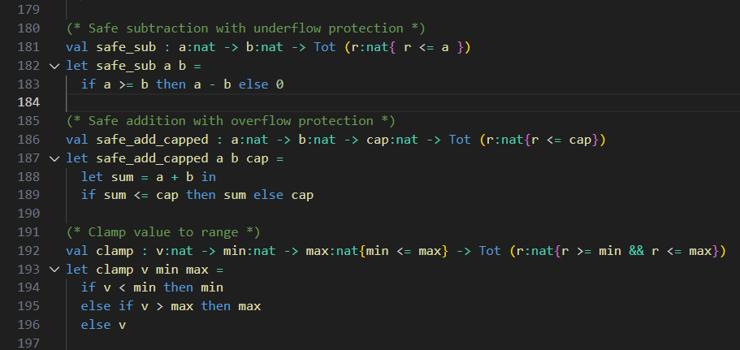

PART 7: Tank Transfer Operations
This part of the implementation models the physical transfer of water and nutrients within the system. Two types of transfer operations are defined: transfers between tanks and transfers from a tank to the soil. These operations form the physical backbone of the Cyber-Physical System, as they represent the actual movement of resources in response to controller decisions.
The transfer between tanks is implemented by the transfer_tanks function. This function takes a source tank, a destination tank, and a requested transfer amount, and returns updated versions of both tanks. Importantly, the actual transferred amount is not equal to the requested amount by default. Instead, it is bounded by two physical constraints: the available water in the source tank and the remaining capacity of the destination tank. This design ensures that no transfer can cause underflow in the source tank or overflow in the destination tank.
The correctness of this behavior is formally captured through preconditions and postconditions. The preconditions require both tanks to be valid, while the postconditions guarantee that tank capacities remain unchanged, tank levels stay within bounds, and water conservation is respected. As a result, the system enforces physical consistency by construction, eliminating an entire class of runtime errors related to invalid tank states.
Irrigation is modeled separately through the transfer_to_soil function, which represents the transfer of water from the irrigation tank to the soil. This operation connects discrete storage with a physical environmental quantity. Similar to tank transfers, the amount of water delivered to the soil is limited by the available water in the tank. The resulting soil moisture is updated using a clamping operation to ensure that it always remains within physically meaningful bounds.
By formally specifying and verifying these transfer operations, the system guarantees that all physical flows respect conservation laws and safety constraints. These guarantees are independent of controller logic and therefore provide a reliable and verified foundation upon which higher-level control decisions are applied.

PART 8: Controller Logic
The controller implements the discrete decision-making logic of the smart agriculture Cyber-Physical System. Its primary role is to determine actuator states based on the current system state and validated sensor inputs. Importantly, the controller does not directly modify physical quantities such as tank levels or soil moisture. Instead, it only updates valve states, operational counters, and system mode flags. This strict separation between decision logic and physical evolution reflects a classical CPS architecture and significantly simplifies formal reasoning.
At the beginning of each control step, sensor readings are sanitized to detect potential faults. The controller operates exclusively on validated or safely substituted sensor values, ensuring that no control decision is influenced by invalid data. If a sensor fault is detected, or if the system is already operating in safe mode, the controller enforces a fail-safe behavior by closing all valves and preventing any further actuation.
During normal operation, the controller evaluates a series of threshold-based conditions to determine appropriate actions. Irrigation decisions are based on soil moisture levels, availability of water in the irrigation tank, and temporal constraints enforced through valve operation counters. Internal refilling between tanks is triggered when intermediate storage levels fall below predefined thresholds, while external refilling is activated only when primary resources become insufficient.
In addition, the controller manages the introduction of nutrient-rich water independently of basic irrigation. This distinction allows the system to differentiate between maintaining minimum moisture levels and achieving a desired target moisture, resulting in more refined and realistic control behavior.
To prevent prolonged or excessive actuation, each valve is associated with a counter that limits the number of consecutive steps during which it may remain open. These counters are updated deterministically at each control step and form part of the global system state. Their inclusion ensures temporal safety and prevents unrealistic or unsafe long-term operation.
Overall, the controller module encapsulates all high-level decision-making logic while preserving global safety invariants. By formally specifying its behavior and proving invariant preservation, the system guarantees that all control decisions remain safe, deterministic, and consistent with the physical constraints of the environment.

PART 9: Physical Dynamics and Environment
The physical evolution of the smart agriculture CPS is modeled independently from the controller logic. A dedicated physics step applies the effects of valve decisions, water transfers, irrigation, and environmental factors. This separation reflects the classical architecture of cyber-physical systems, where discrete control actions influence continuous physical processes.
Evaporation is modeled as a moisture-reducing effect that depends on environmental conditions such as temperature and humidity. Higher temperatures combined with lower humidity increase the evaporation rate, while all evaporation effects are safely bounded to prevent negative soil moisture values.
Rainfall is modeled as an external environmental input that increases soil moisture independently of controller actions. Its effect is bounded using clamping operations to ensure that soil moisture always remains within physically meaningful limits.
The physics step applies water flows in a structured sequence: external refills, internal tank-to-tank transfers, irrigation from the intermediate tank to the soil, and finally environmental effects. Throughout this process, valve states, counters, and system mode remain unchanged, ensuring that the physics module executes decisions without introducing additional control logic.
Formal postconditions guarantee that all system invariants are preserved, including tank capacity constraints and soil moisture bounds. This design enables precise reasoning about the interaction between control decisions and physical dynamics, while maintaining strong safety guarantees.

PART 10: System Evolution and Step Semantics
To reason about the behavior of the Cyber-Physical System over time, the notion of a single execution step is explicitly defined. A system step combines the discrete controller decisions with the continuous physical evolution of the environment.
Each step consists of two phases. First, the controller evaluates the current system state and sensor inputs to determine valve states, counters, and operational mode. Second, the physics step applies the effects of these decisions, including water transfers, irrigation, evaporation, and rainfall.
The step function requires that the system state is valid before execution and formally guarantees that all safety invariants are preserved afterward. This design enables inductive reasoning over system executions: if the system starts in a valid initial state at time t₀, then all states reached through repeated execution steps remain valid.
By defining system evolution in this structured manner, the model supports rigorous reasoning about multi-step behavior, determinism, safety, and liveness properties.

PART 11: Determinism
The system is designed to be fully deterministic. For any given valid system state, the execution of a system step always produces the same resulting state. This property follows directly from the fact that both the controller and the physics components are modeled as pure functions without any sources of nondeterminism.
Determinism is an important property for safety-critical Cyber-Physical Systems, as it ensures predictability and reproducibility of system behavior. It also simplifies formal reasoning, since repeated executions from the same initial state cannot diverge. The determinism lemma explicitly captures this property and serves as a foundation for subsequent safety and liveness proofs.

PART 12: Safety Lemmas and Global Safety Guarantees
While safety invariants and verified helper functions provide strong local correctness guarantees, they are not sufficient on their own to establish the global safety of a Cyber-Physical System. In particular, invariants describe what constitutes a safe system state, but they do not prove that the execution of the system can never violate critical safety properties.
For this reason, the smart agriculture CPS includes a collection of explicit safety lemmas. These lemmas formally prove that, starting from any valid system state, the execution of a complete system step preserves essential safety conditions. In doing so, they elevate the model from a set of locally verified components to a globally verified system.

No-Overflow Safety Lemma
A fundamental safety requirement of the system is that no water tank ever exceeds its physical capacity. Although tank capacity constraints are encoded in the system invariants and enforced by verified transfer functions, it is still necessary to prove that their composition within a full CPS step cannot lead to an overflow.
The no-overflow lemma formally establishes that, for any valid initial state, the execution of one system step results in tank levels that remain within their respective capacities. This proof accounts for all possible interactions, including internal transfers, external refills, and simultaneous valve activations. As a result, the lemma guarantees that overflow states are unreachable in all system executions.

Bounded Soil Moisture Lemma
Another critical safety property concerns soil moisture, which must always remain within physically meaningful bounds. Soil moisture is affected by multiple interacting factors, including irrigation, evaporation, and rainfall. While individual operations use safe arithmetic and clamping, their combined effect over a full CPS step must also be verified.
The soil moisture boundedness lemma proves that, regardless of environmental conditions or controller decisions, soil moisture always remains within predefined minimum and maximum limits. This property ensures that the system cannot produce physically impossible or unsafe moisture levels, even under extreme conditions.

Sensor Fault Safety Lemma
Sensor reliability is a major concern in real-world Cyber-Physical Systems. In this model, sensor readings are explicitly validated, and faulty readings trigger a transition to safe mode. However, the mere presence of fault-detection logic does not guarantee that unsafe actuation cannot occur.
The sensor fault safety lemma formally proves that whenever faulty sensor data is detected, the system necessarily enters safe mode and disables all actuation by closing all valves. This lemma provides a strong safety guarantee: under sensor faults, the system cannot perform any potentially unsafe control actions. This property is essential for fault tolerance and is a defining characteristic of safety-critical CPS design.

Valve Counter Boundedness Lemma
To prevent excessive or continuous actuation, the system employs valve operation counters that limit the number of consecutive steps during which a valve may remain open. While the controller logic updates these counters carefully, it is still necessary to prove that they cannot exceed their predefined maximum values.
The valve counter boundedness lemma establishes that, after any system step, all valve counters remain within their allowed limits. This property prevents uncontrolled or prolonged actuation, protecting both the physical infrastructure and the environment.

PART 13: Liveness Reasoning
In addition to safety, the system satisfies a liveness property ensuring progress under normal operating conditions. When soil moisture drops below the lower threshold and sufficient water is available, the controller is guaranteed to activate irrigation.
Each irrigation step increases soil moisture by a fixed amount, while evaporation reduces it by a strictly smaller bounded amount. As a result, the net effect of each execution step is an increase in soil moisture. This guarantees convergence toward the desired moisture range within a bounded number of steps.
This argument demonstrates that the system is not only safe but also effective: whenever irrigation is required and physically possible, the CPS will eventually restore soil moisture to acceptable levels.
PART 14: Initialization
The execution of the Cyber-Physical System starts from a well-defined initial state. This state represents the system at time $t_{0}$and satisfies all global safety invariants.
The initial state initializes tank levels within their respective capacities, sets all valves to the closed position, resets valve operation counters, and assigns valid sensor readings. The system does not start in safe mode, reflecting normal operating conditions.

By construction, the initial state is proven to satisfy the global invariant state_ok. This guarantees that the verification framework is grounded on a valid and reachable starting point, ensuring that all subsequent safety and liveness results are meaningful.

PART 15: Multi-Step Execution with Invariant Preservation
To reason about long-running system executions, a multi-step execution function is introduced. The function run_n_steps models the repeated application of the system step for an arbitrary number of iterations.
The specification of this function guarantees that if the system starts in a valid state, all states produced after any finite number of steps also satisfy the global invariant. This establishes invariant preservation over unbounded execution horizons.
This result is essential for Cyber-Physical Systems, which are designed to operate continuously. It ensures that safety properties are not only preserved locally but remain valid throughout the entire lifetime of the system.

PART 16: Test Cases and Validation Scenarios
This part contains a collection of test cases that illustrate typical and corner-case system behaviors. These tests exercise the system under representative operating conditions, such as low tank levels, simultaneous refilling and irrigation, sensor faults, and environmental disturbances.
It is important to note that these tests do not replace formal verification. In contrast to conventional testing-based validation, the correctness of the smart agriculture CPS is primarily established through refinement types, invariants, and formally proven lemmas. The test cases serve a complementary role by providing concrete execution scenarios that improve readability, support debugging, and document the intended system behavior.
From a methodological perspective, this combination reflects a realistic CPS development workflow, where formal guarantees establish correctness by construction, while test cases offer additional confidence and aid in system understanding.

3.8 Summary and Discussion
This chapter presented a comprehensive case study of a smart agriculture Cyber-Physical System for automated irrigation management. The system was designed to capture realistic CPS characteristics, including multiple interacting components, environmental dynamics, and fault-handling mechanisms.
At the architectural level, the system integrates discrete control logic with continuous physical processes, explicitly modeling sensors, actuators, environmental effects, and resource constraints. Safety and liveness requirements were identified and expressed as formal properties over the system state.
At the implementation level, the CPS was encoded in a modular and highly structured manner using the F★ verification framework. Key design decisions, such as the separation between controller logic and physical dynamics, explicit sensor sanitization, and safe arithmetic operations, enabled strong safety guarantees to be established by construction.
Formal verification played a central role in the development process. Refinement types, invariants, and lemmas were used to prove that critical safety properties, including bounded tank levels, bounded soil moisture, fault-induced safe mode behavior, and temporal actuation limits, are preserved throughout system execution. In addition, liveness arguments demonstrated that the system achieves its intended functional goals under normal operating conditions.
Overall, this case study demonstrates that formal verification techniques can be effectively applied to realistic Cyber-Physical Systems without sacrificing expressiveness or practical relevance. The resulting model combines strong correctness guarantees with a clear and maintainable system structure, providing a solid foundation for more complex CPS scenarios.

4. Case Study IΙ: Insulin Dose System
This chapter presents the second case study of the thesis: a simplified insulin dose decision system. Although the system is intentionally minimal, it represents a classical safety-critical application from the medical domain. The purpose of this case study is to demonstrate how formal verification can be used to express and prove essential safety properties in a clear and controlled setting.
4.1 System Description
The insulin dose system is designed to assist in deciding whether insulin should be administered based on the current blood sugar level of a patient. The system receives a blood sugar measurement as input and produces either a fixed insulin dose or no action at all. The core safety requirement is that insulin must never be administered when the blood sugar level is within or below a safe range, as this could lead to hypoglycemia.
The decision logic of the system is intentionally simple. A predefined threshold separates safe blood sugar levels from high levels that require intervention. When the blood sugar measurement exceeds this threshold, the system outputs a standard insulin dose. Otherwise, it produces no dose. Despite its simplicity, this decision is safety-critical and therefore well-suited for formal analysis.
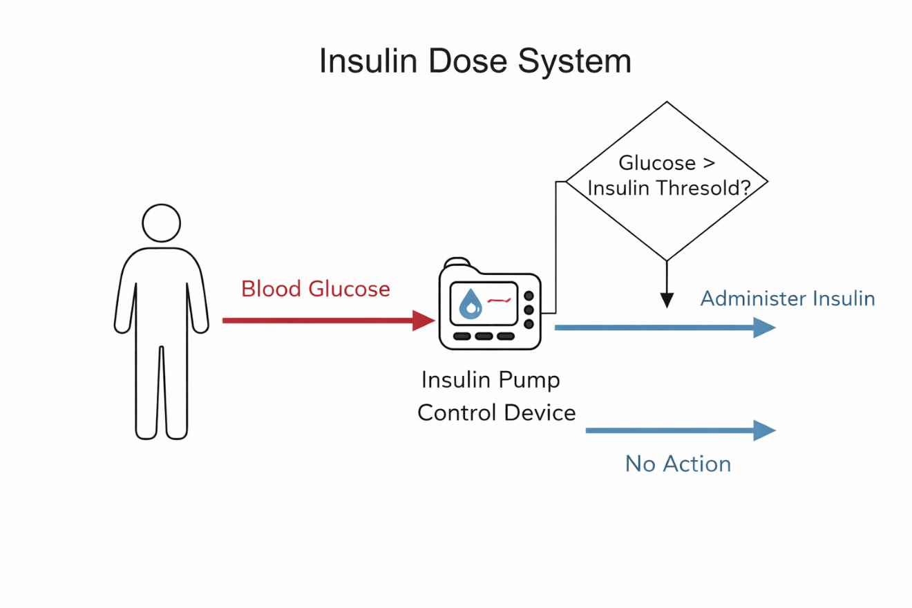
4.2 Formal Modeling
The system is formally modeled using the F★ programming language. Blood sugar values are represented using refinement types that restrict measurements to realistic and positive ranges. This ensures that invalid or physically impossible values are excluded by construction.
Similarly, insulin doses are defined using refinement types that enforce safe bounds on the amount of insulin that can be administered. By encoding these constraints at the type level, the model guarantees that unsafe doses cannot be produced by any valid execution of the system.
The decision function is specified with precise behavioral conditions. Its output is modeled as an optional value, indicating either the presence or absence of an insulin dose. Preconditions and postconditions are used to formally express the relationship between the input blood sugar level and the resulting decision. This modeling style mirrors the approach later adopted in the smart agriculture CPS, where physical and safety constraints are similarly enforced at the type level.
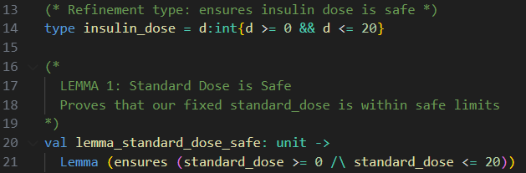
This excerpt illustrates the use of refinement types and a simple lemma in F★ to formally guarantee that the fixed insulin dose always lies within predefined safe bounds. By verifying the safety of the constant dose before it is used in the decision logic, the model prevents unsafe dosing by construction.

4.3 Safety Properties and Lemmas
The primary safety property of the insulin dose system is that no insulin is administered when the blood sugar level is at or below the predefined safety threshold. This property directly addresses the risk of hypoglycemia and is expressed explicitly in the system specification.
A complementary safety property ensures that whenever insulin is administered, the dose always lies within predefined safe limits. This prevents accidental overdosing and further reinforces system safety.
These properties are proven using lemmas in F★. Each lemma corresponds to a specific safety requirement and establishes that the decision function satisfies the required behavior for all admissible inputs. As a result, the system provides formal guarantees that unsafe decisions are impossible within the modeled assumptions. Unlike the smart agriculture case study, this system does not involve liveness properties or temporal evolution. The focus is exclusively on preventing unsafe decisions.

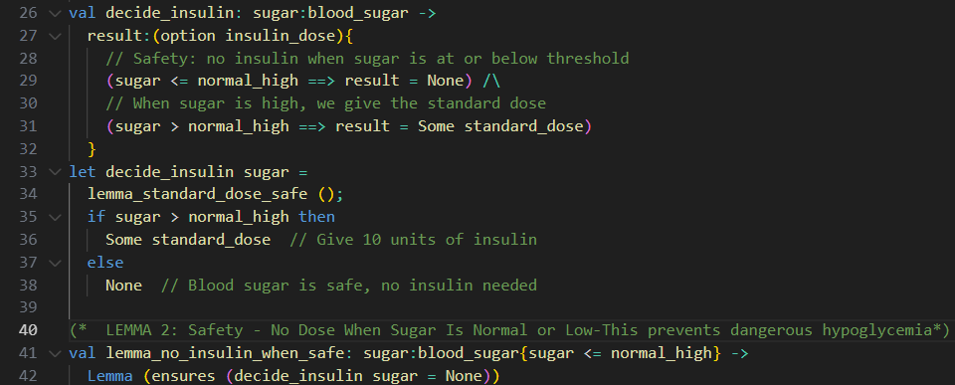
This figure presents the insulin decision function together with its associated safety lemmas. The formal specification and proof ensure that no insulin is administered when the blood sugar level is at or below the safety threshold, thereby providing a formal guarantee against hypoglycemia.

4.4 Discussion
The insulin dose system serves as an introductory example that highlights the strengths of formal verification in a safety-critical context. Its simplicity allows safety properties to be expressed and proven in a direct and transparent manner, making the verification process easy to follow.
While the model abstracts away many aspects of real-world insulin delivery systems, it successfully demonstrates how refinement types, specifications, and lemmas can be combined to produce strong safety guarantees. This case study establishes the foundation for the more complex agriculture Cyber-Physical System presented in the previous chapter.

5. Discussion and Conclusions

5.1 Summary of Results
The primary goal of this thesis was to investigate the application of formal verification techniques to safety-critical Cyber-Physical Systems using the F★ programming language. To achieve this, two case studies of increasing complexity were developed and formally analyzed.
The first case study focused on a simplified insulin dose decision system from the medical domain. Although intentionally minimal, this system captured a classical safety-critical decision problem, where incorrect behavior may lead to severe consequences such as hypoglycemia. Through the use of refinement types, precise specifications, and safety lemmas, the model formally guarantees that insulin is never administered when blood sugar levels are within or below safe limits, and that any administered dose always remains within predefined bounds. This case study demonstrated how strong safety guarantees can be achieved in a clear and controlled setting.
The second case study addressed a smart agriculture Cyber-Physical System for automated irrigation management. This system introduced significantly greater complexity, including multiple interacting components, environmental dynamics, fault-handling mechanisms, and temporal constraints. The system was modeled using an explicit global state and step-based semantics, combining discrete controller decisions with physical evolution. A comprehensive set of safety invariants and liveness properties was formally specified and proven, ensuring bounded tank levels, safe soil moisture, correct fault handling, and guaranteed progress under normal operating conditions.
Across both case studies, the thesis demonstrated a systematic methodology for modeling CPS behavior, encoding safety and liveness properties, and proving their correctness using F★. The results show that formal verification can scale from simple decision logic to more realistic CPS architectures while maintaining strong guarantees about system behavior.

5.2 Limitations
Despite the strong guarantees provided by the formal models, the approach presented in this thesis has several limitations that should be acknowledged.
First, the models necessarily abstract away many aspects of real-world systems. In the insulin dose case study, physiological dynamics, delayed effects of insulin, and patient-specific variability are not modeled. Similarly, the smart agriculture CPS abstracts continuous physical dynamics, such as soil absorption rates and nonlinear environmental effects, into simplified discrete steps. While these abstractions are appropriate for formal reasoning, they may limit direct applicability to real deployments without further refinement.
Second, the verification results depend on the correctness of the model assumptions. Environmental parameters, thresholds, and flow rates are treated as fixed and reliable. In practice, uncertainty in physical processes and imperfect calibration may require more expressive probabilistic or hybrid models.
Finally, the use of formal verification introduces additional development effort and requires specialized expertise. Writing precise specifications, invariants, and lemmas demands a higher upfront cost compared to traditional testing-based approaches. Although this cost is often justified in safety-critical contexts, it may limit adoption in less critical systems.

5.3 Future Work
Several directions for future work naturally emerge from this thesis.
One important extension would be the incorporation of richer physical models, including continuous-time dynamics or probabilistic environmental behavior. Integrating F★ with hybrid or stochastic modeling techniques could improve realism while preserving formal guarantees.
Another promising direction is the modeling of adaptive or learning-based controllers. Extending the verification framework to reason about controllers that evolve over time, while still enforcing strict safety constraints, remains an open research challenge in the CPS domain.
From a practical perspective, applying the proposed methodology to industrial-scale systems would be a valuable next step. This includes integrating formally verified CPS components with existing software and hardware platforms, as well as evaluating the trade-offs between model fidelity and verification complexity.
Finally, future work could explore automated tool support to reduce the effort required for specification and proof construction. Improved libraries, reusable invariants, and higher-level abstractions could make formal verification more accessible to CPS engineers.

6.References

[1] E. M. Clarke, O. Grumberg, D. Peled, Model Checking, MIT Press, 1999.
[2] C. Baier, J.-P. Katoen, Principles of Model Checking, MIT Press, 2008.
[3] E. A. Lee, Cyber Physical Systems: Design Challenges, IEEE ISORC, 2008. https://ieeexplore.ieee.org/document/4519604
[4] R. Alur, Principles of Cyber-Physical Systems, MIT Press, 2015.
[5] N. Leveson, Engineering a Safer World, MIT Press, 2011.
[6] N. Swamy et al., “Dependent Types and Multi-Monadic Effects in F★,”Proc. POPL 2016, pp. 256–270. Available: https://fstar-lang.org/papers/mumon/paper.pdf
[7] N. Swamy et al., Verifying Higher-Order Programs with the Dijkstra Monad, PLDI 2013. https://www.microsoft.com/en-us/research/publication/verifying-higher-order-programs-with-the-dijkstra-monad/
[8] F★ Language Documentation. https://www.fstar-lang.org
[9] T. A. Henzinger, The Theory of Hybrid Automata, LICS 1996.
[10] A. Platzer, Logical Foundations of Cyber-Physical Systems, Springer, 2018.

