Тестовый отчёт формируемый из статичной картинки
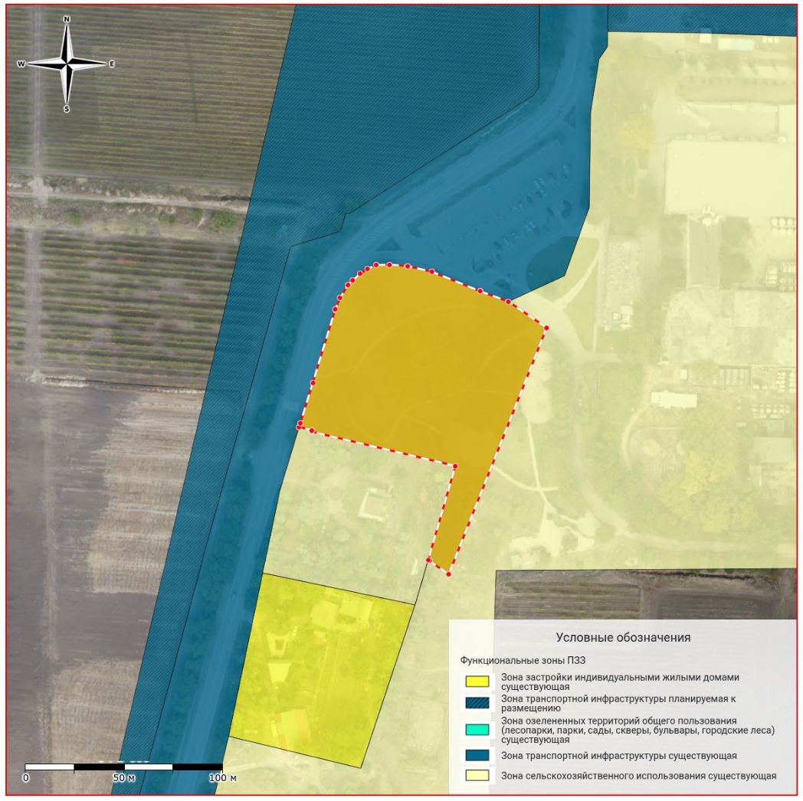
——————————————————————————————————————————
test title | test value

Ведомость координат
Система координат: test crs
Площадь: 123.45
№ | X | Y
1 | 1 | 1
2 | 4924048.5002 | 4388829.67
3 | 4924048.5002 | 4388829.67
4 | 4924048.5002 | 4388829.67
5 | 4924048.5002 | 4388829.67
6 | 4924048.5002 | 4388829.67
7 | 4924048.5002 | 4388829.67
8 | 4924048.5002 | 4388829.67
9 | 4924048.5002 | 4388829.67
10 | 4924048.5002 | 4388829.67
11 | 4924048.5002 | 4388829.67
12 | 4924048.5002 | 4388829.67
13 | 4924048.5002 | 4388829.67
14 | 4924048.5002 | 4388829.67
15 | 4924048.5002 | 4388829.67
16 | 4924048.5002 | 4388829.67
17 | 4924048.5002 | 4388829.67
18 | 4924048.5002 | 4388829.67
19 | 4924048.5002 | 4388829.67
20 | 4924048.5002 | 4388829.67
21 | 4924048.5002 | 4388829.67
22 | 4924048.5002 | 4388829.67
23 | 4924048.5002 | 4388829.67
24 | 4924048.5002 | 4388829.67
25 | 4924048.5002 | 4388829.67
26 | 4924048.5002 | 4388829.67
27 | 4924048.5002 | 4388829.67
28 | 4924048.5002 | 4388829.67
29 | 4924048.5002 | 4388829.67
30 | 4924048.5002 | 4388829.67
31 | 4924048.5002 | 4388829.67
32 | 4924048.5002 | 4388829.67
33 | 4924048.5002 | 4388829.67
34 | 4924048.5002 | 4388829.67
35 | 4924048.5002 | 4388829.67
1 | 4924048.5002 | 4388829.67

