电路设计及封装

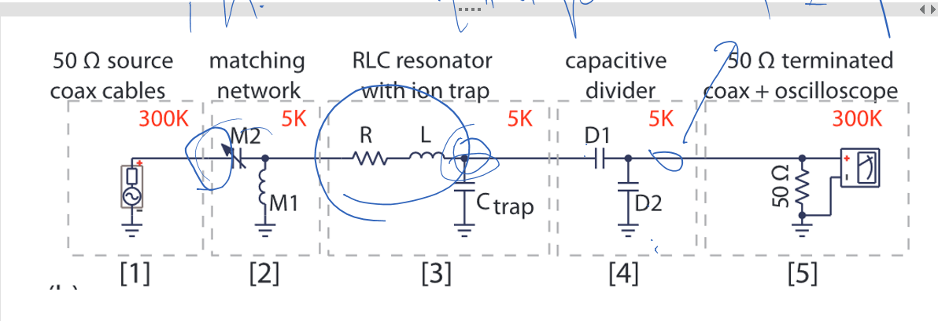

1. M2

**第一种：9328 - 微调电容, 12pF-100pF, 250V, 通孔安装**<http://www.farnell.com/datasheets/1828783.pdf>

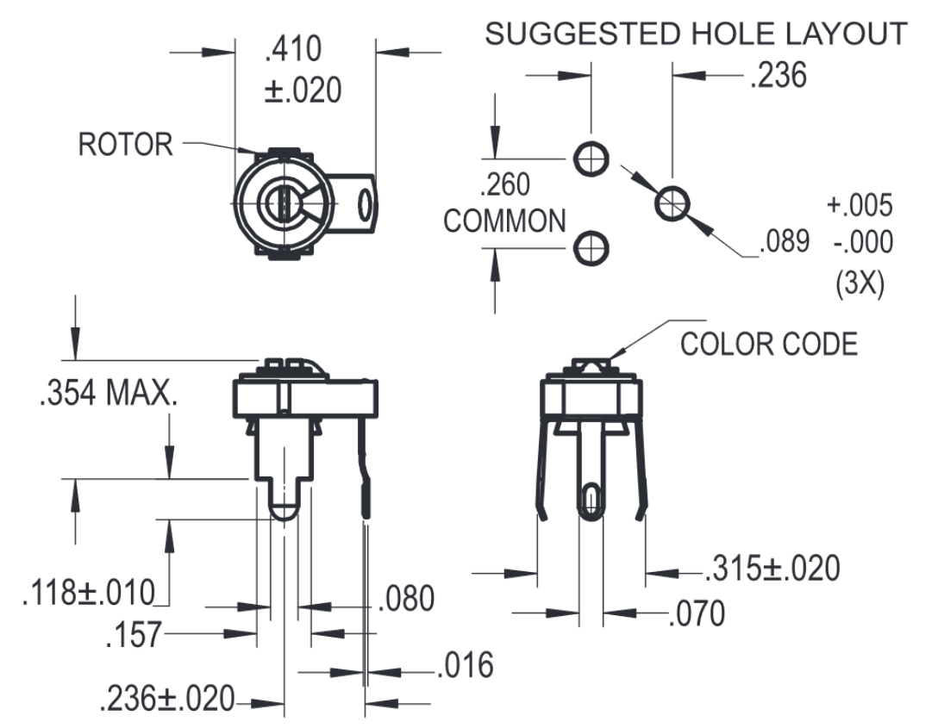

第二种：TZC3P200A110B00 - 可变电容 5.0 至 20.0PF

<http://www.farnell.com/datasheets/81143.pdf>

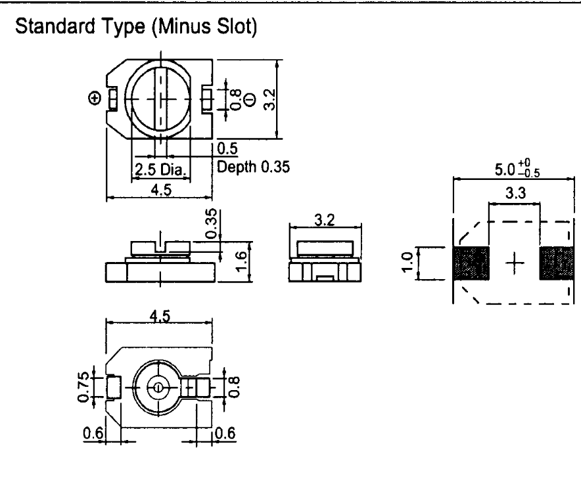

1. D1

第一种：MC12CF050D-F - 云母薄膜电容, 5pF 0.5 pF 1000V电容封装类型:[1210 [3225 Metric]](http://cn.element14.com/w/c/passive-components/capacitors/rf-capacitors?capacitor-case-style=1210-3225-metric-)

<http://www.farnell.com/datasheets/1744647.pdf>

第二种 CBR06C509BAGAC - 射频电容, C0G, 5PF, 250V, 0603 电容封装类型: 0603 [1608 Metric]

http://www.farnell.com/datasheets/2373089.pdf

1. D2

第一种 MC22FD102J-F - 云母薄膜电容, 1000pF 封装[2220 [5650 Metric]](http://cn.element14.com/w/c/passive-components/capacitors/rf-capacitors?capacitor-case-style=2220-5650-metric-) <http://www.farnell.com/datasheets/1744647.pdf>

第二种 电容封装类型: VJ1111D102KXDAJ - 射频电容, 高Q, 1000PF, 300V, 1111 [1111 [2828公制]](http://cn.element14.com/w/c/passive-components/capacitors/rf-capacitors?capacitor-case-style=1111-2828-metric-)

http://www.farnell.com/datasheets/2049205.pdf

产品购买地址：

http://cn.element14.com/?CMP=KNC-BAI-PFB-FIXED-PACK1-title