**Colegiul Național “Decebal” Deva**

The Walt Disney’s World

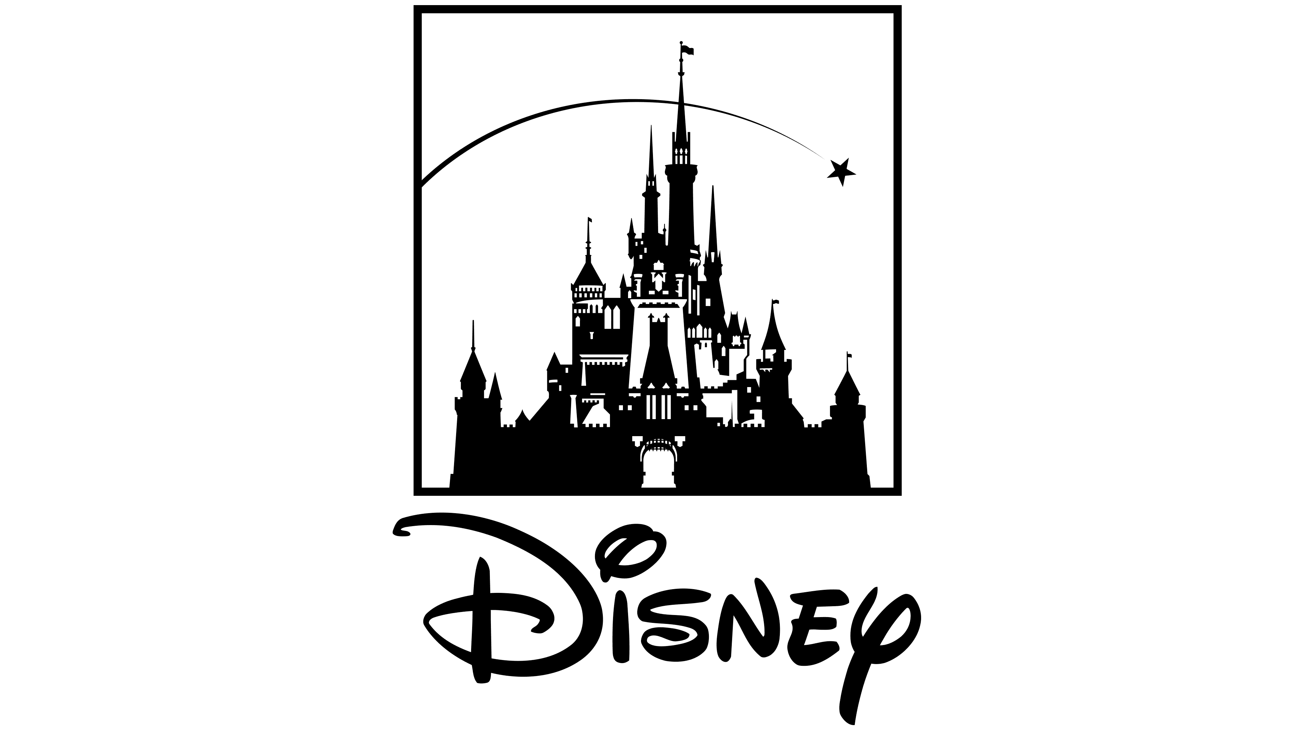

**Coordinating teacher: Student:**

Pănescu Natalia Budoiu-Oancea Bianca-Alessia 12A

**2024**

**Table of Contests**

**Argument3**

**Precis**4

**The story of a creator**

Early ages5

A career in development6

Ilness and death...................................................................................................................7

**The golden age of animation**....................................................................................................8

The most popular productions.........................................................................................9

**Planning and opening of a theme park**.................................................................................10

**Disney in post-war period**.......................................................................................................12

**Disney industry today**.............................................................................................................13

**Bibliography**............................................................................................................................14

**Argument**

No matter how old we are, I can say for sure that we all still love cartoons. However, during childhood, we usually take cartoons for granted and simply enjoy them without thinking about the real message that the story is trying to transmit or the hard work that stands behind the lovely characters. When we are older, we tend to have a different perspective on the cartoons, having a wider view on the real aspects of this fictional world.

With a long history in producing animations, Disney has become an icon in its field all over the world, but with a clear importance in American culture, which shelters the roots of this great company. Althought Disney has become a real empire streching its influence not only in film production, but also in tourism, the cultural significance cannot be diminished by the business aspects, as preserving their reputation in movie industry remains their main aim with the quality of their work as a living proof.

The man behind the mouse, as he has often been called, Walt Disney is given the highest credit for what Disney means today, althought his heritage has been kept in good hands since his death. As a result, Walt Disney has become one of the greatest personalities in the world, adding to the wall of the American culture a new and important brick.

Apart from the significant role that The Walt Disney Company plays at a large scale, for me it is all about the animations produced by it. I as lucky enough to be born in a period in which cartoons were the greatest joy of a child, so every time I think about my childhood I remember about Mickey Mouse, Donald Duck or Goofy.

Having said so, I will let you discover some information about Disney, from its founders to the magic behind the drawings, from the legendary characters to the productions that gave Disney the fame it deserves, from its beggings to the present, hoping that its end is far from our sight.

**Précis**

The word ‘Disney’ itself clearly reveals its significance for anybody who hears it, as it has become a synonym for cartoons, childhood and innocence or why not even for a powerful empire. But a concept with a reputation like this deserves to be discovered from its roots in order for people to understand and appreciate its real value in the American culture and this is what my research paper has intended to do.

Written in chronological order, the brief history of the Walt Disney World that I have tried to present within these pages focuses on Walt Disney, the creator of this magical cultural field and his evolution in the animation world. As a result, I structured my paper in three! chapters, each revealing important stages in the Disney history: *Walt Disney and the Beginning of a Legend, Disney Classics* and *The Magic behind Disneyland.*

The first chapters, as its title suggests, presents the beginning of Walt Disney’s career, from relevant facts about his life as a child and a young entrepreneur, to the creation of Mickey Mouse which brought him the early fame. These chapters leads the reader back in time to let him discover the things that made Walt become what he represents today.

Once the background is set, the next chapters focuses on the most important achievements that Walt Disney obtained in the animation field: his movies, from the well known shorts to the full-length animations, most of them known as Disney classics. However, the history of movie making under the name of Disney continues even after Walt’s death, so this chapter also presents some of the productions that have been made after this event and even in the present.

The last chapters reveals another side of the Walt Disney World, a side which cannot be found on the screen: the history of Disney industry Here the reader can find out about the creation of Disneyland and take an imaginary round trip into the world that took shape under Walt’s magical touch.

**Early ages**

Walter Elias Disney was born on December 5, 1901.His father, Ellias Disney was half Irish, half Canadian and her mother, Flora Call Disney, was of German and English descent.

Growing up in a modest household, Disney's childhood was characterized by a love of drawing and a vivid imagination. He often spent hours sketching cartoons and creating his own characters, finding solace and joy in the act of creation.

Disney's passion for art and animation blossomed during his teenage years when he began taking night classes at the Chicago Art Institute. These classes provided him with the formal training and mentorship he needed to hone his craft and develop his skills as an artist.

In 1917, Disney enlisted in the Red Cross Ambulance Corps and was sent to France during World War I. Although he was underage at the time, Disney was determined to serve his country and forged his birth year on his enlistment papers. His time overseas exposed him to new experiences and cultures, further fueling his creative imagination.

After the war, Disney briefly pursued a career as a newspaper artist before moving to Kansas City, where he started his own animation studio, Laugh-O-Gram Studio, in 1921. Despite facing numerous setbacks and financial difficulties, Disney remained undeterred in his pursuit of his dreams.

It was during this time that Disney created his first successful animated character, Oswald the Lucky Rabbit, which he sold to a distributor in New York. However, Disney's lack of control over the character would ultimately lead to a bitter dispute with his distributor and the loss of Oswald.

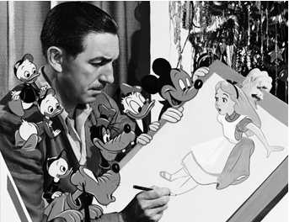Determined to bounce back from this setback, Disney and his brother Roy founded the Disney Brothers Studio in 1923, laying the groundwork for what would eventually become The Walt Disney Company. With the creation of Mickey Mouse in 1928, Disney achieved his first major success and embarked on a journey that would forever change the world of entertainment.

**A career in development**

Disney's career began modestly as a commercial illustrator in Kansas City, where he experimented with animation techniques in his spare time. In 1923, he co-founded the Disney Brothers Studio with his brother Roy. Their early works, including the "Alice Comedies" series, laid the foundation for Disney's future success.

One of Disney's career-defining moments came with the creation of Mickey Mouse in 1928, a character that would become synonymous with the Disney brand. The success of Mickey Mouse propelled Disney into the forefront of animation, leading to the creation of other beloved characters such as Donald Duck, Goofy, and Pluto.

Throughout the 1930s and 1940s, Disney continued to push the boundaries of animation with groundbreaking innovations. His first full-length feature film, "Snow White and the Seven Dwarfs" (1937), was a monumental achievement and the first of many animated classics produced by the studio.

Disney's career took another leap forward with the opening of Disneyland in 1955, the world's first modern theme park. Disneyland not only showcased Disney's storytelling prowess but also demonstrated his ability to create immersive experiences that captivated audiences of all ages.

In the following years, Disney expanded his empire with the creation of Walt Disney World in Florida, as well as ventures into television with programs like "The Mickey Mouse Club" and "The Wonderful World of Disney." His vision extended beyond entertainment, as evidenced by projects like EPCOT (Experimental Prototype Community of Tomorrow), a utopian city concept aimed at addressing societal challenges.

Disney's career was characterized by a relentless pursuit of innovation and excellence. He was not afraid to take risks, whether it was producing feature-length animated films or building elaborate theme parks. His dedication to storytelling, coupled with his keen business acumen, solidified his legacy as one of the most influential figures in the entertainment industry.

Even after his death in 1966, Disney's legacy continued to thrive through the Walt Disney Company, which has grown into a global multimedia conglomerate encompassing film, television, theme parks, and more. Disney's career development serves as a testament to the power of imagination, creativity, and unwavering determination in shaping the world of entertainment as we know it today.

**Ilness and death**

In his later years, Walt Disney battled a series of health issues that ultimately contributed to his untimely death. Despite his relentless work ethic and boundless creativity, Disney's health began to decline in the early 1960s.

In November 1966, Disney underwent surgery to remove a tumor from his left lung, which was diagnosed as lung cancer. At the time, smoking was a common habit, and Disney was known to be a heavy smoker. The surgery was successful in removing the tumor, but Disney's health continued to deteriorate in the months that followed.

Throughout 1966 and early 1967, Disney struggled with complications from his surgery, including pneumonia and circulatory problems. Despite his declining health, Disney remained actively involved in the day-to-day operations of his company, determined to see his creative vision through to fruition.

Tragically, on December 15, 1966, just over a month after his 65th birthday, Walt Disney passed away at St. Joseph Hospital in Burbank, California, from acute circulatory collapse, a complication stemming from his lung cancer treatment.

Disney's death sent shockwaves through the entertainment industry and left a profound void in the hearts of millions around the world. His passing marked the end of an era and left behind a legacy that would endure for generations to come.

Although Walt Disney may have left this world, his spirit lives on through the enduring magic of his creations and the countless lives he touched with his boundless imagination and indomitable spirit. Today, Disney's name is synonymous with creativity, innovation, and the power of dreams, a testament to the lasting impact of his remarkable life and legacy.

In the years following his death, The Walt Disney Company has grown exponentially, expanding its reach into various sectors of entertainment, including film, television, theme parks, and merchandise. Despite his physical absence, Walt Disney's spirit lives on through the enduring magic of his creations and the profound impact he has had on popular culture.

Today, Walt Disney's name remains synonymous with creativity, imagination, and the power of dreams, a testament to the lasting legacy of a man who dared to dream big and forever changed the world of entertainment.

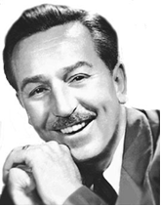

**The Golden Age of Animation**

After the big success of *Snow White and the Seven Dwarfs* he opened a new campus for the Walt Disney Studios in Burbank on December 24, 1939. He continued to produce animated features as *Pinocchio, Fantasia, Bambi, Peter Pan and Wind in the Willows*, though none of them achieved the same success as Snow White. Alice in Wonderland and Peter Pan both had been shelved during the war years, but in the 1940s Disney`s studio managed to continue it. The new star cartoon became *Cinderella*, Disney's most successful film since *Snow White and the Seven Dwarfs*.

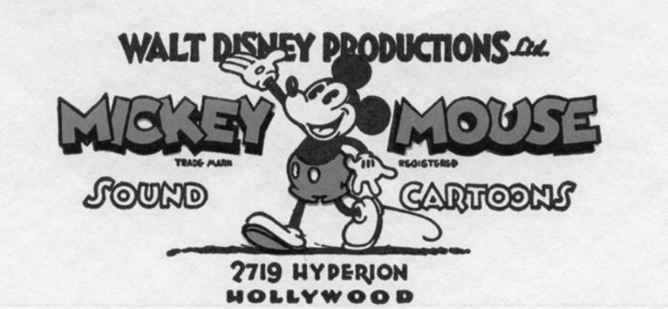Shortly after the release of *Dumbo* in October 1941, the US entered World War II. The U.S. Army and Navy Bureau of Aeronautics obliged Disney`s studios to create films for the military, such as Der Fuehrer's Face and the 1943 feature film Victory Through Air Power, then projects aimed at the Latin American markets, such as Saludos Amigos! (1943) and Three Caballeros (1945). After the war ended animation became increasingly expensive in relation to live action, Disney scaled down production of unprofitable shorts. Live action production is films became unbelievably popular so the company increased films like *Make Mine Music(1946), Song of the South (1946), Melody Time (1948),* and *So Dear to My Heart (1949).* The release of the all-animated feature *Cinderella (1950*) was followed by the studio's first entirely live-action feature, *Treasure Island (1950),* which began a string of live-action adventures, including *The Sword and the Rose (1953)* and *Twenty-thousand Leagues under the Sea (1954).* Disney's other ventures for ABC included "The Mickey Mouse Club" (1955-1959) and "Zorro" (1957-1959).

By the early 1960s, the Disney empire was a major success, and Walt Disney Productions had established itself as the world's leading producer of family entertainment. Through careful market positioning of his product amid those of major film corporations, Disney focused on family entertainment. Live-action films took historical and often patriotic subjects in Johnny Tremain (1957), Old Yeller (1957), Tonka (1958), The Swiss Family Robinson (1960), and Polyanna (1960). The Shaggy Dog (1959) began a series of low-budget comedies such as The Absent Minded Professor (1961) and Son of Flubber (1963) that became mainstays of the company's production. Popular fantasies like Darby O'Gill and the Little People(1959) and Babes in Toyland (1961) led to the blockbuster Mary Poppins (1964). Animation continued in Peter Pan (1953), Lady and the Tramp (1955), Sleeping Beauty(1959), One Hundred and One Dalmatians (1961), The Sword in the Stone (1963), Winnie the Pooh and the Honey Tree (1966), and The Jungle Book (1967).

**The most popular productions**

|  |  |  |
| --- | --- | --- |
| **Title** | **Original release date by**[**Walt Disney Pictures**](http://en.wikipedia.org/wiki/Walt_Disney_Pictures) | **Animation Studio** |
| [Snow White and the Seven Dwarfs](http://en.wikipedia.org/wiki/Snow_White_and_the_Seven_Dwarfs_(1937_film)) | December 21, 1937 | Walt Disney |
| [Pinocchio](http://en.wikipedia.org/wiki/Pinocchio_(1940_film)) | February 7, 1940 | Walt Disney |
| [Dumbo](http://en.wikipedia.org/wiki/Dumbo) | October 23, 1941 | Walt Disney |
| [Bambi](http://en.wikipedia.org/wiki/Bambi) | August 13, 1942 | Walt Disney |
| [Cinderella](http://en.wikipedia.org/wiki/Cinderella_(1950_film)) | February 15, 1950 | Walt Disney |
| [Alice in Wonderland](http://en.wikipedia.org/wiki/Alice_in_Wonderland_(1951_film)) | July 26, 1951 | Walt Disney |
| [Peter Pan](http://en.wikipedia.org/wiki/Peter_Pan_(1953_film)) | February 5, 1953 | Walt Disney |
| [Sleeping Beauty](http://en.wikipedia.org/wiki/Sleeping_Beauty_(1959_film)) | January 29, 1959 | Walt Disney |
| [The Jungle Book](http://en.wikipedia.org/wiki/The_Jungle_Book_(1967_film)) | October 18, 1967 | Walt Disney |
| [Robin Hood](http://en.wikipedia.org/wiki/Robin_Hood_(1973_film)) | November 8, 1973 | Walt Disney |
| [The Little Mermaid](http://en.wikipedia.org/wiki/The_Little_Mermaid_(1989_film)) | November 17, 1989 | Walt Disney |
| [Beauty and the Beast](http://en.wikipedia.org/wiki/Beauty_and_the_Beast_(1991_film)) | November 22, 1991 | Walt Disney |
| [Aladdin](http://en.wikipedia.org/wiki/Aladdin_(1992_Disney_film)) | November 25, 1992 | Walt Disney |
| [The Lion King](http://en.wikipedia.org/wiki/The_Lion_King) | June 15, 1994 | Walt Disney |
| [Pocahontas](http://en.wikipedia.org/wiki/Pocahontas_(1995_film)) | June 23, 1995 | Walt Disney |
| [Toy Story](http://en.wikipedia.org/wiki/Toy_Story) | November 22, 1995 | Pixar |
| [Hercules](http://en.wikipedia.org/wiki/Hercules_(1997_film)) | June 27, 1997 | Walt Disney |
| [Mulan](http://en.wikipedia.org/wiki/Mulan) | June 19, 1998 | Walt Disney |
| [Tarzan](http://en.wikipedia.org/wiki/Tarzan_(1999_film)) | June 18, 1999 | Walt Disney |
| [Atlantis: The Lost Empire](http://en.wikipedia.org/wiki/Atlantis:_The_Lost_Empire) | June 15, 2001 | Walt Disney |
| [Finding Nemo](http://en.wikipedia.org/wiki/Finding_Nemo) | May 30, 2003 | Pixar |
| [Brother Bear](http://en.wikipedia.org/wiki/Brother_Bear) | November 1, 2003 | Walt Disney |
| [WALL-E](http://en.wikipedia.org/wiki/WALL-E) | June 27, 2008 | Pixar |
| [Tinker Bell](http://en.wikipedia.org/wiki/Tinker_Bell_(film)) | September 18, 2008 | DisneyToon Studios |
| [Up](http://en.wikipedia.org/wiki/Up_(2009_film)) | May 29, 2009 | Pixar |
| [A Christmas Carol](http://en.wikipedia.org/wiki/A_Christmas_Carol_(2009_film)) | November 6, 2009 | [ImageMovers Digital](http://en.wikipedia.org/wiki/ImageMovers) |
| [The Princess and the Frog](http://en.wikipedia.org/wiki/The_Princess_and_the_Frog) | December 11, 2009 | Walt Disney |
| [Tangled](http://en.wikipedia.org/wiki/Tangled) | November 24, 2010 | Walt Disney |
| [Winnie the Pooh](http://en.wikipedia.org/wiki/Winnie_the_Pooh_(film)) | July 15, 2011 | Walt Disney |

**Planning and Opening of a Theme Park**

In the late-1940s Walt travelled to Chicago, he drew sketches of his ideas for an amusement park where he imagined his employees spending time with their children. Disney visited a children`s theme park, called Children's Fairyland in Oakland, California, this is where his idea came. People often asked him to let their children visit Walt Disney Studios, but Walt considered that a functional movie studio had little to offer to visiting fans so he wanted to offer them something more. He started to visit other parks for inspiration and ideas, including Tivoli Gardens in Denmark, Efteling in the Netherlands and Greenfield Village, Playland, and Children's Fairyland in the United States.

At first, he imagined a small park, across the street, next to the studio, but it seemed to be a good idea, and worth a bigger investment, a huge centre, named Disneyland. Walt asked proficient help for his project and bought a 65 ha site near Anaheim in 1953.

Once the thematic framework is established, the design process kicks into high gear. Every aspect of the park, from the layout of the lands to the architecture of the buildings, is carefully considered to evoke a sense of wonder and immersion. Attention is paid to sightlines, flow of foot traffic, and the integration of storytelling elements into the physical environment. The construction began in 1954.

Simultaneously, teams work on the logistical aspects of opening the park. This includes infrastructure development, such as transportation systems and utilities, as well as staffing and operational planning. Disneyland is not just a theme park; it's a small city with its own ecosystem of employees, vendors, and service providers.

As opening day approaches, anticipation mounts. Months, if not years, of planning culminate in a flurry of activity as the finishing touches are applied to the park. Attractions are tested, costumes are tailored, and final inspections are conducted to ensure everything meets Disney's exacting standards.

Finally, the big day arrives: opening day. It's a momentous occasion filled with excitement and nervous energy. Disneyland was finally opened on Sunday, July 17, 1955, with thousands of people attending the occasion. Walter Disney gave the following dedication day speech:”To all who come to this happy place; welcome. Disneyland is your land. Here age relives fond memories of the past .... and here youth may savor the challenge and promise of the future. Disneyland is dedicated to the ideals, the dreams and the hard facts that have created America ... with the hope that it will be a source of joy and inspiration to the entire world.” Disneyland turned to be a huge success and it has undergone a number of expansions and renovations adding different attractions like New Orleans Square in 1966, Bear Country in 1972, and Mickey's Toontown in 1993. As the clock strikes opening time, the gates swing open, and the park comes to life with a burst of color, music, and laughter.

But the work doesn't end there. Operating Disneyland is an ongoing endeavor that requires constant maintenance, innovation, and guest engagement. From introducing new attractions to hosting special events, the park evolves over time while staying true to its core values of creativity, imagination, and storytelling.

In 2001 opened Disney California Adventure Park on the site of the original Disneyland plans. Disneyland became the world`s most successful theme park, with over 650 million guests since it opened. According to a March 2005 report from the Disney Company the theme park has a considerable number of employees, more specifically with 65,700 people working there. Walter left us an inspiring message, saying:” Disneyland will never be completed. It will continue to grow as long as there is imagination left in the world.”

In the end, Disneyland isn't just a destination; it's a testament to the power of dreaming big and bringing those dreams to life through careful planning, passion, and perseverance.

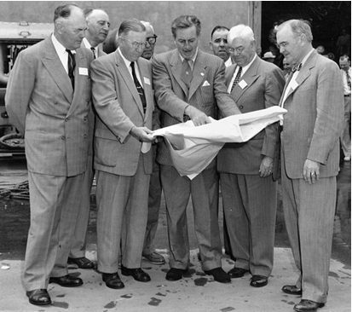

**Disney in post-war period**

In the post-war period, Disney experienced a significant transformation, evolving from a successful animation studio into a multifaceted entertainment empire that would forever change the landscape of popular culture. The years following World War II marked a period of unprecedented growth and innovation for the company, driven by the visionary leadership of Walt Disney himself.

One of the most notable developments during this time was the release of several iconic animated films that would become beloved classics. In 1950, Disney released "Cinderella," marking the studio's return to producing full-length animated features after a hiatus during the war years. This film, along with subsequent releases like "Alice in Wonderland" (1951) and "Peter Pan" (1953), captivated audiences with their enchanting storytelling and groundbreaking animation techniques.

Beyond the silver screen, Disney expanded its reach into new mediums and industries. In 1955, Walt Disney realized his long-held dream of creating a theme park with the opening of Disneyland in Anaheim, California. This groundbreaking venture brought Disney's imaginative worlds to life in a tangible, immersive way, setting the standard for themed entertainment experiences around the globe.

Disney's post-war era also saw the company diversify its offerings through ventures such as television production. In 1954, Walt Disney launched "The Disneyland" television series, which showcased behind-the-scenes looks at the theme park's construction, as well as animated shorts and live-action segments. This successful foray into television helped solidify Disney's position as a dominant force in the entertainment industry.

The 1960s ushered in a new era of expansion and innovation for Disney. In 1964, the company unveiled its most ambitious project yet: the creation of Walt Disney World Resort in Florida. Spanning over 27,000 acres, Walt Disney World would become the largest and most visited vacation resort in the world, featuring multiple theme parks, hotels, and recreational amenities.

Meanwhile, Disney continued to push the boundaries of animation with the release of "Mary Poppins" (1964), a groundbreaking live-action/animated musical that combined traditional filmmaking techniques with cutting-edge special effects. The film's success solidified Disney's reputation as a pioneer in the realm of family entertainment.

Throughout the post-war period, Disney remained at the forefront of innovation, embracing new technologies and storytelling techniques to captivate audiences of all ages. From its iconic animated films to its immersive theme parks and groundbreaking television programming, Disney's influence on popular culture during this era was unparalleled, laying the foundation for its continued success in the decades to come.

**Disney Industry Today**

Today, the Disney industry stands as a global entertainment powerhouse, with its influence reaching into virtually every corner of the entertainment landscape. From its iconic animated films to its vast array of theme parks, television networks, and streaming services, Disney continues to shape the way we experience and consume entertainment in the 21st century.

At the heart of Disney's success today is its diverse portfolio of intellectual properties, which includes beloved characters, franchises, and stories that have captured the imaginations of audiences around the world. From timeless classics like "Snow White and the Seven Dwarfs" to modern hits like "Frozen" and "Moana," Disney's animated films continue to enchant audiences of all ages with their captivating storytelling and innovative animation techniques.

In addition to its animated films, Disney has expanded its reach into live-action filmmaking, producing a wide range of blockbuster hits that appeal to audiences of all ages. From the Marvel Cinematic Universe to the Star Wars saga, Disney's acquisition of Lucasfilm and Marvel Entertainment has allowed the company to tap into some of the most iconic and beloved franchises in pop culture history.

Beyond the big screen, Disney's influence extends into television, with its portfolio of networks including ABC, ESPN, and Disney Channel reaching millions of viewers around the world. Disney's television programming spans a wide range of genres and formats, from scripted dramas and comedies to live sports and children's programming, ensuring that there is something for everyone to enjoy.

In recent years, Disney has also made a significant push into the realm of streaming entertainment with the launch of Disney+, its flagship streaming service. Disney+ offers subscribers access to a vast library of Disney, Pixar, Marvel, Star Wars, and National Geographic content, as well as original programming produced exclusively for the platform. With its unparalleled library of beloved franchises and timeless classics, Disney+ has quickly become a major player in the increasingly competitive streaming market.

Of course, no discussion of Disney's industry today would be complete without mentioning its iconic theme parks and resorts. From Disneyland Resort in California to Walt Disney World Resort in Florida and Disneyland Paris in France, Disney's theme parks continue to attract millions of visitors each year with their immersive attractions, world-class entertainment, and unparalleled attention to detail.

Overall, the Disney industry today remains a dominant force in the global entertainment landscape, with its diverse portfolio of intellectual properties, innovative storytelling, and commitment to quality continuing to captivate audiences of all ages around the world. As Disney continues to expand its reach into new markets and mediums, its influence is sure to remain strong for many years to come.

**Bibliography**

1. [”A Chance to Step Into Disney’s Childhood”](http://www.nytimes.com/2013/12/04/business/media/walt-disneys-chicago-birthplace-to-become-a-private-museum.html?_r=0),  Brooks Barnes, The New York Times, December 3, 2013
2. [”Walt Disney Biography”](http://www.imdb.com/name/nm0000370/bio?ref_=nm_ov_bio_sm), Tommy Peter, imdb.com
3. [”Ruler Of The Magic Kingdom”](http://content.time.com/time/magazine/article/0,9171,989778,00.html), Richard Schickel, TIME magazine, Dec. 07, 1998
4. [Oswald the Lucky Rabbit](http://en.wikipedia.org/wiki/Oswald_the_Lucky_Rabbit), wikipedia.org
5. [Walt Disney Biography](http://www.biography.com/people/walt-disney-9275533#awesm=~oCQvsITwLXiHa5)
6. ["Chronology of the Walt Disney Company (1981)"](http://www.islandnet.com/~kpolsson/disnehis/disn1981.htm) Island Net, May 21, 2008
7. ["Warner Bros. Studio Biography"](http://web.archive.org/web/20090524120920/http:/www.animationusa.com/resources/aboutwb.html) Animation USA, May 21, 2008.