NOAA NESDIS
CENTER for SATELLITE APPLICATIONS and RESEARCH

&

NOAA NOS
U.S. INTEGRATED OCEAN OBSERVING SYSTEMS (IOOS) OFFICE

High-Frequency Radar Network (HFRNet) Algorithm Theoretical Basis Document (ATBD)



Version 1.0
September, 2025

TITLE: HIGH-FREQUENCY RADAR NETWORK (HFRNET) ATBD

AUTHORS:

Brian Zelenke (NOS, U.S. IOOS Office),

Mark Otero (UCSD, Scripps Institution of Oceanography)

Document Revision Log

The Document Revision Log identifies all major and minor revisions made to this document since its original release.

ATBD Version Number | Release Date | Originator of Revisions
1.0 | 09/09/2025 | Brian Zelenke (NOS, U.S. IOOS Office)  Mark Otero (UCSD, Scripps Institution of Oceanography)

Document Change Log

The Document Change Log identifies all major and minor changes made to this document since its original release.

ATBD Version Number | Release Date | Changed By | Document Section | Description of Changes
1.0 | 09/09/2025 | Zelenke (NOS, U.S. IOOS Office), Otero (UCSD, SIO) | All | Original release of document

Table of Contents
Section Page

1. Introduction 6
1.1. Product Overview 6
1.1.1. Product Description 6
1.1.2. Product Requirements 7
1.2. Instrument Description 7
1.2.1. WERA 7
1.2.2. SeaSonde 8
1.2.3. LERA 8
2. Algorithm Description 8
2.1. Processing Outline 8
2.2. Algorithm Input 9
2.3. Theoretical Description 10
2.3.1. Physical Description 10
2.3.2. Mathematical Description 11
2.4. HFRNet Output Products 13
2.5. Performance Estimates 15
2.5.1. Test Data Description 15
2.5.2. Sensor Effects 15
2.5.3. Retrieval Errors 16
2.6. Practical Considerations 17
2.6.1. Numerical Computation Considerations 17
2.6.2. Programming & Procedural Considerations 17
2.6.3. Quality Assessment & Diagnostics 18
2.6.4. Exception Handling 18
2.7. Validation 18
3. Assumptions & Limitations 19
3.1. Performance Assumptions 19
3.2. Potential Improvements 19
4. References 19

List of Tables
Table 1-1. Geographic Domains and Selected Grid Resolutions for HFRNet 7
Table 2-1. HFRNet Input Files 10
Table 2-2. HFRNet Static Input Data Files 10
Table 2-3. HFRNet External Outputs 13
Table 2-4. HFRNet Internal Intermediate Products 14
Table 2-5. HFRNet Output Intermediate Products 15

List of Figures
Figure 2-1. HFRNet Data Flow Diagram 9
Figure 2-2. Example of radials from two HFR stations providing overlapping coverage of Monterey Bay, California. Totals can be calculated for areas of the water which have radials present from both stations. 11
Figure 2-3. Totals calculated from the overlapping radials shown in Figure 2-2. 12
Figure 2-4. Ideal APM (left) vs. measured APM (right) for a SeaSonde at Santa Cruz, California. Coefficients, represented by the shape of this plotted APM, are used by the sensor when deriving the radial velocities from the sea echo signal. 16

Introduction

Product Overview
The NOAA U.S. IOOS Surface Currents Program’s High-Frequency Radar (HFR) National Network measures the speed and direction of ocean and Great Lakes surface currents—and wave height/period/direction at selected stations—in near real-time. Unlike the wave measurements, the surface current data require further processing by the IOOS HFR National Network’s data assembly center, called “HFRNet”, in order to transform them into the surface current velocity data products required by IOOS’s stakeholders, such as maritime search-and-rescue and offshore oil spill emergency responders. Accordingly, the remainder of this ATBD will concentrate on the surface current data.

HFR systems operate continuously in all but the most extreme weather conditions and are installed near the coastline. Depending on the desired horizontal resolution of measured currents, the systems are capable of measuring currents anywhere from 40 to 200 km offshore. The velocities measured are representative of the upper 0.3–2.5 meters of the ocean depending on the HFR’s operating frequency. Remote sensing of surface ocean velocity from shore-based HFR sites bridges the operational observational gap between point samples obtained from in-situ sampling and synoptic-scale relatively low-resolution data obtained from satellites by providing continuous mesoscale coverage at relatively high resolution near the coast.

Product Description
The HFRNet codebase’s algorithms generate the following total ocean surface current velocity (“totals”) gridded data products from the input radial velocities (“radials”) that are ingested from the HFR sensors. Via the HFRNet national server, the radial velocity data are combined to form a gridded dataset of total velocity vectors. These gridded data are comprised of four different grid resolutions. Far offshore, more than approximately 80 km, where only lower resolution radar data are available, the grid resolution is 6 km. From the nearshore to 80 km, the grid resolution is 2 km, while in some areas having higher-resolution radars, the grid resolution is 1 km. In selected bays, where very high frequency (VHF) radars having short maximum ranges with sub-kilometer resolution are installed, the grid size is 0.5 km.

For each of the geographic domains and selected grid resolutions, the total data products are available as an: Hourly Average, 25-hour Average, Month Average, and Year Average.

Table 1-1. Geographic Domains and Selected Grid Resolutions for HFRNet
 | 0.5 km | 1 km | 2 km | 6 km
West Coast | x | x | x | x
East & Gulf Coast |  | x | x | x
Puerto Rico & Virgin Islands |  |  | x | x
Hawaii |  | x | x | x
Alaska North Slope |  |  |  | x
Gulf of Alaska |  | x | x | x
Great Lakes | x | x | x | x

Product Requirements
Real-time vectors (a.k.a. totals) in this dataset are computed from a lower-level product known as radial velocities (a.k.a. radials). Radial velocities are computed from direct measurements of radar backscatter or sea echo by individual HFR sites. Automated quality control measures are used throughout processing.

Similar to satellite data products, these are given a “Level” designation with higher number levels requiring more processing.

• Quality controlled radial currents plus error (Level 1)
The primary use of these data are as input to various hydrodynamic and statistical models of coastal circulation. These data are also important for validating surface currents derived from these models.

• Gridded total vector velocities (Level 2)
Generally, end-users prefer Level 2 data types as input to their own applications. This data type can be delivered in near-real-time or in a delayed mode wherein corrections or improvements to the data can be rendered.

• Near-real-time velocities (presently available via national servers) (Level 2a)

Instrument Description
Three systems comprise the HFR Network: the WERA® manufactured by HELZEL Messtechnik, SeaSonde® manufactured by CODAR Ocean Sensors, and LERA (more formally known as the UH Generic Radar) built by the Radio Oceanography Laboratory at the University of Hawaiʻi at Manoa.

WERA
WERA allows for measurements of the ocean wave spectrum, which requires access to the full backscatter Doppler spectrum for all ranges and directions. This access is achieved by applying a beam-forming (BF) technique. The design uses a modular system that can include 4, 8, 12, or 16 independent, inter-calibrated receiver channels. The processing of the signals is done on the software side and allows for employing BF using a linear array of 8 to 16 antennas and/or direction finding (DF) with 4 antennas in a square. A recent software upgrade allows operators to also apply DF algorithms on the linear array; however, DF implementations do not provide ocean wave parameters.
To avoid high-power transmit pulses in the range of some kilowatts as used in former systems, a frequency-modulated continuous-wave signal at 30 watts is transmitted to achieve range resolution. The depth of the range cells can be adopted to the requirements by reprogramming the frequency span of the transmitted frequency chirp. Typical radial velocity measurement grid specifications resulting from a system operated in the 12-MHz frequency band are a domain segmented into 130 discrete range bands with grid cells in each band at 1.5 kilometers (km) resolution.

SeaSonde
CODAR Ocean Sensors, Ltd. (CODAR) is the developer and manufacturer of the SeaSonde compact HFR system. The CODAR compact DF system is the most widely deployed oceanographic HFR technology, both within the U.S. (approximately 150 sites) and internationally (> 300). The antenna system optionally combines the transmitting and receiving antennas within a single mast and also eliminates the horizontal ground plane whip antennas.

LERA
The University of Hawai‘i High-Frequency Doppler Radar (UH-HFDR; known colloquially as LERA) was developed at the University of Hawaii Radio Oceanography Laboratory starting in 1998. The HFDR systems are produced with an open-source model to minimize hardware costs and operate similar to the WERA systems in terms of data standards and flags.

Algorithm Description

Processing Outline
30-minute to hourly radial velocities collected continuously from HFR sites through HFRNet are processed to produce real-time velocities (RTVs; a.k.a. totals). RTVs are computed every 30 minutes for each continuous section of coastline or domain and each resolution to produce hourly maps of surface ocean velocities. Maps for any given hour are reprocessed whenever new data arrives within the near real-time reprocessing threshold (currently 7 days from real-time).
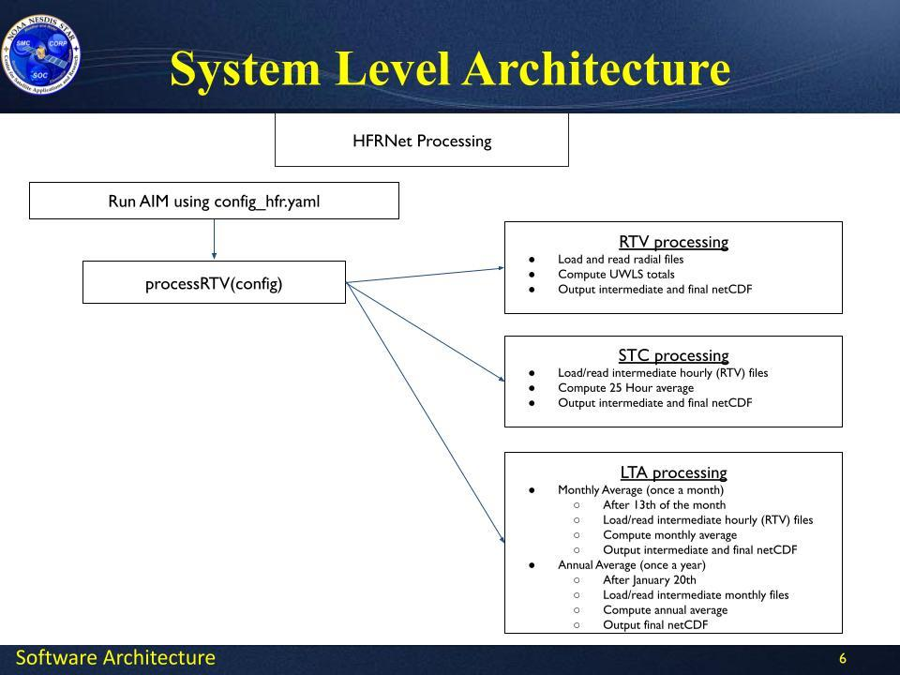
Figure 2-1. HFRNet Data Flow Diagram

Algorithm Input
The HFRNet system ingests radial surface velocities and wave files created on the laptop computers of the individual HFR sites operating throughout the U.S. and its territories. Both radial and wave file types are ASCII text format with some variation in structure between sites/providers.

HFRNet acquires roughly 366 radial velocity files per hour, every hour daily. Each file is about 160 KB, so a total of about 1.4 GB daily. HFRNet also acquires wave data files, which are also about 160 KB and there are presently less than 20 HFRs that generate these.

Table 2-1. HFRNet Input Files
Input File | Format | Frequency | File Size
Radial surface velocities from HFR stations | ruv, ASCII | ~60 minutes | 1 KB–3 MB
Algorithm outputs | NetCDF4 | ~60 minutes | 1 KB–3 MB

Table 2-2. HFRNet Static Input Data Files
Static Input Data
Input File | Format
land data points | JSON
grid data points | NetCDF4

Theoretical Description

Physical Description
The information necessary to compute the gridded surface current velocity data products is stored in the radial velocity text files generated by the HFR sensors. The software provided by the manufacturers of the various HFRs also include hardware and software diagnostics that are saved in their output files. Many of these diagnostics are reported within the radial velocity files. On all the sites, a script independent of the diagnostics files queries the receiver and transmitter to receive pertinent information such as the temperatures, voltages, and transmitted power output. This script is configured to provide information on the laptop as well to include disk use and other laptop-specific information.

Mathematical Description
The gridded total surface current velocity data products (totals; Table 1-1) are computed from the unweighted least squares fit of the radial velocity measurements (radials) that fall within a search radius of each gridpoint. A total solution for a given gridpoint is computed if, within the search radius, the number of radials present and the number of HFR stations contributing radials exceeds pre-set thresholds. The radial coverage of at least two HFR stations must overlap (Figure 2-2) for totals to be computed within that area (Figure 2-3).

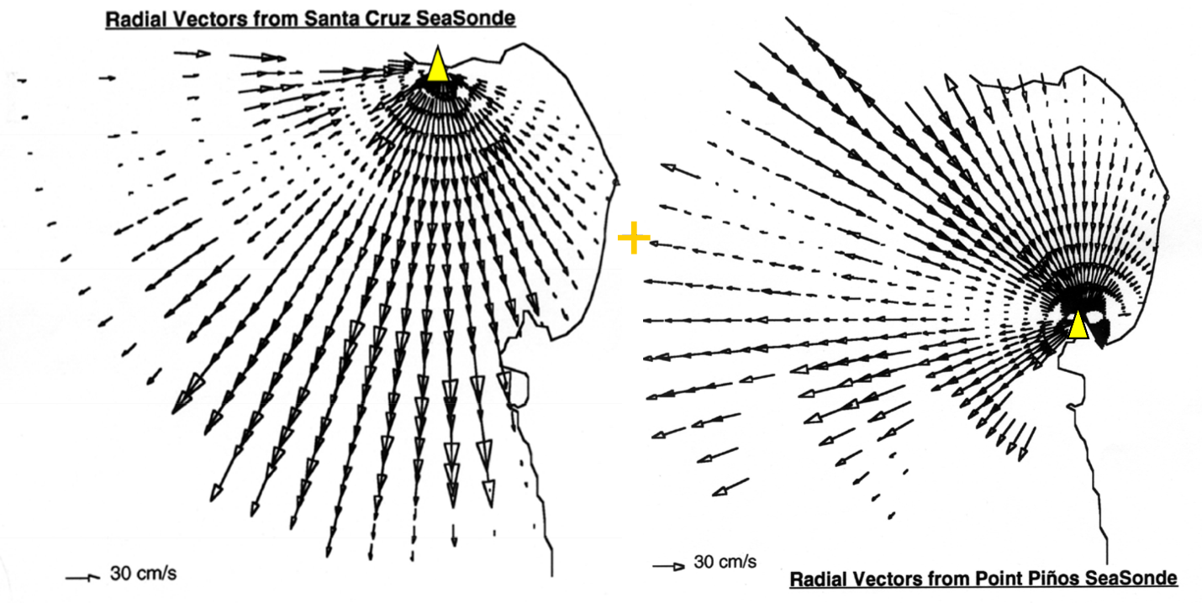
Figure 2-2. Example of radials from two HFR stations providing overlapping coverage of Monterey Bay, California. Totals can be calculated for areas of the water which have radials present from both stations.

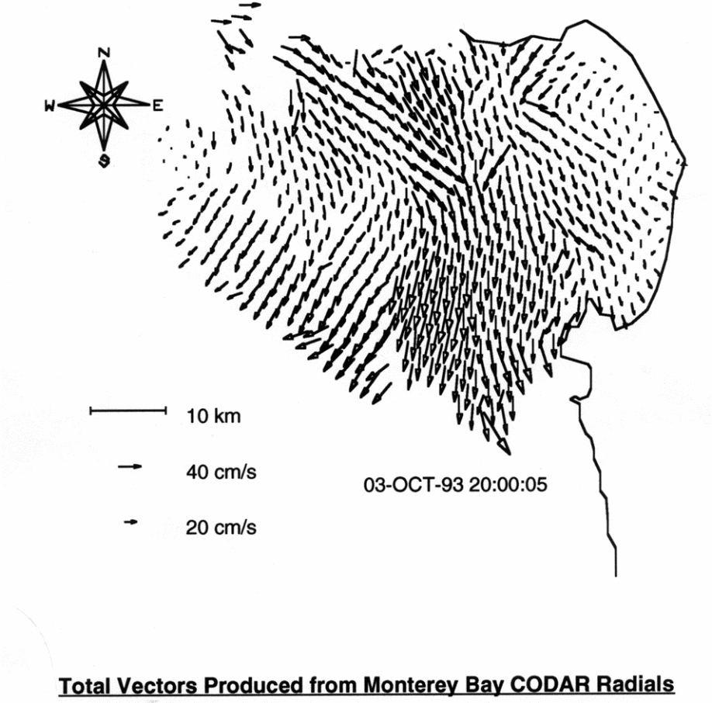
Figure 2-3. Totals calculated from the overlapping radials shown in Figure 2-2.
Additionally, the horizontal dilution of precision (HDOP) and corresponding eastward (DOPx) and northward (DOPy) components are also computed as a metric for assessing the quality of the surface current velocity solutions. Solutions are filtered for exceeding HDOP as well as for exceeding maximum speed thresholds.

The mathematical algorithm for these computations is as follows:

Input:
- rSpeed = Column vector (n* × 1) of radial velocity magnitude
- rHeading = Column vector (n* × 1) of radial velocity heading in degrees counterclockwise from +x (east)
  - *n ≥ 2
Output:
- U = Eastward total velocity
- V = Northward total velocity
- DOPx = Eastward dilution of precision
- DOPy = Northward dilution of precision
- HDOP = Horizontal dilution of precision
  - All output values are scalars, and the units of U and V are the same as the units for rSpeed.

Radial velocities are related to the total velocity by projection of the eastward and northward components of the total velocity onto the radial heading:
$$rSpeed=U*\operatorname{cosd}\left(rHeading\right)+V*\operatorname{sind}\left(rHeading\right)$$
and, in matrix form, as
$$rSpeed=X*b$$
where
$$X=\left[\begin{matrix}\operatorname{cosd}\left(rHeading\right) & \operatorname{sind}\left(rHeading\right)\end{matrix}\right]$$
$$b=\left[\begin{matrix}U & V\end{matrix}\right]$$

The unweighted least squares solution for b is given by
$$b=\operatorname{inv}\left(X^{'}*X\right)*X^{'}*rSpeed$$

The geometric portion of the covariance matrix for b is
$$C=\operatorname{inv}\left(X^{'}*X\right)$$
which provides the dilution of precision along the diagonal where
$$DOPx=\sqrt{C\left(1,1\right)}$$
$$DOPy=\sqrt{C\left(2,2\right)}$$
$$HDOP=\sqrt{C\left(1,1\right)+C\left(2,2\right)}$$

HFRNet Output Products

Table 2-3. HFRNet External Outputs
System-Level Output Data
Output File | Archived/Distributed | Update Frequency | Format | File Size
Hourly surface velocities | Distributed to NDBC  Archived at NCEI | 60 minutes | NetCDF4 | 70 KB~4 MB
25-hr average of surface velocities | Distributed to NDBC  Archived at NCEI | 60 minutes | NetCDF4 | 70 KB~4 MB
Monthly average surface velocities | Distributed to NDBC  Archived at NCEI | once per month | NetCDF4 | 70 KB~4 MB
Annual average surface velocities | Distributed to NDBC  Archived at NCEI | once per year | NetCDF4 | 70 KB~4 MB

Table 2-4. HFRNet Internal Intermediate Products
System-Level Output Data
Output File | Update Frequency | Format | File Size
Radial processing | 60 mins | NetCDF4 | ~717 KB
25 Hour Sum | 60 mins | NetCDF4 | ~8 MB
Monthly Sum | monthly | NetCDF4 | ~8 MB

Table 2-5. HFRNet Output Intermediate Products
Product(s) | Sensor | Number of Files (for a single run) | Output  File Format(s) | Comments
Radial Velocities  Surface Current Vectors (aggregated radials) | HFR Stations | ~372 files | ASCII  GRIB  NetCDF | Surface Currents based on hourly aggregation - 25-hour and monthly totals also calculated
HFR Station status | HFR Stations | 1 file | GeoJSON | File for NDBC to show status of each station in HFRNet and time when it last transmitted data.

Performance Estimates

Test Data Description
This new NESDIS Common Cloud Framework (NCCF)-based HFRNet’s computations were tested against the known-good output of its predecessor system at the University of California - San Diego’s, Scripps Institution of Oceanography’s Coastal Observing Research & Development Center (CORDC). Complete agreement between the two systems was achieved prior to the CORDC legacy HFRNet system being retired effective July 1, 2025.

Sensor Effects
HFR sensors may be subject to ionospheric clutter and effects from interfering radio frequency noise which present as a reduction in the number of valid datapoints in a radial velocity file, once these impacts are filtered out by the sensor manufacturers’ onboard software. Additionally, HFRs’ data are subject to interference from ferrous metals and other signal-distorting objects within their field of view, which can warp the HFR’s measurement of the direction of the incoming sea echo signal. Antenna pattern measurements (APMs) are used by SeaSondes, as they’re a DF type HFR, to compensate for this and other site-specific antenna pattern distorting effects. SeaSondes must be periodically calibrated using APMs to ensure the highest quality data, but an uncalibrated “idealized” antenna pattern may be used by SeaSondes for sea echo signal processing while awaiting an APM if distortion in the observed radial velocity returns is minor (Figure 2-4).

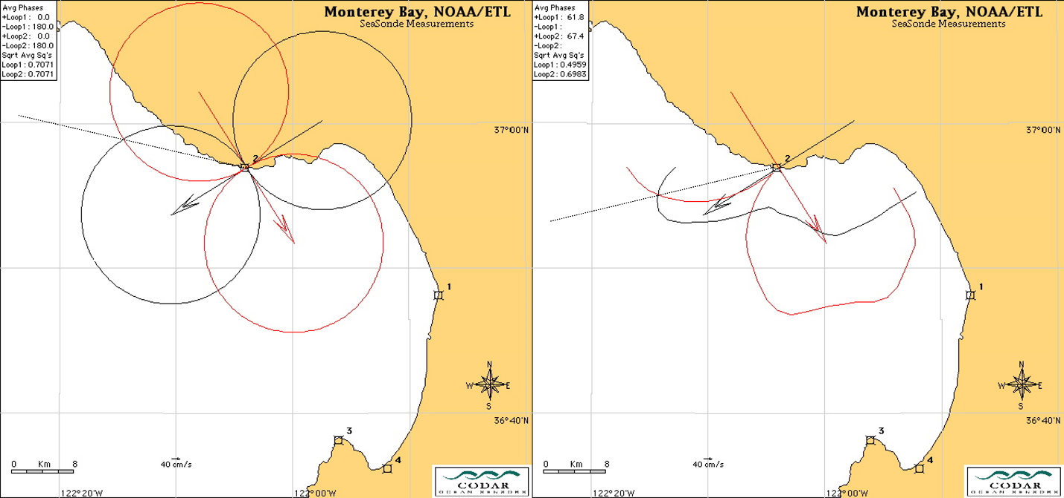
Figure 2-4. Ideal APM (left) vs. measured APM (right) for a SeaSonde at Santa Cruz, California. Coefficients, represented by the shape of this plotted APM, are used by the sensor when deriving the radial velocities from the sea echo signal.
SeaSondes are capable of outputting both APM-calibrated “measured” radials (i.e., radials with RDLm*.ruv filenames) and uncalibrated “ideal” radials (i.e., radials with RDLi*.ruv filenames). The appropriate SQL databases in HFRNet must be configured on a site-by-site basis to use the correct file type, measured or ideal, ingested from each SeaSonde.

Retrieval Errors
As remote coastal sensors, HFRs make the radial velocity data stored locally on their laptops available to HFRNet using local internet connections, which are often mobile hotspots connected to cellular networks or satellite internet connections (e.g., HughesNet, ViaSat, etc.). These on-site internet connections are subject to outages. If a HFR otherwise continues operating during an internet connection outage, radial velocity measurements will continue to be collected on its laptop and later made available to HFRNet once the internet connection is restored. HFRNet is configured to reprocess data products using late-arriving data that’s up to 7 days old.

Some HFRs may also be operated seasonally, especially those which measure areas of the coast that freeze during the winter (e.g., Great Lakes, Alaska’s North Slope). HFRs can only measure liquid water, so HFRs aren’t run during periods with excessive ice cover.

The computers/servers which host HFR radial velocity data are often managed by university Information Technology (IT) departments and are subject to their policies and protocols, which may change with little to no notice. Such changes may impact NCCF Ingest’s ability to retrieve radials for HFRNet processing. In the event of any retrieval errors, the NOAA/NOS/IOOS Office’s Surface Currents Program Manager is to be notified and will work with NESDIS and the HFR data provider to troubleshoot.

Practical Considerations
The sensors in the IOOS HFR National Network are owned and operated by IOOS Regional Association (RA) member institutions, most of which are universities. NOAA’s U.S. IOOS Office funds Principal Investigators (viz. professors) and staff in their labs as HFR technicians, via cooperative agreements with the RAs. Accordingly, most technicians are only funded to work part time on HFR, and these may include graduate or undergraduate student staff. This staffing, blended in seniority and geographically distributed, has varying levels of funding, responsiveness, and capability to address issues with the HFR systems. Requests for work related to the HFRs are to be directed to the NOAA/NOS/IOOS Office’s Surface Currents Program Manager who will coordinate with the RAs within the scope of their cooperative agreements.

Numerical Computation Considerations
This new NCCF-based HFRNet’s computational algorithms were copied directly from a predecessor HFRNet system at CORDC that had been running for nearly two decades on legacy hardware. HFRNet represents a trivial computational burden to the NCCF’s state of the art computing capabilities.

Programming & Procedural Considerations
The latitudinal and longitudinal dilution of precision (DOPy and DOPx) represent the contribution of the available radar array configuration geometry to uncertainty in the
northward (V) and eastward (U) velocity estimates, respectively. DOPy and DOPx are direct multipliers of the standard error in obtaining the standard deviation for the northward and eastward velocity estimate from the unweighted least squares solution. DOPx and DOPy are commonly used to obtain the geometric dilution of precision ($GDOP=\sqrt{{DOPx}^{2}+{DOPy}^{2}}$), a useful metric for filtering errant velocities due to poor geometry. Real-time velocity data are filtered by a GDOP to provide the best usable data. The specific GDOP threshold is documented in the NetCDF metadata.

This new NCCF-based HFRNet’s codebase was refactored in Python, from CORDC’s legacy codebase written in MATLAB. HFRNet continues to rely on SQL databases that its codebase reads and writes to in order to function. The intention is to keep HFRNet’s Python and SQL architecture, making incremental improvements over time.

Quality Assessment & Diagnostics
Built into the HFRNet codebase are a number of quality assurance (QA) metrics and thresholds to prevent output of spurious data. These are in addition to the QA built in to the HFR sensors’ onboard signal processing by their manufacturers. Further NCCF product generation monitoring is in the process of being implemented to build upon this QA, informed by the IOOS Quality Assurance of Real-Time Oceanographic Data (QARTOD) standards for HFR. Select QA information is recorded in the HFRNet data products’ NetCDF metadata.

Exception Handling
Exceptions are handled internally within HFRNet’s codebase, prior to the output of data products. This includes not outputting products if insufficient valid input data exist to compute results for a given geographic region and/or grid resolution.

Validation

When HFRNet’s data were tested as described in § 2.5.1, the following parameters were used for validation:

Quantitative: Confirm that the contents of the following variables are identical in the new NCCF vs. old CORDC file:
- time
- lat
- lon
- time_bnds
- depth
- depth_bnds
- wgs84
- number_of_sites
- processing_parameters
- radial_metadata
Quantitative: Confirm that the contents of the following variables are within the following tolerances in the NCCF new vs. old CORDC file:
- | u(i)_{new} - u(i)_{old} | < 0.01 cm s⁻¹
- | v(i)_{new} - v(i)_{old} | < 0.01 cm s⁻¹
- | dopx(i)_{new} - dopx(i)_{old} | < 0.001
- | dopy(i)_{new} - dopy(i)_{old} | < 0.001
- | hdop(i)_{new} - hdop(i)_{old} | < 0.001
- | number_of_radials(i)_{new} - number_of_radials(i)_{old} | < 2

Assumptions & Limitations

Performance Assumptions
Each HFRNet computational run should only take the NCCF’s servers a few minutes to complete. If performance is slower than this, or if HFRNet is imposing a drain on the NCCF’s resources (e.g., RAM, disk space, CPU), that is likely indicative of an error which should be investigated and fixed.

Potential Improvements
It is anticipated that the HFRNet system, including the mathematical algorithms described in § 2.3.2, will be improved over time at the direction of the IOOS Surface Currents Program. To facilitate and expedite the adoption of improvements, from research into HFRNet’s operations, HFRNet’s codebase will be posted publicly on the IOOS Office’s GitHub (https://github.com/ioos/hfrnet/) and input solicited from the greater radiowave oceanography community.

Anticipated improvements include using a weighted least squares method to compute totals from radials, and expansion/addition of geographic grid products as the network of HFRs grows in new areas. Such changes will require commensurate updates to HFRNet’s codebase, databases, and related output.

These more fundamental improvements anticipated for HFRNet are in addition to its routine maintenance tasks that require action on the part of NESDIS, such as adding or removing HFR stations, changing antenna pattern measurement settings, changing the institutions associated with HFRs, updating NCCF Ingest settings in response to changes in RA HFR data servers, and updating the roster of RA staff associated with HFRs.

References
References to external documents used to create the ATBD are given below:

2022. IOOS Manual for Real-Time Quality Control of High Frequency Radar Surface Current Data: https://cdn.ioos.noaa.gov/media/2022/07/HFR_QARTOD_Manual_Update_Final-1b.pdf

2015. IOOS. A Plan to Meet the National’s Needs for Surface Current Mapping: https://cdn.ioos.noaa.gov/media/2017/12/national_surface_current_planMay2015.pdf

1997. On the accuracy of HF radar surface current measurements: Intercomparisons with ship-based sensors. Chapman, R. D., L. K. Shay, H. C. Graber, J. B. Edson, A. Karachintsev, C. L. Trump, D. B. Ross. J. Geophys. Res. https://doi.org/10.1029/97JC00049

1994. Shipborne measurement of surface current fields by HF radar. Gurgel, K. -W., L’Onde Electr. https://doi.org/10.1109/OCEANS.1994.364167

1986. Guide to GPS Positioning. Wells, D. E., et al. Can. GPS Assoc., Fredericton, N. B., Canada. https://gge.ext.unb.ca/Pubs/LN58S.pdf

1983. Least-squares methods for the extraction of surface currents from CODAR crossed-loop data: Application at ARSLOE. Lipa, B. J., D. E. Barrick. IEEE J. Ocean. Eng. https://doi.org/10.1109/JOE.1983.1145578

END OF DOCUMENT

