Office of Satellite and Product Operations
Environmental Satellite Processing Center


High Frequency Radar Network (HFRNet) External Users’ Manual
Version 1.0
May 20, 2026

U.S. Department of Commerce
National Oceanic and Atmospheric Administration
National Environmental Satellite, Data, and Information Service
Office of Satellite and Product Operations

Authors
Emily Doss (OCS)
David Donahue (OSPO)
Yuping Liu (OSPO)

Approval Page
Environmental Satellite Processing Center
High Frequency Radar Network (HFRNet)
External Users’ Manual

GROUP: Date  Name and Title | GROUP: Date  Name and Title
GROUP: Date  Name and Title | GROUP: Date  Name and Title
GROUP: Date

Name and Title
Changes/Revisions Record
This standard operating procedure is changed as required to reflect system, operational, or organizational changes. Modifications made to this document are recorded in the Changes/Revisions Record below. This record will be maintained throughout the life of the document.
Version Number | Date | Description of Change/Revision | Section/Pages Affected | Changes Made by Name/Title/  Organization
1.0 | 5/20/2025 | Initial version of the document | All | Emily Doss/Product Owner Advisor/OCS  Susan Haworth/Technical Writer/OCS
1.0.1 | 5/15/2026 | 1.3, 3.1 |  | Yuping (David) Liu

Preface
This document comprises the National Oceanic and Atmospheric Administration (NOAA) National Environmental Satellite, Data, and Information Service (NESDIS), Office of Satellite and Product Operations (OSPO), publication of this High Frequency Radar Network (HFRNet) External Users’ Manual (EUM) for the NOAA National Ocean Service (NOS) U.S. Integrated Ocean Observing System (IOOS) Office’s Surface Currents Program. This document reflects current operations for the DOC/NOAA/NESDIS Environmental Satellite Processing Center (ESPC) (NOAA5045) information technology systems. This document describes the established ESPC procedure for external users of HFRNet in accordance with Federal, DOC, NOAA, NESDIS, NOS, IOOS, and OSPO requirements.
The baseline version of this document can be found at: <SharePoint location of document>

Table of Contents
1. Products 1
1.1. Product Overview 1
1.2. Product Performance 6
1.3. Product Access 7
2. Output Files 8
2.1. Expected Output Files 8
2.2. Reformatted (BUFR/GRIB2) Output Files 16
3. Operations Documentation 16
3.1. Links to Algorithm Theoretical Basis Document 16
3.2. Data Flow Diagram 17
4. Appendix 19
4.1. Acronyms 19

List of Tables

Table 1-1 - Product Team Member Information 1
Table 1-2 - Geographic Domains & Grid Resolutions 3
Table 1-3 - Product Generation Frequency 4
Table 1-4 - Product Accuracy 5
Table 1-5 - HFRNet Quality Information 7
Table 2-1 - Product File Naming Convention 8
Table 2-2 - Product File Convention Meanings 8
Table 2-3 – Hourly Average Product File Output Variables 9
Table 2-4 – 25-Hour, Month, and Year Product File Output Variables 11
Table 2-5 - Product File Metadata 13
Table 3-1 - ATBD Version and Link 17
Table 4-1 - Acronyms 19

List of Figures

Figure 1-1 - HFRNet Geographic Domains 5
Figure 3-1 - HFRNet Data Flow Diagram 18

Products

Product Overview
The High Frequency Radar Network (HFRNet) data assembly center algorithm package computes the speed and direction of ocean and lake surface currents in near real time from radial velocity measurements made by coastal high-frequency radar (HFR) sensors. HFRs operate continuously in all weather conditions and are installed near the coastline. Depending on the desired horizontal resolution of measured currents, the systems are capable of measuring currents anywhere from 40 to 200 km offshore. Velocities are measured in the upper 0.3 – 2.5 meters of the ocean depending on the operating frequency. Remote sensing of surface velocity from shore-based HFRs bridges the operational observational gap between point samples obtained from in-situ sampling and synoptic scale relatively low resolution data obtained from satellites by providing continuous mesoscale coverage at relatively high resolution near the coast.

Product Team
The product team consists of members from several organizations. Information including the team member’s organizations, roles, and contact information can be found in Table 1-1.
Table 1-1 - Product Team Member Information
Team Member | Organization | Role | Contact Information
Walter Wolf | OCS | Product Management Division Chief | walter.wolf@noaa.gov
Melissa Zweng | OCS | Product Management Branch Chief | melissa.zweng@noaa.gov
Brian Zelenke | NOS, U.S. IOOS Office | Science Team Lead | brian.zelenke@noaa.gov
Mark Otero  (only until HFRNet implementation) | UCSD | Science Team | motero@ucsd.edu
Micah Wengren | NOS, U.S. IOOS Office | Science Team | micah.wengren@noaa.gov
Joseph Chen  (only until HFRNet implemention) | UCSD | Science Team | joechen@ucsd.edu
Sarina Mann | NOS, U.S. IOOS Office | Science Team | sarina.mann@noaa.gov
David Donahue | OSPO | PAL | david.r.donahue@noaa.gov
Zhaohui Cheng | OSPO | OSPO Team | zhaohui.cheng@noaa.gov
Jena Kent | NESDIS | PPM | jena.kent@noaa.gov
Inger Kittle | NESDIS | PIB | inger.kittle@noaa.gov
Priyanka Roy | OCS | ASSISTT Program Manager | priyanka.roy@noaa.gov
Michael Butler | OCS | ASSISTT Integration Team Lead | michael.butler@noaa.gov
Zhengpeng Li | OCS | ASSISTT Integration Team Lead | zhengpeng.li@noaa.gov
Letitia Soulliard | OCS | ASSISTT Integration Team Lead | letitia.soulliard@noaa.gov
Shukming (Eva) Wu | OCS | ASSISTT Integration Team Lead | shukming.wu@noaa.gov
Milap Patel | OCS | ASSISTT Integration Team | milap.patel@noaa.gov
Ismail Mohamed | OCS | ASSISTT Integration Team | ismail.mohamed@noaa.gov
Tianzhu Qiao | OCS | ASSISTT Integration Team | tianzhu.qiao@noaa.gov
Yunhui Zhao | OCS | ASSISTT Configuration Management Team Lead | yunhui.zhao@noaa.gov
Susan Haworth | OCS | ASSISTT Technical Writer | susan.haworth@noaa.gov
Tracey Dorian | OCS | ASSISTT Lifecycle QA Team Lead | tracey.dorian@noaa.gov
Emily Doss | OCS | ASSISTT Lifecycle QA | emily.doss@noaa.gov
Hua Xie | OCS | ASSISTT Science QA Team Lead | hua.xie@noaa.gov

Product Description
The High Frequency Radar Network (HFRNet) data assembly center algorithm package is capable of generating hourly average, 25-hour average, month average, and year average product files for pre-defined gridded geographic domains at set resolutions.
The algorithms that make up the HFRNet codebase generate total ocean and lake surface current velocity (i.e., “totals”) gridded data products from input radial velocities (i.e., “radials”). At the national server level, the radials data are combined to form a gridded dataset of total velocity vectors. These gridded datasets come in the following four grid resolutions:
- Far offshore (more than approximately 80 km)
  - Grid Resolution: 6 km
  - Only lower resolution radar data available
- Nearshore to 80 km
  - Grid Resolutions: 2 km and 1 km
  - In areas with higher resolution radars, the grid resolution will be 1 km
- Selected Bays
  - Grid Resolution: 0.5 km
  - Selected bays and waterways have Very High Frequency (VHF) radars with short maximum ranges and sub-kilometer resolution installed
HFRNet totals products are generated for the following geographic domains:
- West Coast
- East & Gulf Coast
- Puerto Rico & Virgin Islands
- Hawaii
- Alaska North Slope
- Gulf of Alaska
- Great Lakes
Table 1-2 indicates which grid resolutions are available in each of the selected geographic domains the HFRNet products may cover.
Table 1-2 - Geographic Domains & Grid Resolutions
 | 0.5 km | 1 km | 2 km | 6 km
West Coast (uswc) | X | X | X | X
East & Gulf Coast (usegc) |  | X | X | X
Puerto Rico & Virgin Islands (prvi) |  |  | X | X
Hawaii (ushi) |  | X | X | X
Alaska North Slope (akns) |  |  |  | X
Gulf of Alaska (gak) |  | X | X | X
Great Lakes (glna) | X | X | X | X

Generation Frequency
Table 1-3 - Product Generation Frequency
Product Name | Generation Frequency
Hourly Average | Once per a given one-hour period
25-Hour Average | Once per a given one-hour period
Month Average | Once per a given calendar month (will occur after the 13th of the month)
Year Average | Once per a given calendar year (will occur after the 20th of January)

Geographic Domain
For additional information concerning the geographic domains of the HFRNet products, refer to Table 1-2. Figure 1-1 provides a graphical representation of the geographic domains.
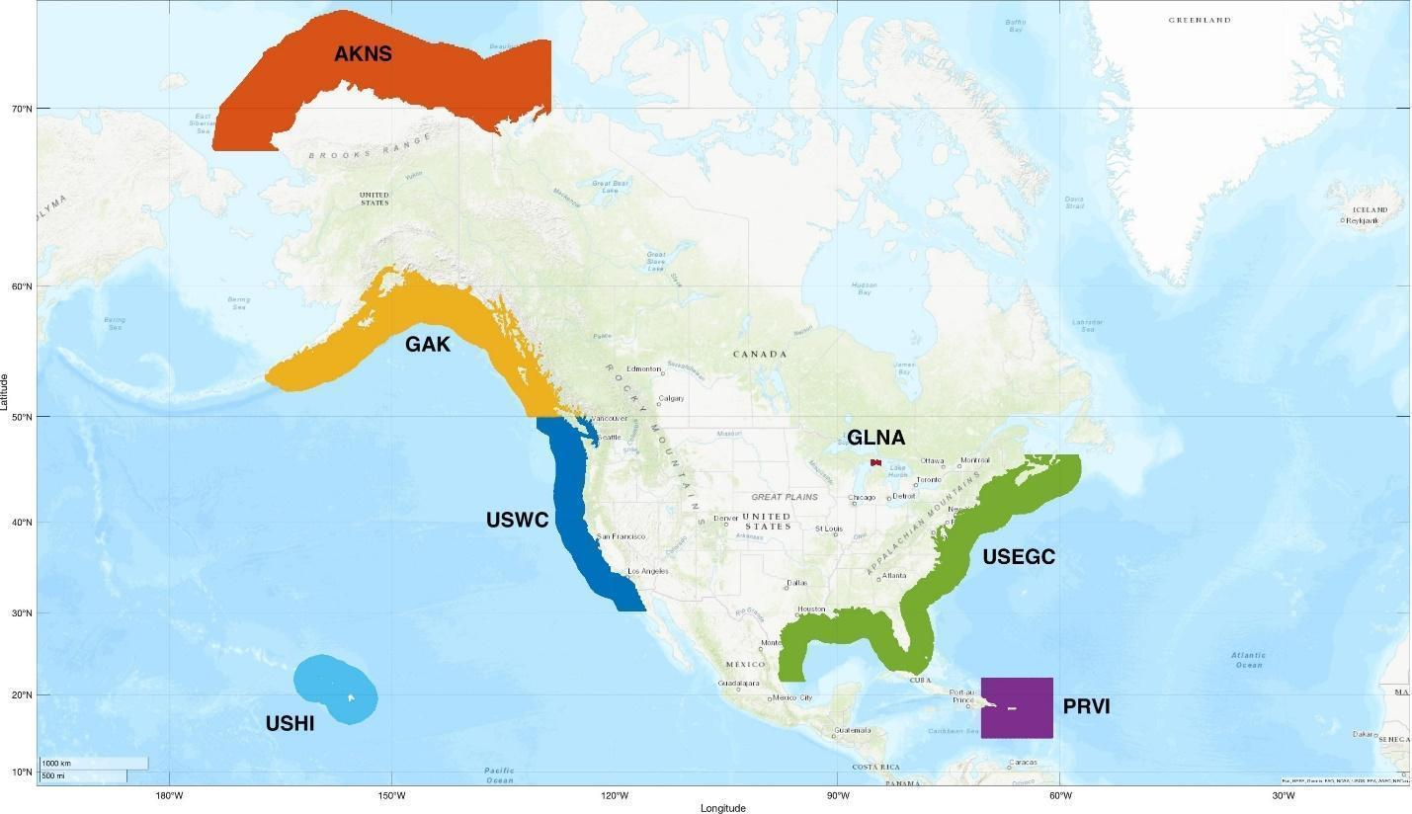
Figure 1-1 - HFRNet Geographic Domains

Resolution
For additional information concerning the HFRNet products’ resolutions, refer to Table 1-2.

Accuracy
Table 1-4 - Product Accuracy
Product Name | Accuracy
Hourly, 25-Hour, Month, Year Average | Spatial average and temporal resolution based on operating frequency: 3 – 50 km offshore & 15 – 60 minutes

Satellite & Sensor Information
There are three systems that make up the High Frequency Radar (HFR) Network: SeaSonde®, WERA, and UH Generic Radars (formerly known as LERA).

SeaSonde
The SeaSonde compact High Frequency (HF) radar system is manufactured and developed by CODAR Ocean Sensors, Ltd. (CODAR). CODAR’s compact direction-finding system is the most widely deployed oceanographic HF technology with approximately 180 sites within the United States of America and over 300 sites internationally. The antenna system optionally combines the transmitting and receiving antennas within a single mast and eliminates the horizontal ground plane whip antennas.

WERA
The Wellen Radar (WERA) allows for measurements of the ocean wave spectrum. This requires access to the full backscatter Doppler spectrum for all ranges and directions. To achieve this access, WERA uses a beam-forming technique. The design uses a modular system that can include 4, 8, 12, or 16 independent, inter-calibrated receiver channels. Signals are processed on the software side, and they allow for the employment of Beam Forming (BF) using a linear array of 8 to 16 antennas and/or Direction Finding (DF) with 4 antennas in a square. Recently, a software upgrade allows WERA to apply Doppler Radar (DR) algorithms on the linear array. However, DF implementations do not provide ocean wave parameters.
To avoid high-power transmit pulses in the range of some kilowatts similar to what was used in former systems, a frequency-modulated continuous-wave signal at 30 watts is transmitted to achieve range resolution. The depth of the range cells can be adopted to the requirements by reprogramming the frequency span of the transmitted frequency chirp. Typical values for a system operated in the 12-MHz frequency band are 130 ranges at 1.5 km resolution.

UH Generic Radars
The University of Hawaiʻi Generic Radars are high-frequency Doppler radars (colloquially known as LERA for “least expensive radar”) developed at the University of Hawaiʻi Radio Oceanography Laboratory starting in 1998. The UH Generic Radar systems are produced using an open source model to minimize hardware costs and operate similarly to the WERA systems in terms of data standards and flags.

Product Performance

Product Testing

Test Data Description
Test cases are provided with each package for product verification before that version of the package is transitioned into operations. These test cases provide input, static ancillary data, dynamic ancillary data, and other product datasets required for product verification. All requirements must be met during testing. Once end users of the products are satisfied that each output file meets all requirements, the products are transitioned into operations.

Unit Test Plans
The HFRNet products are tested during each update to the package. The Science Team, who is responsible for developing these products, tests the files for accuracy and validation. Each algorithm package is tested before delivery to ensure that all requirements are sufficiently met. Operations personnel must test these products to ensure the products can be successfully generated on the intended system. If any issues arise during the testing procedures, they must be dealt with before the package can be transitioned into operations.

Test Results
The validation test results can be found in the ATBD associated with the HFRNet algorithm package (NOAA/NESDIS/STAR, 2025).

Product Accuracy
All HFRNet product files have been validated against observations to ensure their accuracy and precision falls within the required specifications. For more information, contact the Product Area Lead (PAL).

Product Quality
Due to the unique nature of the HFRNet algorithm package, the variables u and v within each NetCDF4 output file are used to assess the product quality. More information on these variables can be seen in Table 1-5.
Table 1-5 - HFRNet Quality Information
Attribute | Description
u | Surface eastward sea water velocity
v | Surface northward sea water velocity

External Product Tools
There are no external product tools provided with the HFRNet algorithm package.

Product Access
The NESDIS Policy on Access and Distribution of Environmental Data and Products is provided at http://www.ospo.noaa.gov/Organization/About/access.html.
Users need to fill out the Data Access Request Form. This form can be downloaded from the same webpage where the NESDIS Policy on Access and Distribution of Environmental Data and Products is displayed. A completed copy of the form should be sent to both the PAL and the OSPO Data Access Team (nesdis.data.access@noaa.gov). Once the request is approved, the data will be delivered using the Product Distribution and Access (PDA) system.
SPSDuserservices@noaa.gov should be contacted for any data accessibility and data distribution problems.

Links to External Web Pages for Users (mainly URLs)
- Tetra Tech HFRNet
- NDBC NOAA HF Radar Server

Output Files

Expected Output Files
Table 2-1 describes the product file naming convention for the HFRNet expected output product files. Note that the information in this table only describes the expected, or final, output of the HFRNet algorithm package and does not include any information on the intermediate output.
Table 2-1 - Product File Naming Convention
Product File | Naming Convention
Hourly Average | rtv-<domain>-<resolution>-<product>_<version>_hfr_s<time>_e<time>_c<time>.nc
25-Hour Average | rtv-<domain>-<resolution>-<product>_<version>_hfr_s<time>_e<time>_c<time>.nc
Month Average | rtv-<domain>-<resolution>-<product>_<version>_hfr_s<time>_e<time>_c<time>.nc
Year Average | rtv-<domain>-<resolution>-<product>_<version>_hfr_s<time>_e<time>_c<time>.nc

Table 2-2 provides the meaning of the naming conventions associated with each product file.
Table 2-2 - Product File Convention Meanings
Convention | Meaning
<domain> | Location of the data processing; will be one of the seven regions mentioned in Table 1-2; ushi, usegc, uswc, prvi, gak, glna, akns
<resolution> | Spatial resolution of the data; will be one of the four resolutions mentioned in Table 1-2; 500m, 1km, 2km, 6km
<product> | Indicates which product data is in the file; will be the following:  Hourly Average: uwls  25-Hour Average: 25h-avg  Month Average: mon-avg  Year Average: ann-avg
<version> | Indicates the version number of the algorithm used to generate the product file; will be v1r0
<time> | Indicates timestamp associated with file in 4-digit year, 2-digit month, 2-digit day, 2-digit hour, 2-digit minute, 3-digit second (i.e., YYYYMMDDhhmmsss)

Table 2-3 describes the hourly average variables associated with the NetCDF4 expected output product file.
Table 2-3 – Hourly Average Product File Output Variables
Variable | Type | Description | Dimensions | Units | Range
depth | 32-bit floating point | Nominal depth (and corresponding bounds) based on contributing radars | 1 | m | N/A
depth_bnds | 32-bit floating point | depth_bnds | 2 | N/A | N/A
dopx | 16-bit integer | The longitudinal dilution of precision (dopx) represents the contribution of radial geometry to uncertainty in the eastward velocity estimate (u) | 1 x 482 x 602 | N/A | N/A
dopy | 16-bit integer | The latitudinal dilution of precision (dopy) represents the contribution of radial geometry to uncertainty in the northward velocity estimate (v) | 1 x 482 x 602 | N/A | N/A
hdop | 16-bit integer | The horizontal dilution of precision (hdop) is the vector length (magnitude) of the eastward (dopx) and northward (dopy) dilution of precision. It represents the contribution of radial geometry to the overall uncertainty in the total velocity (u and v) estimate. | 1 x 482 x 602 | N/A | N/A
lat | 32-bit floating point | Latitude | 482 | degrees_north | N/A
lon | 32-bit floating point | Longitude | 602 | degrees_east | N/A
number_of_radials | 16-bit integer | Number of radials contributing to the total solution | 1 x 482 x 602 | count | N/A
number_of_sites | 8-bit character | Number of radars contributing radials to the total solution | 1 x 482 x 602 | count | N/A
processing_parameters | 8-bit character | Method used to compute total solutions from radial velocities | 1 | N/A | N/A
prod_mon | 32-bit unsigned integer | Total (actual) number of retrievals | 1 | N/A | N/A
radial_metadata | 8-bit character | Metadata on radial velocities used to compute total solutions | 1 | N/A | N/A
time | 32-bit integer | Time | 1 | seconds since 1970-01-01 | N/A
time_bnds | 32-bit integer | time_bnds | 1 x 2 | N/A | N/A
u | 16-bit integer | Surface eastward sea water velocity | 1 x 482 x 602 | m s-1 | N/A
v | 16-bit integer | Surface northward sea water velocity | 1 x 482 x 602 | m s-1 | N/A
wgs84 | 8-bit character | wgs84 | 1 | N/A | N/A

Table 2-4 describes the 25-hour, month, and year variables associated with the NetCDF4 expected output product file.
Table 2-4 – 25-Hour, Month, and Year Product File Output Variables
Variable | Type | Description | Dimensions | Units | Range
depth | 32-bit floating point | Nominal depth (and corresponding bounds) based on contributing radars | 1 | m | N/A
depth_bnds | 32-bit floating point | depth_bnds | 2 | N/A | N/A
lat | 32-bit floating point | Latitude | 482 | degrees_north | N/A
lon | 32-bit floating point | Longitude | 602 | degrees_east | N/A
n_obs | 16-bit integer | Number of observations | 1 x 482 x 602 | count | N/A
processing_parameters | 8-bit character | Method used to compute hourly total solutions from radial velocities | 1 | N/A | N/A
time | 32-bit integer | Time | 1 | seconds since 1970-01-01 | N/A
time_bnds | 32-bit integer | time_bnds | 1 x 2 | N/A | N/A
u_max | 16-bit integer | Maximum eastward surface velocity | 1 x 482 x 602 | m s-1 | N/A
u_mean | 15-bit integer | Mean eastward surface velocity | 1 x 482 x 602 | m s-1 | N/A
u_min | 16-bit integer | Minimum eastward surface velocity | 1 x 482 x 602 | m s-1 | N/A
u_var | 16-bit integer | Eastward surface velocity variance | 1 x 482 x 602 | m2 s-2 | N/A
v_max | 16-bit integer | Maximum northward surface velocity | 1 x 482 x 602 | m s-1 | N/A
v_mean | 16-bit integer | Mean northward surface velocity | 1 x 482 x 602 | m s-1 | N/A
v_min | 16-bit integer | Minimum northward surface velocity | 1 x 482 x 602 | m s-1 | N/A
v_var | 16-bit integer | Northward surface velocity variance | 1 x 482 x 602 | m2 s-2 | N/A
wgs84 | 8-bit character | wgs84 | 1 | N/A | N/A

Table 2-5 describes the hourly average, 25-hour, month, and year metadata associated with the NetCDF4 expected output product file.
Table 2-5 - Product File Metadata
Attribute | Description | Data Type
Conventions | Provides a comma-separated list of conventions followed by the dataset that the product file follows. | String
_NCProperties | NetCDF and HDF version numbers, will be automatically generated | String
cdm_data_type | Describes the geographic category the product data represents. The data type is derived from Unidata’s Common Data Model Scientific Data types and is understood by THREDDS. | String
creator_email | Provides an email address for the algorithm development team. | String
creator_name | Provides the name of the algorithm team responsible for development of the product. | String
creator_type | Provides the type of the algorithm development team. | String
creator_url | Provides a URL that users can access. | String
date_created | Provides the UTC time the product file was created in YYYY-MM-DDThh:mm:ssZ format. | String
day_night_data_flag | Set to “night” for night, “day” for day, and “both” for both depending on sunlight conditions for observation. | String
format_version | Indicates the version of the format of the variables in the product file. | String
geospatial_lat_max | Describes a simple upper latitude limit; may be part of a two- or three-dimensional bounding region. Specifies the northernmost latitude covered by the dataset. | 32-bit floating point
geospatial_lat_min | Describes a simple lower latitude limit; may be part of a two- or three-dimensional bounding region. Specifies the southernmost latitude covered by the dataset. | 32-bit floating point
geospatial_lat_resolution | Provides information about the targeted spacing of points in latitude. | String
geospatial_lat_units | Should be “degrees_north.” | String
geospatial_lon_max | Describes a simple longitude limit; may be part of a two- or three-dimensional bounding region. Specifies the easternmost longitude covered by the dataset. | 32-bit floating point
geospatial_lon_min | Describes a simple longitude limit; may be part of a two- or three-dimensional bounding region. Specifies the westernmost longitude covered by the dataset. | 32-bit floating point
geospatial_lon_resolution | Provides information about the targeted spacing of points in longitude. | String
geospatial_lon_units | Should be “degrees_east.” | String
history | Reflects the algorithm name and version used to produce the product. | String
id | Provides the Unique User Identifier (UUID) Version 4. Version 4 UUIDs have the form xxxxxxxx-xxxx-4xxx-yxxx-xxxxxxxxxxxx where x is any hexadecimal digit and y is one of 8, 9, A, or B. | String
id_HFR | Provides an HFR-specific identifier in the format <YYYYMMDDHHMM>siohfruwlsrtv<domain><resolution>. For information on the meanings of domain and resolution, refer to Table 2-2. | String
institution | Should be “DOC/NOAA/NESDIS/OSPO > Office of Satellite and Product Operations, NESDIS, NOAA, U.S. Department of Commerce.” | String
instrument | Reflects the instrument(s) used to derive the product. | String
instrument_vocabulary | Indicates the unique name or identifier of the vocabulary from which keywords are taken. | String
keywords | Provides a comma-separated list of key words and/or phrases. | String
keywords_vocabulary | Indicates the unique name or identifier of the vocabulary from which keywords are taken. | String
metadata_link | Provides a URL that gives the location of more complete metadata or a product information web page. | String
naming_authority | Indicates the organization that provides the “id” attribute. | String
platform | Reflects the satellite(s) used to derive the product. | String
platform_vocabulary | Indicates the unique name or identifier of the vocabulary from which keywords are taken. | String
processing_level | Describes the level of processing associated with the product file. | String
product_version | Provides the version of the product. | String
production_environment | Provides the processing string generating the product. | String
production_site | Provides the processing site for the product. | String
program | Describes the program associated with the product. | String
project | Describes the project associated with the product. | String
publisher_email | Provides the OSPO ESPC Help Desk email address. | String
publisher_name | Provides the name of the publisher, which will be “DOC/NOAA/NESDIS/ESPDS > ESPDS, NESDIS, NOAA, U.S. Department of Commerce.” | String
publisher_type | Provides the type of the publisher. | String
publisher_url | Provides the URL to OSPO’s website, which will be “http://www.ospo.noaa.gov.” | String
references | Lists published or web-based references that describe the data or methods used to produce it. | String
source | Provides a comma delimited list of all major input files. | String
standard_name_vocabulary | Provides the name and version number of the CF Standard Name Table associated with the product. | String
summary | Provides a brief description of the product. | String
time_coverage_end | Set to the UTC end time of an observation as “YYYY-MM-DDThh:mm:ssZ.” | String
time_coverage_start | Set to the UTC start time of an observation as “YYYY-MM-DDThh:mm:ssZ.” | String
title | Provides the unique and descriptive short name of the product. | String

Reformatted (BUFR/GRIB2) Output Files
There are no files from the HFRNet algorithm package that are input into the NetCDF4 Reformatting Toolkit (N4RT).

Operations Documentation

Links to Algorithm Theoretical Basis Document
Table 3-1 - ATBD Version and Link
ATBD Version | Corresponding EUM & SMM Version | ATBD URL
1.0 | EUM: v1.0  SMM: v1.0 | https://docs.google.com/document/d/1kXa8eeFG-oxxbyTWZSQct0RwVzkx1UAM/edit

Data Flow Diagram
Figure 3-1 provides a data flow diagram for the HFRNet algorithm package.
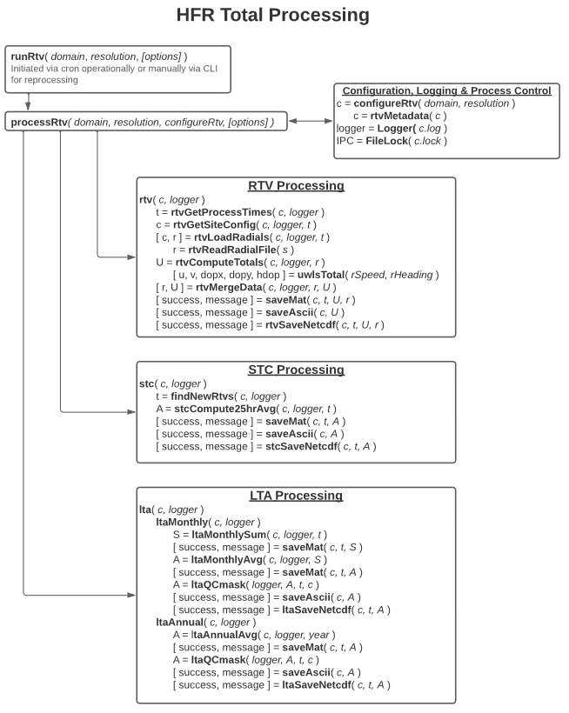
Figure 3-1 - HFRNet Data Flow Diagram

Appendix

Acronyms
Table 4-1 - Acronyms
Acronym | Definition
ASSISTT | Algorithm Scientific Software Integration and System Transition Team
ATBD | Algorithm Theoretical Basis Document
BF | Beam Forming
CCAP | Cloud Containerized Algorithm Package
CM | Configuration Management
DF | Direction Finding
DOC | Department of Commerce
DR | Doppler Radar
ESPC | Environmental Satellite Processing Center
ERT | Earth Resources Technology, Inc.
EUM | External Users’ Manual
HFRNet | High Frequency Radar Network
HF | High Frequency
IOOS | U.S. Integrated Ocean Observing System
LERA | The University of Hawaiʻi Generic Radars (colloquially known as LERA for “least expensive radar”)
NCCF | NESDIS Common Cloud Framework
NCEI | National Centers for Environmental Information
NESDIS | National Environmental Satellite, Data, and Information Service
NetCDF | Network Common Data Form
NOAA | National Oceanic and Atmospheric Administration
NOS | National Ocean Service
OCS | Office of Common Services
OSPO | Office of Satellite and Product Operations
PAL | Product Area Lead
PDA | Product Distribution and Access
QA | Quality Assurance
R2O | Research to Operations
RAD | Requirements Allocation Document
STAR | Center for Satellite Applications and Research
UCSD | University of California San Diego
V&V | Verification and Validation
VHF | Very High Frequency
WERA | Wellen Radar

