Office of Satellite and Product Operations
Environmental Satellite Processing Center


High Frequency Radar Network (HFRNet) System Maintenance Manual

Version 1.0
May 20, 2026

U.S. Department of Commerce
National Oceanic and Atmospheric Administration
National Environmental Satellite, Data, and Information Service
Office of Satellite and Product Operations
Authors
Emily Doss (OCS)
David Donahue (OSPO)
Yuping Liu (OSPO)

Approval Page
Environmental Satellite Processing Center
High Frequency Radar Network (HFRNet)
System Maintenance Manual

GROUP: Date  Name and Title | GROUP: Date  Name and Title
GROUP: Date  Name and Title | GROUP: Date  Name and Title
GROUP: Date

Name and Title
Changes/Revisions Record
This standard operating procedure is changed as required to reflect system, operational, or organizational changes. Modifications made to this document are recorded in the Changes/Revisions Record below. This record will be maintained throughout the life of the document.
Version Number | Date | Description of Change/Revision | Section/Pages Affected | Changes Made by Name/Title/  Organization
1.0 | 5/9/2025 | Initial version of the document | All | Emily Doss/Product Owner Advisor/OCS  Susan Haworth/Technical Writer/OCS
1.0.1 | 5/15/2026 | Added section HFRNet Station Updates, Updated Interfaces Overview, Problem Diagnosis and Recovery, Application Shutdown and Restart, and References | 1.3, 5.3, 5.4, 5.5, 6. | David Donahue, Yuping (David) Liu

Preface
This document comprises the National Oceanic and Atmospheric Administration (NOAA) National Environmental Satellite, Data, and Information Service (NESDIS), Office of Satellite and Product Operations (OSPO), publication of this High Frequency Radar Network (HFRNet) System Maintenance Manual (SMM) for the NOAA National Ocean Service (NOS) U.S. Integrated Ocean Observing System (IOOS) Office’s Surface Currents Program. This document reflects current operations for the DOC/NOAA/NESDIS Environmental Satellite Processing Center (ESPC) (NOAA5045) information technology systems. This document describes the established ESPC procedure for HFRNet system maintenance in accordance with Federal, DOC, NOAA, NESDIS, NOS, IOOS, and OSPO requirements.
The baseline version of this document can be found at: <SharePoint location of document>

Table of Contents
1. Introduction 1
1.1. Product Overview 1
1.2. Algorithm Overview 3
1.3. Interfaces Overview 4
2. Software & Infrastructure 4
2.1. Software Description 4
2.2. Container Description 5
2.3. Application Requirements 6
2.4. Output File Naming Conventions 7
2.5. Directory Description 8
2.6. Source Code Description 9
2.7. Software Control 10
2.8. Processing Control 11
2.9. Compilation Procedures 11
2.10. Production Rules 11
3. Software Configuration 12
4. Data 12
4.1. Data Flow 12
4.2. Input Data Files 14
4.3. Ancillary Data Files 14
4.4. Lookup Tables 14
4.5. Intermediate Dataset Description 14
4.6. Output Dataset Description (including Product Quality) 15
4.7. Archive Data Description 23
4.8. Data Distribution 23
5. Monitoring and Maintenance 24
5.1. Data and Products Processing Monitoring 24
5.2. Product Monitoring (prodmon, visualization/web) 24
5.3. Maintenance 24
5.4. Problem Diagnosis and Recovery 25
5.5. Application Shutdown and Restart 26
6. References 27
6.1. NCCF SMM 27
7. Appendix 27
7.1. Acronyms 27

List of Tables
Table 1-1 - Product Team Member Information 1
Table 1-2 - Geographic Domains & Grid Resolutions 4
Table 2-1 - HFRNet Software Description 4
Table 2-2 - HFRNet Storage Information 6
Table 2-3 - Product File Naming Convention 7
Table 2-4 - Product File Convention Meanings 7
Table 2-5 - HFRNet Top-Level Directory Tree Description 9
Table 2-6 - HFRNet Source Code Description 9
Table 2-7 - Application Configuration YAML File 10
Table 4-1 - Input File Naming Convention 14
Table 4-2 - Input File Naming Convention Meanings 14
Table 4-3 - Intermediate File Naming Convention 15
Table 4-4 - Intermediate File Naming Convention Meanings 15
Table 4-5 – Hourly Average Product File Output Variables 15
Table 4-6 – 25-Hour, Month, and Year Product File Output Variables 18
Table 4-7 - Product File Metadata 20
Table 5-1 - HFRNet Quality Information 25
Table 7-1 - Acronyms 27

List of Figures
Figure 4-1 - HFRNet Data Flow Diagram 13

Introduction

Product Overview
The High Frequency Radar Network (HFRNet) data assembly center algorithm package computes the speed and direction of ocean and lake surface currents in near real time from radial velocity measurements made by coastal high-frequency radar (HFR) sensors. HFRs operate continuously in all weather conditions and are installed near the coastline. Depending on the desired horizontal resolution of measured currents, the systems are capable of measuring currents anywhere from 40 to 200 km offshore. Velocities are measured in the upper 0.3 – 2.5 meters of the ocean depending on the operating frequency. Remote sensing of surface velocity from shore-based HFRs bridges the operational observational gap between point samples obtained from in-situ sampling and synoptic scale relatively low resolution data obtained from satellites by providing continuous mesoscale coverage at relatively high resolution near the coast.

Product Team
The product team consists of members from several organizations. Information including the team member’s organizations, roles, and contact information can be found in Table 1-1.
Table 1-1 - Product Team Member Information
Team Member | Organization | Role | Contact Information
Walter Wolf | OCS | Product Management Division Chief | walter.wolf@noaa.gov
Melissa Zweng | OCS | Product Management Branch Chief | melissa.zweng@noaa.gov
Brian Zelenke | NOS, U.S. IOOS Office | Science Team Lead | brian.zelenke@noaa.gov
Mark Otero  (only until HFRNet implementation) | UCSD | Science Team | motero@ucsd.edu
Micah Wengren | NOS, U.S. IOOS Office | Science Team | micah.wengren@noaa.gov
Joseph Chen  (only until HFRNet implementation) | UCSD | Science Team | joechen@ucsd.edu
Sarina Mann | NOS, U.S. IOOS Office | Science Team | sarina.mann@noaa.gov
David Donahue | OSPO | PAL | david.r.donahue@noaa.gov
Zhaohui Cheng | OSPO | OSPO Team | zhaohui.cheng@noaa.gov
Jena Kent | NESDIS | PPM | jena.kent@noaa.gov
Inger Kittle | NESDIS | PIB | inger.kittle@noaa.gov
Priyanka Roy | OCS | ASSISTT Program Manager | priyanka.roy@noaa.gov
Michael Butler | OCS | ASSISTT Integration Team Lead | michael.butler@noaa.gov
Zhengpeng Li | OCS | ASSISTT Integration Team Lead | zhengpeng.li@noaa.gov
Letitia Soulliard | OCS | ASSISTT Integration Team Lead | letitia.soulliard@noaa.gov
Shukming (Eva) Wu | OCS | ASSISTT Integration Team Lead | shukming.wu@noaa.gov
Milap Patel | OCS | ASSISTT Integration Team | milap.patel@noaa.gov
Ismail Mohamed | OCS | ASSISTT Integration Team | ismail.mohamed@noaa.gov
Tianzhu Qiao | OCS | ASSISTT Integration Team | tianzhu.qiao@noaa.gov
Yunhui Zhao | OCS | ASSISTT Configuration Management Team Lead | yunhui.zhao@noaa.gov
Susan Haworth | OCS | ASSISTT Technical Writer | susan.haworth@noaa.gov
Tracey Dorian | OCS | ASSISTT Lifecycle QA Team Lead | tracey.dorian@noaa.gov
Emily Doss | OCS | ASSISTT Lifecycle QA | emily.doss@noaa.gov
Hua Xie | OCS | ASSISTT Science QA Team Lead | hua.xie@noaa.gov

Algorithm Overview
The High Frequency Radar Network (HFRNet) data assembly center algorithm package is capable of generating hourly average, 25-hour average, month average, and year average product files for pre-defined gridded geographic domains at set resolutions.
The algorithms that make up the HFRNet codebase generate total ocean and lake surface current velocity (i.e., “totals”) gridded data products from input radial velocities (i.e., “radials”). At the national server level, the radials data are combined to form a gridded dataset of total velocity vectors. These gridded datasets come in the following four grid resolutions:
- Far offshore (more than approximately 80 km)
  - Grid Resolution: 6 km
  - Only lower resolution radar data available
- Nearshore to 80 km
  - Grid Resolutions: 2 km and 1 km
  - In areas with higher resolution radars, the grid resolution will be 1 km
- Selected Bays
  - Grid Resolution: 0.5 km
  - Selected bays and waterways have Very High Frequency (VHF) radars with short maximum ranges and sub-kilometer resolution installed
HFRNet totals products are generated for the following geographic domains:
- West Coast
- East & Gulf Coast
- Puerto Rico & Virgin Islands
- Hawaii
- Alaska North Slope
- Gulf of Alaska
- Great Lakes
Table 1-2 indicates which grid resolutions are available in each of the selected geographic domains the HFRNet products may cover.
Table 1-2 - Geographic Domains & Grid Resolutions
 | 0.5 km | 1 km | 2 km | 6 km
West Coast (uswc) | X | X | X | X
East & Gulf Coast (usegc) |  | X | X | X
Puerto Rico & Virgin Islands (prvi) |  |  | X | X
Hawaii (ushi) |  | X | X | X
Alaska North Slope (akns) |  |  |  | X
Gulf of Alaska (gak) |  | X | X | X
Great Lakes (glna) | X | X | X | X

Interfaces Overview
- High-Frequency Radar (HFR) network
  - HF radar stations send text files of radial velocities, waves, and diagnostic data to remote hosts.
- Secure Ingest
  - Pulls data from all HFRNet stations
  - Obtains a list of files based on the configured criteria and deduplicates against existing data within the designated AWS S3 Untrust Bucket
  - Sends collected files to the downloader function via AWS SQS.
  - The Downloader (lambda function), triggered by SQS, copies the collected list of files to the S3 Untrust Bucket
- Processing Environment and Science Algorithm
  - AO cron job reads available data — 20 jobs running in parallel
  - AO spins-up EKS nodes to execute jobs
  - The jobs use the HFRNetDB (MySQL Aurora RDS) to determine which files are available to process, and pull the required data
  - The HFRNet algorithm runs in a container based on the HFRNet image in ECR
  - Products are written to the PG Results bucket with the correct prefixes, tags and S3 object metadata
  - The HFRNetDB is updated to indicate the files have been processed and the products generated
  - Products are hourly, algorithm runs every 30 minutes
  - Each algorithm execution revises output hourly products going back 26 hours in cases where data is delayed coming in
  - algo updates monthly and annual averages
  - annual - averages of the monthly averages
● Data Dissemination/Distribution
  - The Subscription Fulfillment component is responsible for disseminating data to consumers who have a need for a constant flow of various Products
  - The Subscription Fulfillment component either pushes data to a consumer or makes data available for a consumer to pull
  - The Subscription Fulfillment service runs in the Dissemination account in the Dissemination EKS Cluster
  - Subscriptions for the HFRNet Products are configured to push files to the S3 Buckets owned by Tetra Tech and NDBC

- Web Portals
  - Handled by Tetra Tech HFRNet and NDBC NOAA HF Radar Server

Software & Infrastructure

Software Description
The HFRNet algorithm package is comprised of one processing unit responsible for generating all intermediate and final output files. Table 2-1 provides additional information on the processing unit.
Table 2-1 - HFRNet Software Description
Processing Segment | Description
HFRNet | The HFRNet unit is responsible for generating the Hourly Average Intermediate, 25-Hour Average Intermediate, Monthly Average Intermediate files along with the Hourly Average, 25-Hour Average, Month Average, and Year Average product files. The processing unit generates the Hourly Average and 25-Hour Average products once per one-hour period. Since the HFRNet system runs every 30 minutes, there will be a total of 48 jobs run throughout the entire day. The Month Average product file is generated at 00:00 (UTC) on the 13th of each month (i.e., once per month). The Year Average product file is generated at 00:00 on the 20th of January (i.e., once per year).

Container Description
The HFRNet algorithm package requires the following libraries and utilities to successfully generate the expected product files:
- zlib
- szip
- HDF5
- Netcdf4
- Boost libraries
- python=3.9.19
  - pyyaml=6.0.1
  - autologging==1.3.2
  - charset-normalizer==3.3.2
  - scipy==1.13.0
  - shapely==2.0.4
  - polycircles==0.3.7
  - pymysql==1.1.1
  - pandas==2.2.2
  - numpy==1.26.4
  - geographiclib==2.0
  - geopandas==0.14.4
  - scipy==1.13.0
  - h5py==3.11.0
  - netCDF4==1.6.5
  - boto3==1.35.71

The following information describes the Docker container associated with the HFRNet algorithm package:
- Base Image: Red Hat Enterprise Linux release 9.5
- Image Size: 2.5GB
- Repository Name:
git.star.nesdis.noaa.gov:4567/assistt/plait/standalone/hfrnet/process:v1.1
- Tag Name: v1.1

Application Requirements

Storage Requirements
Table 2-2 - HFRNet Storage Information
Catalog | Storage Item | Number of Expected Files Per Run | Approximate Size per Storage Item
Input Files | Radial File | 1 | 500 B – 3 MB
Intermediate Files | Hourly Average Intermediate | Hourly Average Product: 1 Hourly Average Intermediate  25-Hour Average Product: 25 Hourly Average Intermediate  Month Average Product: 760 Hourly Average Intermediate | 1 MB – 8 MB
Intermediate Files | Monthly Average Intermediate | Year Average Product: 12 Monthly Average Intermediate | 1 MB – 8 MB
Input Ancillary Data | Dynamic Ancillary | N/A | N/A
Input Ancillary Data | Static Ancillary | 30 | 12 GB
Log Files | HFRNet Log File | 1 | 200 KB
Output Files | Hourly Average | 1 | 75 KB
Output Files | 25-Hour Average | 1 | 91 KB
Output Files | Month Average | 1 once per month | 91 KB
Output Files | Year Average | 1 once per year | 89 KB
Total | N/A | N/A | 12 GB

Computer Resource Requirements
All libraries and utilities that are required by the HFRNet algorithm package can be found in the $root/packages/hfrnet/utils_funcs directory.

Egress Data Volumes
The target processing system for the HFRNet algorithm package is the NESDIS Common Cloud Framework (NCCF) environment. The communication needs of the system must be sufficient and meet all processing requirements specified throughout section 2.3 of this document.

Output File Naming Conventions
Table 2-3 describes the product file naming convention for the HFRNet expected output product files. Please note that the information in this table only describes the expected, or final, output of the HFRNet algorithm package and does not include any information on the intermediate output.
Table 2-3 - Product File Naming Convention
Product File | Naming Convention
Hourly Average | rtv-<domain>-<resolution>-<product>_<version>_hfr_s<time>_e<time>_c<time>.nc
25-Hour Average | rtv-<domain>-<resolution>-<product>_<version>_hfr_s<time>_e<time>_c<time>.nc
Month Average | rtv-<domain>-<resolution>-<product>_<version>_hfr_s<time>_e<time>_c<time>.nc
Year Average | rtv-<domain>-<resolution>-<product>_<version>_hfr_s<time>_e<time>_c<time>.nc
Table 2-4 provides the meaning of the naming conventions associated with each product file.
Table 2-4 - Product File Convention Meanings
Convention | Meaning
<domain> | Location of the data processing; will be one of the seven regions mentioned in Table 1-2: ushi, usegc, uswc, prvi, gak, glna, akns
<resolution> | Spatial resolution of the data; will be one of the four resolutions mentioned in Table 1-2: 500m, 1km, 2km, 6km
<product> | Indicates which product data is in the file; will be the following:  Hourly Average: uwls  25-Hour Average: 25h-avg  Month Average: mon-avg  Year Average: ann-avg
<version> | Indicates the version number of the algorithm used to generate the product file; will be v1r0
<time> | Indicates timestamp associated with file in 4-digit year, 2-digit month, 2-digit day, 2-digit hour, 2-digit minute, 3-digit second (i.e., YYYYMMDDhhmmsss)

Directory Description
The following is a top-level directory tree describing the HFRNet algorithm package. Please note that this is only a top-level directory tree and reflects the directory structure of the algorithm package immediately after it is unpacked in the current working directory. The main software directory is fully expanded to provide additional software information to end users of both this document and the expected output product files.

DOCS
|
CODE
├──hfrnet
│ ├── ancillary_data
│ │ ├── grid_data
│ │ └── land_data
│ ├── docker
│ │ └── process
│ ├── packages
│ │ ├── aim
│ │ └── hfrnet
│ │ ├── run_config
│ │ ├── run_rtv
│ │ └── utils_funcs
│ ├── test_data
│ └── wrappers
│ └── config
Table 2-5 contains a brief description of each of the top-level directories.
Table 2-5 - HFRNet Top-Level Directory Tree Description
Directory | Description
DOCS | Contains documentation associated with the algorithm package
CODE | Contains code, including the science code, that supports the algorithm package

Source Code Description
Table 2-6 describes each of the important source code files present within the HFRNet algorithm package. When possible, this information is pulled from the header of the listed source code file.
Table 2-6 - HFRNet Source Code Description
File Name | Description
ltaSaveNetcdf.py | Saves long-term average solutions and corresponding metadata in NetCDF format using the Climate and Forecast (CF) and Attribute Convention for Data Discovery (ACDD) metadata standards.
processRtv.py | Processes all RTV products for the given domain and resolution based on configuration parameters obtained by configFunction. This form is typically used in near real-time processing. Process locking is mandatory and prevents concurrent instances for the given domain and resolution from running.
rtv.py | Loads available radial data, computes total solutions, and saves results based on configuration parameters provided in c while logging to the logger object.
rtvComputeTotals.py | Returns a structure containing total velocity solutions computed from radial velocity measurements using input processing parameters.
rtvGetProcessTimes.py | Returns a datetime vector of hours that needs to be processed for RTV solutions based on new radial data. Messages are written to the logger class and all other configuration properties are obtained from the structure c. The current and new (but not yet updated) state values are written to c for reference. The calling function writes the state value.
rtvGetSiteConfig.py | Obtains time-dependent HF-RADAR site configurations from the database for the domain, resolution, and time being processed.
rtvLoadRadials.py | Returns a structure containing radial data from all sites for the given hour of RTV processing. Data are provided for the preferred beam pattern and filtered by velocity flag (if available), speed threshold, and landmasked.
rtvMergeData.py | Merges radial and total data from the current run with previous runs and appends to the history. When reprocessing, an error is thrown if previous runs are found since it is expected that they have already been removed.
rtvProcessMetadata.py | Updates the title, summary, keywords, processingLevel, and references with process or method specific metadata.
rtvReadRadialFile.py | Reads the radial file defined in the structure and returns a structure containing radial data used during RTV processing. The radial file format must be lluv. The radar location is used to compute speed and heading fields from radial velocity if they aren’t directly available in the file.
rtvSaveNetcdf.py | Saves total solutions and corresponding metadata in NetCDF format using the Climate and Forecast (CF) and Attribute Convention for Data Discovery (ACDD) metadata standards.
stcSaveNetcdf.py | Saves sub-tidal current solutions and corresponding metadata in NetCDF format using the Climate and Forecast (CF) and Attribute Convention for Data Discovery (ACDD) metadata standards.
sumAvg.py | Computes the sums and averages over the 25-hour, monthly, and annual time periods.
uwlsTotal.py | Provides information regarding the totals for the hourly time period.

Software Control
There must be at least one YAML file present in the algorithm package responsible for guiding the inner script as it chooses what processing or preprocessing steps will occur, which granule will be processed, and which span of time will be observed. This file is located in the following directory:
$root/hfrnet/test_data/config_hfr.yml
For convenience, all items in the file that have a possibility of variation or are system specific will be located at the top of the YAML file as anchors. Each of these keys are listed below.
Table 2-7 - Application Configuration YAML File
Key Name | Value Description
processing.domain | Domain of the radial data to process
processing.resolution | Resolution of radial data to process
processing.batch_processing | True if re-running over previous data  False if running real-time data
time.start_date | Start date of data processing: YYYYMMDDhhmmsss
time.end_date | End date of data processing: YYYYMMDDhhmmsss
production.site | Site where code is being run
production.environment | Environment where code is being run
production.version | Product version
directory.algorithm_dir | Location of working directory
directory.log | Location of logfile
directory.output | Location of output files
directory.radial_local_dir | Location of radial files in local area
directory.interm_local_dir | Location of intermediate files in local area
directory.output_s3_bucket | Location of output to the s3 bucket
directory.output_intermediate_s3_bucket | Location of intermediate output to the s3 bucket

Processing Control
For information about the Docker configuration, see section 2.7 Software Control.

Compilation Procedures
There are no compilation procedures for the HFRNet algorithm package.

Production Rules
HFRNet will run once every 30 minutes, so there should be 48 jobs run during the day. It will process the latest data that are available from the stations. It will also look back a certain number of hours (currently set to 26 hours, but it is adjustable) to see if new data has come in to be processed. There will be an hourly average and an hourly intermediate file that is output when the algorithm runs. There will be a running 25-hour average that uses the hourly intermediates and is output when the algorithm runs. The monthly average is calculated at 00:00 on the 13th of each month. Along with the data from the stations, this calculation requires 760 hourly average intermediate files. The annual average is calculated at 00:00 on the 20th of January. If the algorithm finds new data for a prior hour (as mentioned above) and that hour is in a prior month or year, it will also recalculate the relevant monthly or yearly average. Along with the data from the stations, this calculation requires 12 monthly average intermediate files.
If input is missing, the algorithm package will attempt to run any calculations that it is able to complete with the provided data. For example, if inputs are missing for the Month Average calculation but present for the Hourly Average calculation, the Hourly Average product will be generated but the Month Average product will not. There will be a message in the log file that indicates when input is missing.

Software Configuration
The following are the general CM procedures for ASSISTT Lifecycle projects.
- The algorithm code/scripts/configuration files received from the science teams are stored in GitLab repositories.
- The branching strategy is defined for the code updates promotion.
- The Dockerfile is added to the repository to create containers to build/execute algorithms.
- The CI/CD pipelines are utilized to automate the build, test, and security scanning jobs.
- The JIRA tickets/GitLab issues are created to track the updates.
- The feature branches are used for the integration/development work.
- The tested updates are reviewed and merged from feature branch to the development branch.
- The updates are reviewed and merged from the development branch to the main branch for the deliveries, and the tags are created to track the deliveries.

Data

Data Flow

External Interfaces
HFRNet does not have upstream or downstream dependencies.

System Level Design & Data Flow
Figure 4-1 provides a data flow diagram for the HFRNet algorithm package.
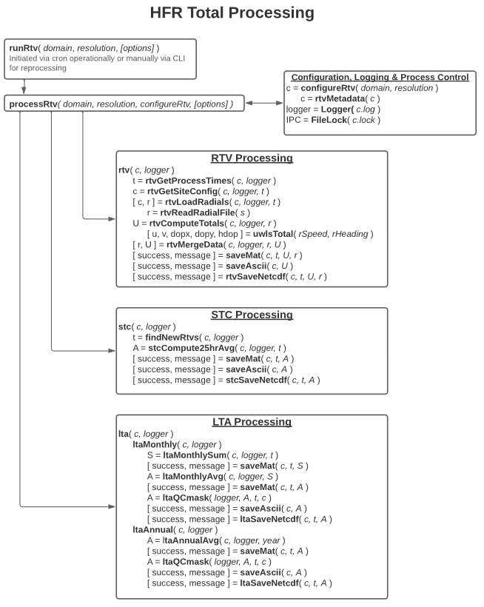
Figure 4-1 - HFRNet Data Flow Diagram

Input Data Files
Table 4-1 describes the file naming convention for the HFRNet input files.
Table 4-1 - Input File Naming Convention
Product File | Naming Convention
Hourly Radial File | RDL_<domain>_<site>_<YYYY>_<MM>_<DD>_<hhmm>.ruv
Table 4-2 provides the meaning of the naming conventions associated with each input file.
Table 4-2 - Input File Naming Convention Meanings
Convention | Meaning
<domain> | Location of the data processing; will be one of the seven regions mentioned in Table 1-2: ushi, usegc, uswc, prvi, gak, glna, akns
<site> | Indicates the site of the HF radar
<YYYY> | 4-digit year
<MM> | 2-digit month
<DD> | 2-digit day
<hhmm> | 2-digit hour, 2-digit minute

Ancillary Data Files
There are no dynamic ancillary data files associated with the algorithm package. All ancillary data needed by the HFRNet algorithm package is included in the package itself.

Lookup Tables
All lookup tables (LUTs) associated with the HFRNet algorithm package are included with the static ancillary data described in section 4.3.

Intermediate Dataset Description
The naming convention associated with each of the intermediate files can be seen in Table 4-3. Please note that the 25-Hour Average Intermediate file is only used for monitoring and is not used in any calculations.
Table 4-3 - Intermediate File Naming Convention
Product File | Naming Convention
Hourly Average Intermediate | rtv-<domain>-<resolution>-<product>_<version>_hfr_intermediate_s<time>_e<time>_c<time>.nc
25-Hour Average Intermediate | rtv-25HrSum-<domain>-<resolution>-_uwls_<version>_hfr_s<time>_e<time>_c<time>.nc
Monthly Average Intermediate | rtv-monthSum-<domain>-<resolution>-_uwls_<version>_hfr_s<time>_e<time>_c<time>.nc
Table 4-4 provides the meaning of the naming conventions associated with each intermediate file.
Table 4-4 - Intermediate File Naming Convention Meanings
Convention | Meaning
<domain> | Location of the data processing; will be one of the seven regions mentioned in Table 1-2; ushi, usegc, uswc, prvi, gak, glna, akns
<resolution> | Spatial resolution of the data; will be one of the four resolutions mentioned in Table 1-2; 500m, 1km, 2km, 6km
<product> | Indicates which product data is in the file; will be the following:  Hourly Average: uwls  25-Hour Average: 25h-avg  Month Average: mon-avg  Year Average: ann-avg
<version> | Indicates the version number of the algorithm used to generate the product file; will be v1r0
<time> | Indicates timestamp associated with file in 4-digit year, 2-digit month, 2-digit day, 2-digit hour, 2-digit minute, 3-digit second (i.e., YYYYMMDDhhmmsss)

Output Dataset Description (including Product Quality)
Table 4-5 describes the hourly average variables associated with the NetCDF4 expected output product file.
Table 4-5 – Hourly Average Product File Output Variables
Variable | Type | Description | Dimensions | Units | Range
depth | 32-bit floating point | Nominal depth (and corresponding bounds) based on contributing radars | 1 | m | N/A
depth_bnds | 32-bit floating point | depth_bnds | 2 | N/A | N/A
dopx | 16-bit integer | The longitudinal dilution of precision (dopx) represents the contribution of radial geometry to uncertainty in the eastward velocity estimate (u) | 1 x 482 x 602 | N/A | N/A
dopy | 16-bit integer | The latitudinal dilution of precision (dopy) represents the contribution of radial geometry to uncertainty in the northward velocity estimate (v) | 1 x 482 x 602 | N/A | N/A
hdop | 16-bit integer | The horizontal dilution of precision (hdop) is the vector length (magnitude) of the eastward (dopx) and northward (dopy) dilution of precision. It represents the contribution of radial geometry to the overall uncertainty in the total velocity (u and v) estimate. | 1 x 482 x 602 | N/A | N/A
lat | 32-bit floating point | Latitude | 482 | degrees_north | N/A
lon | 32-bit floating point | Longitude | 602 | degrees_east | N/A
number_of_radials | 16-bit integer | Number of radials contributing to the total solution | 1 x 482 x 602 | count | N/A
number_of_sites | 8-bit character | Number of radars contributing radials to the total solution | 1 x 482 x 602 | count | N/A
processing_parameters | 8-bit character | Method used to compute total solutions from radial velocities | 1 | N/A | N/A
prod_mon | 32-bit unsigned integer | Total (actual) number of retrievals | 1 | N/A | N/A
radial_metadata | 8-bit character | Metadata on radial velocities used to compute total solutions | 1 | N/A | N/A
time | 32-bit integer | Time | 1 | seconds since 1970-01-01 | N/A
time_bnds | 32-bit integer | time_bnds | 1 x 2 | N/A | N/A
u | 16-bit integer | Surface eastward sea water velocity | 1 x 482 x 602 | m s-1 | N/A
v | 16-bit integer | Surface northward sea water velocity | 1 x 482 x 602 | m s-1 | N/A
wgs84 | 8-bit character | wgs84 | 1 | N/A | N/A

Table 4-6 describes the 25-hour, month, and year variables associated with the NetCDF4 expected output product file.
Table 4-6 – 25-Hour, Month, and Year Product File Output Variables
Variable | Type | Description | Dimensions | Units | Range
depth | 32-bit floating point | Nominal depth (and corresponding bounds) based on contributing radars | 1 | m | N/A
depth_bnds | 32-bit floating point | depth_bnds | 2 | N/A | N/A
lat | 32-bit floating point | Latitude | 482 | degrees_north | N/A
lon | 32-bit floating point | Longitude | 602 | degrees_east | N/A
n_obs | 16-bit integer | Number of observations | 1 x 482 x 602 | count | N/A
processing_parameters | 8-bit character | Method used to compute hourly total solutions from radial velocities | 1 | N/A | N/A
time | 32-bit integer | Time | 1 | seconds since 1970-01-01 | N/A
time_bnds | 32-bit integer | time_bnds | 1 x 2 | N/A | N/A
u_max | 16-bit integer | Maximum eastward surface velocity | 1 x 482 x 602 | m s-1 | N/A
u_mean | 15-bit integer | Mean eastward surface velocity | 1 x 482 x 602 | m s-1 | N/A
u_min | 16-bit integer | Minimum eastward surface velocity | 1 x 482 x 602 | m s-1 | N/A
u_var | 16-bit integer | Eastward surface velocity variance | 1 x 482 x 602 | m2 s-2 | N/A
v_max | 16-bit integer | Maximum northward surface velocity | 1 x 482 x 602 | m s-1 | N/A
v_mean | 16-bit integer | Mean northward surface velocity | 1 x 482 x 602 | m s-1 | N/A
v_min | 16-bit integer | Minimum northward surface velocity | 1 x 482 x 602 | m s-1 | N/A
v_var | 16-bit integer | Northward surface velocity variance | 1 x 482 x 602 | m2 s-2 | N/A
wgs84 | 8-bit character | wgs84 | 1 | N/A | N/A

Table 4-7 describes the hourly average, 25-hour, month, and year metadata associated with the NetCDF4 expected output product file.
Table 4-7 - Product File Metadata
Attribute | Description | Data Type
Conventions | Provides a comma-separated list of conventions followed by the dataset that the product file follows. | String
_NCProperties | NetCDF and HDF version numbers, will be automatically generated | String
cdm_data_type | Describes the geographic category the product data represents. The data type is derived from Unidata’s Common Data Model Scientific Data types and is understood by THREDDS. | String
creator_email | Provides an email address for the algorithm development team. | String
creator_name | Provides the name of the algorithm team responsible for development of the product. | String
creator_type | Provides the type of the algorithm development team. | String
creator_url | Provides a URL that users can access. | String
date_created | Provides the UTC time the product file was created in YYYY-MM-DDThh:mm:ssZ format. | String
day_night_data_flag | Set to “night” for night, “day” for day, and “both” for both depending on sunlight conditions for observation. | String
format_version | Indicates the version of the format of the variables in the product file. | String
geospatial_lat_max | Describes a simple upper latitude limit; may be part of a two- or three-dimensional bounding region. Specifies the northernmost latitude covered by the dataset. | 32-bit floating point
geospatial_lat_min | Describes a simple lower latitude limit; may be part of a two- or three-dimensional bounding region. Specifies the southernmost latitude covered by the dataset. | 32-bit floating point
geospatial_lat_resolution | Provides information about the targeted spacing of points in latitude. | String
geospatial_lat_units | Should be “degrees_north.” | String
geospatial_lon_max | Describes a simple longitude limit; may be part of a two- or three-dimensional bounding region. Specifies the easternmost longitude covered by the dataset. | 32-bit floating point
geospatial_lon_min | Describes a simple longitude limit; may be part of a two- or three-dimensional bounding region. Specifies the westernmost longitude covered by the dataset. | 32-bit floating point
geospatial_lon_resolution | Provides information about the targeted spacing of points in longitude. | String
geospatial_lon_units | Should be “degrees_east.” | String
history | Reflects the algorithm name and version used to produce the product. | String
id | Provides the Unique User Identifier (UUID) Version 4. Version 4 UUIDs have the form xxxxxxxx-xxxx-4xxx-yxxx-xxxxxxxxxxxx where x is any hexadecimal digit and y is one of 8, 9, A, or B. | String
id_HFR | Provides an HFR-specific identifier in the format <YYYYMMDDHHMM>siohfruwlsrtv<domain><resolution>. For information on the meanings of domain and resolution, refer to Table 2-2. | String
institution | Should be “DOC/NOAA/NESDIS/OSPO > Office of Satellite and Product Operations, NESDIS, NOAA, U.S. Department of Commerce.” | String
instrument | Reflects the instrument(s) used to derive the product. | String
instrument_vocabulary | Indicates the unique name or identifier of the vocabulary from which keywords are taken. | String
keywords | Provides a comma-separated list of key words and/or phrases. | String
keywords_vocabulary | Indicates the unique name or identifier of the vocabulary from which keywords are taken. | String
metadata_link | Provides a URL that gives the location of more complete metadata or a product information web page. | String
naming_authority | Indicates the organization that provides the “id” attribute. | String
platform | Reflects the satellite(s) used to derive the product. | String
platform_vocabulary | Indicates the unique name or identifier of the vocabulary from which keywords are taken. | String
processing_level | Describes the level of processing associated with the product file. | String
product_version | Provides the version of the product. | String
production_environment | Provides the processing string generating the product. | String
production_site | Provides the processing site for the product. | String
program | Describes the program associated with the product. | String
project | Describes the project associated with the product. | String
publisher_email | Provides the OSPO ESPC Help Desk email address. | String
publisher_name | Provides the name of the publisher, which will be “DOC/NOAA/NESDIS/ESPDS > ESPDS, NESDIS, NOAA, U.S. Department of Commerce.” | String
publisher_type | Provides the type of the publisher. | String
publisher_url | Provides the URL to OSPO’s website, which will be “http://www.ospo.noaa.gov.” | String
references | Lists published or web-based references that describe the data or methods used to produce it. | String
source | Provides a comma delimited list of all major input files. | String
standard_name_vocabulary | Provides the name and version number of the CF Standard Name Table associated with the product. | String
summary | Provides a brief description of the product. | String
time_coverage_end | Set to the UTC end time of an observation as “YYYY-MM-DDThh:mm:ssZ.” | String
time_coverage_start | Set to the UTC start time of an observation as “YYYY-MM-DDThh:mm:ssZ.” | String
title | Provides the unique and descriptive short name of the product. | String

Archive Data Description
HFRNet product files are currently produced by NDBC and transferred to NCEI for archiving on a monthly basis. This process will continue until the NCEI migration into the NCCF allows the capability internally.

Data Distribution

Data Transfer / Communications
- Secure Ingest Service
  - Pulling Data (Configuration based)
    - Data is pulled for HFRNet via SFTP protocol.
    - Configuration (stored in secrets) allows for the pulling of data from all HFRNet stations and addition of metadata details to incoming files.
    - Collector (lambda function) obtains a list of files based on the configured criteria and deduplicates against existing data within the designated AWS S3 Untrust Bucket. Sends collected files to the downloader function via AWS SQS.
    - Downloader (lambda function), triggered by SQS, copies the collected list of files to the S3 Untrust Bucket.
  - Scanning Data
    - Additions to the HFRNet Untrust Bucket triggers the HFRNet Scanner.
    - Data undergoes multiple checks (Regex Check, Hash Check, Virus Check, Format Check) and is copied to the Trust Bucket upon passing the checks (passes object tags and metadata).
  - Details are made available downstream via AWS SNS, EventBridge & Elasticsearch Dashboards.

- The Subscription Fulfillment component receives Metadata Messages from the Consolidated Ingest Pipelines
- The Product Short Names in the Enhanced Events are first matched to Products and then matched to Subscriptions in the Subscription Fulfillment database
- Subscriptions for the HFRNet Products are configured to push files to the S3 Buckets owned by Tetra Tech and NDBC
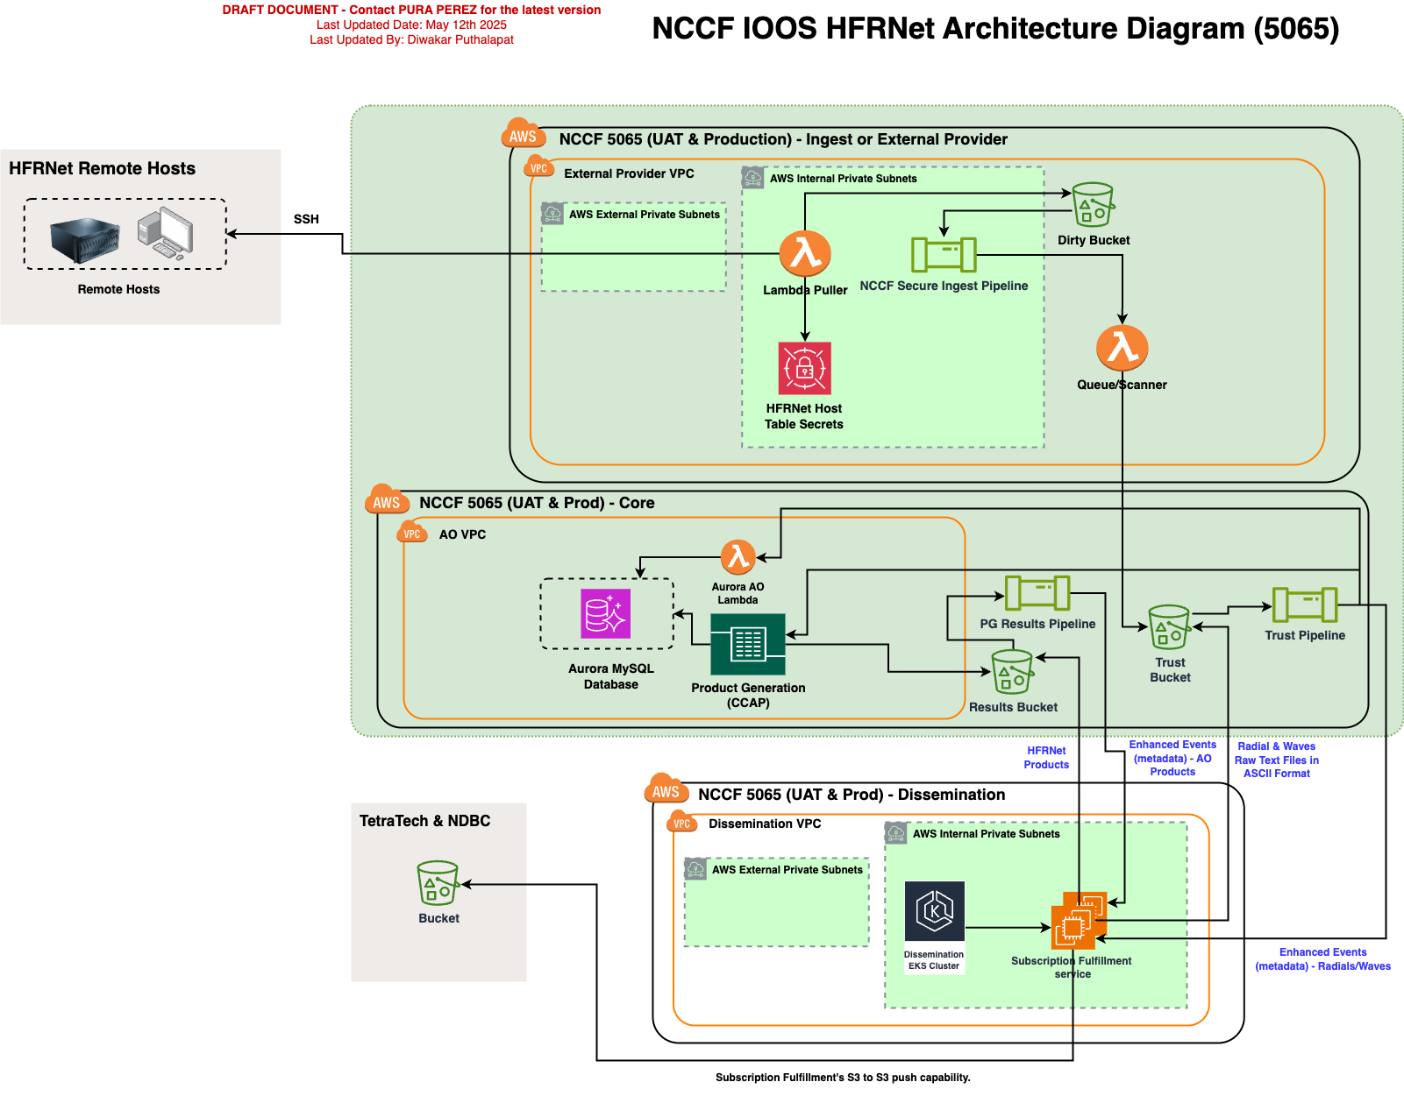

Distribution Restrictions
There are no restrictions regarding the distribution or release of HFRNet data/products or software.

Product Retention Requirements
Hourly files - 62 days to allow for generation of monthly statistics
Monthly files - 1 year to allow for generation of yearly statistics

External Product Tools
There are no external product tools provided with the HFRNet algorithm package.

Monitoring and Maintenance

Data and Products Processing Monitoring
Processing Monitoring
Dashboard to monitor job run status and end-to-end latency of the products processing
Monitoring Dashboard - NCCF Ingest Success Rate & Scan Time
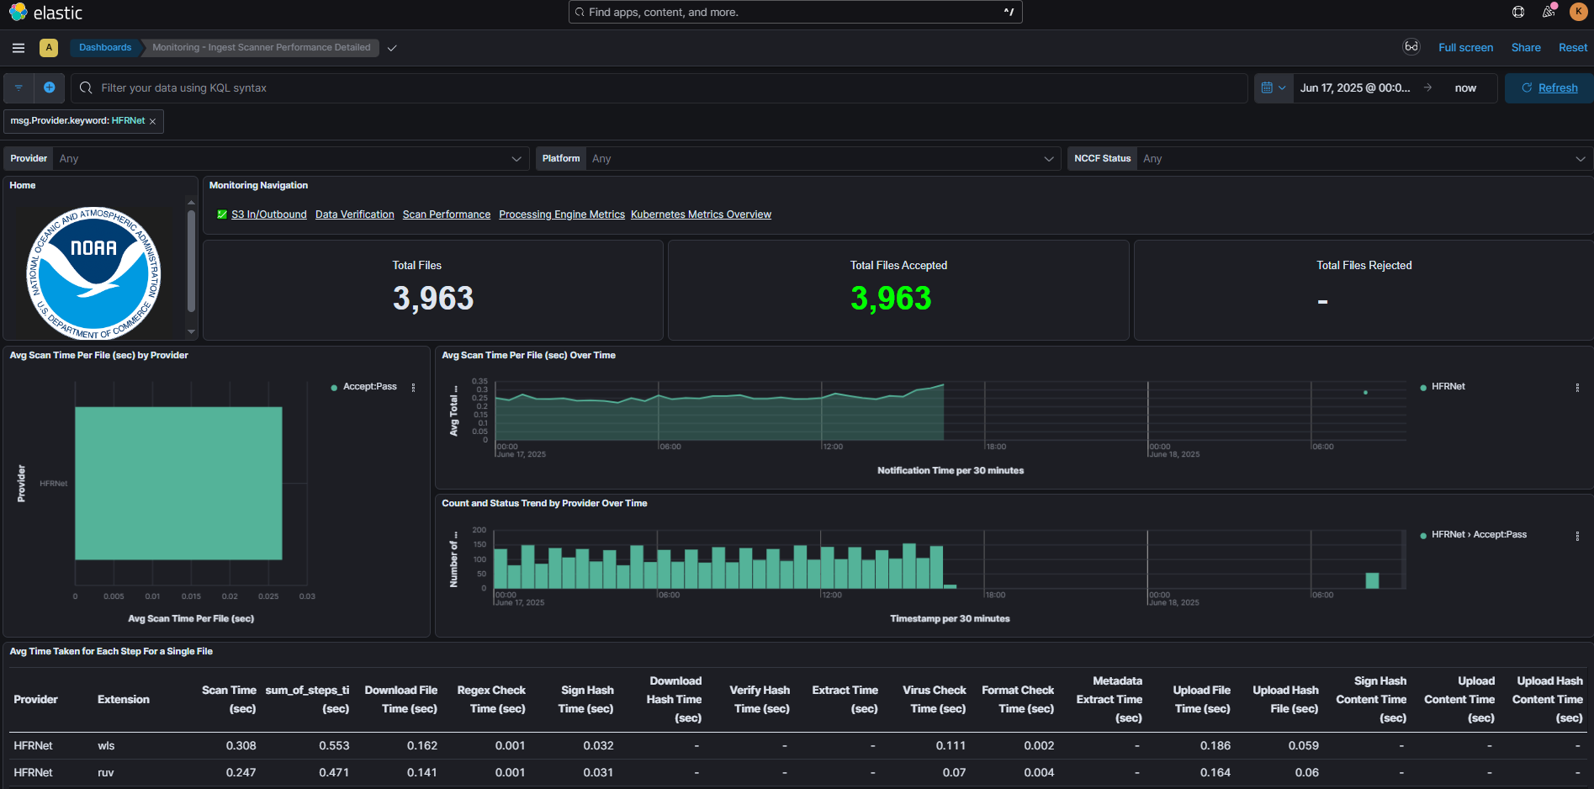

Monitoring Dashboard - NCCF S3 Bucket Details (File count/size in trust, untrust, and pg results S3 buckets)
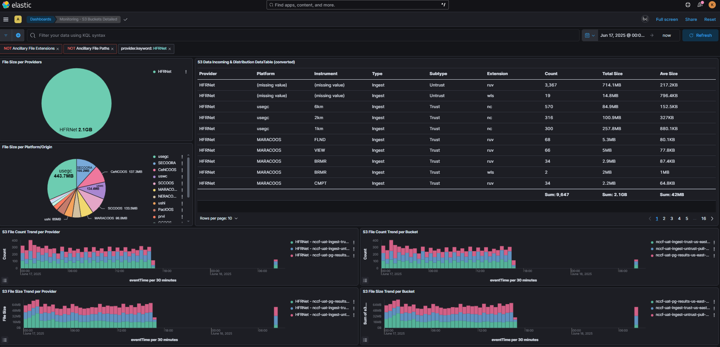

Monitoring Dashboard - NCCF S3 Bucket Details (File count/size in trust, untrust, and pg results S3 buckets)
Monitoring Dashboard - HFRNet Targeted S3 Bucket Details (File count/size in trust buckets, station totals, etc)
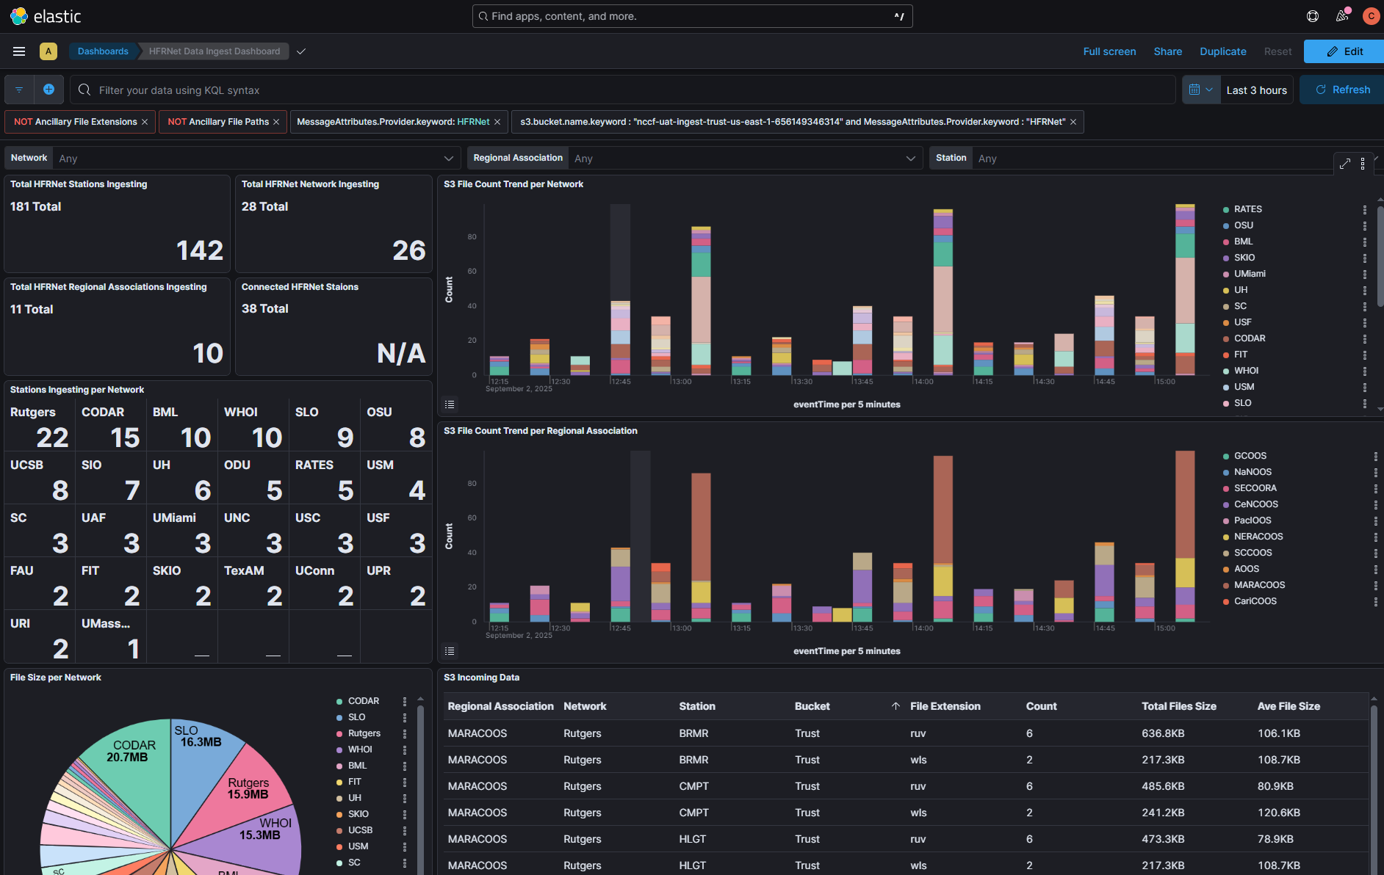

Monitoring Dashboard - HFRNet Server Connectivity Details (Connection Count, Connection Error Details, etc.)
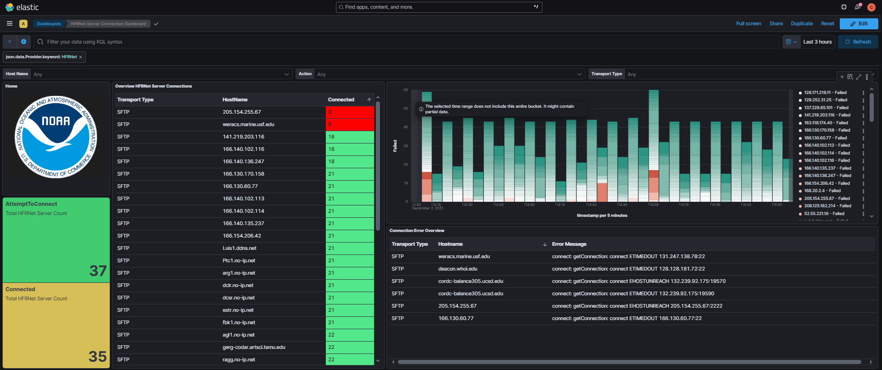

Monitoring Dashboard - HFRNet Job Status - Run Unit Dashboard
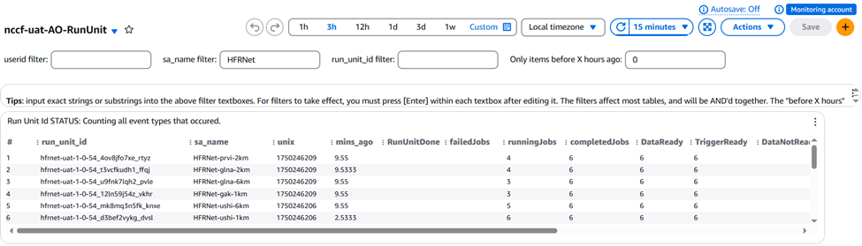

Monitoring Dashboard - Product Generation Latency - Metrics Dashboard
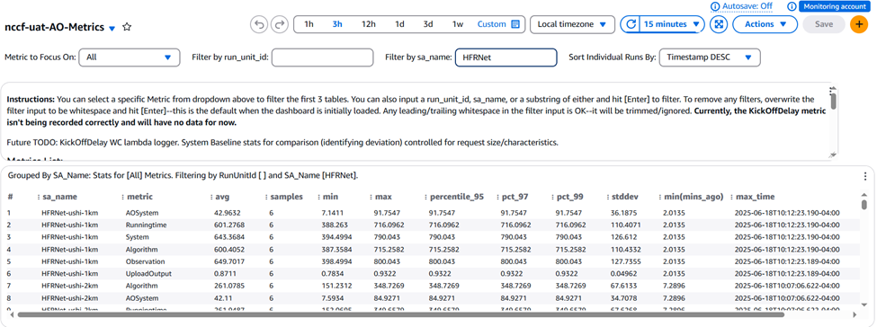
Operators, PALs, and maintenance programmers can access the above tools under ESPC VPN

Product Monitoring (prodmon, visualization/web)
Monitoring Dashboard - ProdMon - Product Quality Monitoring
  - Monitors the quality of generated products
  - Simple interface shows the product quality status for a given day
  - Each product team defines the parameters to be monitored
  - Configurable thresholds for indicating “good”, “warning”, or “bad” results
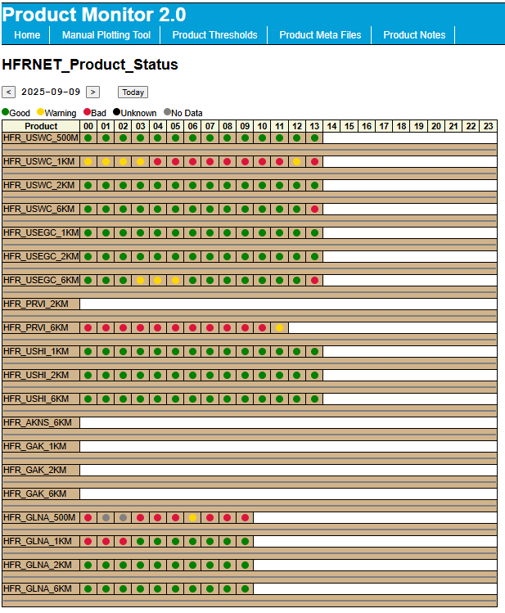
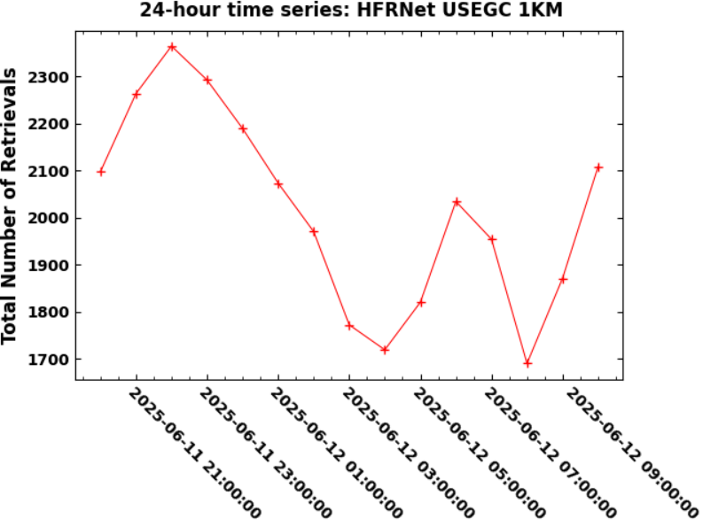

Maintenance
System Maintenance: See the master NCCF SMM: Maintenance Utilities (or Document Object: 84). See NCCF SMM link in References section at 6.1.

5.3.1. Monitoring
- Help Desk monitors the Dashboard for any system, job and product failure and opens ECMT help tickets
- OMS (ENTARIAN) will support any system level failure 24x7
- Product team (PALs team) conducts the routine monitoring. If there is any product failure, the product team checks the Dashboard, Product Trending and Visualization Tools for the initial analysis.
- OCS/ASSISTT will support any algorithm failure 8x5
- Products Monitoring (https://confluence.nesdis-hq.noaa.gov/confluence/spaces/NCCFOP/pages/324776921/HFRNet+High-Frequency+Radar+Network#HFRNet%3AHighFrequencyRadarNetwork-ProductsMonitoring, https://nccf-dev-pvpm-group-01.s3.amazonaws.com/Tools/PVPM/index.html#)
Emergency Recovery Capability
- Not available

5.3.2. Science Maintenance
PALs will coordinate with STAR and OMS staff to deliver and implement a patch in the NCCF Science Maintenance Supports

5.3.3. Library Maintenance
See the master NCCF SMM: Library Maintenance (or Document Object: 71). See NCCF SMM link in References section at 6.1

5.3.4. Special Maintenance Procedures
See the master NCCF SMM: Library Maintenance (or Document Object: 72). See NCCF SMM link in References section at 6.1

5.3.5. HFRNet Station Updates
Service request forms for HFRNet station updates will be routinely submitted and processed on a biannual schedule, with exceptions for emergency situations that prevent or compromise operational production. There are four use cases identified:
- Case 1: Decommission a HFR station from HFRNet
- Case 2: Add or Recommission a Station
- Case 3: Change the beampattern type of the radials that will be processed from a CODAR SeaSonde® model HFR
- Case 4: Changing the email address of the HFR operator designated as a point-of-contact for a station

5.3.5.1 Steps for processing each case
All Use Cases
Step | Action | Notes
1 | Provider submits completed Service Request Form to data.ioos@noaa.gov to be vetted by Brian Zelenke.
2 | Brian will forward the vetted form to the OSPO HFRNet PAL (nccf_pg_monitoring@noaa.gov) | PAL: David Donahue (david.r.donahue@noaa.gov).
3 | OSPO PAL will coordinate with the appropriate team to take the actions to implement the changes, depending on the Use Case. | Cc: Mark Middlebusher, Kelly Cermak (AP-Pink ART), Zhaohui Cheng, and User Services (SPSD.Userservices@noaa.gov)

Use Case 1: Decommission a HFR station from HFRNet
Step | Action | Responsible POC
4 | PAL forwards the Service Request Form to Ingest and Data Management team (Include Brian Zelenke) | PAL: David Donahue (david.r.donahue@noaa.gov)
5 | PAL notify the users, NDBC (ndbc-hfradar@noaa.gov), and Tetra Tech (hfrnetsupport@tetratech.com) of the changes | PAL: David Donahue (david.r.donahue@noaa.gov)
6 | Ingest stops collecting data from Station (update in NCCF Dev, deploy to NCCF UAT and Prod using CI/CD) | Clement Familusi (clement.familusi@noaa.gov)
7 | Data Management team removes station from the SQL database (update in NCCF Dev, deploy to NCCF UAT and Prod using CI/CD)  [See HFRNet Station Update Procedure – below] | Chad Davis (chad.davis@noaa.gov) Shawn (Xiangfeng) Wang (xiangfeng.wang@noaa.gov)
8 | Verify the station removal | PAL: David Donahue (david.r.donahue@noaa.gov)
9 | Inform Brian Zelenke, NDBC (ndbc-hfradar@noaa.gov), Tetra Tech (hfrnetsupport@tetratech.com), and the original requestor that the station has been successfully decommissioned | PAL: David Donahue (david.r.donahue@noaa.gov)

Use Case 2: Add or Recommission a Station
Step | Action | Responsible POC
4 | PAL forwards Service Request Form to Infrastructure, Ingest, Data Management teams, and ASSISTT (Include Brian Zelenke) | David Donahue (david.r.donahue@noaa.gov)
5 | PAL notify the users, NDBC (ndbc-hfradar@noaa.gov), and Tetra Tech (hfrnetsupport@tetratech.com) of the changes | David Donahue (david.r.donahue@noaa.gov)
6 | Infrastructure team updates the firewalls of the new stations, if needed., | Diwakar Puthalapat (diwakar.puthalapat@noaa.gov)
7 | Ingest team adds IP address for new stations and onboard the data in the ingest pipeline (update in NCCF Dev, deploy to NCCF UAT and Prod using CI/CD) | Clement Familusi (clement.familusi@noaa.gov)
8 | Data Management team updates Station related tables in the HFRADAR schema  a) Tables in the HFRADAR schema are updated  b) Diagnostics confirmation is given  c) Tables are updated in RTVPROC schema  [See HFRNet Station Update Procedure – below] | Chad Davis (chad.davis@noaa.gov) and Shawn (Xiangfeng) Wang (xiangfeng.wang@noaa.gov)
9 | Diagnostic confirmation of map plots of station’s radial velocities (e.g., confirm radials aren’t pointing in the wrong direction, radials are over water and not over land, etc.) | Brian Zelenke (brian.zelenke@noaa.govl)
10 | Data Management team updates Station related tables in the RTVPROC schema  [See HFRNet Station Update Procedure – below] | Chad Davis (chad.davis@noaa.gov) and Shawn (Xiangfeng) Wang (xiangfeng.wang@noaa.gov)
11 | Data Management team deploys the SQL changes to NCCF UAT and Prod using CI/CD  [See HFRNet Station Update Procedure – below] | Chad Davis (chad.davis@noaa.gov) and Shawn (Xiangfeng) Wang (xiangfeng.wang@noaa.gov)
12 | Verify the addition of the new stations | PAL: David Donahue (david.r.donahue@noaa.gov)
13 | Inform Brian Zelenke, NDBC (ndbc-hfradar@noaa.gov), Tetra Tech (hfrnetsupport@tetratech.com), and the original requestor the new station has been added/recommissioned. | PAL: David Donahue (david.r.donahue@noaa.gov)

Use Case 3: Change the beampattern type of the radials that will be processed from a CODAR SeaSonde® model HFR
Step | Action | Responsible POC
4 | PAL forwards Service Request Form to Data Management team and possibly Ingest (Include Brian Zelenke) | David Donahue (david.r.donahue@noaa.gov)
5 | PAL notify Tetra Tech (hfrnetsupport@tetratech.com) and the users of the changes | David Donahue (david.r.donahue@noaa.gov)
6 | Data Management team updates the SQL database for the station in question (update in NCCF Dev, deploy to NCCF UAT and Prod using CI/CD)  [See HFRNet Station Update Procedure – below] | Chad Davis (chad.davis@noaa.gov) and Shawn (Xiangfeng) Wang (xiangfeng.wang@noaa.gov)
7 | Ingest team may or may not require change to ingest? | Clement Familusi (clement.familusi@noaa.gov)
8 | Inform Brian Zelenke, Tetra Tech (hfrnetsupport@tetratech.com), and the original requestor the beampattern type has been changed as requested | PAL: David Donahue (david.r.donahue@noaa.gov)

Use Case 4: Changing the email address of the HFR operator designated as a point-of-contact for a station
Step | Action | Responsible POC
4 | PAL updates distribution list (Inform Brian Zelenke) | David Donahue (david.r.donahue@noaa.gov)
5 | Inform the original requestor that the distribution list has been updated, as requested. | PAL: David Donahue (david.r.donahue@noaa.gov)

NCCF Team Contact Email
- Infrastructure: nccf_infrastructure@noaa.gov
- Ingest: nccf.secure.ingest@noaa.gov
- Data Management teams: ocs.sdas.green.art@noaa.gov
- ASSISTT: ocs.sdas.pink.art@noaa.gov
- OSPO: nccf_pg_monitoring@noaa.gov
- User Services: SPSD.Userservices@noaa.gov

5.3.5.2 HFRNet Station Update Procedure

Overview
This repository is used to run stored procedure jobs that query or update station information in the hfradar and rtvproc schemas of the HFRNet database.

Jobs Overview
There is one query job and six station update jobs available:
- query-stations
- Executes two SQL queries to list the stations and networks in the hfradar schema.
- add-site-hfradar
-Adds station information to the site table and, if needed, the network table in the hfradar schema.
- add-site-rtvproc
-Adds station information to the site and site_config tables in the rtvproc schema.
⚠️These tables should not be updated until diagnostics confirmation has been completed.
- upd-beam-pattern
-Updates the beam pattern for a station.
- decom-site
-Decommissions a station in both the hfradar and rtvproc schemas.
- undecom-site-hfradar
-Reinstates a previously decommissioned station in the hfradar schema.
- undecom-site-rtvproc
-Reinstates a previously decommissioned station in the rtvproc schema.
⚠️These tables should not be updated until diagnostics confirmation has been completed.

How to Run Jobs
The following steps should be followed to perform an HFRNet station update:

Step 1: Create Branch To Run Jobs
Create a new branch under main giving it an appropriate name.
- Under the "Code" dropdown, you can find a “Branches" option. Click on that.
- In the upper right corner of the Branches window you will find a "New Branch" button. Click on that.
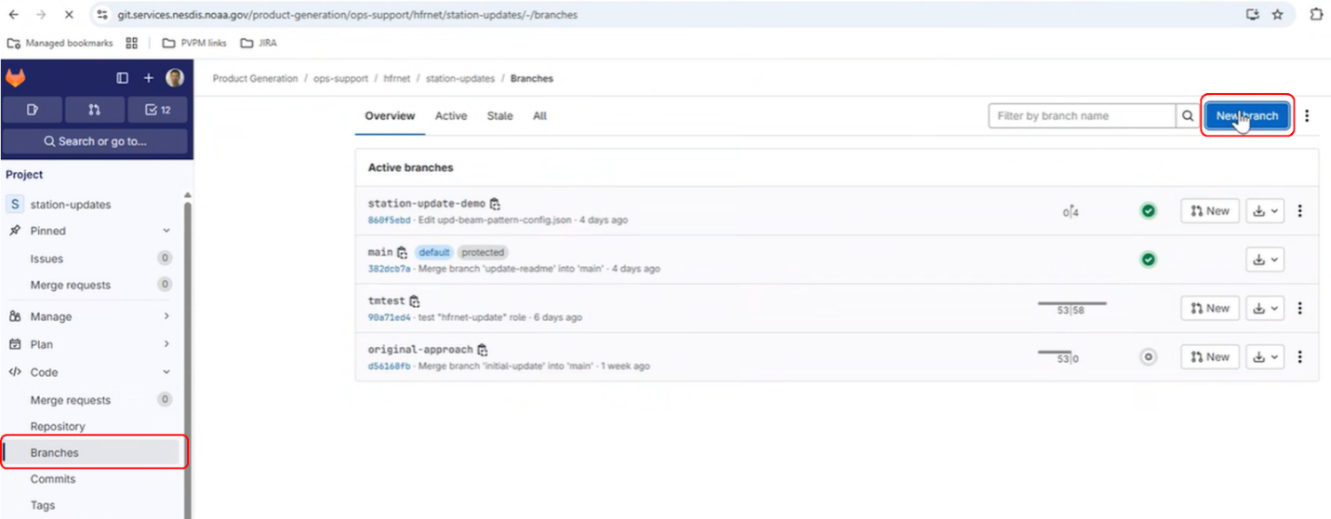
- In the New branches window, enter an appropriate branch name and create it from main and then click on the "Create branch" button.
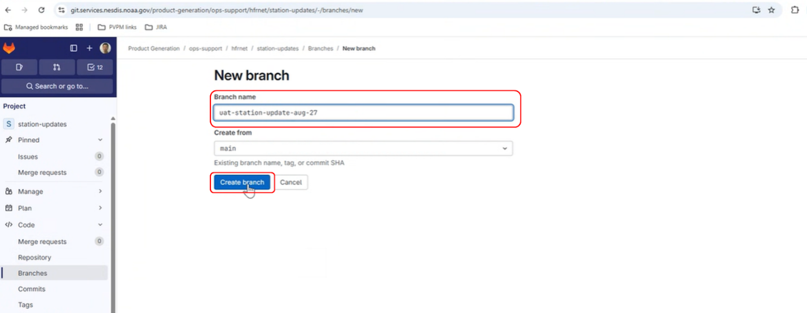
Note: You can run all the stored procedure job updates, one by one, in the same branch.

Step 2: Update Job Related Config (unless running query-stations)
Edit the appropriate config for the station update job you intend to run in the branch the jobs are going to run in.
- Under the "Code" dropdown, you can find the "Repository" tab. Click on that.
- Select the branch you just created from the branch pulldown and then click on the configs folder.
- Once in the configs folder, then select the appropriate job-specific config to edit.
- Once the job-specific config is shown, then select the "Edit single file" option of the "Edit" button.
- Make necessary changes and then "Commit changes" to the branch the job is going to be run in.
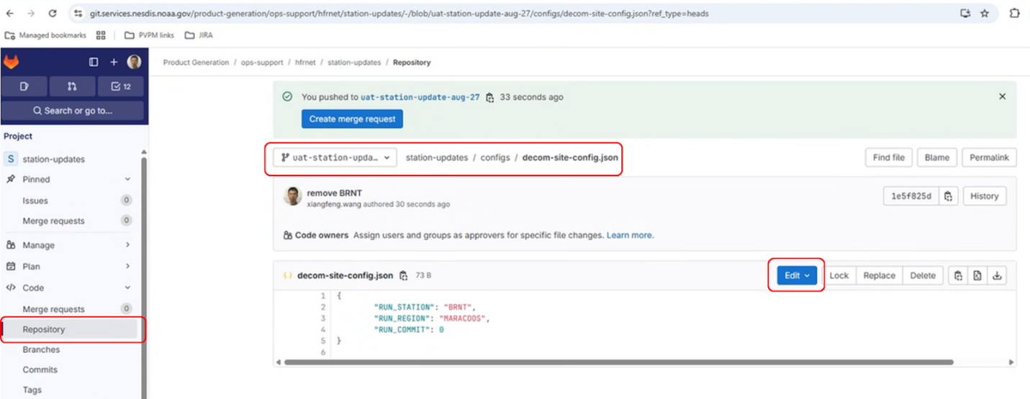
For the add-site-hfradar job, update the add-site-hfradar-config.json as shown below:
{
"RUN_STATION": "MIKE",
"RUN_STATION_FN": "MICHAEL",
"RUN_NETWORK": "ROYNET",
"RUN_NETWORK_FN": "ROYER NETWORK",
"RUN_REGION": "ROY REGION",
"RUN_COMMIT": 0
}

For the site-rtvproc job, update the add-site-rtvproc-config.json as shown below:
{
"RUN_STATION": "MIKE",
"RUN_NETWORK": "ROYNET",
"RUN_DOMAIN": "ushi",
"RUN_FREQUENCY_MHz": 45,
"RUN_BEAMPATTERN": "measured",
"RUN_RADIAL_MINUTE": 0,
"RUN_COMMIT": 0
}
For the upd-beam-pattern job, update the upd-beam-pattern-config.json as shown below:
{
"RUN_STATION": "LUIS",
"RUN_REGION": "SCCOOS",
"RUN_BEAMPATTERN": "ideal",
"RUN_DATETIME": "'2025-07-01 00:00:00'",
"RUN_COMMIT": 0
}
For the decom-site job, update the undecom-site-config.json as shown below:
{
"RUN_STATION": "HAUL",
"RUN_REGION": "SECOORA",
"RUN_COMMIT": 0
}

For the undecom-site-hfradar job, update the undecom-site-hfradar-config.json as shown below:
{
"RUN_STATION": "HAUL",
"RUN_NETWORK": "FAU",
"RUN_COMMIT": 0
}
For the undecom-site-rtvproc job, update the undecom-site-rtvproc-config.json as shown below:
{
"RUN_STATION": "LUIS",
"RUN_REGION": "SCCOOS",
"RUN_BEAMPATTERN": "ideal",
"RUN_DATETIME": "'2025-07-01 00:00:00'",
"RUN_COMMIT": 0
}

NOTE: FOR ALL JOBS, SET RUN_COMMIT to 0 THE FIRST TIME YOU RUN TO SEE HOW IT WOULD HAVE RUN. THEN, SET IT TO 1 WHEN READY TO OFFICIALLY UPDATE.

Step 3: Add New Pipeline Job
Add a new pipeline job for your specific stored procedure that you are running.
- Under the "Build" dropdown, select the "Pipelines" option.
- Select the "New pipeline" button in the top right corner.
- Select the branch you are running the job in.
- Select the appropriate account_id and job_type and then click on the "New pipeline" button.
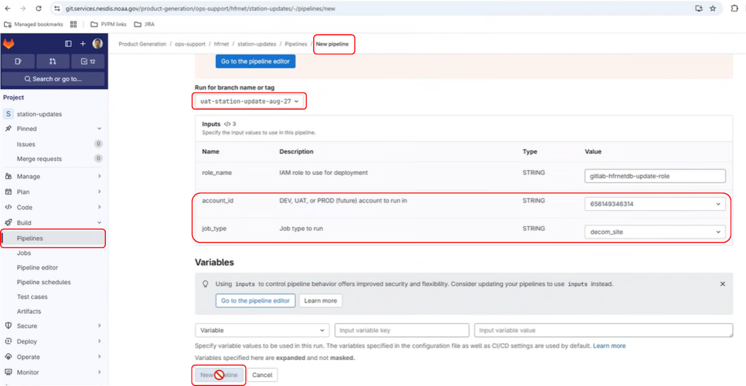

Step 4: Run Manual Job
Once the pipeline job is submitted, then manually trigger the stored procedure job.
- Option 1:
  - When you have created a new pipeline, it will show you the jobs in the pipeline. Your job should be there and you can click on it to run it.
- Option 2:
  - Under the "Build" dropdown, select the "Pipelines" option.
  - Select the pipeline related to your new pipeline submission. The pipeline name will be listed as job_type and account_id and will be shown as "Blocked" in the status. Click on that.
  - Click on the run button to run it.
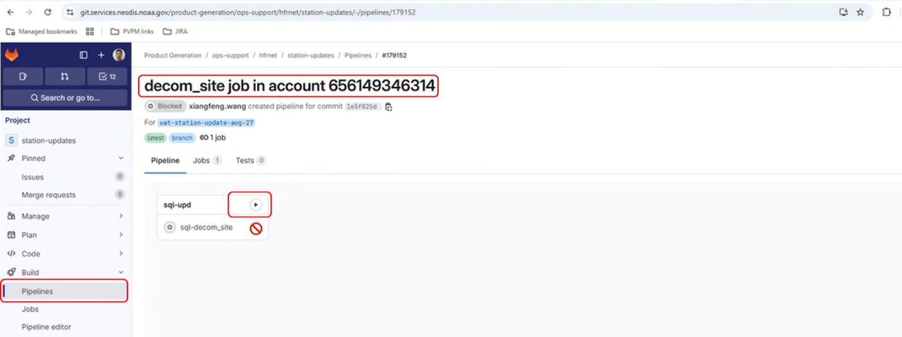

Step 5: Review Job Results
Once the job has finished running, then review the job results.
- In the pipeline window, the job status should show as passed or failed. Click on that.
- Look for your specific pipeline and, once found, click on the job.
- Scroll through the results of the job.
The following is an example of the job output for running the decom-site job for station "HAUL" in a rollback mode (i.e., simulate running job without updating).
$ mkdir -p dml_logs
$ mariadb -u hfrnetadmin -p$RDSPASSWORD -e "select name as 'station_name', id as 'station_id', network as 'network' from rtvproc.site where name='$RUN_STATION';"
station_name station_id network
HAUL 74 FAU
$ mariadb -u hfrnetadmin -p$RDSPASSWORD -e "select sta as 'station_name', site_id as 'station_id', network_id as 'network_id', decommissioned from hfradar.site where sta='$RUN_STATION' AND decommissioned = '0';"
station_name station_id network_id decommissioned
HAUL 251 47 0
$ mariadb -u hfrnetadmin -p$RDSPASSWORD -e "select n.network_id as 'network_id', n.net as 'network', n.regional_association as 'regional_association' from hfradar.site s left join hfradar.network n on s.network_id = n.network_id where s.sta='$RUN_STATION' and n.regional_association = '$RUN_REGION' and s.decommissioned = '0';"
network_id network regional_association
47 FAU SECOORA
$ mariadb -u hfrnetadmin -p$RDSPASSWORD -e "select s.name as 'station_name', s.id as 'station_id', sc.id as 'site_config_id', r.name as 'resolution', sc.start_time as 'start_time', sc.end_time as 'end_time', sc.beampattern as 'beampattern' from rtvproc.site s, rtvproc.site_config sc, rtvproc.resolution r where s.id = sc.site_id AND sc.resolution_id = r.id AND s.name = '$RUN_STATION' order by 4 ASC, 5 ASC"
station_name station_id site_config_id resolution start_time end_time beampattern
HAUL 74 5685 2km 2017-02-10 21:00:00 2018-12-07 16:00:00 measured
HAUL 74 5686 2km 2018-12-07 16:00:00 2018-12-08 02:00:00 ideal
HAUL 74 5687 2km 2018-12-08 02:00:00 2019-02-17 18:00:00 measured
HAUL 74 5688 2km 2019-02-17 18:00:00 2019-02-17 19:00:00 ideal
HAUL 74 5689 2km 2019-02-17 19:00:00 2019-07-23 16:00:00 measured
HAUL 74 5690 2km 2019-07-23 16:00:00 2019-07-23 17:00:00 ideal
HAUL 74 5691 2km 2019-07-23 17:00:00 2019-07-25 10:00:00 measured
HAUL 74 5692 2km 2019-07-25 10:00:00 2019-07-25 11:00:00 ideal
HAUL 74 5693 2km 2019-07-25 11:00:00 2022-08-29 23:00:00 measured
HAUL 74 31558 2km 2025-07-01 00:00:00 NULL measured
HAUL 74 11334 6km 2017-02-10 21:00:00 2018-12-07 16:00:00 measured
HAUL 74 11335 6km 2018-12-07 16:00:00 2018-12-08 02:00:00 ideal
HAUL 74 11336 6km 2018-12-08 02:00:00 2019-02-17 18:00:00 measured
HAUL 74 11337 6km 2019-02-17 18:00:00 2019-02-17 19:00:00 ideal
HAUL 74 11338 6km 2019-02-17 19:00:00 2019-07-23 16:00:00 measured
HAUL 74 11339 6km 2019-07-23 16:00:00 2019-07-23 17:00:00 ideal
HAUL 74 11340 6km 2019-07-23 17:00:00 2019-07-25 10:00:00 measured
HAUL 74 11341 6km 2019-07-25 10:00:00 2019-07-25 11:00:00 ideal
HAUL 74 11342 6km 2019-07-25 11:00:00 2022-08-29 23:00:00 measured
HAUL 74 31559 6km 2025-07-01 00:00:00 NULL measured
$ RUN_NET=$(echo $(mariadb -u hfrnetadmin -p$RDSPASSWORD -N -e "select n.net from hfradar.site s left join hfradar.network n on s.network_id = n.network_id where s.sta='$RUN_STATION' and n.regional_association = '$RUN_REGION' and s.decommissioned = '0';")) # collapsed multi-line command
Update hfradar.decom_site
Recreate hfradar.decom_site procedure
Update rtvproc.decom_site_config
Recreate rtvproc.decom_site_config procedure
$ cat dml_logs/decom_site_run.log
HFRADAR.SITE station HAUL on network FAU has site id 251
HFRADAR.SITE update not applied (rollback)
0
$ cat dml_logs/decom_site_config_run.log
RTVPROC.SITE station HAUL on network FAU has site id 74
RTVPROC.SITE_CONFIG update not applied (rollback)
RTVPROC.SITE_CONFIG 2 records would have been updated
0
Uploading artifacts for successful job
00:01
Uploading artifacts...
WARNING: .env: no matching files. Ensure that the artifact path is relative to the working directory (/builds/ssboxes/science_codes/nos/ioos/hfrnetdb)
ERROR: No files to upload
Cleaning up project directory and file based variables
00:01
Job succeeded

Follow the above steps for a smooth and successful outcome. Good luck!

5.3.6. Maintenance Utilities

Problem Diagnosis and Recovery

Quality Control Output
Due to the unique nature of the HFRNet algorithm package, the variables u and v within each NetCDF4 output file are used to assess the product quality. More information on these variables can be seen in Table 5-1.
Table 5-1 - HFRNet Quality Information
Attribute | Description
u | Surface eastward sea water velocity
v | Surface northward sea water velocity

Error Correction
See the master NCCF SMM: Error Correction – Warnings and Messages for Systems and Error Codes, Menus and Navigation (or Document Object: 43,44,45)

Problem Diagnosis and Recovery Procedures
See the master NCCF SMM: Problem Diagnosis and Recovery Procedures (or Document Object: 82).

Application Shutdown and Restart

5.5.1 Application Shutdown Procedures
See the master NCCF SMM: Program Recovery Procedures (or Document Object: 94).

5.5.2 Application Restart Procedures
See the master NCCF SMM: Application Shutdown Procedures (or Document Object: 92).

References

NCCF SMM
https://docs.google.com/document/d/1W2m4Mc0WXDc4AeqIbHDR-BiK1kPCE3ZCoSoBTJ7lsXg/edit?usp=sharing

HFRNet ORR:
https://docs.google.com/presentation/d/1JXXhZBWYZBDqfxZleAZcgoYxf82FNoSp/edit?slide=id.p1#slide=id.p1

Appendix

Acronyms
Table 7-1 - Acronyms
Acronym | Definition
ASSISTT | Algorithm Scientific Software Integration and System Transition Team
ATBD | Algorithm Theoretical Basis Document
CCAP | Cloud Containerized Algorithm Package
CI/CD | Continuous Integration and Continuous Development
CM | Configuration Management
DOC | Department of Commerce
ESPC | Environmental Satellite Processing Center
ERT | Earth Resources Technology, Inc.
EUM | External Users’ Manual
HFRNet | High Frequency Radar Network
IOOS | U.S. Integrated Ocean Observing System
NCCF | NESDIS Common Cloud Framework
NCEI | National Centers for Environmental Information
NESDIS | National Environmental Satellite, Data, and Information Service
NetCDF | Network Common Data Form
NOAA | National Oceanic and Atmospheric Administration
NOS | National Ocean Service
OCS | Office of Common Services
OSPO | Office of Satellite and Product Operations
PAL | Product Area Lead
PDA | Product Distribution and Access
QA | Quality Assurance
R2O | Research to Operations
RAD | Requirements Allocation Document
STAR | Center for Satellite Applications and Research
UCSD | University of California San Diego
V&V | Verification and Validation
VHF | Very High Frequency

