Encoding IOOS v0.6.0 Observations

Introduction

The DIF XML specification includes schema and data record definitions for six IOOS core variables (currents, temperature, salinity, water level, winds and waves) and a variety of
sampling feature types (points, profiles, trajectories, and collections or time series thereof). It consists of an Open Geospatial Consortium (OGC) Geography Markup Language (GML)
application schema (ioosTypes.xsd) that extends and specializes GML and Sensor Web Enablement (SWE) schema definitions, a profile (observationSpecializations.xsd) of the Observations and Measurements (O&M) schema, a collection of O&M sample observation XML documents, and an associated set of SWE sample XML record definition XML documents.

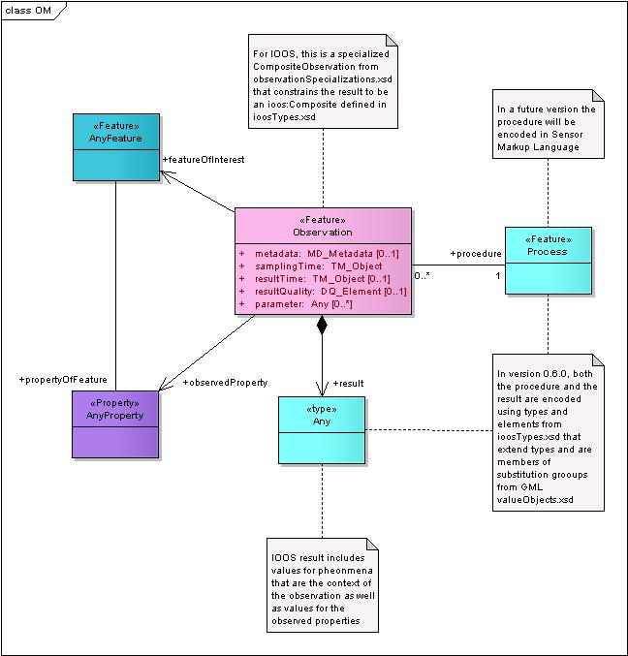
Figure 1
As shown in Figure 1 above, for IOOS an Observation is a CompositeObservation from observationSpecializations.xsd that constrains the result of the observation to be an ioos:Composite from ioosTypes.xsd. The result of an IOOS observation includes values for phenomena that are the context of the observation as well as values for the observed properties. In version 0.6.0, both the procedure that describes the observation process and the result of the observation are encoded using thes and elements from ioosTypes.xsd that extend types and are members of substitution groups from GML valueObjects.xsd.

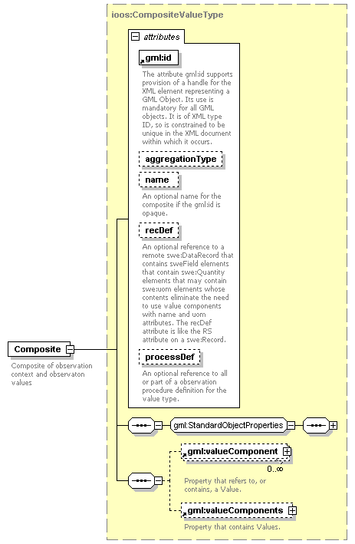
Figure 2
The ioos:Composite element shown in Figure 2 above is of type ioos:CompositeValueType, defined in ioosTypes.xsd, which extends gml:CompositeValueType from the GML valueObjects.xsd. It is intended to serve as a container for result values of both observation context Phenomena and the phenomena of interest. An ioos:CompositeContext element with the same type definition is intended to serve as a container only for observation context phenomena, or for observation procedure process definitions. An ioos:CompositeValue element with the same type definition is intended to serve as a container only for result values of the phenomena of interest. All of these elements contain gml:Value elements in either gml:valueComponent or gml:ValueComponents properties. The contained gml:Value elements may be of different type definitions, as described below.

A gml:id attribute is mandatory, as shown by its solid line rectangle border in Figure 2. The values of gml:id attributes must be unique within an XML document, because they are defined as XML ID types. The value of gml:id attributes should be made meaningful to concisely describe as well as identify XML elements unless there is an overriding policy for the use of opaque ID values. If opaque gml:id values are used, they should be supplemented with name attribute values. The ioos:Composite element that contains the result of an observation or the process definition for the observation procedure should also have a recDef attribute with a URL value referencing the SWE record definition for the ioos:Composite XML element and the elements it contains. If the ioos:Composite element that contains the result of an observation is not part of the om:CompositeObservation, but is a separate XML document, it should also have a processDef attribute with a URL value referencing the ioos:Composite element containing the definition of the observation procedure.

The ioos:Array element shown in Figure 3 below is of type ioos:ValueArrayType, defined in ioosTypes.xsd, which extends gml:ValueArrayType from the GML valueObjects.xsd. Its structural definition in XML schema is similar to that of ioos:CompositeValueType, with additional codeSpace and uom attributes. Its semantic use is constrained to containment of elements with the same type definitions, or those with derived type definitions in the base element substitution groups. It is intended to serve as a container for result values of both observation context Phenomena and the phenomena of interest. An ioos:ContextArray element with the same type definition is intended to serve as a container only for observation context phenomena, or for observation procedure process definitions. An ioos:ValueArray element with the same type definition is intended to serve as a container only for result values of the phenomena of interest.

In process or results encodings, the ioos:Array element must be preceeded by an ioos:Count element specifying the size of the array, as shown in the following example from the sample currentsPoint.xml.

<om:procedure>
<om:Process>
<ioos:CompositeContext gml:id="StationsSensors" recDef="http://www.csc.noaa.gov/ioos/schema/IOOS-DIF/IOOS/0.6.0/recordDefinitions/StationSensorRecordDefinition.xml">
<gml:valueComponents>
<ioos:Count name="NumberOfStations">1</ioos:Count>
<ioos:ContextArray gml:id="StationArray">
<gml:valueComponents>
<ioos:CompositeContext gml:id="StationInfo">

This count is referenced by the swe:Count elements in the record definition, so that a separate record definition documents with a “hard-coded” swe:Count for the array size does not have to be generated for each observation with an array containing a different number of elements. Here is the beginning of the sample StationSensorRecordDefinition.xml. The first swe:Count element in this record definition corresponds to the ioos:Count element in the extract from currentsPoint.xml above. The second swe:Cound element , contained in the swe:DataArray gml:id=”StationArrayRecord” refers to the first one by its gml:id to obtain the array size from the observation result.

<?xml version="1.0" encoding="UTF-8"?>
<swe:DataRecord
xmlns:xlink="http://www.w3.org/1999/xlink"
xmlns:gml="http://www.opengis.net/gml/3.2"
xmlns:swe="http://www.opengis.net/swe/1.0.2"
xmlns:ioos="http://www.noaa.gov/ioos/0.6.0"
xmlns:xsi="http://www.w3.org/2001/XMLSchema-instance"
xsi:schemaLocation="http://www.opengis.net/swe/1.0.2 ../../../OGC/sweCommon/1.0.2/swe.xsd"
gml:id="StationsSensorsDataRecord">
<swe:field name="NumberOfStations">
<swe:Count gml:id="NumberOfStations"/>
</swe:field>
<swe:field name="StationArray">
<swe:DataArray gml:id="StationArrayRecord">
<swe:elementCount ref="NumberOfStations"/>
<swe:elementType name="Station">

The gml:Value element is defined as a choice group of generic value types, including GML abstract geometries, abstract time objects, and a variety of composite and scalar value types. In ioosTypes.xsd, both specific and general scalar value types are defined for encoding procedure definition and result values. Specific elements were defined for commonly used values. The generic elements may be used for any other required information, as shown in the sample instance documents. Specific element definitions may be created in future versions of ioosTypes.xsd to replace widely used ones encoded using the generic elements.

The specific elements defined in v0.6.0 include:
- SensorId
- SensorModel
- SensorNumberOfBeams
- SamplingRate
- ReportingInterval
- VerticalDatum
- ProcessingLevel
- VerticalPosition

The generic elements include:

- Text
- Integer
- Count
- Quantity (real data type)
- Context (real data type)

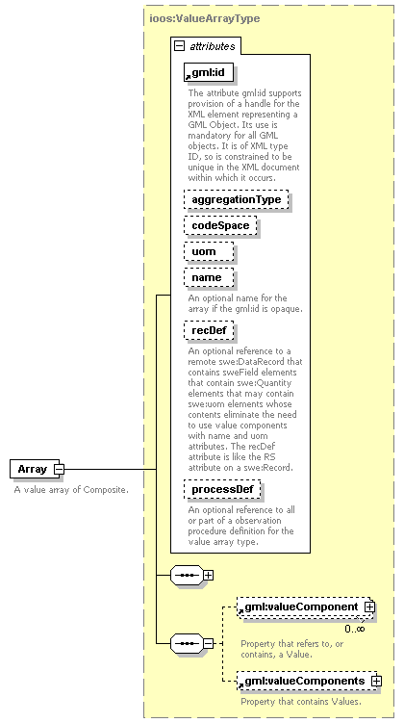
Figure 3

Not shown in Figure 1 are the SWE record definitions that describe the structure of both the procedure and result sections of the XML Observation instance documents. PlatformsSensorsStationsRecordDefinition.xml describes the structure used for the sample observation procedures for moving platforms like ships, drifters, airplanes, or balloons. StationSensorRecordDefinition.xml describes the structure used for the observation procedures of all of the other sample observation documents. The record structure definitions for the result values of the sample observations have names similar to those of the observation documents. For example, the structure of currentsPoint.xml is defined by CurrentsPointDataRecordDefinition.xml.

The observed property shown in Figure 1 is encoded in the sample instance documents as a reference to an entry in phenomenonDicitionary.xml, like this:

<om:observedProperty xlink:href="http://www.csc.noaa.gov/ioos/schema/IOOS-DIF/IOOS/0.6.0/dictionaries/phenomenaDictionary.xml#Currents">
<!-- A remote reference to phenomena dictionary entry that provides the semantics for the observed property. A new dictionary entry must be created if a relevant one does not exist. -->

The feature of interest shown in Figure 1 is encoded in a sample instant document either as an in-line GML feature as shown in currentsPoint.xml:

<!-- Feature Of Interest -->
<om:featureOfInterest>
<!-- the feature of interest may be provided in-line as follows or referenced via an XLink, e.g. to a WFS, as shown in other samples -->
<ioos:WaterBodyFeature gml:id="NarragansettBay">
<gml:name>NarragansettBay</gml:name>
<ioos:surface>
<gml:Polygon gml:id="NBPoly">
<!-- srsName is not specified, so the one from gml:Envelope above applies here by default -->
<gml:exterior>
<gml:Ring>
<gml:curveMember>
<!-- this is just a place-holder; gml:Curve or gml:LineString with coordintes goes here -->
</gml:curveMember>
</gml:Ring>
</gml:exterior>
</gml:Polygon>
</ioos:surface>
</ioos:WaterBodyFeature>
</om:featureOfInterest>

or as an xlink:href URL containing a request to a Web Feature Service (WFS) to return the feature of interest, as shown in the other example documents.

<om:featureOfInterest xlink:href="http://wfs.ioos.noaa.gov?request=getFeature&amp;featureid=NarragansettBay "/>
<!-- a notional WFS call identifying the object regarding which the observation was made -->

