МИНИСТЕРСТВО ОБРАЗОВАНИЯ РЕСПУБЛИКИ БЕЛАРУСЬ

УЧРЕЖДЕНИЕ ОБРАЗОВАНИЯ
«ГОМЕЛЬСКИЙ ГОСУДАРСТВЕННЫЙ ТЕХНИЧЕСКИЙ УНИВЕРСИТЕТ ИМЕНИ П. О. СУХОГО»

Факультет автоматизированных и информационных систем

Кафедра «Информатика»

дисциплина «Избранные главы информатики»
ОТЧЕТ ПО ЛАБОРАТОРНОЙ РАБОТЕ № 5
«Разработка интерфейса приложения баз данных
с использованием аутентификации и авторизации»
Вариант № 13

Выполнил:
студент группы ИП-31, Ореховский И.В.
Принял:
доцент Асенчик О.Д.

Гомель 2018
Цель работы: Получить навыки создания типовых web-приложений для работы с информацией из реляционных баз данных, ознакомиться со способами аутентификации и авторизации в ASP.NET MVC Сore.

Ход работы

Github: https://github.com/iorehovski/ChemistShop/tree/master/lab5

ЗАДАНИЕ:
Используя разработанное ранее создать интерфейс Web-приложения для работы с данными, хранящимися в базе данных, на основе ASP.NET Core MVC Framework и Entity Framework Core.
Web- приложение должно удовлетворять следующим требованиям:
- Любой пользователь для работы с приложением должен пройти аутентификацию.
- Поддерживать реализацию не менее двух ролевых политик для доступа к классам и (или) методам контроллеров.
- Управлять пользователями: просматривать, создавать, удалять и редактировать данные учетных записей.
- Осуществлять ввод, редактирование, добавление и просмотр данных не менее чем из трех таблиц реляционной базы согласно варианту.
- Вводимые и редактируемые данные должны проходить валидацию на стороне сервера и клиента.
- Осуществлять разбиение таблично представленных данных, выбранных их реляционного источника, на страницы, их фильтрацию и сортировку.
- Сохранять состояния элементов форм, используемых для фильтрации данных, и использовать их при повторном посещении соответствующей Web-страницы.
- Использовать не менее одного разработанного html- хэлпера и не менее одного Tag-хэлпера. Например, хэлперы для разбиения на страницы, сортировки, генерации табличных данных и др.
- Использовать не менее одного частичного представления (Partial View).
- Иметь единое стилевое оформление, основанное на использовании одной или нескольких мастер-страниц, и систему навигации (строка меню, гиперссылки, кнопки), которая обеспечивает оптимальный путь перехода между двумя произвольно выбранными страницами в соответствии с логикой приложения.

Решение:

Коды класса (классов) контроллеров:

Исходный код класса AccountController.cs:
using System;
using System.Collections.Generic;
using System.Linq;
using System.Threading.Tasks;
using Microsoft.AspNetCore.Mvc;
using Microsoft.AspNetCore.Identity;
using Microsoft.AspNetCore.Authorization;
using ChemistShopSite.Models;
using ChemistShopSite.ViewModels;
using System.Text;

namespace ChemistShopSite.Controllers
{
public class AccountController : Controller
{
private UserManager<User> _userManager;
private readonly SignInManager<User> _signInManager;
private readonly RoleManager<IdentityRole> _roleManager;
public AccountController(UserManager<User> userManager, SignInManager<User> signInManager, System.IServiceProvider serviceProvider, RoleManager<IdentityRole> roleManager)
{
_userManager = userManager;
_signInManager = signInManager;
_roleManager = roleManager;
}

public IActionResult Register()
{
return View();
}

public IActionResult Login()
{
return View();
}

[HttpPost]
[ValidateAntiForgeryToken]
[AllowAnonymous]
public async Task<IActionResult> Register(RegisterViewModel model)
{
if (ModelState.IsValid)
{
User user = new User { Email = model.Email, UserName = model.Login };
var result = await _userManager.CreateAsync(user, model.Password);
if (result.Succeeded)
{
await _userManager.AddToRoleAsync(user, "user");
await _signInManager.SignInAsync(user, true);
return RedirectToAction("Index", "Home");
}
else
{
foreach (var error in result.Errors)
{
ModelState.AddModelError(string.Empty, error.Description);
}
}
}
else
{
return View(model);
}
return View(model);

}
[HttpPost]
[ValidateAntiForgeryToken]
[AllowAnonymous]
public async Task<IActionResult> Login(LoginViewModel model)
{
if (ModelState.IsValid)
{
var result =
await _signInManager.PasswordSignInAsync(model.Login, model.Password, true, false);
if (result.Succeeded)
{
return RedirectToAction("Index", "Home");
}
}
else
{
return View(model);
}
return View(model);

}
public async Task<IActionResult> Logout()
{
// удаляем аутентификационные куки
await _signInManager.SignOutAsync();
return RedirectToAction("Index", "Home");
}
}
}

Исходный код класса ConsumptionController.cs:
using System;
using System.Collections.Generic;
using System.Diagnostics;
using Microsoft.AspNetCore.Mvc;
using ChemistShopSite.Models;
using System.Linq;
using System.Threading.Tasks;
using Microsoft.EntityFrameworkCore;
using Newtonsoft.Json;
using Microsoft.AspNetCore.Http;
using Microsoft.Extensions.Caching.Memory;
using ChemistShopSite.Filters;
using ChemistShopSite.ViewModels;

namespace ChemistShopSite.Controllers
{
[LogFilter]
[SessionFilter]
public class ConsumptionController : Controller
{
public enum SortState
{
NameInc,
NameDec,
DateInc,
DateDec,
CountInc,
CountDec,
CostInc,
CostDec
}
IMemoryCache _memoryCache;

public ConsumptionController(IMemoryCache memoryCache)
{
_memoryCache = memoryCache;
}
[ResponseCache(CacheProfileName = "Caching")]
public IActionResult Consumption(string MedicamentName, SortState conSortOrder, int page = 1)
{
int pageSize = 6;
string path = Request.Path.Value.ToLower();
Consumption conFromMemory = (Consumption)_memoryCache.Get(path);

if (HttpContext.Session.Get("conSession") != null)
{
Consumption conSession = JsonConvert.DeserializeObject<Consumption>(HttpContext.Session.GetString("conSession"));
ViewData["conSession"] = conSession;
}

if (HttpContext.Session.Get("conSortOrderSession") != null)
{
conSortOrder = JsonConvert.DeserializeObject<SortState>(HttpContext.Session.GetString("conSortOrderSession"));
}

using (MedicamentsContext db = new MedicamentsContext())
{
IQueryable<Consumption> consumptions = db.Consumptions.Include(x => x.Medicament);

if (!String.IsNullOrEmpty(MedicamentName))
{
consumptions = consumptions.Where(p => p.Medicament.MedicamentName.Contains(MedicamentName));
}

ViewData["NameSort"] = conSortOrder == SortState.NameInc ? SortState.NameDec : SortState.NameInc;
ViewData["DateSort"] = conSortOrder == SortState.DateInc ? SortState.DateDec : SortState.DateInc;
ViewData["CountSort"] = conSortOrder == SortState.CountInc ? SortState.CountDec : SortState.CountInc;
ViewData["CostSort"] = conSortOrder == SortState.CostInc ? SortState.CostDec : SortState.CostInc;

switch (conSortOrder)
{
case SortState.NameDec:
consumptions = consumptions.OrderByDescending(s => s.Medicament.MedicamentName);
break;
case SortState.DateInc:
consumptions = consumptions.OrderBy(s => s.RealisationDate);
break;
case SortState.DateDec:
consumptions = consumptions.OrderByDescending(s => s.RealisationDate);
break;
case SortState.CountInc:
consumptions = consumptions.OrderBy(s => s.Count);
break;
case SortState.CountDec:
consumptions = consumptions.OrderByDescending(s => s.Count);
break;
case SortState.CostInc:
consumptions = consumptions.OrderBy(s => s.RealisationCost);
break;
case SortState.CostDec:
consumptions = consumptions.OrderByDescending(s => s.RealisationCost);
break;
default:
consumptions = consumptions.OrderBy(s => s.Medicament.MedicamentName);
break;
}
int count = consumptions.Count();
consumptions = consumptions.Skip((page - 1) * pageSize).Take(pageSize);

PageViewModel pageViewModel = new PageViewModel(count, page, pageSize);
ConsumptionViewModel viewModel = new ConsumptionViewModel
{
PageViewModel = pageViewModel,
Consumptions = consumptions.ToList()
};

ViewData["consumptions"] = consumptions.ToList();
ViewData["medicaments"] = db.Medicaments.ToList();
ViewData["conFromMemory"] = conFromMemory;
return View(viewModel);
}
}

[HttpPost]
public IActionResult AddConsumption(Consumption consumption)
{
using (MedicamentsContext db = new MedicamentsContext())
{
db.Consumptions.Add(consumption);
db.SaveChanges();
}
return RedirectToAction("Consumption");
}

[HttpPost]
public async Task<ActionResult> Delete(string id)
{
using (MedicamentsContext db = new MedicamentsContext())
{
var cons = await db.Consumptions.FindAsync(Convert.ToInt32(id));

if (cons != null)
{

db.Consumptions.Remove(cons);
await db.SaveChangesAsync();
}
}

return RedirectToAction("Consumption");
}
public async Task<IActionResult> Edit(string id)
{
Consumption model;
using (MedicamentsContext db = new MedicamentsContext())
{
model = await db.Consumptions.FindAsync(Convert.ToInt32(id));
if (model == null)
{
return NotFound();
}
}
return View(model);
}

[HttpPost]
public async Task<IActionResult> Edit(Consumption model)
{
if (ModelState.IsValid)
{
using (MedicamentsContext db = new MedicamentsContext())
{
Consumption rec = await db.Consumptions.FindAsync(Convert.ToInt32(model.Id));
if (rec != null)
{
rec.RealisationDate = model.RealisationDate;
rec.Count = model.Count;
rec.RealisationCost = model.RealisationCost;

db.Consumptions.Update(rec);
await db.SaveChangesAsync();
}
}
}
return RedirectToAction("Consumption");
}
}
}

Исходный код класса HomeController.cs:
using System;
using System.Collections.Generic;
using System.Diagnostics;
using Microsoft.AspNetCore.Mvc;
using ChemistShopSite.Models;
using System.Linq;
using System.Threading.Tasks;
using Microsoft.EntityFrameworkCore;
using Newtonsoft.Json;
using Microsoft.AspNetCore.Http;
using Microsoft.Extensions.Caching.Memory;
using ChemistShopSite.Filters;
using ChemistShopSite.ViewModels;

namespace ChemistShopSite.Controllers
{
[LogFilter]
[SessionFilter]
public class HomeController : Controller
{
public enum SortState
{
NameInc,
NameDec,
ProducerInc,
ProducerDec,
StorageInc,
StorageDec
}

IMemoryCache _memoryCache;
List<String> storages = new List<String>(new string[] { "Минск-1", "Гомель-1", "Гродно-1", "Минск-2", "Гомель-2", "Гродно-2" });

public HomeController(IMemoryCache memoryCache)
{
_memoryCache = memoryCache;
}

[ResponseCache(CacheProfileName = "Caching")]
public IActionResult Index(string MedicamentName, SortState medSortOrder = SortState.NameInc, int page = 1)
{
int pageSize = 6;

string path = Request.Path.Value.ToLower();
Medicament medicamentFromMemoryCache = (Medicament)_memoryCache.Get(path);

ViewData["storages"] = storages;

if (HttpContext.Session.Get("medSession") != null)
{
Medicament medSession = JsonConvert.DeserializeObject<Medicament>(HttpContext.Session.GetString("medSession"));
ViewData["medSession"] = medSession;
}

if (HttpContext.Session.Get("medSortOrderSession") != null)
{
medSortOrder = JsonConvert.DeserializeObject<SortState>(HttpContext.Session.GetString("medSortOrderSession"));
}

using (MedicamentsContext db = new MedicamentsContext())
{
//PharmacyInitializer.Initialize(db);

IQueryable<Medicament> medicaments = db.Medicaments;

if (!String.IsNullOrEmpty(MedicamentName))
{
medicaments = medicaments.Where(p => p.MedicamentName.Contains(MedicamentName));
}

ViewData["NameSort"] = medSortOrder == SortState.NameInc ? SortState.NameDec : SortState.NameInc;
ViewData["ProducerSort"] = medSortOrder == SortState.ProducerInc ? SortState.ProducerDec : SortState.ProducerInc;
ViewData["StorageSort"] = medSortOrder == SortState.StorageInc ? SortState.StorageDec : SortState.StorageInc;

switch (medSortOrder)
{
case SortState.NameDec:
medicaments = medicaments.OrderByDescending(s => s.MedicamentName);
break;
case SortState.ProducerInc:
medicaments = medicaments.OrderBy(s => s.Manufacturer);
break;
case SortState.ProducerDec:
medicaments = medicaments.OrderByDescending(s => s.Manufacturer);
break;
case SortState.StorageInc:
medicaments = medicaments.OrderBy(s => s.Storage);
break;
case SortState.StorageDec:
medicaments = medicaments.OrderByDescending(s => s.Storage);
break;
default:
medicaments = medicaments.OrderBy(s => s.MedicamentName);
break;
}
int count = medicaments.Count();
medicaments = medicaments.Skip((page - 1) * pageSize).Take(pageSize);

PageViewModel pageViewModel = new PageViewModel(count, page, pageSize);
IndexViewModel viewModel = new IndexViewModel
{
PageViewModel = pageViewModel,
Medicaments = medicaments.ToList()
};

//ViewData["medicaments"] = medicaments.ToList();

ViewData["medFromMemory"] = medicamentFromMemoryCache;

return View(viewModel);
}

}

[HttpPost]
public IActionResult AddMedicament(Medicament medicament)
{
//CookieOptions cookie = new CookieOptions();
//cookie.Expires = DateTime.Now.AddMinutes(1);

//if(Request.Cookies["FormMedicament"] == null)
//{
// string value = JsonConvert.SerializeObject(medicament);
// //string value = medicament.MedicamentName + ';' + medicament.Manufacturer + ';' + medicament.Storage;
// Response.Cookies.Append("FormMedicament", value);
//}

using (MedicamentsContext db = new MedicamentsContext())
{
db.Medicaments.Add(medicament);
db.SaveChanges();
}
return RedirectToAction("Index");
}

[HttpPost]
public async Task<ActionResult> Delete(string id)
{
using (MedicamentsContext db = new MedicamentsContext())
{
var med = await db.Medicaments.FindAsync(Convert.ToInt32(id));

var consumptions = db.Consumptions.Where(c => c.MedicamentID == med.Id);
var receptions = db.Receptions.Where(c => c.MedicamentID == med.Id);

if (med != null)
{
foreach(Reception i in receptions)
{
db.Receptions.Remove(i);
}
foreach (Consumption i in consumptions)
{
db.Consumptions.Remove(i);
}

db.Medicaments.Remove(med);
await db.SaveChangesAsync();
}
}

return RedirectToAction("Index");
}

public async Task<IActionResult> Edit(string id)
{
Medicament model;
using (MedicamentsContext db = new MedicamentsContext())
{
model = await db.Medicaments.FindAsync(Convert.ToInt32(id));
if (model == null)
{
return NotFound();
}
}
ViewData["storages"] = storages;
return View(model);
}

[HttpPost]
public async Task<IActionResult> Edit(Medicament model)
{
if (ModelState.IsValid)
{
using (MedicamentsContext db = new MedicamentsContext())
{
Medicament med = await db.Medicaments.FindAsync(Convert.ToInt32(model.Id));
if(med != null)
{
med.MedicamentName = model.MedicamentName;
med.Manufacturer = model.Manufacturer;
med.Storage = model.Storage;

db.Medicaments.Update(med);
await db.SaveChangesAsync();
}
}
}
return RedirectToAction("Index");
}

[HttpGet]
public String GetCurrentDate()
{
return DateTime.Today.ToShortDateString();
}
public IActionResult Error()
{
return View(new ErrorViewModel { RequestId = Activity.Current?.Id ?? HttpContext.TraceIdentifier });
}
}
}

Исходный код класса ReceptionController.cs:
using System;
using System.Collections.Generic;
using System.Diagnostics;
using Microsoft.AspNetCore.Mvc;
using ChemistShopSite.Models;
using System.Linq;
using System.Threading.Tasks;
using Microsoft.EntityFrameworkCore;
using Newtonsoft.Json;
using Microsoft.AspNetCore.Http;
using Microsoft.Extensions.Caching.Memory;
using ChemistShopSite.Filters;
using ChemistShopSite.ViewModels;

namespace ChemistShopSite.Controllers
{
[LogFilter]
[SessionFilter]
public class ReceptionController : Controller
{
public enum SortState
{
NameInc,
NameDec,
DateInc,
DateDec,
CountInc,
CountDec,
CostInc,
CostDec
}
IMemoryCache _memoryCache;

public ReceptionController(IMemoryCache memoryCache)
{
_memoryCache = memoryCache;
}

public IActionResult Index() => RedirectToAction("/Reception");

[ResponseCache(CacheProfileName = "Caching")]
public IActionResult Reception(string MedicamentName, SortState recSortOrder, int page = 1)
{
int pageSize = 6;

string path = Request.Path.Value.ToLower();
Reception recFromMemoryCache = (Reception)_memoryCache.Get(path);

if (HttpContext.Session.Get("recSession") != null)
{
Reception recSession = JsonConvert.DeserializeObject<Reception>(HttpContext.Session.GetString("recSession"));
ViewData["recSession"] = recSession;
}

if (HttpContext.Session.Get("recSortOrderSession") != null)
{
recSortOrder = JsonConvert.DeserializeObject<SortState>(HttpContext.Session.GetString("recSortOrderSession"));
}

using (MedicamentsContext db = new MedicamentsContext())
{
IQueryable<Reception> receptions = db.Receptions.Include(x => x.Medicine);

if (!String.IsNullOrEmpty(MedicamentName))
{
receptions = receptions.Where(p => p.Medicine.MedicamentName.Contains(MedicamentName));
}

ViewData["NameSort"] = recSortOrder == SortState.NameInc ? SortState.NameDec : SortState.NameInc;
ViewData["DateSort"] = recSortOrder == SortState.DateInc ? SortState.DateDec : SortState.DateInc;
ViewData["CountSort"] = recSortOrder == SortState.CountInc ? SortState.CountDec : SortState.CountInc;
ViewData["CostSort"] = recSortOrder == SortState.CostInc ? SortState.CostDec : SortState.CostInc;

switch (recSortOrder)
{
case SortState.NameDec:
receptions = receptions.OrderByDescending(s => s.Medicine.MedicamentName);
break;
case SortState.DateInc:
receptions = receptions.OrderBy(s => s.ReceiptDate);
break;
case SortState.DateDec:
receptions = receptions.OrderByDescending(s => s.ReceiptDate);
break;
case SortState.CountInc:
receptions = receptions.OrderBy(s => s.Count);
break;
case SortState.CountDec:
receptions = receptions.OrderByDescending(s => s.Count);
break;
case SortState.CostInc:
receptions = receptions.OrderBy(s => s.OrderCost);
break;
case SortState.CostDec:
receptions = receptions.OrderByDescending(s => s.OrderCost);
break;
default:
receptions = receptions.OrderBy(s => s.Medicine.MedicamentName);
break;
}

int count = receptions.Count();
receptions = receptions.Skip((page - 1) * pageSize).Take(pageSize);

PageViewModel pageViewModel = new PageViewModel(count, page, pageSize);
ReceptionViewModel viewModel = new ReceptionViewModel
{
PageViewModel = pageViewModel,
Receptions = receptions.ToList()
};

//ViewData["receptions"] = receptions.ToList();
ViewData["medicaments"] = db.Medicaments.ToList();
ViewData["recFromMemory"] = recFromMemoryCache;
return View(viewModel);
}
}

[HttpPost]
public IActionResult AddReception(Reception reception)
{
using (MedicamentsContext db = new MedicamentsContext())
{
db.Receptions.Add(reception);
db.SaveChanges();
}

return RedirectToAction("Reception");
}

[HttpPost]
public async Task<ActionResult> Delete(string id)
{
using (MedicamentsContext db = new MedicamentsContext())
{
var rec = await db.Receptions.FindAsync(Convert.ToInt32(id));

if (rec != null)
{

db.Receptions.Remove(rec);
await db.SaveChangesAsync();
}
}

return RedirectToAction("Reception");
}

public async Task<IActionResult> Edit(string id)
{
Reception model;
using (MedicamentsContext db = new MedicamentsContext())
{
model = await db.Receptions.FindAsync(Convert.ToInt32(id));
if (model == null)
{
return NotFound();
}
}
return View(model);
}

[HttpPost]
public async Task<IActionResult> Edit(Reception model)
{
if (ModelState.IsValid)
{
using (MedicamentsContext db = new MedicamentsContext())
{
Reception rec = await db.Receptions.FindAsync(Convert.ToInt32(model.Id));
if (rec != null)
{
rec.ReceiptDate = model.ReceiptDate;
rec.Count = model.Count;
rec.OrderCost = model.OrderCost;

db.Receptions.Update(rec);
await db.SaveChangesAsync();
}
}
}
return RedirectToAction("Reception");
}
}
}

Исходный код класса RolesController.cs:
using System.Collections.Generic;
using System.Linq;
using System.Threading.Tasks;
using Microsoft.AspNetCore.Mvc;
using Microsoft.AspNetCore.Identity;
using Microsoft.AspNetCore.Identity.EntityFrameworkCore;
using ChemistShopSite.Models;
using ChemistShopSite.ViewModels;
using Microsoft.AspNetCore.Authorization;

namespace ChemistShopSite.Controllers
{
[Authorize(Roles = "admin")]
public class RolesController : Controller
{
RoleManager<IdentityRole> _roleManager;
UserManager<User> _userManager;
public RolesController(RoleManager<IdentityRole> roleManager, UserManager<User> userManager)
{
_roleManager = roleManager;
_userManager = userManager;
}
public IActionResult Index() => View(_roleManager.Roles.ToList());

public IActionResult Create() => View();
[HttpPost]
public async Task<IActionResult> Create(string name)
{
if (!string.IsNullOrEmpty(name))
{
IdentityResult result = await _roleManager.CreateAsync(new IdentityRole(name));
if (result.Succeeded)
{
return RedirectToAction("Index");
}
else
{
foreach (var error in result.Errors)
{
ModelState.AddModelError(string.Empty, error.Description);
}
}
}
return View(name);
}

[HttpPost]
public async Task<IActionResult> Delete(string id)
{
IdentityRole role = await _roleManager.FindByIdAsync(id);
if (role != null)
{
IdentityResult result = await _roleManager.DeleteAsync(role);
}
return RedirectToAction("Index");
}

public IActionResult UserList() => View(_userManager.Users.ToList());

public async Task<IActionResult> Edit(string userId)
{
// получаем пользователя
User user = await _userManager.FindByIdAsync(userId);
if (user != null)
{
// получем список ролей пользователя
var userRoles = await _userManager.GetRolesAsync(user);
var allRoles = _roleManager.Roles.ToList();
ChangeRoleViewModel model = new ChangeRoleViewModel
{
UserId = user.Id,
UserEmail = user.Email,
UserRoles = userRoles,
AllRoles = allRoles
};
return View(model);
}

return NotFound();
}
[HttpPost]
public async Task<IActionResult> Edit(string userId, List<string> roles)
{
// получаем пользователя
User user = await _userManager.FindByIdAsync(userId);
if (user != null)
{
// получем список ролей пользователя
var userRoles = await _userManager.GetRolesAsync(user);
// получаем все роли
var allRoles = _roleManager.Roles.ToList();
// получаем список ролей, которые были добавлены
var addedRoles = roles.Except(userRoles);
// получаем роли, которые были удалены
var removedRoles = userRoles.Except(roles);

await _userManager.AddToRolesAsync(user, addedRoles);

await _userManager.RemoveFromRolesAsync(user, removedRoles);

return RedirectToAction("UserList");
}

return NotFound();
}
}
}

Исходный код класса UsersController.cs:
using System.Linq;
using System.Threading.Tasks;
using Microsoft.AspNetCore.Mvc;
using Microsoft.AspNetCore.Identity;
using ChemistShopSite.Models;
using ChemistShopSite.ViewModels;
using Microsoft.AspNetCore.Authorization;

namespace ChemistShopSite.Controllers
{
[Authorize(Roles = "admin")]
public class UsersController : Controller
{
UserManager<User> _userManager;
RoleManager<IdentityRole> _roleManager;
public UsersController(UserManager<User> userManager, RoleManager<IdentityRole> roleManager)
{
_userManager = userManager;
_roleManager = roleManager;
}

public IActionResult Index() => Redirect("/Users/UsersView");

public IActionResult UsersView() => View(_userManager.Users.ToList());

public IActionResult Create() => View();

[HttpPost]
public async Task<IActionResult> Create(RegisterViewModel model)
{
if (ModelState.IsValid)
{
User user = new User { Email = model.Email, UserName = model.Login };
var result = await _userManager.CreateAsync(user, model.Password);

if (result.Succeeded)
{
await _userManager.AddToRoleAsync(user, "user");
return RedirectToAction("Index");
}
else
{
foreach (var error in result.Errors)
{
ModelState.AddModelError(string.Empty, error.Description);
}
}
}
return View(model);
}

public async Task<IActionResult> Edit(string id)
{
User user = await _userManager.FindByIdAsync(id);
if (user == null)
{
return NotFound();
}
EditUserViewModel model = new EditUserViewModel { Id = user.Id, Email = user.Email, Login = user.UserName };
return View(model);
}

[HttpPost]
public async Task<IActionResult> Edit(EditUserViewModel model)
{
if (ModelState.IsValid)
{
User user = await _userManager.FindByIdAsync(model.Id);
if (user != null)
{
user.Email = model.Email;
user.UserName = model.Login;

var result = await _userManager.UpdateAsync(user);
if (result.Succeeded)
{
return RedirectToAction("Index");
}
else
{
foreach (var error in result.Errors)
{
ModelState.AddModelError(string.Empty, error.Description);
}
}
}
}
return View(model);
}

[HttpPost]
public async Task<ActionResult> Delete(string id)
{
User user = await _userManager.FindByIdAsync(id);
if (user != null)
{
IdentityResult result = await _userManager.DeleteAsync(user);
}
return RedirectToAction("Index");
}
}
}

Коды классов разработанных хэлперов:

Исходный код класса TableHelper.cs:
using Microsoft.AspNetCore.Html;
using Microsoft.AspNetCore.Mvc.Rendering;
using ChemistShopSite.Models;
using System.Collections.Generic;
using System;
using System.Linq;

namespace ChemistShopSite.Helpers
{
public static class TableHelper
{
public static HtmlString CreateMedicamentsList(this IHtmlHelper html, IEnumerable<Medicament> medicaments)
{
string result = "";
foreach (Medicament item in medicaments)
{
result += "<tr>";
result += $"<td>{item.MedicamentName}</td>";
result += $"<td>{item.Manufacturer}</td>";
result += $"<td>{item.Storage}</td>";
result += $"<td class=\"act\"><form asp-action=\"Delete\" asp-route-id=\""+ item.Id +"\" method=\"post\"><a class=\"btn btn-sm btn-primary\" asp-action=\"Edit\" asp-route-id=\"" + item.Id + "\">Изменить</a><button type = \"submit\" class=\"btn btn-sm btn-danger\">Удалить</button></form></td>";
result += "</tr>";
}
return new HtmlString(result);
}
}
}

Исходный код класса TempTagHelper.cs:
using System;
using System.Collections.Generic;
using System.Linq;
using System.Threading.Tasks;

using Microsoft.AspNetCore.Razor.TagHelpers;

namespace ChemistShopSite.TagHelpers
{
public class TempTagHelper : TagHelper
{
public override void Process(TagHelperContext context, TagHelperOutput output)
{
output.TagName = "button";
output.Attributes.SetAttribute("id", "getTime");
output.Content.SetContent("get request");
}
}
}

Исходные коды представлений:

Исходный код представления Login.cshtml:
@model ChemistShopSite.ViewModels.LoginViewModel
@{
ViewData["Title"] = "Login";
Layout = "~/Views/Shared/_Layout.cshtml";
}

@using (Html.BeginForm("Login", "Account", FormMethod.Post))
{
<div asp-validation-summary="ModelOnly"></div>
<div>
<label asp-for="Login"></label>
<input asp-for="Login" />
<span asp-validation-for="Login"></span>
</div>
<div>
<label asp-for="Password"></label>
<input asp-for="Password" />
<span asp-validation-for="Password"></span>
</div>
<div>
<input type="submit" class="btn btn-toolbar" value="Register" />
</div>
}
Исходный код представления Register.cshtml:
@model ChemistShopSite.ViewModels.RegisterViewModel
@{
ViewData["Title"] = "Register";
Layout = "~/Views/Shared/_Layout.cshtml";
}

@using (Html.BeginForm("Register", "Account", FormMethod.Post))
{
<div asp-validation-summary="ModelOnly"></div>
<div>
<label asp-for="Email"></label>
<input asp-for="Email" />
<span asp-validation-for="Email"></span>
</div>
<div>
<label asp-for="Login"></label>
<input asp-for="Login" />
<span asp-validation-for="Login"></span>
</div>
<div>
<label asp-for="Password"></label>
<input asp-for="Password" />
<span asp-validation-for="Password"></span>
</div>
<div>
<label asp-for="PasswordConfirm"></label>
<input asp-for="PasswordConfirm" />
<span asp-validation-for="PasswordConfirm"></span>
</div>
<div>
<input type="submit" value="Register" />
</div>
}

Исходный код представления Consumption.cshtml:
@{
ViewData["Title"] = "Consumption";
}

@using ChemistShopSite.ViewModels

@model ConsumptionViewModel

<img src="~/images/apteka.jpg" />
<h1>Consumptions</h1>

@using (Html.BeginForm("Consumption", "Consumption", FormMethod.Get))
{
<p>
<label>Medicament Name</label>
@Html.TextBox("MedicamentName")
<input type="submit" value="Filter" />
</p>
}

<table>
<thead>
<tr>
<th>
<a asp-action="Consumption" asp-route-conSortOrder="@ViewBag.NameSort">
Medicament Name
</a>
</th>
<th>
<a asp-action="Consumption" asp-route-conSortOrder="@ViewBag.DateSort">
Realisation Date
</a>
</th>
<th>
<a asp-action="Consumption" asp-route-conSortOrder="@ViewBag.CountSort">
Count
</a>
</th>
<th>
<a asp-action="Consumption" asp-route-conSortOrder="@ViewBag.CostSort">
Realization Cost
</a>
</th>
<th class="act">
<span>Action</span>
</th>
</tr>
</thead>
<tbody>
@{
List<Consumption> consumptions = (List<Consumption>)ViewData["consumptions"];
foreach (var item in Model.Consumptions)//consumptions)
{
List<Medicament> medicaments = (List<Medicament>)ViewData["medicaments"];
string tmp = "";
foreach (var med in medicaments)
{
if (item.MedicamentID == med.Id)
{
tmp = med.MedicamentName;
}
}

<tr>
<td>@tmp</td>
<td>@item.RealisationDate</td>
<td>@item.Count</td>
<td>@item.RealisationCost</td>
<td class="act">
<form asp-action="Delete" asp-route-id="@item.Id" method="post">
<a class="btn btn-sm btn-primary" asp-action="Edit" asp-route-id="@item.Id">Изменить</a>
<button type="submit" class="btn btn-sm btn-danger">
Удалить
</button>
</form>
</td>
</tr>
}
}
</tbody>
</table>

@if (Model.PageViewModel.HasPreviousPage)
{
<a asp-action="Consumption"
asp-route-page="@(Model.PageViewModel.PageNumber - 1)"
class="btn btn-default btn">
<i class="glyphicon glyphicon-chevron-left"></i>
Назад
</a>
}

@if (Model.PageViewModel.HasNextPage)
{
<a asp-action="Consumption"
asp-route-page="@(Model.PageViewModel.PageNumber + 1)"
class="btn btn-default btn">
Вперед
<i class="glyphicon glyphicon-chevron-right"></i>
</a>
}

@using (Html.BeginForm("AddConsumption", "Consumption", FormMethod.Post))
{
<p>
<label>Medicament</label>
<select name="MedicamentID">
{
@{
Consumption conSession = (Consumption)ViewData["conSession"];
List<Medicament> medicaments = (List<Medicament>)ViewData["medicaments"];
foreach (var item in medicaments)
{
if (conSession != null && conSession.MedicamentID == item.Id)
{
<option selected value=@item.Id>@item.MedicamentName</option>
}
else
{
<option value=@item.Id>@item.MedicamentName</option>
}
}
}
}
</select>
</p>

<p>
<label>RealisationDate</label>
@{
if (conSession != null)
{
DateTime tmp = Convert.ToDateTime(conSession.RealisationDate);
string n = tmp.ToString("yyyy-MM-dd");
<input type="date" name="RealisationDate" value=@n />
}
else
{
<input type="date" name="RealisationDate" />
}
}

</p>

<p>
<label>Count</label>
@{
if (conSession != null)
{
@Html.TextBox("Count", conSession.Count)
}
else
{
@Html.TextBox("Count")
}
}
</p>

<p>
<label>Realisation Cost</label>
@{
if (conSession != null)
{
@Html.TextBox("RealisationCost", conSession.RealisationCost)
}
else
{
@Html.TextBox("RealisationCost")
}
}
</p>

<p>
<input type="submit" value="Send" />
</p>
}

Исходный код представления /Consumption/Edit.cshtml:
@model ChemistShopSite.Models.Consumption
@{
ViewData["Title"] = "Edit Consumption";
}

@using (Html.BeginForm("Edit", "Consumption", FormMethod.Post))
{
<div asp-validation-summary="ModelOnly"></div>
<div class="form-group">
<input type="hidden" asp-for="Id" />
</div>
<div class="form-group">
<label asp-for="RealisationDate" class="control-label">Realisation Date</label>
@{
DateTime tmp = Convert.ToDateTime(Model.RealisationDate);
string n = tmp.ToString("yyyy-MM-dd");
}
<input type="date" asp-for="RealisationDate" class="form-control" value="@n"/>
</div>
<div class="form-group">
<label asp-for="Count" class="control-label">Count</label>
<input type="text" asp-for="Count" class="form-control" />
</div>
<div class="form-group">
<label asp-for="RealisationCost" class="control-label">Realisation Cost</label>
<input type="text" asp-for="RealisationCost" class="form-control" />
</div>
<div class="form-group">
<input type="submit" value="Save" class="btn btn-success" />
</div>
}
Исходный код представления /Home/Edit.cshtml:
@model ChemistShopSite.Models.Medicament

@{
ViewData["Title"] = "Edit medicament";
}

<h2>Edit</h2>

@using (Html.BeginForm("Edit", "Home", FormMethod.Post))
{
<div asp-validation-summary="ModelOnly"></div>
<div class="form-group">
<input type="hidden" asp-for="Id" />
</div>
<div class="form-group">
<label asp-for="MedicamentName" class="control-label">Medicament Name</label>
<input type="text" asp-for="MedicamentName" class="form-control" />
</div>
<div class="form-group">
<label asp-for="Manufacturer" class="control-label">Manufacturer</label>
<input type="text" asp-for="Manufacturer" class="form-control" />
</div>
<div class="form-group">
<select name="Storage">
{
@{
List<String> list = (List<String>)ViewData["storages"];
foreach (var item in list)
{
if(Model.Storage == item)
{
<option value=@item selected>@item</option>
}
else
{
<option value=@item>@item</option>
}
}
}
}
</select>
</div>
<div class="form-group">
<input type="submit" value="Save" class="btn btn-success" />
</div>
}

Исходный код представления /Home/Index.cshtml:
@{
ViewData["Title"] = "Chemist shop";
Layout = "~/Views/Shared/_Layout.cshtml";
}
@using Microsoft.AspNetCore.Identity
@using ChemistShopSite.ViewModels
@using ChemistShopSite.Helpers
@using ChemistShopSite.TagHelpers

@model IndexViewModel

@inject SignInManager<ChemistShopSite.Models.User> SignInManager
@inject UserManager<ChemistShopSite.Models.User> UserManager

@addTagHelper *, Microsoft.AspNetCore.Mvc.TagHelpers
@addTagHelper "*, ChemistShopSite"

<img src="~/images/apteka.jpg" />
@*<h1>Medicaments</h1>*@
@{Html.RenderPartial("GetMessage");}

@using (Html.BeginForm("Index", "Home", FormMethod.Get))
{
<p>
<label>Medicament Name</label>
@Html.TextBox("MedicamentName")
<input type="submit" value="Filter" />
</p>
}

<table>
<thead>
<tr>
<th>
<a asp-action="Index" asp-route-medSortOrder="@ViewData["NameSort"]">
Name
</a>
@* <HeadCell asp-route-medSortOrder="@ViewData["NameSort"]">Name</HeadCell>*@
</th>
<th>
<a asp-action="Index" asp-route-medSortOrder="@ViewData["ProducerSort"]">
Producer
</a>
</th>
<th>
<a asp-action="Index" asp-route-medSortOrder="@ViewData["StorageSort"]">
Storage
</a>
</th>
<th class="act">
<span>Action</span>
</th>
</tr>
</thead>
<tbody>

@TableHelper.CreateMedicamentsList(Html, Model.Medicaments)

@*@{
//List<Medicament> medicaments = (List<Medicament>)ViewData["medicaments"];
foreach (var item in Model.Medicaments)//medicaments)
{
<tr>
<td>@item.MedicamentName</td>
<td>@item.Manufacturer</td>
<td>@item.Storage</td>
<td class="act">
<form asp-action="Delete" asp-route-id="@item.Id" method="post">
<a class="btn btn-sm btn-primary" asp-action="Edit" asp-route-id="@item.Id">Изменить</a>
<button type="submit" class="btn btn-sm btn-danger">
Удалить
</button>
</form>
</td>
</tr>
}
}*@
</tbody>
</table>

@if (Model.PageViewModel.HasPreviousPage)
{
<a asp-action="Index"
asp-route-page="@(Model.PageViewModel.PageNumber - 1)"
class="btn btn-default btn">
<i class="glyphicon glyphicon-chevron-left"></i>
Назад
</a>
}

@if (Model.PageViewModel.HasNextPage)
{
<a asp-action="Index"
asp-route-page="@(Model.PageViewModel.PageNumber + 1)"
class="btn btn-default btn">
Вперед
<i class="glyphicon glyphicon-chevron-right"></i>
</a>
}

@*<button id="getTime">get request</button>*@
<temp></temp>

<script src="~/lib/jquery/dist/jquery.js"></script>
<script>
$("#getTime").on("click", function () {
$.ajax({
url: "Home/GetCurrentDate",
type: "GET",
dataType: 'text',
success: function (date) {
alert("today is: " + date)
}
});
});
</script>

@if (SignInManager.IsSignedIn(User))
{
@using (Html.BeginForm("AddMedicament", "Home", FormMethod.Post))
{
<div asp-validation-summary="ModelOnly"></div>
<p>
<label asp-for="medicament.MedicamentName">Name</label>
@{
Medicament medSession = (Medicament)ViewData["medSession"];
if (medSession != null)
{
@*@Html.TextBox("MedicamentName", medSession.MedicamentName);*@
<input asp-for="medicament.MedicamentName" value="@medSession.MedicamentName" />
}
else
{
<input asp-for="medicament.MedicamentName" />
}
}
<span asp-validation-for="medicament.MedicamentName"></span>
@*@Html.EditorFor(x => x.MedicamentName, "1212s3")*@

</p>
<p>
<label asp-for="medicament.Manufacturer">Producer</label>
@*@Html.EditorFor(x => x.Manufacturer)*@
@{
if (medSession != null)
{
<input asp-for="medicament.Manufacturer" value="@medSession.Manufacturer" />
@*@Html.TextBox("Manufacturer", medSession.Manufacturer);*@
}
else
{
<input asp-for="medicament.Manufacturer" />
@*@Html.TextBox("Manufacturer");*@
}
}
<span asp-validation-for="medicament.Manufacturer"></span>

</p>
<p>
<label asp-for="medicament.Storage">Storage</label>
<select asp-for="medicament.Storage">
{
@{
List<String> list = (List<String>)ViewData["storages"];
foreach (var item in list)
{
if (medSession != null && medSession.Storage == item)
{
<option asp-for="medicament.Storage" value=@item selected>@item</option>
}
else
{
<option asp-for="medicament.Storage" value=@item>@item</option>
}
}
}
}
</select>
</p>
<p>
<input type="submit" value="Add" />
</p>
}
}

Исходный код представления /Reception/Edit.cshtml:
@model ChemistShopSite.Models.Reception

@{
ViewData["Title"] = "Edit Reception";
}

@using (Html.BeginForm("Edit", "Reception", FormMethod.Post))
{
<div asp-validation-summary="ModelOnly"></div>
<div class="form-group">
<input type="hidden" asp-for="Id" />
</div>
<div class="form-group">
<label asp-for="ReceiptDate" class="control-label">Receipt Data</label>
@{
DateTime tmp = Convert.ToDateTime(Model.ReceiptDate);
string n = tmp.ToString("yyyy-MM-dd");
}
<input type="date" asp-for="ReceiptDate" class="form-control" value="@n" />
</div>
<div class="form-group">
<label asp-for="Count" class="control-label">Count</label>
<input type="text" asp-for="Count" class="form-control" />
</div>
<div class="form-group">
<label asp-for="OrderCost" class="control-label">Order Cost</label>
<input type="text" asp-for="OrderCost" class="form-control" />
</div>
<div class="form-group">
<input type="submit" value="Save" class="btn btn-success" />
</div>
}
Исходный код представления Reception.cshtml:
@{
ViewData["Title"] = "Reception";
}

@using ChemistShopSite.ViewModels

@model ReceptionViewModel

<img src="~/images/apteka.jpg" />
<h1>Receptions</h1>

@using (Html.BeginForm("Reception", "Reception", FormMethod.Get))
{
<p>
<label>Medicament Name</label>
@Html.TextBox("MedicamentName")
<input type="submit" value="Filter" />
</p>
}

<table>
<thead>
<tr>
<th>
<a asp-action="Reception" asp-route-recSortOrder="@ViewBag.NameSort">
Medicament Name
</a>
</th>
<th>
<a asp-action="Reception" asp-route-recSortOrder="@ViewBag.DateSort">
Receipt Date
</a>
</th>
<th>
<a asp-action="Reception" asp-route-recSortOrder="@ViewBag.CountSort">
Count
</a>
</th>
<th>
<a asp-action="Reception" asp-route-recSortOrder="@ViewBag.CostSort">
Order Cost
</a>
</th>
<th class="act">
<span>Action</span>
</th>
</tr>
</thead>
<tbody>
@{
//List<Reception> receptions = (List<Reception>)ViewData["receptions"];
foreach (var item in Model.Receptions) //receptions)
{
List<Medicament> medicaments = (List<Medicament>)ViewData["medicaments"];
string tmp = "";
foreach (var med in medicaments)
{
if (item.MedicamentID == med.Id)
{
tmp = med.MedicamentName;
}
}

<tr>
<td>@tmp</td>
<td>@Convert.ToDateTime(item.ReceiptDate).ToLongDateString()</td>
<td>@item.Count</td>
<td>@item.OrderCost</td>
<td class="act">
<form asp-action="Delete" asp-route-id="@item.Id" method="post">
<a class="btn btn-sm btn-primary" asp-action="Edit" asp-route-id="@item.Id">Изменить</a>
<button type="submit" class="btn btn-sm btn-danger">
Удалить
</button>
</form>
</td>
</tr>
}
}
</tbody>
</table>

@if (Model.PageViewModel.HasPreviousPage)
{
<a asp-action="Reception"
asp-route-page="@(Model.PageViewModel.PageNumber - 1)"
class="btn btn-default btn">
<i class="glyphicon glyphicon-chevron-left"></i>
Назад
</a>
}

@if (Model.PageViewModel.HasNextPage)
{
<a asp-action="Reception"
asp-route-page="@(Model.PageViewModel.PageNumber + 1)"
class="btn btn-default btn">
Вперед
<i class="glyphicon glyphicon-chevron-right"></i>
</a>
}

@{
ChemistShopSite.Models.Reception recSession = (ChemistShopSite.Models.Reception)ViewData["recSession"];
}

@using (Html.BeginForm("AddReception", "Reception", FormMethod.Post))
{
<p>
<label>Medicament</label>
<select name="MedicamentID">
{
@{
List<Medicament> medicaments = (List<Medicament>)ViewData["medicaments"];
foreach (var item in medicaments)
{
if (recSession != null && recSession.MedicamentID == item.Id)
{
<option selected value=@item.Id>@item.MedicamentName</option>
}
else
{
<option value=@item.Id>@item.MedicamentName</option>
}
}
}
}
</select>
</p>

<p>
<label>Receipt Date</label>
@{
if (recSession != null)
{
DateTime tmp = Convert.ToDateTime(recSession.ReceiptDate);
string n = tmp.ToString("yyyy-MM-dd");
<input type="date" name="ReceiptDate" value=@n />
}
else
{
<input type="date" name="ReceiptDate" />
}
}

</p>

<p>
<label>Count</label>
@{
if (recSession != null)
{
@Html.TextBox("Count", recSession.Count)
}
else
{
@Html.TextBox("Count")
}
}

</p>

<p>
<label>Order cost</label>
@{
if (recSession != null)
{
@Html.TextBox("OrderCost", recSession.OrderCost)
}
else
{
@Html.TextBox("OrderCost")
}
}

</p>

<p>
<input type="submit" value="Send" />
</p>
}

Исходный код представления /Roles/Create.cshtml:
@model string
@{
ViewData["Title"] = "Create";
}

<div asp-validation-summary="All" class="text-danger"></div>

<form asp-action="Create" method="post">
<div class="form-group">
<label for="name">New role</label>
<input name="name" class="form-control" />
</div>
<button type="submit" class="btn btn-primary">Add</button>
</form>
Исходный код представления /Roles/Edit.cshtml:
@using Microsoft.AspNetCore.Identity
@model ChemistShopSite.ViewModels.ChangeRoleViewModel
@{
ViewData["Title"] = "Edit";
}

<h2>Change role for user @Model.UserEmail</h2>

<form asp-action="Edit" method="post">
<input type="hidden" name="userId" value="@Model.UserId" />
<div class="form-group">
@foreach (IdentityRole role in Model.AllRoles)
{
<input type="checkbox" name="roles" value="@role.Name"
@(Model.UserRoles.Contains(role.Name) ? "checked=\"checked\"" : "") />@role.Name <br />
}
</div>
<button type="submit" class="btn btn-primary">Сохранить</button>
</form>
Исходный код представления /Roles/Index.cshtml:
@model IEnumerable<Microsoft.AspNetCore.Identity.IdentityRole>

@{
ViewData["Title"] = "Index";
}

<h2>Roles</h2>

<table class="table">
@foreach (var role in Model)
{
<tr>
<td>@role.Name</td>
<td>
<form asp-action="Delete" asp-route-id="@role.Id" method="post">
<button type="submit" class="btn btn-sm btn-danger">
Удалить
</button>
</form>
</td>
</tr>
}
</table>
<a class="btn btn-info" asp-action="Create">Add role</a>
<a class="btn btn-info" asp-action="UserList">User list</a>
Исходный код представления /Roles/UserList.cshtml:
@model IEnumerable<ChemistShopSite.Models.User>

@{
ViewData["Title"] = "UserList";
}

<h2>Users List</h2>

<table class="table">
@foreach (var user in Model)
{
<tr>
<td>@user.Email</td>
<td >
<a class="btn btn-sm btn-primary" asp-action="Edit" asp-route-userid="@user.Id">Права доступа</a>
</td>
</tr>
}
</table>
Исходный код представления /Users/Create.cshtml:
@model ChemistShopSite.ViewModels.RegisterViewModel

@{
ViewData["Title"] = "Create new User";
}

<h2>Create new User</h2>
@using (Html.BeginForm("Create", "Users", FormMethod.Post))
{
<div asp-validation-summary="ModelOnly"></div>
<div>
<label asp-for="Email"></label>
<input asp-for="Email" />
<span asp-validation-for="Email"></span>
</div>
<div>
<label asp-for="Login"></label>
<input asp-for="Login" />
<span asp-validation-for="Login"></span>
</div>
<div>
<label asp-for="Password"></label>
<input asp-for="Password" />
<span asp-validation-for="Password"></span>
</div>
<div>
<label asp-for="PasswordConfirm"></label>
<input asp-for="PasswordConfirm" />
<span asp-validation-for="PasswordConfirm"></span>
</div>
<div>
<input type="submit" class="btn btn-success" value="Register" />
</div>
}
Исходный код представления /Users/Edit.cshtml:
@model ChemistShopSite.ViewModels.EditUserViewModel
@{
ViewData["Title"] = "Edit user";
}

@using (Html.BeginForm("Edit", "Users", FormMethod.Post))
{
<div asp-validation-summary="ModelOnly"></div>
<div class="form-group">
<input type="hidden" asp-for="Id" />
</div>
<div class="form-group">
<label asp-for="Email" class="control-label">Email</label>
<input type="text" asp-for="Email" class="form-control" />
</div>
<div class="form-group">
<label asp-for="Login" class="control-label">Login</label>
<input type="text" asp-for="Login" class="form-control" />
</div>
<div class="form-group">
<input type="submit" value="Save" class="btn btn-success" />
</div>
}
Исходный код представления /Users/UserView.cshtml:
@model IEnumerable<ChemistShopSite.Models.User>
@{
ViewBag.Title = "Users list";
}

<h2>Users</h2>
<a id="createUser" asp-action="Create" class="btn btn-info">Create new user</a>

<table class="table">
<tr>
<th>Email</th>
<th>Login</th>
<th class="act">Action</th>
</tr>
@foreach (var user in Model)
{
<tr>
<td>@user.Email</td>
<td>@user.UserName</td>
<td class="act">
<form asp-action="Delete" asp-route-id="@user.Id" method="post">
<a class="btn btn-sm btn-primary" asp-action="Edit" asp-route-id="@user.Id">Изменить</a>
<button type="submit" class="btn btn-sm btn-danger">
Удалить
</button>
</form>
</td>
</tr>
}
</table>

Исходный код частичного представления /Home /GetMessage.cshtml:
<h1>Medicaments</h1>

Копии экранов браузера, демонстрирующие отображение представлений:
Представление Login.cshtml:
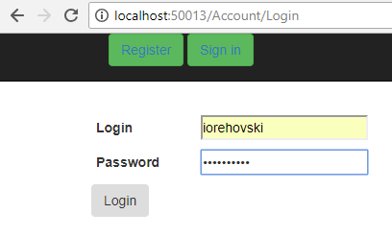
Представление Register.cshtml:
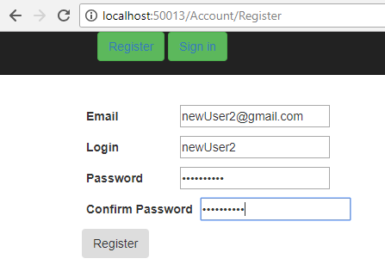
Представление Consumption.cshtml:
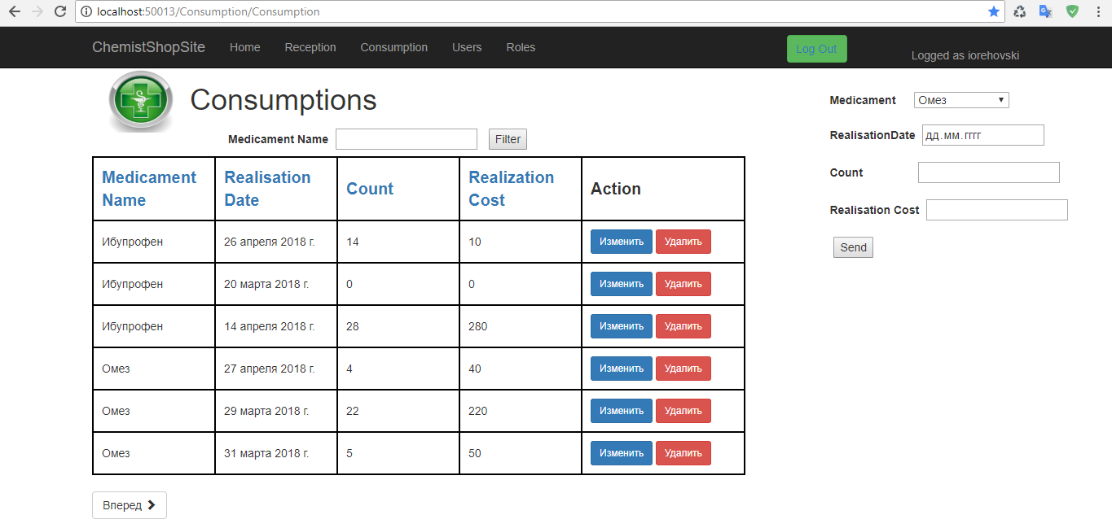

Представление /Consumption/Edit.cshtml:
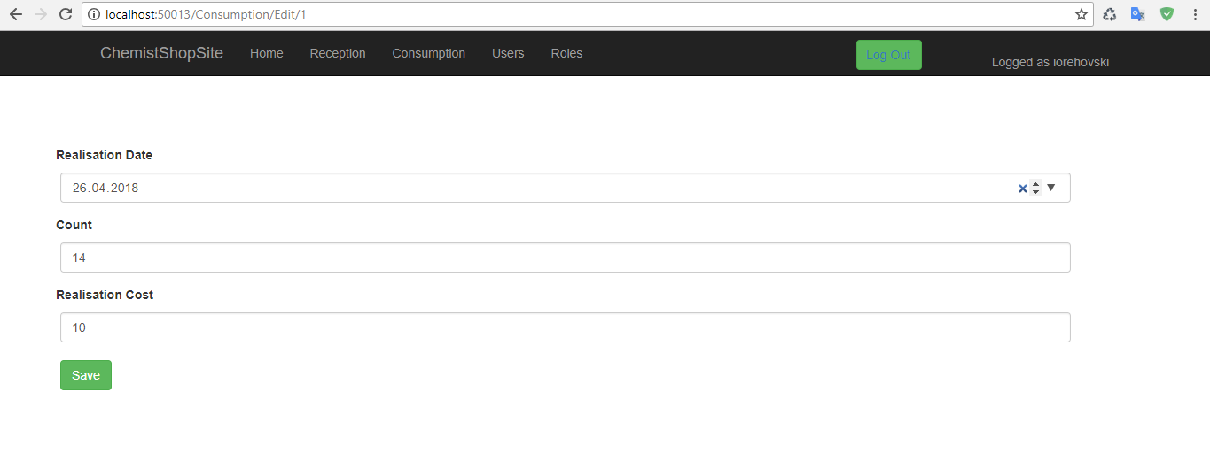
Представление /Home/Edit.cshtml:
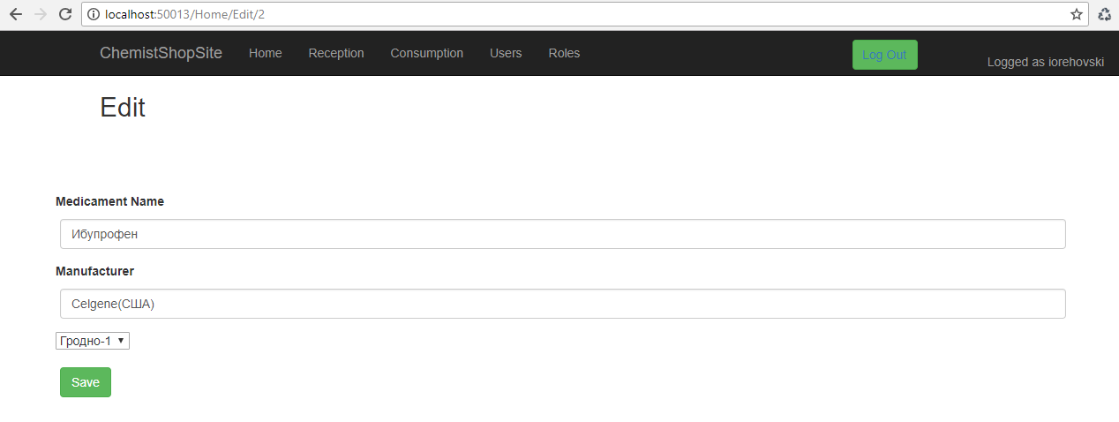
Представление /Home/Index.cshtml:
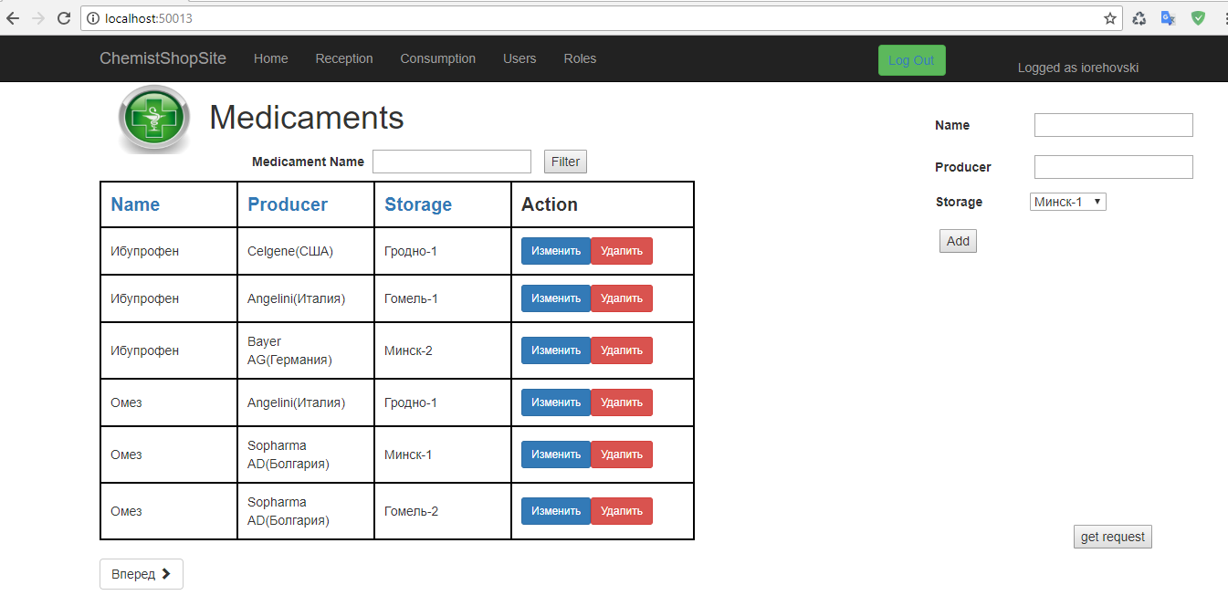

Представление /Reception/Edit.cshtml:
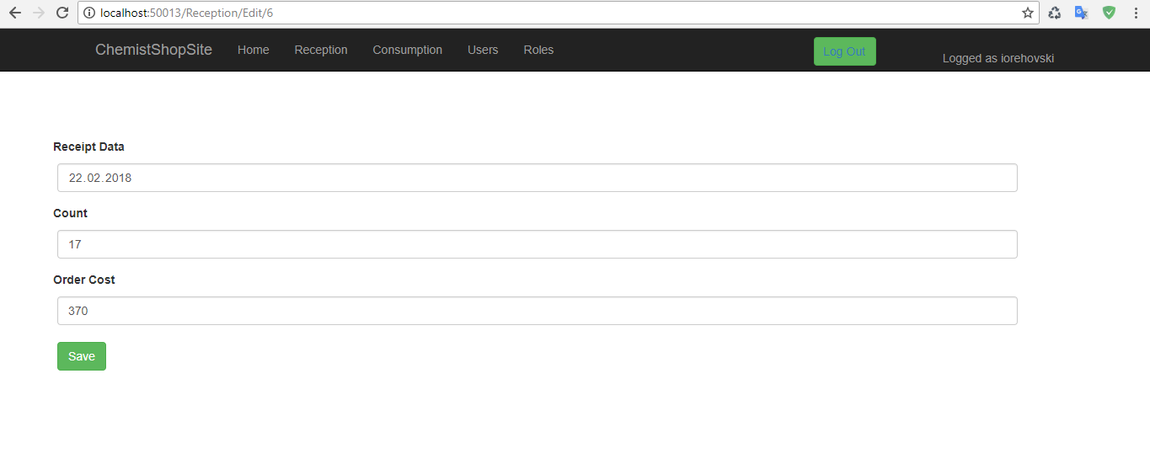
Представление /Reception/Reception.cshtml:
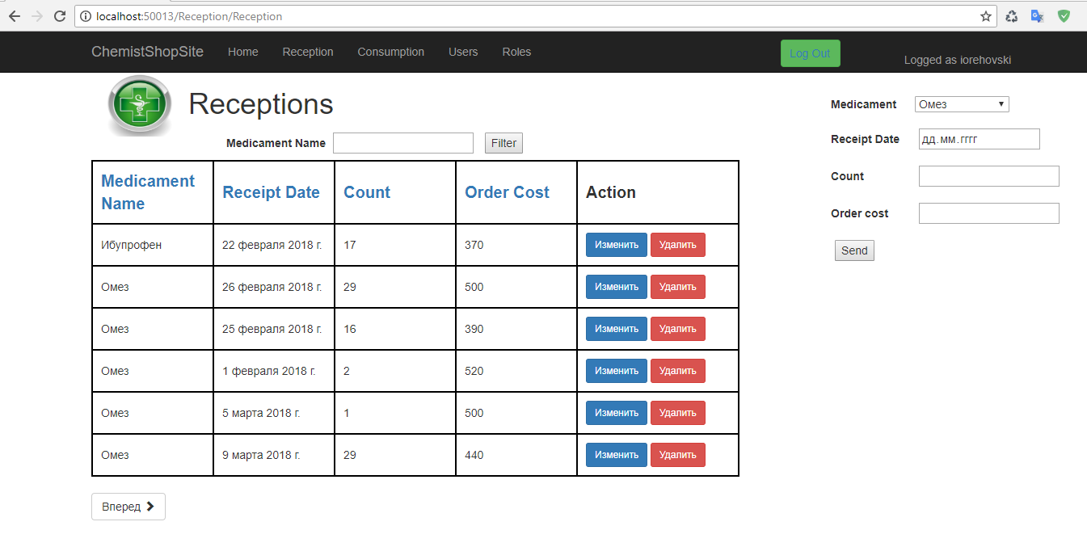
Представление /Roles/Create.cshtml:
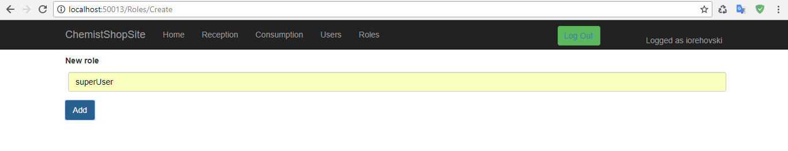
Представление /Roles/Edit.cshtml:
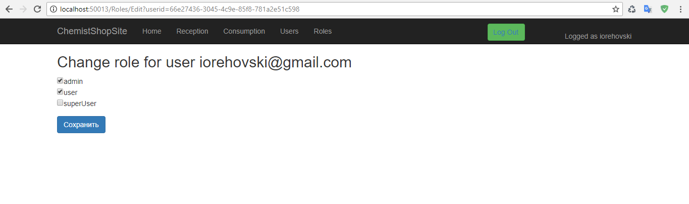
Представление /Roles/Index.cshtml:
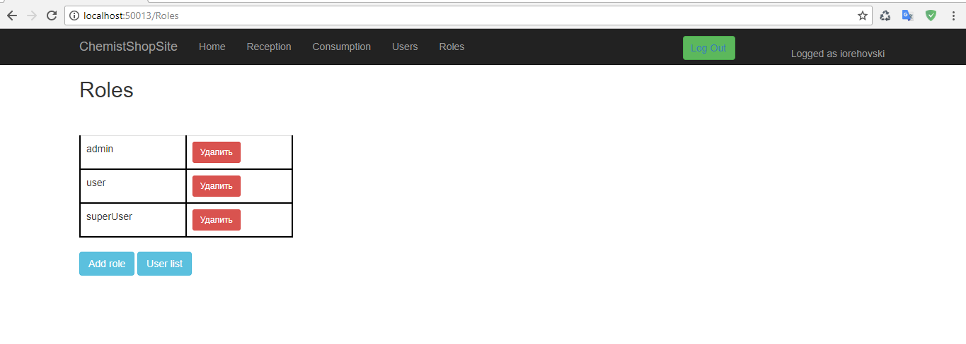
Представление /Roles/UserList.cshtml:
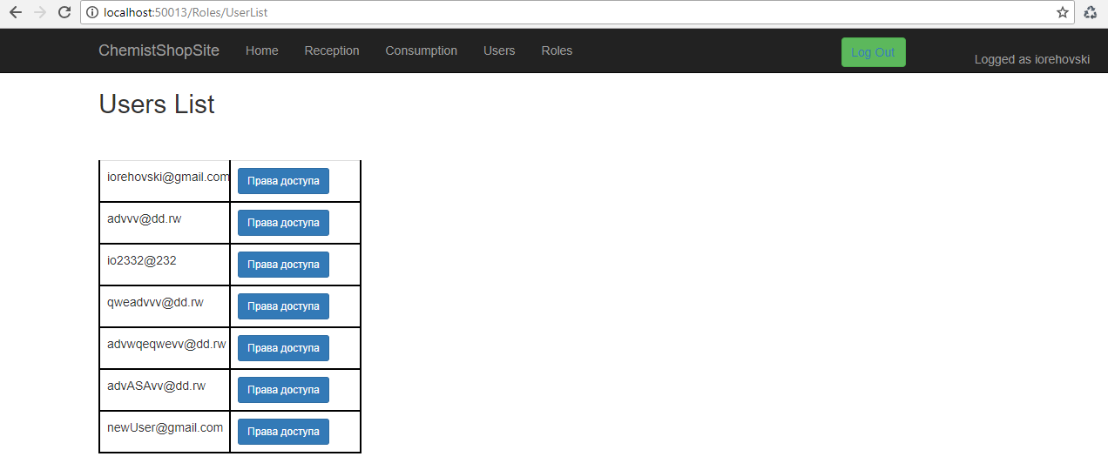
Представление /Users/Create.cshtml:
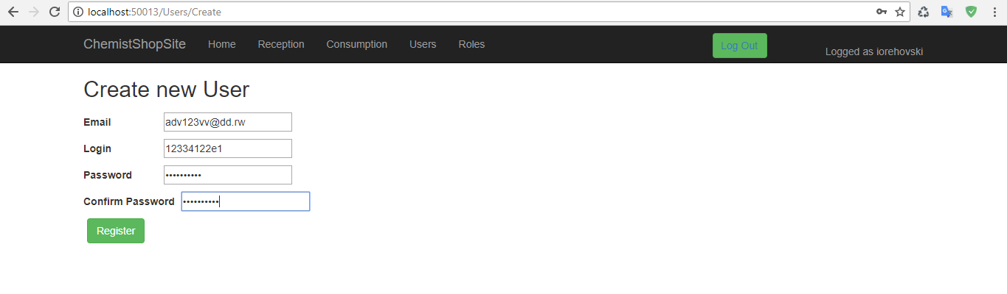
Представление /Users/Edit.cshtml:
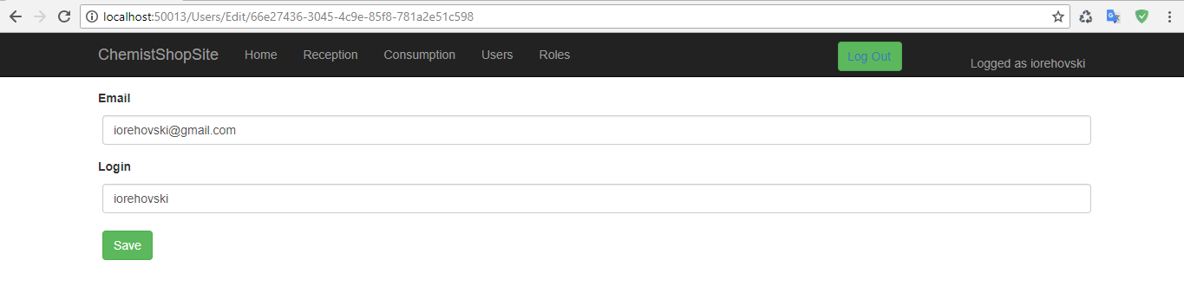
Представление /Users/UsersView.cshtml:
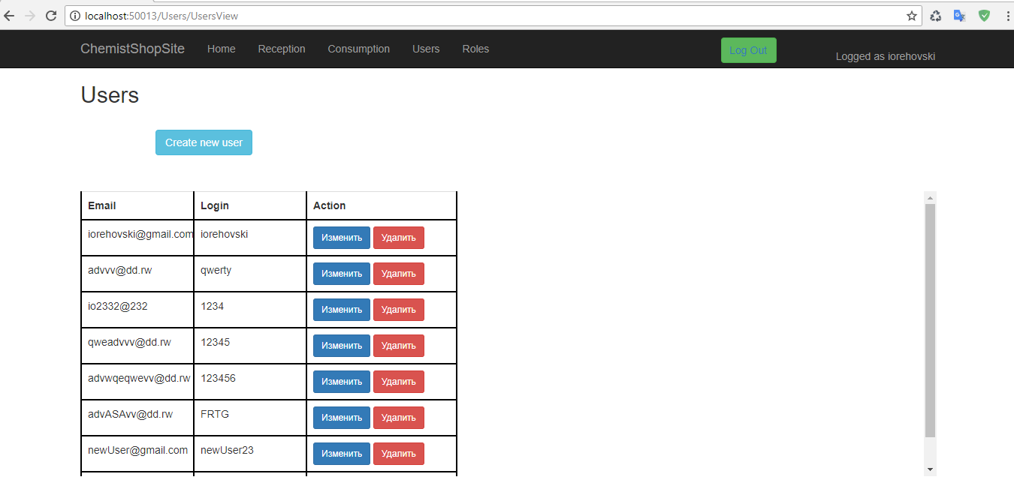

Копии экранов браузера, демонстрирующие отображение не прошедших валидацию данных:
Валидация данных при регистрации:
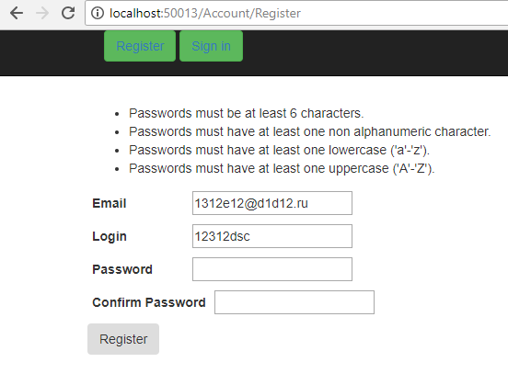

Валидация данных при входе:
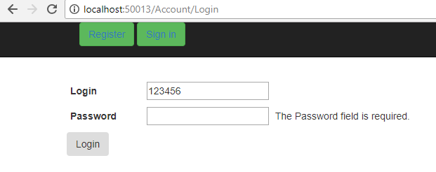

Вывод: Получил навыки создания типовых web-приложений для работы с информацией из реляционных баз данных, ознакомился со способами аутентификации и авторизации в ASP.NET MVC Сore. Ознакомися с администрированием пользователей в asp.net.

