1) Create (or find image on Google) an image 1536x1536 using [pixlr.com](http://pixlr.com/) and save as icon.pxd (keeps layers) & icon.png. Make sure image has background color.

2) Go here: [http://makeappicon.com](http://makeappicon.com/)

3) Upload icon.png

4) Follow instructions to have icons sent to your email

5) Download and extract .zip file emailed to you

* For icons use folder: **AppIcon.appiconset**
* For launch screen and other places use: **iTunesArtwork@3x.png**

6) From XCODE project

- Click on Project Name in Navigator

- Click on **App Icons Source** (see below)

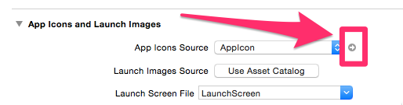

7) Drag and Drop **AppIcon.appiconset**folder into App Icon source (see below)

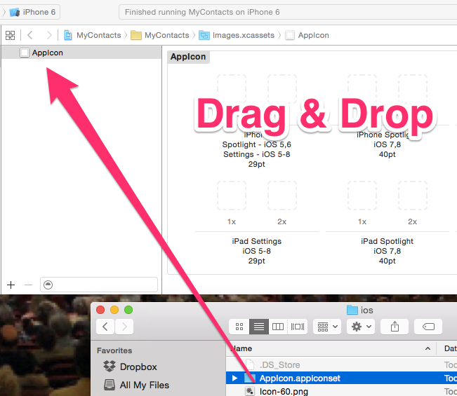

8) Select New Icon Source.

- Click on Project Name in Navigator

- Change **App Icon Source** (see below) to **AppIcon-1**

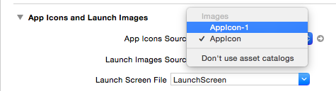

9) Compile (CMD + R)

10) From Simulator Click **Hardware > Home**(see below) to see new icon!

