MYFAVS

1. File > New Project > Master-Detail Application > Next
2. Fill out Options (Put in YourName in place of mine in Organization Name) > Next

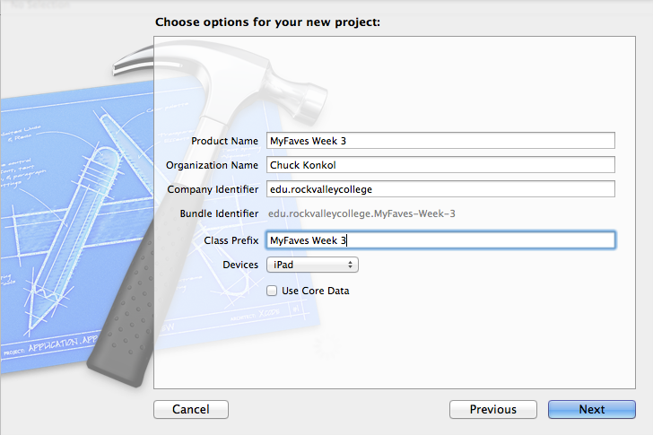

1. Find place to save > Create
2. Uncheck “Upside Down” under Deployment Info
3. Click on Main.StoryBoard under project navigator on left side
4. Rename “Master” and “Detail”
   1. Master ViewController > Rename to “MyFaves”

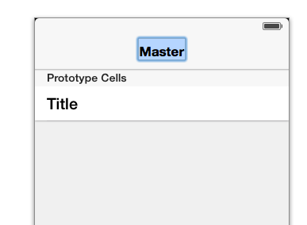

* 1. Detail View Controller > Rename to “MyFaves Detail”

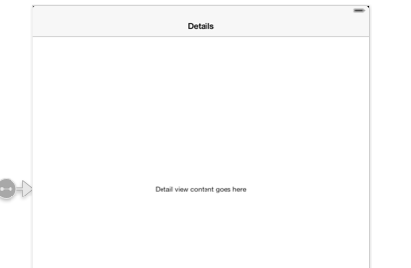

1. Add UIWebView to MyFaves_Week_3DetailViewController
   1. Drag and drop UIWebView onto ViewController and resize to fit.
   2. Control + Drag UIWebView to .h
   3. Name “WebSite”
2. Click on and Edit “MyFaves_Week_3DetailViewController.m”
   1. 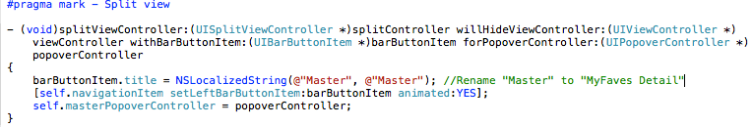
   2. 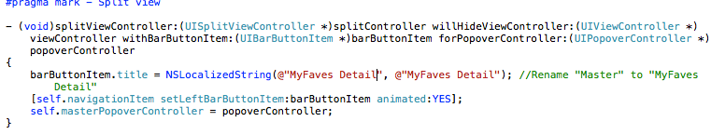
3. Click on and Edit “MyFaves_Week_3MasterViewController.h”
   1. Declare Arrays for Menu and Websites
   2. 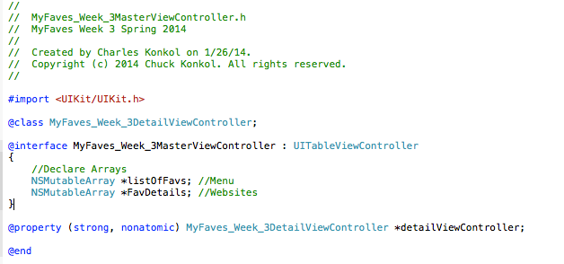
4. Click on and Edit “"MyFaves_Week_3MasterViewController.h"
   1. find and edit ViewDidLoad
   2. 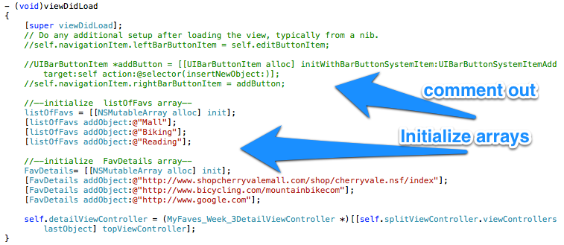
   3. find and edit function

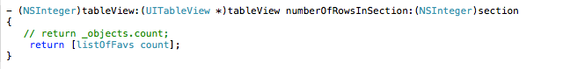

* 1. find and edit function

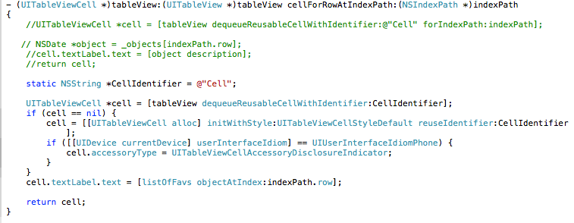

* 1. find and edit function

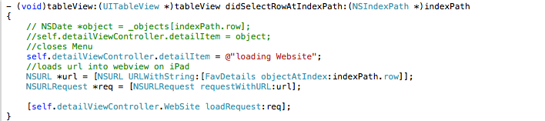

1. Done now run app