My Movie App – In Class Exercise

This app shows how to load local movies into your app. You will find 1 of your favorite movie trailers, download the movie and embed in app to play. The app will have a main title screen with options to launch the movie. The app will only run in landscape mode.

1. Start new storyboard iPhone single view app named “MyMovies”

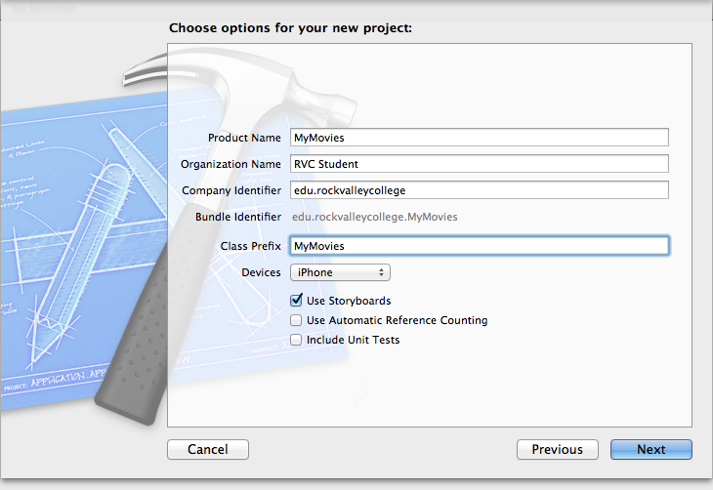

1. Change supported interface to Landscape

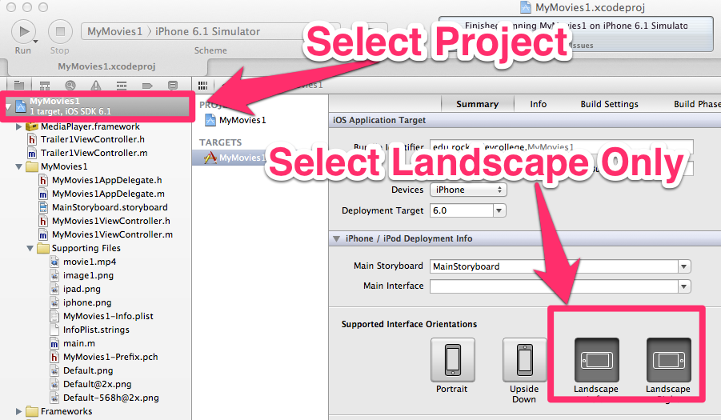

1. Add label with “**My Movie**” title along top of main view
2. Download 3 movies from youtube.com and save as .mp4 files (Use FireFox addon to download youtube videos)  
   <https://addons.mozilla.org/en-us/firefox/addon/easy-youtube-video-downl-10137/>
   1. Download to **movie** folder into project
   2. Make sure it play using Quicktime
3. Add movie into supporting files (rename to **trailer1,trailer2,trailer3)**
4. Add image from movie (use http://imdb.com) into supporting files. You might have to [shift]+[command]+4 to capture image. (rename to **trailer1, trailer2,trailer3)**
5. Add 1 button and add image to “image” property to bring in **trailer1** image from step 5
6. Run App [Command] + R
7. Add new View Controller (to load movie trailer)
   1. Change View Controller Attributes to below
   2. 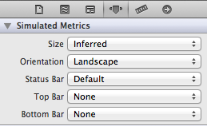
8. Create a new group named **Trailers** in project navigator
9. Add 3 Classes. New File 🡪 Objective C Class to group **Trailers** and name below
   1. trailer1ViewController, trailer2ViewController, trailer3ViewController
   2. There should be an. h and .m create

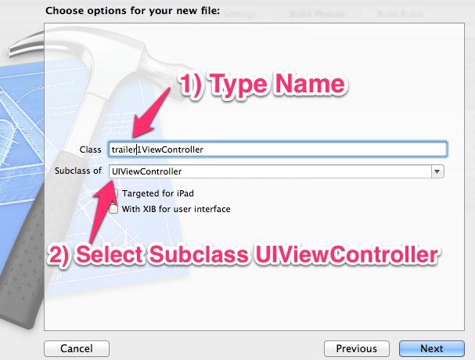

1. Bind new View Controllers to new classes
2. Connect Viewcontrollers via Segue
   1. [CNTRL] drag button from main view to new view
   2. Select Segue action **modal**
3. Connect viewcontrol to view on new viewcontrol
   1. 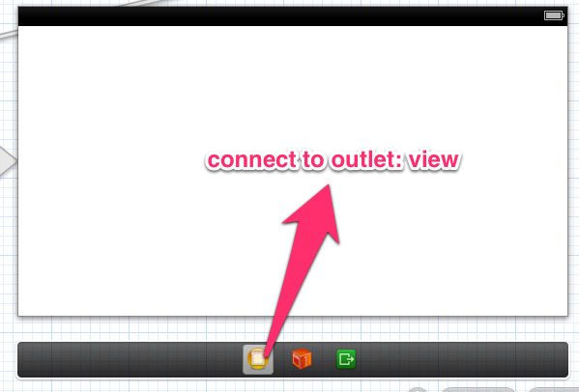
4. Add **Navigation Bar** to top of new ViewController and change title to title of movie

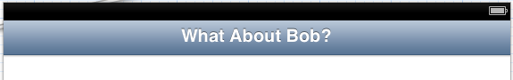

1. Add **Bar Button** item and change text to **Back.** [Cntrl] + drag to home view control and select **modal** action

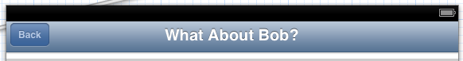

1. Add to link library MediaPlayer.Framework

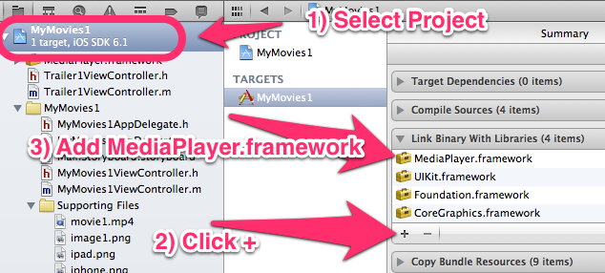

1. Code for .h file (Yellow highlighted text needs added)

#import <UIKit/UIKit.h>

#import <MediaPlayer/MediaPlayer.h>

@interface Trailer1ViewController : UIViewController

{

MPMoviePlayerController *player;

}

@end

1. Add code to .m file (Yellow highlighted text needs added)

- (void)viewDidLoad

{

//Change to match you video filename in supporting files

NSString *url = [[NSBundle mainBundle]

pathForResource:@"movie1"

ofType:@"mp4"];

player = [[MPMoviePlayerController alloc]

initWithContentURL:[NSURL fileURLWithPath:url]];

[[NSNotificationCenter defaultCenter]

addObserver:self

selector:@selector(movieFinishedCallback:)

name:MPMoviePlayerPlaybackDidFinishNotification

object:player];

//—set the size of the movie view and then add it to the View window—

player.view.frame = CGRectMake(10, 40, 550,250);

[self.view addSubview:player.view];

//—play movie—

[player play];

[super viewDidLoad];

// Do any additional setup after loading the view, typically from a nib.

}

//copy paste right below viewdidload

- (void) movieFinishedCallback:(NSNotification*) aNotification {

MPMoviePlayerController *moviePlayer = [aNotification object];

[[NSNotificationCenter defaultCenter]

removeObserver:self

name:MPMoviePlayerPlaybackDidFinishNotification

object:moviePlayer];

[moviePlayer.view removeFromSuperview];

[player release];

}

-(BOOL)shouldAutorotateToInterfaceOrientation:(UIInterfaceOrientation)interfaceOrientation

{

// Return YES for supported orientations

return (interfaceOrientation != UIInterfaceOrientationPortraitUpsideDown);

}

- (void)viewDidUnload

{

[super viewDidUnload];

}

- (void)viewWillAppear:(BOOL)animated

{

[super viewWillAppear:animated];

}

- (void)viewDidAppear:(BOOL)animated

{

[super viewDidAppear:animated];

}

- (void)viewWillDisappear:(BOOL)animated

{

[super viewWillDisappear:animated];

}

- (void)viewDidDisappear:(BOOL)animated

{

//Stop Player when Back button caused view to disappear

[player stop];

[super viewDidDisappear:animated];

}

1. Save App icons (57X57, 114X114) Application main folder . Remember <http://pixlr.com>
   1. Right-click > **Select File** for 57X57
   2. Right-Click > **Select File** 114X114

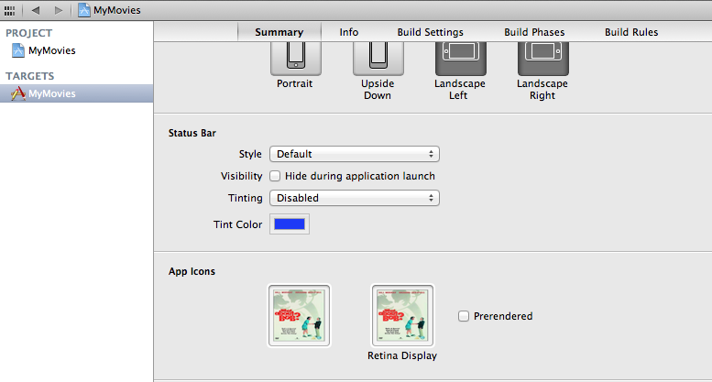

1. Test, Done