My lab is interested in developing single-cell transcriptomic technologies to characterise circulating tumour cells (CTCs). CTCs are diverse cells in the form of single cells or cell clusters that are released by solid tumours into the circulation (blood circulation and lymphatic system). CTCs can be used as a liquid biopsy to obtain information from tumours in a minimally invasive way. The lab aims to investigate whether CTC can potentially serve as a predictive/prognostic biomarker in solid cancers. To reach to this aim, we develop the technology we need.

Previous projects
We developed Smart-seq2, a method for single-cell full-length RNA sequencing. The method has been used worldwide to detect low expressed genes/exons and SNPs in single cells. Recently, we introduced Smart-seq3, an accurate and highly sensitive method to profile expressed genes in full-length, to detect SNPs and to construct isoforms. Smart-seq3 uses UMI to count the number of RNA molecules.

BioRxiv, 2019 https://www.biorxiv.org/content/10.1101/817924v1

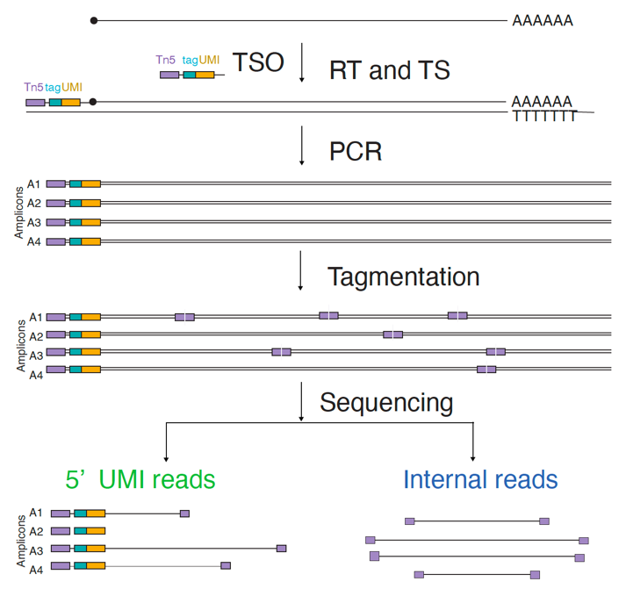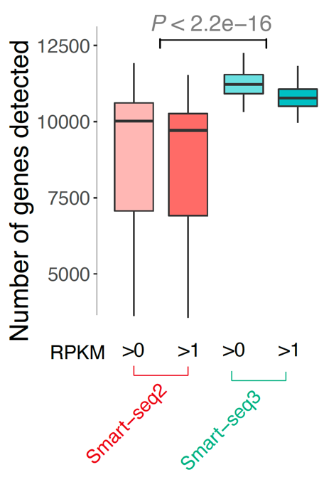

Furthermore, we created Small-seq, the first method to detect expression of small RNAs and specifically microRNAs in individual cells. We could cluster cell types by their miRNA expression.

Nature Biotechnology, 2016. https://www.nature.com/articles/nbt.3701
Nature Protocols, 2018. https://www.nature.com/articles/s41596-018-0049-y

