(side picture)

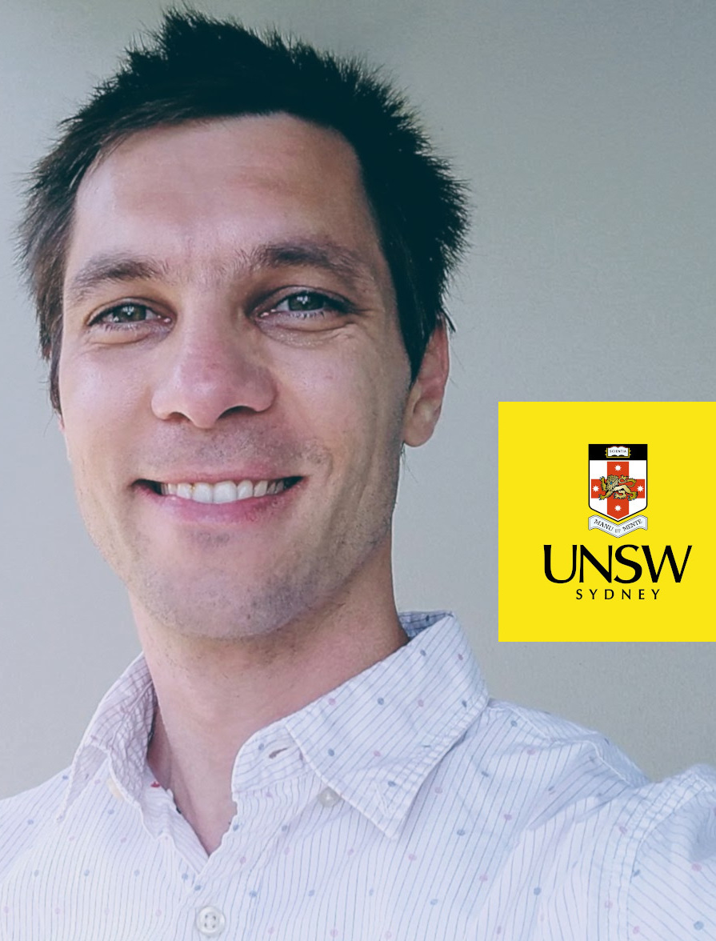

We walk the slippery line between biomedicine and computer science with a special interest in single cell analyses.

## Projects

### Single cell immunology of severe dengue

Dengue is the most widespread mosquito-transmitted viral disease with 400 million infections every year. Millions of people including children and pregnant women suffer from severe symptoms such as internal bleeding and organ failure. The pathogenesis of severe dengue is unclear. We develop new single-cell transcriptomic approaches to understand what different arms of the immune system is doing right and wrong during dengue and severe dengue.

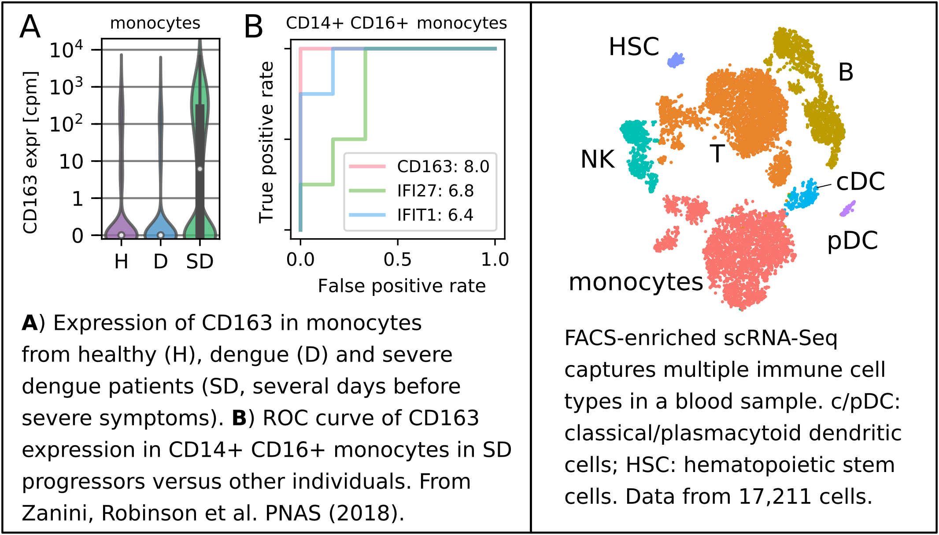

**References:**

[Zanini F, Robinson ML et al. PNAS (2018).](https://www.pnas.org/content/115/52/E12363)

[Zanini F, Pu SY et al. eLife (2018).](https://elifesciences.org/articles/32942)

### Atlas-guided cell type classification

Cell atlases are huge collections of single cell transcriptomes that describe in extreme molecular detail the composition of human tissues. We pioneer new algorithm to leverage cell atlases to rapidly elucidate the composition of tumor biopsies.

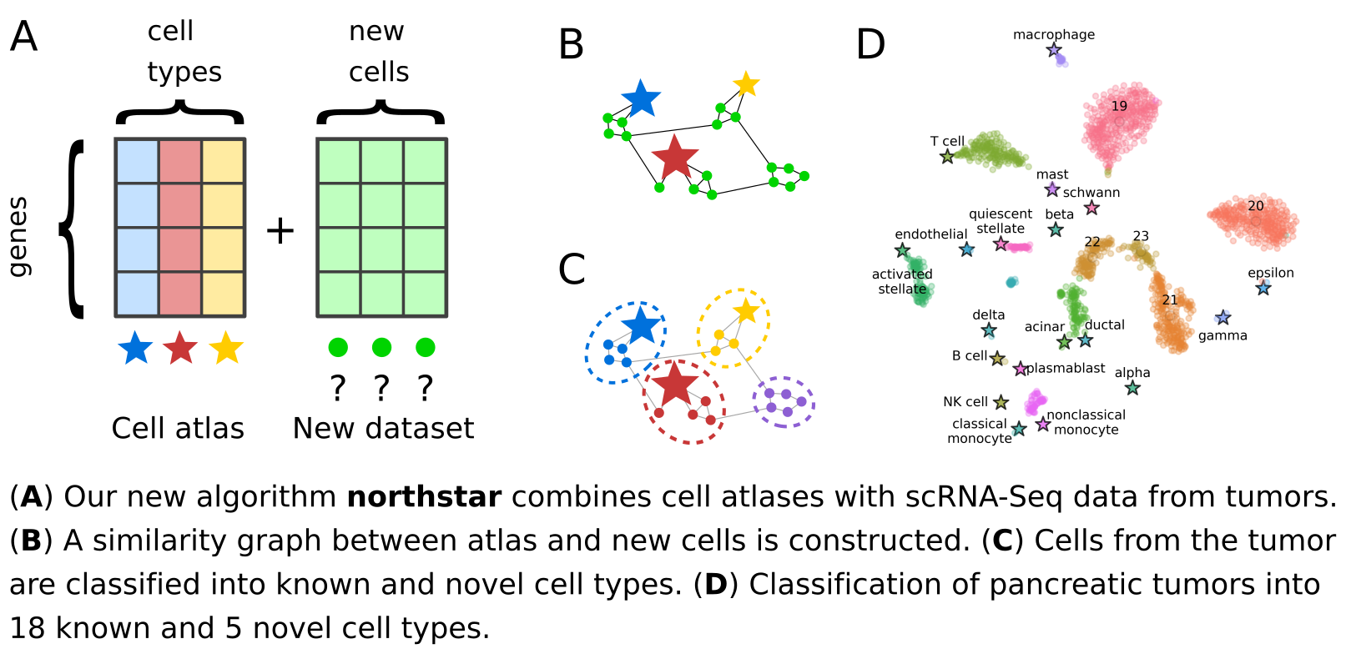

**References:**

[Zanini F, Berghuis B et al. biorXiv (2019).](https://www.biorxiv.org/content/10.1101/820928v1)

### A breath of fresh air: **shock and complexity in** the lung at birth

TBA.