Quan Truong

June 23rd, 2017

CSC205

Mrs. Heil

Algorithms Question

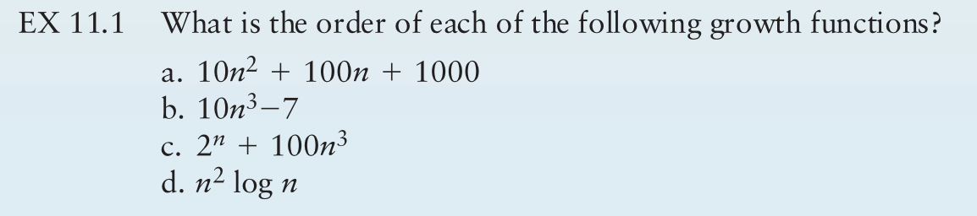

1. O(n^2) – squared growth
2. O(n^3) -- cubed growth
3. O(2^n) -- exponential
4. O(n log n)