HS-422 HITEC SERVO
How Does a Servo Work?

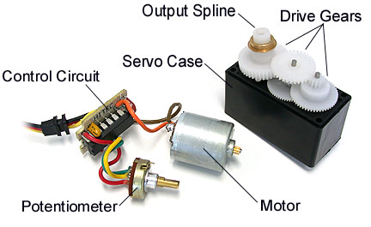
Servos are controlled by sending them a pulse of variable width. The control wire is used to send this pulse. The parameters for this pulse are that it has a minimum pulse, a maximum pulse, and a repetition rate. Given the rotation constraints of the servo, neutral is defined to be the position where the servo has exactly the same amount of potential rotation in the clockwise direction as it does in the counter clockwise direction. It is important to note that different servos will have different constraints on their rotation but they all have a neutral position, and that position is always around 1.5 milliseconds (ms).
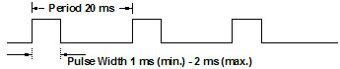
The angle is determined by the duration of a pulse that is applied to the control wire. This is called Pulse width Modulation. The servo expects to see a pulse every 20 ms. The length of the pulse will determine how far the motor turns. For example, a 1.5 ms pulse will make the motor turn to the 90 degree position (neutral position).
When these servos are commanded to move they will move to the position and hold that position. If an external force pushes against the servo while the servo is holding a position, the servo will resist from moving out of that position. The maximum amount of force the servo can exert is the torque rating of the servo. Servos will not hold their position forever though; the position pulse must be repeated to instruct the servo to stay in position.
When a pulse is sent to a servo that is less than 1.5 ms the servo rotates to a position and holds its output shaft some number of degrees counterclockwise from the neutral point. When the pulse is wider than 1.5 ms the opposite occurs. The minimal width and the maximum width of pulse that will command the servo to turn to a valid position are functions of each servo. Different brands, and even different servos of the same brand, will have different maximum and minimums. Generally the minimum pulse will be about 1 ms wide and the maximum pulse will be 2 ms wide.
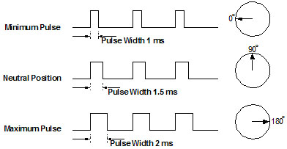
Another parameter that varies from servo to servo is the turn rate. This is the time it takes from the servo to change from one position to another. The worst case turning time is when the servo is holding at the minimum rotation and it is commanded to go to maximum rotation. This can take several seconds on very high torque servos.
The purpose of this information is to give an overview of how servos operate and how to communicate with them. Though we have taken steps to assure the quality of information here, ServoCity makes no guarantees about the information presented. ServoCity cannot be held liable or accountable for any use or misuse of the provided information. If you have questions about this information please e-mail tech@servocity.com.

Servo Connector Types
All of our Hitec servos come with the “S” or universal connector. This connector works with any brand of receiver, servo controller or servo extension.
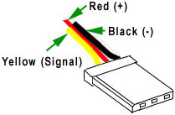
Note: This plug can be accidentally plugged into a receiver in reverse. If this happens, no damage will occur, the servo will simply will not work. If you receive a servo and it does not work, make sure that you have plugged it in correctly.

Rotating a Servo 180°
When controlled with a radio control system, most hobby servos offer 90° (45° either direction) rotation right out of the box. This can sometimes be increased if your radio system offers end point adjustments or your servo controller has a 180° jumper pin. If you are using Hitec digital servos, you simply want to purchase the hand-held programmer to increase the rotation. If you have a Hitec or Futaba analog servo that only offers 90° of rotation, the amount of rotation can sometimes be increased to 180° by performing a simple modification.
Note: You can purchase Hitec servos from us that are pre-modified in our own manufacturing facility on the individual Hitec servo pages. This modification voids all ServoCity and Hitec warranties.
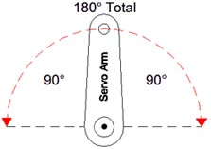

Servo Direction Information
All servos will rotate clockwise and counterclockwise. The direction the servo rotates all depends on the signal the servo is receiving. Futaba and Hitec are different from one another in regards to direction of rotation right out of the box. If you plug in a Hitec servo into your radio control receiver or servo controller and you tell the servo to turn to the right, it will move to the right, if you then plug a Futaba servo into the same receiver or servo controller and tell it to go the same direction as the Hitec servo did, it will move the opposite direction. This is an easy fix with most radio control units since they have a servo reversing function on the transmitter. If you are using a servo controller though and are mixing Hitec and Futaba servos it may cause a problem. This problem can easily be fixed but not as easy as flipping a switch on a transmitter. This is why under the “specification” section for each servo we list the direction of rotation as either clockwise or counter clockwise.

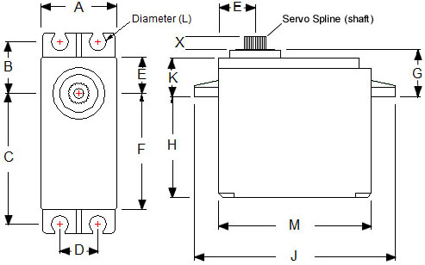

Dimensions | 1.59" x 0.77" x 1.44" (40.39 x 19.56 x 36.58mm)
Product Weight | 1.6oz (45.5g)
Output Shaft Style | 24 tooth (C1) spline
Voltage Range | 4.8V - 6.0V
No-Load Speed (4.8V) | 0.21sec/60°
No-Load Speed (6.0V) | 0.16sec/60°
Stall Torque (4.8V) | 45.82 oz/in. (3.3kg.cm)
Stall Torque (6.0V) | 56.93 oz/in. (4.1kg.cm)
Pulse Amplitude | 3-5V
Operating Temperature | -20°C to +60°C
Current Drain - idle (4.8V) | 8mA
Current Drain - idle (6.0V) | 8.8mA
Current Drain - no-load (4.8V) | 150mA
Current Drain - no-load (6V) | 180mA
Continuous Rotation Modifiable | Yes
Direction w/ Increasing PWM Signal | Clockwise
Deadband Width | 8µs
Motor Type | 3 Pole Ferrite
Potentiometer Drive | Indirect Drive
Feedback Style | 5KΩ Potentiometer
Output Shaft Support | Dual Oilite Bushing
Gear Type | Straight Cut Spur
Gear Material | Nylon
Wire Length | 11.81" (300mm)
Wire Gauge | 25AWG

