analyze_第二次作業

資料來源：https://api.finmindtrade.com/api/v4/data
讀取資料：
提示：
import requests
import pandas as pd
import matplotlib.pyplot as plt

# ==========================================
# 1. 設定股票與日期
# ==========================================
stock_id = "2330"
start_date = "2026-01-01"
end_date = "2026-09-30"
url = "https://api.finmindtrade.com/api/v4/data"
params = {
"dataset": "TaiwanStockPrice",
"data_id": stock_id,
"start_date": start_date,
"end_date": end_date
}
# ==========================================
# 2. 取得 API 資料
# ==========================================
response = requests.get(url, params=params)

print("HTTP Status Code:", response.status_code)
data = response.json()
df = pd.DataFrame(data["data"])
print("\n========== 原始資料 ==========")
print(df.head())
說明:
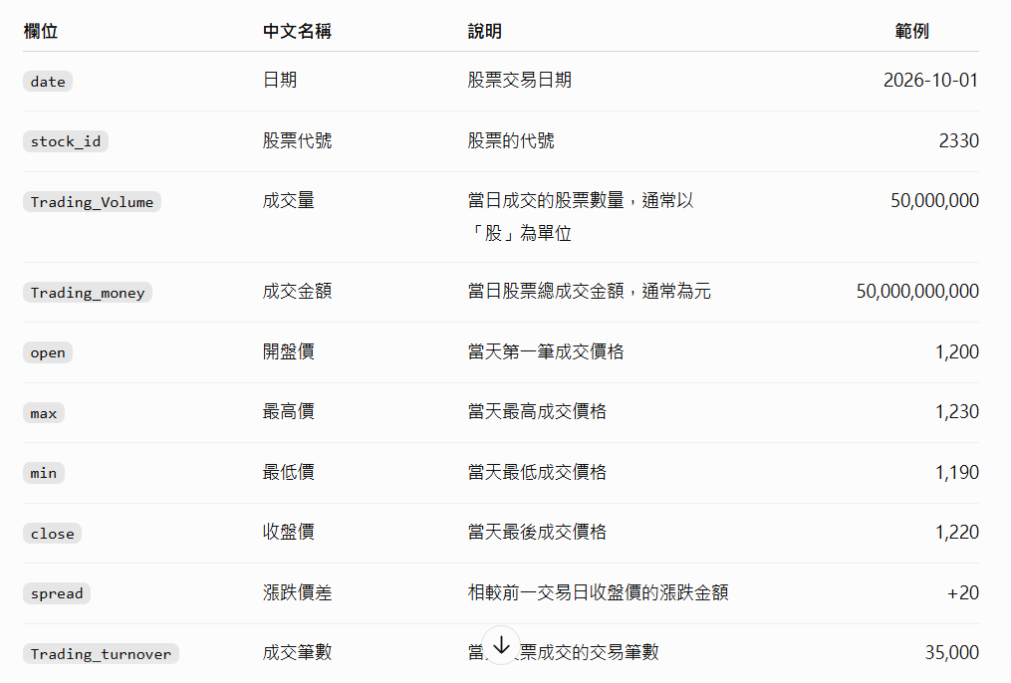

1. 繪製收盤價走勢圖，結果參考如下：
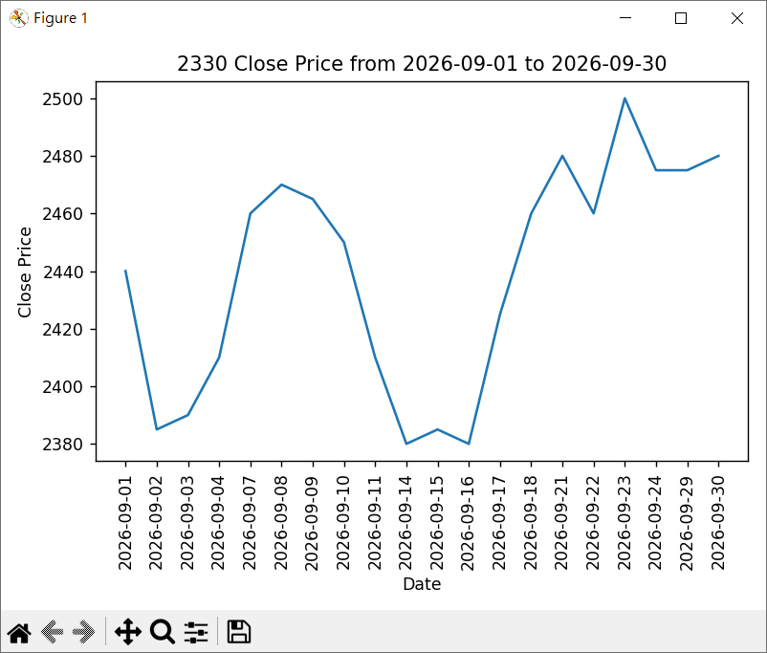
2. 繪製成交量走勢圖，結果參考如下：
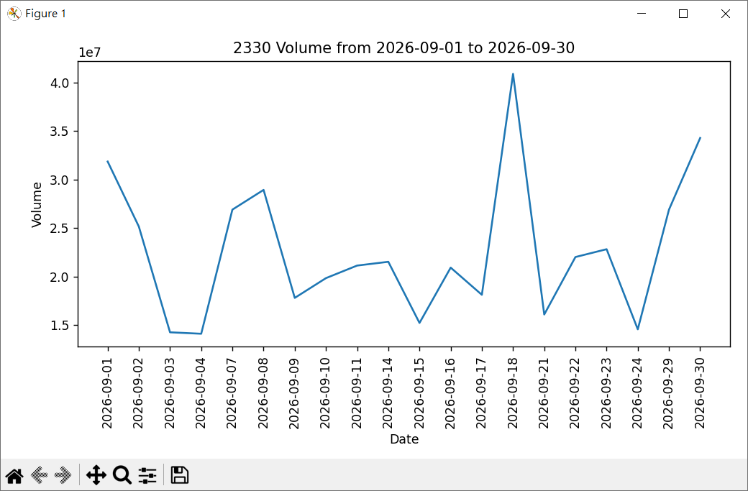

3. 將系統改成讓使用者輸入如下：
