analyze_第二次作業

資料來源：https://api.finmindtrade.com/api/v4/data
讀取資料：
提示：
import requests
import pandas as pd
import matplotlib.pyplot as plt

# ==========================================
# 1. 設定股票與日期
# ==========================================
stock_id = "2330"
start_date = "2026-01-01"
end_date = "2026-09-30"
url = "https://api.finmindtrade.com/api/v4/data"
params = {
"dataset": "TaiwanStockPrice",
"data_id": stock_id,
"start_date": start_date,
"end_date": end_date
}
# ==========================================
# 2. 取得 API 資料
# ==========================================
response = requests.get(url, params=params)

print("HTTP Status Code:", response.status_code)
data = response.json()
df = pd.DataFrame(data["data"])
print("\n========== 原始資料 ==========")
print(df.head())
說明:
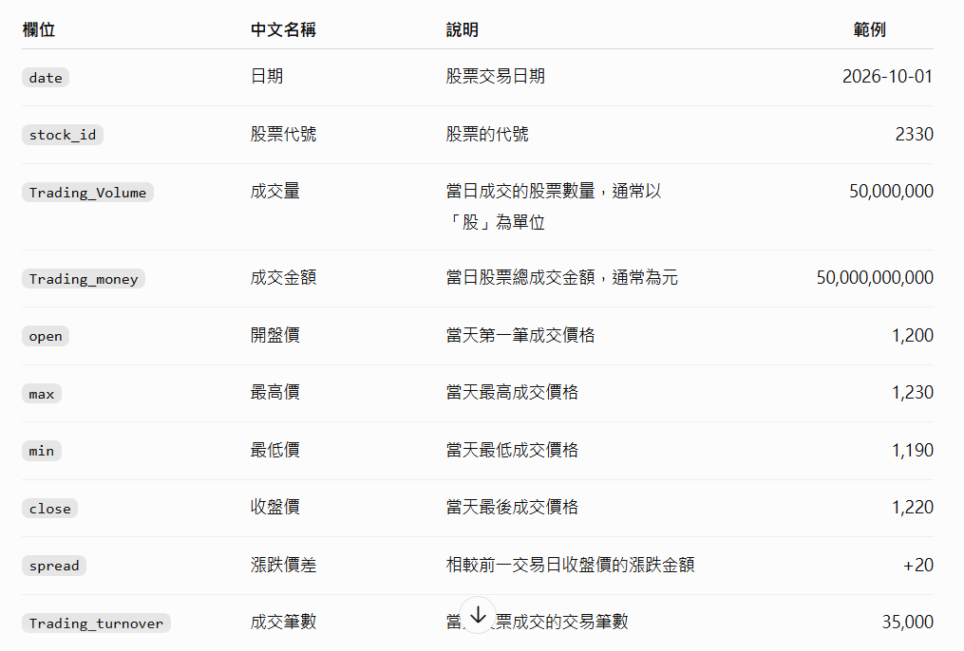

1. 繪製收盤價走勢圖，結果參考如下：
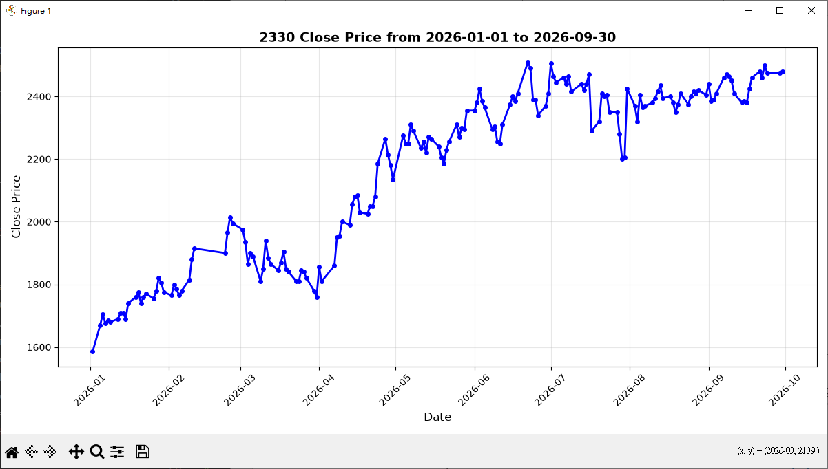
Code:
# -*- coding: utf-8 -*-
"""
EX2-1: 繪製收盤價走勢圖
功能: 從FinMind API獲取股票數據，繪製收盤價走勢圖
股票代碼: 2330 (台積電)
時間範圍: 2026-01-01 到 2026-09-30
"""

import sys
import io
sys.stdout = io.TextIOWrapper(sys.stdout.buffer, encoding='utf-8')

import requests
import pandas as pd
import matplotlib.pyplot as plt

# ==========================================
# 設定股票代碼和日期範圍
# ==========================================
stock_id = "2330"
start_date = "2026-01-01"
end_date = "2026-09-30"
url = "https://api.finmindtrade.com/api/v4/data"

# 準備API參數
params = {
"dataset": "TaiwanStockPrice",
"data_id": stock_id,
"start_date": start_date,
"end_date": end_date
}

# ==========================================
# 獲取API數據
# ==========================================
print(f"[*] 正在獲取 {stock_id} 從 {start_date} 到 {end_date} 的股票數據...")
response = requests.get(url, params=params)

if response.status_code != 200:
print(f"[ERROR] 獲取數據失敗，HTTP狀態碼: {response.status_code}")
sys.exit(1)

# ==========================================
# 數據處理
# ==========================================
print("[*] 數據處理中...")
data = response.json()
df = pd.DataFrame(data["data"])

# 轉換日期格式並排序
df['date'] = pd.to_datetime(df['date'])
df = df.sort_values('date').reset_index(drop=True)

print(f"[OK] 成功獲取 {len(df)} 筆資料")

# ==========================================
# 繪製收盤價走勢圖
# ==========================================
print("[*] 繪製收盤價走勢圖...")

plt.figure(figsize=(12, 6))
plt.plot(df['date'], df['close'], marker='o', linewidth=2, markersize=4, color='blue')

# 設定圖表標題和軸標籤
plt.title(f'{stock_id} Close Price from {start_date} to {end_date}',
fontsize=14, fontweight='bold')
plt.xlabel('Date', fontsize=12)
plt.ylabel('Close Price', fontsize=12)

# 旋轉X軸日期標籤以便閱讀
plt.xticks(rotation=45)

# 添加網格線
plt.grid(True, alpha=0.3)

# 調整佈局並保存
plt.tight_layout()

output_file = 'EX2-1_close_price.png'
plt.savefig(output_file, dpi=100, bbox_inches='tight')
print(f"[OK] 圖表已保存到: {output_file}")

# 顯示圖表
plt.show()

# ==========================================
# 數據統計
# ==========================================
print("\n========== 收盤價統計 ==========")
print(f"最高價: {df['close'].max()}")
print(f"最低價: {df['close'].min()}")
print(f"平均價: {df['close'].mean():.2f}")
print(f"振幅: {df['close'].max() - df['close'].min()}")

2. 繪製成交量走勢圖，結果參考如下：
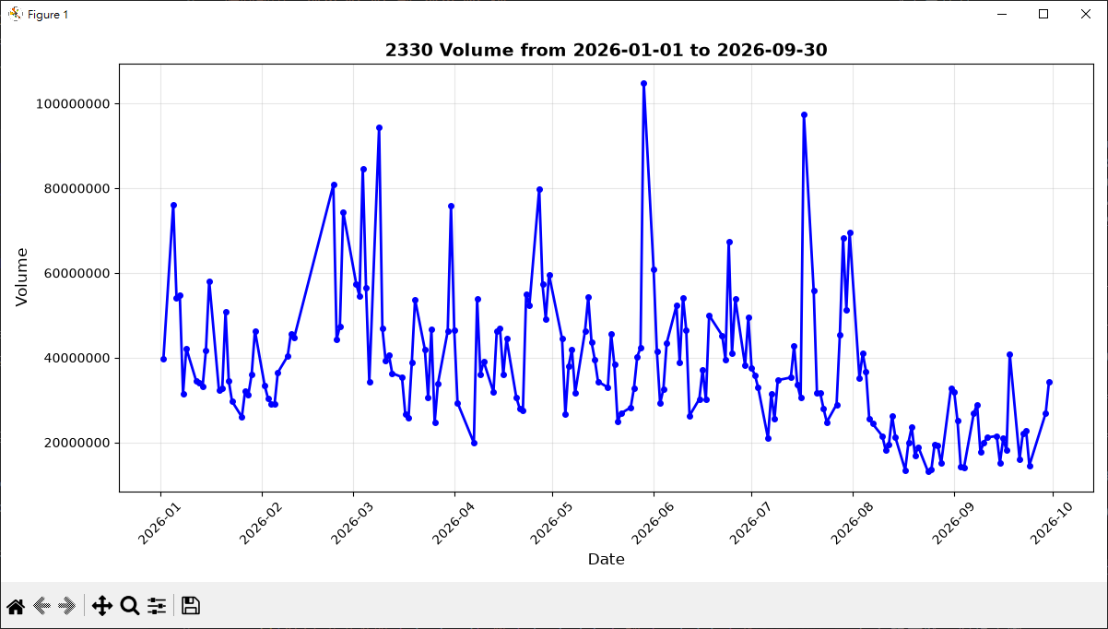
Code:
# -*- coding: utf-8 -*-
"""
EX2-2: 繪製成交量走勢圖
功能: 從FinMind API獲取股票數據，繪製成交量走勢圖
股票代碼: 2330 (台積電)
時間範圍: 2026-01-01 到 2026-09-30
"""

import sys
import io
sys.stdout = io.TextIOWrapper(sys.stdout.buffer, encoding='utf-8')

import requests
import pandas as pd
import matplotlib.pyplot as plt

# ==========================================
# 設定股票代碼和日期範圍
# ==========================================
stock_id = "2330"
start_date = "2026-01-01"
end_date = "2026-09-30"
url = "https://api.finmindtrade.com/api/v4/data"

# 準備API參數
params = {
"dataset": "TaiwanStockPrice",
"data_id": stock_id,
"start_date": start_date,
"end_date": end_date
}

# ==========================================
# 獲取API數據
# ==========================================
print(f"[*] 正在獲取 {stock_id} 從 {start_date} 到 {end_date} 的股票數據...")
response = requests.get(url, params=params)

if response.status_code != 200:
print(f"[ERROR] 獲取數據失敗，HTTP狀態碼: {response.status_code}")
sys.exit(1)

# ==========================================
# 數據處理
# ==========================================
print("[*] 數據處理中...")
data = response.json()
df = pd.DataFrame(data["data"])

# 轉換日期格式並排序
df['date'] = pd.to_datetime(df['date'])
df = df.sort_values('date').reset_index(drop=True)

print(f"[OK] 成功獲取 {len(df)} 筆資料")

# ==========================================
# 繪製成交量走勢圖
# ==========================================
print("[*] 繪製成交量走勢圖...")

plt.figure(figsize=(12, 6))
plt.plot(df['date'], df['Trading_Volume'], marker='o', linewidth=2, markersize=4, color='blue')

# 設定圖表標題和軸標籤
plt.title(f'{stock_id} Volume from {start_date} to {end_date}',
fontsize=14, fontweight='bold')
plt.xlabel('Date', fontsize=12)
plt.ylabel('Volume', fontsize=12)

# 使用普通格式顯示Y軸（避免科學記號）
plt.ticklabel_format(style='plain', axis='y')

# 旋轉X軸日期標籤以便閱讀
plt.xticks(rotation=45)

# 添加網格線
plt.grid(True, alpha=0.3)

# 調整佈局並保存
plt.tight_layout()

output_file = 'EX2-2_volume.png'
plt.savefig(output_file, dpi=100, bbox_inches='tight')
print(f"[OK] 圖表已保存到: {output_file}")

# 顯示圖表
plt.show()

# ==========================================
# 數據統計
# ==========================================
print("\n========== 成交量統計 ==========")
print(f"最高成交量: {df['Trading_Volume'].max():,}")
print(f"最低成交量: {df['Trading_Volume'].min():,}")
print(f"平均成交量: {df['Trading_Volume'].mean():,.0f}")
print(f"總成交量: {df['Trading_Volume'].sum():,}")

3. 將系統改成讓使用者輸入如下：
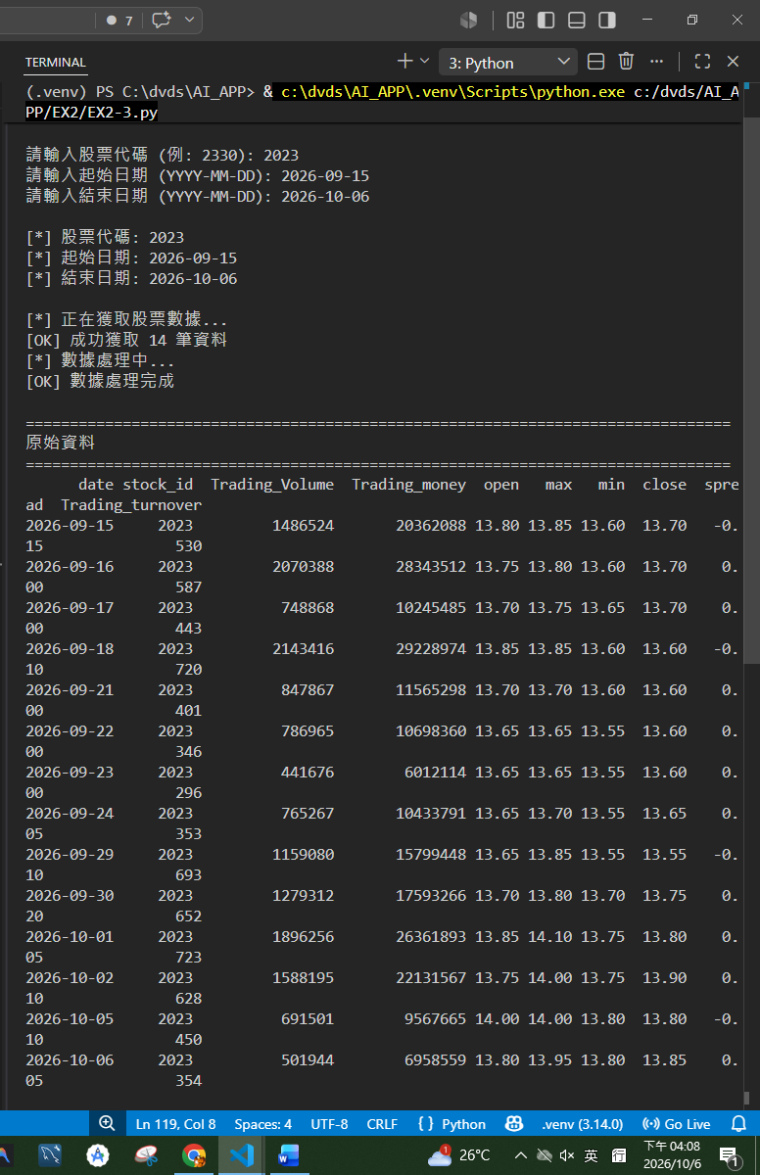
Code:
# -*- coding: utf-8 -*-
"""
EX2-3: 互動式股票數據分析工具
功能: 讓使用者輸入股票代碼和日期範圍，繪製收盤價和成交量走勢圖
特點: 支持用戶自定義查詢參數
"""

import sys
import io
sys.stdout = io.TextIOWrapper(sys.stdout.buffer, encoding='utf-8')

import requests
import pandas as pd
import matplotlib.pyplot as plt

# ==========================================
# 用戶輸入
# ==========================================
print("=" * 60)
print(" 股票數據分析工具 - FinMind API")
print("=" * 60)
print()

# 輸入股票代碼
while True:
stock_id = input("請輸入股票代碼 (例: 2330): ").strip()
if stock_id:
break
print("[警告] 股票代碼不能為空，請重新輸入")

# 輸入起始日期
while True:
start_date = input("請輸入起始日期 (YYYY-MM-DD): ").strip()
# 簡單驗證日期格式
if len(start_date) == 10 and start_date.count('-') == 2:
break
print("[警告] 日期格式錯誤，請使用 YYYY-MM-DD 格式")

# 輸入結束日期
while True:
end_date = input("請輸入結束日期 (YYYY-MM-DD): ").strip()
# 簡單驗證日期格式
if len(end_date) == 10 and end_date.count('-') == 2:
break
print("[警告] 日期格式錯誤，請使用 YYYY-MM-DD 格式")

print()
print(f"[*] 股票代碼: {stock_id}")
print(f"[*] 起始日期: {start_date}")
print(f"[*] 結束日期: {end_date}")
print()

# ==========================================
# API 設定
# ==========================================
url = "https://api.finmindtrade.com/api/v4/data"
params = {
"dataset": "TaiwanStockPrice",
"data_id": stock_id,
"start_date": start_date,
"end_date": end_date
}

# ==========================================
# 獲取API數據
# ==========================================
print("[*] 正在獲取股票數據...")
try:
response = requests.get(url, params=params, timeout=10)

if response.status_code != 200:
print(f"[ERROR] 獲取數據失敗，HTTP狀態碼: {response.status_code}")
sys.exit(1)

data = response.json()

# 檢查是否有數據
if not data.get("data") or len(data["data"]) == 0:
print(f"[ERROR] 找不到股票代碼 {stock_id} 的數據，請檢查股票代碼是否正確")
sys.exit(1)

df = pd.DataFrame(data["data"])
print(f"[OK] 成功獲取 {len(df)} 筆資料")

except requests.exceptions.Timeout:
print("[ERROR] 連接超時，請檢查網絡連接")
sys.exit(1)
except requests.exceptions.RequestException as e:
print(f"[ERROR] 獲取數據出錯: {e}")
sys.exit(1)

# ==========================================
# 數據處理
# ==========================================
print("[*] 數據處理中...")
df['date'] = pd.to_datetime(df['date'])
df = df.sort_values('date').reset_index(drop=True)

print(f"[OK] 數據處理完成")
print()

# ==========================================
# 打印所有原始資料
# ==========================================
print("=" * 80)
print("原始資料")
print("=" * 80)

# 選擇需要的列
columns_order = ['date', 'stock_id', 'Trading_Volume', 'Trading_money',
'open', 'max', 'min', 'close', 'spread', 'Trading_turnover']
available_columns = [col for col in columns_order if col in df.columns]

# 打印所有原始資料
df_display = df[available_columns].copy()
print(df_display.to_string(index=False))
print()
print(f"總筆數: {len(df_display)}")
print()

# ==========================================
# 顯示數據基本信息
# ==========================================
print("=" * 60)
print(f" {stock_id} 股票數據統計 ({start_date} ~ {end_date})")
print("=" * 60)
print()

